**Testing object: device-api**

Let’s check our endpoints.

We have the following resources for our service:

* /api/v1/devices
* /api/v1/devices/{deviceID}

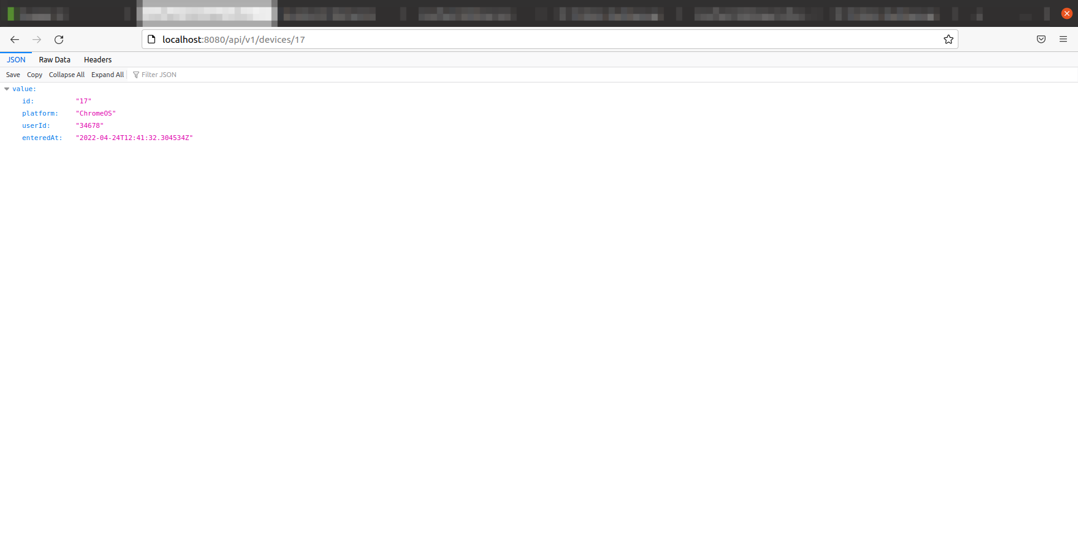

According to the Swagger UI spec we have the following requests:

**GET ListDevicesV1 - List of devices**

This request returns list of each devices in given pages

Code 200 - A successful response

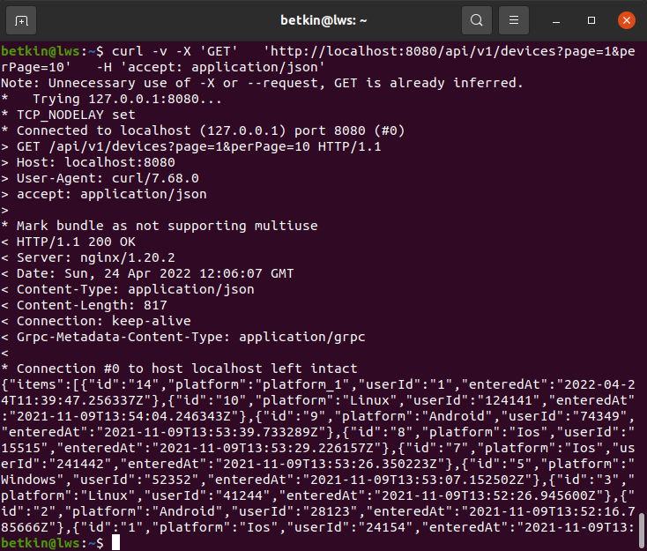

**POST CreateDeviceV1 - Create a device**

Input restriction

userId: [1 : 9223372036854775807]

Code 200 - A successful response

Code 400 - Bad Request

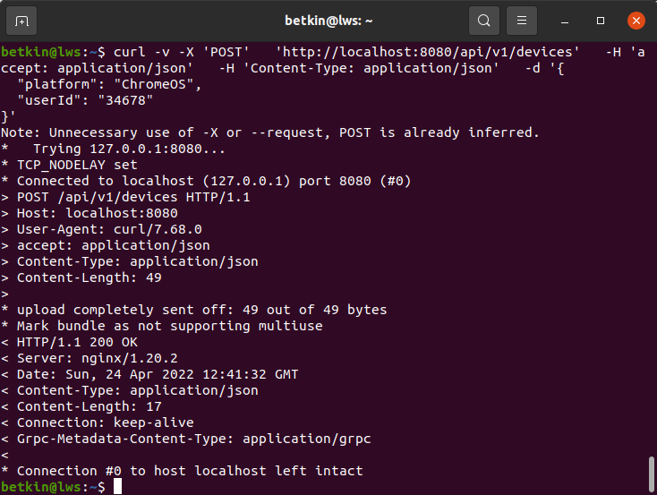

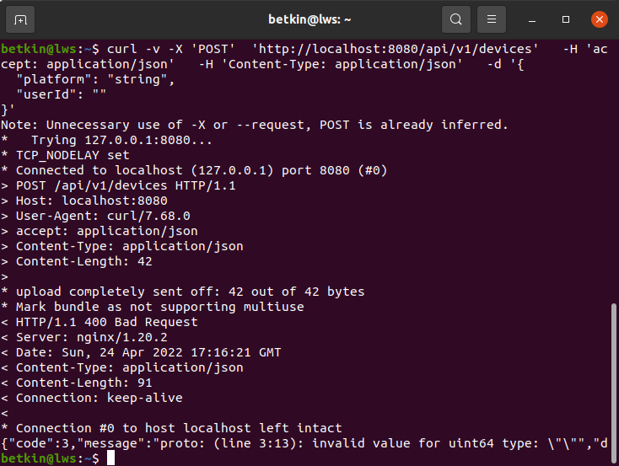

**GET DescribeDeviceV1 - Describe a device**

This request returns information about device{id}

Input restriction

id: [1 : 2147483647]

Code 200 - A successful response

Code 400 - Bad Request

Code 404 - Not Found

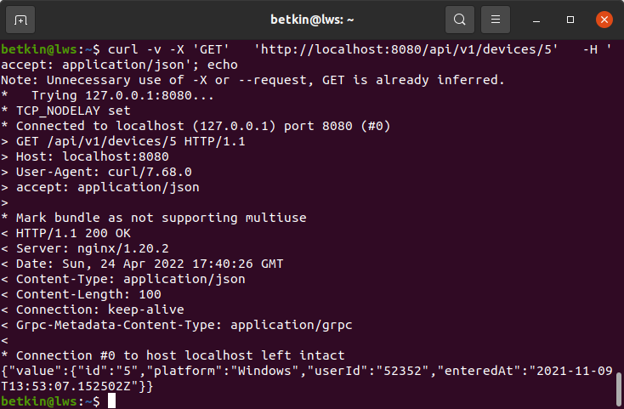Code 500 - Internal server error

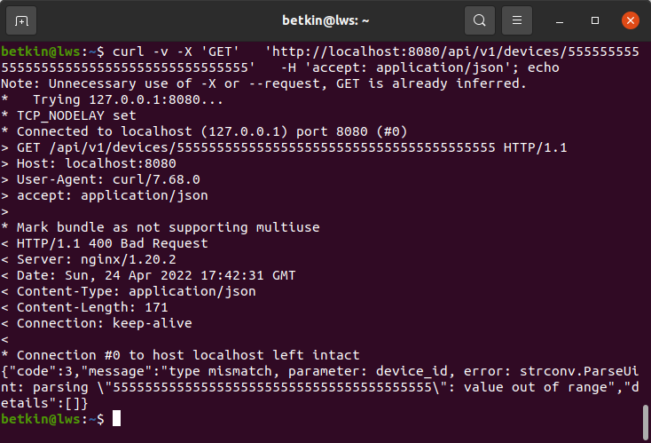

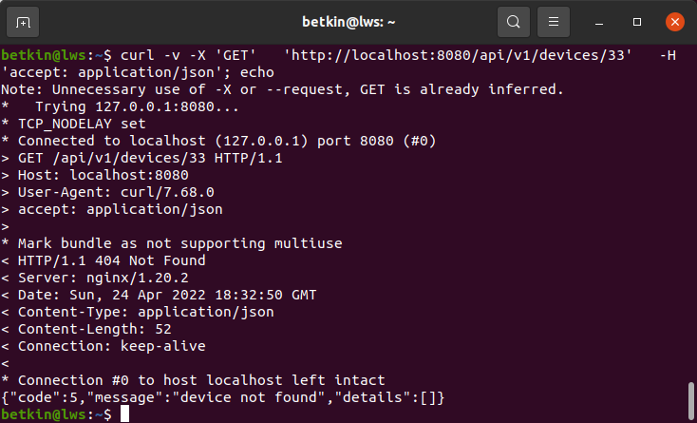

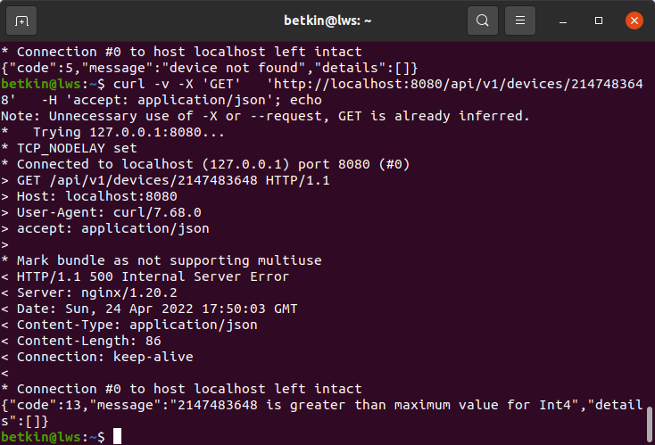

**DELETE RemoveDeviceV1 - Remove a device**

This request removes device{id}

Input restriction

id: [1 : 2147483647]

Code 200 - A successful response (if we have ““found”: true” in response’ body!!!)

Code 400 - Bad Request

Code 500 - Internal Server Error

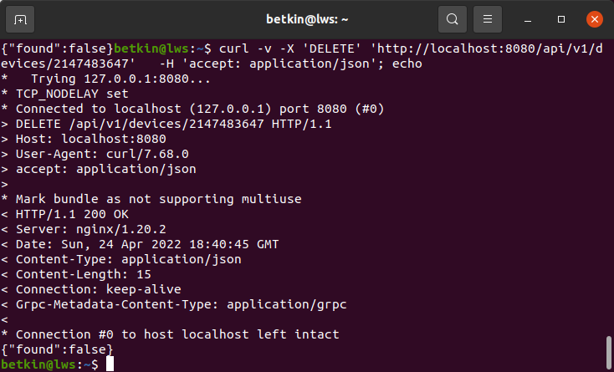

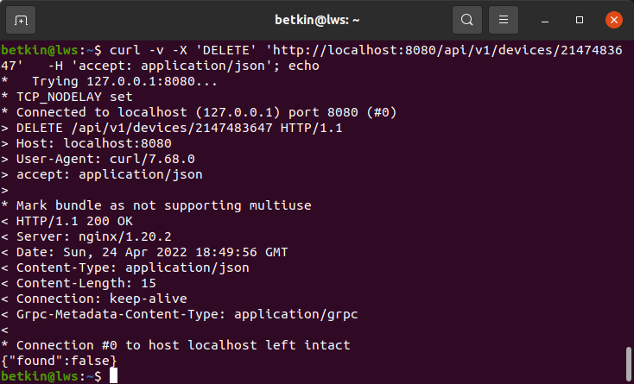

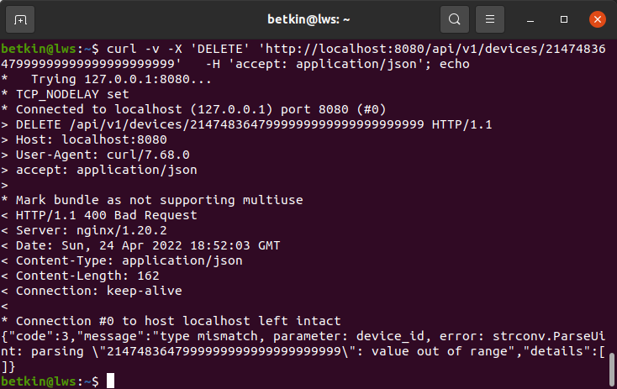

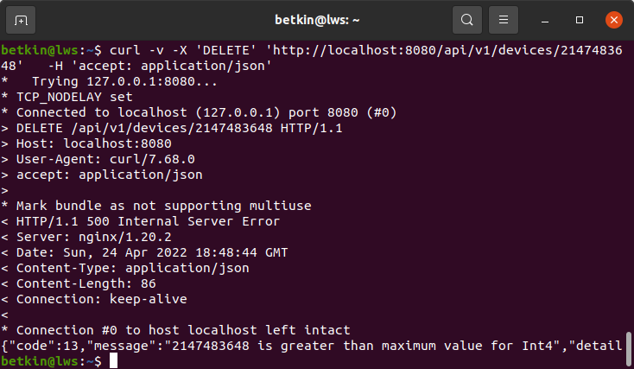

**PUT UpdateDeviceV1 - Update a device**

This request update device{id}

Input restriction

id: [1 : 2147483647]

Code 200 - A successful response (if we have ““found”: true” in response’ body!!!)

Code 400 - Bad Request

Code 500 - Internal Server Error

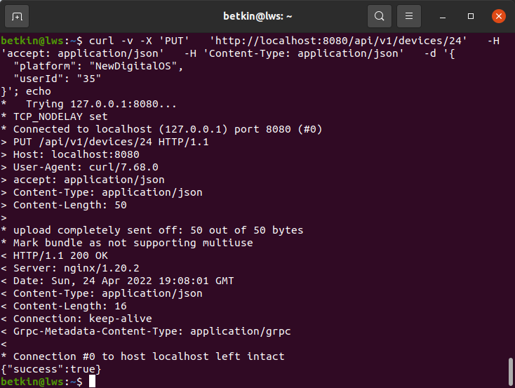

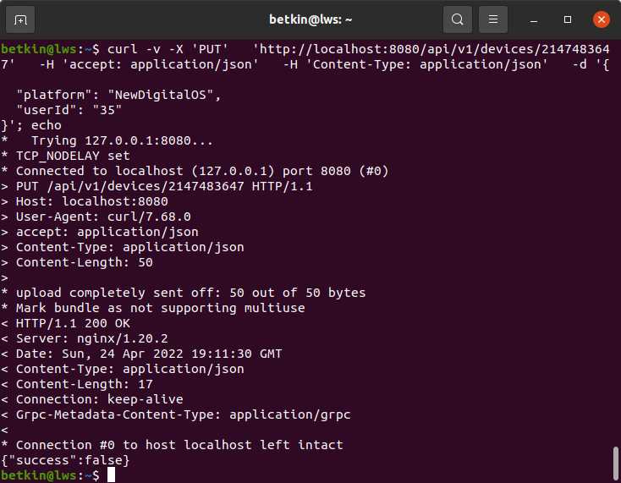

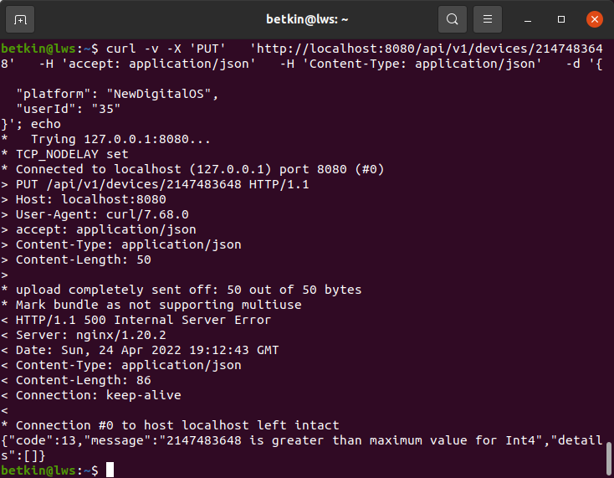

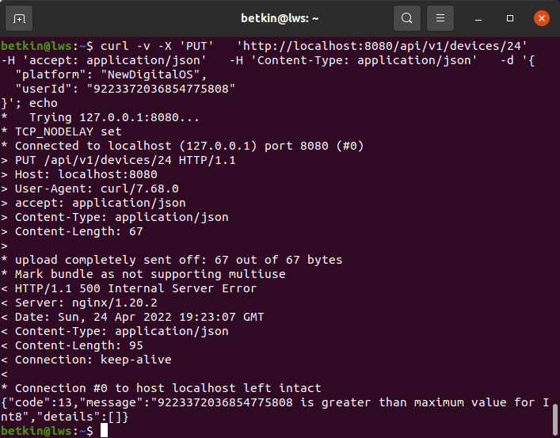

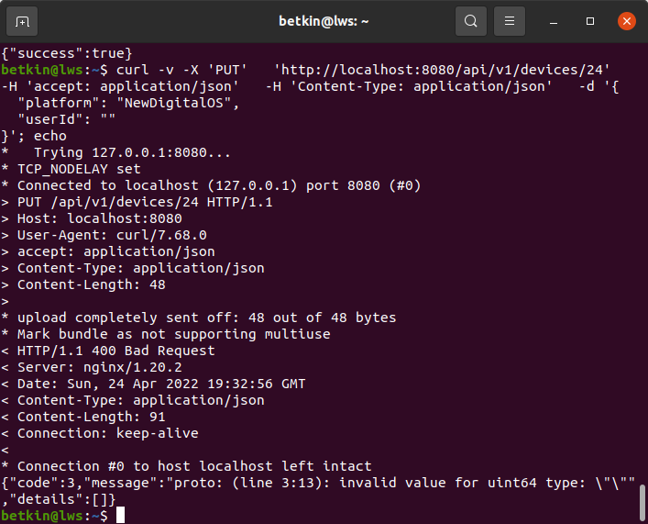

***Results of the research tour***

*We have tested the basic functionality of the service. No critical or blocker bugs found.*

*There is a mismatch between the actual and declared data types for the* ***id*** *field. The range of valid values for this field is from 1 to* 2147483647.