Grupo05
Lista de exercícios
Semana 03

Eberton Chaves Dias – 11621BSI215
Elisângela Rithiely Evaristo de Souza - 11811BSI251
Gabriel Miranda Silva - 11621BSI222

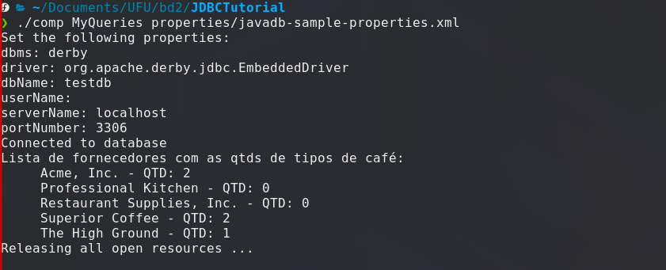

public MyQueries(Connection connArg, JDBCUtilities settingsArg) {
this.con = connArg;
this.settings = settingsArg;
}

public static void getMyData(Connection con) throws SQLException {
Statement stmt = null;
String query =
"(SELECT S.SUP_NAME, COUNT(C.COF_NAME) " +
"FROM COFFEES AS C NATURAL INNER JOIN SUPPLIERS AS S " +
"WHERE C.SUP_ID = S.SUP_ID " +
"GROUP BY S.SUP_NAME)" +
"UNION " +
"(SELECT S.SUP_NAME, SUM(0) " +
"FROM SUPPLIERS AS S LEFT JOIN COFFEES AS C " +
"ON S.SUP_ID = C.SUP_ID " +
"WHERE C.COF_NAME IS NULL " +
"GROUP BY S.SUP_NAME)";

try {
stmt = con.createStatement();
ResultSet rs = stmt.executeQuery(query);
System.out.println("Lista de fornecedores com as qtds de tipos de café: ");
while (rs.next()) {
String coffeeName = rs.getString(1);
String qtd_coffees = rs.getString(2);
System.out.println(" " + coffeeName + " - QTD: " + qtd_coffees);
}
} catch (SQLException e) {
JDBCUtilities.printSQLException(e);
} finally {
if (stmt != null) { stmt.close(); }
}
}

