Criando uma API completa com Rails
Leonardo Scorza (One Bit Code)

https://www.youtube.com/watch?v=EqOoElCjpNI

Resumo do curso feito por Roberto Pinheiro

Aula 01 - Planejando nossa API

O que é uma API?

É uma maneira de conversar com outros serviços.

Caso você precise de informações e dados que não possui em sua aplicação, você pode consumir uma API.

As API's podem ser pagas ou públicas.

O que vamos criar?

Vamos criar uma API de agenda de contatos.

O que vamos usar no projeto?

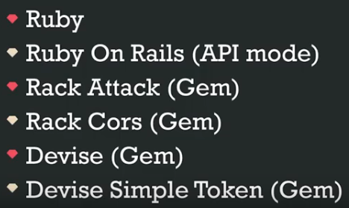

Planejando nossa API

SwaggerHub

Esse software permite documentar as API's.

Uma API normalmente é constituída de diversos endpoints. Cada URL é basicamente um endpoint. E cada endpoint tem uma função.

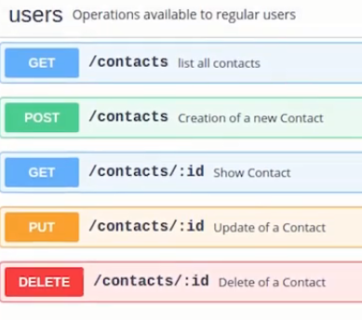

https://app.swaggerhub.com/apis/lscorza/OneBitContacts/1.0.0

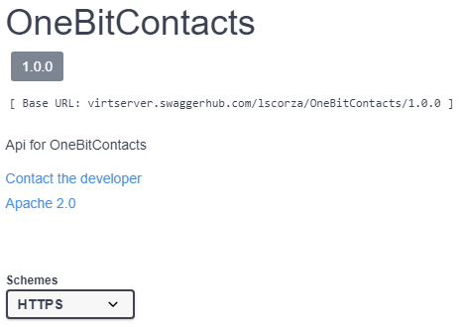

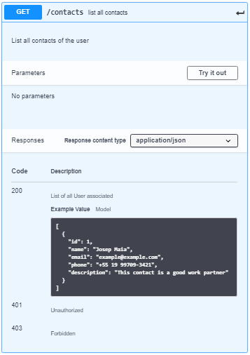
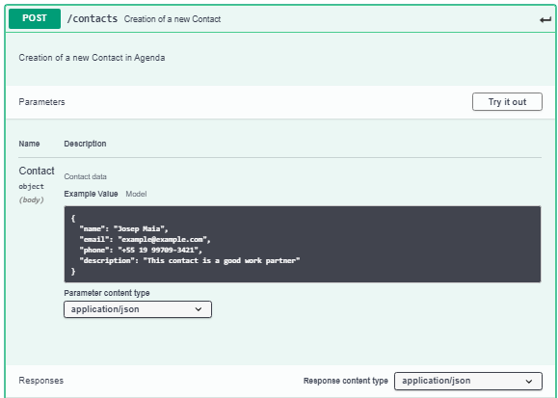

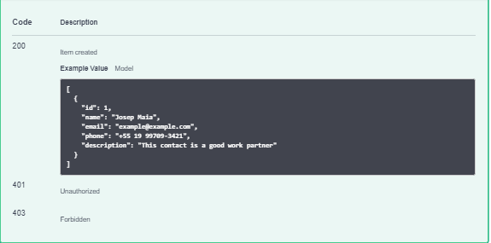

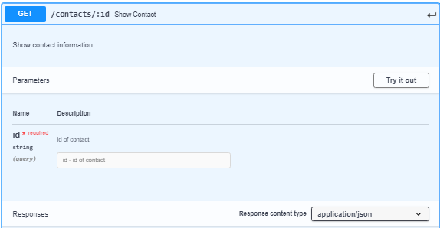

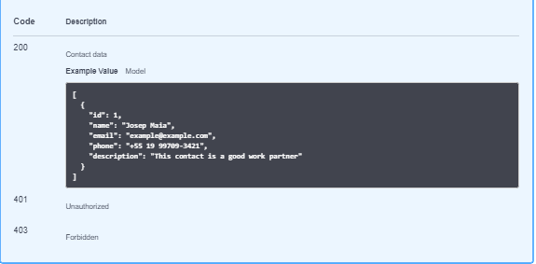

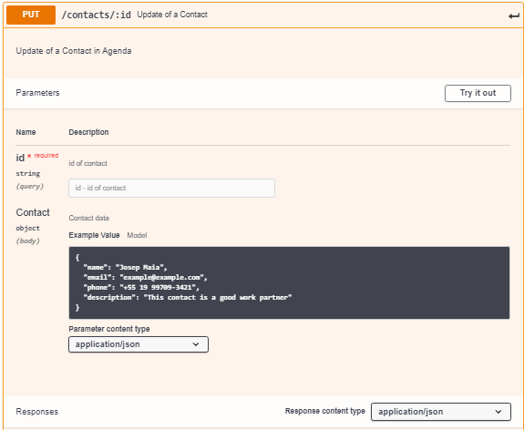
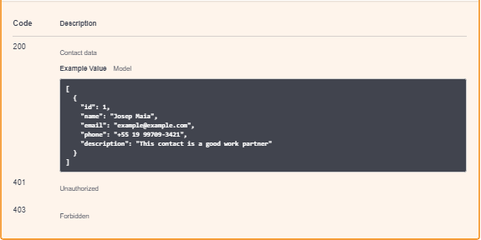
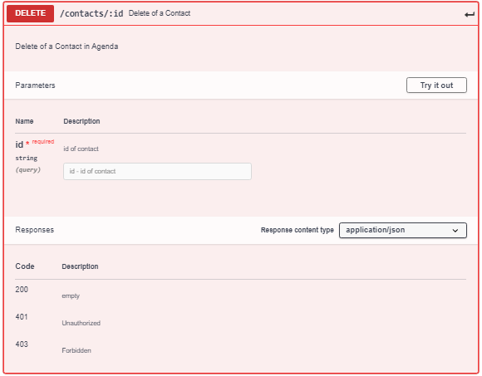

Aula 02 - Preparando a base da API

API’s são maneiras de conectar serviços, com elas é possível se conectar ao Google para traduzir uma frase ou ao Watson da IBM para realizar um processamento de linguagem natural. Vamos ver o que é essencial para criar uma usando Ruby On Rails.

O que vamos utilizar

- Ruby
- Ruby On Rails
- Devise
- Devise Simple Token
- Rack Cors
- Rack Attack
- Postman

Gerando nosso Projeto

1 – Rode no console

rails new OneBitContacts --api

*Se quiser utilizar o PostgreSQL adicione ao comando:

--database=postgresql

Versionando a API

1 – Dentro da pasta controllers crie uma pasta chamada api
2 – Dentro da pasta criada crie uma nova pasta chamada v1
3 – Dentro da pasta criada crie um arquivo chamado api_controller.rb e coloque nele:

module Api::V1
class ApiController < ApplicationController
# Métodos globais
end
end

Habilitando o CORS

Acrescente no seu Gemfile:

gem 'rack-cors'

Instale a gem rodando:

bundle install

Acrescente no seu config/application.rb:

config.middleware.insert_before 0, Rack::Cors do
allow do
origins '*'
resource '*',
headers: :any,
methods: %i(get post put patch delete options head)
end
end

config/application.rb

require_relative 'boot'

require "rails"
# Pick the frameworks you want:
require "active_model/railtie"
require "active_job/railtie"
require "active_record/railtie"
require "active_storage/engine"
require "action_controller/railtie"
require "action_mailer/railtie"
require "action_view/railtie"
require "action_cable/engine"
# require "sprockets/railtie"
require "rails/test_unit/railtie"

# Require the gems listed in Gemfile, including any gems
# you've limited to :test, :development, or :production.
Bundler.require(*Rails.groups)

module OneBitContacts
class Application < Rails::Application
# Initialize configuration defaults for originally generated Rails version.
config.load_defaults 5.2

# Settings in config/environments/* take precedence over those specified here.
# Application configuration can go into files in config/initializers
# -- all .rb files in that directory are automatically loaded after loading
# the framework and any gems in your application.

# Only loads a smaller set of middleware suitable for API only apps.
# Middleware like session, flash, cookies can be added back manually.
# Skip views, helpers and assets when generating a new resource.
config.api_only = true

config.middleware.insert_before 0, Rack::Cors do
allow do
origins '*'
resource '*',
headers: :any,
methods: %i(get post put patch delete options head)
end
end

end
end

Configurando o Rack Attack

Acrescente no seu Gemfile:

gem 'rack-attack'

Instale a gem:

bundle install

Acrescente em config/application:

config.middleware.use Rack::Attack

config/application.rb

require_relative 'boot'

require "rails"
# Pick the frameworks you want:
require "active_model/railtie"
require "active_job/railtie"
require "active_record/railtie"
require "active_storage/engine"
require "action_controller/railtie"
require "action_mailer/railtie"
require "action_view/railtie"
require "action_cable/engine"
# require "sprockets/railtie"
require "rails/test_unit/railtie"

# Require the gems listed in Gemfile, including any gems
# you've limited to :test, :development, or :production.
Bundler.require(*Rails.groups)

module OneBitContacts
class Application < Rails::Application
# Initialize configuration defaults for originally generated Rails version.
config.load_defaults 5.2

# Settings in config/environments/* take precedence over those specified here.
# Application configuration can go into files in config/initializers
# -- all .rb files in that directory are automatically loaded after loading
# the framework and any gems in your application.

# Only loads a smaller set of middleware suitable for API only apps.
# Middleware like session, flash, cookies can be added back manually.
# Skip views, helpers and assets when generating a new resource.
config.api_only = true

config.middleware.insert_before 0, Rack::Cors do
allow do
origins '*'
resource '*',
headers: :any,
methods: %i(get post put patch delete options head)
end
end

config.middleware.use Rack::Attack

end
end

Crie um arquivo chamado rack_attack.rb no seu config/initializers/ e coloque nele:

config/initializers/rack_attack.rb

class Rack::Attack
Rack::Attack.cache.store = ActiveSupport::Cache::MemoryStore.new

# Allow all local traffic
safelist('allow-localhost') do |req|
'127.0.0.1' == req.ip || '::1' == req.ip
end

# Allow an IP address to make 10 requests every 10 seconds
throttle('req/ip', limit: 5, period: 5) do |req|
req.ip
end

# Throttle login attempts by email address
#throttle("logins/email", limit: 5, period: 20.seconds) do |req|
# if req.path == '/users/sign_in' && req.post?
# req.params['email'].presence
# end
#end
end

Instalando o Devise

Acrescente no seu Gemfile:

gem 'devise'

Instale rodando:

bundle install

Em config/environments/development.rb coloque:

config.action_mailer.default_url_options = { host: 'localhost', port: 3000 }

config/environments/development.rb

Rails.application.configure do
# Settings specified here will take precedence over those in config/application.rb.

# In the development environment your application's code is reloaded on
# every request. This slows down response time but is perfect for development
# since you don't have to restart the web server when you make code changes.
config.cache_classes = false

# Do not eager load code on boot.
config.eager_load = false

# Show full error reports.
config.consider_all_requests_local = true

# Enable/disable caching. By default caching is disabled.
if Rails.root.join('tmp/caching-dev.txt').exist?
config.action_controller.perform_caching = true

config.cache_store = :memory_store
config.public_file_server.headers = {
'Cache-Control' => "public, max-age=#{2.days.seconds.to_i}"
}
else
config.action_controller.perform_caching = false

config.cache_store = :null_store
end

# Don't care if the mailer can't send.
config.action_mailer.raise_delivery_errors = false

config.action_mailer.perform_caching = false

# Print deprecation notices to the Rails logger.
config.active_support.deprecation = :log

# Raise an error on page load if there are pending migrations.
config.active_record.migration_error = :page_load

config.action_mailer.default_url_options = { host: 'localhost', port: 3000 }

# Raises error for missing translations
# config.action_view.raise_on_missing_translations = true

# Use an evented file watcher to asynchronously detect changes in source code,
# routes, locales, etc. This feature depends on the listen gem.
config.file_watcher = ActiveSupport::EventedFileUpdateChecker
end

Rode no console:

rails generate devise:install

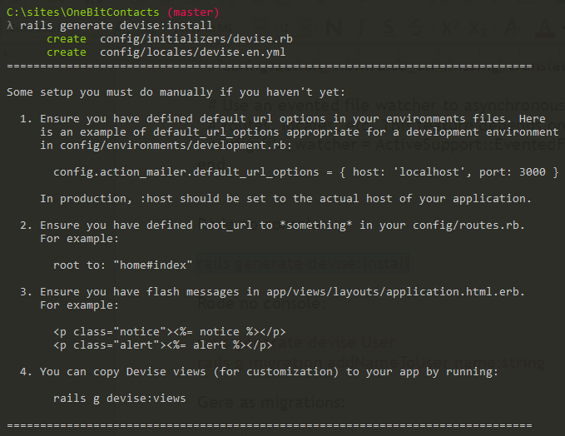

Rode no console:

rails generate devise User

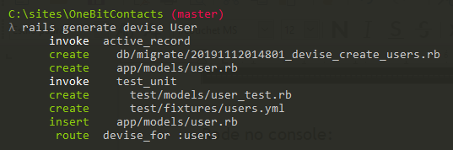

rails g migration addNameToUser name:string

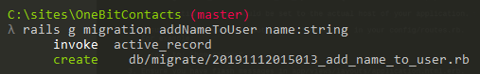

Crie o banco de dados:

rails db:create

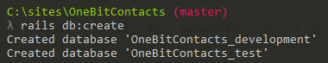

Gere as migrations:

rails db:migrate

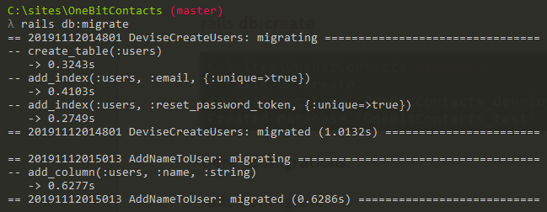

Devise Simple Token

Adicione ao seu Gemfile:

gem 'simple_token_authentication', '~> 1.0'

Instale rodando:

bundle install

Adicione ao seu User Model:

acts_as_token_authenticatable

app/models/user.rb

class User < ApplicationRecord

acts_as_token_authenticatable

# Include default devise modules. Others available are:
# :confirmable, :lockable, :timeoutable, :trackable and :omniauthable

devise :database_authenticatable, :registerable,
:recoverable, :rememberable, :validatable
end

Rode no console:

rails g migration add_authentication_token_to_users "authentication_token:string{30}:uniq"

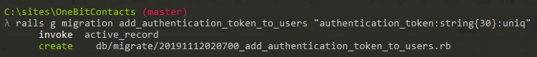

rake db:migrate

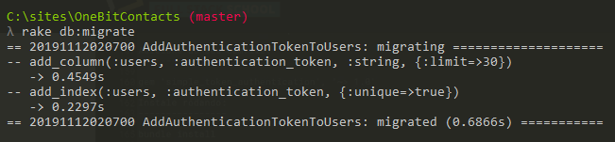

Coloque no seu controler api/v1/api_controller.rb:

app/controllers/api/v1/api_controller.rb

module Api::V1
class ApiController < ApplicationController
acts_as_token_authentication_handler_for User
before_action :require_authentication!

private
def require_authentication!
throw(:warden, scope: :user) unless current_user.presence
end
end
end

Testando

rails c

User.create(email: 'bootcamp@onebitcode.com', password: '123456')

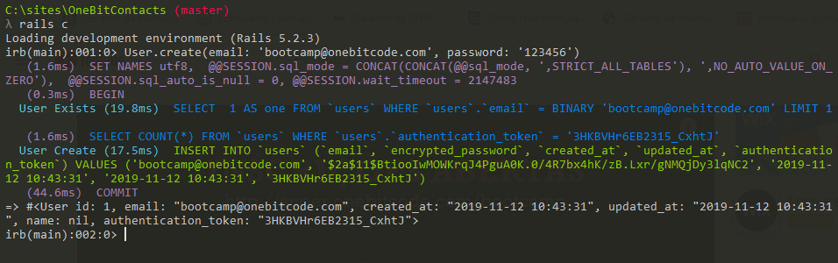

Aula 03 - Desenvolvendo e testando nossa API

Gerando os models

Rode no console:

rails g model Contact name:string email:string phone:string description:text user:references

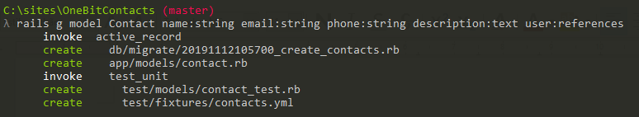

rails db:migrate

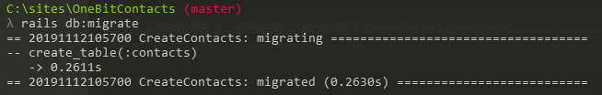

Adicione ao seu Model Contact:

validates :name, :user, presence: true

app/models/contact.rb

class Contact < ApplicationRecord
belongs_to :user
validates :name, :user, presence: true
end

Adicione ao seu Model User:

has_many :contacts, dependent: :destroy

app/models/user.rb

class User < ApplicationRecord
acts_as_token_authenticatable
# Include default devise modules. Others available are:
# :confirmable, :lockable, :timeoutable and :omniauthable
devise :database_authenticatable, :registerable,
:recoverable, :rememberable, :trackable, :validatable

has_many :contacts, dependent: :destroy
end

Gerando os controllers

Rode no console:

rails g controller api/v1/contacts

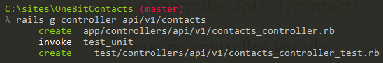

Coloque no controller gerado:

app/controllers/api/v1/contacts_controller.rb

class Api::V1::ContactsController < Api::V1::ApiController
before_action :set_contact, only: [:show, :update, :destroy]
before_action :require_authorization!, only: [:show, :update, :destroy]

# GET /api/v1/contacts
def index
@contacts = current_user.contacts

render json: @contacts
end

# GET /api/v1/contacts/1
def show
render json: @contact
end

# POST /api/v1/contacts
def create
@contact = Contact.new(contact_params.merge(user: current_user))

if @contact.save
render json: @contact, status: :created
else
render json: @contact.errors, status: :unprocessable_entity
end
end

# PATCH/PUT /api/v1/contacts/1
def update
if @contact.update(contact_params)
render json: @contact
else
render json: @contact.errors, status: :unprocessable_entity
end
end

# DELETE /api/v1/contacts/1
def destroy
@contact.destroy
end

private
# Use callbacks to share common setup or constraints between actions.
def set_contact
@contact = Contact.find(params[:id])
end

# Only allow a trusted parameter "white list" through.
def contact_params
params.require(:contact).permit(:name, :email, :phone, :description)
end

def require_authorization!
unless current_user == @contact.user
render json: {}, status: :forbidden
end
end
end

Ajustando as rotas

config/routes.rb

Rails.application.routes.draw do
devise_for :users
namespace :api do
namespace :v1 do
resources :contacts
end
end

# constraints subdomain: 'api' do
# scope module: 'api' do
# namespace :v1 do
# resources :contacts
# end
# end
# end
end

Testando os endpoints

Teste usando Postman ou CURL como no vídeo.

rails s

localhost:3000/api/v1/contacts.json

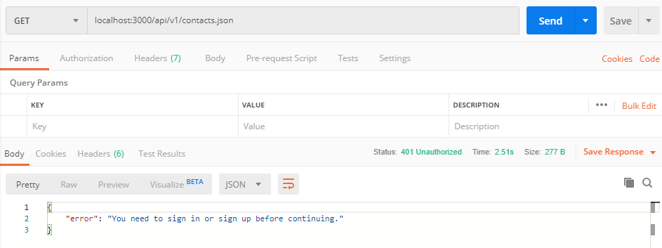

rails c

User.create(email: 'bootcamp@onebitcode.com', password: '123456')

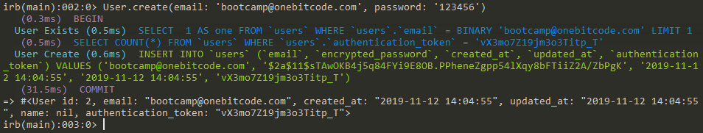

email: bootcamp@onebitcode.com
authentication_token: vX3mo7Z19jm3o3Titp_T

Em header, entre com:

Key Value
X-User-Email bootcamp@onebitcode.com
X-User-Token vX3mo7Z19jm3o3Titp_T

Reinicie com:

rails s

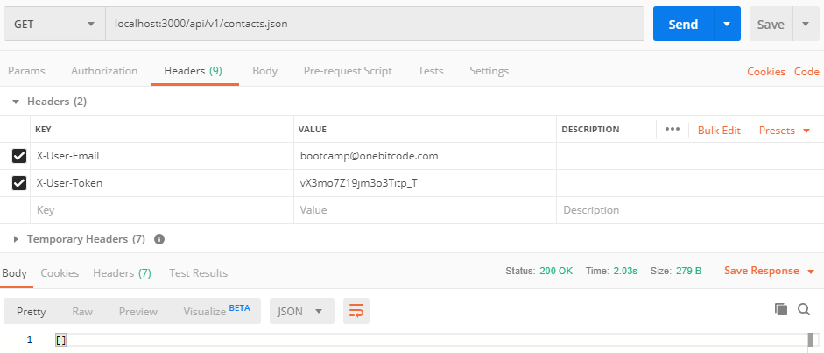

Criando usuários

Em body entre com:

{
"name": "Leonardo Scorza",
"email": "contato@onebitcode.com"
}

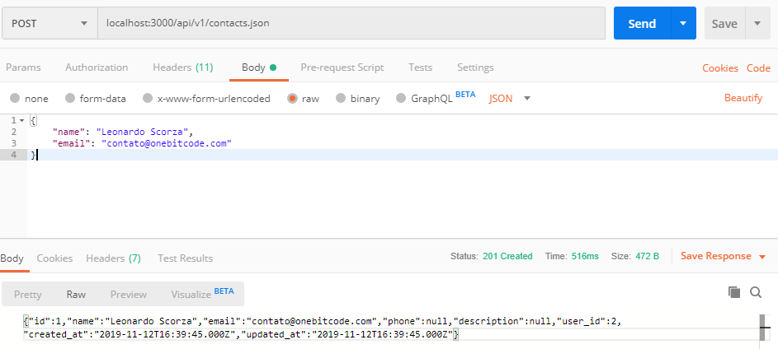

Em body entre com:

{
"name": "Jackson Pires",
"email": "jacksonpires@onebitcode.com",
"phone": "(51) 3547-8741",
"description": "Organizador de cursos do One Bit Code"
}

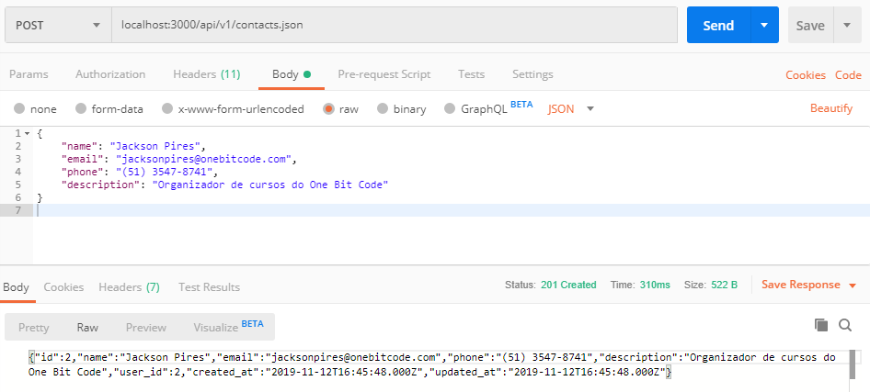

Em body entre com:

{
"name": "Roberto Pinheiro",
"email": "betopinheiro1005@yahoo.com.br",
"phone": "(43) 2963-5324",
"description": "Usuário colaborador do One Bit Code"
}

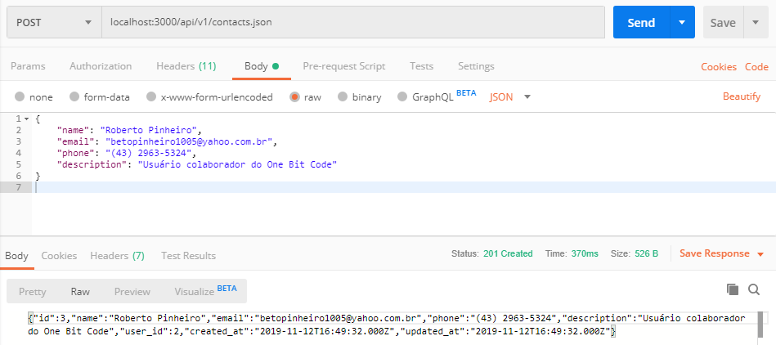

Listando os usuários

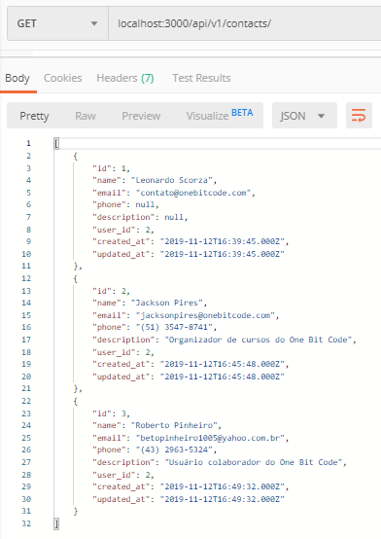

Exibindo detalhes de um usuário

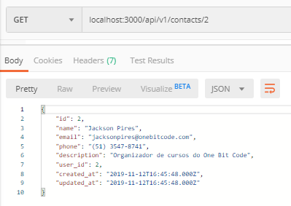

Excluindo um usuário

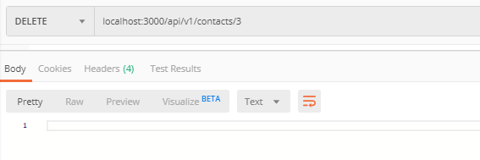

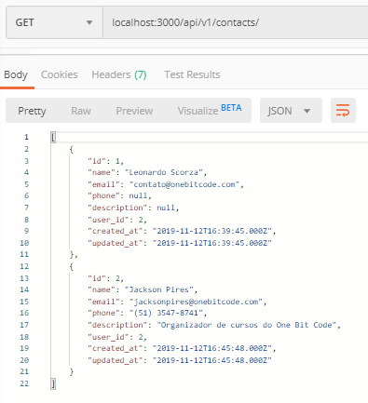

Atualizando os dados de um usuário

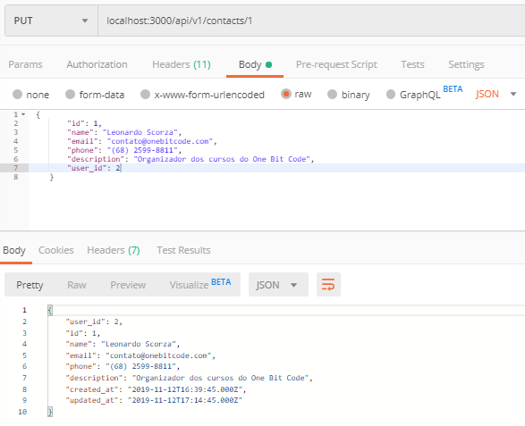

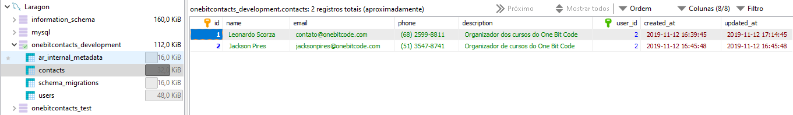

Desafios

1 – Paginar os retornos do endpoint /contacts

2 – Criar a estrutura para permitir a inclusão de multiplos endereços nos Contatos

