Como criar uma API com o framework Slim
Rafael Wendel Pinheiro

Vídeo: https://www.youtube.com/watch?v=WTf0lvJ0PLg

https://www.slimframework.com/

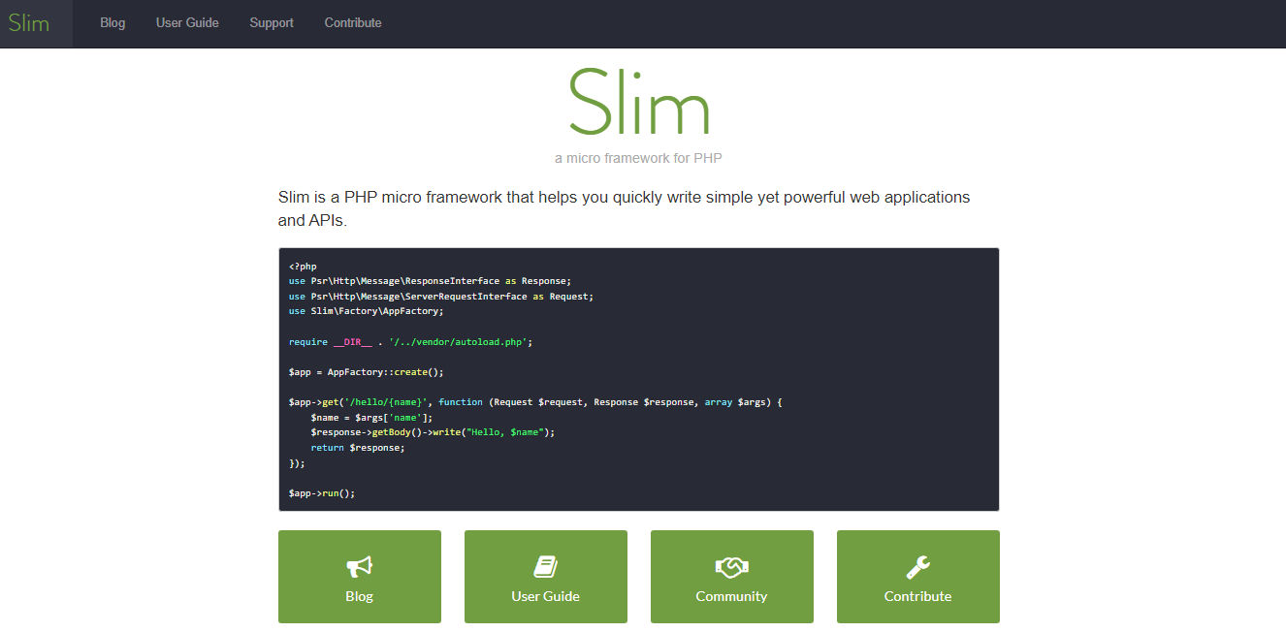

Versão mínima: PHP 7.2

php -v

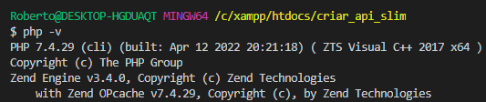

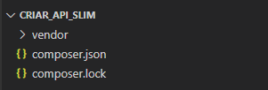

Instalando o framework Slim

composer require slim/slim

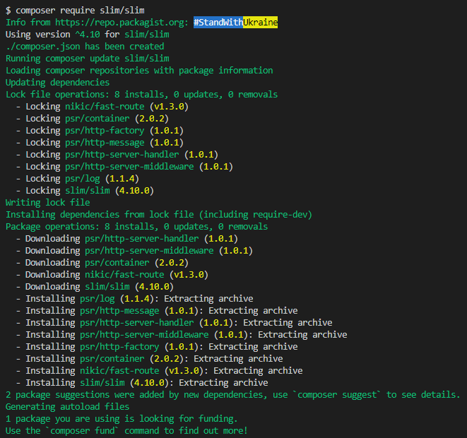

Baixando e instalando o Slim PSR-7

composer require slim/psr7

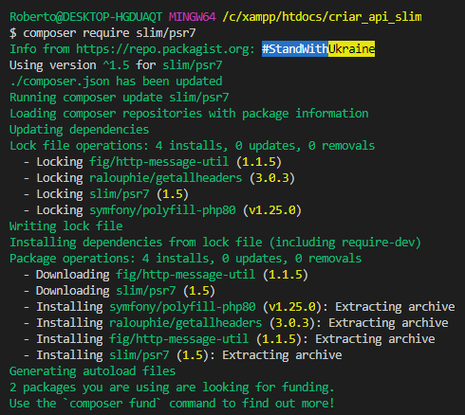

.htaccess

RewriteEngine On
RewriteCond %{REQUEST_FILENAME} !-f
RewriteCond %{REQUEST_FILENAME} !-d
Rewrite ^ index.php [QSA,L]

index.php

<?php
use Psr\Http\Message\ResponseInterface as Response;
use Psr\Http\Message\ServerRequestInterface as Request;
use Slim\Factory\AppFactory;

require __DIR__ . '/vendor/autoload.php';

$app = AppFactory::create();

$app->get('/', function (Request $request, Response $response, $args) {
$response->getBody()->write("Hello world!");
return $response;
});

$app->run();

Subindo o servidor PHP

php -S localhost:8000

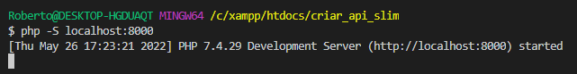

localhost:8000



Usando o Postman

Teste inicial

GET
http://localhost:8000/

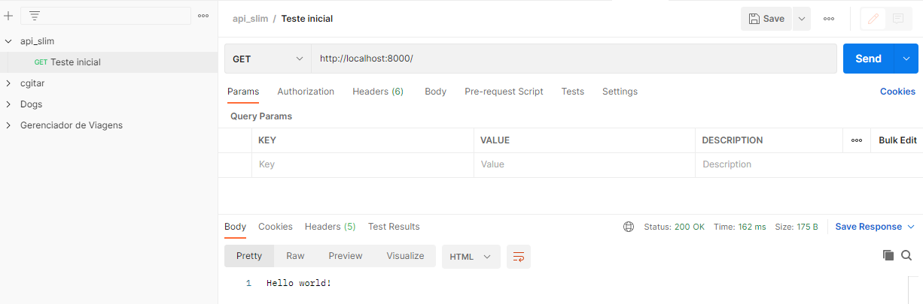

Listando todas as frutas

index.php

<?php

use Psr\Http\Message\ResponseInterface as Response;
use Psr\Http\Message\ServerRequestInterface as Request;
use Slim\Factory\AppFactory;

require __DIR__ . '/vendor/autoload.php';

$app = AppFactory::create();

$app->get('/', function (Request $request, Response $response, $args) {
$response->getBody()->write("Hello world!");
return $response;
});

$app->get('/fruits', function (Request $request, Response $response, $args) {
$fruits = [
'1' => 'Banana',
'2' => 'Laranja',
'3' => 'Abacaxi'
];

$response->getBody()->write(json_encode($fruits));
return $response->withHeader('Content-Type', 'application/json');
});

$app->run();

http://localhost:8000/fruits

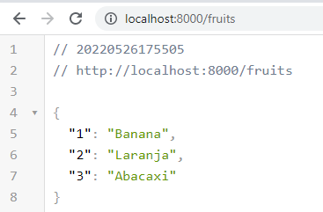

- No Postman:

Listando frutas

GET
http://localhost:8000/fruits

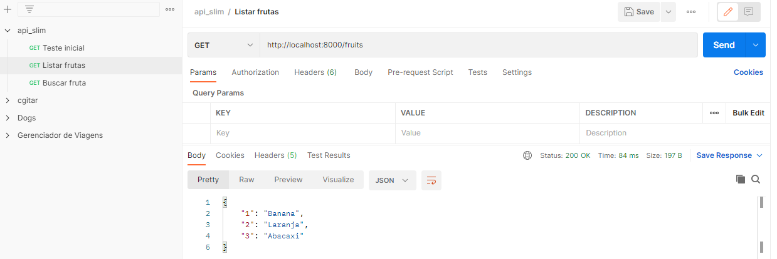

Buscando uma fruta

index.php

<?php

use Psr\Http\Message\ResponseInterface as Response;
use Psr\Http\Message\ServerRequestInterface as Request;
use Slim\Factory\AppFactory;

require __DIR__ . '/vendor/autoload.php';

$app = AppFactory::create();

$app->get('/', function (Request $request, Response $response, $args) {
$response->getBody()->write("Hello world!");
return $response;
});

$app->get('/fruits', function (Request $request, Response $response, $args) {
$fruits = [
'1' => 'Banana',
'2' => 'Laranja',
'3' => 'Abacaxi'
];

$response->getBody()->write(json_encode($fruits));
return $response->withHeader('Content-Type', 'application/json');
});

$app->get('/fruits/{id}', function (Request $request, Response $response, $args) {
$fruits = [
'1' => 'Banana',
'2' => 'Laranja',
'3' => 'Abacaxi'
];

$fruit[$args['id']] = $fruits[$args['id']];

$response->getBody()->write(json_encode($fruit));
return $response->withHeader('Content-Type', 'application/json');
});

$app->run();

http://localhost:8000/fruits/2

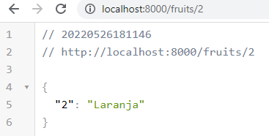

No Postman:

Buscar fruta

GET
http://localhost:8000/fruits/3

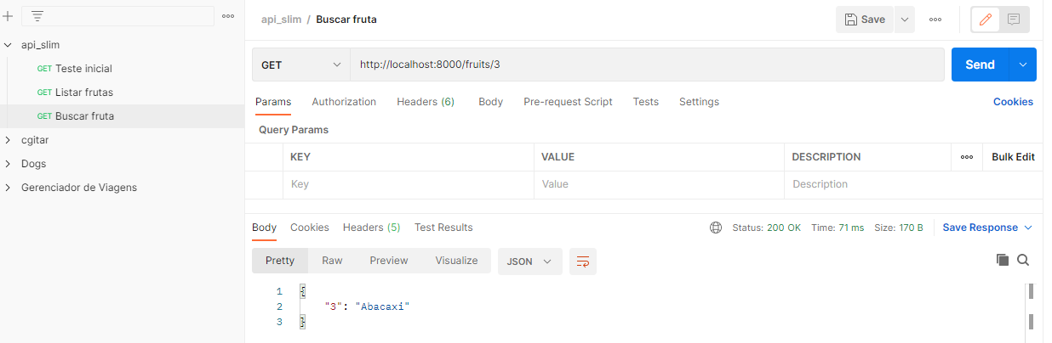

- No Postman:

Buscar fruta

GET
http://localhost:8000/fruits

