Curso Laravel - Roles y Permisos
Italo Morales (Rimorsoft)

https://www.youtube.com/watch?v=EwqZgypiKYk&list=PLhCiuvlix-rSgQNLIl7Qg2KbQni3fz-ea

Resumo do curso feito por Roberto Pinheiro

Aula 2 - Instalação de pacotes

Instalando o Laravel Collective

Acesse a URL:
https://github.com/LaravelCollective/docs/blob/5.6/html.md

No terminal, na pasta do projeto, entre com o seguinte comando:
composer require "laravelcollective/html":"^5.4.0"

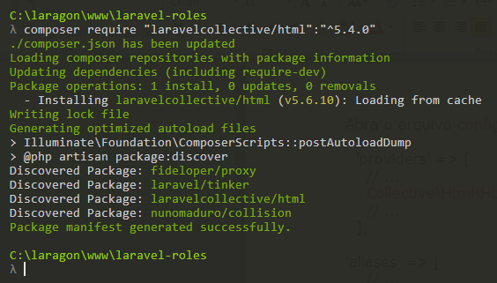

Abra o arquivo config/app.php e insira as seguintes linhas:

'providers' => [
// ...
Collective\Html\HtmlServiceProvider::class,
// ...
],

'aliases' => [
// ...
'Form' => Collective\Html\FormFacade::class,
'Html' => Collective\Html\HtmlFacade::class,
// ...
],

Instalando shinobi

Trata-se de um pacote para administrar as permissões.

Acesse a URL:
https://github.com/caffeinated/shinobi

No terminal, na pasta do projeto, entre com o seguinte comando:

composer require caffeinated/shinobi

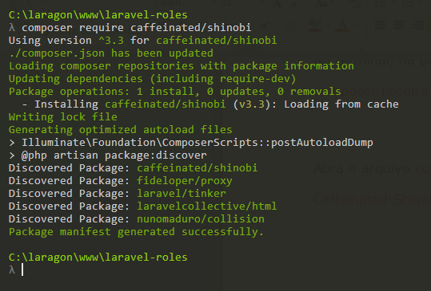

Abra o arquivo config/app.php e, em providers, insira a seguinte linha:

Caffeinated\Shinobi\ShinobiServiceProvider::class,

Aula 3 - Estrutura base de um sistema com regras e permissões

Alterando tamanho padrão de campo string

app/Providers/AppServiceProvider.php

<?php

namespace App\Providers;

use Illuminate\Support\ServiceProvider;
use Illuminate\Support\Facades\Schema;

class AppServiceProvider extends ServiceProvider
{
public function boot()
{
Schema::defaultStringLength(120);
}
public function register()
{
//
}
}

Criando as tabelas

php artisan migrate

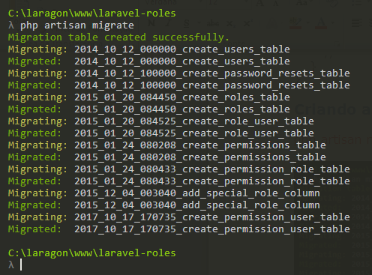

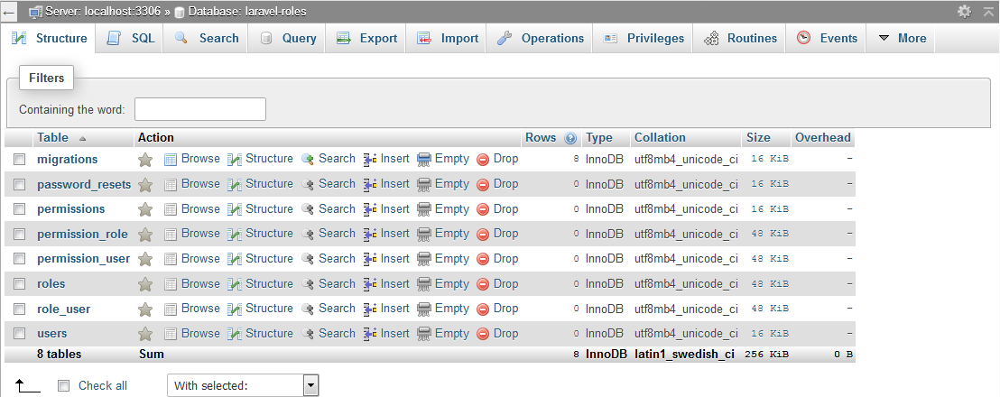

As migrações de Shinobi localizam-se na pasta:

vendor/caffeinate/shinobi/migrations

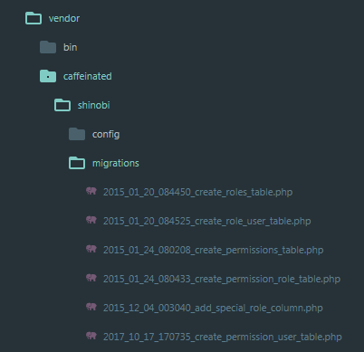

Relações entre as tabelas

Acesse o phpmyadmin e clique na aba More→Design

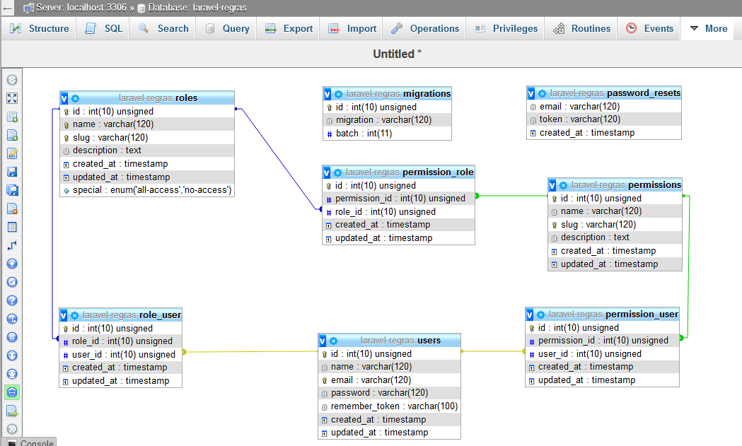

Criando um seed de Permissões

php artisan make:seeder PermissionsTableSeeder

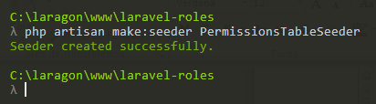

database/seeds/PermissionsTableSeeder

<?php

use Illuminate\Database\Seeder;

class PermissionsTableSeeder extends Seeder
{
public function run()
{
//
}
}

Aula 4 - Definição de permissões do sistema

database/seeds/PermissionsTableSeeder

<?php

use Illuminate\Database\Seeder;
use Caffeinated\Shinobi\Models\Permission;

class PermissionsTableSeeder extends Seeder
{
public function run()
{
// users
Permission::create([
'name' => 'Exibir usuários',
'slug' => 'users.index',
'description' => 'Lista e exibe todos os usuários do sistema',
]);
Permission::create([
'name' => 'Ver detalhes de usuário',
'slug' => 'users.show',
'description' => 'Ver em detalhes cada usuário do sistema',
]);
Permission::create([
'name' => 'Edição de usuários',
'slug' => 'users.edit',
'description' => 'Editar qualquer dado de um usuário do sistema',
]);
Permission::create([
'name' => 'Eliminar usuário',
'slug' => 'users.destroy',
'description' => 'Eliminar qualquer usuário do sistema',
]);

// Roles

Permission::create([
'name' => 'Exibir roles',
'slug' => 'roles.index',
'description' => 'Lista e exibe todos os roles do sistema',
]);
Permission::create([
'name' => 'Ver detalhes de rol',
'slug' => 'roles.show',
'description' => 'Ver em detalhes cada role do sistema',
]);

Permission::create([
'name' => 'Criação de rol',
'slug' => 'roles.create',
'description' => 'Criar role do sistema',
]);
Permission::create([
'name' => 'Edição de rol',
'slug' => 'roles.edit',
'description' => 'Editar qualquer dado de um role do sistema',
]);
Permission::create([
'name' => 'Eliminar rol',
'slug' => 'roles.destroy',
'description' => 'Eliminar qualquer role do sistema',
]);

// Products

Permission::create([
'name' => 'Exibir produtos',
'slug' => 'products.index',
'description' => 'Lista e exibe todos os produtos do sistema',
]);
Permission::create([
'name' => 'Ver detalhes de produto',
'slug' => 'products.show',
'description' => 'Ver em detalhes cada produto do sistema',
]);
Permission::create([
'name' => 'Criação de produto',
'slug' => 'products.create',
'description' => 'Criar produto do sistema',
]);
Permission::create([
'name' => 'Edição de produto',
'slug' => 'products.edit',
'description' => 'Editar qualquer dado de um produto do sistema',
]);
Permission::create([
'name' => 'Eliminar produto',
'slug' => 'products.destroy',
'description' => 'Eliminar qualquer produto do sistema',
]);
}
}

database/seeds/DatabaseTableSeeder

<?php

use Illuminate\Database\Seeder;

class DatabaseSeeder extends Seeder
{
public function run()
{
$this->call(PermissionsTableSeeder::class);
}
}

Criando os registros de permissões

php artisan migrate:refresh --seed

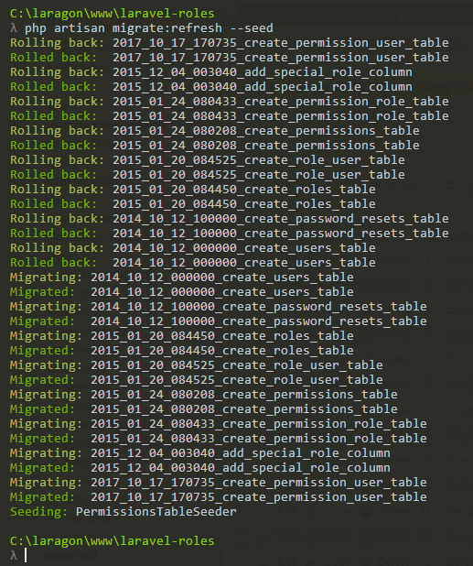

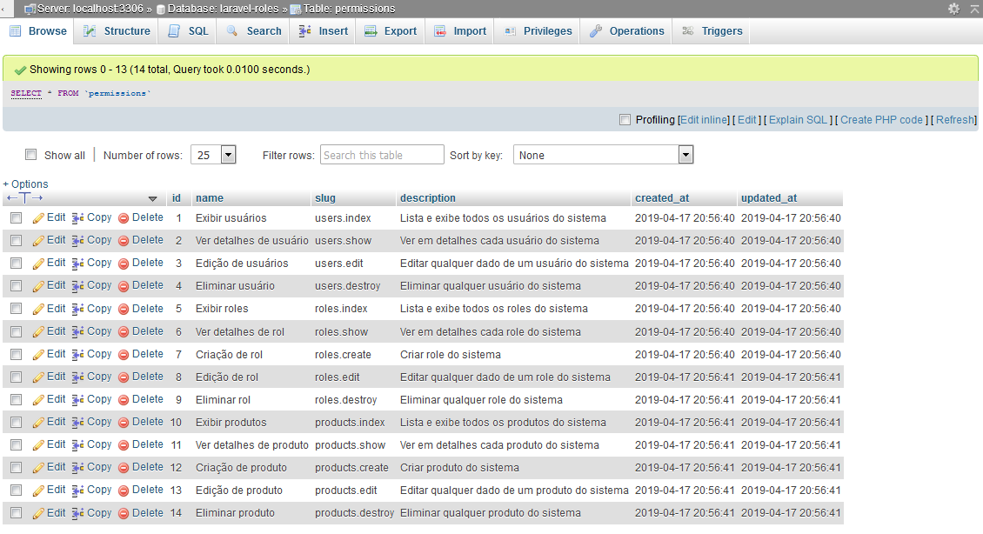

Aula 5 - Factory, migrations, models, controllers

model, factory, migration e controller de Produtos

php artisan make:model Product -a

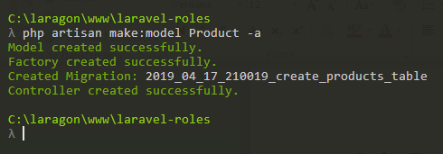

criando seeders para usuários e produtos

php artisan make:seeder ProductsTableSeeder

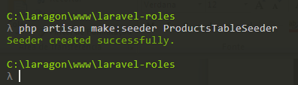

php artisan make:seeder UsersTableSeeder

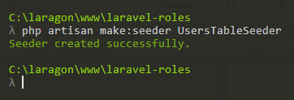

Aula 6 - Seeders

database/migrations/ 2019_04_17_210019_create_products_table.php

<?php

use Illuminate\Support\Facades\Schema;
use Illuminate\Database\Schema\Blueprint;
use Illuminate\Database\Migrations\Migration;

class CreateProductsTable extends Migration
{
public function up()
{
Schema::create('products', function (Blueprint $table) {
$table->increments('id');
$table->string('name');
$table->string('description');
$table->timestamps();
});
}

public function down()
{
Schema::dropIfExists('products');
}
}

database/factories/ProductFactory.php

<?php

use Faker\Generator as Faker;

$factory->define(App\Product::class, function (Faker $faker) {
return [
'name' => $faker -> sentence,
'description' => $faker -> sentence
];
});

database/factories/UserFactory.php

<?php

use Faker\Generator as Faker;

/*
|--------------------------------------------------------------------------
| Model Factories
|--------------------------------------------------------------------------
|
| This directory should contain each of the model factory definitions for
| your application. Factories provide a convenient way to generate new
| model instances for testing / seeding your application's database.
|
*/

$factory->define(App\User::class, function (Faker $faker) {
return [
'name' => $faker->name,
'email' => $faker->unique()->safeEmail,
'password' => '$2y$10$TKh8H1.PfQx37YgCzwiKb.KjNyWgaHb9cbcoQgdIVFlYg7B77UdFm', // secret
'remember_token' => str_random(10),
];
});

database/seeds/UsersTableSeeder.php

<?php

use Illuminate\Database\Seeder;
use Caffeinated\Shinobi\Models\Role;

class UsersTableSeeder extends Seeder
{
public function run()
{
factory(App\User::class, 20)->create();
Role::create([
'name' => 'Admin',
'slug' => 'admin',
'special' => 'all-access'
]);
}
}
database/seeds/ProductsTableSeeder.php

<?php

use Illuminate\Database\Seeder;

class ProductsTableSeeder extends Seeder
{
public function run()
{
factory(App\Product::class, 80) -> create();
}
}

database/seeds/DatabaseTableSeeder

<?php

use Illuminate\Database\Seeder;

class DatabaseSeeder extends Seeder
{
public function run()
{
$this->call(PermissionsTableSeeder::class);
$this->call(ProductsTableSeeder::class);
$this->call(UsersTableSeeder::class);
}
}

Populando as tabelas de produtos e usuários

php artisan migrate:refresh --seed

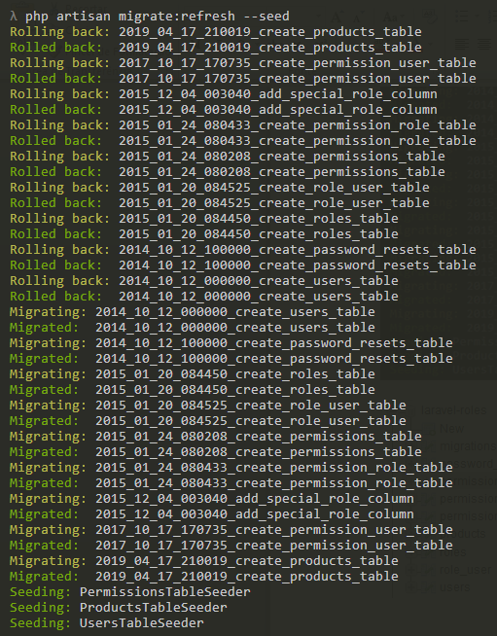

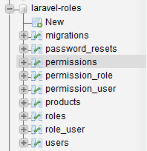
Tabela de Usuários

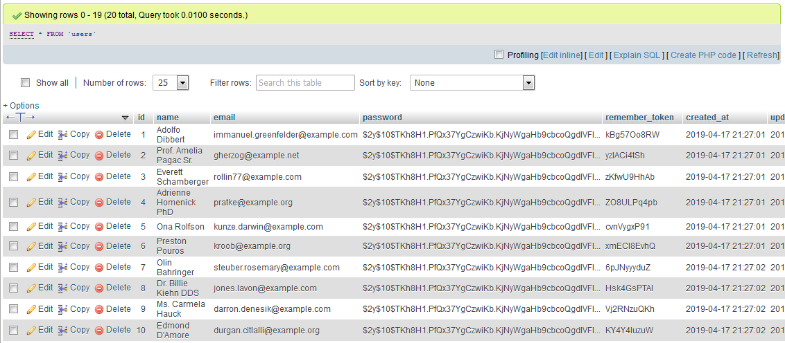
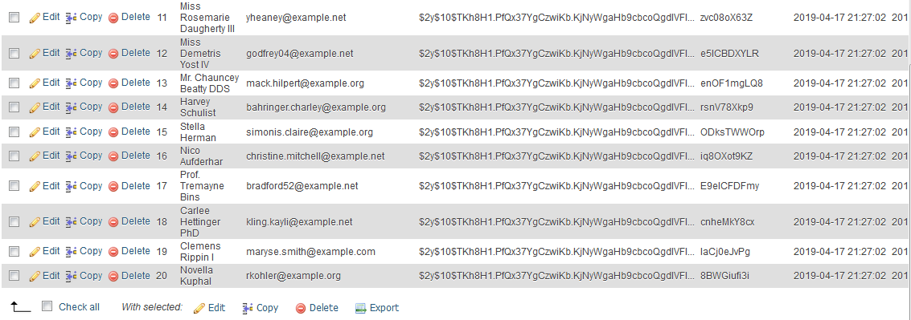

Tabela de produtos

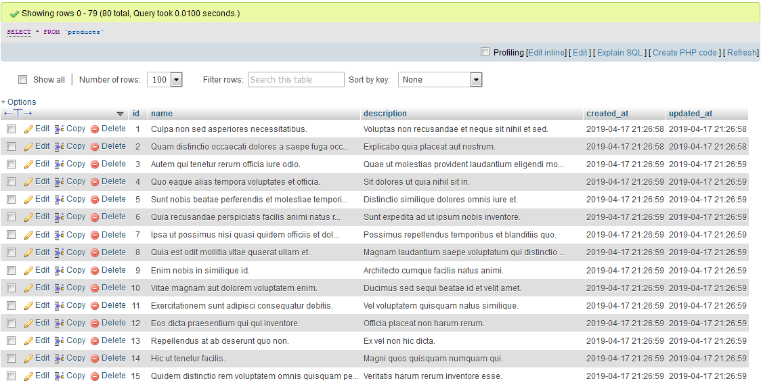

Tabela de roles:

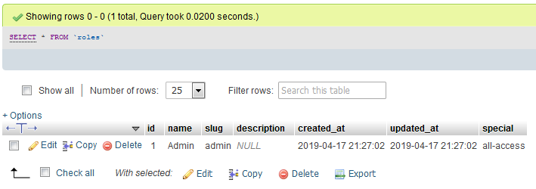

Aula 7 - Middleware de Papéis e Permissões

Autenticação

php artisan make:auth

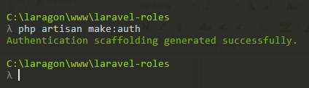

routes/web.php

<?php

/*
|--------------------------------------------------------------------------
| Web Routes
|--------------------------------------------------------------------------
|
| Here is where you can register web routes for your application. These
| routes are loaded by the RouteServiceProvider within a group which
| contains the "web" middleware group. Now create something great!
|
*/

Route::get('/', function () {
return view('welcome');
});

Auth::routes();

Route::get('/home', 'HomeController@index')->name('home');

Configurando Middleware

app/Http/kernel.php

<?php

namespace App\Http;

use Illuminate\Foundation\Http\Kernel as HttpKernel;

class Kernel extends HttpKernel
{
/**
* The application's global HTTP middleware stack.
*
* These middleware are run during every request to your application.
*
* @var array
*/
protected $middleware = [
\Illuminate\Foundation\Http\Middleware\CheckForMaintenanceMode::class,
\Illuminate\Foundation\Http\Middleware\ValidatePostSize::class,
\App\Http\Middleware\TrimStrings::class,
\Illuminate\Foundation\Http\Middleware\ConvertEmptyStringsToNull::class,
\App\Http\Middleware\TrustProxies::class,
];

/**
* The application's route middleware groups.
*
* @var array
*/
protected $middlewareGroups = [
'web' => [
\App\Http\Middleware\EncryptCookies::class,
\Illuminate\Cookie\Middleware\AddQueuedCookiesToResponse::class,
\Illuminate\Session\Middleware\StartSession::class,
// \Illuminate\Session\Middleware\AuthenticateSession::class,
\Illuminate\View\Middleware\ShareErrorsFromSession::class,
\App\Http\Middleware\VerifyCsrfToken::class,
\Illuminate\Routing\Middleware\SubstituteBindings::class,
],

'api' => [
'throttle:60,1',
'bindings',
],
];

/**
* The application's route middleware.
*
* These middleware may be assigned to groups or used individually.
*
* @var array
*/
protected $routeMiddleware = [
'auth' => \Illuminate\Auth\Middleware\Authenticate::class,
'auth.basic' => \Illuminate\Auth\Middleware\AuthenticateWithBasicAuth::class,
'bindings' => \Illuminate\Routing\Middleware\SubstituteBindings::class,
'cache.headers' => \Illuminate\Http\Middleware\SetCacheHeaders::class,
'can' => \Illuminate\Auth\Middleware\Authorize::class,
'guest' => \App\Http\Middleware\RedirectIfAuthenticated::class,
'signed' => \Illuminate\Routing\Middleware\ValidateSignature::class,
'throttle' => \Illuminate\Routing\Middleware\ThrottleRequests::class,

'role' => \Caffeinated\Shinobi\Middleware\UserHasRole::class,
'permission' => \Caffeinated\Shinobi\Middleware\UserHasPermission::class,

];
}

Aula 8 - Rotas e atribuição de permissões

routes/web.php

<?php

/*
|--------------------------------------------------------------------------
| Web Routes
|--------------------------------------------------------------------------
|
| Here is where you can register web routes for your application. These
| routes are loaded by the RouteServiceProvider within a group which
| contains the "web" middleware group. Now create something great!
|
*/

Route::get('/', function () {
return view('welcome');
});

Auth::routes();

Route::get('/home', 'HomeController@index')->name('home');

Route::middleware(['auth'])->group(function(){
// Roles
Route::post('roles/store', 'RoleController@store')->name('roles.store')
->middleware('permission:roles.create');
Route::get('roles', 'RoleController@index')->name('roles.index')
->middleware('permission:roles.index');
Route::get('roles/create', 'RoleController@create')->name('roles.create')
->middleware('permission:roles.create');
Route::put('roles/{role}', 'RoleController@update')->name('roles.update')
->middleware('permission:roles.edit');
Route::get('roles/{role}', 'RoleController@show')->name('roles.show')
->middleware('permission:roles.show');
Route::delete('roles/{role}', 'RoleController@destroy')->name('roles.destroy')
->middleware('permission:roles.destroy');
Route::get('roles/{role}/edit', 'RoleController@edit')->name('roles.edit')
->middleware('permission:roles.edit');

// Products
Route::post('products/store', 'ProductController@store')->name('products.store')
->middleware('permission:products.create');
Route::get('products', 'ProductController@index')->name('products.index')
->middleware('permission:products.index');
Route::get('products/create', 'ProductController@create')->name('products.create')
->middleware('permission:products.create');
Route::put('products/{product}', 'ProductController@update')->name('products.update')
->middleware('permission:products.edit');
Route::get('products/{product}', 'ProductController@show')->name('products.show')
->middleware('permission:products.show');
Route::delete('products/{product}', 'ProductController@destroy')->name('products.destroy')
->middleware('permission:products.destroy');
Route::get('products/{product}/edit', 'ProductController@edit')->name('products.edit')
->middleware('permission:products.edit');

// Users
Route::get('users', 'UserController@index')->name('users.index')
->middleware('permission:users.index');
Route::put('users/{user}', 'UserController@update')->name('users.update')
->middleware('permission:users.edit');
Route::get('users/{user}', 'UserController@show')->name('users.show')
->middleware('permission:users.show');
Route::delete('users/{user}', 'UserController@destroy')->name('users.destroy')
->middleware('permission:users.destroy');
Route::get('users/{user}/edit', 'UserController@edit')->name('users.edit')
->middleware('permission:users.edit');
});

Aula 9 - Ocultar botões se não há permissões

Inserindo um usuário

Senha: 123456

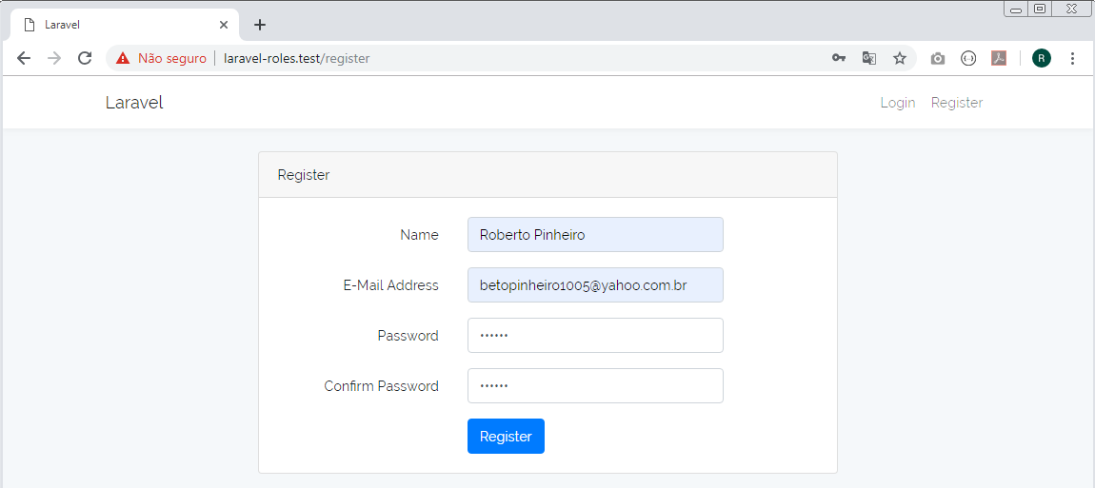

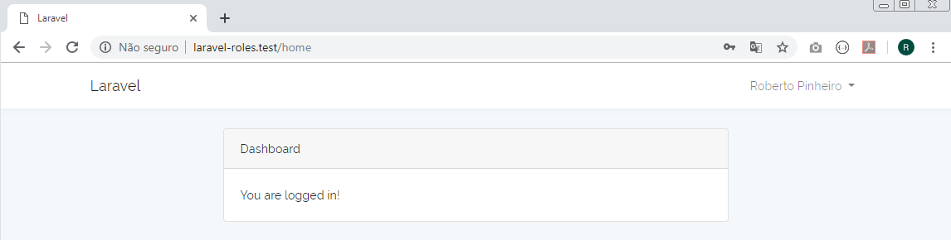

Criando controllers para usuários e funções

php artisan make:controller UserController --resource

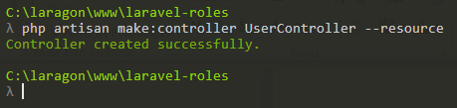

php artisan make:controller RoleController --resource

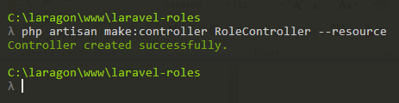

resources/views/welcome.php

<!doctype html>
<html lang="{{ app()->getLocale() }}">
<head>
<meta charset="utf-8">
<meta http-equiv="X-UA-Compatible" content="IE=edge">
<meta name="viewport" content="width=device-width, initial-scale=1">

<title>Roles e Permissions</title>

<!-- Fonts -->
<link href="https://fonts.googleapis.com/css?family=Raleway:100,600" rel="stylesheet" type="text/css">

<!-- Styles -->
<style>
html, body {
background-color: #fff;
color: #636b6f;
font-family: 'Raleway', sans-serif;
font-weight: 100;
height: 100vh;
margin: 0;
}

.full-height {
height: 100vh;
}

.flex-center {
align-items: center;
display: flex;
justify-content: center;
}

.position-ref {
position: relative;
}

.top-right {
position: absolute;
right: 10px;
top: 18px;
}

.content {
text-align: center;
}

.title {
font-size: 84px;
}

.links > a {
color: #636b6f;
padding: 0 25px;
font-size: 12px;
font-weight: 600;
letter-spacing: .1rem;
text-decoration: none;
text-transform: uppercase;
}

.m-b-md {
margin-bottom: 30px;
}
</style>
</head>
<body>
<div class="flex-center position-ref full-height">
@if (Route::has('login'))
<div class="top-right links">
@auth
<a href="{{ url('/home') }}">Home</a>
@else
<a href="{{ route('login') }}">Login</a>
<a href="{{ route('register') }}">Registro</a>
@endauth
</div>
@endif

<div class="content">
<div class="title m-b-md">
Roles e Permissions
</div>

<div class="links">
<a href="http://oriontecinfo.com.br/">OrionTecInfo</a>
</div>
</div>
</div>
</body>
</html>

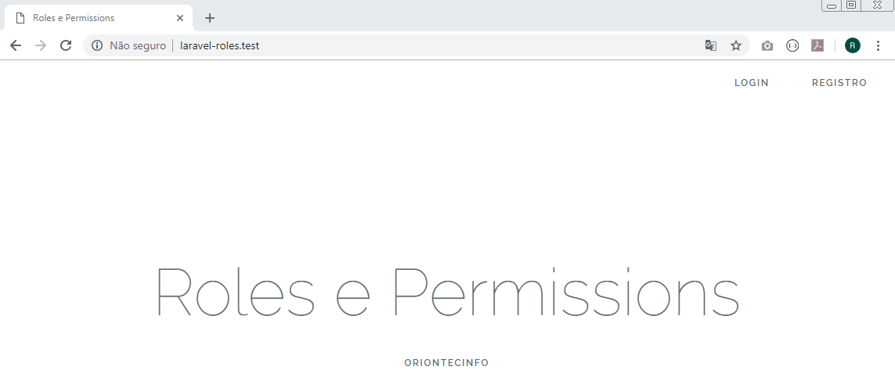

resources/views/layouts/app.blade.php

<!DOCTYPE html>
<html lang="{{ str_replace('_', '-', app()->getLocale()) }}">
<head>
<meta charset="utf-8">
<meta http-equiv="X-UA-Compatible" content="IE=edge">
<meta name="viewport" content="width=device-width, initial-scale=1">

<!-- CSRF Token -->
<meta name="csrf-token" content="{{ csrf_token() }}">

<title>{{ config('app.name', 'Laravel') }}</title>

<!-- Scripts -->
<script src="{{ asset('js/app.js') }}" defer></script>

<!-- Fonts -->
<link rel="dns-prefetch" href="https://fonts.gstatic.com">
<link href="https://fonts.googleapis.com/css?family=Nunito" rel="stylesheet" type="text/css">

<!-- Styles -->
<link href="{{ asset('css/app.css') }}" rel="stylesheet">
</head>
<body>
<div id="app">
<nav class="navbar navbar-expand-md navbar-light navbar-laravel">
<div class="container">
<a class="navbar-brand" href="{{ url('/') }}">
{{ config('app.name', 'Laravel') }}
</a>
<button class="navbar-toggler" type="button" data-toggle="collapse" data-target="#navbarSupportedContent" aria-controls="navbarSupportedContent" aria-expanded="false" aria-label="{{ __('Toggle navigation') }}">
<span class="navbar-toggler-icon"></span>
</button>

<div class="collapse navbar-collapse" id="navbarSupportedContent">
<!-- Left Side Of Navbar -->
<ul class="navbar-nav mr-auto">
@can('products.index')
<li class="nav-item">
<a class="nav-link" href="{{ route('products.index') }}">Produtos</a>
</li>
@endcan
@can('users.index')
<li class="nav-item">
<a class="nav-link" href="{{ route('users.index') }}">Usuários</a>
</li>
@endcan
@can('roles.index')
<li class="nav-item">
<a class="nav-link" href="{{ route('roles.index') }}">Funções</a>
</li>
@endcan
</ul>

<!-- Right Side Of Navbar -->
<ul class="navbar-nav ml-auto">
<!-- Authentication Links -->
@guest
<li class="nav-item">
<a class="nav-link" href="{{ route('login') }}">{{ __('Login') }}</a>
</li>
<li class="nav-item">
<a class="nav-link" href="{{ route('register') }}">{{ __('Register') }}</a>
</li>
@else
<li class="nav-item dropdown">
<a id="navbarDropdown" class="nav-link dropdown-toggle" href="#" role="button" data-toggle="dropdown" aria-haspopup="true" aria-expanded="false" v-pre>
{{ Auth::user()->name }} <span class="caret"></span>
</a>

<div class="dropdown-menu dropdown-menu-right" aria-labelledby="navbarDropdown">
<a class="dropdown-item" href="{{ route('logout') }}"
onclick="event.preventDefault();
document.getElementById('logout-form').submit();">
{{ __('Logout') }}
</a>

<form id="logout-form" action="{{ route('logout') }}" method="POST" style="display: none;">
@csrf
</form>
</div>
</li>
@endguest
</ul>
</div>
</div>
</nav>

<main class="py-4">
@yield('content')
</main>
</div>
</body>
</html>

Aula 10 - Aplicando roles e permissions

app/User.php

<?php

namespace App;

use Caffeinated\Shinobi\Traits\ShinobiTrait;
use Illuminate\Notifications\Notifiable;
use Illuminate\Foundation\Auth\User as Authenticatable;

class User extends Authenticatable
{
use Notifiable, ShinobiTrait;

protected $fillable = [
'name', 'email', 'password',
];

protected $hidden = [
'password', 'remember_token',
];
}

roles

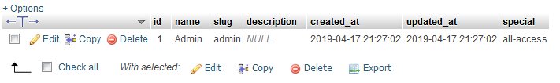

role_user

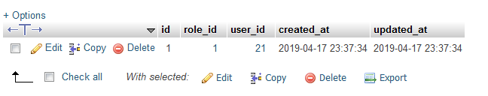

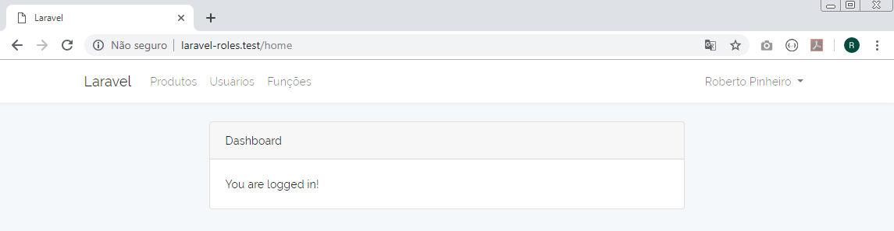

roles

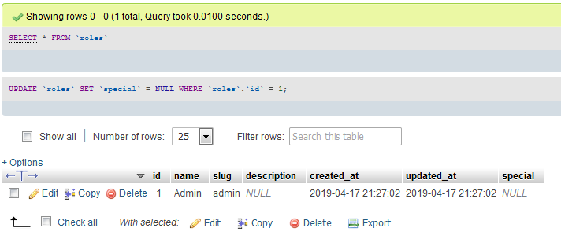

permission_role

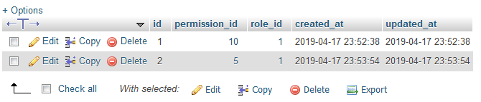

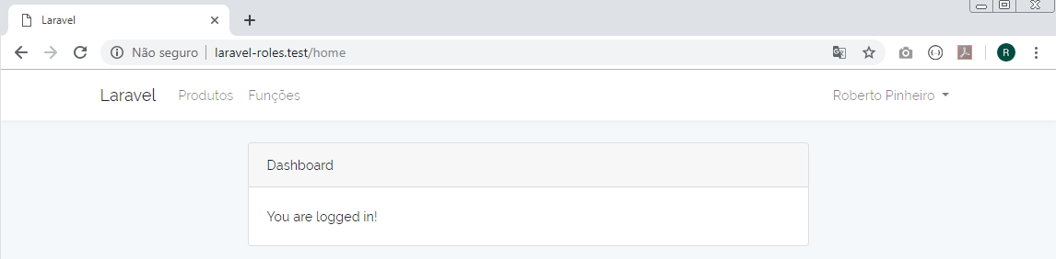

Aula 11 - Ocultar ou mostrar botões segundo a permissão atribuída

Volte a deixar o usuário 21 com todos os acessos:

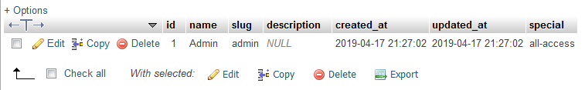

Na tabela permission_role, apague os dois acessos personalizados

http/Controllers/ProductController.php

<?php

namespace App\Http\Controllers;

use App\Product;
use Illuminate\Http\Request;

class ProductController extends Controller
{
public function index()
{
$products = Product::paginate();
return view('products.index', compact('products'));
}
public function create()
{
//
}

public function store(Request $request)
{
//
}

public function show(Product $product)
{
//
}

public function edit(Product $product)
{
//
}

public function update(Request $request, Product $product)
{
//
}

public function destroy(Product $product)
{
//
}

}

resources/views/products/index.blade.php

@extends('layouts.app')

@section('content')
<div class="container">
<div class="row justify-content-center">
<div class="col-md-1"></div>
<div class="col-md-10">
<div class="card">
<div class="card-header">
Produtos
@can('products.create')
<a href="{{ route('products.create') }}"
class="btn btn-sm btn-primary float-right">
Criar
</a>
@endcan
</div>
<div class="card-body">
<table class="table table-striped table-hover">
<thead>
<tr>
<th width="10px">ID</th>
<th>Nome</th>
<th colspan="3">&nbsp;</th>
</tr>
</thead>
<tbody>
@foreach($products as $product)
<tr>
<td>{{ $product->id }}</td>
<td>{{ $product->name }}</td>
<td width="10px">
@can('products.show')
<a href="{{ route('products.show', $product->id) }}"
class="btn btn-sm btn-success">Ver</a>
@endcan
</td>
<td width="10px">
@can('products.edit')
<a href="{{ route('products.edit', $product->id) }}"
class="btn btn-sm btn-warning">Editar</a>
@endcan
</td>
<td width="10px">
@can('products.destroy')
{!! Form::open(['route' => ['products.destroy', $product->id],
'method' => 'DELETE']) !!}
<button class="btn btn-sm btn-danger">Eliminar</button>
{!! Form::close() !!}
@endcan
</td>
</tr>
@endforeach
</tbody>
</table>
{{ $products->render() }}
</div>
</div>
</div>
<div class="col-md-1"></div>
</div>
</div>
@endsection

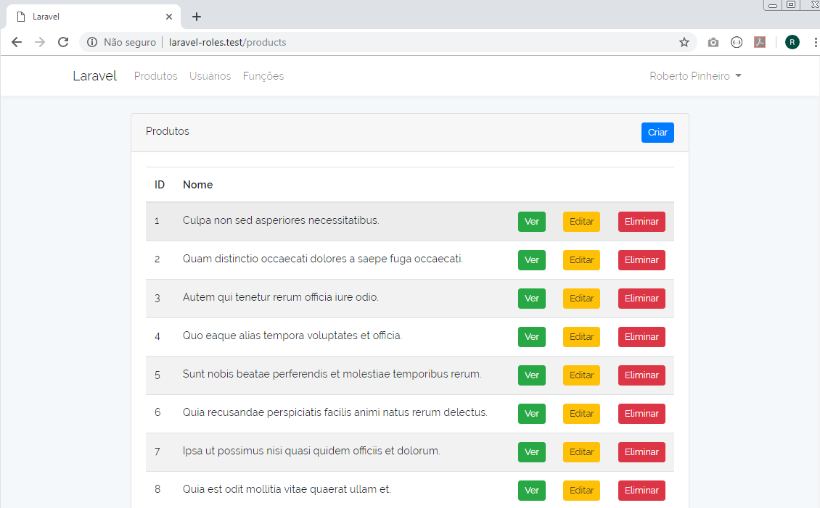
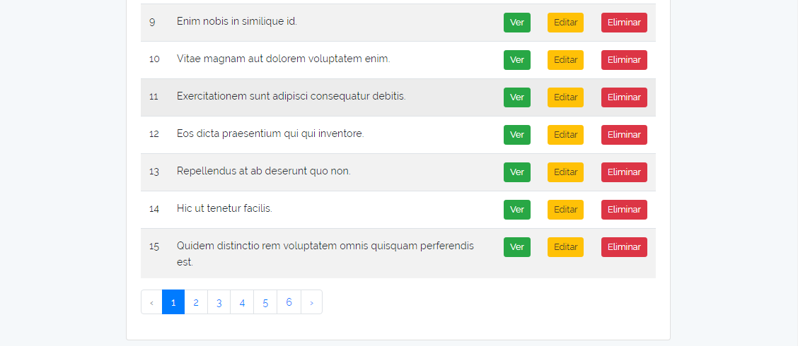

Aula 12 - Métodos de um controlador - Injeção de método

http/Controllers/ProductController.php

<?php

namespace App\Http\Controllers;

use App\Product;
use Illuminate\Http\Request;

class ProductController extends Controller
{
public function index()
{
$products = Product::paginate();
return view('products.index', compact('products'));
}
public function create()
{
return view('products.create');
}
public function store(Request $request)
{
$product = Product::create($request->all());
return redirect()->route('products.edit', $product->id)
->with('info', 'Produto gravado com sucesso!');
}
public function show(Product $product)
{
return view('products.show', compact('product'));
}
public function edit(Product $product)
{
return view('products.edit', compact('product'));
}
public function update(Request $request, Product $product)
{
$product->update($request->all());
return redirect()->route('products.edit', $product->id)
->with('info', 'Produto atualizado com sucesso!');
}
public function destroy(Product $product)
{
$product->delete();
return back()->with('info', 'Produto eliminado com sucesso!');
}
}
app/Product.php

<?php

namespace App;

use Illuminate\Database\Eloquent\Model;

class Product extends Model
{
protected $fillable = [
'name', 'description'
];
}

Aula 13 - Vista form e show | Debug de erros

resources/views/products/partials/form.blade.php

<div class="form-group">
{{ Form::label('name', 'Nome do produto') }}
{{ Form::text('name', null, ['class' => 'form-control']) }}
</div>
<div class="form-group">
{{ Form::label('description', 'Descrição do produto') }}
{{ Form::text('description', null, ['class' => 'form-control']) }}
</div>
<div class="form-group">
{{ Form::submit('Gravar', ['class' => 'btn btn-sm btn-primary']) }}
</div>

resources/views/products/show.blade.php

@extends('layouts.app')

@section('content')
<div class="container">
<div class="row justify-content-center">
<div class="col-md-1"></div>
<div class="col-md-10">
<div class="card">
<div class="card-header">Produto</div>
<div class="card-body">
<p><strong>Produto: </strong> {{ $product->name }}</p>
<p><strong>Descrição: </strong> {{ $product->description }}</p>
</div>
</div>
</div>
<div class="col-md-1"></div>
</div>
</div>
@endsection

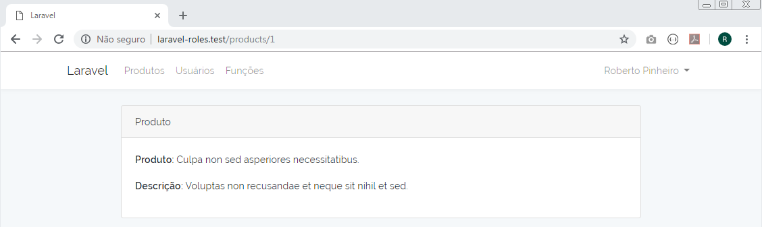

Aula 14 - Formulário criar e editar do módulo de produtos

resources/views/products/edit.blade.php

@extends('layouts.app')

@section('content')
<div class="container">
<div class="row justify-content-center">
<div class="col-md-1"></div>
<div class="col-md-10">
<div class="card">
<div class="card-header">Produto</div>
<div class="card-body">
{!! Form::model($product, ['route' => ['products.update', $product->id], 'method' => 'PUT']) !!}
@include('products.partials.form')
{!! Form::close() !!}
</div>
</div>
</div>
<div class="col-md-1"></div>
</div>
</div>
@endsection

resources/views/products/create.blade.php

@extends('layouts.app')

@section('content')
<div class="container">
<div class="row justify-content-center">
<div class="col-md-1"></div>
<div class="col-md-10">
<div class="card">
<div class="card-header">Produto</div>
<div class="card-body">
{!! Form::open(['route' => 'products.store']) !!}
@include('products.partials.form')
{!! Form::close() !!}
</div>
</div>
</div>
<div class="col-md-1"></div>
</div>
</div>
@endsection
resources/views/layouts/app.blade.php

<!DOCTYPE html>
<html lang="{{ str_replace('_', '-', app()->getLocale()) }}">
<head>
<meta charset="utf-8">
<meta http-equiv="X-UA-Compatible" content="IE=edge">
<meta name="viewport" content="width=device-width, initial-scale=1">

<!-- CSRF Token -->
<meta name="csrf-token" content="{{ csrf_token() }}">

<title>{{ config('app.name', 'Laravel') }}</title>

<!-- Scripts -->
<script src="{{ asset('js/app.js') }}" defer></script>

<!-- Fonts -->
<link rel="dns-prefetch" href="https://fonts.gstatic.com">
<link href="https://fonts.googleapis.com/css?family=Nunito" rel="stylesheet" type="text/css">

<!-- Styles -->
<link href="{{ asset('css/app.css') }}" rel="stylesheet">
</head>
<body>
<div id="app">
<nav class="navbar navbar-expand-md navbar-light navbar-laravel">
<div class="container">
<a class="navbar-brand" href="{{ url('/') }}">
{{ config('app.name', 'Laravel') }}
</a>
<button class="navbar-toggler" type="button" data-toggle="collapse" data-target="#navbarSupportedContent" aria-controls="navbarSupportedContent" aria-expanded="false" aria-label="{{ __('Toggle navigation') }}">
<span class="navbar-toggler-icon"></span>
</button>

<div class="collapse navbar-collapse" id="navbarSupportedContent">
<!-- Left Side Of Navbar -->
<ul class="navbar-nav mr-auto">
@can('products.index')
<li class="nav-item">
<a class="nav-link" href="{{ route('products.index') }}">Produtos</a>
</li>
@endcan
@can('users.index')
<li class="nav-item">
<a class="nav-link" href="{{ route('users.index') }}">Usuários</a>
</li>
@endcan
@can('roles.index')
<li class="nav-item">
<a class="nav-link" href="{{ route('roles.index') }}">Funções</a>
</li>
@endcan
</ul>
<!-- Right Side Of Navbar -->
<ul class="navbar-nav ml-auto">
<!-- Authentication Links -->
@guest
<li class="nav-item">
<a class="nav-link" href="{{ route('login') }}">{{ __('Login') }}</a>
</li>
<li class="nav-item">
<a class="nav-link" href="{{ route('register') }}">{{ __('Register') }}</a>
</li>
@else
<li class="nav-item dropdown">
<a id="navbarDropdown" class="nav-link dropdown-toggle" href="#" role="button" data-toggle="dropdown" aria-haspopup="true" aria-expanded="false" v-pre>
{{ Auth::user()->name }} <span class="caret"></span>
</a>

<div class="dropdown-menu dropdown-menu-right" aria-labelledby="navbarDropdown">
<a class="dropdown-item" href="{{ route('logout') }}"
onclick="event.preventDefault();
document.getElementById('logout-form').submit();">
{{ __('Logout') }}
</a>

<form id="logout-form" action="{{ route('logout') }}" method="POST" style="display: none;">
@csrf
</form>
</div>
</li>
@endguest
</ul>
</div>
</div>
</nav>
<br>
@if(session('info'))
<div class="container">
<div class="row">
<div class="col-md-1"></div>
<div class="col-md-10">
<div class="alert alert-success">
{{ session('info') }}
</div>
</div>
<div class="col-md-1"></div>
</div>
</div>
@endif

@yield('content')
</div>
</body>
</html>

Editando um produto:

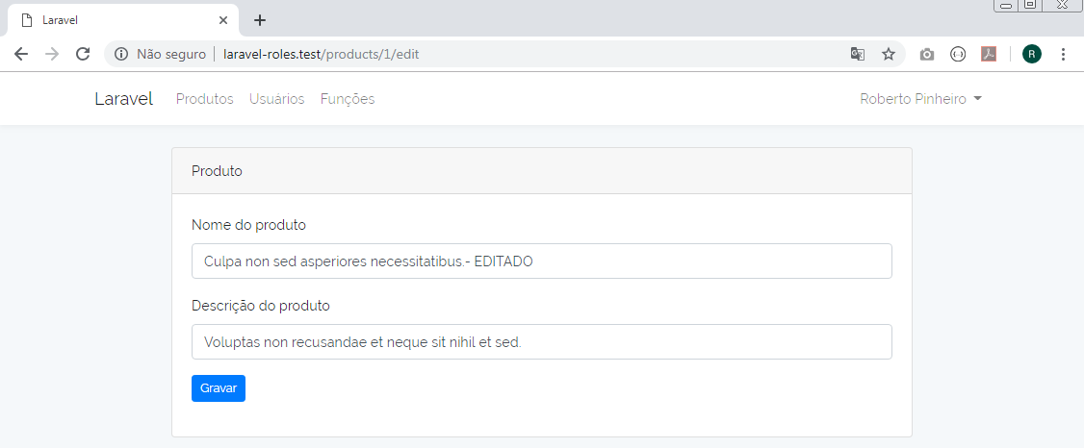

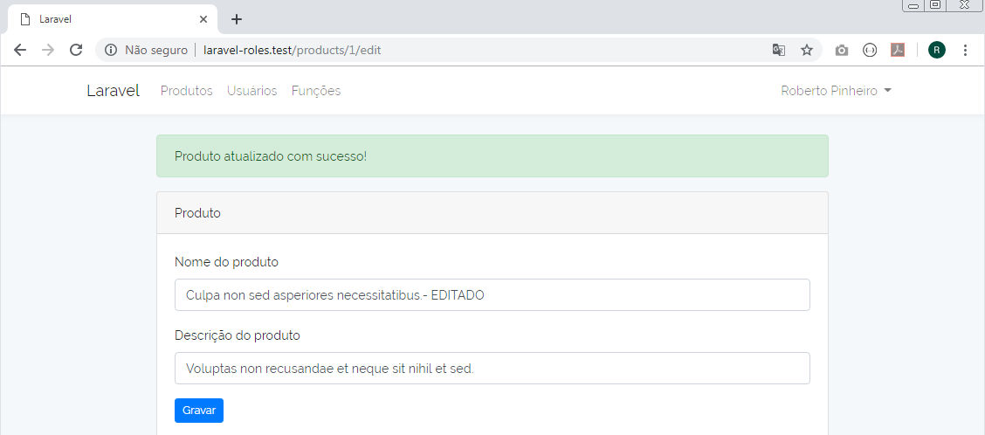

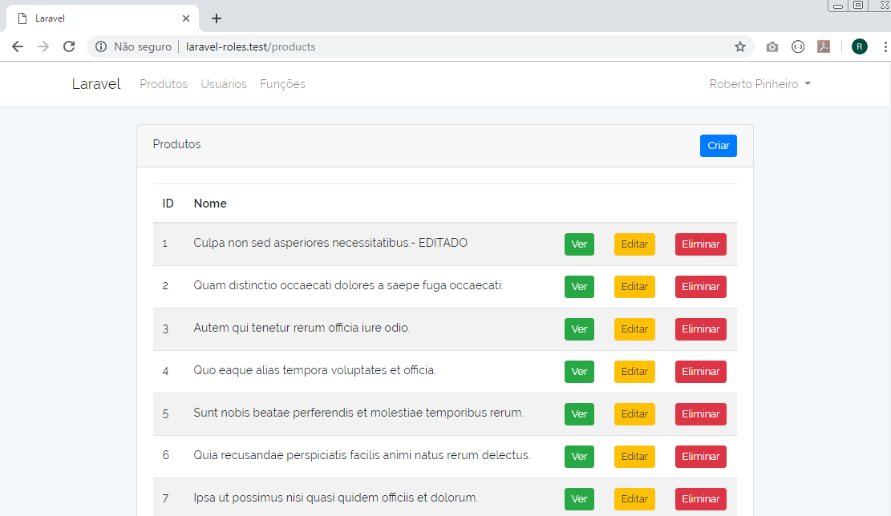

Criando um produto:

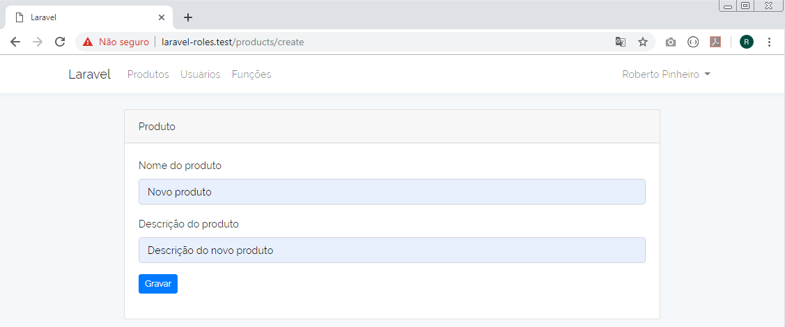

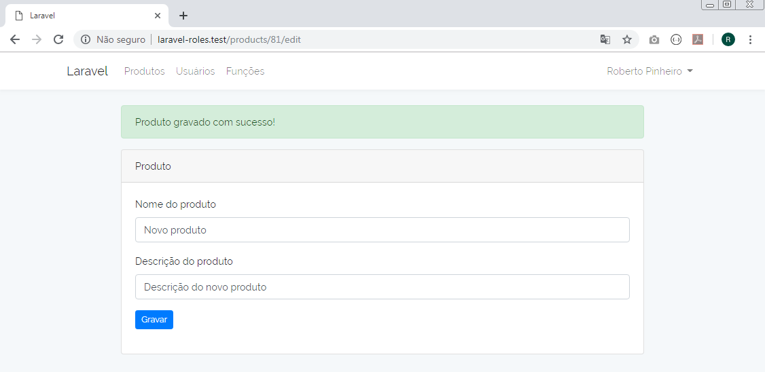

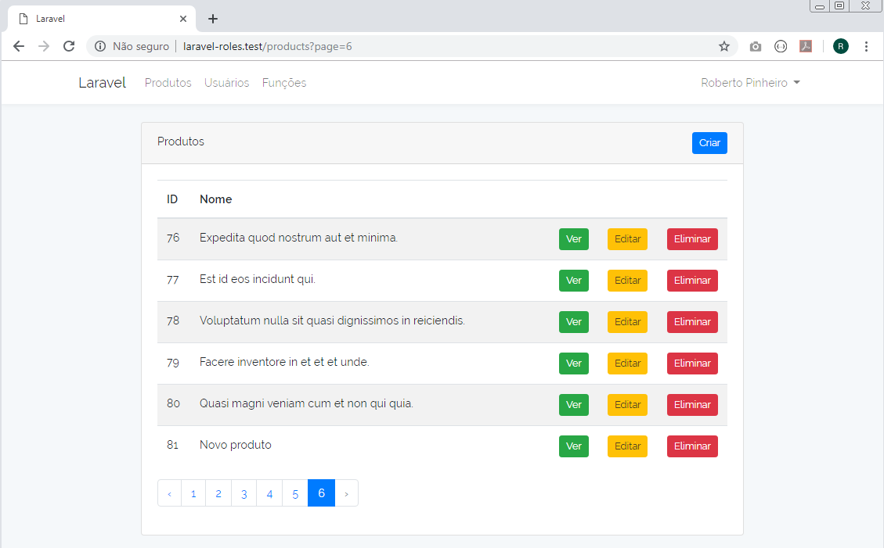
Eliminando um produto (id 81)

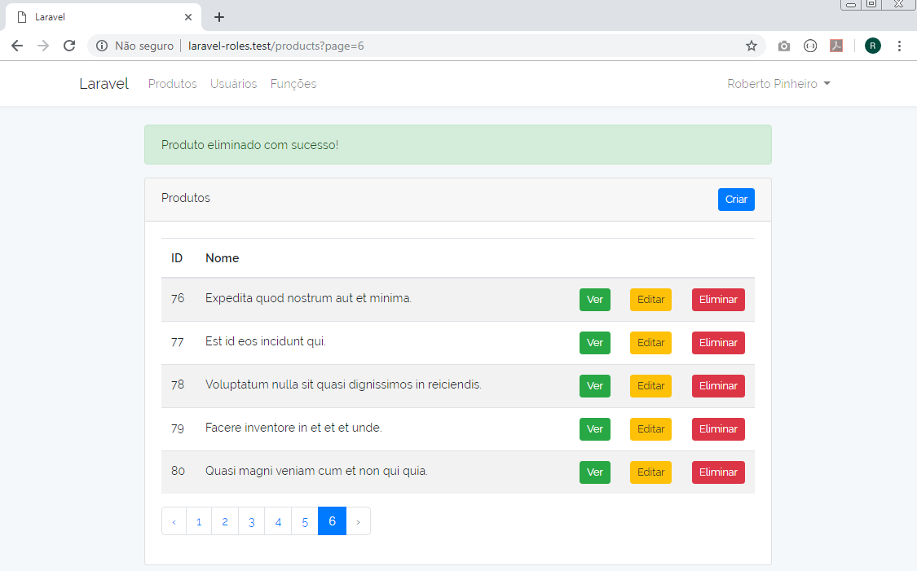

Aula 15 - Módulo de usuário - index

http/Controllers/UserController.php

<?php

namespace App\Http\Controllers;

use App\User;
use Illuminate\Http\Request;

class UserController extends Controller
{
public function index()
{
$users = User::paginate();
return view('users.index', compact('users'));
}

public function show(User $user)
{
return view('users.show', compact('user'));
}

public function edit(User $user)
{
return view('users.edit', compact('user'));
}

public function update(Request $request, User $user)
{
$user->update($request->all());
return redirect()->route('users.index', $user->id)
->with('info', 'Usuário atualizado com sucesso!');
}

public function destroy(User $user)
{
$user->delete();
return back()->with('info', 'Usuário eliminado com sucesso!');
}
}

Duplique (copie) a pasta views/resources/products como views/resources/users

Elimine o arquivo create.blade.php

Nesta primeira etapa, altere apenas o arquivo abaixo

resources/views/users/index.blade.php

@extends('layouts.app')

@section('content')
<div class="container">
<div class="row justify-content-center">
<div class="col-md-1"></div>
<div class="col-md-10">
<div class="card">
<div class="card-header">
Usuários
</div>
<div class="card-body">
<table class="table table-striped table-hover">
<thead>
<tr>
<th width="10px">ID</th>
<th>Nome</th>
<th colspan="3">&nbsp;</th>
</tr>
</thead>
<tbody>
@foreach($users as $user)
<tr>
<td>{{ $user->id }}</td>
<td>{{ $user->name }}</td>
<td width="10px">
@can('users.show')
<a href="{{ route('users.show', $user->id) }}"
class="btn btn-sm btn-success">Ver</a>
@endcan
</td>
<td width="10px">
@can('users.edit')
<a href="{{ route('users.edit', $user->id) }}"
class="btn btn-sm btn-warning">Editar</a>
@endcan
</td>
<td width="10px">
@can('users.destroy')
{!! Form::open(['route' => ['users.destroy', $user->id],
'method' => 'DELETE']) !!}
<button class="btn btn-sm btn-danger">Eliminar</button>
{!! Form::close() !!}
@endcan
</td>
</tr>
@endforeach

</tbody>
</table>
{{ $users->render() }}
</div>
</div>
</div>
<div class="col-md-1"></div>
</div>
</div>
@endsection

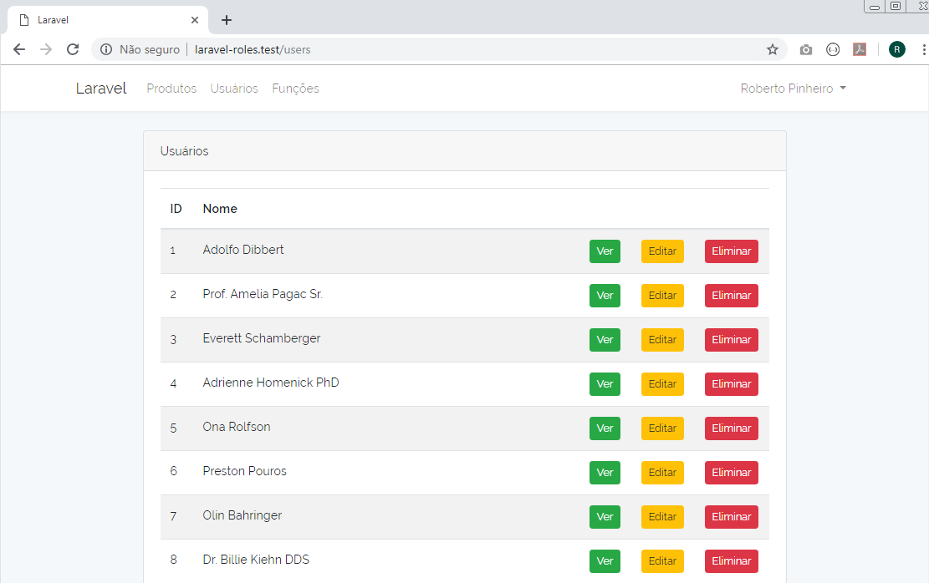
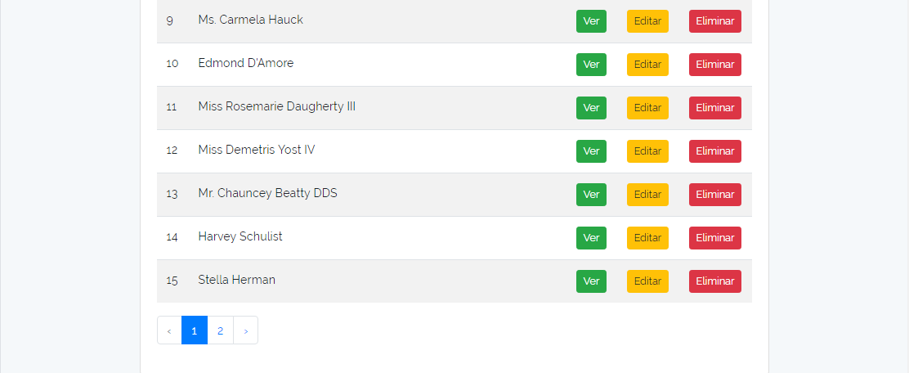

Aula 16 - Módulo de usuário - show, destroy, edit

resources/views/users/show.blade.php

@extends('layouts.app')

@section('content')
<div class="container">
<div class="row justify-content-center">
<div class="col-md-1"></div>
<div class="col-md-10">
<div class="card">
<div class="card-header">Usuário</div>
<div class="card-body">
<p><strong>Nome: </strong> {{ $user->name }}</p>
<p><strong>Email: </strong> {{ $user->email }}</p>
</div>
</div>
</div>
<div class="col-md-1"></div>
</div>
</div>
@endsection

resources/views/users/edit.blade.php

@extends('layouts.app')

@section('content')
<div class="container">
<div class="row justify-content-center">
<div class="col-md-1"></div>
<div class="col-md-10">
<div class="card">
<div class="card-header">Usuário</div>
<div class="card-body">
{!! Form::model($user, ['route' => ['users.update', $user->id], 'method' => 'PUT']) !!}
@include('users.partials.form')
{!! Form::close() !!}
</div>
</div>
</div>
<div class="col-md-1"></div>
</div>
</div>
@endsection

resources/views/users/partials/form.blade.php

<div class="form-group">
{{ Form::label('name', 'Nome do usuário') }}
{{ Form::text('name', null, ['class' => 'form-control']) }}
</div>
<div class="form-group">
{{ Form::label('email', 'Email') }}
{{ Form::text('email', null, ['class' => 'form-control']) }}
</div>
<div class="form-group">
{{ Form::submit('Gravar', ['class' => 'btn btn-sm btn-primary']) }}
</div>

Exibindo informações de usuário:

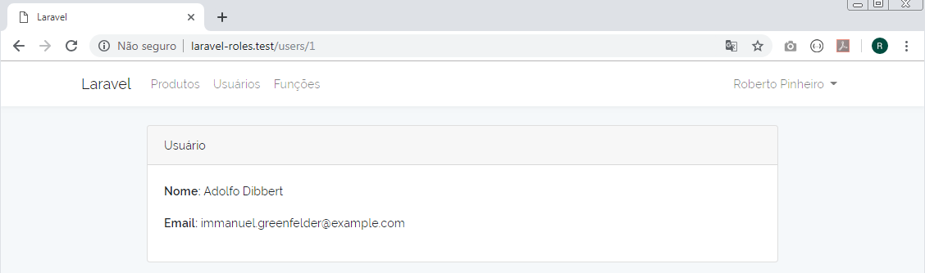

Editando informações de usuário:

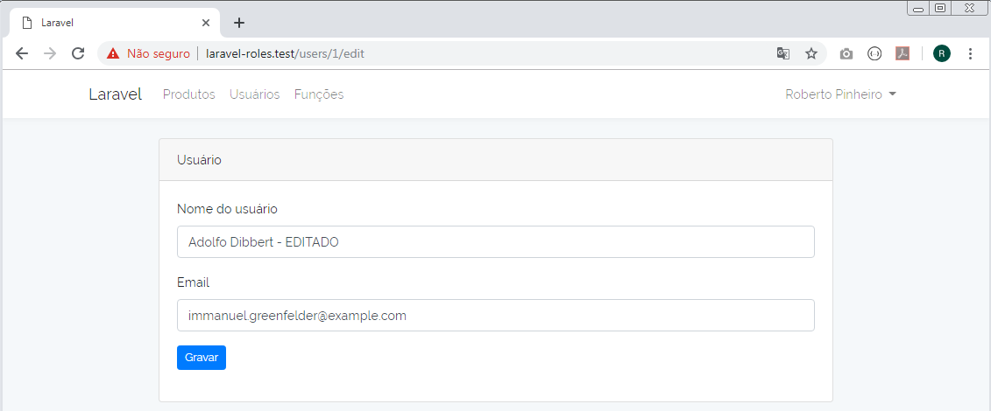

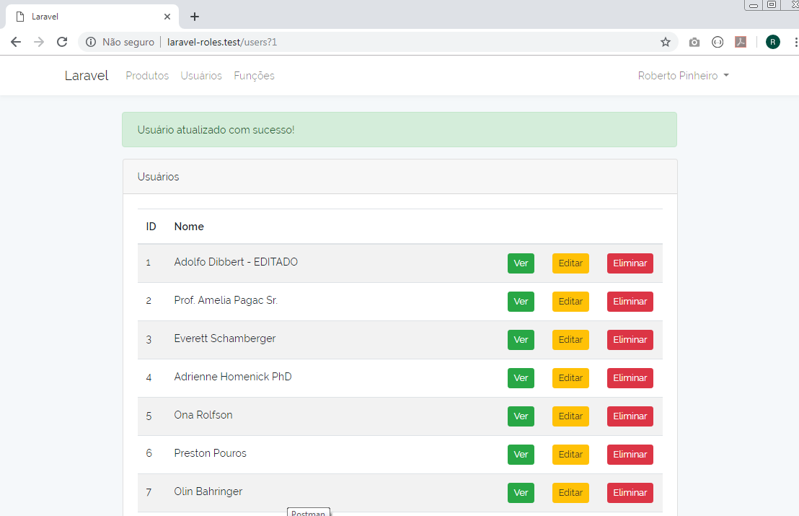

Eliminando usuário de id 2:

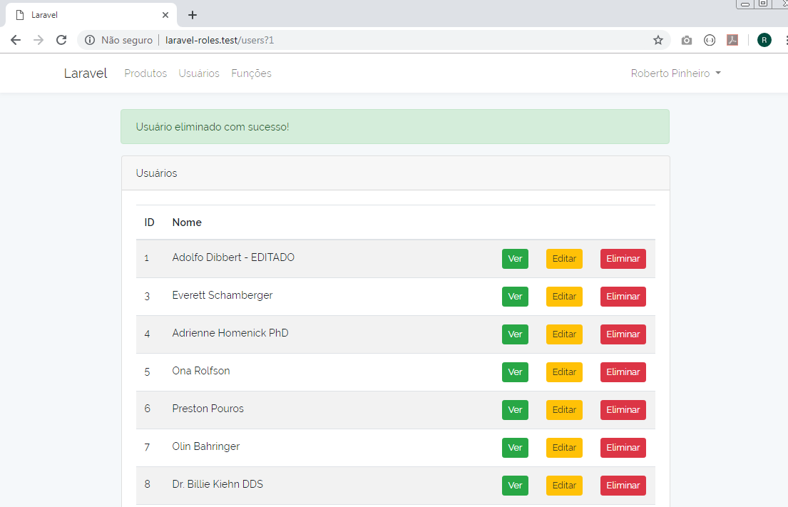

Aula 17 - Desenho de edição de usuários (Listagem de roles)

resources/views/users/partials/form.blade.php

<div class="form-group">
{{ Form::label('name', 'Nome') }}
{{ Form::text('name', null, ['class' => 'form-control']) }}
</div>
<hr>
<h3>Lista de roles</h3>
<div class="form-group">
<ul class="list-unstyled">
@foreach($roles as $role)
<li>
<label>
{{ Form::checkbox('roles[]', $role->id, null) }}
{{ $role->name }}
<em>({{ $role->description ? : 'Sem descrição' }})</em>
</label>
</li>
@endforeach
</ul>
</div>
<div class="form-group">
{{ Form::submit('Gravar', ['class' => 'btn btn-sm btn-primary']) }}
</div>

http/Controllers/UserController.php

<?php

namespace App\Http\Controllers;

use App\User;
use Caffeinated\Shinobi\Models\Role;
use Illuminate\Http\Request;

class UserController extends Controller
{
public function index()
{
$users = User::paginate();
return view('users.index', compact('users'));
}

public function show(User $user)
{
return view('users.show', compact('user'));
}

public function edit(User $user)
{
$roles = Role::get();
return view('users.edit', compact('user', 'roles'));
}

public function update(Request $request, User $user)
{
$user->update($request->all());
return redirect()->route('users.index', $user->id)
->with('info', 'Usuário atualizado com sucesso!');
}

public function destroy(User $user)
{
$user->delete();
return back()->with('info', 'Usuário eliminado com sucesso!');
}
}

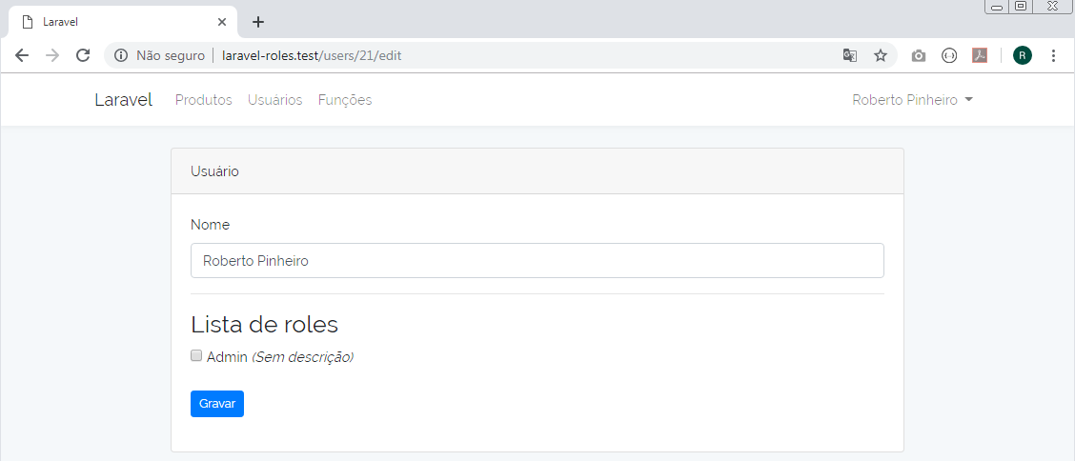

Aula 18 - Atribuição de roles a usuários

Na tabela roles, altere description de "null" para "Role Administrador"

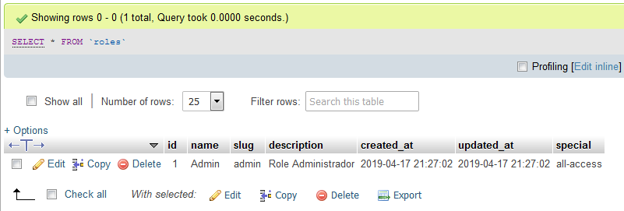

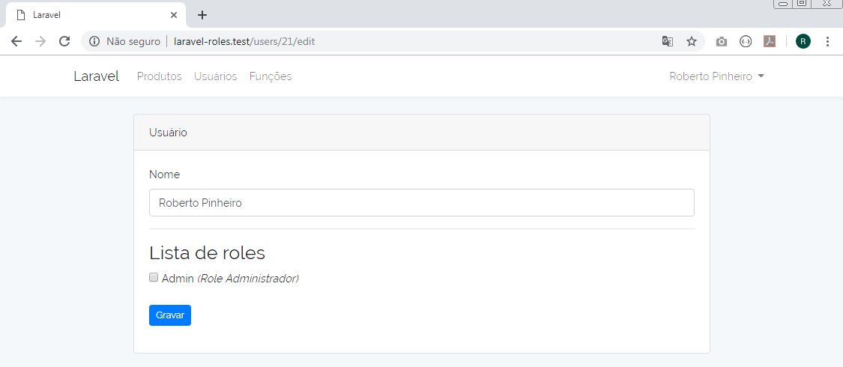

Crie um novo role: Suspenso

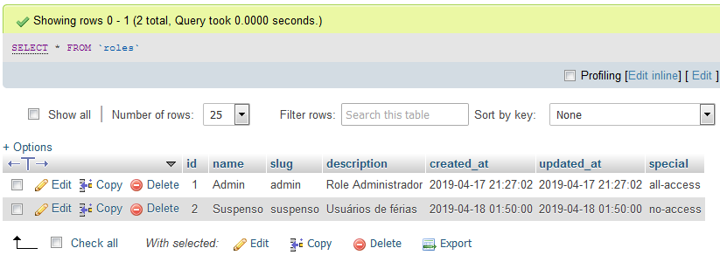

http/Controllers/UserController.php

<?php

namespace App\Http\Controllers;

use App\User;
use Caffeinated\Shinobi\Models\Role;
use Illuminate\Http\Request;

class UserController extends Controller
{
public function index()
{
$users = User::paginate();
return view('users.index', compact('users'));
}

public function show(User $user)
{
return view('users.show', compact('user'));
}

public function edit(User $user)
{
$roles = Role::get();
return view('users.edit', compact('user', 'roles'));
}

public function update(Request $request, User $user)
{
// Atualizar usuário
$user->update($request->all());

// Atualizar roles
$user->roles()->sync($request->get('roles'));

return redirect()->route('users.index', $user->id)
->with('info', 'Usuário atualizado com sucesso!');
}

public function destroy(User $user)
{
$user->delete();
return back()->with('info', 'Usuário eliminado com sucesso!');
}
}

Editando roles do usuário de id 1:

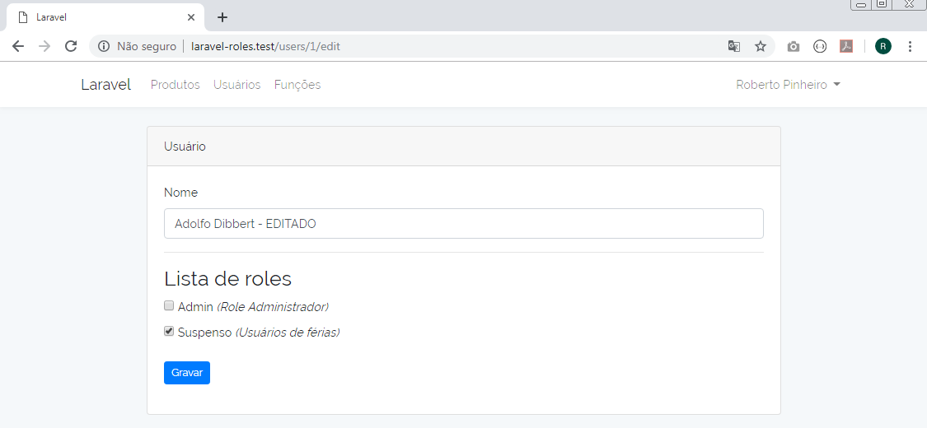

Marque a opção "Suspenso" e clique no botão "Gravar".

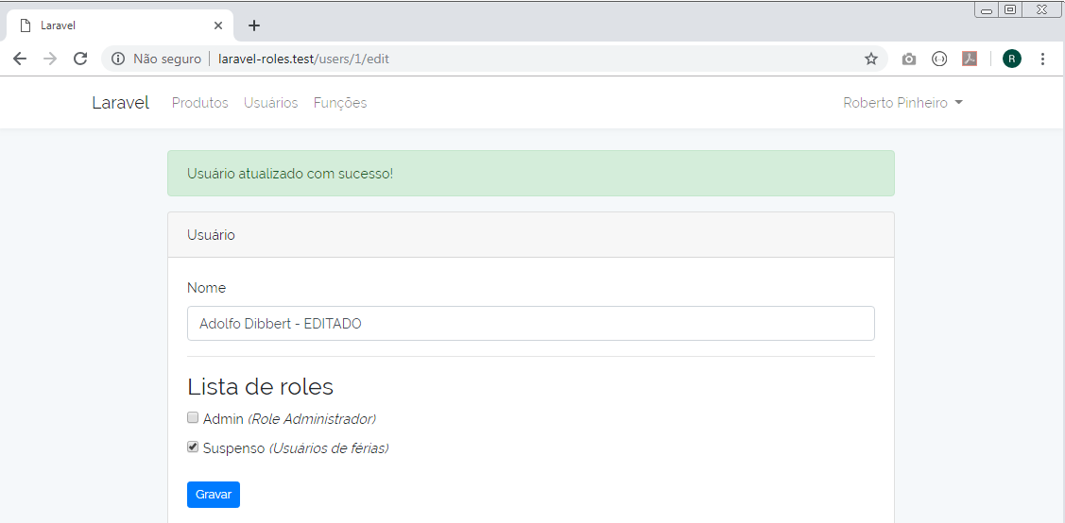

tabela role_user

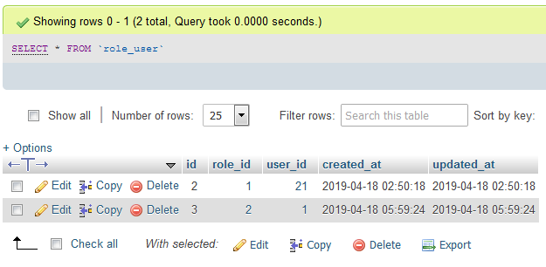

Aula 19 - Desenho do módulo Roles

http/Controllers/RoleController.php

<?php

namespace App\Http\Controllers;

use Caffeinated\Shinobi\Models\Role;
use Caffeinated\Shinobi\Models\Permission;
use Illuminate\Http\Request;

class RoleController extends Controller
{
public function index()
{
$roles = Role::paginate();
return view('roles.index', compact('roles'));
}

public function create()
{
return view('roles.create');
}

public function store(Request $request)
{
$role = Role::create($request->all());
return redirect()->route('roles.edit', $role->id)
->with('info', 'Role gravado com sucesso!');
}

public function show(Role $role)
{
return view('roles.show', compact('role'));
}

public function edit(Role $role)
{
$roles = Role::get();
return view('roles.edit', compact('role', 'roles'));
}

public function update(Request $request, Role $role)
{
// Atualizar usuário
$role->update($request->all());

// Atualizar roles
$role->roles()->sync($request->get('roles'));

return redirect()->route('roles.edit', $role->id)
->with('info', 'Role atualizado com sucesso!');
}

public function destroy(Role $role)
{
$role->delete();
return back()->with('info', 'Role eliminado com sucesso!');
}
}

resources/views/roles/index.blade.php

@extends('layouts.app')

@section('content')
<div class="container">
<div class="row justify-content-center">
<div class="col-md-1"></div>
<div class="col-md-10">
<div class="card">
<div class="card-header">
Roles
@can('roles.create')
<a href="{{ route('roles.create') }}"
class="btn btn-sm btn-primary float-right">
Criar
</a>
@endcan
</div>
<div class="card-body">
<table class="table table-striped table-hover">
<thead>
<tr>
<th width="10px">ID</th>
<th>Role</th>
<th colspan="3">&nbsp;</th>
</tr>
</thead>
<tbody>
@foreach($roles as $role)
<tr>
<td>{{ $role->id }}</td>
<td>{{ $role->name }}</td>
<td width="10px">
@can('roles.show')
<a href="{{ route('roles.show', $role->id) }}"
class="btn btn-sm btn-success">Ver</a>
@endcan
</td>
<td width="10px">
@can('roles.edit')
<a href="{{ route('roles.edit', $role->id) }}"
class="btn btn-sm btn-warning">Editar</a>
@endcan
</td>
<td width="10px">
@can('roles.destroy')
{!! Form::open(['route' => ['roles.destroy', $role->id],
'method' => 'DELETE']) !!}
<button class="btn btn-sm btn-danger">Eliminar</button>
{!! Form::close() !!}
@endcan
</td>
</tr>
@endforeach
</tbody>
</table>
{{ $roles->render() }}
</div>
</div>
</div>
<div class="col-md-1"></div>
</div>
</div>
@endsection

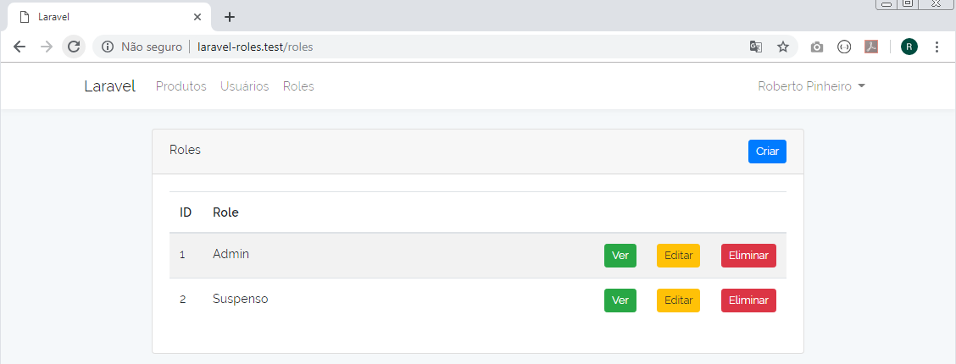

resources/views/roles/create.blade.php

@extends('layouts.app')

@section('content')
<div class="container">
<div class="row justify-content-center">
<div class="col-md-1"></div>
<div class="col-md-10">
<div class="card">
<div class="card-header">Role</div>
<div class="card-body">
{!! Form::open(['route' => 'roles.store']) !!}
@include('roles.partials.form')
{!! Form::close() !!}
</div>
</div>
</div>
<div class="col-md-1"></div>
</div>
</div>
@endsection

resources/views/roles/edit.blade.php

@extends('layouts.app')

@section('content')
<div class="container">
<div class="row justify-content-center">
<div class="col-md-1"></div>
<div class="col-md-10">
<div class="card">
<div class="card-header">Role</div>
<div class="card-body">
{!! Form::model($role, ['route' => ['roles.update', $role->id], 'method' => 'PUT']) !!}
@include('roles.partials.form')
{!! Form::close() !!}
</div>
</div>
</div>
<div class="col-md-1"></div>
</div>
</div>
@endsection

resources/views/roles/show.blade.php

@extends('layouts.app')

@section('content')
<div class="container">
<div class="row justify-content-center">
<div class="col-md-1"></div>
<div class="col-md-10">
<div class="card">
<div class="card-header">Role</div>
<div class="card-body">
<p><strong>Role: </strong> {{ $role->name }}</p>
<p><strong>Slug: </strong> {{ $role->slug }}</p>
<p><strong>Descrição: </strong> {{ $role->description }}</p>
</div>
</div>
</div>
<div class="col-md-1"></div>
</div>
</div>
@endsection

Eliminando um role

Elimine o role de id 2

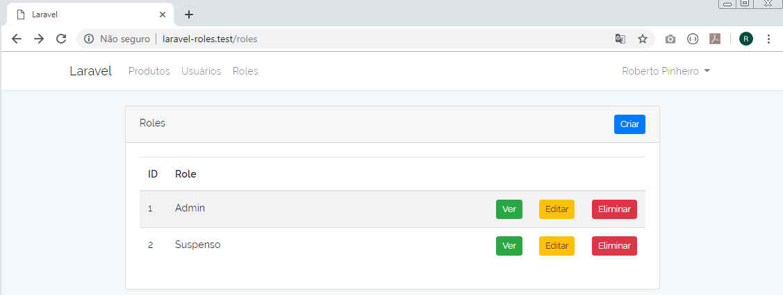

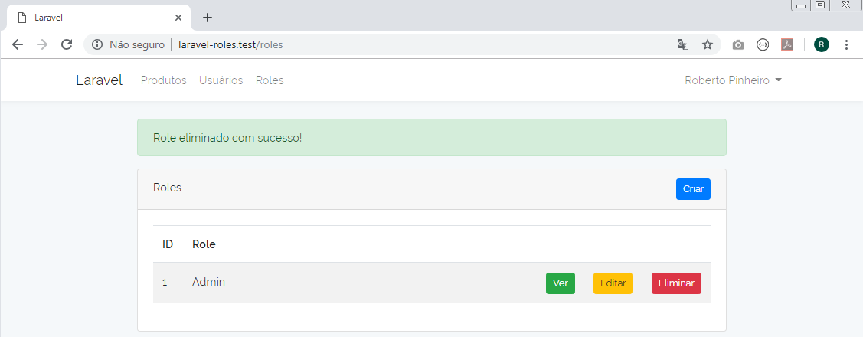

Aula 20 - Gravar e editar roles e permissions

resources/views/roles/partials/form.blade.php

<div class="form-group">
{{ Form::label('name', 'Nome') }}
{{ Form::text('name', null, ['class' => 'form-control']) }}
</div>
<div class="form-group">
{{ Form::label('slug', 'URL amigável') }}
{{ Form::text('slug', null, ['class' => 'form-control']) }}
</div>
<div class="form-group">
{{ Form::label('description', 'Descrição') }}
{{ Form::textarea('description', null, ['class' => 'form-control']) }}
</div>
<hr>
<h3>Permissão especial</h3>
<div class="form-group">
<label>{{ Form::radio('special', 'all-access') }} Acesso Total</label>
<label>{{ Form::radio('special', 'no-access') }} Nenhum Acesso</label>
</div>
<h3>Lista de permissions</h3>
<div class="form-group">
<ul class="list-unstyled">
@foreach($permissions as $permission)
<li>
<label>
{{ Form::checkbox('permissions[]', $permission->id, null) }}
{{ $permission->name }}
<em>({{ $permission->description ? : 'Sem descrição' }})</em>
</label>
</li>
@endforeach
</ul>
</div>
<div class="form-group">
{{ Form::submit('Gravar', ['class' => 'btn btn-sm btn-primary']) }}
</div>

http/Controllers/RoleController.php

<?php

namespace App\Http\Controllers;

use Caffeinated\Shinobi\Models\Role;
use Caffeinated\Shinobi\Models\Permission;
use Illuminate\Http\Request;

class RoleController extends Controller
{
public function index()
{
$roles = Role::paginate();
return view('roles.index', compact('roles'));
}

public function create()
{
$permissions = Permission::get();
return view('roles.create', compact('permissions'));
}

public function store(Request $request)
{
$role = Role::create($request->all());

// Atualizar permissions
$role->permissions()->sync($request->get('permissions'));

return redirect()->route('roles.edit', $role->id)
->with('info', 'Role gravado com sucesso!');
}

public function show(Role $role)
{
return view('roles.show', compact('role'));
}

public function edit(Role $role)
{
$permissions = Permission::get();
return view('roles.edit', compact('role', 'permissions'));
}

public function update(Request $request, Role $role)
{
// Atualizar role
$role->update($request->all());

// Atualizar permissions
$role->permissions()->sync($request->get('permissions'));

return redirect()->route('roles.edit', $role->id)
->with('info', 'Role atualizado com sucesso!');
}

public function destroy(Role $role)
{
$role->delete();
return back()->with('info', 'Role eliminado com sucesso!');
}
}

Criando role e permissions

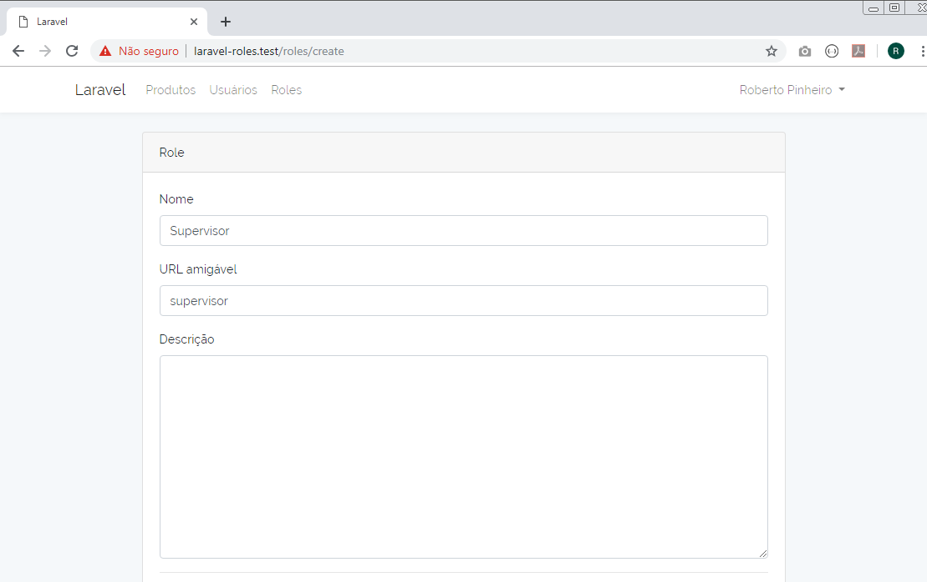
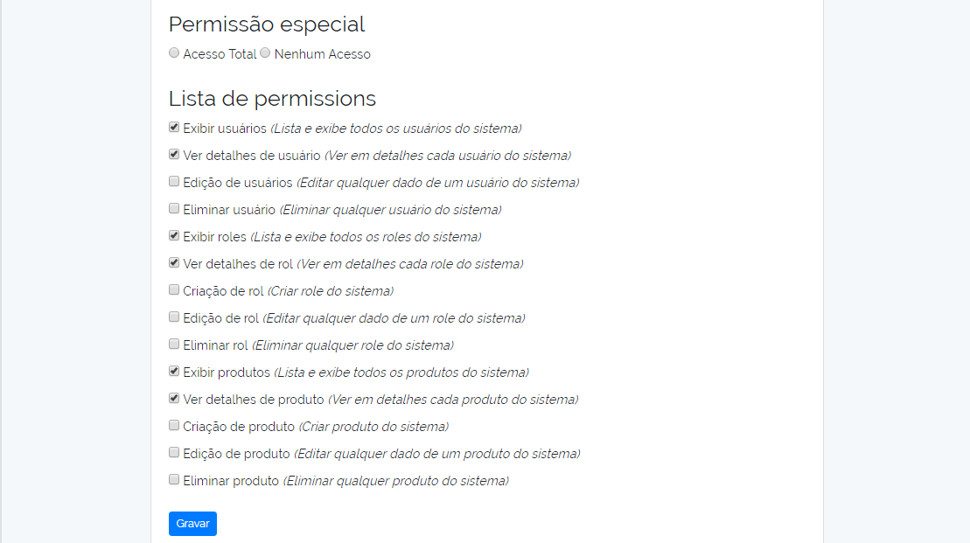

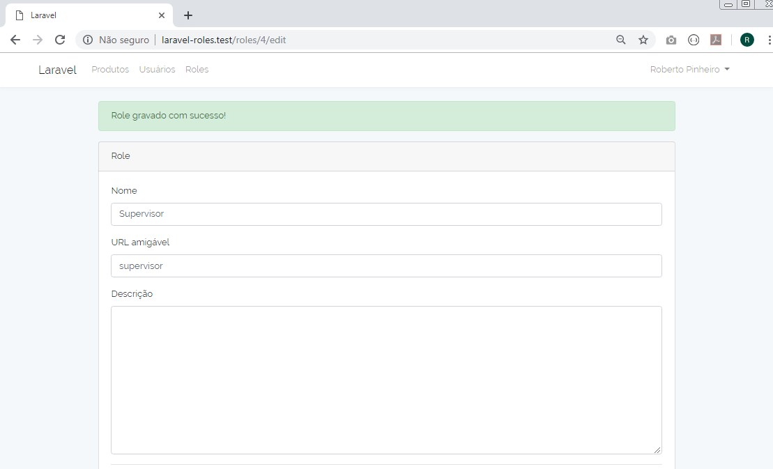
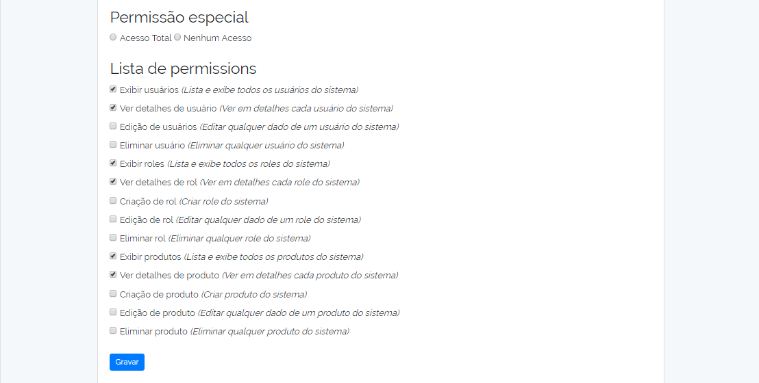

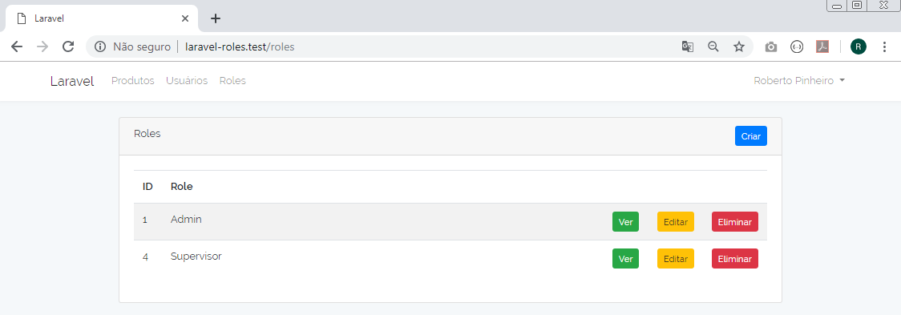
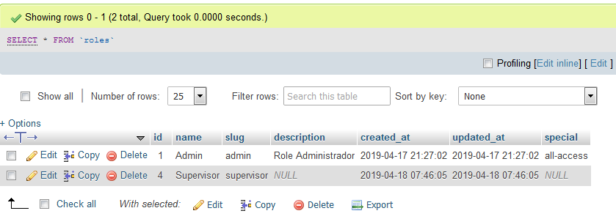

Registrando um novo usuário

Senha: 123456

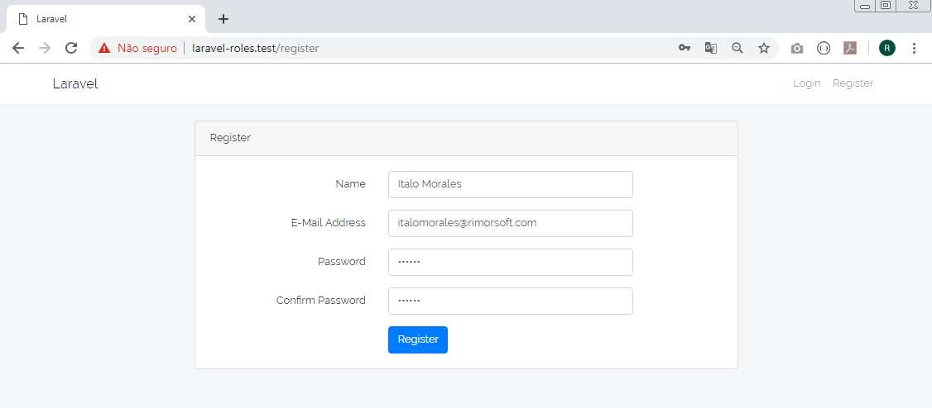

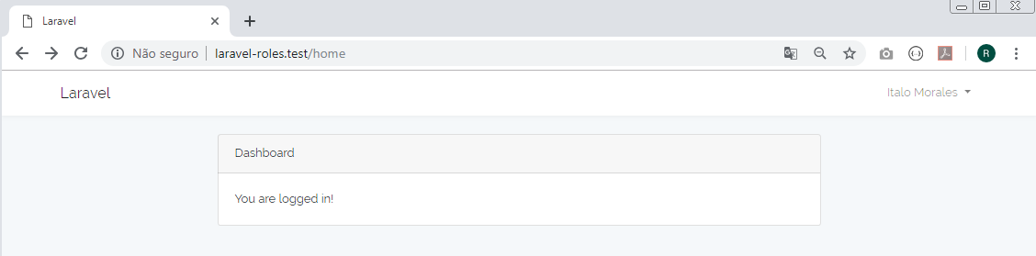

Administrador atribuindo role de supervisor ao usuário registrado

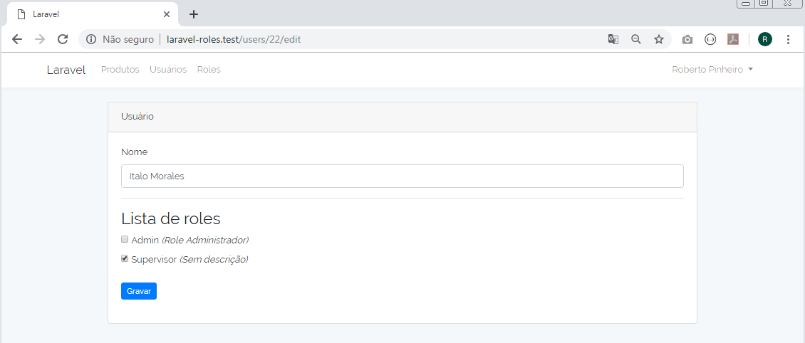

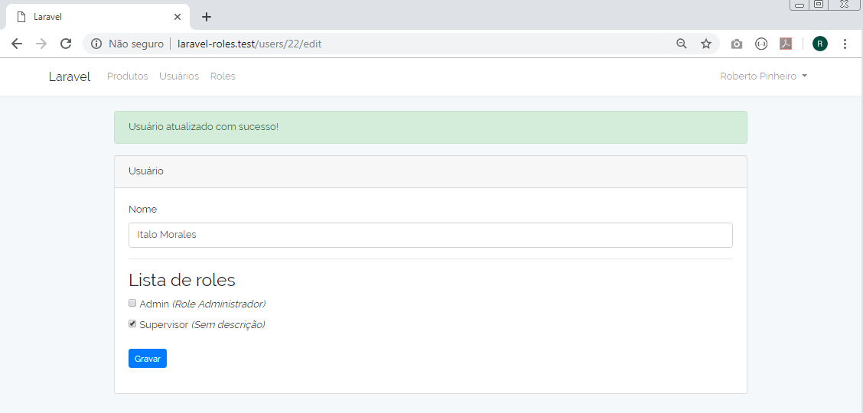

Usuário criado (Italo Morales) acessando o sistema

Produtos:

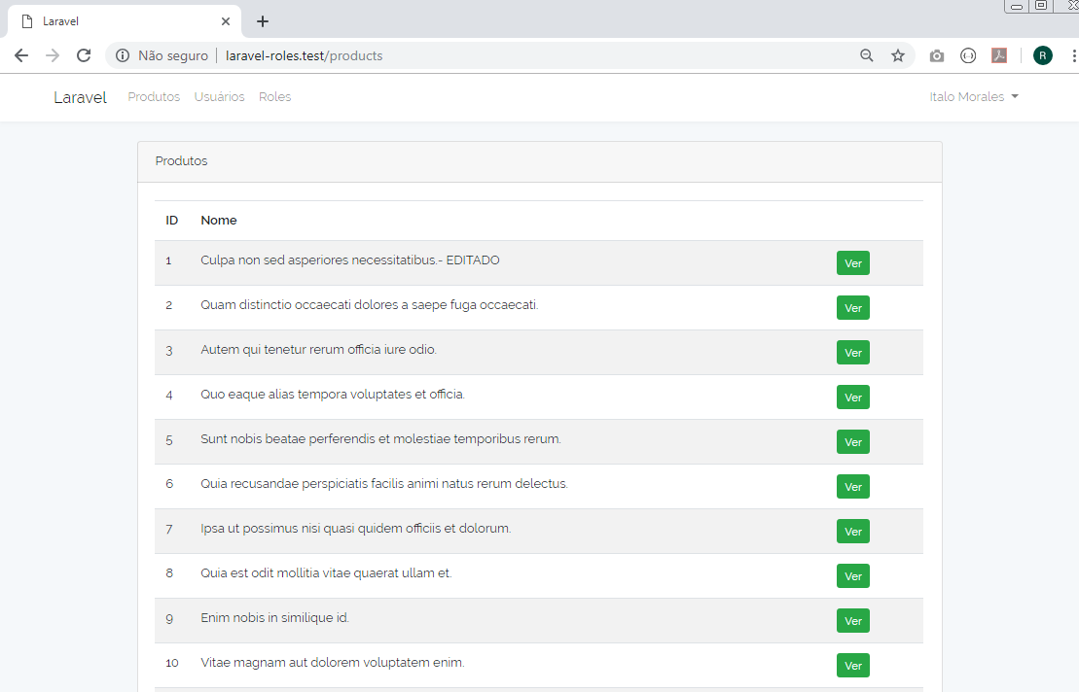

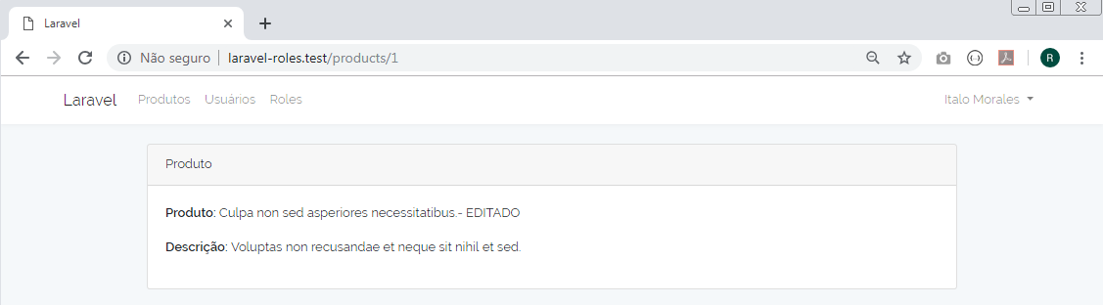

Usuários:

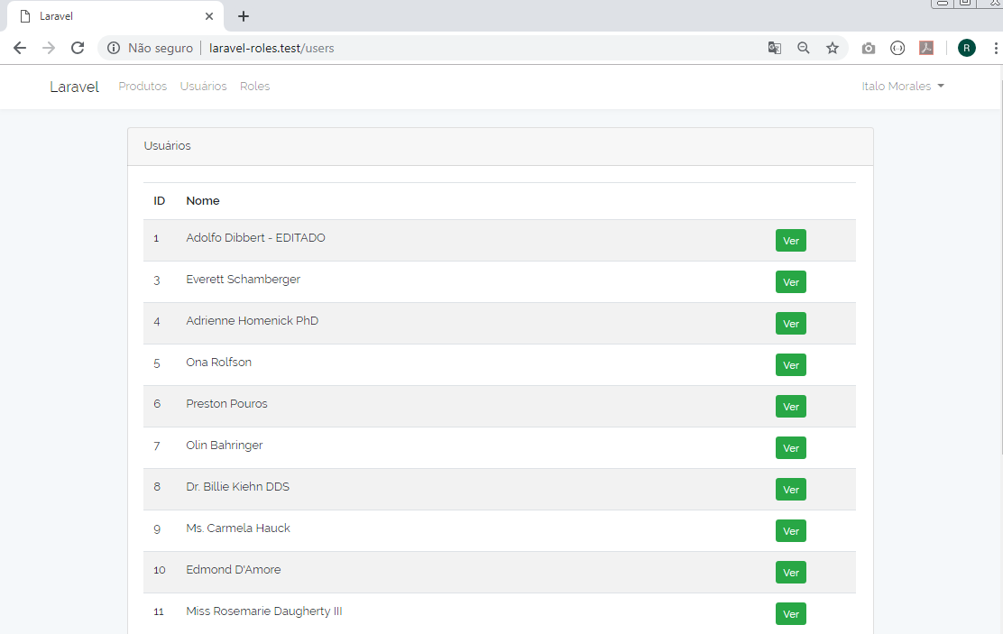

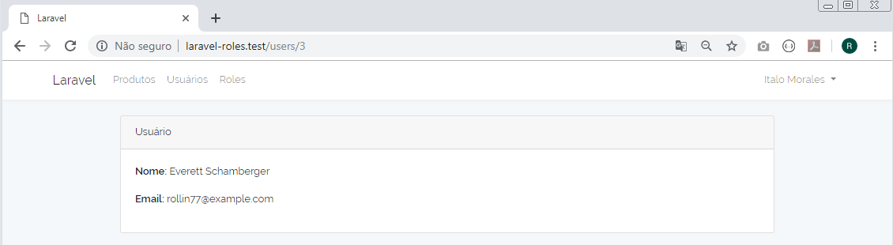

Roles:

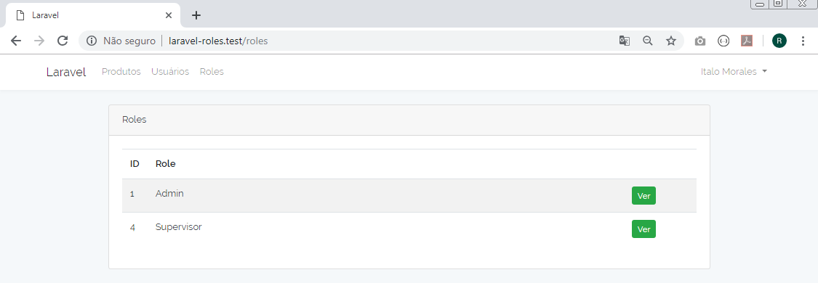
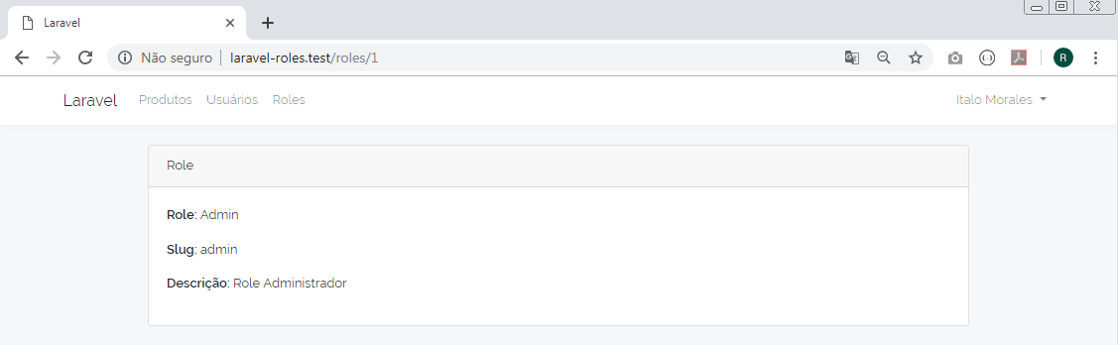

Aula 21 - Atribuindo permissões a partir das rotas e do controlador

routes/web.php

<?php

/*
|--------------------------------------------------------------------------
| Web Routes
|--------------------------------------------------------------------------
|
| Here is where you can register web routes for your application. These
| routes are loaded by the RouteServiceProvider within a group which
| contains the "web" middleware group. Now create something great!
|
*/

Route::get('/', function () {
return view('welcome');
});

Auth::routes();

Route::get('/home', 'HomeController@index')->name('home');

Route::middleware(['auth'])->group(function(){
// Roles
Route::resource('roles', 'RoleController');

// Products
Route::post('products/store', 'ProductController@store')->name('products.store')
->middleware('permission:products.create');
Route::get('products', 'ProductController@index')->name('products.index')
->middleware('permission:products.index');
Route::get('products/create', 'ProductController@create')->name('products.create')
->middleware('permission:products.create');
Route::put('products/{product}', 'ProductController@update')->name('products.update')
->middleware('permission:products.edit');
Route::get('products/{product}', 'ProductController@show')->name('products.show')
->middleware('permission:products.show');
Route::delete('products/{product}', 'ProductController@destroy')->name('products.destroy')
->middleware('permission:products.destroy');
Route::get('products/{product}/edit', 'ProductController@edit')->name('products.edit')
->middleware('permission:products.edit');

// Users
Route::get('users', 'UserController@index')->name('users.index')
->middleware('permission:users.index');
Route::put('users/{user}', 'UserController@update')->name('users.update')
->middleware('permission:users.edit');
Route::get('users/{user}', 'UserController@show')->name('users.show')
->middleware('permission:users.show');
Route::delete('users/{user}', 'UserController@destroy')->name('users.destroy')
->middleware('permission:users.destroy');
Route::get('users/{user}/edit', 'UserController@edit')->name('users.edit')
->middleware('permission:users.edit');
});

http/Controllers/RoleController.php

<?php

namespace App\Http\Controllers;

use Caffeinated\Shinobi\Models\Role;
use Caffeinated\Shinobi\Models\Permission;
use Illuminate\Http\Request;

class RoleController extends Controller
{

public function __construct()
{
$this->middleware('permission:roles.create')->only(['create', 'store']);
$this->middleware('permission:roles.index')->only(['index']);
$this->middleware('permission:roles.edit')->only(['edit', 'update']);
$this->middleware('permission:roles.show')->only(['show']);
$this->middleware('permission:roles.destroy')->only(['destroy']);
}

public function index()
{
$roles = Role::paginate();
return view('roles.index', compact('roles'));
}

public function create()
{
$permissions = Permission::get();
return view('roles.create', compact('permissions'));
}

public function store(Request $request)
{
$role = Role::create($request->all());

// Atualizar permissions
$role->permissions()->sync($request->get('permissions'));

return redirect()->route('roles.edit', $role->id)
->with('info', 'Role gravado com sucesso!');
}

public function show(Role $role)
{
return view('roles.show', compact('role'));
}

public function edit(Role $role)
{
$permissions = Permission::get();
return view('roles.edit', compact('role', 'permissions'));
}

public function update(Request $request, Role $role)
{
// Atualizar role
$role->update($request->all());

// Atualizar permissions
$role->permissions()->sync($request->get('permissions'));

return redirect()->route('roles.edit', $role->id)
->with('info', 'Role atualizado com sucesso!');
}

public function destroy(Role $role)
{
$role->delete();
return back()->with('info', 'Role eliminado com sucesso!');
}
}

resources/views/errors/403.blade.php

<!doctype html>
<html lang="{{ app()->getLocale() }}">
<head>
<meta charset="utf-8">
<meta http-equiv="X-UA-Compatible" content="IE=edge">
<meta name="viewport" content="width=device-width, initial-scale=1">

<title>Erro 403</title>

<!-- Fonts -->
<link href="https://fonts.googleapis.com/css?family=Raleway:100,600" rel="stylesheet" type="text/css">

<!-- Styles -->
<style>
html, body {
background-color: #fff;
color: #636b6f;
font-family: 'Raleway', sans-serif;
font-weight: 100;
height: 100vh;
margin: 0;
}

.full-height {
height: 100vh;
}

.flex-center {
align-items: center;
display: flex;
justify-content: center;
}

.position-ref {
position: relative;
}

.top-right {
position: absolute;
right: 10px;
top: 18px;
}

.content {
text-align: center;
}

.title {
font-size: 84px;
}

.links > a {
color: #636b6f;
padding: 0 25px;
font-size: 12px;
font-weight: 600;
letter-spacing: .1rem;
text-decoration: none;
text-transform: uppercase;
}

.m-b-md {
margin-bottom: 30px;
}
</style>
</head>
<body>
<div class="flex-center position-ref full-height">

<div class="content">
<div class="title m-b-md">
403 - Ação não autorizada!
</div>

<div class="links">
<a href={{ route('home') }}>Ir para Home</a>
</div>
</div>
</div>
</body>
</html>

resources/views/errors/403.blade.php

<!doctype html>
<html lang="{{ app()->getLocale() }}">
<head>
<meta charset="utf-8">
<meta http-equiv="X-UA-Compatible" content="IE=edge">
<meta name="viewport" content="width=device-width, initial-scale=1">

<title>Erro 404</title>

<!-- Fonts -->
<link href="https://fonts.googleapis.com/css?family=Raleway:100,600" rel="stylesheet" type="text/css">

<!-- Styles -->
<style>
html, body {
background-color: #fff;
color: #636b6f;
font-family: 'Raleway', sans-serif;
font-weight: 100;
height: 100vh;
margin: 0;
}

.full-height {
height: 100vh;
}

.flex-center {
align-items: center;
display: flex;
justify-content: center;
}

.position-ref {
position: relative;
}

.top-right {
position: absolute;
right: 10px;
top: 18px;
}

.content {
text-align: center;
}

.title {
font-size: 84px;
}

.links > a {
color: #636b6f;
padding: 0 25px;
font-size: 12px;
font-weight: 600;
letter-spacing: .1rem;
text-decoration: none;
text-transform: uppercase;
}

.m-b-md {
margin-bottom: 30px;
}
</style>
</head>
<body>
<div class="flex-center position-ref full-height">

<div class="content">
<div class="title m-b-md">
404 - Esta rota não existe!
</div>

<div class="links">
<a href={{ route('home') }}>Ir para Home</a>
</div>
</div>
</div>
</body>
</html>

Alterar a lista de permissões para supervisor para:

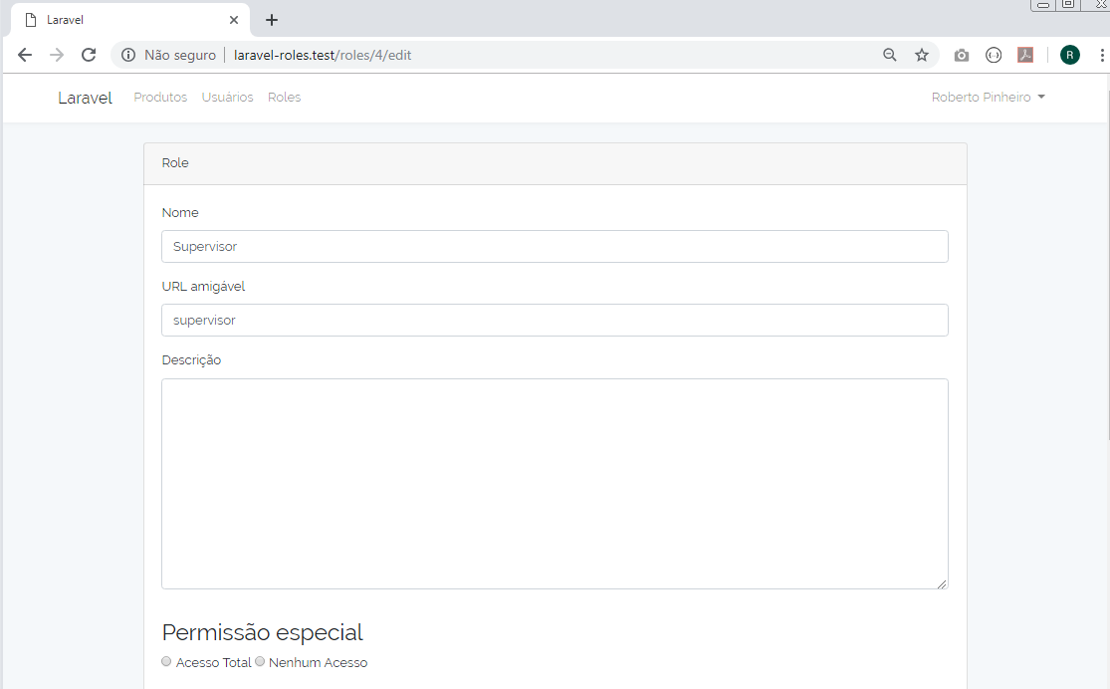
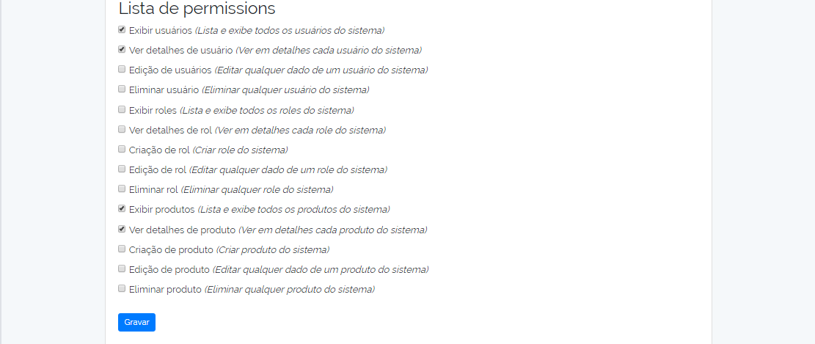

E gravar.

Entrar como usuário supervisor (Italo Morales):

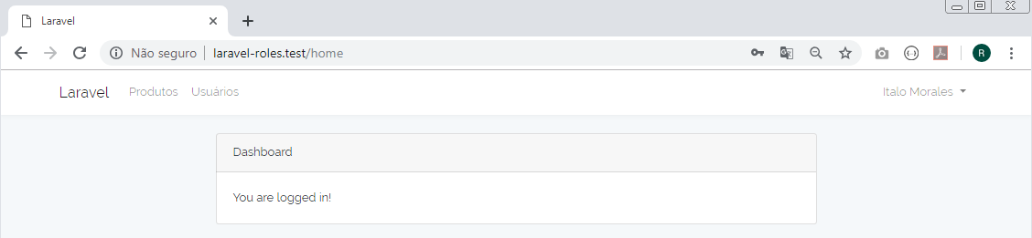

Entre com a URL:

http://laravel-roles.test/roles

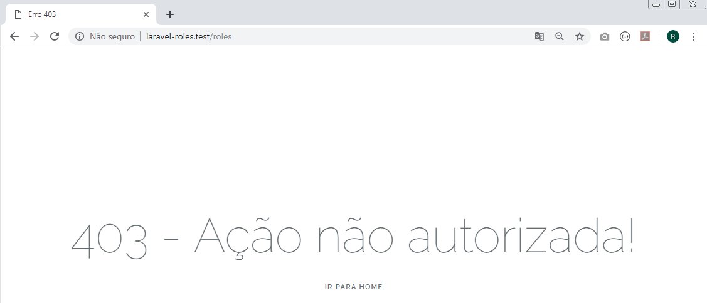

Entre com a URL:

http://laravel-roles.test/roles/1/edit

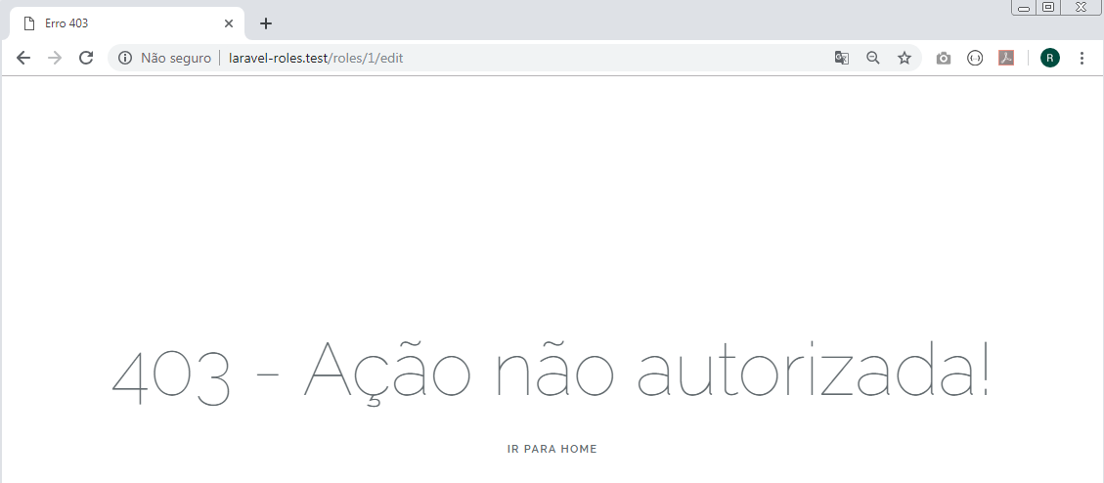

Entre com a URL:

http://laravel-roles.test/roles/11/edit

