Laravel 5.7 desde cero (Aulas 1 a 15)
Aprendible

https://www.youtube.com/watch?v=QRwuPHeagaQ&list=PLpKWS6gp0jd_uZiWmjuqLY7LAMaD8UJhc

Resumo do curso feito por Roberto Pinheiro

Aula 04 - Rotas

routes/web.php

Route::get('/', function () {
return 'Página inicial';
});

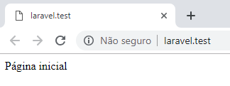
Route::get('/contato', function () {
return 'Página de contato';
});

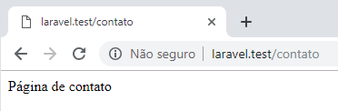

Route::get('/saudacoes/{nome}', function ($nome) {
return 'Saudações ' . $nome;
});

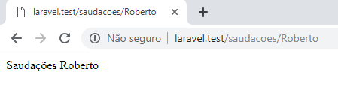
Dessa forma o parâmetro é obrigatório e se não for especificado é retornado uma mensagem de erro:

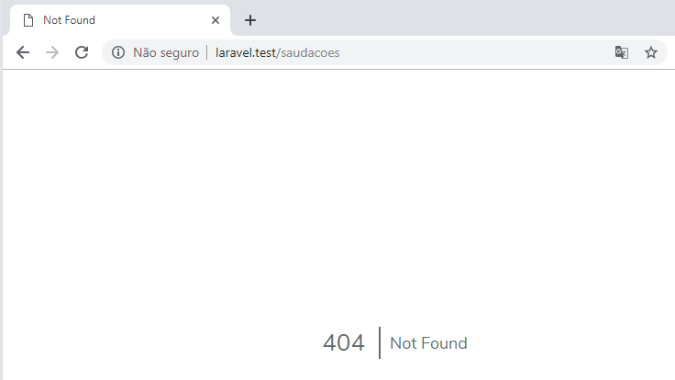

Para que o parâmetro seja opcional (não obrigatório ) a rota deve ser especificada da seguinte forma:

Route::get('/saudacoes/{nome?}', function ($nome='Convidado') {
return 'Saudações ' . $nome;
});

Onde é passado um valor padrão para o parâmetro (que também pode ser nulo):

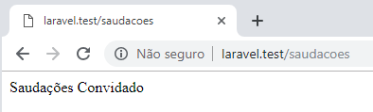

Aula 05 - Rotas nomeadas

routes/web.php

Route::get('/contato', function () {
return 'Seção de contato';
})->name('contatos');

Route::get('/', function () {
echo "<a href='" . route('contatos') . "'>Contatos 1</a><br />";
echo "<a href='" . route('contatos') . "'>Contatos 2</a><br />";
echo "<a href='" . route('contatos') . "'>Contatos 3</a><br />";
echo "<a href='" . route('contatos') . "'>Contatos 4</a><br />";
echo "<a href='" . route('contatos') . "'>Contatos 5</a><br />";
});

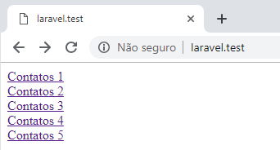

Clicando em qualquer um dos links:

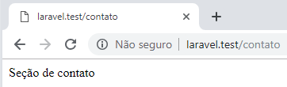

Se for alterada a URL:

Route::get('/contact-me', function () {
return 'Seção de contato';
})->name('contatos');

Route::get('/', function () {
echo "<a href='" . route('contatos') . "'>Contatos 1</a><br />";
echo "<a href='" . route('contatos') . "'>Contatos 2</a><br />";
echo "<a href='" . route('contatos') . "'>Contatos 3</a><br />";
echo "<a href='" . route('contatos') . "'>Contatos 4</a><br />";
echo "<a href='" . route('contatos') . "'>Contatos 5</a><br />";
});

Clicando em qualquer um dos links:

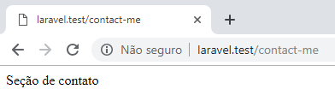

Aula 6 - Views

routes/web.php

Route::get('/', function () {
return view('home');
})->name('home');

resources/views/home.blade.php

<!DOCTYPE html>
<html lang="pt-br">
<head>
<meta charset="UTF-8">
<title>Home</title>
</head>
<body>
<h1>Home</h1>
</body>
</html>

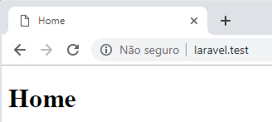

Passando valores para a view

resources/views/home.blade.php

<!DOCTYPE html>
<html lang="pt-br">
<head>
<meta charset="UTF-8">
<title>Home</title>
</head>
<body>
<h1>Home</h1>
Bem-vindo <?php echo $nome ?>
</body>
</html>

Primeira forma

routes/web.php

Route::get('/', function () {
$nome = 'Roberto';
return view('home')->with('nome', $nome);
})->name('home');

Segunda forma

Route::get('/', function () {
$nome = 'Roberto';
return view('home')->with(['nome' => $nome]);
})->name('home');

Terceira forma

Route::get('/', function () {
$nome = 'Roberto';
return view('home', compact('nome'));
})->name('home');

Quarta forma

routes/web.php

Route::view('/', 'home', ['nome' => 'Roberto'])->name('home');

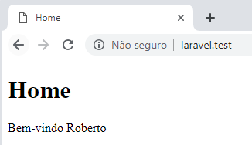

routes/web.php

Route::view('/', 'home')->name('home');
Route::view('/about', 'about')->name('about');
Route::view('/portfolio', 'portfolio')->name('portfolio');
Route::view('/contato', 'contato')->name('contato');

resources/views/home.blade.php

<!DOCTYPE html>
<html lang="pt-br">
<head>
<meta charset="UTF-8">
<title>Home</title>
</head>
<body>
<nav>
<ul>
<li><a href="/">Home</a></li>
<li><a href="/about">About</a></li>
<li><a href="/portfolio">Portfolio</a></li>
<li><a href="/contato">Contato</a></li>
</ul>
</nav>

<h1>Home</h1>
Bem-vindo <?php echo $nome ?? 'Convidado' ?>
</body>
</html>

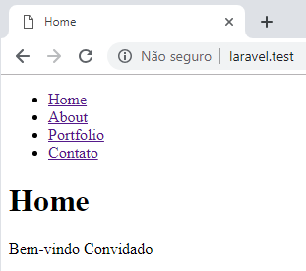

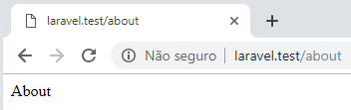

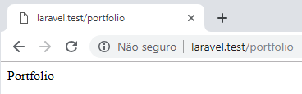

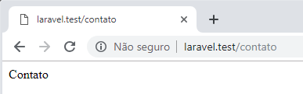

Nesse caso, é sempre necessário voltar a página home para ter acesso aos links.

Aula 7 - Blade, o motor de templates

resources/views/layouts/template.blade.php

<!DOCTYPE html>
<html lang="pt-br">
<head>
<meta charset="UTF-8">
<title>@yield('title', 'Aprendible')</title>
</head>
<body>
<nav>
<ul>
<li><a href="/">Home</a></li>
<li><a href="/about">About</a></li>
<li><a href="/portfolio">Portfolio</a></li>
<li><a href="/contato">Contato</a></li>
</ul>
</nav>

@yield('content')

</body>
</html>

resources/views/home.blade.php

@extends('layouts.template')

@section('title','Home')

@section('content')
<h1>Home</h1>
@endsection

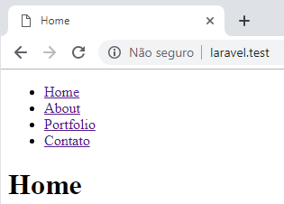

resources/views/about.blade.php

@extends('layouts.template')

@section('title','About')

@section('content')
<h1>About</h1>
@endsection

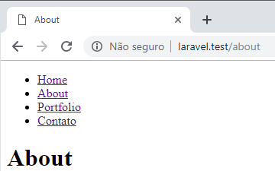

resources/views/portfolio.blade.php

@extends('layouts.template')

@section('title','Portfolio')

@section('content')
<h1>Portfolio</h1>
@endsection

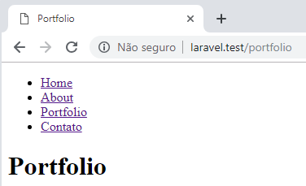

resources/views/contato.blade.php

@extends('layouts.template')

@section('title', 'Contato')

@section('content')
<h1>Contato</h1>
@endsection

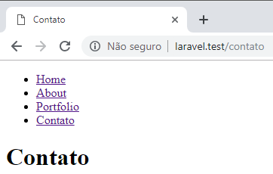

Aula 8 - Estruturas de controle

routes/web.php

$portfolio = [
["title" => "Projeto #1"],
["title" => "Projeto #2"],
["title" => "Projeto #3"],
["title" => "Projeto #4"]
];

Route::view('/', 'home')->name('home');
Route::view('/about', 'about')->name('about');
Route::view('/portfolio', 'portfolio', compact('portfolio'))->name('portfolio');
Route::view('/contato', 'contato')->name('contato');

resources/views/portfolio.blade.php

@extends('layouts.template')

@section('title','Portfolio')

@section('content')
<h1>Portfolio</h1>

<ul>
<?php
foreach($portfolio as $portfolioItem)
{
echo "<li>" . $portfolioItem['title'] . "</li>";
}
?>
</ul>
@endsection

Com Blade:

resources/views/portfolio.blade.php

@extends('layouts.template')

@section('title','Portfolio')

@section('content')
<h1>Portfolio</h1>

<ul>
@foreach($portfolio as $portfolioItem)
<li>{{ $portfolioItem['title'] }}</li>
@endforeach
</ul>
@endsection

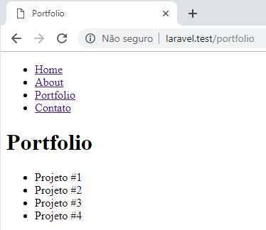

routes/web.php

$portfolio = [
// ["title" => "Projeto #1"],
// ["title" => "Projeto #2"],
// ["title" => "Projeto #3"],
// ["title" => "Projeto #4"]
];

Route::view('/', 'home')->name('home');
Route::view('/about', 'about')->name('about');
Route::view('/portfolio', 'portfolio', compact('portfolio'))->name('portfolio');
Route::view('/contato', 'contato')->name('contato');

resources/views/portfolio.blade.php

@extends('layouts.template')

@section('title','Portfolio')

@section('content')
<h1>Portfolio</h1>
<ul>
@if ($portfolio)
@foreach($portfolio as $portfolioItem)
<li>{{ $portfolioItem['title'] }}</li>
@endforeach
@else
<li>Não há projetos para mostrar!</li>
@endif
</ul>
@endsection

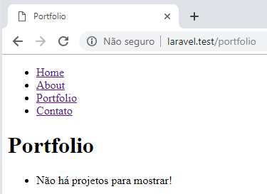

routes/web.php

// $portfolio = [
// ["title" => "Projeto #1"],
// ["title" => "Projeto #2"],
// ["title" => "Projeto #3"],
// ["title" => "Projeto #4"]
// ];

Route::view('/', 'home')->name('home');
Route::view('/about', 'about')->name('about');
Route::view('/portfolio', 'portfolio', compact('portfolio'))->name('portfolio');
Route::view('/contato', 'contato')->name('contato');

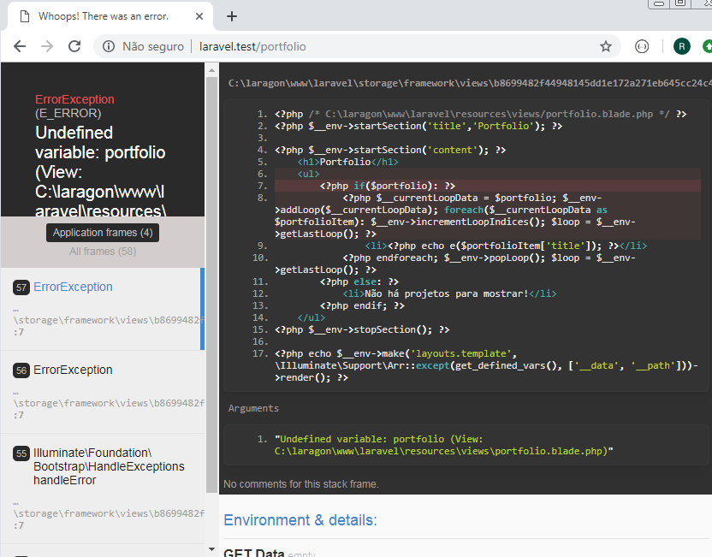

Diretiva @isset

routes/web.php

$portfolio = [
// ["title" => "Projeto #1"],
// ["title" => "Projeto #2"],
// ["title" => "Projeto #3"],
// ["title" => "Projeto #4"]
];

Route::view('/', 'home')->name('home');
Route::view('/about', 'about')->name('about');
Route::view('/portfolio', 'portfolio', compact('portfolio'))->name('portfolio');
Route::view('/contato', 'contato')->name('contato');

resources/views/portfolio.blade.php

@extends('layouts.template')

@section('title','Portfolio')

@section('content')
<h1>Portfolio</h1>
<ul>
@isset($portfolio)
@foreach($portfolio as $portfolioItem)
<li>{{ $portfolioItem['title'] }}</li>
@endforeach
@else
<li>Não há projetos para mostrar!</li>
@endisset
</ul>
@endsection

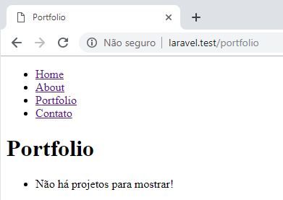

Diretiva @forelse

resources/views/portfolio.blade.php

@extends('layouts.template')

@section('title','Portfolio')

@section('content')
<h1>Portfolio</h1>
<ul>
@forelse($portfolio as $portfolioItem)
<li>{{ $portfolioItem['title'] }}</li>
@empty
<li>Não há projetos para mostrar!</li>
@endforelse
</ul>
@endsection

routes/web.php

$portfolio = [
["title" => "Projeto #1"],
["title" => "Projeto #2"],
// ["title" => "Projeto #3"],
// ["title" => "Projeto #4"]
];

Route::view('/', 'home')->name('home');
Route::view('/about', 'about')->name('about');
Route::view('/portfolio', 'portfolio', compact('portfolio'))->name('portfolio');
Route::view('/contato', 'contato')->name('contato');

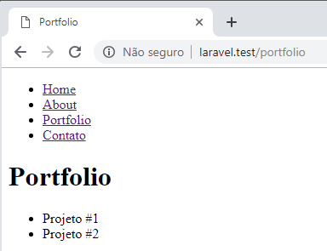

resources/views/portfolio.blade.php

@extends('layouts.template')

@section('title','Portfolio')

@section('content')
<h1>Portfolio</h1>
<ul>
@forelse($portfolio as $portfolioItem)
<li>{{ $portfolioItem['title'] }} <pre>{{var_dump($loop)}}</pre></li>
@empty
<li>Não há projetos para mostrar!</li>
@endforelse
</ul>
@endsection

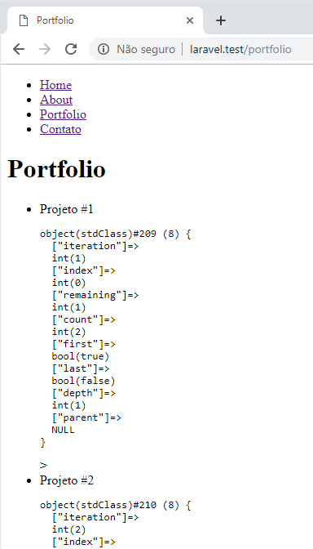

routes/web.php

$portfolio = [
["title" => "Projeto #1"],
["title" => "Projeto #2"],
["title" => "Projeto #3"],
["title" => "Projeto #4"]
];

Route::view('/', 'home')->name('home');
Route::view('/about', 'about')->name('about');
Route::view('/portfolio', 'portfolio', compact('portfolio'))->name('portfolio');
Route::view('/contato', 'contato')->name('contato');

resources/views/portfolio.blade.php

@extends('layouts.template')

@section('title','Portfolio')

@section('content')
<h1>Portfolio</h1>
<ul>
@forelse($portfolio as $portfolioItem)
<li>{{ $portfolioItem['title'] }} <small>{{ $loop->last ? 'Último loop' : ''}}</small></li>
@empty
<li>Não há projetos para mostrar!</li>
@endforelse
</ul>
@endsection

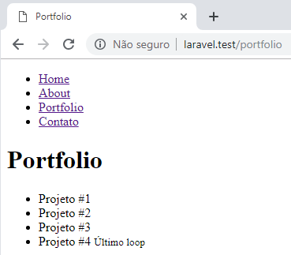

resources/views/portfolio.blade.php

@extends('layouts.template')

@section('title','Portfolio')

@section('content')
<h1>Portfolio</h1>
<ul>
@forelse($portfolio as $portfolioItem)
<li>{{ $portfolioItem['title'] }} <small>{{ $loop->first ? 'Primeiro loop' : ''}}</small></li>
@empty
<li>Não há projetos para mostrar!</li>
@endforelse
</ul>
@endsection

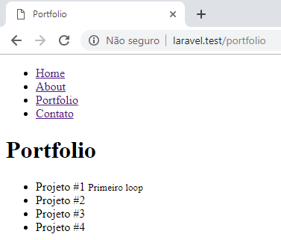

Aula 9 - Controllers

Listando as rotas existentes

php artisan route:list

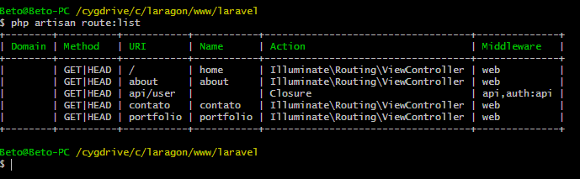

Comentando a rota em api.php

routes/api.php

// Route::middleware('auth:api')->get('/user', function (Request $request) {
// return $request->user();
// });

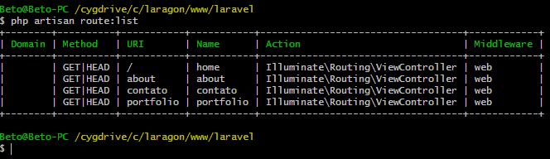

Controller - Opções

php artisan make:controller PortfolioController -h

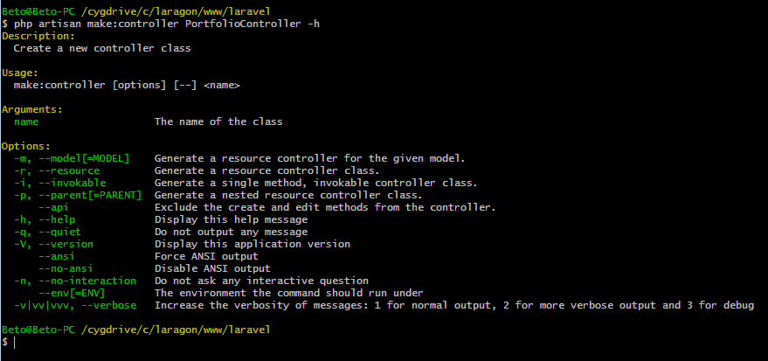

Criando um controller sem opções

php artisan make:controller PortfolioController

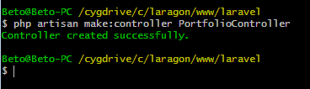

app/Http/Controllers/PortfolioController.php

<?php

namespace App\Http\Controllers;
use Illuminate\Http\Request;

class PortfolioController extends Controller
{
//
}

app/Http/Controllers/Controller.php

<?php

namespace App\Http\Controllers;

use Illuminate\Foundation\Bus\DispatchesJobs;
use Illuminate\Routing\Controller as BaseController;
use Illuminate\Foundation\Validation\ValidatesRequests;
use Illuminate\Foundation\Auth\Access\AuthorizesRequests;

class Controller extends BaseController
{
use AuthorizesRequests, DispatchesJobs, ValidatesRequests;
}

Criando um controller com método invoke

Elimine o controller PortfolioController e o recrie com a opção i:

php artisan make:controller PortfolioController -i

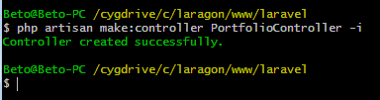

routes/web.php

Route::view('/', 'home')->name('home');
Route::view('/about', 'about')->name('about');
Route::get('/portfolio','PortfolioController')->name('portfolio');
Route::view('/contato', 'contato')->name('contato');

app/Http/Controllers/PortfolioController.php

<?php

namespace App\Http\Controllers;

use Illuminate\Http\Request;

class PortfolioController extends Controller
{
public function __invoke(Request $request)
{
$portfolio = [
["title" => "Projeto #1"],
["title" => "Projeto #2"],
["title" => "Projeto #3"],
["title" => "Projeto #4"]
];

return view('portfolio', compact('portfolio'));
}
}

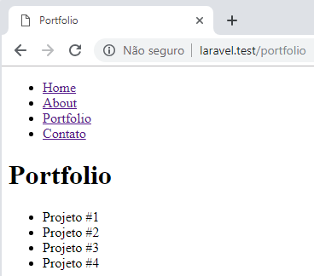

Listando as rotas

php artisan route:list

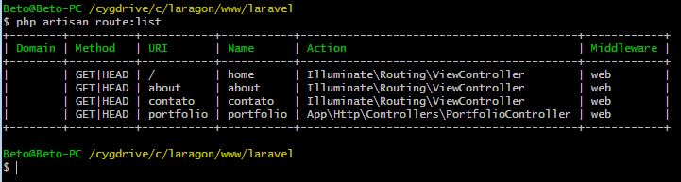

Aula 10 - Controllers resources & API

Controllers do tipo resource

- Elimine o controller PortfolioController.

- Comente a rota criada anteriormente para ele.

- Recrie o controller PortfolioController com o comando:

php artisan make:controller PortfolioController -r

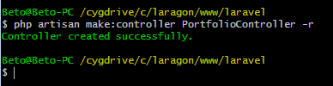

Neste controlador são criados sete métodos:

- index
- create
- store
- show
- edit
- update
- destroy

- index: lista os projetos;
- create: usado para criar um novo projeto para portfolio;
- store: usado para guardar recursos (projetos) que foram enviados previamente pelo método create na base de dados;
- show: exibe um recurso (projeto) específico encontrado por seu identificador;
- edit: exibe um formulário para editar um recurso (projeto) já existente (um projeto previamente criado).
- update: guarda as alterações feitas no formulário de edição (alterações nos projetos);
- destroy: elimina o recurso (um projeto) pelo seu identificador.

app/Http/Controllers/PortfolioController.php

<?php

namespace App\Http\Controllers;

use Illuminate\Http\Request;

class PortfolioController extends Controller
{
public function index()
{
$portfolio = [
["title" => "Projeto #1"],
["title" => "Projeto #2"],
["title" => "Projeto #3"],
["title" => "Projeto #4"]
];
return view('portfolio', compact('portfolio'));
}
public function create()
{
//
}
public function store(Request $request)
{
//
}
public function show($id)
{
//
}

public function edit($id)
{
//
}
public function update(Request $request, $id)
{
//
}
public function destroy($id)
{
//
}
}

routes/web.php

Route::resource('projetos','PortfolioController');

Listando as rotas

php artisan route:list

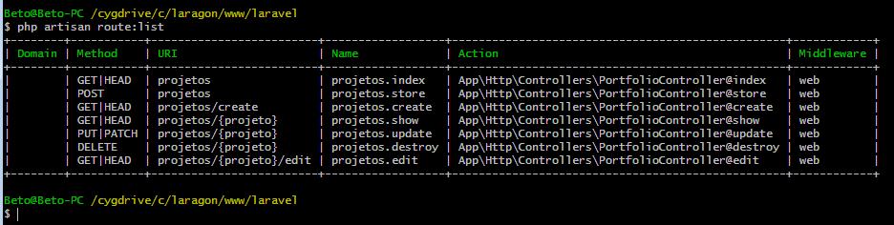

Roteando apenas alguns métodos

routes/web.php

Route::resource('projetos','PortfolioController')->only(['index', 'show']);

php artisan route:list

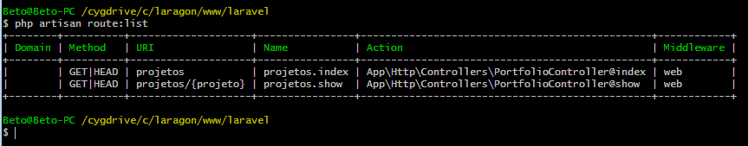

Route::resource('projetos','PortfolioController')->except(['index', 'show']);

Listando as rotas

php artisan route:list

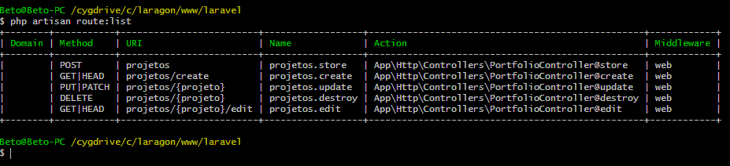

Criando controller do tipo API

php artisan make:controller PortfolioController --api

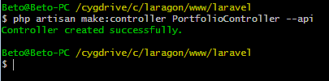

São criados cinco métodos:

- index
- store
- show
- update
- destroy

Obs.: Os métodos create e edit não são criados porque não são utilizados em API.

app/Http/Controllers/PortfolioController.php

<?php

namespace App\Http\Controllers;

use Illuminate\Http\Request;

class PortfolioController extends Controller
{
public function index()
{
//
}
public function store(Request $request)
{
//
}
public function show($id)
{
//
}

public function update(Request $request, $id)
{
//
}
public function destroy($id)
{
//
}
}

routes/web.php

Route::apiResource('projetos','PortfolioController');

Listando as rotas

php artisan route:list

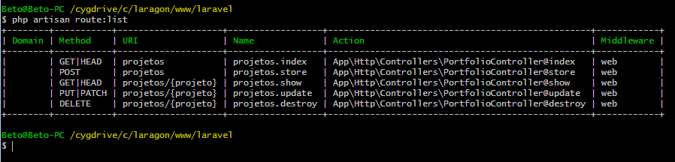

Alterando o nome de métodos padrões

app/Providers/AppServiceProvider.php

<?php

namespace App\Providers;

use Illuminate\Support\Facades\Route;
use Illuminate\Support\ServiceProvider;

class AppServiceProvider extends ServiceProvider
{
public function register()
{
//
}
public function boot()
{
Route::resourceVerbs([
'create' => 'criar',
'edit' => 'editar'
]);
}
}

routes/web.php

Route::resource('projetos','PortfolioController');

Listando as rotas

php artisan route:list

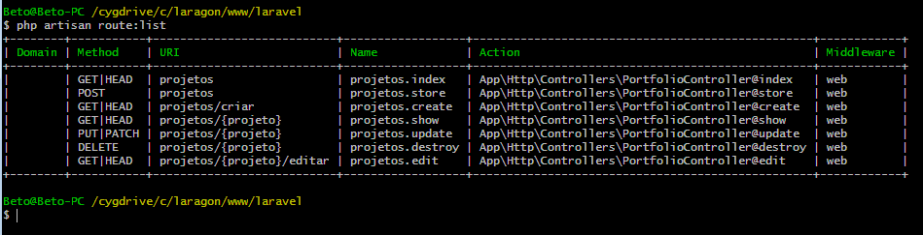

app/Http/Controllers/PortfolioController.php

<?php

namespace App\Http\Controllers;

use Illuminate\Http\Request;

class PortfolioController extends Controller
{
public function index()
{
$portfolio = [
["title" => "Projeto #1"],
["title" => "Projeto #2"],
["title" => "Projeto #3"],
["title" => "Projeto #4"]
];
return view('portfolio', compact('portfolio'));
}
public function store(Request $request)
{
//
}
public function show($id)
{
//
}
public function update(Request $request, $id)
{
//
}
public function destroy($id)
{
//
}
public function criar(){

}
public function editar(){

}

}

routes/web.php

Route::view('/', 'home')->name('home');
Route::view('/about', 'about')->name('about');
Route::get('/portfolio','PortfolioController@index')->name('portfolio');
Route::view('/contato', 'contato')->name('contato');

app/Http/Controllers/PortfolioController.php

<?php

namespace App\Http\Controllers;

use Illuminate\Http\Request;

class PortfolioController extends Controller
{
public function index()
{
$portfolio = [
["title" => "Projeto #1"],
["title" => "Projeto #2"],
["title" => "Projeto #3"],
["title" => "Projeto #4"]
];
return view('portfolio', compact('portfolio'));
}
}

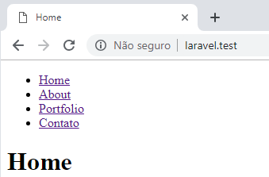

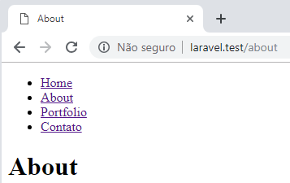

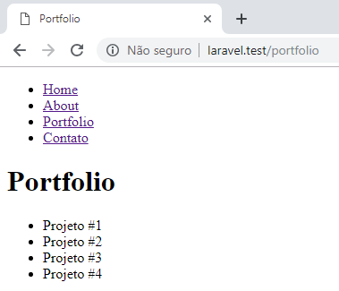

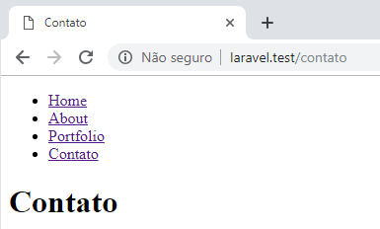

Aula 11 - Ativação de links de navegação

resources/views/layouts/template.blade.php

<!DOCTYPE html>
<html lang="pt-br">
<head>
<meta charset="UTF-8">
<title>@yield('title', 'Aprendible')</title>
<style>
.active a{
color: red;
text-decoration: none;
}
</style>
</head>
<body>
<nav>
<ul>
<li class={{request()->routeIs('home') ? 'active' : ''}}>
<a href="/">Home</a></li>
<li class={{request()->routeIs('about') ? 'active' : ''}}>
<a href="/about">About</a></li>
<li class={{request()->routeIs('portfolio') ? 'active' : ''}}>
<a href="/portfolio">Portfolio</a></li>
<li class={{request()->routeIs('contato') ? 'active' : ''}}>
<a href="/contato">Contato</a></li>
</ul>
</nav>

@yield('content')

</body>
</html>

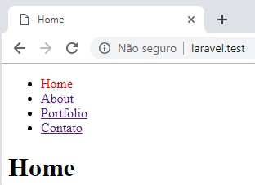

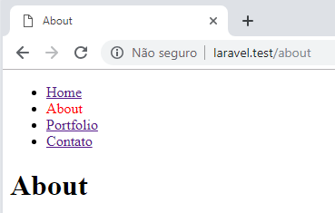

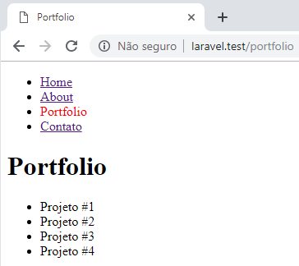

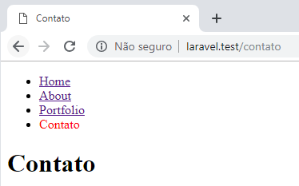

Criando uma função reutilizável

app/helpers.php

<?php

function setActive($routeName)
{
return request()->routeIs($routeName) ? 'active' : '';
}

resources/views/layouts/template.blade.php

<!DOCTYPE html>
<html lang="pt-br">
<head>
<meta charset="UTF-8">
<title>@yield('title', 'Aprendible')</title>
<style>
.active a{
color: red;
text-decoration: none;
}
</style>
</head>
<body>
<nav>
<ul>
<li class={{ setActive('home') }}><a href="/">Home</a></li>
<li class={{ setActive('abour') }}><a href="/about">About</a></li>
<li class={{ setActive('portfolio') }}><a href="/portfolio">Portfolio</a></li>
<li class={{ setActive('contato') }}><a href="/contato">Contato</a></li>
</ul>
</nav>

@yield('content')

</body>
</html>

composer.json

"autoload": {
"psr-4": {
"App\\": "app/"
},
"classmap": [
"database/seeds",
"database/factories"
],
"files": [
"app/helpers.php"
]
}

Atualizando o arquivo de dependências

composer dump-autoload

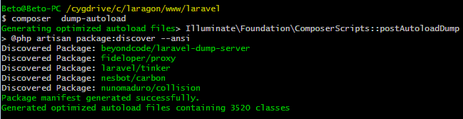

resources/views/partials/nav.blade.php

<nav>
<ul>
<li class={{ setActive('home') }}><a href="/">Home</a></li>
<li class={{ setActive('about') }}><a href="/about">About</a></li>
<li class={{ setActive('portfolio') }}><a href="/portfolio">Portfolio</a></li>
<li class={{ setActive('contato') }}><a href="/contato">Contato</a></li>
</ul>
</nav>

resources/views/layouts/template.blade.php

<!DOCTYPE html>
<html lang="pt-br">
<head>
<meta charset="UTF-8">
<title>@yield('title', 'Aprendible')</title>
<style>
.active a{
color: red;
text-decoration: none;
}
</style>
</head>
<body>
@include('partials.nav')
@yield('content')
</body>
</html>

Aula 12 - Como enviar formulários

Criando o controller

php artisan make:controller MessagesController

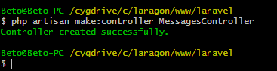

routes/web.php

Route::post('/contato','MessagesController@store');

Formulário de contato

resources/views/contato.blade.php

@extends('layouts.template')

@section('title', 'Contato')

@section('content')

<form method="POST" action="{{ route('contato') }}">
@csrf
<input type="text" name="nome" placeholder="Nome" value="Roberto"><br>
<input type="email" name="email" placeholder="Email" value="betopinheiro1005@yahoo.com.br"><br>
<input type="text" name="subject" placeholder="Assunto" value="Teste de envio"><br>
<textarea name="message" id="message" cols="30" rows="10" placeholder="Mensagem" value="Mensagem a ser enviada"></textarea><br>
<button type="submit">Enviar</button>
</form>

@endsection

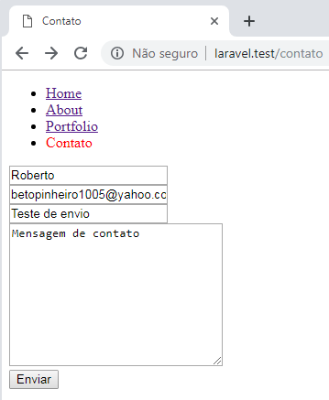

Retornando todos os dados do formulário

app/http/Controllers/MessagesController.php

<?php

namespace App\Http\Controllers;

use Illuminate\Http\Request;

class MessagesController extends Controller
{
public function store(Request $request){
// return 'Processar o formulário';
return $request;
}
}

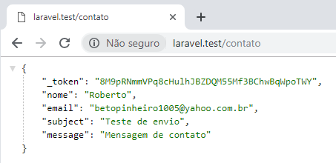

Retornando dados parciais do formulário

app/http/Controllers/MessagesController.php

<?php

namespace App\Http\Controllers;

use Illuminate\Http\Request;

class MessagesController extends Controller
{
public function store(Request $request){
return $request->get('nome'); }
}

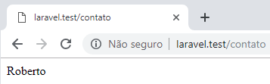

app/http/Controllers/MessagesController.php

<?php

namespace App\Http\Controllers;

class MessagesController extends Controller
{
public function store(){
return request('email');
}
}

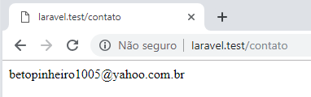

Aula 13 - Como validar formulários

Exibindo a lista de todos os erros de validação

app/http/Controllers/MessagesController.php

<?php

namespace App\Http\Controllers;

class MessagesController extends Controller
{
public function store(){

request()->validate([
'nome' => 'required',
'email' => 'required'
]);

return 'Dados validados!';
}
}

resources/views/contato.blade.php

@extends('layouts.template')

@section('title', 'Contato')

@section('content')

@if($errors->any())
<ul>
@foreach($errors->all() as $error)
<li>{{ $error }}</li>
@endforeach
</ul>
@endif

<form method="POST" action="{{ route('contato') }}">
@csrf
<input type="text" name="nome" placeholder="Nome" value=""><br>
<input type="email" name="email" placeholder="Email" value=""><br>
<input type="text" name="subject" placeholder="Assunto" value="Teste de envio"><br>
<textarea name="message" id="message" cols="30" rows="10" placeholder="Mensagem">Mensagem de contato</textarea><br>
<button type="submit">Enviar</button>
</form>

@endsection

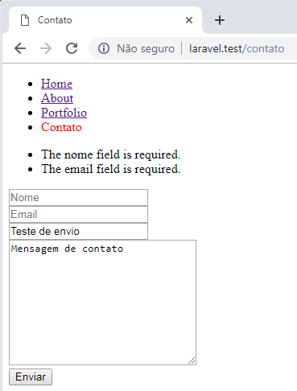

Exibindo os erros abaixo de cada campo

app/http/Controllers/MessagesController.php

<?php

namespace App\Http\Controllers;

class MessagesController extends Controller
{
public function store(){

request()->validate([
'nome' => 'required',
'email' => 'required|email',
'subject' => 'required',
'content' => 'required|min:3'
]);

return 'Dados validados!';
}
}

resources/views/contato.blade.php

@extends('layouts.template')

@section('title', 'Contato')

@section('content')

<form method="POST" action="{{ route('contato') }}">
@csrf
<input type="text" name="nome" placeholder="Nome" value="{{ old('nome') }}"><br>
{!! $errors->first('nome', '<small>:message</small><br>') !!}
<input type="text" name="email" placeholder="Email" value="{{ old('email') }}"><br>
{!! $errors->first('email', '<small>:message</small><br>') !!}
<input type="text" name="subject" placeholder="Assunto" value="{{ old('subject') }}"><br>
{!! $errors->first('subject', '<small>:message</small><br>') !!}
<textarea name="content" cols="30" rows="10" placeholder="Mensagem">{{ old('content') }}</textarea><br>
{!! $errors->first('content', '<small>:message</small><br>') !!}
<button type="submit">Enviar</button>
</form>

@endsection

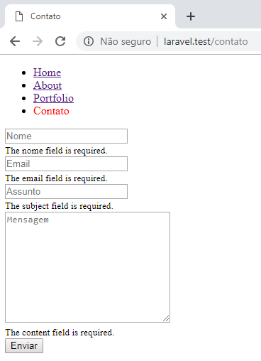

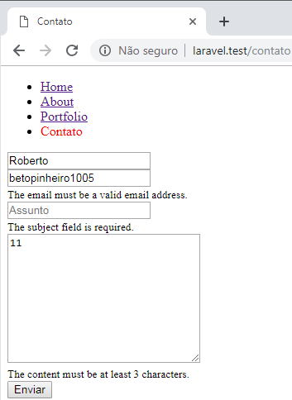

Aula 14 - Como traduzir suas aplicações

Traduzindo mensagens de validação

config/app.php

'locale' => 'pt-BR',

'fallback_locale' => 'en',

resources/lang/pt-BR/validation.php

<?php
return [
/*
|--------------------------------------------------------------------------
| Validation Language Lines
|--------------------------------------------------------------------------
|
| The following language lines contain the default error messages used by
| the validator class. Some of these rules have multiple versions such
| as the size rules. Feel free to tweak each of these messages.
|
*/
'accepted' => 'O campo :attribute deve ser aceito.',
'active_url' => 'O campo :attribute deve conter uma URL válida.',
'after' => 'O campo :attribute deve conter uma data posterior a :date.',
'after_or_equal' => 'O campo :attribute deve conter uma data superior ou igual a :date.',
'alpha' => 'O campo :attribute deve conter apenas letras.',
'alpha_dash' => 'O campo :attribute deve conter apenas letras, números e traços.',
'alpha_num' => 'O campo :attribute deve conter apenas letras e números .',
'array' => 'O campo :attribute deve conter um array.',
'before' => 'O campo :attribute deve conter uma data anterior a :date.',
'before_or_equal' => 'O campo :attribute deve conter uma data inferior ou igual a :date.',
'between' => [
'numeric' => 'O campo :attribute deve conter um número entre :min e :max.',
'file' => 'O campo :attribute deve conter um arquivo de :min a :max kilobytes.',
'string' => 'O campo :attribute deve conter entre :min a :max caracteres.',
'array' => 'O campo :attribute deve conter de :min a :max itens.',
],
'boolean' => 'O campo :attribute deve conter o valor verdadeiro ou falso.',
'confirmed' => 'A confirmação para o campo :attribute não coincide.',
'date' => 'O campo :attribute não contém uma data válida.',
'date_equals' => 'O campo :attribute deve ser uma data igual a :date.',
'date_format' => 'A data informada para o campo :attribute não respeita o formato :format.',
'different' => 'Os campos :attribute e :other devem conter valores diferentes.',
'digits' => 'O campo :attribute deve conter :digits dígitos.',
'digits_between' => 'O campo :attribute deve conter entre :min a :max dígitos.',
'dimensions' => 'O valor informado para o campo :attribute não é uma dimensão de imagem válida.',
'distinct' => 'O campo :attribute contém um valor duplicado.',
'email' => 'O campo :attribute não contém um endereço de email válido.',
'exists' => 'O valor selecionado para o campo :attribute é inválido.',
'file' => 'O campo :attribute deve conter um arquivo.',
'filled' => 'O campo :attribute é obrigatório.',
'gt' => [
'numeric' => 'O campo :attribute deve ser maior que :value.',
'file' => 'O arquivo :attribute deve ser maior que :value kilobytes.',
'string' => 'O campo :attribute deve ser maior que :value caracteres.',
'array' => 'O campo :attribute deve ter mais que :value itens.',
],
'gte' => [
'numeric' => 'O campo :attribute deve ser maior ou igual a :value.',
'file' => 'O arquivo :attribute deve ser maior ou igual a :value kilobytes.',
'string' => 'O campo :attribute deve ser maior ou igual a :value caracteres.',
'array' => 'O campo :attribute deve ter :value itens ou mais.',
],
'image' => 'O campo :attribute deve conter uma imagem.',
'in' => 'O campo :attribute não contém um valor válido.',
'in_array' => 'O campo :attribute não existe em :other.',
'integer' => 'O campo :attribute deve conter um número inteiro.',
'ip' => 'O campo :attribute deve conter um IP válido.',
'ipv4' => 'O campo :attribute deve conter um IPv4 válido.',
'ipv6' => 'O campo :attribute deve conter um IPv6 válido.',
'json' => 'O campo :attribute deve conter uma string JSON válida.',
'lt' => [
'numeric' => 'O campo :attribute deve ser menor que :value.',
'file' => 'O arquivo :attribute ser menor que :value kilobytes.',
'string' => 'O campo :attribute deve ser menor que :value caracteres.',
'array' => 'O campo :attribute deve ter menos que :value itens.',
],
'lte' => [
'numeric' => 'O campo :attribute deve ser menor ou igual a :value.',
'file' => 'O arquivo :attribute ser menor ou igual a :value kilobytes.',
'string' => 'O campo :attribute deve ser menor ou igual a :value caracteres.',
'array' => 'O campo :attribute não deve ter mais que :value itens.',
],
'max' => [
'numeric' => 'O campo :attribute não pode conter um valor superior a :max.',
'file' => 'O campo :attribute não pode conter um arquivo com mais de :max kilobytes.',
'string' => 'O campo :attribute não pode conter mais de :max caracteres.',
'array' => 'O campo :attribute deve conter no máximo :max itens.',
],
'mimes' => 'O campo :attribute deve conter um arquivo do tipo: :values.',
'mimetypes' => 'O campo :attribute deve conter um arquivo do tipo: :values.',
'min' => [
'numeric' => 'O campo :attribute deve conter um número superior ou igual a :min.',
'file' => 'O campo :attribute deve conter um arquivo com no mínimo :min kilobytes.',
'string' => 'O campo :attribute deve conter no mínimo :min caracteres.',
'array' => 'O campo :attribute deve conter no mínimo :min itens.',
],
'not_in' => 'O campo :attribute contém um valor inválido.',
'not_regex' => 'O formato do valor :attribute é inválido.',
'numeric' => 'O campo :attribute deve conter um valor numérico.',
'present' => 'O campo :attribute deve estar presente.',
'regex' => 'O formato do valor informado no campo :attribute é inválido.',
'required' => 'O campo :attribute é obrigatório.',
'required_if' => 'O campo :attribute é obrigatório quando o valor do campo :other é igual a :value.',
'required_unless' => 'O campo :attribute é obrigatório a menos que :other esteja presente em :values.',
'required_with' => 'O campo :attribute é obrigatório quando :values está presente.',
'required_with_all' => 'O campo :attribute é obrigatório quando um dos :values está presente.',
'required_without' => 'O campo :attribute é obrigatório quando :values não está presente.',
'required_without_all' => 'O campo :attribute é obrigatório quando nenhum dos :values está presente.',
'same' => 'Os campos :attribute e :other devem conter valores iguais.',
'size' => [
'numeric' => 'O campo :attribute deve conter o número :size.',
'file' => 'O campo :attribute deve conter um arquivo com o tamanho de :size kilobytes.',
'string' => 'O campo :attribute deve conter :size caracteres.',
'array' => 'O campo :attribute deve conter :size itens.',
],
'starts_with' => 'O campo :attribute deve começar com um dos seguintes valores: :values',
'string' => 'O campo :attribute deve ser uma string.',
'timezone' => 'O campo :attribute deve conter um fuso horário válido.',
'unique' => 'O valor informado para o campo :attribute já está em uso.',
'uploaded' => 'Falha no Upload do arquivo :attribute.',
'url' => 'O formato da URL informada para o campo :attribute é inválido.',
'uuid' => 'O campo :attribute deve ser um UUID válido.',
/*
|--------------------------------------------------------------------------
| Custom Validation Language Lines
|--------------------------------------------------------------------------
|
| Here you may specify custom validation messages for attributes using the
| convention "attribute.rule" to name the lines. This makes it quick to
| specify a specific custom language line for a given attribute rule.
|
*/
'custom' => [
'attribute-name' => [
'rule-name' => 'custom-message',
],
],
/*
|--------------------------------------------------------------------------
| Custom Validation Attributes
|--------------------------------------------------------------------------
|
| The following language lines are used to swap attribute place-holders
| with something more reader friendly such as E-Mail Address instead
| of "email". This simply helps us make messages a little cleaner.
|
*/
'attributes' => [
'address' => 'endereço',
'age' => 'idade',
'body' => 'conteúdo',
'city' => 'cidade',
'country' => 'país',
'date' => 'data',
'day' => 'dia',
'description' => 'descrição',
'excerpt' => 'resumo',
'first_name' => 'primeiro nome',
'gender' => 'gênero',
'hour' => 'hora',
'last_name' => 'sobrenome',
'message' => 'mensagem',
'minute' => 'minuto',
'mobile' => 'celular',
'month' => 'mês',
'name' => 'nome',
'password_confirmation' => 'confirmação da senha',
'password' => 'senha',
'phone' => 'telefone',
'second' => 'segundo',
'sex' => 'sexo',
'state' => 'estado',
'subject' => 'assunto',
'text' => 'texto',
'time' => 'hora',
'title' => 'título',
'username' => 'usuário',
'year' => 'ano',
'email' => 'e-mail',
'remember' => 'lembrar-se de mim',
],
];

resources/lang/pt-BR/auth.php

<?php
return [
/*
|--------------------------------------------------------------------------
| Authentication Language Lines
|--------------------------------------------------------------------------
|
| The following language lines are used during authentication for various
| messages that we need to display to the user. You are free to modify
| these language lines according to your application's requirements.
|
*/
'failed' => 'Credenciais informadas não correspondem com nossos registros.',
'throttle' => 'Você realizou muitas tentativas de login. Por favor, tente novamente em :seconds segundos.',
];

resources/lang/pt-BR/pagination.php

<?php
return [
/*
|--------------------------------------------------------------------------
| Pagination Language Lines
|--------------------------------------------------------------------------
|
| The following language lines are used by the paginator library to build
| the simple pagination links. You are free to change them to anything
| you want to customize your views to better match your application.
|
*/
'previous' => '&laquo; Anterior',
'next' => 'Próxima &raquo;',
];

resources/lang/pt-BR/passwords.php

<?php
return [
/*
|--------------------------------------------------------------------------
| Password Reminder Language Lines
|--------------------------------------------------------------------------
|
| The following language lines are the default lines which match reasons
| that are given by the password broker for a password update attempt
| has failed, such as for an invalid token or invalid new password.
|
*/
'password' => 'A senha deve conter pelo menos seis caracteres e ser igual à confirmação.',
'reset' => 'Sua senha foi redefinida!',
'sent' => 'Enviamos um link para redefinir a sua senha por e-mail.',
'token' => 'Esse código de redefinição de senha é inválido.',
'user' => 'Não conseguimos encontrar nenhum usuário com o endereço de e-mail informado.',
];

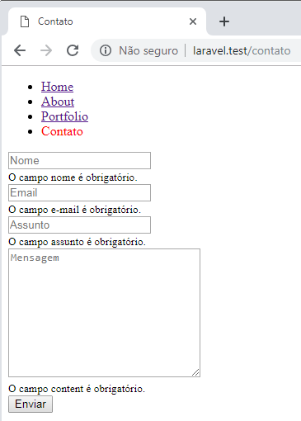

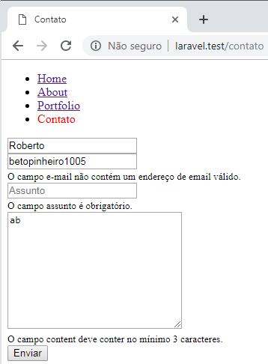

resources/lang/pt-BR/pt-BR.json

{
"A fresh verification link has been sent to your email address.": "Um novo link de verificação foi enviado para seu endereço de e-mail.",
"All rights reserved.": "Todos os direitos reservados.",
"Before proceeding, please check your email for a verification link.": "Antes de prosseguir, verifique seu e-mail em busca de um link de verificação.",
"click here to request another": "clique aqui para solicitar outro",
"Confirm Password": "Confirmar senha",
"E-Mail Address": "Endereço de e-mail",
"Error": "Erro",
"Forbidden": "Proibido",
"Forgot Your Password?": "Esqueceu a senha?",''
"Go Home": "Ir para o início",
"Hello!": "Olá!",
"hi": "oi",
"If you did not create an account, no further action is required.": "Se você não criou uma conta, ignore este e-mail.",
"If you did not receive the email": "Se você não recebeu o e-mail",
"If you did not request a password reset, no further action is required.": "Se você não solicitou essa redefinição de senha, ignore este e-mail.",
"If you’re having trouble clicking the \":actionText\" button, copy and paste the URL below\ninto your web browser: [:actionURL](:actionURL)": "Se você estiver com problemas para clicar no botão \":actionText\", copie e cole o URL abaixo\nem seu navegador da web: [:actionURL](:actionURL)",
"Login": "Entrar",
"Logout": "Sair",
"Name": "Nome",
"Oh no": "Ah não",
"Page Expired": "Página expirou",
"Page Not Found": "Página não encontrada",
"Password": "Senha",
"Please click the button below to verify your email address.": "Por favor, clique no botão abaixo para verificar seu endereço de e-mail.",
"Regards": "Atenciosamente",
"Register": "Registrar",
"Remember Me": "Lembre-se de mim",
"Reset Password": "Redefinir senha",
"Reset Password Notification": "Notificação de redefinição de senha",
"Send Password Reset Link": "Link de redefinição de senha enviado",
"Service Unavailable": "Serviço indisponível",
"Sorry, the page you are looking for could not be found.": "Desculpe, a página que você está procurando não foi encontrada.",
"Sorry, you are forbidden from accessing this page.": "Desculpe, você está proibido de acessar esta página.",
"Sorry, you are making too many requests to our servers.": "Desculpe, você está fazendo muitas solicitações para nossos servidores.",
"Sorry, you are not authorized to access this page.": "Desculpe, você não está autorizado a acessar esta página.",
"Sorry, your session has expired. Please refresh and try again.": "Desculpe, sua sessão expirou. Por favor, atualize e tente novamente.",
"Sorry, we are doing some maintenance. Please check back soon.": "Desculpe, estamos fazendo algumas manutenções. Por favor, volte em breve.",
"This password reset link will expire in :count minutes." : "O Link de redefinição de senha irá expirar em :count minutos.",
"Toggle navigation": "Alternar navegação",
"Too Many Requests": "Muitas solicitações",
"Unauthorized": "Não autorizado",
"Verify Email Address": "Verifique o endereço de e-mail",
"Verify Your Email Address": "Verifique seu endereço de e-mail",
"You are receiving this email because we received a password reset request for your account.": "Você recebeu esse e-mail porque foi solicitado uma redefinição de senha na sua conta.",
"Whoops!": "Ops!",
"Whoops, something went wrong on our servers.": "Ops, algo deu errado em nossos servidores."
}

Obs: Esses arquivos podem ser baixados em:

https://github.com/caouecs/Laravel-lang/tree/master/src
https://github.com/caouecs/Laravel-lang/tree/master/json

Aula 15 - Como enviar emails

Criando um mailable

php artisan make:mail MessageReceived

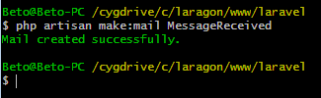

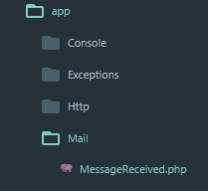

app/Mail/MessageReceived.php

<?php

namespace App\Mail;

use Illuminate\Bus\Queueable;
use Illuminate\Mail\Mailable;
use Illuminate\Queue\SerializesModels;
use Illuminate\Contracts\Queue\ShouldQueue;

class MessageReceived extends Mailable
{
use Queueable, SerializesModels;

public function __construct()
{
//
}
public function build()
{
return $this->view('emails.message-received');
}
}

resources/views/emails/message-received.blade.php

Conteúdo do email

app/Http/Controller/MessagesController.php

<?php

namespace App\Http\Controllers;

use App\Mail\MessageReceived;
use Illuminate\Support\Facades\Mail;

class MessagesController extends Controller
{
public function store(){

request()->validate([
'nome' => 'required',
'email' => 'required|email',
'subject' => 'required',
'content' => 'required|min:3'
]);

/* Enviar email */
Mail::to('betopinheiro1005@yahoo.com.br')->send(new MessageReceived);

// return 'Dados validados!';
return 'Mensagem enviada!';
}
}

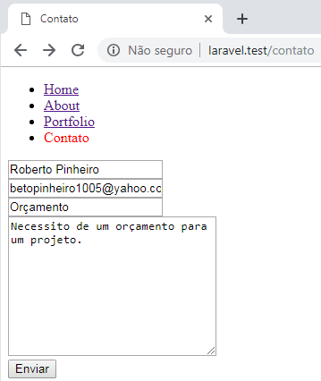

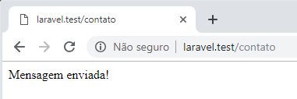

storage/logs/laravel-2019-03-12.log

[2019-03-12 02:13:04] local.DEBUG: Message-ID: <66e3a116829bf8018f3afb00935e5f31@laravel.test>
Date: Tue, 12 Mar 2019 02:13:04 +0000
Subject: Message Received
From: Example <hello@example.com>
To: betopinheiro1005@yahoo.com.br
MIME-Version: 1.0
Content-Type: text/html; charset=utf-8
Content-Transfer-Encoding: quoted-printable

Conteúdo do email

Enviando mensagem em HTML

resources/views/emails/message-received.blade.php

<!DOCTYPE html>
<html lang="pt-br">
<head>
<meta charset="UTF-8">
<title>Message Received</title>
</head>
<body>
<p>Conteúdo do email</p>
</body>
</html>

storage/logs/laravel-2019-03-12.log

[2019-03-12 02:20:50] local.DEBUG: Message-ID: <1e70e7a3a71338bd0ef94241a4f02ad7@laravel.test>
Date: Tue, 12 Mar 2019 02:20:50 +0000
Subject: Message Received
From: Example <hello@example.com>
To: betopinheiro1005@yahoo.com.br
MIME-Version: 1.0
Content-Type: text/html; charset=utf-8
Content-Transfer-Encoding: quoted-printable

<!DOCTYPE html>
<html lang="pt-br">
<head>
<meta charset="UTF-8">
<title>Message Received</title>
</head>
<body>
<p>Conteúdo do email</p>
</body>
</html>

Alterando o endereço de email do remetente

config/mail.php

'from' => [
'address' => env('MAIL_FROM_ADDRESS', 'contato@oriontecinfo.com.br'),
'name' => env('MAIL_FROM_NAME', 'Roberto Pinheiro'),
],

ou:

.env

MAIL_DRIVER=log
MAIL_HOST=smtp.mailtrap.io
MAIL_PORT=2525
MAIL_USERNAME=null
MAIL_PASSWORD=null
MAIL_ENCRYPTION=null
MAIL_FROM_ADDRESS='contato@oriontecinfo.com.br'
MAIL_FROM_NAME='Roberto Pinheiro'

storage/logs/laravel-2019-03-12.log

[2019-03-12 02:27:58] local.DEBUG: Message-ID: <a2007c36b68bf029af07eb27f27712a7@laravel.test>
Date: Tue, 12 Mar 2019 02:27:58 +0000
Subject: Message Received
From: Roberto Pinheiro <contato@oriontecinfo.com.br>
To: betopinheiro1005@yahoo.com.br
MIME-Version: 1.0
Content-Type: text/html; charset=utf-8
Content-Transfer-Encoding: quoted-printable

<!DOCTYPE html>
<html lang="pt-br">
<head>
<meta charset="UTF-8">
<title>Message Received</title>
</head>
<body>
<p>Conteúdo do email</p>
</body>
</html>

Alterando o assunto

app/Mail/MessageReceived.php

<?php

namespace App\Mail;

use Illuminate\Bus\Queueable;
use Illuminate\Mail\Mailable;
use Illuminate\Queue\SerializesModels;
use Illuminate\Contracts\Queue\ShouldQueue;

class MessageReceived extends Mailable
{
use Queueable, SerializesModels;

public $subject = 'Mensagem recebida';

public function __construct()
{
//
}

public function build()
{
return $this->view('emails.message-received');
}
}

storage/logs/laravel-2019-03-12.log

[2019-03-12 02:42:15] local.DEBUG: Message-ID: <dc78987d537e79811075cf52d10389b1@laravel.test>
Date: Tue, 12 Mar 2019 02:42:15 +0000
Subject: Mensagem recebida
From: Roberto Pinheiro <contato@oriontecinfo.com.br>
To: betopinheiro1005@yahoo.com.br
MIME-Version: 1.0
Content-Type: text/html; charset=utf-8
Content-Transfer-Encoding: quoted-printable

<!DOCTYPE html>
<html lang="pt-br">
<head>
<meta charset="UTF-8">
<title>Message Received</title>
</head>
<body>
<p>Conteúdo do email</p>
</body>
</html>

Obtendo as informações do formulário de contato

app/Mail/MessageReceived.php

<?php

namespace App\Mail;

use Illuminate\Bus\Queueable;
use Illuminate\Mail\Mailable;
use Illuminate\Queue\SerializesModels;
use Illuminate\Contracts\Queue\ShouldQueue;

class MessageReceived extends Mailable
{
use Queueable, SerializesModels;

public $subject = 'Mensagem recebida';
public $msg;

public function __construct($msg)
{
$this->msg = $msg;
}

public function build()
{
return $this->view('emails.message-received');
}
}

resources/views/emails/message-received.blade.php

<!DOCTYPE html>
<html lang="pt-br">
<head>
<meta charset="UTF-8">
<title>Message Received</title>
</head>
<body>
<p>Conteúdo do email</p>
{{ var_dump($msg) }}
</body>
</html>

storage/logs/laravel-2019-03-12.log

<!DOCTYPE html>
<html lang="pt-br">
<head>
<meta charset="UTF-8">
<title>Message Received</title>
</head>
<body>
<p>Conteúdo do email</p>
array(4) {
["nome"]=>
string(16) "Roberto Pinheiro"
["email"]=>
string(29) "betopinheiro1005@yahoo.com.br"
["subject"]=>
string(10) "Orçamento"
["content"]=>
string(43) "Necessito de um orçamento para um projeto."
}

</body>
</html>

resources/views/emails/message-received.blade.php

<!DOCTYPE html>
<html lang="pt-br">
<head>
<meta charset="UTF-8">
<title>Message Received</title>
</head>
<body>
<p>Recebestes uma mensagem de {{ $msg['nome'] }} - {{ $msg['email'] }}</p>
<p><strong>Assunto: </strong> {{ $msg['subject'] }}</p>
<p><strong>Conteúdo: </strong> {{ $msg['content'] }}</p>
</body>
</html>

storage/logs/laravel-2019-03-12.log

[2019-03-12 03:26:09] local.DEBUG: Message-ID: <4af02db853e2ce3c3b4654ca9968c305@laravel.test>
Date: Tue, 12 Mar 2019 03:26:09 +0000
Subject: Mensagem recebida
From: Roberto Pinheiro <contato@oriontecinfo.com.br>
To: betopinheiro1005@yahoo.com.br
MIME-Version: 1.0
Content-Type: text/html; charset=utf-8
Content-Transfer-Encoding: quoted-printable

<!DOCTYPE html>
<html lang="pt-br">
<head>
<meta charset="UTF-8">
<title>Message Received</title>
</head>
<body>
<p>Recebestes uma mensagem de Roberto Pinheiro - betopinheiro1005@yahoo.com.br</p>
<p><strong>Assunto: </strong> Orçamento</p>
<p><strong>Conteúdo: </strong> Necessito de um orçamento para um projeto.</p>
</body>
</html>

Utilizando queue (processos em segundo plano)

app/Http/Controller/MessagesController.php

<?php

namespace App\Http\Controllers;

use App\Mail\MessageReceived;
use Illuminate\Support\Facades\Mail;

class MessagesController extends Controller
{
public function store(){
// return request('email');

$message = request()->validate([
'nome' => 'required',
'email' => 'required|email',
'subject' => 'required',
'content' => 'required|min:3'
]);

/* Enviar email */
Mail::to('betopinheiro1005@yahoo.com.br')->queue(new MessageReceived($message));

// return 'Dados validados!';
return 'Mensagem enviada!';
}
}

Visualizando o email no navegador

<?php

namespace App\Http\Controllers;

use App\Mail\MessageReceived;
use Illuminate\Support\Facades\Mail;

class MessagesController extends Controller
{
public function store(){
// return request('email');

$message = request()->validate([
'nome' => 'required',
'email' => 'required|email',
'subject' => 'required',
'content' => 'required|min:3'
]);

/* Enviar email */
return new MessageReceived($message);

}
}

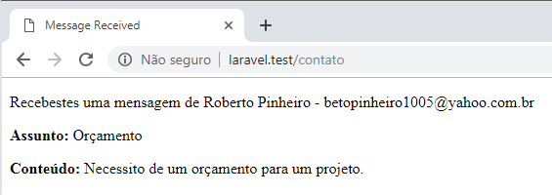

Usando mailtrap.io

Acesse: https://mailtrap.io

E abra uma conta gratuita.

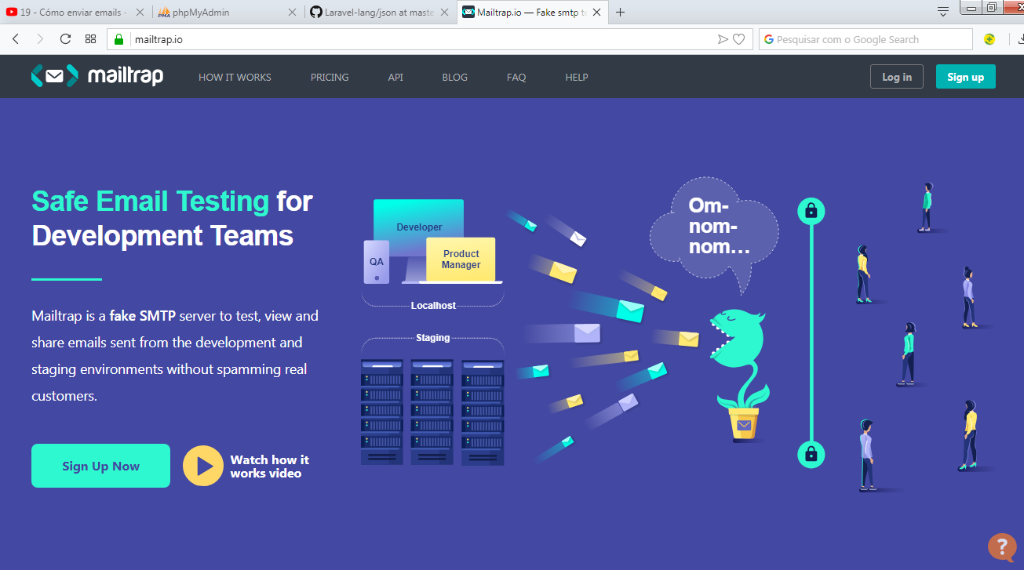

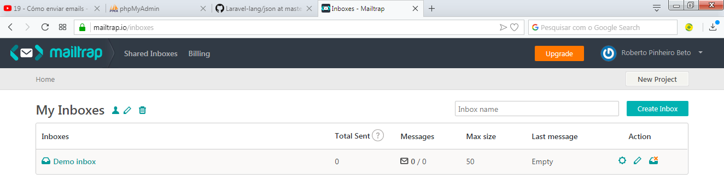

Renomeie "Demo inbox" para "Testes"

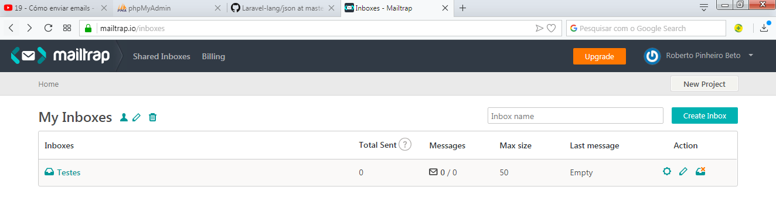

Clique no link:

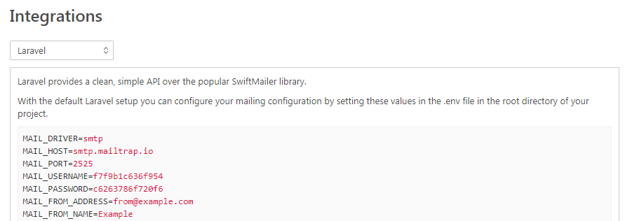

Copie os dados de MAIL_USERNAME e de MAIL_PASSWORD para o seu arquivo .env e altere MAIL_DRIVER de log para smtp

.env

MAIL_DRIVER=smtp
MAIL_HOST=smtp.mailtrap.io
MAIL_PORT=2525
MAIL_USERNAME=f7f9b1c636f954
MAIL_PASSWORD=c6263786f720f6
MAIL_ENCRYPTION=null
MAIL_FROM_ADDRESS='contato@oriontecinfo.com.br'
MAIL_FROM_NAME='Roberto Pinheiro'

Envie novamente o formulário de contato e verifique se ele chegou em sua caixa postal:

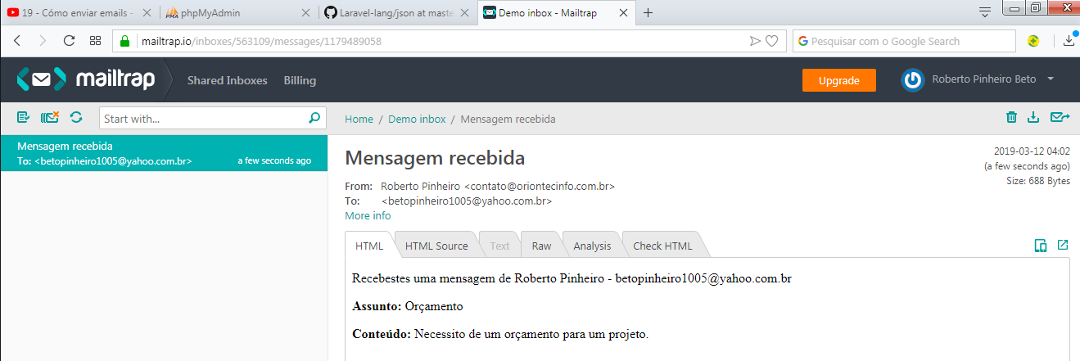

Sendgrid

Acesse:

https://sendgrid.com/pricing/

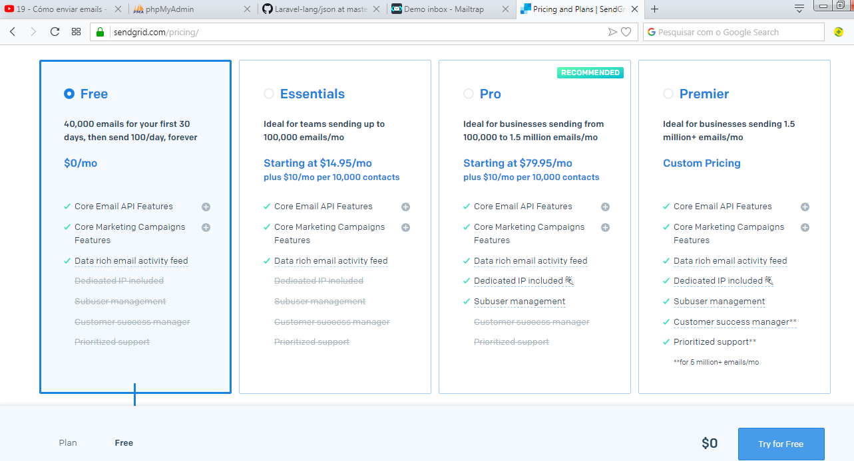

Selecione o plano FREE que permite enviar até 40 mil emails num período de 1 mês.

Instalando sendgrid

Por padrão o Laravel não vem nativamente o sendgrid. Portanto é necessário instalá-lo.

Acesse:

https://github.com/s-ichikawa/laravel-sendgrid-driver

Instale-o com o composer:

composer require s-ichikawa/laravel-sendgrid-driver

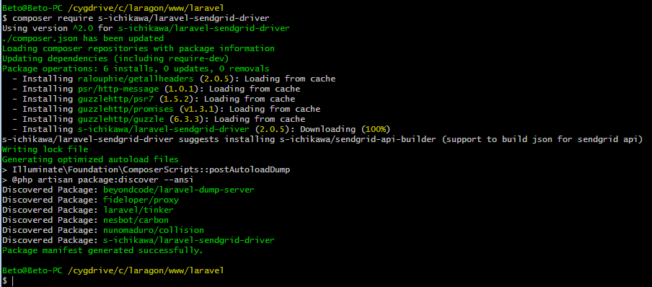

Configurando o arquivo .env

.env

#MAIL_DRIVER=sendgrid
#SENDGRID_API_KEY='YOUR_SENDGRID_API_KEY'

MAIL_DRIVER=smtp
MAIL_HOST=smtp.mailtrap.io

MAIL_PORT=2525
MAIL_USERNAME=f7f9b1c636f954
MAIL_PASSWORD=c6263786f720f6
MAIL_ENCRYPTION=null
MAIL_FROM_ADDRESS='contato@oriontecinfo.com.br'
MAIL_FROM_NAME='Roberto Pinheiro'

Na conta do sendgrid, clique em Settings -> API Keys. Clique no botão Create API Key e insira o número gerado no campo SENDGRID_API_KEY.

Obs: Em modo local vamos utilizar mailtrap e em modo de produção vamos usar sendgrip

config/services.php

Insira as linhas a seguir:

<?php

return [

'mailgun' => [
'domain' => env('MAILGUN_DOMAIN'),
'secret' => env('MAILGUN_SECRET'),
'endpoint' => env('MAILGUN_ENDPOINT', 'api.mailgun.net'),
],

'postmark' => [
'token' => env('POSTMARK_TOKEN'),
],

'sendgrid' => [
'api_key' => env('SENDGRID_API_KEY'),
],

'ses' => [
'key' => env('AWS_ACCESS_KEY_ID'),
'secret' => env('AWS_SECRET_ACCESS_KEY'),
'region' => env('AWS_DEFAULT_REGION', 'us-east-1'),
],

'sparkpost' => [
'secret' => env('SPARKPOST_SECRET'),
],

'stripe' => [
'model' => App\User::class,
'key' => env('STRIPE_KEY'),
'secret' => env('STRIPE_SECRET'),
'webhook' => [
'secret' => env('STRIPE_WEBHOOK_SECRET'),
'tolerance' => env('STRIPE_WEBHOOK_TOLERANCE', 300),
],
],

];

