Curso de Ruby on Rails - aulas 31 a 40
Jackson Pires

https://www.youtube.com/watch?v=ZHPondVB9RQ&list=PLe3LRfCs4go-mkvHRMSXEOG-HDbzesyaP

Resumo do curso feito por Roberto Pinheiro

Aula 31 - Nitrous.IO

É uma plataforma onde se pode desenvolver uma aplicação Ruby on Rails toda na Web.

Nitrous.IO foi descontinuado.

Aula 32 - Self e Monkey Patch em Ruby

Self

Self é uma palavra reservada que dá acesso ao objeto corrente.

Assim podemos dizer que ao usar obj.meth, estamos enviando o meth ao obj.

Gemfile

source 'https://rubygems.org'
git_source(:github) { |repo| "https://github.com/#{repo}.git" }

ruby '2.5.1'

gem 'pry', '~> 0.11.3'
gem 'rb-readline', '~> 0.5.3'
# Bundle edge Rails instead: gem 'rails', github: 'rails/rails'
gem 'rails', '~> 5.2.3'
# Use mysql as the database for Active Record
gem 'mysql2', '>= 0.4.4', '< 0.6.0'
# Use Puma as the app server
gem 'puma', '~> 3.11'
# Use SCSS for stylesheets
gem 'sass-rails', '~> 5.0'
# Use Uglifier as compressor for JavaScript assets
gem 'uglifier', '>= 1.3.0'
# See https://github.com/rails/execjs#readme for more supported runtimes
gem 'duktape'
# Use CoffeeScript for .coffee assets and views
gem 'coffee-rails', '~> 4.2'
# Turbolinks makes navigating your web application faster. Read more: https://github.com/turbolinks/turbolinks
gem 'turbolinks', '~> 5'
# Build JSON APIs with ease. Read more: https://github.com/rails/jbuilder
gem 'jbuilder', '~> 2.5'
# Use Redis adapter to run Action Cable in production
# gem 'redis', '~> 4.0'
# Use ActiveModel has_secure_password
# gem 'bcrypt', '~> 3.1.7'

# Use ActiveStorage variant
# gem 'mini_magick', '~> 4.8'

# Use Capistrano for deployment
# gem 'capistrano-rails', group: :development

# Reduces boot times through caching; required in config/boot.rb
gem 'bootsnap', '>= 1.1.0', require: false

group :development, :test do
# Call 'byebug' anywhere in the code to stop execution and get a debugger console
gem 'byebug', platforms: [:mri, :mingw, :x64_mingw]
end

group :development do
# Access an interactive console on exception pages or by calling 'console' anywhere in the code.
gem 'web-console', '>= 3.3.0'
end

group :test do
# Adds support for Capybara system testing and selenium driver
gem 'capybara', '>= 2.15'
gem 'selenium-webdriver'
# Easy installation and use of chromedriver to run system tests with Chrome
gem 'chromedriver-helper'
end

# Windows does not include zoneinfo files, so bundle the tzinfo-data gem
gem 'tzinfo-data', platforms: [:mingw, :mswin, :x64_mingw, :jruby]

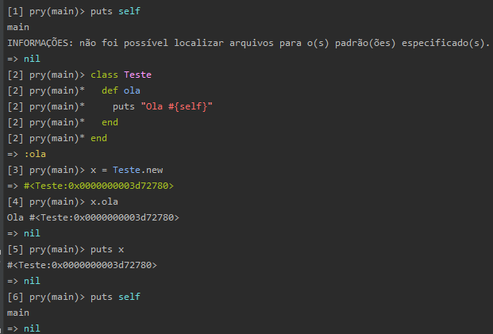

Monkey Patch

É quando se altera em tempo de execução uma classe.

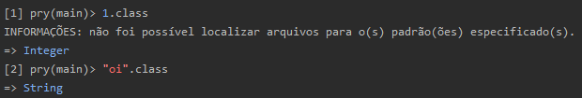

Para, por exemplo, abrir a classe String, basta redeclará-la

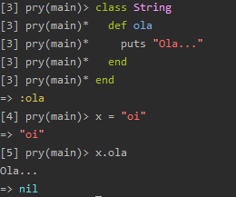

O self de uma string é a própria string.

Sobrescrevendo o método existente dentro da classe String

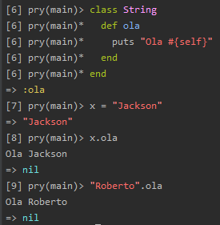

Outra forma de abrir uma classe é usar class_eval:

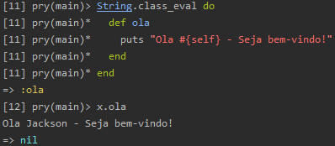

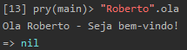

class_eval funciona apenas se a classe já existir.

Aula 33 - Métodos de instância x Métodos de classe

Métodos de instância

São métodos que são criados dentro de uma classe e ficam disponíveis para os objetos daquela classe.

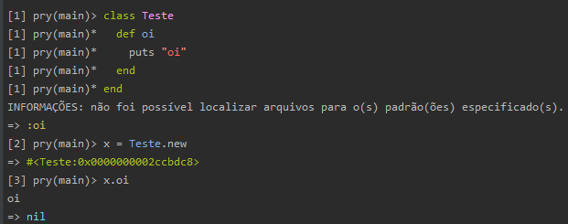

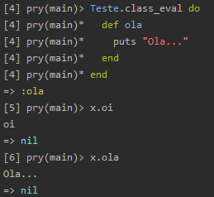

Métodos de Classe

São métodos estáticos acessados diretamente na classe sem precisar instanciar a classe.

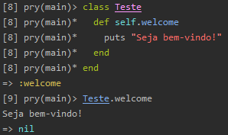

instance_eval

É declarar métodos específicos para uma determinada instância (objeto).

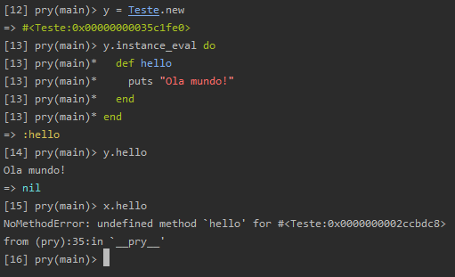

Aula 34 - Singleton Pattern vs Singleton Class

Singleton Pattern

Singleton é um padrão de projeto de software (do inglês Design Pattern). Este padrão garante a existência de apenas uma instância de uma classe, mantendo um ponto global de acesso ao seu objeto.

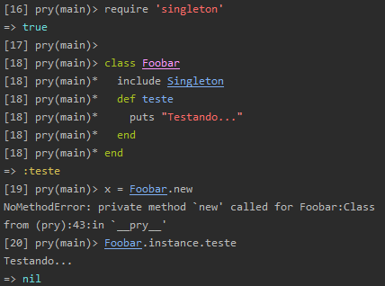

Singleton Class

class << object

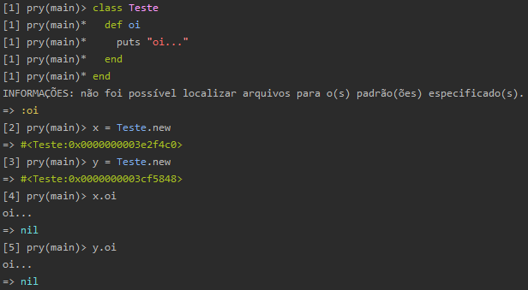

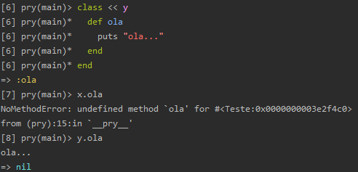

Aula 35 - Parênteses, Colchetes e Chaves no Ruby

Parênteses

No Ruby é opcional.

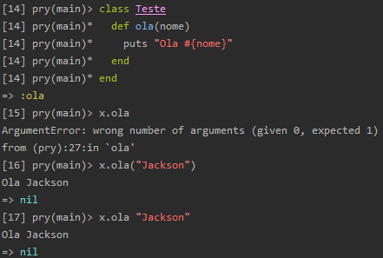

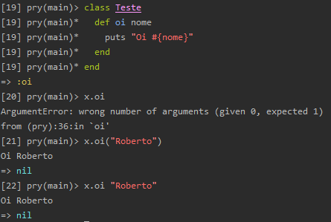

Guia de boas práticas do Ruby

https://github.com/rubensmabueno/ruby-style-guide/blob/master/README-PT-BR.md

Colchetes

Basicamente são utilizados com arrays ou posicionamento de arrays.

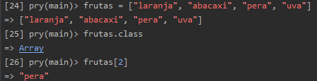

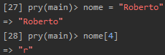

Chaves

São utilizadas com hash e blocos de código.

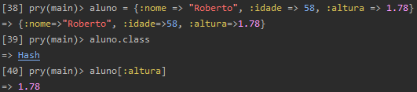

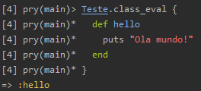

Aula 36 - Criando um formulário de pesquisa

rails g scaffold Customer name:string email:string

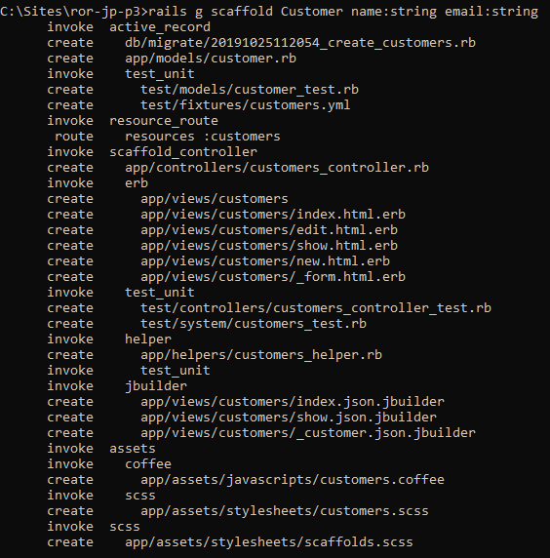

rake db:create

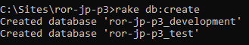

rake db:migrate

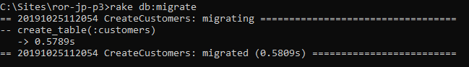

Gemfile

source 'https://rubygems.org'
git_source(:github) { |repo| "https://github.com/#{repo}.git" }

ruby '2.5.1'

# Faker
gem 'faker'
gem 'pry', '~> 0.11.3'
gem 'rb-readline', '~> 0.5.3'
# Bundle edge Rails instead: gem 'rails', github: 'rails/rails'
gem 'rails', '~> 5.2.3'
# Use mysql as the database for Active Record
gem 'mysql2', '>= 0.4.4', '< 0.6.0'
# Use Puma as the app server
gem 'puma', '~> 3.11'
# Use SCSS for stylesheets
gem 'sass-rails', '~> 5.0'
# Use Uglifier as compressor for JavaScript assets
gem 'uglifier', '>= 1.3.0'
# See https://github.com/rails/execjs#readme for more supported runtimes
gem 'duktape'
# Use CoffeeScript for .coffee assets and views
gem 'coffee-rails', '~> 4.2'
# Turbolinks makes navigating your web application faster. Read more: https://github.com/turbolinks/turbolinks
gem 'turbolinks', '~> 5'
# Build JSON APIs with ease. Read more: https://github.com/rails/jbuilder
gem 'jbuilder', '~> 2.5'
# Use Redis adapter to run Action Cable in production
# gem 'redis', '~> 4.0'
# Use ActiveModel has_secure_password
# gem 'bcrypt', '~> 3.1.7'

# Use ActiveStorage variant
# gem 'mini_magick', '~> 4.8'

# Use Capistrano for deployment
# gem 'capistrano-rails', group: :development

# Reduces boot times through caching; required in config/boot.rb
gem 'bootsnap', '>= 1.1.0', require: false

group :development, :test do
# Call 'byebug' anywhere in the code to stop execution and get a debugger console
gem 'byebug', platforms: [:mri, :mingw, :x64_mingw]
end

group :development do
# Access an interactive console on exception pages or by calling 'console' anywhere in the code.
gem 'web-console', '>= 3.3.0'
end

group :test do
# Adds support for Capybara system testing and selenium driver
gem 'capybara', '>= 2.15'
gem 'selenium-webdriver'
# Easy installation and use of chromedriver to run system tests with Chrome
gem 'chromedriver-helper'
end

# Windows does not include zoneinfo files, so bundle the tzinfo-data gem
gem 'tzinfo-data', platforms: [:mingw, :mswin, :x64_mingw, :jruby]

db/seeds.rb

50.times do |i|
customer_name = Faker::Name.name
customer_email = Faker::Internet.email
customer = "#{customer_name} - #{customer_email}"
puts "Cadastrando #{customer}"
Customer.create(name: customer_name, email: customer_email)
end

rake db:seeds

app/controllers/customers_controller.rb

class CustomersController < ApplicationController
before_action :set_customer, only: [:show, :edit, :update, :destroy]

# GET /customers
# GET /customers.json
def index
if params[:search]
@customers = Customer.where("name like ?", "%#{params[:search]}%")
else
@customers = Customer.all
end
end

# GET /customers/1
# GET /customers/1.json
def show
end

# GET /customers/new
def new
@customer = Customer.new
end

# GET /customers/1/edit
def edit
end

# POST /customers
# POST /customers.json
def create
@customer = Customer.new(customer_params)

respond_to do |format|
if @customer.save
format.html { redirect_to @customer, notice: 'Customer was successfully created.' }
format.json { render :show, status: :created, location: @customer }
else
format.html { render :new }
format.json { render json: @customer.errors, status: :unprocessable_entity }
end
end
end

# PATCH/PUT /customers/1
# PATCH/PUT /customers/1.json
def update
respond_to do |format|
if @customer.update(customer_params)
format.html { redirect_to @customer, notice: 'Customer was successfully updated.' }
format.json { render :show, status: :ok, location: @customer }
else
format.html { render :edit }
format.json { render json: @customer.errors, status: :unprocessable_entity }
end
end
end

# DELETE /customers/1
# DELETE /customers/1.json
def destroy
@customer.destroy
respond_to do |format|
format.html { redirect_to customers_url, notice: 'Customer was successfully destroyed.' }
format.json { head :no_content }
end
end

private
# Use callbacks to share common setup or constraints between actions.
def set_customer
@customer = Customer.find(params[:id])
end

# Never trust parameters from the scary internet, only allow the white list through.
def customer_params
params.require(:customer).permit(:name, :email)
end
end

app/views/customers/index.html.erb

<p id="notice"><%= notice %></p>

<%= form_tag(customers_path, :method => :get) do %>
<%= text_field_tag 'search', nil, placeholder: 'Enter search term...' %>
<%= submit_tag "Search" %>
<% end %>

<h1>Customers</h1>

<table>
<thead>
<tr>
<th>Name</th>
<th>Email</th>
<th colspan="3"></th>
</tr>
</thead>

<tbody>
<% @customers.each do |customer| %>
<tr>
<td><%= customer.name %></td>
<td><%= customer.email %></td>
<td><%= link_to 'Show', customer %></td>
<td><%= link_to 'Edit', edit_customer_path(customer) %></td>
<td><%= link_to 'Destroy', customer, method: :delete, data: { confirm: 'Are you sure?' } %></td>
</tr>
<% end %>
</tbody>
</table>

<br>

<%= link_to 'New Customer', new_customer_path %>

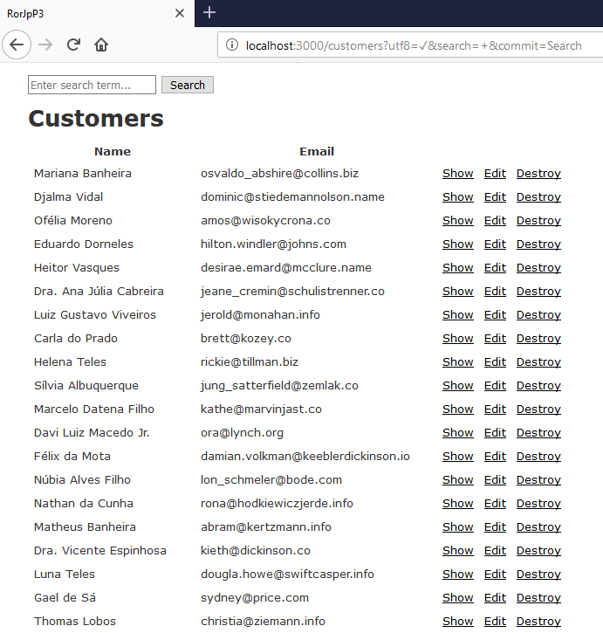

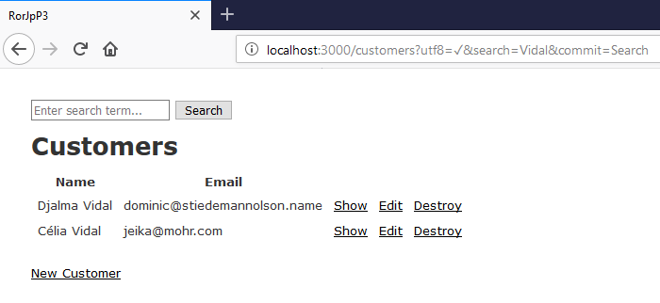

Criando a pesquisa como um método de classe

app/models/customer.rb

class Customer < ApplicationRecord
def self.search(query)
where("name like ?", "%#{query}%")
end
end

app/controllers/customers_controller.rb

class CustomersController < ApplicationController
before_action :set_customer, only: [:show, :edit, :update, :destroy]

# GET /customers
# GET /customers.json
def index

if params[:search]
@customers = Customer.search(params[:search])
else
@customers = Customer.all
end
end

# GET /customers/1
# GET /customers/1.json
def show
end

# GET /customers/new
def new
@customer = Customer.new
end

# GET /customers/1/edit
def edit
end

# POST /customers
# POST /customers.json
def create
@customer = Customer.new(customer_params)

respond_to do |format|
if @customer.save
format.html { redirect_to @customer, notice: 'Customer was successfully created.' }
format.json { render :show, status: :created, location: @customer }
else
format.html { render :new }
format.json { render json: @customer.errors, status: :unprocessable_entity }
end
end
end

# PATCH/PUT /customers/1
# PATCH/PUT /customers/1.json
def update
respond_to do |format|
if @customer.update(customer_params)
format.html { redirect_to @customer, notice: 'Customer was successfully updated.' }
format.json { render :show, status: :ok, location: @customer }
else
format.html { render :edit }
format.json { render json: @customer.errors, status: :unprocessable_entity }
end
end
end

# DELETE /customers/1
# DELETE /customers/1.json
def destroy
@customer.destroy
respond_to do |format|
format.html { redirect_to customers_url, notice: 'Customer was successfully destroyed.' }
format.json { head :no_content }
end
end

private
# Use callbacks to share common setup or constraints between actions.
def set_customer
@customer = Customer.find(params[:id])
end

# Never trust parameters from the scary internet, only allow the white list through.
def customer_params
params.require(:customer).permit(:name, :email)
end
end

Usando scopes

Scopes permite encadeamento de métodos.

app/models/customer.rb

class Customer < ApplicationRecord
scope :search, -> (query) {where("name like ?", "%#{query}%")}
end

Aula 37 - Formulários Complexos / Nested Attributes

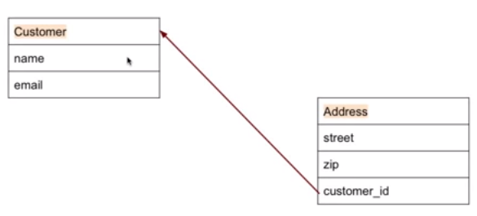

rails g scaffold Address street:string zip:string customer:references

rake db:migrate

app/models/customer.rb

class Customer < ApplicationRecord
has_one :address
scope :search, -> (query) {where("name like ?", "%#{query}%")}
end

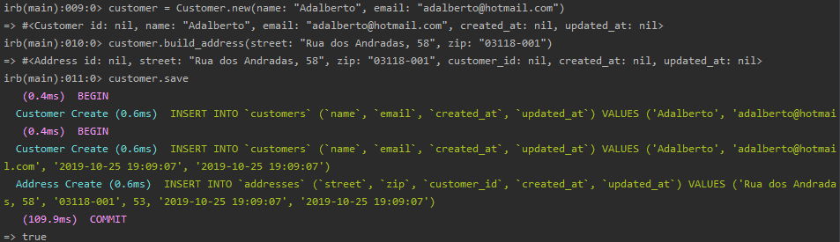

https://api.rubyonrails.org/classes/ActiveRecord/NestedAttributes/ClassMethods.html

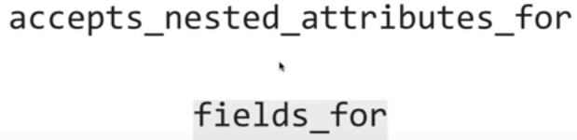

app/models/customer.rb

class Customer < ApplicationRecord
has_one :address
accepts_nested_attributes_for :address
scope :search, -> (query) {where("name like ?", "%#{query}%")}
end

app/controllers/customers_controller.rb

class CustomersController < ApplicationController
before_action :set_customer, only: [:show, :edit, :update, :destroy]

# GET /customers
# GET /customers.json
def index

if params[:search]
# @customers = Customer.where("name like ?", "%#{params[:search]}%")
@customers = Customer.search(params[:search])
else
@customers = Customer.all
end
end

# GET /customers/1
# GET /customers/1.json
def show
end

# GET /customers/new
def new
@customer = Customer.new
@customer.build_address
end

# GET /customers/1/edit
def edit
end

# POST /customers
# POST /customers.json
def create
@customer = Customer.new(customer_params)

respond_to do |format|
if @customer.save
format.html { redirect_to @customer, notice: 'Customer was successfully created.' }
format.json { render :show, status: :created, location: @customer }
else
format.html { render :new }
format.json { render json: @customer.errors, status: :unprocessable_entity }
end
end
end

# PATCH/PUT /customers/1
# PATCH/PUT /customers/1.json
def update
respond_to do |format|
if @customer.update(customer_params)
format.html { redirect_to @customer, notice: 'Customer was successfully updated.' }
format.json { render :show, status: :ok, location: @customer }
else
format.html { render :edit }
format.json { render json: @customer.errors, status: :unprocessable_entity }
end
end
end

# DELETE /customers/1
# DELETE /customers/1.json
def destroy
@customer.destroy
respond_to do |format|
format.html { redirect_to customers_url, notice: 'Customer was successfully destroyed.' }
format.json { head :no_content }
end
end

private
# Use callbacks to share common setup or constraints between actions.
def set_customer
@customer = Customer.find(params[:id])
end

# Never trust parameters from the scary internet, only allow the white list through.
def customer_params
params.require(:customer).permit(:name, :email, :address_attributes => [:street, :zip])
end
end

app/views/customers/_form.html.erb

<%= form_with(model: customer, local: true) do |form| %>
<% if customer.errors.any? %>
<div id="error_explanation">
<h2><%= pluralize(customer.errors.count, "error") %> prohibited this customer from being saved:</h2>

<ul>
<% customer.errors.full_messages.each do |message| %>
<li><%= message %></li>
<% end %>
</ul>
</div>
<% end %>

<div class="field">
<%= form.label :name %>
<%= form.text_field :name %>
</div>

<div class="field">
<%= form.label :email %>
<%= form.text_field :email %>
</div>

<%= form.fields_for :address do |ff| %>
<div class="field">
<%= ff.label :street %>
<%= ff.text_field :street %>
</div>
<div class="field">
<%= ff.label :zip %>
<%= ff.text_field :zip %>
</div>
<% end %>

<div class="actions">
<%= form.submit %>
</div>
<% end %>

app/views/customers/show.html.erb

<p id="notice"><%= notice %></p>

<p>
<strong>Name:</strong>
<%= @customer.name %>
</p>

<p>
<strong>Email:</strong>
<%= @customer.email %>
</p>

<p>
<strong>Street:</strong>
<%= @customer.address.street %>
</p>

<p>
<strong>Zip</strong>
<%= @customer.address.zip %>
</p>

<%= link_to 'Edit', edit_customer_path(@customer) %> |
<%= link_to 'Back', customers_path %>

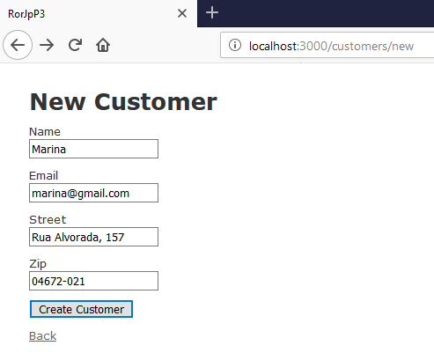

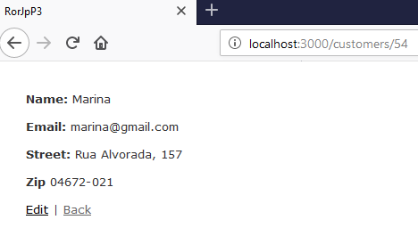

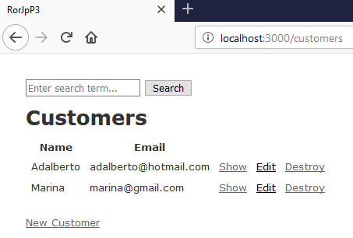

app/views/addresses/index.html.erb

<p id="notice"><%= notice %></p>

<h1>Addresses</h1>

<table>
<thead>
<tr>
<th>Street</th>
<th>Zip</th>
<th>Customer</th>
<th colspan="3"></th>
</tr>
</thead>

<tbody>
<% @addresses.each do |address| %>
<tr>
<td><%= address.street %></td>
<td><%= address.zip %></td>
<td><%= address.customer.name %></td>
<td><%= link_to 'Show', address %></td>
<td><%= link_to 'Edit', edit_address_path(address) %></td>
<td><%= link_to 'Destroy', address, method: :delete, data: { confirm: 'Are you sure?' } %></td>
</tr>
<% end %>
</tbody>
</table>

<br>

<%= link_to 'New Address', new_address_path %>

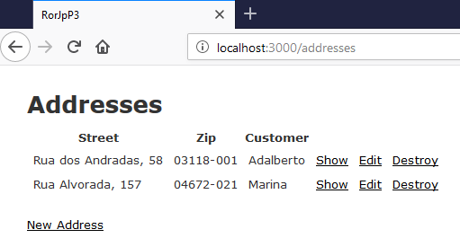

Aula 38 - Autenticação de usuários com Devise

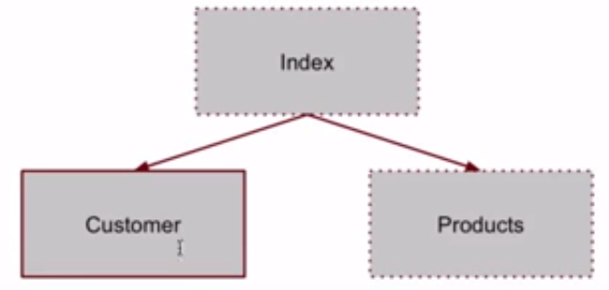

rails generate scaffold Product description:string quantity:integer

rails g controller Welcome index

rake db:migrate

config/routes.rb

Rails.application.routes.draw do
get 'welcome/index'
root 'welcome#index'
resources :products
resources :addresses
resources :customers
end

app/views/welcome/index.html.erb

<h1>Página Principal</h1>
<ul>
<li><%= link_to "Clientes", customers_path %></li>
<li><%= link_to "Produtos", products_path %></li>
</ul>

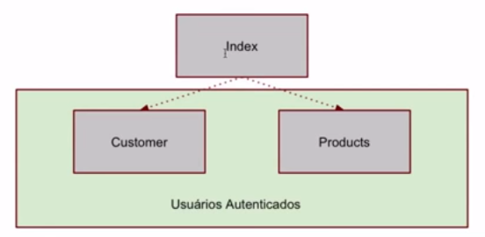

Gemfile

source 'https://rubygems.org'
git_source(:github) { |repo| "https://github.com/#{repo}.git" }

ruby '2.5.1'

# Devise
gem 'devise'
# Faker
gem 'faker'
gem 'pry', '~> 0.11.3'
gem 'rb-readline', '~> 0.5.3'
# Bundle edge Rails instead: gem 'rails', github: 'rails/rails'
gem 'rails', '~> 5.2.3'
# Use mysql as the database for Active Record
gem 'mysql2', '>= 0.4.4', '< 0.6.0'
# Use Puma as the app server
gem 'puma', '~> 3.11'
# Use SCSS for stylesheets
gem 'sass-rails', '~> 5.0'
# Use Uglifier as compressor for JavaScript assets
gem 'uglifier', '>= 1.3.0'
# See https://github.com/rails/execjs#readme for more supported runtimes
gem 'duktape'
# Use CoffeeScript for .coffee assets and views
gem 'coffee-rails', '~> 4.2'
# Turbolinks makes navigating your web application faster. Read more: https://github.com/turbolinks/turbolinks
gem 'turbolinks', '~> 5'
# Build JSON APIs with ease. Read more: https://github.com/rails/jbuilder
gem 'jbuilder', '~> 2.5'
# Use Redis adapter to run Action Cable in production
# gem 'redis', '~> 4.0'
# Use ActiveModel has_secure_password
# gem 'bcrypt', '~> 3.1.7'

# Use ActiveStorage variant
# gem 'mini_magick', '~> 4.8'

# Use Capistrano for deployment
# gem 'capistrano-rails', group: :development

# Reduces boot times through caching; required in config/boot.rb
gem 'bootsnap', '>= 1.1.0', require: false

group :development, :test do
# Call 'byebug' anywhere in the code to stop execution and get a debugger console
gem 'byebug', platforms: [:mri, :mingw, :x64_mingw]
end

group :development do
# Access an interactive console on exception pages or by calling 'console' anywhere in the code.
gem 'web-console', '>= 3.3.0'
end

group :test do
# Adds support for Capybara system testing and selenium driver
gem 'capybara', '>= 2.15'
gem 'selenium-webdriver'
# Easy installation and use of chromedriver to run system tests with Chrome
gem 'chromedriver-helper'
end

# Windows does not include zoneinfo files, so bundle the tzinfo-data gem
gem 'tzinfo-data', platforms: [:mingw, :mswin, :x64_mingw, :jruby]

bundle install

rails generate devise:install

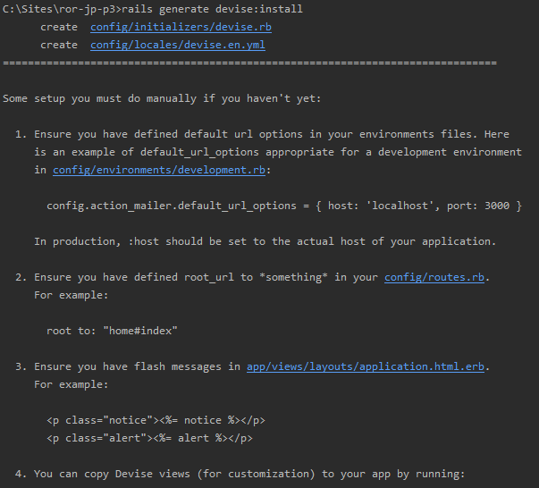
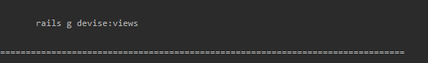

Traduzindo mensagens do Devise

https://gist.github.com/mateusg/924555

config/locales/devise.pt-BR.yml

# encoding: UTF-8
# pt-BR translations for Devise
pt-BR:
devise:
confirmations:
confirmed: "Sua conta foi confirmada com sucesso. Você está logado."
send_instructions: "Dentro de minutos, você receberá um e-mail com instruções para a confirmação da sua conta."
send_paranoid_instructions: "Se o seu endereço de e-mail estiver cadastrado, você receberá uma mensagem com instruções para confirmação da sua conta."
failure:
already_authenticated: "Você já está logado."
inactive: "Sua conta ainda não foi ativada."
invalid: "%{authentication_keys} ou senha inválida."
locked: "Sua conta está bloqueada."
last_attempt: "Você tem mais uma tentativa antes de bloquear sua conta."
not_found_in_database: "%{authentication_keys} ou senha inválida."
timeout: "Sua sessão expirou, por favor, efetue login novamente para continuar."
unauthenticated: "Para continuar, efetue login ou registre-se."
unconfirmed: "Antes de continuar, confirme a sua conta."
mailer:
confirmation_instructions:
subject: "Instruções de confirmação"
reset_password_instructions:
subject: "Instruções de troca de senha"
unlock_instructions:
subject: "Instruções de desbloqueio"
omniauth_callbacks:
failure: "Não foi possível autenticá-lo como %{kind} porque %{reason}."
success: "Autenticado com sucesso com uma conta de %{kind}."
passwords:
no_token: "Você só pode acessar essa página através de um e-mail de troca de senha. Se já estiver acessando por um e-mail, verifique se a URL fornecida está completa."
send_instructions: "Dentro de minutos, você receberá um e-mail com instruções para a troca da sua senha."
send_paranoid_instructions: "Se o seu endereço de e-mail estiver cadastrado, você receberá um link de recuperação da senha via e-mail."
updated: "Sua senha foi alterada com sucesso. Você está logado."
updated_not_active: "Sua senha foi alterada com sucesso."
registrations:
destroyed: "Sua conta foi cancelada com sucesso. Esperamos vê-lo novamente em breve."
signed_up: "Login efetuado com sucesso. Se não foi autorizado, a confirmação será enviada por e-mail."
signed_up_but_inactive: "Você foi cadastrado com sucesso. No entanto, não foi possível efetuar login, pois sua conta não foi ativada."
signed_up_but_locked: "Você foi cadastrado com sucesso. No entanto, não foi possível efetuar login, pois sua conta está bloqueada."
signed_up_but_unconfirmed: "Uma mensagem com um link de confirmação foi enviada para o seu endereço de e-mail. Por favor, abra o link para confirmar a sua conta."
update_needs_confirmation: "Você atualizou a sua conta com sucesso, mas o seu novo endereço de e-mail precisa ser confirmado. Por favor, acesse-o e clique no link de confirmação que enviamos."
updated: "Sua conta foi atualizada com sucesso."
sessions:
signed_in: "Login efetuado com sucesso!"
signed_out: "Saiu com sucesso."
already_signed_out: "Saiu com sucesso."
unlocks:
send_instructions: "Dentro de minutos, você receberá um email com instruções para o desbloqueio da sua conta."
send_paranoid_instructions: "Se sua conta existir, você receberá um e-mail com instruções para desbloqueá-la em alguns minutos."
unlocked: "Sua conta foi desbloqueada com sucesso. Efetue login para continuar."

errors:
messages:
already_confirmed: "já foi confirmado"
confirmation_period_expired: "precisa ser confirmada em até %{period}, por favor, solicite uma nova"
expired: "expirou, por favor, solicite uma nova"
not_found: "não encontrado"
not_locked: "não foi bloqueado"
not_saved:
one: "Não foi possível salvar %{resource}: 1 erro"
other: "Não foi possível salvar %{resource}: %{count} erros."

Adicionando o devise ao model

rails generate devise User

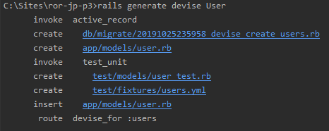

db/migrate/20191025235958_devise_create_users.rb

# frozen_string_literal: true

class DeviseCreateUsers < ActiveRecord::Migration[5.2]
def change
create_table :users do |t|
## Database authenticatable
t.string :email, null: false, default: ""
t.string :encrypted_password, null: false, default: ""

## Recoverable
t.string :reset_password_token
t.datetime :reset_password_sent_at

## Rememberable
t.datetime :remember_created_at

## Trackable
# t.integer :sign_in_count, default: 0, null: false
# t.datetime :current_sign_in_at
# t.datetime :last_sign_in_at
# t.string :current_sign_in_ip
# t.string :last_sign_in_ip

## Confirmable
# t.string :confirmation_token
# t.datetime :confirmed_at
# t.datetime :confirmation_sent_at
# t.string :unconfirmed_email # Only if using reconfirmable

## Lockable
# t.integer :failed_attempts, default: 0, null: false # Only if lock strategy is :failed_attempts
# t.string :unlock_token # Only if unlock strategy is :email or :both
# t.datetime :locked_at

t.timestamps null: false
end

add_index :users, :email, unique: true
add_index :users, :reset_password_token, unique: true
# add_index :users, :confirmation_token, unique: true
# add_index :users, :unlock_token, unique: true
end
end

app/models/user.rb

class User < ApplicationRecord
# Include default devise modules. Others available are:
# :confirmable, :lockable, :timeoutable, :trackable and :omniauthable
devise :database_authenticatable, :registerable,
:recoverable, :rememberable, :validatable
end

rake db:migrate

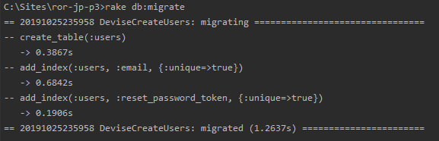

Ajustar os ambientes para envio de email

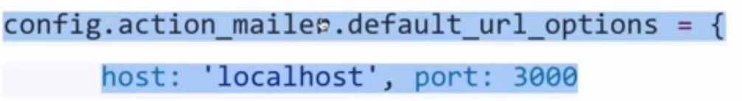

config/enviroments/development.rb

Rails.application.configure do
# Settings specified here will take precedence over those in config/application.rb.

# Devise
config.action_mailer.default_url_options = { host: 'localhost', port: 3000 }

# In the development environment your application's code is reloaded on
# every request. This slows down response time but is perfect for development
# since you don't have to restart the web server when you make code changes.
config.cache_classes = false

# Do not eager load code on boot.
config.eager_load = false

# Show full error reports.
config.consider_all_requests_local = true

# Enable/disable caching. By default caching is disabled.
# Run rails dev:cache to toggle caching.
if Rails.root.join('tmp', 'caching-dev.txt').exist?
config.action_controller.perform_caching = true

config.cache_store = :memory_store
config.public_file_server.headers = {
'Cache-Control' => "public, max-age=#{2.days.to_i}"
}
else
config.action_controller.perform_caching = false

config.cache_store = :null_store
end

# Store uploaded files on the local file system (see config/storage.yml for options)
config.active_storage.service = :local

# Don't care if the mailer can't send.
config.action_mailer.raise_delivery_errors = false

config.action_mailer.perform_caching = false

# Print deprecation notices to the Rails logger.
config.active_support.deprecation = :log

# Raise an error on page load if there are pending migrations.
config.active_record.migration_error = :page_load

# Highlight code that triggered database queries in logs.
config.active_record.verbose_query_logs = true

# Debug mode disables concatenation and preprocessing of assets.
# This option may cause significant delays in view rendering with a large
# number of complex assets.
config.assets.debug = true

# Suppress logger output for asset requests.
config.assets.quiet = true

# Raises error for missing translations
# config.action_view.raise_on_missing_translations = true

# Use an evented file watcher to asynchronously detect changes in source code,
# routes, locales, etc. This feature depends on the listen gem.
# config.file_watcher = ActiveSupport::EventedFileUpdateChecker
end

Adicionar filtros nos controllers que deseja autenticação

app/controllers/customers_controller.rb

class CustomersController < ApplicationController
before_action :set_customer, only: [:show, :edit, :update, :destroy]
before_action :authenticate_user!

# GET /customers
# GET /customers.json
def index

if params[:search]
# @customers = Customer.where("name like ?", "%#{params[:search]}%")
@customers = Customer.search(params[:search])
else
@customers = Customer.all
end
end

# GET /customers/1
# GET /customers/1.json
def show
end

# GET /customers/new
def new
@customer = Customer.new
@customer.build_address
end

# GET /customers/1/edit
def edit
end

# POST /customers
# POST /customers.json
def create
@customer = Customer.new(customer_params)

respond_to do |format|
if @customer.save
format.html { redirect_to @customer, notice: 'Customer was successfully created.' }
format.json { render :show, status: :created, location: @customer }
else
format.html { render :new }
format.json { render json: @customer.errors, status: :unprocessable_entity }
end
end
end

# PATCH/PUT /customers/1
# PATCH/PUT /customers/1.json
def update
respond_to do |format|
if @customer.update(customer_params)
format.html { redirect_to @customer, notice: 'Customer was successfully updated.' }
format.json { render :show, status: :ok, location: @customer }
else
format.html { render :edit }
format.json { render json: @customer.errors, status: :unprocessable_entity }
end
end
end

# DELETE /customers/1
# DELETE /customers/1.json
def destroy
@customer.destroy
respond_to do |format|
format.html { redirect_to customers_url, notice: 'Customer was successfully destroyed.' }
format.json { head :no_content }
end
end

private
# Use callbacks to share common setup or constraints between actions.
def set_customer
@customer = Customer.find(params[:id])
end

# Never trust parameters from the scary internet, only allow the white list through.
def customer_params
params.require(:customer).permit(:name, :email, :address_attributes => [:street, :zip])
end
end

app/controllers/products_controller.rb

class ProductsController < ApplicationController
before_action :set_product, only: [:show, :edit, :update, :destroy]
before_action :authenticate_user!

# GET /products
# GET /products.json
def index
@products = Product.all
end

# GET /products/1
# GET /products/1.json
def show
end

# GET /products/new
def new
@product = Product.new
end

# GET /products/1/edit
def edit
end

# POST /products
# POST /products.json
def create
@product = Product.new(product_params)

respond_to do |format|
if @product.save
format.html { redirect_to @product, notice: 'Product was successfully created.' }
format.json { render :show, status: :created, location: @product }
else
format.html { render :new }
format.json { render json: @product.errors, status: :unprocessable_entity }
end
end
end

# PATCH/PUT /products/1
# PATCH/PUT /products/1.json
def update
respond_to do |format|
if @product.update(product_params)
format.html { redirect_to @product, notice: 'Product was successfully updated.' }
format.json { render :show, status: :ok, location: @product }
else
format.html { render :edit }
format.json { render json: @product.errors, status: :unprocessable_entity }
end
end
end

# DELETE /products/1
# DELETE /products/1.json
def destroy
@product.destroy
respond_to do |format|
format.html { redirect_to products_url, notice: 'Product was successfully destroyed.' }
format.json { head :no_content }
end
end

private
# Use callbacks to share common setup or constraints between actions.
def set_product
@product = Product.find(params[:id])
end

# Never trust parameters from the scary internet, only allow the white list through.
def product_params
params.require(:product).permit(:description, :quantity)
end
end

Tente acessar os cadastros envolvidos

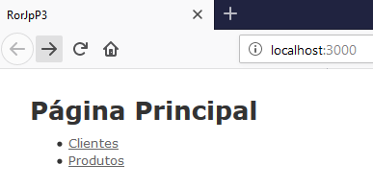

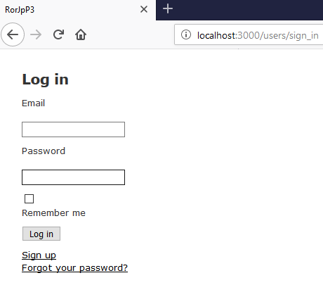

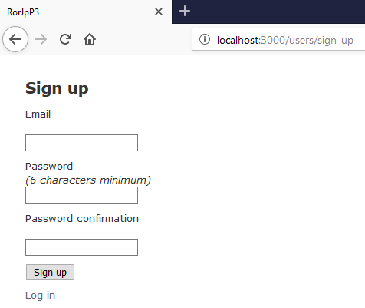

Senha: 123456

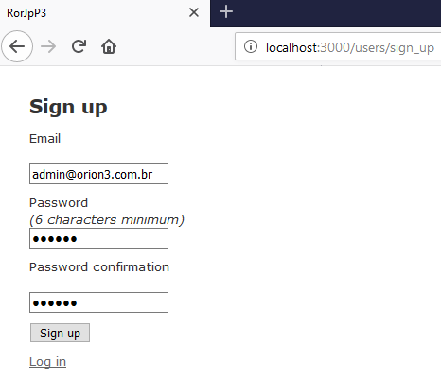

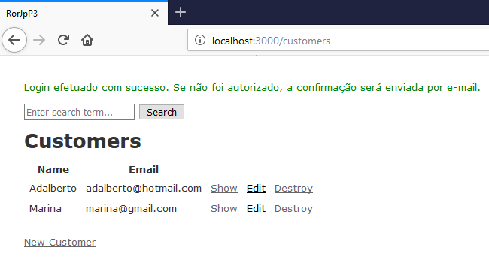

Verifique as novas rotas

rake routes ou, no navegador: localhost:3000/rails/info/routes

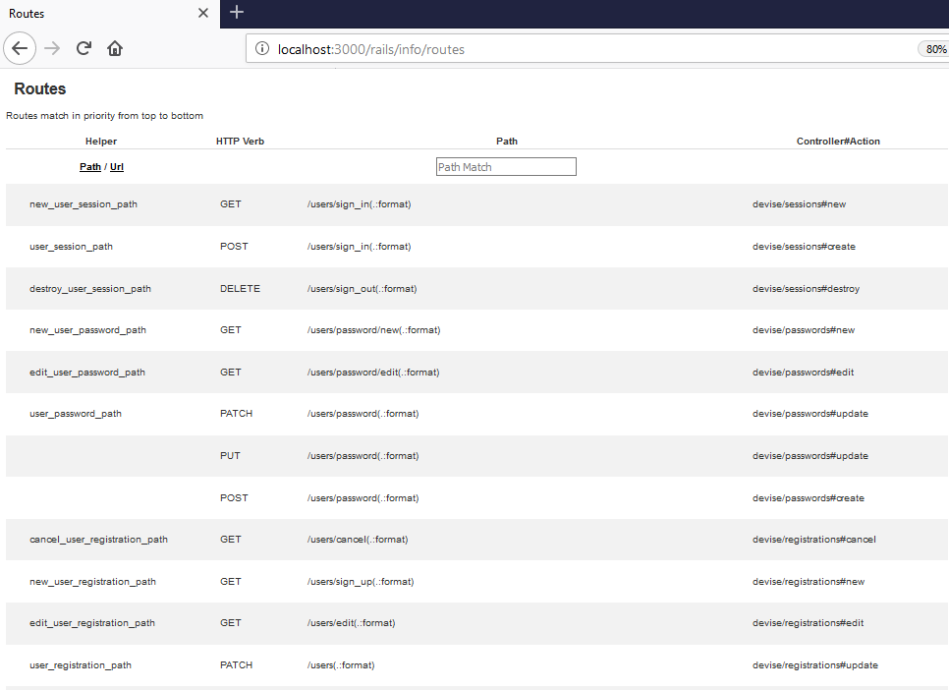
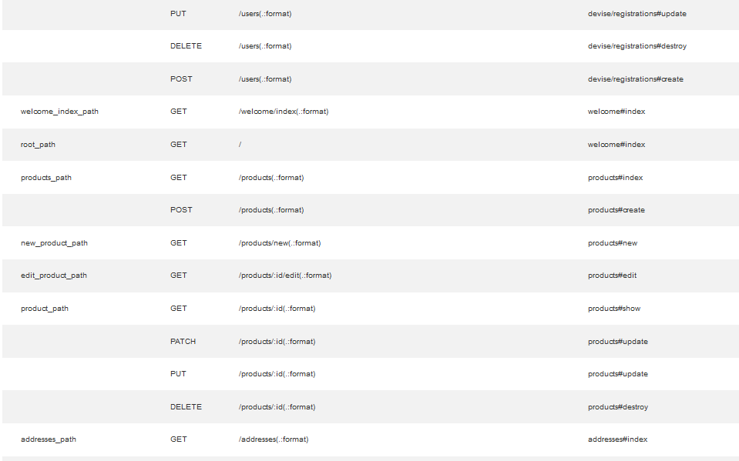
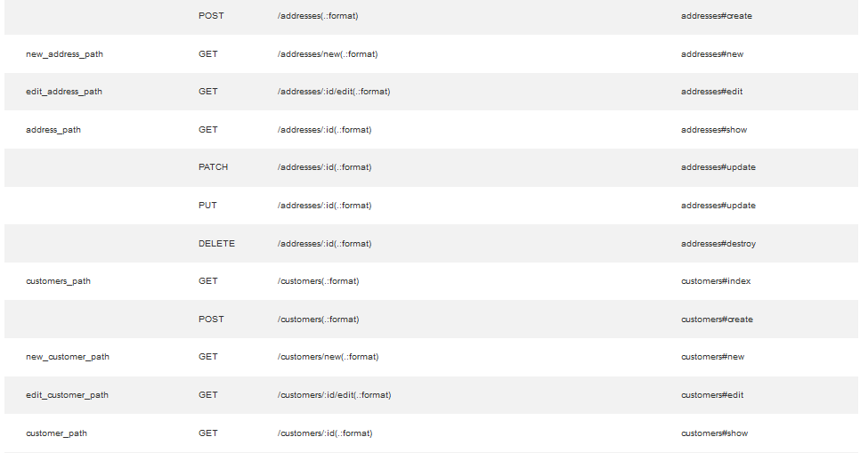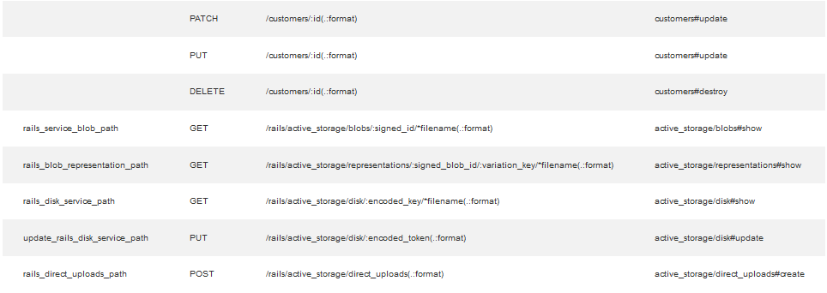

Para sair (deslogar):

Crie os links para o cadastro de novos usuários

app/views/welcome/index.html.erb

<h1>Página Principal</h1>

<ul>
<li><%= link_to "Cadastro de novo usuário", new_user_registration_path %></li>
<li><%= link_to "Logar", new_user_session_path %></li>
<li><%= link_to "Sair", destroy_user_session_path, method: :delete %></li>
</ul>

<ul>
<li><%= link_to "Clientes", customers_path %></li>
<li><%= link_to "Produtos", products_path %></li>
</ul>

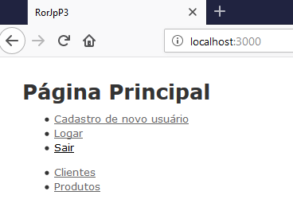

Helpers

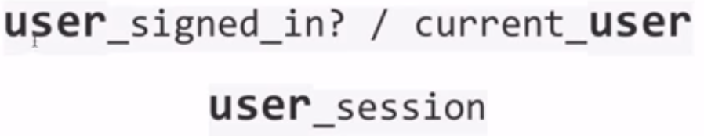

app/views/welcome/index.html.erb

<h1>Página Principal</h1>

<% if user_signed_in? %>
<ul>
<li><%= current_user.email %></li>
<li><%= link_to "Sair", destroy_user_session_path, method: :delete %></li>
</ul>
<% else %>
<ul>
<li><%= link_to "Cadastro de novo usuário", new_user_registration_path %></li>
<li><%= link_to "Logar", new_user_session_path %></li>
</ul>
<% end %>

<ul>
<li><%= link_to "Clientes", customers_path %></li>
<li><%= link_to "Produtos", products_path %></li>
</ul>

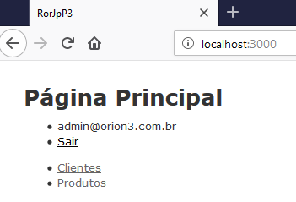

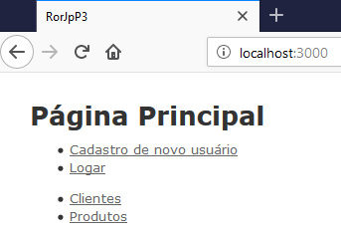

Customizando as views

Ative a opção de scoped_views

config/initializers/devise.rb

config.scoped_views = true

config/initializers/devise.rb

# frozen_string_literal: true

# Use this hook to configure devise mailer, warden hooks and so forth.
# Many of these configuration options can be set straight in your model.
Devise.setup do |config|
# The secret key used by Devise. Devise uses this key to generate
# random tokens. Changing this key will render invalid all existing
# confirmation, reset password and unlock tokens in the database.
# Devise will use the `secret_key_base` as its `secret_key`
# by default. You can change it below and use your own secret key.
# config.secret_key = 'c058d9d14b6543788a7c4513045a34fa55910701086b2dc93d137ddfc4d4349ea209f2c63daf1c2895eb54396dd7719d639588d12a850a8f4f90cbf972d0a761'

# ==> Controller configuration
# Configure the parent class to the devise controllers.
# config.parent_controller = 'DeviseController'

# ==> Mailer Configuration
# Configure the e-mail address which will be shown in Devise::Mailer,
# note that it will be overwritten if you use your own mailer class
# with default "from" parameter.
config.mailer_sender = 'please-change-me-at-config-initializers-devise@example.com'

# Configure the class responsible to send e-mails.
# config.mailer = 'Devise::Mailer'

# Configure the parent class responsible to send e-mails.
# config.parent_mailer = 'ActionMailer::Base'

# ==> ORM configuration
# Load and configure the ORM. Supports :active_record (default) and
# :mongoid (bson_ext recommended) by default. Other ORMs may be
# available as additional gems.
require 'devise/orm/active_record'

# ==> Configuration for any authentication mechanism
# Configure which keys are used when authenticating a user. The default is
# just :email. You can configure it to use [:username, :subdomain], so for
# authenticating a user, both parameters are required. Remember that those
# parameters are used only when authenticating and not when retrieving from
# session. If you need permissions, you should implement that in a before filter.
# You can also supply a hash where the value is a boolean determining whether
# or not authentication should be aborted when the value is not present.
# config.authentication_keys = [:email]

# Configure parameters from the request object used for authentication. Each entry
# given should be a request method and it will automatically be passed to the
# find_for_authentication method and considered in your model lookup. For instance,
# if you set :request_keys to [:subdomain], :subdomain will be used on authentication.
# The same considerations mentioned for authentication_keys also apply to request_keys.
# config.request_keys = []

# Configure which authentication keys should be case-insensitive.
# These keys will be downcased upon creating or modifying a user and when used
# to authenticate or find a user. Default is :email.
config.case_insensitive_keys = [:email]

# Configure which authentication keys should have whitespace stripped.
# These keys will have whitespace before and after removed upon creating or
# modifying a user and when used to authenticate or find a user. Default is :email.
config.strip_whitespace_keys = [:email]

# Tell if authentication through request.params is enabled. True by default.
# It can be set to an array that will enable params authentication only for the
# given strategies, for example, `config.params_authenticatable = [:database]` will
# enable it only for database (email + password) authentication.
# config.params_authenticatable = true

# Tell if authentication through HTTP Auth is enabled. False by default.
# It can be set to an array that will enable http authentication only for the
# given strategies, for example, `config.http_authenticatable = [:database]` will
# enable it only for database authentication. The supported strategies are:
# :database = Support basic authentication with authentication key + password
# config.http_authenticatable = false

# If 401 status code should be returned for AJAX requests. True by default.
# config.http_authenticatable_on_xhr = true

# The realm used in Http Basic Authentication. 'Application' by default.
# config.http_authentication_realm = 'Application'

# It will change confirmation, password recovery and other workflows
# to behave the same regardless if the e-mail provided was right or wrong.
# Does not affect registerable.
# config.paranoid = true

# By default Devise will store the user in session. You can skip storage for
# particular strategies by setting this option.
# Notice that if you are skipping storage for all authentication paths, you
# may want to disable generating routes to Devise's sessions controller by
# passing skip: :sessions to `devise_for` in your config/routes.rb
config.skip_session_storage = [:http_auth]

# By default, Devise cleans up the CSRF token on authentication to
# avoid CSRF token fixation attacks. This means that, when using AJAX
# requests for sign in and sign up, you need to get a new CSRF token
# from the server. You can disable this option at your own risk.
# config.clean_up_csrf_token_on_authentication = true

# When false, Devise will not attempt to reload routes on eager load.
# This can reduce the time taken to boot the app but if your application
# requires the Devise mappings to be loaded during boot time the application
# won't boot properly.
# config.reload_routes = true

# ==> Configuration for :database_authenticatable
# For bcrypt, this is the cost for hashing the password and defaults to 11. If
# using other algorithms, it sets how many times you want the password to be hashed.
#
# Limiting the stretches to just one in testing will increase the performance of
# your test suite dramatically. However, it is STRONGLY RECOMMENDED to not use
# a value less than 10 in other environments. Note that, for bcrypt (the default
# algorithm), the cost increases exponentially with the number of stretches (e.g.
# a value of 20 is already extremely slow: approx. 60 seconds for 1 calculation).
config.stretches = Rails.env.test? ? 1 : 11

# Set up a pepper to generate the hashed password.
# config.pepper = '1013e3739d35769f618383d2fe954a506f68bdf0f629792cc53ffd5cd2974420fa19c559cf00c24d19b8b840477d8a92e67366279d379d6c4cccd7d1d1292d0f'

# Send a notification to the original email when the user's email is changed.
# config.send_email_changed_notification = false

# Send a notification email when the user's password is changed.
# config.send_password_change_notification = false

# ==> Configuration for :confirmable
# A period that the user is allowed to access the website even without
# confirming their account. For instance, if set to 2.days, the user will be
# able to access the website for two days without confirming their account,
# access will be blocked just in the third day.
# You can also set it to nil, which will allow the user to access the website
# without confirming their account.
# Default is 0.days, meaning the user cannot access the website without
# confirming their account.
# config.allow_unconfirmed_access_for = 2.days

# A period that the user is allowed to confirm their account before their
# token becomes invalid. For example, if set to 3.days, the user can confirm
# their account within 3 days after the mail was sent, but on the fourth day
# their account can't be confirmed with the token any more.
# Default is nil, meaning there is no restriction on how long a user can take
# before confirming their account.
# config.confirm_within = 3.days

# If true, requires any email changes to be confirmed (exactly the same way as
# initial account confirmation) to be applied. Requires additional unconfirmed_email
# db field (see migrations). Until confirmed, new email is stored in
# unconfirmed_email column, and copied to email column on successful confirmation.
config.reconfirmable = true

# Defines which key will be used when confirming an account
# config.confirmation_keys = [:email]

# ==> Configuration for :rememberable
# The time the user will be remembered without asking for credentials again.
# config.remember_for = 2.weeks

# Invalidates all the remember me tokens when the user signs out.
config.expire_all_remember_me_on_sign_out = true

# If true, extends the user's remember period when remembered via cookie.
# config.extend_remember_period = false

# Options to be passed to the created cookie. For instance, you can set
# secure: true in order to force SSL only cookies.
# config.rememberable_options = {}

# ==> Configuration for :validatable
# Range for password length.
config.password_length = 6..128

# Email regex used to validate email formats. It simply asserts that
# one (and only one) @ exists in the given string. This is mainly
# to give user feedback and not to assert the e-mail validity.
config.email_regexp = /\A[^@\s]+@[^@\s]+\z/

# ==> Configuration for :timeoutable
# The time you want to timeout the user session without activity. After this
# time the user will be asked for credentials again. Default is 30 minutes.
# config.timeout_in = 30.minutes

# ==> Configuration for :lockable
# Defines which strategy will be used to lock an account.
# :failed_attempts = Locks an account after a number of failed attempts to sign in.
# :none = No lock strategy. You should handle locking by yourself.
# config.lock_strategy = :failed_attempts

# Defines which key will be used when locking and unlocking an account
# config.unlock_keys = [:email]

# Defines which strategy will be used to unlock an account.
# :email = Sends an unlock link to the user email
# :time = Re-enables login after a certain amount of time (see :unlock_in below)
# :both = Enables both strategies
# :none = No unlock strategy. You should handle unlocking by yourself.
# config.unlock_strategy = :both

# Number of authentication tries before locking an account if lock_strategy
# is failed attempts.
# config.maximum_attempts = 20

# Time interval to unlock the account if :time is enabled as unlock_strategy.
# config.unlock_in = 1.hour

# Warn on the last attempt before the account is locked.
# config.last_attempt_warning = true

# ==> Configuration for :recoverable
#
# Defines which key will be used when recovering the password for an account
# config.reset_password_keys = [:email]

# Time interval you can reset your password with a reset password key.
# Don't put a too small interval or your users won't have the time to
# change their passwords.
config.reset_password_within = 6.hours

# When set to false, does not sign a user in automatically after their password is
# reset. Defaults to true, so a user is signed in automatically after a reset.
# config.sign_in_after_reset_password = true

# ==> Configuration for :encryptable
# Allow you to use another hashing or encryption algorithm besides bcrypt (default).
# You can use :sha1, :sha512 or algorithms from others authentication tools as
# :clearance_sha1, :authlogic_sha512 (then you should set stretches above to 20
# for default behavior) and :restful_authentication_sha1 (then you should set
# stretches to 10, and copy REST_AUTH_SITE_KEY to pepper).
#
# Require the `devise-encryptable` gem when using anything other than bcrypt
# config.encryptor = :sha512

# ==> Scopes configuration
# Turn scoped views on. Before rendering "sessions/new", it will first check for
# "users/sessions/new". It's turned off by default because it's slower if you
# are using only default views.
# config.scoped_views = false
config.scoped_views = true

# Configure the default scope given to Warden. By default it's the first
# devise role declared in your routes (usually :user).
# config.default_scope = :user

# Set this configuration to false if you want /users/sign_out to sign out
# only the current scope. By default, Devise signs out all scopes.
# config.sign_out_all_scopes = true

# ==> Navigation configuration
# Lists the formats that should be treated as navigational. Formats like
# :html, should redirect to the sign in page when the user does not have
# access, but formats like :xml or :json, should return 401.
#
# If you have any extra navigational formats, like :iphone or :mobile, you
# should add them to the navigational formats lists.
#
# The "*/*" below is required to match Internet Explorer requests.
# config.navigational_formats = ['*/*', :html]

# The default HTTP method used to sign out a resource. Default is :delete.
config.sign_out_via = :delete

# ==> OmniAuth
# Add a new OmniAuth provider. Check the wiki for more information on setting
# up on your models and hooks.
# config.omniauth :github, 'APP_ID', 'APP_SECRET', scope: 'user,public_repo'

# ==> Warden configuration
# If you want to use other strategies, that are not supported by Devise, or
# change the failure app, you can configure them inside the config.warden block.
#
# config.warden do |manager|
# manager.intercept_401 = false
# manager.default_strategies(scope: :user).unshift :some_external_strategy
# end

# ==> Mountable engine configurations
# When using Devise inside an engine, let's call it `MyEngine`, and this engine
# is mountable, there are some extra configurations to be taken into account.
# The following options are available, assuming the engine is mounted as:
#
# mount MyEngine, at: '/my_engine'
#
# The router that invoked `devise_for`, in the example above, would be:
# config.router_name = :my_engine
#
# When using OmniAuth, Devise cannot automatically set OmniAuth path,
# so you need to do it manually. For the users scope, it would be:
# config.omniauth_path_prefix = '/my_engine/users/auth'

# ==> Turbolinks configuration
# If your app is using Turbolinks, Turbolinks::Controller needs to be included to make redirection work correctly:
#
# ActiveSupport.on_load(:devise_failure_app) do
# include Turbolinks::Controller
# end

# ==> Configuration for :registerable

# When set to false, does not sign a user in automatically after their password is
# changed. Defaults to true, so a user is signed in automatically after changing a password.
# config.sign_in_after_change_password = true
end

Gere as view e faça as alterações

rails generate devise:views users

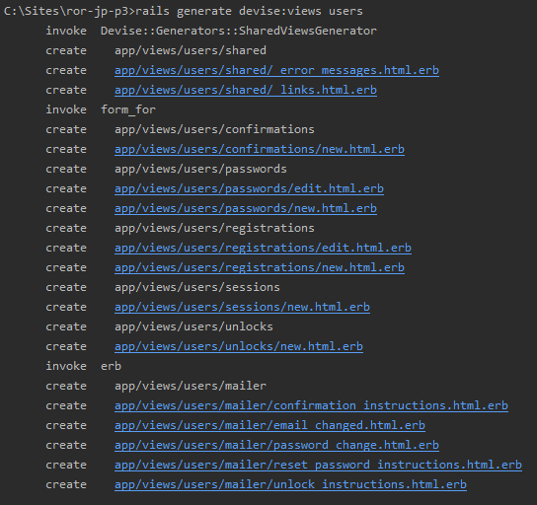

views/users/registrations/new.html.erb

<h2>Registro de novo usuário</h2>

<%= form_for(resource, as: resource_name, url: registration_path(resource_name)) do |f| %>
<%= render "devise/shared/error_messages", resource: resource %>

<div class="field">
<%= f.label :email %><br />
<%= f.email_field :email, autofocus: true, autocomplete: "email" %>
</div>

<div class="field">
<%= f.label :password %>
<% if @minimum_password_length %>
<em>(<%= @minimum_password_length %> characters minimum)</em>
<% end %><br />
<%= f.password_field :password, autocomplete: "new-password" %>
</div>

<div class="field">
<%= f.label :password_confirmation %><br />
<%= f.password_field :password_confirmation, autocomplete: "new-password" %>
</div>

<div class="actions">
<%= f.submit "Sign up" %>
</div>
<% end %>

<%= render "users/shared/links" %>

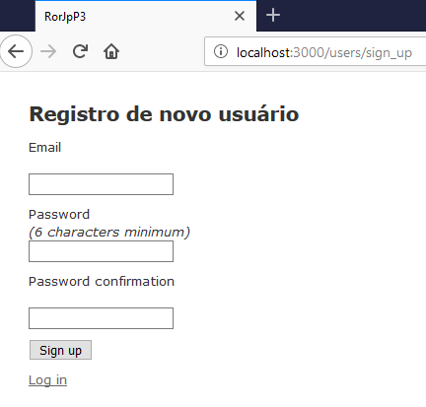

Aula 39 - Usando autorização com Pundit e Devise

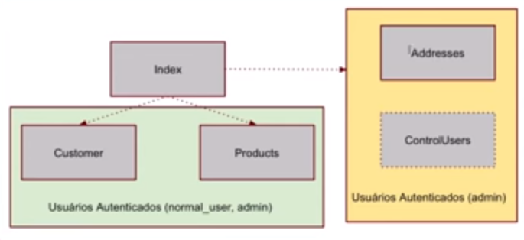

rails g controller ControlUsers index

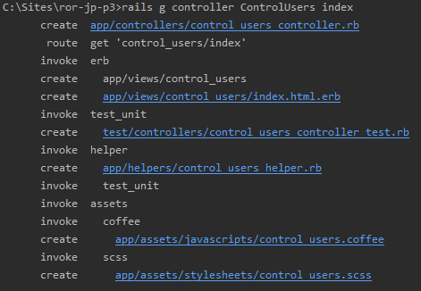

app/controllers/control_users_controller.rb

class ControlUsersController < ApplicationController
before_action :authenticate_user!

def index
@users = User.all
end
end

app/controllers/addresses_controller.rb

class AddressesController < ApplicationController
before_action :set_address, only: [:show, :edit, :update, :destroy]
before_action :authenticate_user!

# GET /addresses
# GET /addresses.json
def index
@addresses = Address.all
end

# GET /addresses/1
# GET /addresses/1.json
def show
end

# GET /addresses/new
def new
@address = Address.new
end

# GET /addresses/1/edit
def edit
end

# POST /addresses
# POST /addresses.json
def create
@address = Address.new(address_params)

respond_to do |format|
if @address.save
format.html { redirect_to @address, notice: 'Address was successfully created.' }
format.json { render :show, status: :created, location: @address }
else
format.html { render :new }
format.json { render json: @address.errors, status: :unprocessable_entity }
end
end
end

# PATCH/PUT /addresses/1
# PATCH/PUT /addresses/1.json
def update
respond_to do |format|
if @address.update(address_params)
format.html { redirect_to @address, notice: 'Address was successfully updated.' }
format.json { render :show, status: :ok, location: @address }
else
format.html { render :edit }
format.json { render json: @address.errors, status: :unprocessable_entity }
end
end
end

# DELETE /addresses/1
# DELETE /addresses/1.json
def destroy
@address.destroy
respond_to do |format|
format.html { redirect_to addresses_url, notice: 'Address was successfully destroyed.' }
format.json { head :no_content }
end
end

private
# Use callbacks to share common setup or constraints between actions.
def set_address
@address = Address.find(params[:id])
end

# Never trust parameters from the scary internet, only allow the white list through.
def address_params
params.require(:address).permit(:street, :zip, :customer_id)
end
end

views/control_users/index.html.erb

<p id="notice"><%= notice %></p>

<h1>Users</h1>

<table>
<thead>
<tr>
<th>Email</th>
</tr>
</thead>

<tbody>
<% @users.each do |user| %>
<tr>
<td><%= user.email %></td>
</tr>
<% end %>
</tbody>
</table>

<br>

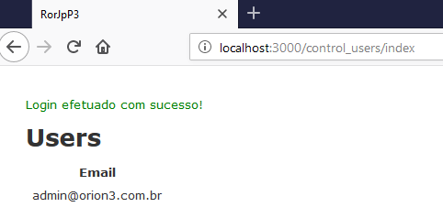

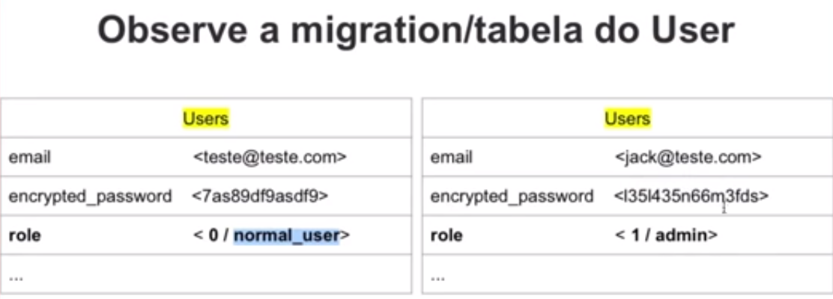

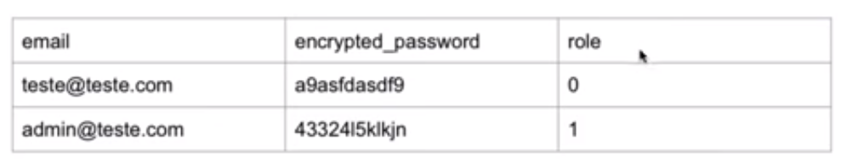

Adicionando uma migration para a role

rails g migration AddRole ToUsers

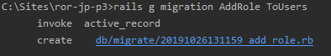

Altere a migration

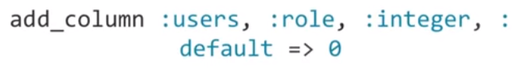

db/migrate/20191026131159_add_role.rb

class AddRole < ActiveRecord::Migration[5.2]
def change
add_column :users, :role, :integer, :default => 0
end
end

app/models/user.rb

class User < ApplicationRecord
enum role: [:normal_user, :admin]
# Include default devise modules. Others available are:
# :confirmable, :lockable, :timeoutable, :trackable and :omniauthable
devise :database_authenticatable, :registerable,
:recoverable, :rememberable, :validatable
end

Rode a migration e teste a criação de um novo user

rake db:migrate

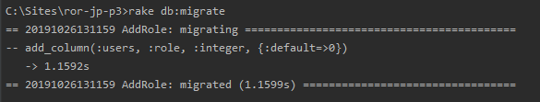

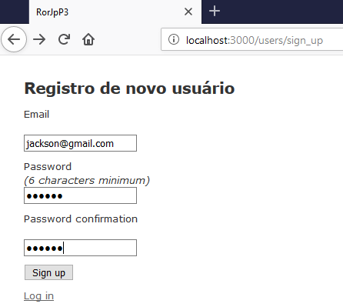

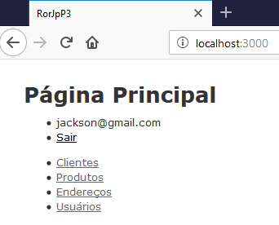

app/views/control_users/index.html.erb

<p id="notice"><%= notice %></p>

<h1>Users</h1>

<table>
<thead>
<tr>
<th>Email</th>
<th>Role</th>
</tr>
</thead>

<tbody>
<% @users.each do |user| %>
<tr>
<td><%= user.email %></td>
<td><%= user.role %></td>
</tr>
<% end %>
</tbody>
</table>

<br>

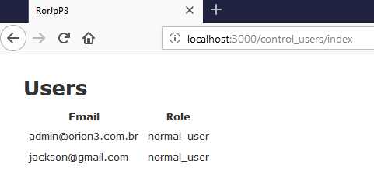

Ajuste a visualização dos usuários e faça testes no rails console

rails c

x = User.first
x.role = :admin
x.save

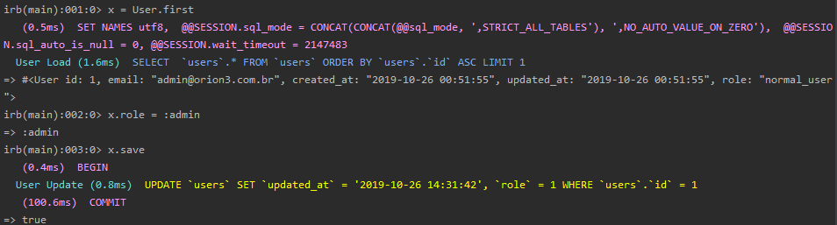

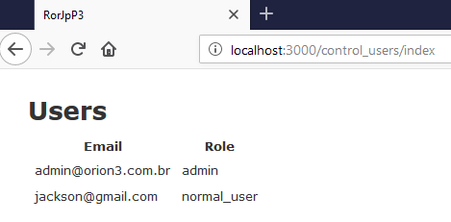

Pundit

Adicione ao Gemfile.

Gemfile

source 'https://rubygems.org'
git_source(:github) { |repo| "https://github.com/#{repo}.git" }

ruby '2.5.1'

# Pundit
gem 'pundit'
# Devise
gem 'devise'
# Faker
gem 'faker'
gem 'pry', '~> 0.11.3'
gem 'rb-readline', '~> 0.5.3'
# Bundle edge Rails instead: gem 'rails', github: 'rails/rails'
gem 'rails', '~> 5.2.3'
# Use mysql as the database for Active Record
gem 'mysql2', '>= 0.4.4', '< 0.6.0'
# Use Puma as the app server
gem 'puma', '~> 3.11'
# Use SCSS for stylesheets
gem 'sass-rails', '~> 5.0'
# Use Uglifier as compressor for JavaScript assets
gem 'uglifier', '>= 1.3.0'
# See https://github.com/rails/execjs#readme for more supported runtimes
gem 'duktape'
# Use CoffeeScript for .coffee assets and views
gem 'coffee-rails', '~> 4.2'
# Turbolinks makes navigating your web application faster. Read more: https://github.com/turbolinks/turbolinks
gem 'turbolinks', '~> 5'
# Build JSON APIs with ease. Read more: https://github.com/rails/jbuilder
gem 'jbuilder', '~> 2.5'
# Use Redis adapter to run Action Cable in production
# gem 'redis', '~> 4.0'
# Use ActiveModel has_secure_password
# gem 'bcrypt', '~> 3.1.7'

# Use ActiveStorage variant
# gem 'mini_magick', '~> 4.8'

# Use Capistrano for deployment
# gem 'capistrano-rails', group: :development

# Reduces boot times through caching; required in config/boot.rb
gem 'bootsnap', '>= 1.1.0', require: false

group :development, :test do
# Call 'byebug' anywhere in the code to stop execution and get a debugger console
gem 'byebug', platforms: [:mri, :mingw, :x64_mingw]
end

group :development do
# Access an interactive console on exception pages or by calling 'console' anywhere in the code.
gem 'web-console', '>= 3.3.0'
end

group :test do
# Adds support for Capybara system testing and selenium driver
gem 'capybara', '>= 2.15'
gem 'selenium-webdriver'
# Easy installation and use of chromedriver to run system tests with Chrome
gem 'chromedriver-helper'
end

# Windows does not include zoneinfo files, so bundle the tzinfo-data gem
gem 'tzinfo-data', platforms: [:mingw, :mswin, :x64_mingw, :jruby]

bundle install

Inclua o Pundit no ApplicationController

app/controllers/application_controller.rb

class ApplicationController < ActionController::Base
include Pundit
protect_from_forgery
end

Instale o pundit na aplicação

rails g pundit:install

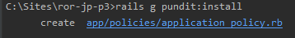

Após a instalação o pundit irá criar a pasta: app/policies

Crie uma nova política para o model User

rails g pundit:policy user

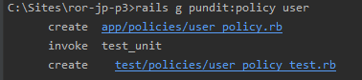

app/policies/user_policy.rb

class UserPolicy < ApplicationPolicy
class Scope < Scope
def resolve
scope.all
end
end
end

Crie o método para testar se o usuário é admin

app/policies/user_policy.rb

class UserPolicy < ApplicationPolicy
def index?
user.admin?
end

class Scope < Scope
def resolve
scope.all
end
end
end

Ajustando mensagens de erro

app/policies/user_policy.rb

class ApplicationController < ActionController::Base
protect_from_forgery
include Pundit

rescue_from Pundit::NotAuthorizedError, with: :user_not_authorized

private

def user_not_authorized
flash[:notice] = "Você não tem permissão para fazer esta ação."
redirect_to(request.referrer || root_path)
end

end

app/views/welcome/index.html.erb

<p id="notice"><%= notice %></p>

<h1>Página Principal</h1>

<% if user_signed_in? %>
<ul>
<li><%= current_user.email %></li>
<li><%= link_to "Sair", destroy_user_session_path, method: :delete %></li>
</ul>
<% else %>
<ul>
<li><%= link_to "Cadastro de novo usuário", new_user_registration_path %></li>
<li><%= link_to "Logar", new_user_session_path %></li>
</ul>
<% end %>

<ul>
<li><%= link_to "Clientes", customers_path %></li>
<li><%= link_to "Produtos", products_path %></li>
<li><%= link_to "Endereços", addresses_path %></li>
<li><%= link_to "Usuários", control_users_index_path %></li>
</ul>

Quando um usuário normal tenta acessar a página de usuários:

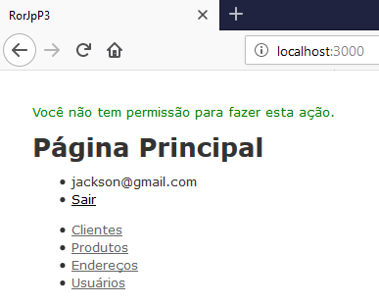

Quando um administrador tenta acessar a página de usuários:

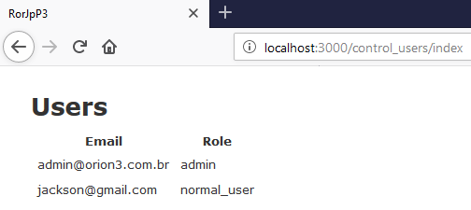

Fazendo o mesmo para o model Address

Crie uma nova política para o model Address

rails g pundit:policy address

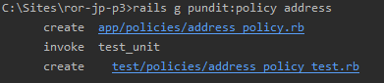

Testando na view

app/views/addresses/index.html.erb

<p id="notice"><%= notice %></p>

<h1>Listing Addresses</h1>

<% if policy(@addresses).index? %>
<table>
<thead>
<tr>
<th>Street</th>
<th>Zip</th>
<th>Customer</th>
<th colspan="3"></th>
</tr>
</thead>

<tbody>
<% @addresses.each do |address| %>
<tr>
<td><%= address.street %></td>
<td><%= address.zip %></td>
<td><%= address.customer.name %></td>
<td><%= link_to 'Show', address %></td>
<td><%= link_to 'Edit', edit_address_path(address) %></td>
<td><%= link_to 'Destroy', address, method: :delete, data: { confirm: 'Are you sure?' } %></td>
</tr>
<% end %>
</tbody>
</table>

<br>

<%= link_to 'New Address', new_address_path %>
<% else %>
<table>
<thead>
<tr>
<th>Street</th>
<th>Zip</th>
</tr>
</thead>

<tbody>
<% @addresses.each do |address| %>
<tr>
<td><%= address.street %></td>
<td><%= address.zip %></td>
</tr>
<% end %>
</tbody>
</table>

<% end %>

Crie o método para testar se o usuário é admin

app/policies/address_policy.rb

class AddressPolicy < ApplicationPolicy
def index?
user.admin?
end

class Scope < Scope
def resolve
scope.all
end
end
end

Acessando como usuário normal:

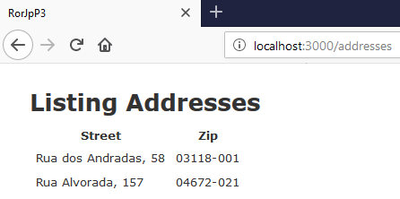

Acessando como administrador:

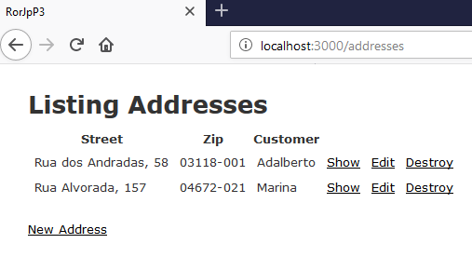

Otimizando o código

app/views/addresses/index.html.erb

<p id="notice"><%= notice %></p>

<h1>Listing Addresses</h1>

<% if policy(@addresses).index? %>
<%= render partial: "admin_index" %>
<% else %>
<%= render partial: "normal_user_index" %>
<% end %>

app/views/addresses/_admin_index.html.erb

<table>
<thead>
<tr>
<th>Street</th>
<th>Zip</th>
<th>Customer</th>
<th colspan="3"></th>
</tr>
</thead>

<tbody>
<% @addresses.each do |address| %>
<tr>
<td><%= address.street %></td>
<td><%= address.zip %></td>
<td><%= address.customer.name %></td>
<td><%= link_to 'Show', address %></td>
<td><%= link_to 'Edit', edit_address_path(address) %></td>
<td><%= link_to 'Destroy', address, method: :delete, data: { confirm: 'Are you sure?' } %></td>
</tr>
<% end %>
</tbody>
</table>

<br>
<%= link_to 'New Address', new_address_path %>

app/views/addresses/_normal_user_index.html.erb

<table>
<thead>
<tr>
<th>Street</th>
<th>Zip</th>
</tr>
</thead>

<tbody>
<% @addresses.each do |address| %>
<tr>
<td><%= address.street %></td>
<td><%= address.zip %></td>
</tr>
<% end %>
</tbody>
</table>

Aula 40 - Criando pesquisas com o Ransack

Gemfile

source 'https://rubygems.org'
git_source(:github) { |repo| "https://github.com/#{repo}.git" }

ruby '2.5.1'

# Ransack
gem 'ransack'
# Pundit
gem 'pundit'
# Devise
gem 'devise'
# Faker
gem 'faker'
gem 'pry', '~> 0.11.3'
gem 'rb-readline', '~> 0.5.3'
# Bundle edge Rails instead: gem 'rails', github: 'rails/rails'
gem 'rails', '~> 5.2.3'
# Use mysql as the database for Active Record
gem 'mysql2', '>= 0.4.4', '< 0.6.0'
# Use Puma as the app server
gem 'puma', '~> 3.11'
# Use SCSS for stylesheets
gem 'sass-rails', '~> 5.0'
# Use Uglifier as compressor for JavaScript assets
gem 'uglifier', '>= 1.3.0'
# See https://github.com/rails/execjs#readme for more supported runtimes
gem 'duktape'
# Use CoffeeScript for .coffee assets and views
gem 'coffee-rails', '~> 4.2'
# Turbolinks makes navigating your web application faster. Read more: https://github.com/turbolinks/turbolinks
gem 'turbolinks', '~> 5'
# Build JSON APIs with ease. Read more: https://github.com/rails/jbuilder
gem 'jbuilder', '~> 2.5'
# Use Redis adapter to run Action Cable in production
# gem 'redis', '~> 4.0'
# Use ActiveModel has_secure_password
# gem 'bcrypt', '~> 3.1.7'

# Use ActiveStorage variant
# gem 'mini_magick', '~> 4.8'

# Use Capistrano for deployment
# gem 'capistrano-rails', group: :development

# Reduces boot times through caching; required in config/boot.rb
gem 'bootsnap', '>= 1.1.0', require: false

group :development, :test do
# Call 'byebug' anywhere in the code to stop execution and get a debugger console
gem 'byebug', platforms: [:mri, :mingw, :x64_mingw]
end

group :development do
# Access an interactive console on exception pages or by calling 'console' anywhere in the code.
gem 'web-console', '>= 3.3.0'
end

group :test do
# Adds support for Capybara system testing and selenium driver
gem 'capybara', '>= 2.15'
gem 'selenium-webdriver'
# Easy installation and use of chromedriver to run system tests with Chrome
gem 'chromedriver-helper'
end

# Windows does not include zoneinfo files, so bundle the tzinfo-data gem
gem 'tzinfo-data', platforms: [:mingw, :mswin, :x64_mingw, :jruby]

bundle install

Simple Mode

Helper

search_form_for

Na view

app/views/products/index.html.erb

<p id="notice"><%= notice %></p>

<%= search_form_for @q do |f| %>
<%= f.label :description_cont %>
<%= f.search_field :description_cont %>
<%= f.submit %>
<% end %>

<h1>Listing Products</h1>

<table>
<thead>
<tr>
<th>Description</th>
<th>Quantity</th>
<th colspan="3"></th>
</tr>
</thead>

<tbody>
<% @products.each do |product| %>
<tr>
<td><%= product.description %></td>
<td><%= product.quantity %></td>
<td><%= link_to 'Show', product %></td>
<td><%= link_to 'Edit', edit_product_path(product) %></td>
<td><%= link_to 'Destroy', product, method: :delete, data: { confirm: 'Are you sure?' } %></td>
</tr>
<% end %>
</tbody>
</table>

<br>

<%= link_to 'New Product', new_product_path %>

No controller

def index
@q = Product.ransack(params[:q])
@products = @q.result
end

app/controllers/product_controller.rb

class ProductsController < ApplicationController
before_action :set_product, only: [:show, :edit, :update, :destroy]
before_action :authenticate_user!

# GET /products
# GET /products.json
def index
@q = Product.ransack(params[:q])
@products = @q.result

# @products = Product.all
end

# GET /products/1
# GET /products/1.json
def show
end

# GET /products/new
def new
@product = Product.new
end

# GET /products/1/edit
def edit
end

# POST /products
# POST /products.json
def create
@product = Product.new(product_params)

respond_to do |format|
if @product.save
format.html { redirect_to @product, notice: 'Product was successfully created.' }
format.json { render :show, status: :created, location: @product }
else
format.html { render :new }
format.json { render json: @product.errors, status: :unprocessable_entity }
end
end
end

# PATCH/PUT /products/1
# PATCH/PUT /products/1.json
def update
respond_to do |format|
if @product.update(product_params)
format.html { redirect_to @product, notice: 'Product was successfully updated.' }
format.json { render :show, status: :ok, location: @product }
else
format.html { render :edit }
format.json { render json: @product.errors, status: :unprocessable_entity }
end
end
end

# DELETE /products/1
# DELETE /products/1.json
def destroy
@product.destroy
respond_to do |format|
format.html { redirect_to products_url, notice: 'Product was successfully destroyed.' }
format.json { head :no_content }
end
end

private
# Use callbacks to share common setup or constraints between actions.
def set_product
@product = Product.find(params[:id])
end

# Never trust parameters from the scary internet, only allow the white list through.
def product_params
params.require(:product).permit(:description, :quantity)
end
end

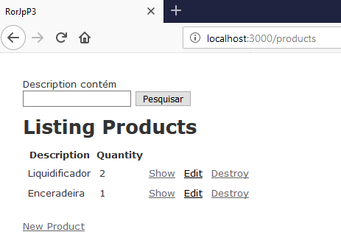

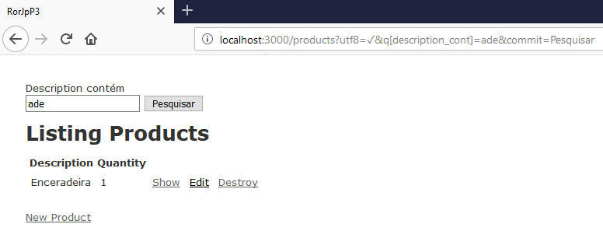

Ordenando colunas

sort_link

app/views/products/index.html.erb

<p id="notice"><%= notice %></p>

<%= search_form_for @q do |f| %>
<%= f.label :description_cont %>
<%= f.search_field :description_cont %>
<%= f.submit %>
<% end %>

<h1>Listing Products</h1>

<table>
<thead>
<tr>
<th><%= sort_link(@q, :description) %></th>
<th><%= sort_link(@q, :quantity) %></th>
<th colspan="3"></th>
</tr>
</thead>

<tbody>
<% @products.each do |product| %>
<tr>
<td><%= product.description %></td>
<td><%= product.quantity %></td>
<td><%= link_to 'Show', product %></td>
<td><%= link_to 'Edit', edit_product_path(product) %></td>
<td><%= link_to 'Destroy', product, method: :delete, data: { confirm: 'Are you sure?' } %></td>
</tr>
<% end %>
</tbody>
</table>

<br>

<%= link_to 'New Product', new_product_path %>

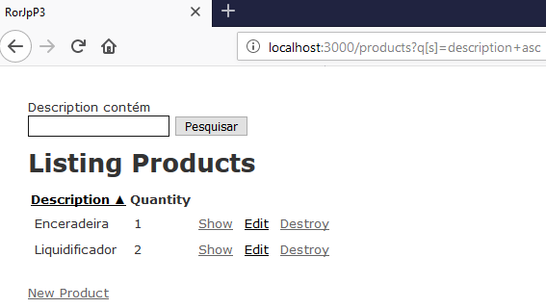

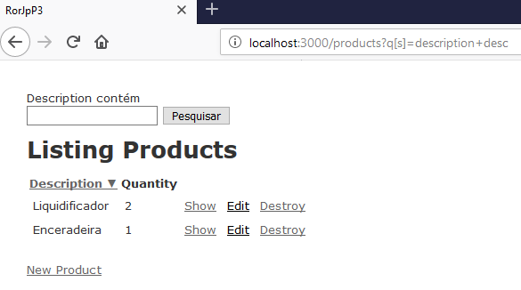

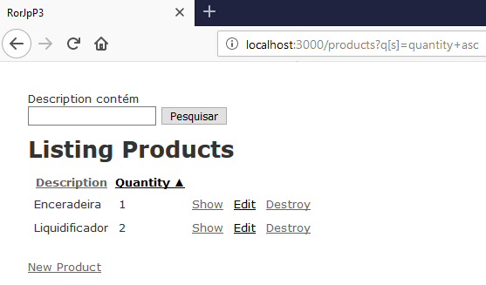

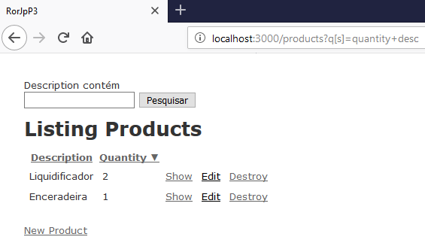

Adicionando mais opções de pesquisa na view

app/views/products/index.html.erb

<p id="notice"><%= notice %></p>

<%= search_form_for @q do |f| %>
<%= f.label :description_cont, "Descrição contendo:" %>
<%= f.search_field :description_cont %>

<%= f.label :quantity_lteq, "Quantidade menor que:" %>
<%= f.search_field :quantity_lt %>

<br>

<%= f.submit %>
<% end %>

<h1>Listing Products</h1>

<table>
<thead>
<tr>
<th><%= sort_link(@q, :description) %></th>
<th><%= sort_link(@q, :quantity) %></th>
<th colspan="3"></th>
</tr>
</thead>

<tbody>
<% @products.each do |product| %>
<tr>
<td><%= product.description %></td>
<td><%= product.quantity %></td>
<td><%= link_to 'Show', product %></td>
<td><%= link_to 'Edit', edit_product_path(product) %></td>
<td><%= link_to 'Destroy', product, method: :delete, data: { confirm: 'Are you sure?' } %></td>
</tr>
<% end %>
</tbody>
</table>

<br>

<%= link_to 'New Product', new_product_path %>

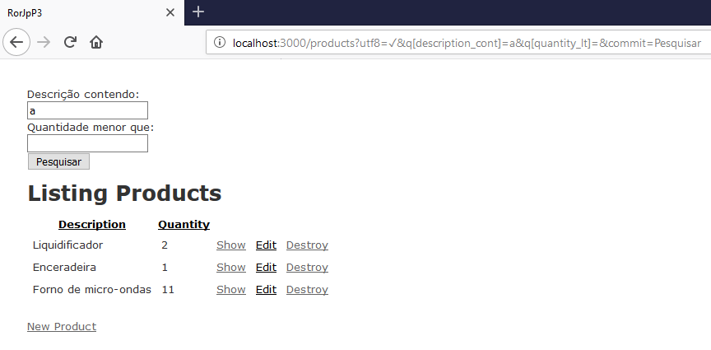

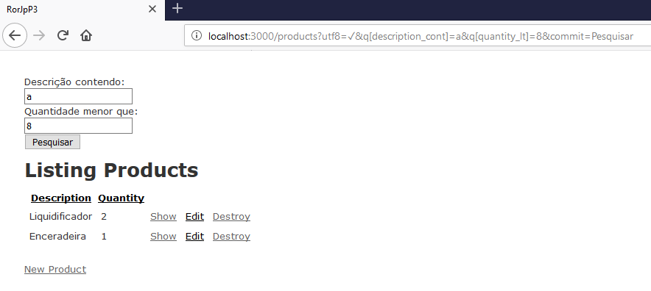

Pesquisas não restritivas (ou)

AND => OR

app/controllers/product_controller.rb

class ProductsController < ApplicationController
before_action :set_product, only: [:show, :edit, :update, :destroy]
before_action :authenticate_user!

# GET /products
# GET /products.json
def index
# @q = Product.ransack(params[:q])
@q = Product.ransack(params[:q].try(:merge, m: 'or'))
@products = @q.result

# @products = Product.all
end

# GET /products/1
# GET /products/1.json
def show
end

# GET /products/new
def new
@product = Product.new
end

# GET /products/1/edit
def edit
end

# POST /products
# POST /products.json
def create
@product = Product.new(product_params)

respond_to do |format|
if @product.save
format.html { redirect_to @product, notice: 'Product was successfully created.' }
format.json { render :show, status: :created, location: @product }
else
format.html { render :new }
format.json { render json: @product.errors, status: :unprocessable_entity }
end
end
end

# PATCH/PUT /products/1
# PATCH/PUT /products/1.json
def update
respond_to do |format|
if @product.update(product_params)
format.html { redirect_to @product, notice: 'Product was successfully updated.' }
format.json { render :show, status: :ok, location: @product }
else
format.html { render :edit }
format.json { render json: @product.errors, status: :unprocessable_entity }
end
end
end

# DELETE /products/1
# DELETE /products/1.json
def destroy
@product.destroy
respond_to do |format|
format.html { redirect_to products_url, notice: 'Product was successfully destroyed.' }
format.json { head :no_content }
end
end

private
# Use callbacks to share common setup or constraints between actions.
def set_product
@product = Product.find(params[:id])
end

# Never trust parameters from the scary internet, only allow the white list through.
def product_params
params.require(:product).permit(:description, :quantity)
end
end

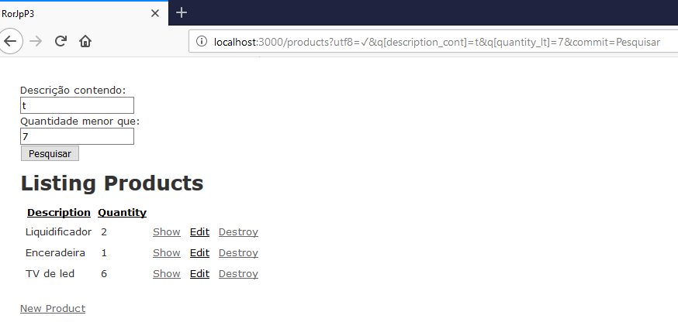

Automatizando o E/OU

app/controllers/product_controller.rb

class ProductsController < ApplicationController
before_action :set_product, only: [:show, :edit, :update, :destroy]
before_action :authenticate_user!

# GET /products
# GET /products.json
def index
# @q = Product.ransack(params[:q])
# @q = Product.ransack(params[:q].try(:merge, m: 'or'))
@q = Product.ransack(params[:q].try(:merge, m: params[:combinator]))
@products = @q.result

# @products = Product.all
end

# GET /products/1
# GET /products/1.json
def show
end

# GET /products/new
def new
@product = Product.new
end

# GET /products/1/edit
def edit
end

# POST /products
# POST /products.json
def create
@product = Product.new(product_params)

respond_to do |format|
if @product.save
format.html { redirect_to @product, notice: 'Product was successfully created.' }
format.json { render :show, status: :created, location: @product }
else
format.html { render :new }
format.json { render json: @product.errors, status: :unprocessable_entity }
end
end
end

# PATCH/PUT /products/1
# PATCH/PUT /products/1.json
def update
respond_to do |format|
if @product.update(product_params)
format.html { redirect_to @product, notice: 'Product was successfully updated.' }
format.json { render :show, status: :ok, location: @product }
else
format.html { render :edit }
format.json { render json: @product.errors, status: :unprocessable_entity }
end
end
end

# DELETE /products/1
# DELETE /products/1.json
def destroy
@product.destroy
respond_to do |format|
format.html { redirect_to products_url, notice: 'Product was successfully destroyed.' }
format.json { head :no_content }
end
end

private
# Use callbacks to share common setup or constraints between actions.
def set_product
@product = Product.find(params[:id])
end

# Never trust parameters from the scary internet, only allow the white list through.
def product_params
params.require(:product).permit(:description, :quantity)
end
end

app/views/products/index.html.erb

<p id="notice"><%= notice %></p>

<%= search_form_for @q do |f| %>
<%= f.label :description_cont, "Descrição contendo:" %>
<%= f.search_field :description_cont %>

<%= f.select :combinator, [['E','and'],['OU','or']] %>

<%= f.label :quantity_lteq, "Quantidade menor que:" %>
<%= f.search_field :quantity_lt %>

<br>

<%= f.submit %>
<% end %>

<h1>Listing Products</h1>

<table>
<thead>
<tr>
<th><%= sort_link(@q, :description) %></th>
<th><%= sort_link(@q, :quantity) %></th>
<th colspan="3"></th>
</tr>
</thead>

<tbody>
<% @products.each do |product| %>
<tr>
<td><%= product.description %></td>
<td><%= product.quantity %></td>
<td><%= link_to 'Show', product %></td>
<td><%= link_to 'Edit', edit_product_path(product) %></td>
<td><%= link_to 'Destroy', product, method: :delete, data: { confirm: 'Are you sure?' } %></td>
</tr>
<% end %>
</tbody>
</table>

<br>

<%= link_to 'New Product', new_product_path %>

