Curso de Ruby on Rails - aulas 41 a 50
Jackson Pires

https://www.youtube.com/watch?v=ZHPondVB9RQ&list=PLe3LRfCs4go-mkvHRMSXEOG-HDbzesyaP

Resumo do curso feito por Roberto Pinheiro

Aula 42 - Testes com Rails - Parte 1/2

Testes unitários

Teste de unidade é toda a aplicação de teste nas assinaturas de entrada e saída de um sistema. Consiste em validar dados válidos e inválidos via I/O (entrada/saída) sendo aplicado por desenvolvedores ou analistas de teste. Uma unidade é a menor parte testável de um programa de computador.

Testes de integração

Teste de integração é a fase do teste de software em que módulos são combinados e testados em grupo. Ela sucede o teste de unidade, em que os módulos são testados individualmente, e antecede o teste de sistema, em que o sistema completo (integrado) é testado num ambiente que simula o ambiente de produção.

Testes de aceitação

Teste de aceitação é uma fase do processo de teste em que um teste de caixa-preta é realizado num sistema antes de sua disponibilização. Tem por função verificar o sistema em relação aos seus requisitos originais, e às necessidades atuais do usuário.

Testes unitários e de integração

- TestUnit <= Rails 3
- MiniTest >= Rails 4
- RSpec

Testes de aceitação

- Capybara

TDD (Test Driven Development)

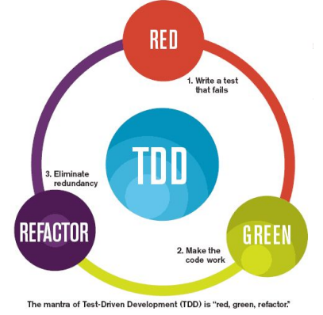

Para não criar a pasta "teste" com MiniTest usar -T

rails new ror-jp-p4 -T --database=mysql

RSpec

Instalação

group :development, :test do
gem 'rspec-rails', '~> 3.0'
end

Gemfile

source 'https://rubygems.org'
git_source(:github) { |repo| "https://github.com/#{repo}.git" }

ruby '2.5.1'

# Bundle edge Rails instead: gem 'rails', github: 'rails/rails'
gem 'rails', '~> 5.2.3'
# Use mysql as the database for Active Record
gem 'mysql2', '>= 0.4.4', '< 0.6.0'
# Use Puma as the app server
gem 'puma', '~> 3.11'
# Use SCSS for stylesheets
gem 'sass-rails', '~> 5.0'
# Use Uglifier as compressor for JavaScript assets
gem 'uglifier', '>= 1.3.0'
# See https://github.com/rails/execjs#readme for more supported runtimes
gem 'duktape'
# Use CoffeeScript for .coffee assets and views
gem 'coffee-rails', '~> 4.2'
# Turbolinks makes navigating your web application faster. Read more: https://github.com/turbolinks/turbolinks
gem 'turbolinks', '~> 5'
# Build JSON APIs with ease. Read more: https://github.com/rails/jbuilder
gem 'jbuilder', '~> 2.5'
# Use Redis adapter to run Action Cable in production
# gem 'redis', '~> 4.0'
# Use ActiveModel has_secure_password
# gem 'bcrypt', '~> 3.1.7'

# Use ActiveStorage variant
# gem 'mini_magick', '~> 4.8'

# Use Capistrano for deployment
# gem 'capistrano-rails', group: :development

# Reduces boot times through caching; required in config/boot.rb
gem 'bootsnap', '>= 1.1.0', require: false

group :development, :test do
# Call 'byebug' anywhere in the code to stop execution and get a debugger console
gem 'byebug', platforms: [:mri, :mingw, :x64_mingw]
gem 'rspec-rails', '~> 3.0'
end

group :development do
# Access an interactive console on exception pages or by calling 'console' anywhere in the code.
gem 'web-console', '>= 3.3.0'
end

# Windows does not include zoneinfo files, so bundle the tzinfo-data gem
gem 'tzinfo-data', platforms: [:mingw, :mswin, :x64_mingw, :jruby]

bundle install

rails generate rspec:install

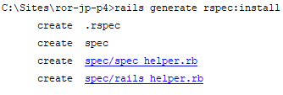

.rspec

--color
--require spec_helper
--format documentation

Configurações adicionais

config/application.rb :

config.generators do |g|
g.test_framework :rspec
end

config/application.rb

require_relative 'boot'

require "rails"
# Pick the frameworks you want:
require "active_model/railtie"
require "active_job/railtie"
require "active_record/railtie"
require "active_storage/engine"
require "action_controller/railtie"
require "action_mailer/railtie"
require "action_view/railtie"
require "action_cable/engine"
require "sprockets/railtie"
# require "rails/test_unit/railtie"

# Require the gems listed in Gemfile, including any gems
# you've limited to :test, :development, or :production.
Bundler.require(*Rails.groups)

module RorJpP4
class Application < Rails::Application
# Initialize configuration defaults for originally generated Rails version.
config.load_defaults 5.2

# Settings in config/environments/* take precedence over those specified here.
# Application configuration can go into files in config/initializers
# -- all .rb files in that directory are automatically loaded after loading
# the framework and any gems in your application.

# Don't generate system test files.
config.generators.system_tests = nil

config.generators do |g|
g.test_framework :rspec
end

end
end

Gerando teste

rails g scaffold User name:string email:string

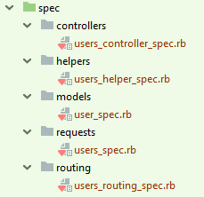

rake db:create db:migrate

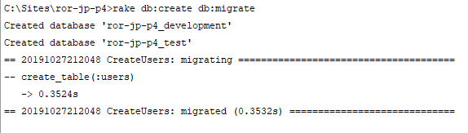

rake spec

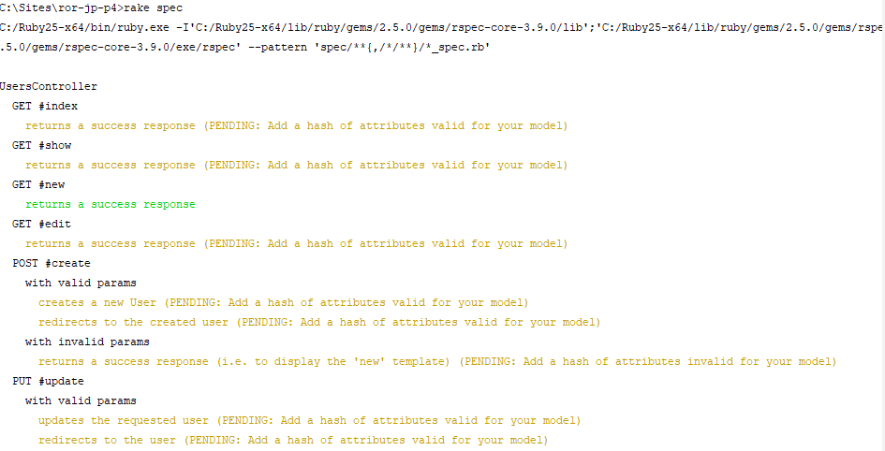
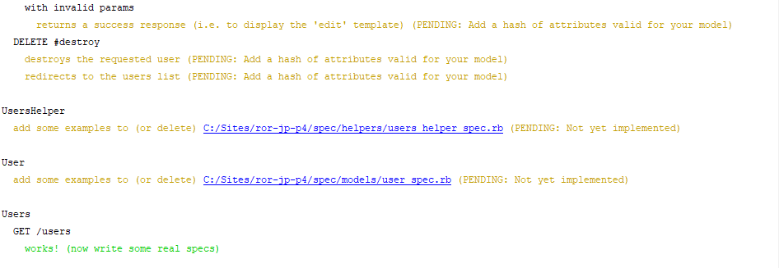
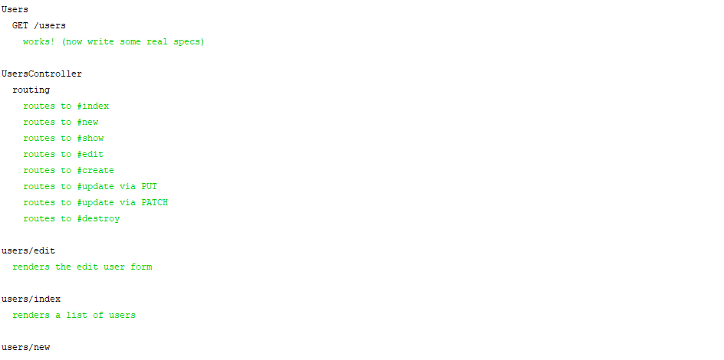
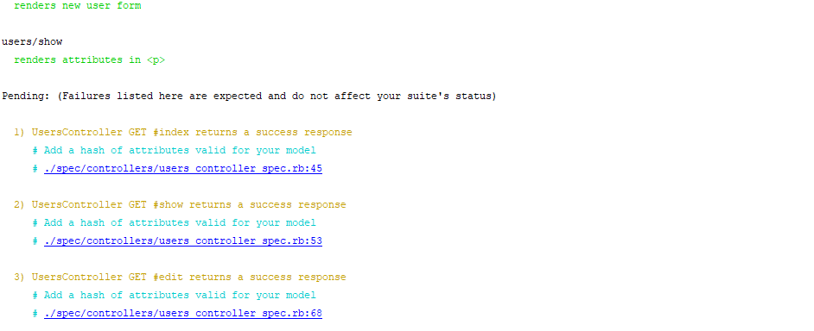
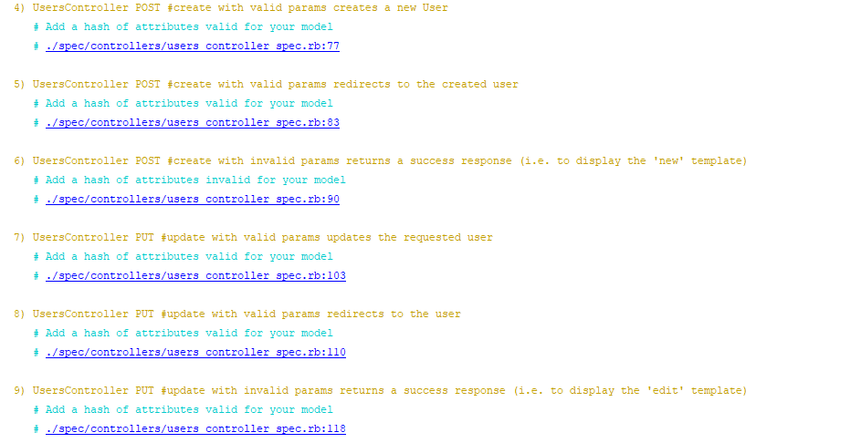

Fazendo apenas teste dos models

Configurações adicionais:

config.generators do |g|
g.test_framework :rspec,
:view_specs => false,
:controller_specs => false,
:helper_specs => false,
:routing_specs => false,
:request_specs => false
end

config/application.rb

require_relative 'boot'

require "rails"
# Pick the frameworks you want:
require "active_model/railtie"
require "active_job/railtie"
require "active_record/railtie"
require "active_storage/engine"
require "action_controller/railtie"
require "action_mailer/railtie"
require "action_view/railtie"
require "action_cable/engine"
require "sprockets/railtie"
# require "rails/test_unit/railtie"

# Require the gems listed in Gemfile, including any gems
# you've limited to :test, :development, or :production.
Bundler.require(*Rails.groups)

module RorJpP4
class Application < Rails::Application
# Initialize configuration defaults for originally generated Rails version.
config.load_defaults 5.2

# Settings in config/environments/* take precedence over those specified here.
# Application configuration can go into files in config/initializers
# -- all .rb files in that directory are automatically loaded after loading
# the framework and any gems in your application.

# Don't generate system test files.
config.generators.system_tests = nil

#Rspec configuration
config.generators do |g|
g.test_framework :rspec, :view_specs => false,
:controller_specs => false,
:helper_specs => false,
:routing_specs => false,
:request_specs => false
end

end
end

- Dentro da pasta spec apague todas as subpastas.

rails destroy scaffold User

rails g scaffold User name:string email:string

rake db:drop db:create db:migrate

rake spec

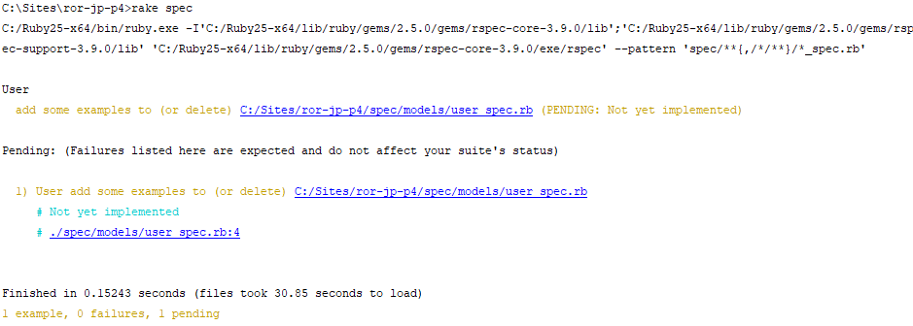

Validações

app/models/user.rb

class User < ApplicationRecord
validates :name, presence: true
validates :email, presence: true
end

Estrutura básica do Rspec

- context
- it

- Context tem a única finalidade de organizar seus testes.
- It especifica a ação a ser feita/testada

Exemplo:

context "Validade de um Usuário" do
it "Usuário válido?" do
… teste …
end
end

expectations/matchers

spec/models/user_spec.rb

require 'rails_helper'

RSpec.describe User, type: :model do
context "Validade de um Usuário" do
it "Usuário válido?" do
user = User.new
user.name = "Jackson"
user.email = "jackson@gmail.com"
expect(user.valid?).to be_truthy
end
end
end

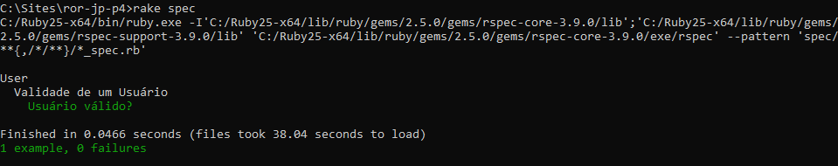

spec/models/user_spec.rb

require 'rails_helper'

RSpec.describe User, type: :model do
context "Validade de um Usuário" do
it "Usuário válido?" do
user = User.new
user.name = "Jackson"
user.email = "jackson@gmail.com"
expect(user.valid?).to be_truthy
end

it "Usuário inválido?" do
user = User.new
user.name = "Jackson"
user.email = nil
expect(user.valid?).to be_falsey
end

end
end

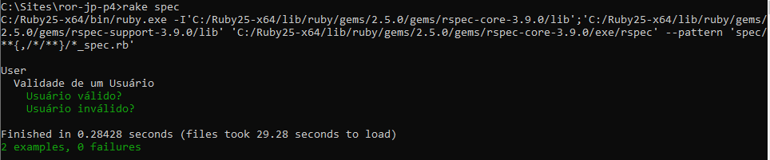

spec/models/user_spec.rb

require 'rails_helper'

RSpec.describe User, type: :model do
context "Validade de um Usuário" do
it "Usuário válido?" do
user = User.new
user.name = "Jackson"
user.email = "jackson@gmail.com"
expect(user.valid?).to be_truthy
end

it "Usuário inválido?" do
user = User.new
user.name = "Jackson"
user.email = nil
expect(user.valid?).to be_falsey
end
end

context "Títulos válidos" do
it "Título completo" do
user = User.new
user.name = "Jackson"
user.email = "jackson@gmail.com"
expect(user.titulo_completo).to eq("Sr. Jackson - Email: jackson@gmail.com")
end
end

end

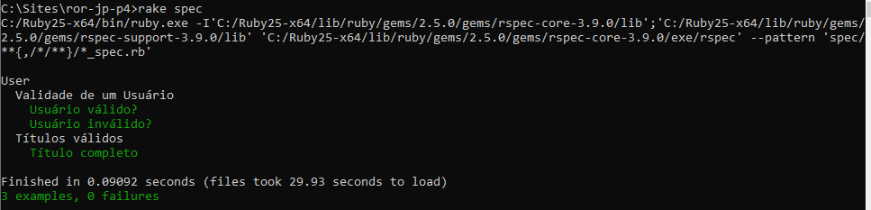

Links úteis

https://www.relishapp.com
http://betterspecs.org/br/

Aula 43 - Testes com Rails - Parte 2/2

Gemfile

source 'https://rubygems.org'
git_source(:github) { |repo| "https://github.com/#{repo}.git" }

ruby '2.5.1'

# Bundle edge Rails instead: gem 'rails', github: 'rails/rails'
gem 'rails', '~> 5.2.3'
# Use mysql as the database for Active Record
gem 'mysql2', '>= 0.4.4', '< 0.6.0'
# Use Puma as the app server
gem 'puma', '~> 3.11'
# Use SCSS for stylesheets
gem 'sass-rails', '~> 5.0'
# Use Uglifier as compressor for JavaScript assets
gem 'uglifier', '>= 1.3.0'
# See https://github.com/rails/execjs#readme for more supported runtimes
gem 'duktape'
# Use CoffeeScript for .coffee assets and views
gem 'coffee-rails', '~> 4.2'
# Turbolinks makes navigating your web application faster. Read more: https://github.com/turbolinks/turbolinks
gem 'turbolinks', '~> 5'
# Build JSON APIs with ease. Read more: https://github.com/rails/jbuilder
gem 'jbuilder', '~> 2.5'
# Use Redis adapter to run Action Cable in production
# gem 'redis', '~> 4.0'
# Use ActiveModel has_secure_password
# gem 'bcrypt', '~> 3.1.7'

# Use ActiveStorage variant
# gem 'mini_magick', '~> 4.8'

# Use Capistrano for deployment
# gem 'capistrano-rails', group: :development

# Reduces boot times through caching; required in config/boot.rb
gem 'bootsnap', '>= 1.1.0', require: false

group :development, :test do
# Call 'byebug' anywhere in the code to stop execution and get a debugger console
gem 'byebug', platforms: [:mri, :mingw, :x64_mingw]
gem 'rspec-rails', '~> 3.0'
gem 'capybara'
end

group :development do
# Access an interactive console on exception pages or by calling 'console' anywhere in the code.
gem 'web-console', '>= 3.3.0'
end

# Windows does not include zoneinfo files, so bundle the tzinfo-data gem
gem 'tzinfo-data', platforms: [:mingw, :mswin, :x64_mingw, :jruby]

Configuração Adicional

rails_helper.rb

config.include Capybara::DSL

spec/rails_helper.rb

# This file is copied to spec/ when you run 'rails generate rspec:install'
require 'spec_helper'
ENV['RAILS_ENV'] ||= 'test'

require File.expand_path('../config/environment', __dir__)

# Prevent database truncation if the environment is production
abort("The Rails environment is running in production mode!") if Rails.env.production?
require 'rspec/rails'
# Add additional requires below this line. Rails is not loaded until this point!

# Requires supporting ruby files with custom matchers and macros, etc, in
# spec/support/ and its subdirectories. Files matching `spec/**/*_spec.rb` are
# run as spec files by default. This means that files in spec/support that end
# in _spec.rb will both be required and run as specs, causing the specs to be
# run twice. It is recommended that you do not name files matching this glob to
# end with _spec.rb. You can configure this pattern with the --pattern
# option on the command line or in ~/.rspec, .rspec or `.rspec-local`.
#
# The following line is provided for convenience purposes. It has the downside
# of increasing the boot-up time by auto-requiring all files in the support
# directory. Alternatively, in the individual `*_spec.rb` files, manually
# require only the support files necessary.
#
# Dir[Rails.root.join('spec', 'support', '**', '*.rb')].each { |f| require f }

# Checks for pending migrations and applies them before tests are run.
# If you are not using ActiveRecord, you can remove these lines.
begin
ActiveRecord::Migration.maintain_test_schema!
rescue ActiveRecord::PendingMigrationError => e
puts e.to_s.strip
exit 1
end
RSpec.configure do |config|
# Remove this line if you're not using ActiveRecord or ActiveRecord fixtures
config.fixture_path = "#{::Rails.root}/spec/fixtures"

# If you're not using ActiveRecord, or you'd prefer not to run each of your
# examples within a transaction, remove the following line or assign false
# instead of true.
config.use_transactional_fixtures = true

# RSpec Rails can automatically mix in different behaviours to your tests
# based on their file location, for example enabling you to call `get` and
# `post` in specs under `spec/controllers`.
#
# You can disable this behaviour by removing the line below, and instead
# explicitly tag your specs with their type, e.g.:
#
# RSpec.describe UsersController, :type => :controller do
# # ...
# end
#
# The different available types are documented in the features, such as in
# https://relishapp.com/rspec/rspec-rails/docs
config.infer_spec_type_from_file_location!

# Filter lines from Rails gems in backtraces.
config.filter_rails_from_backtrace!
# arbitrary gems may also be filtered via:
# config.filter_gems_from_backtrace("gem name")

# Capybara
config.include Capybara::DSL
end

Configuração Adicional

evironments/test.rb

config.allow_concurrency = false

config/ evironments/test.rb

Rails.application.configure do
# Settings specified here will take precedence over those in config/application.rb.

# The test environment is used exclusively to run your application's
# test suite. You never need to work with it otherwise. Remember that
# your test database is "scratch space" for the test suite and is wiped
# and recreated between test runs. Don't rely on the data there!
config.cache_classes = true

# Do not eager load code on boot. This avoids loading your whole application
# just for the purpose of running a single test. If you are using a tool that
# preloads Rails for running tests, you may have to set it to true.
config.eager_load = false

# Configure public file server for tests with Cache-Control for performance.
config.public_file_server.enabled = true
config.public_file_server.headers = {
'Cache-Control' => "public, max-age=#{1.hour.to_i}"
}

# Show full error reports and disable caching.
config.consider_all_requests_local = true
config.action_controller.perform_caching = false

# Raise exceptions instead of rendering exception templates.
config.action_dispatch.show_exceptions = false

# Disable request forgery protection in test environment.
config.action_controller.allow_forgery_protection = false

# Store uploaded files on the local file system in a temporary directory
config.active_storage.service = :test

config.action_mailer.perform_caching = false

# Tell Action Mailer not to deliver emails to the real world.
# The :test delivery method accumulates sent emails in the
# ActionMailer::Base.deliveries array.
config.action_mailer.delivery_method = :test

# Print deprecation notices to the stderr.
config.active_support.deprecation = :stderr

# Raises error for missing translations
# config.action_view.raise_on_missing_translations = true
config.allow_concurrency = false
end

Usando!

require 'capybara/rspec'

spec/models/user_spec.rb

require 'rails_helper'

RSpec.describe User, type: :model do

context "Testando a View User" do
it "Cadastrar um usuário" do
visit '/users/new'
within("#form_user") do
fill_in 'Name', with: 'Jackson'
fill_in 'Email', with: 'jackson@gmail.com'
end
click_button 'Create User'
expect(page).to have_content 'User was successfully created.'
end
end

context "Validade de um Usuário" do
it "Usuário válido?" do
user = User.new
user.name = "Jackson"
user.email = "jackson@gmail.com"
expect(user.valid?).to be_truthy
end

it "Usuário inválido?" do
user = User.new
user.name = "Jackson"
user.email = nil
expect(user.valid?).to be_falsey
end
end

context "Títulos válidos" do
it "Título completo" do
user = User.new
user.name = "Jackson"
user.email = "jackson@gmail.com"
expect(user.titulo_completo).to eq("Sr. Jackson - Email: jackson@gmail.com")
end
end

end

app/views/users/_form.html.erb

<%= form_with(model: user, id: "form_user", local: true) do |form| %>
<% if user.errors.any? %>
<div id="error_explanation">
<h2><%= pluralize(user.errors.count, "error") %> prohibited this user from being saved:</h2>

<ul>
<% user.errors.full_messages.each do |message| %>
<li><%= message %></li>
<% end %>
</ul>
</div>
<% end %>

<div class="field">
<%= form.label :name %>
<%= form.text_field :name %>
</div>

<div class="field">
<%= form.label :email %>
<%= form.text_field :email %>
</div>

<div class="actions">
<%= form.submit %>
</div>
<% end %>

rake spec

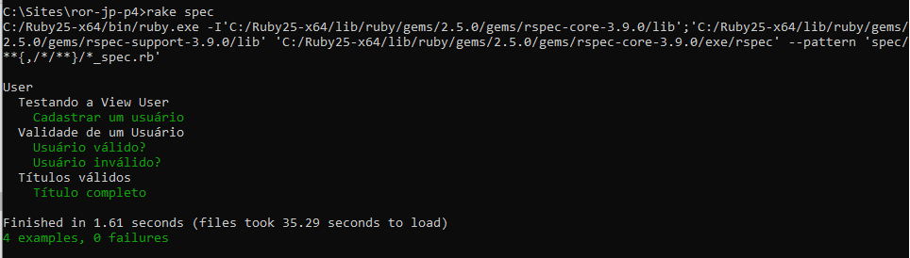

spec/models/user_spec.rb

require 'rails_helper'

RSpec.describe User, type: :model do

context "Testando a View User" do
it "Cadastrar um usuário" do
users = User.all
size_old = users.size
visit '/users/new'
within("#form_user") do
fill_in 'Name', with: 'Jackson'
fill_in 'Email', with: 'jackson@gmail.com'
end
click_button 'Create User'
expect(page).to have_content 'User was successfully created.'
users = User.all
expect(users.size).to eq(size_old + 1)

end
end

context "Validade de um Usuário" do
it "Usuário válido?" do
user = User.new
user.name = "Jackson"
user.email = "jackson@gmail.com"
expect(user.valid?).to be_truthy
end

it "Usuário inválido?" do
user = User.new
user.name = "Jackson"
user.email = nil
expect(user.valid?).to be_falsey
end
end

context "Títulos válidos" do
it "Título completo" do
user = User.new
user.name = "Jackson"
user.email = "jackson@gmail.com"
expect(user.titulo_completo).to eq("Sr. Jackson - Email: jackson@gmail.com")
end
end

end

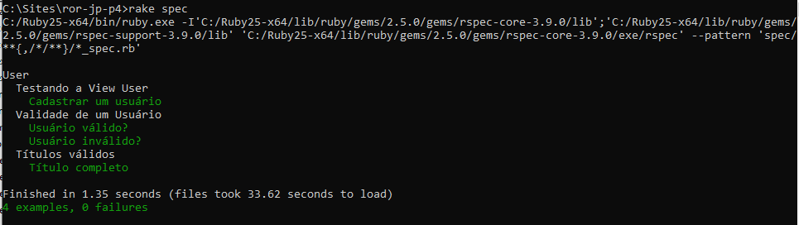

Aula 44 - Asset Pipeline 1/2

O que é?

Asset Pipeline fornece uma estrutura para concatenar e minificar ou comprimir os assets JavaScript e CSS. Ele também adiciona a capacidade de escrever esses assets em outros idiomas e pré-processadores como CoffeeScript, Sass e ERB.

Organização

- app/assets
- lib/assets
- vendor/assets.

Usando

<%= stylesheet_link_tag "application", media: "all" %>
<%= javascript_include_tag "application" %>

app/views/layouts/application.html.erb

<!DOCTYPE html>
<html>
<head>
<title>RorJpP4</title>
<%= csrf_meta_tags %>
<%= csp_meta_tag %>

<%= stylesheet_link_tag 'application', media: 'all', 'data-turbolinks-track': 'reload' %>
<%= javascript_include_tag 'application', 'data-turbolinks-track': 'reload' %>
</head>

<body>
<%= yield %>
</body>
</html>

app/asset/javascripts/application.js

// This is a manifest file that'll be compiled into application.js, which will include all the files
// listed below.
//
// Any JavaScript/Coffee file within this directory, lib/assets/javascripts, or any plugin's
// vendor/assets/javascripts directory can be referenced here using a relative path.
//
// It's not advisable to add code directly here, but if you do, it'll appear at the bottom of the
// compiled file. JavaScript code in this file should be added after the last require_* statement.
//
// Read Sprockets README (https://github.com/rails/sprockets#sprockets-directives) for details
// about supported directives.
//
//= require rails-ujs
//= require activestorage
//= require turbolinks
//= require_tree .

Aula 45 - Asset Pipeline 2/2

rails g scaffold Customer name:string address:string

rake db:migrate

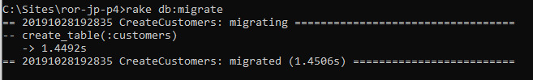

Assets para controllers específicos

params[:controller]

app/assets/javascripts/application.js

// This is a manifest file that'll be compiled into application.js, which will include all the files
// listed below.
//
// Any JavaScript/Coffee file within this directory, lib/assets/javascripts, or any plugin's
// vendor/assets/javascripts directory can be referenced here using a relative path.
//
// It's not advisable to add code directly here, but if you do, it'll appear at the bottom of the
// compiled file. JavaScript code in this file should be added after the last require_* statement.
//
// Read Sprockets README (https://github.com/rails/sprockets#sprockets-directives) for details
// about supported directives.
//
//= require rails-ujs
//= require activestorage
//= require turbolinks
//= require_tree .

app/assets/stylesheets/application.css

/*
* This is a manifest file that'll be compiled into application.css, which will include all the files
* listed below.
*
* Any CSS and SCSS file within this directory, lib/assets/stylesheets, or any plugin's
* vendor/assets/stylesheets directory can be referenced here using a relative path.
*
* You're free to add application-wide styles to this file and they'll appear at the bottom of the
* compiled file so the styles you add here take precedence over styles defined in any other CSS/SCSS
* files in this directory. Styles in this file should be added after the last require_* statement.
* It is generally better to create a new file per style scope.
*
*= require_tree .
*= require_self
*/

Precompilar Assets Adicionais

Rails.application.config.assets.precompile += %w( search.js )

config/initializers/assets.rb

# Be sure to restart your server when you modify this file.

# Version of your assets, change this if you want to expire all your assets.
Rails.application.config.assets.version = '1.0'

# Add additional assets to the asset load path.
# Rails.application.config.assets.paths << Emoji.images_path
# Add Yarn node_modules folder to the asset load path.
Rails.application.config.assets.paths << Rails.root.join('node_modules')

# Precompile additional assets.
# application.js, application.css, and all non-JS/CSS in the app/assets
# folder are already added.
# Rails.application.config.assets.precompile += %w( admin.js admin.css )
Rails.application.config.assets.precompile += %w( customers.coffee
customers.scss
users.coffee
users.scss )

content_for

<%= yield :head %>

<% content_for :head do %>
....
<% end %>

app/views/layouts/application.html.erb

<!DOCTYPE html>
<html>
<head>
<title>RorJpP4</title>
<%= csrf_meta_tags %>
<%= csp_meta_tag %>

<%= stylesheet_link_tag 'application', media: 'all', 'data-turbolinks-track': 'reload' %>
<%= javascript_include_tag 'application', 'data-turbolinks-track': 'reload' %>

<%= yield :head %>

</head>

<body>
<%= yield %>
</body>
</html>

app/views/customers/index.html.erb

<% content_for :head do %>
<%= stylesheet_link_tag params[:controller] %>
<%= javascript_include_tag params[:controller] %>
<% end %>

<p id="notice"><%= notice %></p>

<h1>Customers</h1>

<table>
<thead>
<tr>
<th>Name</th>
<th>Address</th>
<th colspan="3"></th>
</tr>
</thead>

<tbody>
<% @customers.each do |customer| %>
<tr>
<td><%= customer.name %></td>
<td><%= customer.address %></td>
<td><%= link_to 'Show', customer %></td>
<td><%= link_to 'Edit', edit_customer_path(customer) %></td>
<td><%= link_to 'Destroy', customer, method: :delete, data: { confirm: 'Are you sure?' } %></td>
</tr>
<% end %>
</tbody>
</table>

<br>

<%= link_to 'New Customer', new_customer_path %>

app/views/users/index.html.erb

<% content_for :head do %>
<%= stylesheet_link_tag params[:controller] %>
<%= javascript_include_tag params[:controller] %>
<% end %>

<p id="notice"><%= notice %></p>

<h1>Users</h1>

<table>
<thead>
<tr>
<th>Name</th>
<th>Email</th>
<th colspan="3"></th>
</tr>
</thead>

<tbody>
<% @users.each do |user| %>
<tr>
<td><%= user.name %></td>
<td><%= user.email %></td>
<td><%= link_to 'Show', user %></td>
<td><%= link_to 'Edit', edit_user_path(user) %></td>
<td><%= link_to 'Destroy', user, method: :delete, data: { confirm: 'Are you sure?' } %></td>
</tr>
<% end %>
</tbody>
</table>

<br>

<%= link_to 'New User', new_user_path %>

Aula 46 - Ajax

- Copie o arquivo jquery.js para dentro da pasta app/assets/javascripts.

app/assets/javascripts/application.js

// This is a manifest file that'll be compiled into application.js, which will include all the files
// listed below.
//
// Any JavaScript/Coffee file within this directory, lib/assets/javascripts, or any plugin's
// vendor/assets/javascripts directory can be referenced here using a relative path.
//
// It's not advisable to add code directly here, but if you do, it'll appear at the bottom of the
// compiled file. JavaScript code in this file should be added after the last require_* statement.
//
// Read Sprockets README (https://github.com/rails/sprockets#sprockets-directives) for details
// about supported directives.
//
//= require jquery
//= require rails-ujs
//= require activestorage
//= require turbolinks

app/views/users/new.html.erb

<div class="message">
<h1 style="color:green;">Teste!</h1>
</div>

<h1>New User</h1>

<%= render 'form', user: @user %>

<%= link_to 'Back', users_path %>

Testes com o jquery

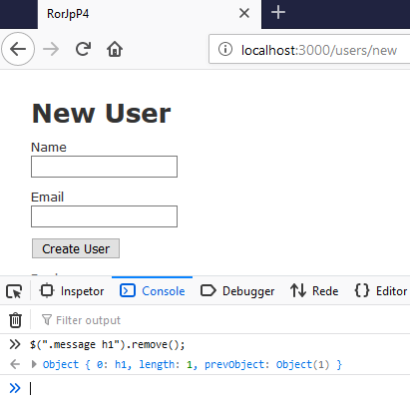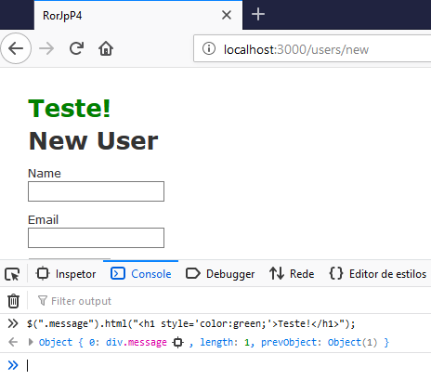

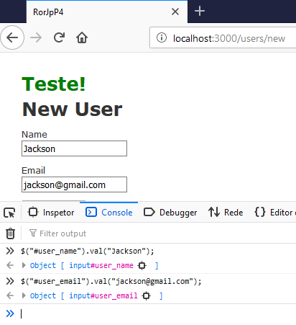

Rails + Ajax

app/views/users/_form.html.erb

<%= form_with(model: user, remote: true, id: "form_user", local: true) do |form| %>
<% if user.errors.any? %>
<div id="error_explanation">
<h2><%= pluralize(user.errors.count, "error") %> prohibited this user from being saved:</h2>

<ul>
<% user.errors.full_messages.each do |message| %>
<li><%= message %></li>
<% end %>
</ul>
</div>
<% end %>

<div class="field">
<%= form.label :name %>
<%= form.text_field :name %>
</div>

<div class="field">
<%= form.label :email %>
<%= form.text_field :email %>
</div>

<div class="actions">
<%= form.submit %>
</div>
<% end %>

app/controllers/users_controller.rb

class UsersController < ApplicationController
before_action :set_user, only: [:show, :edit, :update, :destroy]

# GET /users
# GET /users.json
def index
@users = User.all
end

# GET /users/1
# GET /users/1.json
def show
end

# GET /users/new
def new
@user = User.new
end

# GET /users/1/edit
def edit
end

# POST /users
# POST /users.json
def create
@user = User.new(user_params)

respond_to do |format|
if @user.save
format.html { redirect_to @user, notice: 'User was successfully created.' }
format.json { render :show, status: :created, location: @user }
format.js # views/users/create.js.erb
else
format.html { render :new }
format.json { render json: @user.errors, status: :unprocessable_entity }
format.js # views/users/create.js.erb
end
end
end

# PATCH/PUT /users/1
# PATCH/PUT /users/1.json
def update
respond_to do |format|
if @user.update(user_params)
format.html { redirect_to @user, notice: 'User was successfully updated.' }
format.json { render :show, status: :ok, location: @user }
else
format.html { render :edit }
format.json { render json: @user.errors, status: :unprocessable_entity }
end
end
end

# DELETE /users/1
# DELETE /users/1.json
def destroy
@user.destroy
respond_to do |format|
format.html { redirect_to users_url, notice: 'User was successfully destroyed.' }
format.json { head :no_content }
end
end

private
# Use callbacks to share common setup or constraints between actions.
def set_user
@user = User.find(params[:id])
end

# Never trust parameters from the scary internet, only allow the white list through.
def user_params
params.require(:user).permit(:name, :email)
end
end

app/views/users/create.js.erb

var qtdErrors = <%= @user.errors.count %>;

if (qtdErrors > 0) {
$(".message").html("<h1>Ocorreu um erro!</h1>").css({color: "red"});
} else {
$(".message").html("<h1>Cadastrado com sucesso!</h1>").css({color: "green"});
$("#user_name").val("");
$("#user_email").val("");
}
setTimeout(function(){ $(".message h1").remove() }, 5000);

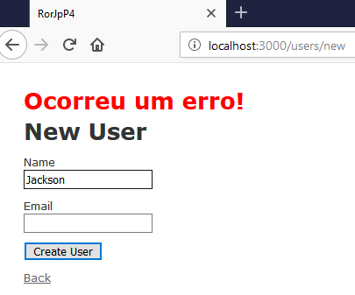

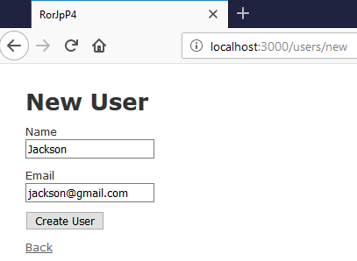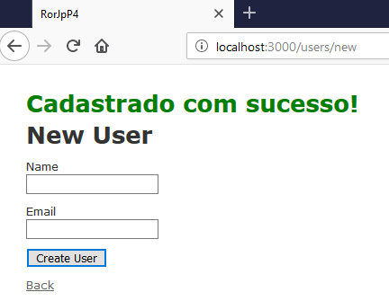

Aula 47 - Notify.js + Rails

https://notifyjs.jpillora.com/

- Baixar notify.js e copiá-lo para a pasta app/assets/javascripts.

config/initializers/assets.rb

# Be sure to restart your server when you modify this file.

# Version of your assets, change this if you want to expire all your assets.
Rails.application.config.assets.version = '1.0'

# Add additional assets to the asset load path.
# Rails.application.config.assets.paths << Emoji.images_path
# Add Yarn node_modules folder to the asset load path.
Rails.application.config.assets.paths << Rails.root.join('node_modules')

# Precompile additional assets.
# application.js, application.css, and all non-JS/CSS in the app/assets
# folder are already added.
# Rails.application.config.assets.precompile += %w( admin.js admin.css )
Rails.application.config.assets.precompile += %w( customers.coffee
customers.scss
users.coffee
users.scss
jquery.js
notify.js )

app/views/users/new.html.erb

<% content_for :head do %>
<%= javascript_include_tag 'notify' %>
<% end %>

<h1>New User</h1>

<%= render 'form', user: @user %>

<%= link_to 'Back', users_path %>

app/views/users/create.js.erb

var qtdErrors = <%= @user.errors.count %>;

if (qtdErrors > 0) {
$.notify("Ocorreu um erro!", "error");
} else {
$.notify("Cadastrado com sucesso!", "success");
$("#user_name").val("");
$("#user_email").val("");
}

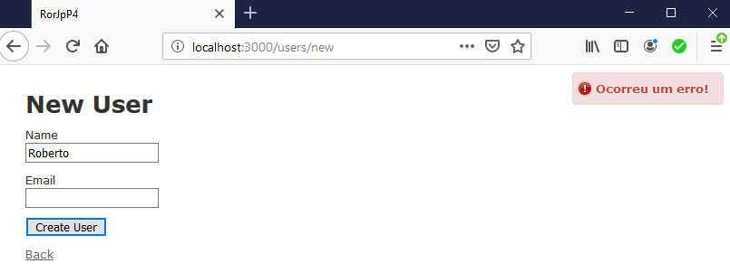

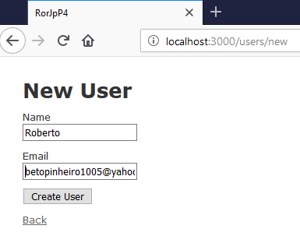

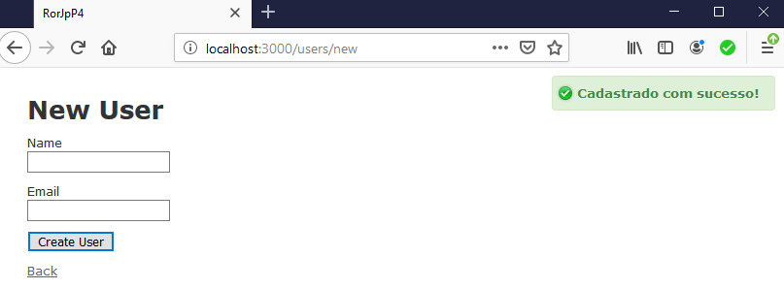

Aula 48 - Has Many Through + Cocoon gem

https://guides.rubyonrails.org/association_basics.html#the-has-many-through-association

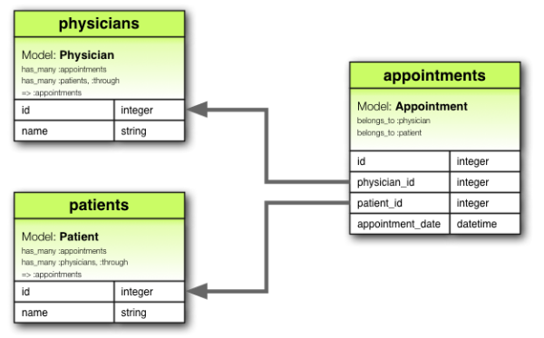

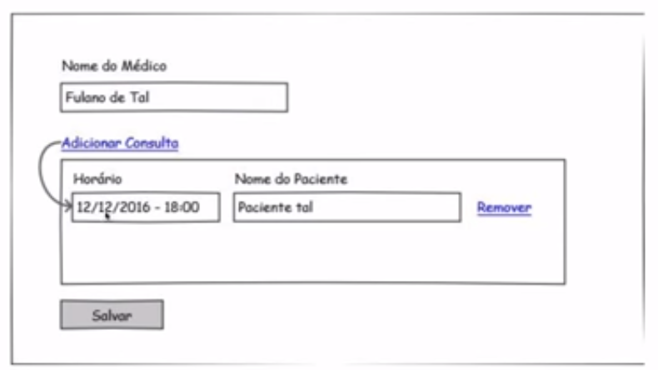

Gerando os scaffolds

rails generate scaffold Physician name:string

rails generate scaffold Appointment physician:references patient:references appointment_date:datetime

rails generate scaffold Patient name:string

rake db:migrate
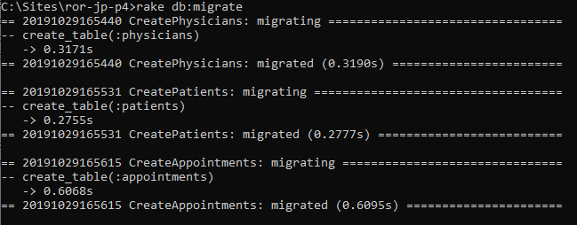

app/models/patient.rb

class Patient < ActiveRecord::Base
has_many :appointments
has_many :physicians, through: :appointments
end

app/models/physician.rb

class Physician < ActiveRecord::Base
has_many :appointments
has_many :patients, through: :appointments
end

app/models/appointment.rb

class Appointment < ApplicationRecord
belongs_to :physician
belongs_to :patient
end

Nested Attributes

app/models/appointment.rb

class Appointment < ApplicationRecord
belongs_to :physician
belongs_to :patient

accepts_nested_attributes_for :patient, reject_if: :all_blank, allow_destroy: true
end

app/models/physician.rb

class Physician < ActiveRecord::Base
has_many :appointments
has_many :patients, through: :appointments

accepts_nested_attributes_for :appointments, reject_if: :all_blank, allow_destroy: true
end

Strong Parameters

def physician_params
params.require(:physician).permit(:name, :appointments_attributes => [:id, :appointment_date, :physician_id, :patient_id, :_destroy, :patient_attributes => [:id, :name]])
end

app/controllers/physicians_controller.rb

class PhysiciansController < ApplicationController
before_action :set_physician, only: [:show, :edit, :update, :destroy]

# GET /physicians
# GET /physicians.json
def index
@physicians = Physician.all
end

# GET /physicians/1
# GET /physicians/1.json
def show
end

# GET /physicians/new
def new
@physician = Physician.new
end

# GET /physicians/1/edit
def edit
end

# POST /physicians
# POST /physicians.json
def create
@physician = Physician.new(physician_params)

respond_to do |format|
if @physician.save
format.html { redirect_to @physician, notice: 'Physician was successfully created.' }
format.json { render :show, status: :created, location: @physician }
else
format.html { render :new }
format.json { render json: @physician.errors, status: :unprocessable_entity }
end
end
end

# PATCH/PUT /physicians/1
# PATCH/PUT /physicians/1.json
def update
respond_to do |format|
if @physician.update(physician_params)
format.html { redirect_to @physician, notice: 'Physician was successfully updated.' }
format.json { render :show, status: :ok, location: @physician }
else
format.html { render :edit }
format.json { render json: @physician.errors, status: :unprocessable_entity }
end
end
end

# DELETE /physicians/1
# DELETE /physicians/1.json
def destroy
@physician.destroy
respond_to do |format|
format.html { redirect_to physicians_url, notice: 'Physician was successfully destroyed.' }
format.json { head :no_content }
end
end

private
# Use callbacks to share common setup or constraints between actions.
def set_physician
@physician = Physician.find(params[:id])
end

# Never trust parameters from the scary internet, only allow the white list through.
def physician_params
params.require(:physician).permit(:name, :appointments_attributes => [:id, :appointment_date, :physician_id, :patient_id, :_destroy, :patient_attributes => [:id, :name]])
end
end

Cocoon

https://github.com/nathanvda/cocoon

Gemfile

source 'https://rubygems.org'
git_source(:github) { |repo| "https://github.com/#{repo}.git" }

ruby '2.5.1'

gem 'rails', '~> 5.2.3'
# Use mysql as the database for Active Record
gem 'mysql2', '>= 0.4.4', '< 0.6.0'
# Use Puma as the app server
gem 'puma', '~> 3.11'
# Use SCSS for stylesheets
gem 'sass-rails', '~> 5.0'
# Use Uglifier as compressor for JavaScript assets
gem 'uglifier', '>= 1.3.0'
# See https://github.com/rails/execjs#readme for more supported runtimes
gem 'duktape'
# Use CoffeeScript for .coffee assets and views
gem 'coffee-rails', '~> 4.2'
# Turbolinks makes navigating your web application faster. Read more: https://github.com/turbolinks/turbolinks
gem 'turbolinks', '~> 5'
# Build JSON APIs with ease. Read more: https://github.com/rails/jbuilder
gem 'jbuilder', '~> 2.5'
# Use Redis adapter to run Action Cable in production
# gem 'redis', '~> 4.0'
# Use ActiveModel has_secure_password
# gem 'bcrypt', '~> 3.1.7'

# Use ActiveStorage variant
# gem 'mini_magick', '~> 4.8'

# Use Capistrano for deployment
# gem 'capistrano-rails', group: :development

# Reduces boot times through caching; required in config/boot.rb
gem 'bootsnap', '>= 1.1.0', require: false
# Cocoon
gem "cocoon"

group :development, :test do
# Call 'byebug' anywhere in the code to stop execution and get a debugger console
gem 'byebug', platforms: [:mri, :mingw, :x64_mingw]
gem 'rspec-rails', '~> 3.0'
gem 'capybara'
end

group :development do
# Access an interactive console on exception pages or by calling 'console' anywhere in the code.
gem 'web-console', '>= 3.3.0'
end

# Windows does not include zoneinfo files, so bundle the tzinfo-data gem
gem 'tzinfo-data', platforms: [:mingw, :mswin, :x64_mingw, :jruby]

bundle install

Rails 3.1+/Rails 4/Rails 5

Add the following to application.js so it compiles to the asset pipeline:

//= require cocoon

app/assets/javascripts/application.js

// This is a manifest file that'll be compiled into application.js, which will include all the files
// listed below.
//
// Any JavaScript/Coffee file within this directory, lib/assets/javascripts, or any plugin's
// vendor/assets/javascripts directory can be referenced here using a relative path.
//
// It's not advisable to add code directly here, but if you do, it'll appear at the bottom of the
// compiled file. JavaScript code in this file should be added after the last require_* statement.
//
// Read Sprockets README (https://github.com/rails/sprockets#sprockets-directives) for details
// about supported directives.
//
//= require jquery
//= require rails-ujs
//= require activestorage
//= require turbolinks
//= require cocoon

Helpers

link_to_add_association

This function adds a link to your markup that, when clicked, dynamically adds a new partial form for the given association.

link_to_remove_association

This function will add a link to your markup that, when clicked, dynamically removes the surrounding partial form. This should be placed inside the partial _<association-object-singular>_fields.

Formulário Physician

...

<%= link_to_add_association 'add appointment', f, :appointments, 'data-association-insertion-node' => "#appointments-patient ol", 'data-association-insertion-method' => "append", :wrap_object => Proc. new {|appointment| appointment.build_patient; appointment } %>

<hr/>

<fieldset id="appointments-patient">
<ol>
<%= f.fields_for :appointments do |appointment| %>
<%= render partial: "appointment_fields", locals: { f:appointment } %>
<% end %>
</ol>
<fieldset/>

_appointment_fields.html.erb

<li class="control-group nested-fields">
<div class="controls">
<%= f.datetime_select :appointment_date %>>
<%= f.fields_for :patient do |appointment_patient| %>
<%= appointment_patient.text_field :name %>
<% end %>
<%= link_to_remove_association "remove", f %>
</div>
</li>

app/views/physicians/_form.html.erb

<%= form_for @physician do |f| %>
<% if @physician.errors.any? %>
<div id="error_explanation">
<h2><%= pluralize(@physician.errors.count, "error") %> prohibited this physician from being saved:</h2>

<ul>
<% @physician.errors.full_messages.each do |message| %>
<li><%= message %></li>
<% end %>
</ul>
</div>
<% end %>

<div class="field">
<%= f.label :name %>
<%= f.text_field :name %>

<br><br>

<%= link_to_add_association 'add appointment', f,
:appointments, 'data-association-insertion-node' => "#appointments-patient ol",
'data-association-insertion-method' => "append",
:wrap_object => Proc. new {|appointment| appointment.build_patient; appointment },
class: "btn btn-primary"
%>

<hr/>

<fieldset id="appointments-patient">
<ol>
<%= f.fields_for :appointments do |appointment| %>
<%= render partial: "appointment_fields", locals: { f:appointment } %>
<% end %>
</ol>
<fieldset/>
</div>

<div class="actions">
<%= f.submit class: "btn btn-success" %>
</div>
<% end %>

app/views/physicians/_appointment_fields.html.erb

<li class="control-group nested-fields">
<div class="controls">
<%= f.datetime_select :appointment_date %>>
<%= f.fields_for :patient do |appointment_patient| %>
<%= appointment_patient.text_field :name %>
<% end %>
<%= link_to_remove_association "Remover", f, class: "btn btn-default" %>
</div>
</li>

rake db:migrate

- Baixe e copie o arquivo bootstrap.css para a pasta app/assets/stylesheets.

config/initializers/assets.rb

# Be sure to restart your server when you modify this file.

# Version of your assets, change this if you want to expire all your assets.
Rails.application.config.assets.version = '1.0'

# Add additional assets to the asset load path.
# Rails.application.config.assets.paths << Emoji.images_path
# Add Yarn node_modules folder to the asset load path.
Rails.application.config.assets.paths << Rails.root.join('node_modules')

# Precompile additional assets.
# application.js, application.css, and all non-JS/CSS in the app/assets
# folder are already added.
# Rails.application.config.assets.precompile += %w( admin.js admin.css )
Rails.application.config.assets.precompile += %w( customers.coffee
customers.scss
users.coffee
users.scss
jquery.js
notify.js
bootstrap.css )

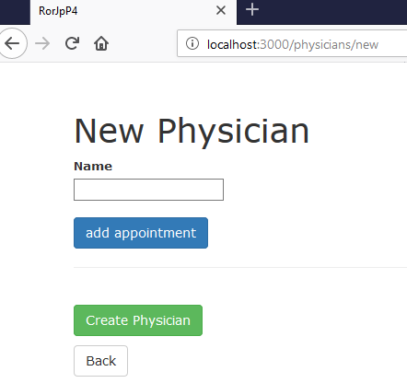

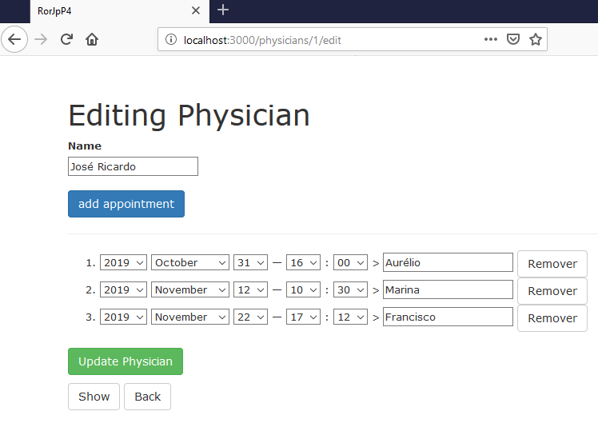

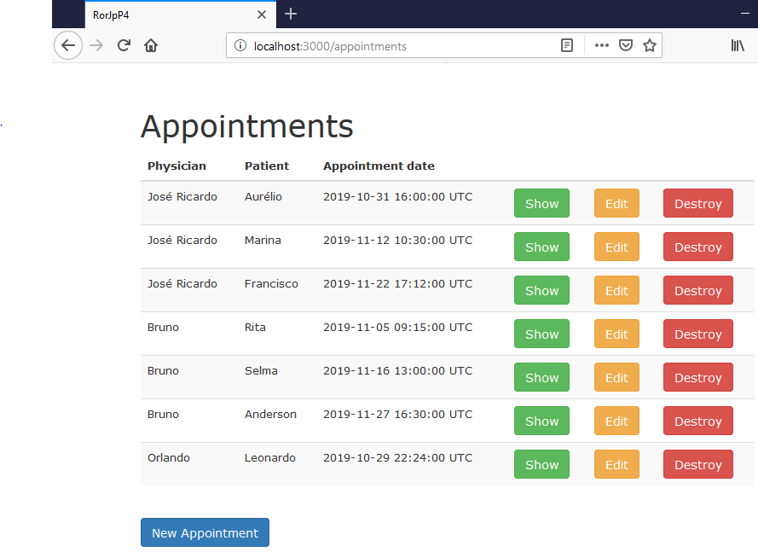

Aula 49 - Rails Admin Interfaces

Ruby-Toolbox

https://www.ruby-toolbox.com/categories/rails_admin_interfaces

Active Scaffold

https://github.com/activescaffold/active_scaffold

Gemfile

source 'https://rubygems.org'
git_source(:github) { |repo| "https://github.com/#{repo}.git" }

ruby '2.5.1'

gem 'rails', '~> 5.2.3'
# Use mysql as the database for Active Record
gem 'mysql2', '>= 0.4.4', '< 0.6.0'
# Use Puma as the app server
gem 'puma', '~> 3.11'
# Use SCSS for stylesheets
gem 'sass-rails', '~> 5.0'
# Use Uglifier as compressor for JavaScript assets
gem 'uglifier', '>= 1.3.0'
# See https://github.com/rails/execjs#readme for more supported runtimes
gem 'duktape'
# Use CoffeeScript for .coffee assets and views
gem 'coffee-rails', '~> 4.2'
# Turbolinks makes navigating your web application faster. Read more: https://github.com/turbolinks/turbolinks
gem 'turbolinks', '~> 5'
# Build JSON APIs with ease. Read more: https://github.com/rails/jbuilder
gem 'jbuilder', '~> 2.5'
# ActiveScaffold
gem 'active_scaffold'
# Use Redis adapter to run Action Cable in production
# gem 'redis', '~> 4.0'
# Use ActiveModel has_secure_password
# gem 'bcrypt', '~> 3.1.7'

# Use ActiveStorage variant
# gem 'mini_magick', '~> 4.8'

# Use Capistrano for deployment
# gem 'capistrano-rails', group: :development

# Reduces boot times through caching; required in config/boot.rb
gem 'bootsnap', '>= 1.1.0', require: false
# Cocoon
gem "cocoon"

group :development, :test do
# Call 'byebug' anywhere in the code to stop execution and get a debugger console
gem 'byebug', platforms: [:mri, :mingw, :x64_mingw]
gem 'rspec-rails', '~> 3.0'
gem 'capybara'
end

group :development do
# Access an interactive console on exception pages or by calling 'console' anywhere in the code.
gem 'web-console', '>= 3.3.0'
end

# Windows does not include zoneinfo files, so bundle the tzinfo-data gem
gem 'tzinfo-data', platforms: [:mingw, :mswin, :x64_mingw, :jruby]

bundle install

rake db:create

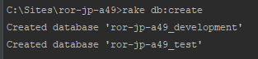

rails g active_scaffold:install

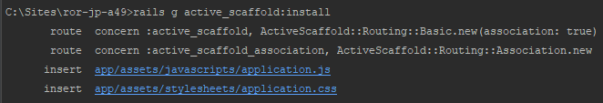

rails g active_scaffold:resource Category name:string

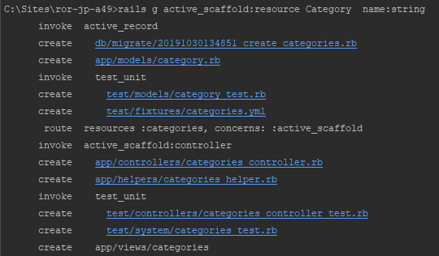

rake db:migrate

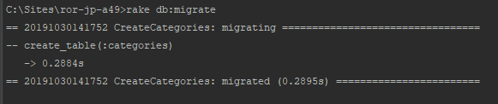

Active Admin

Gemfile

source 'https://rubygems.org'
git_source(:github) { |repo| "https://github.com/#{repo}.git" }

ruby '2.5.1'

gem 'rails', '~> 5.2.1'
# Use mysql as the database for Active Record
gem 'mysql2', '>= 0.4.4', '< 0.6.0'
# Use Puma as the app server
gem 'puma', '~> 3.11'
# Use SCSS for stylesheets
gem 'sass-rails', '~> 5.0'
# Use Uglifier as compressor for JavaScript assets
gem 'uglifier', '>= 1.3.0'
# See https://github.com/rails/execjs#readme for more supported runtimes
gem 'duktape'
# Use CoffeeScript for .coffee assets and views
gem 'coffee-rails', '~> 4.2'
# Turbolinks makes navigating your web application faster. Read more: https://github.com/turbolinks/turbolinks
gem 'turbolinks', '~> 5'
# Build JSON APIs with ease. Read more: https://github.com/rails/jbuilder
gem 'jbuilder', '~> 2.5'
gem 'activeadmin'
gem 'devise'
# Use Redis adapter to run Action Cable in production
# gem 'redis', '~> 4.0'
# Use ActiveModel has_secure_password
# gem 'bcrypt', '~> 3.1.7'

# Use ActiveStorage variant
# gem 'mini_magick', '~> 4.8'

# Use Capistrano for deployment
# gem 'capistrano-rails', group: :development

# Reduces boot times through caching; required in config/boot.rb
gem 'bootsnap', '>= 1.1.0', require: false
# Cocoon
gem "cocoon"

group :development, :test do
# Call 'byebug' anywhere in the code to stop execution and get a debugger console
gem 'byebug', platforms: [:mri, :mingw, :x64_mingw]
gem 'rspec-rails', '~> 3.0'
gem 'capybara'
end

group :development do
# Access an interactive console on exception pages or by calling 'console' anywhere in the code.
gem 'web-console', '>= 3.3.0'
end

# Windows does not include zoneinfo files, so bundle the tzinfo-data gem
gem 'tzinfo-data', platforms: [:mingw, :mswin, :x64_mingw, :jruby]

bundle install

rails g active_admin:install

rake db:migrate

rake db:seed

db/seeds.rb

# This file should contain all the record creation needed to seed the database with its default values.
# The data can then be loaded with the rails db:seed command (or created alongside the database with db:setup).
#
# Examples:
#
# movies = Movie.create([{ name: 'Star Wars' }, { name: 'Lord of the Rings' }])
# Character.create(name: 'Luke', movie: movies.first)
AdminUser.create!(email: 'admin@example.com', password: 'password', password_confirmation: 'password') if Rails.env.development?

rails generate scaffold Customer name:string address:string

rake db:migrate

rails generate active_admin:resource Customer

Visit http://localhost:3000/admin and log in using:
User: admin@example.com
Password: password

