Curso de SASS
SYS4SOFT (João Ribeiro)

https://www.youtube.com/watch?v=-6yxC-0Nux8&list=PLXik_5Br-zO9AMTaAqq7EpYllTPSDUZut

Resumo do curso feito por Roberto Pinheiro

Aula 1 - Instalação e modo de funcionamento

O SASS é um pré-processador de CSS.



- Instalação e modo de funcionamento
- Variáveis
- Aninhamento
- Partials e Import
- Mixins
- Hereditariedade
- Operadores

https://sass-lang.com

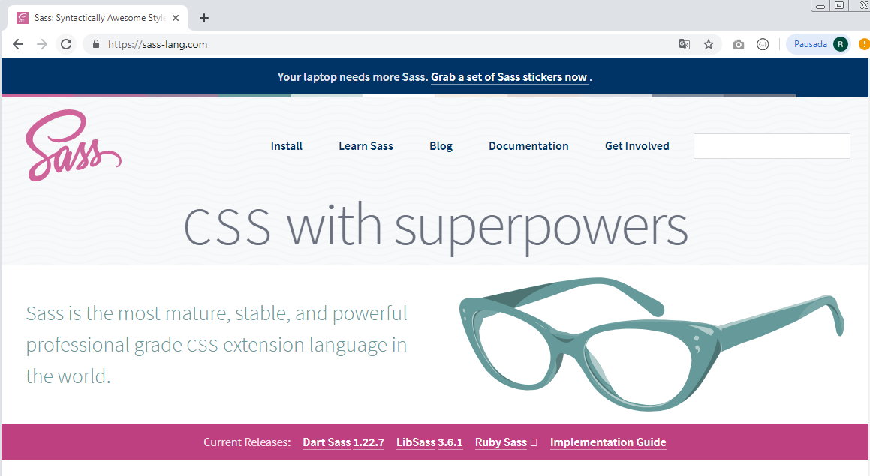

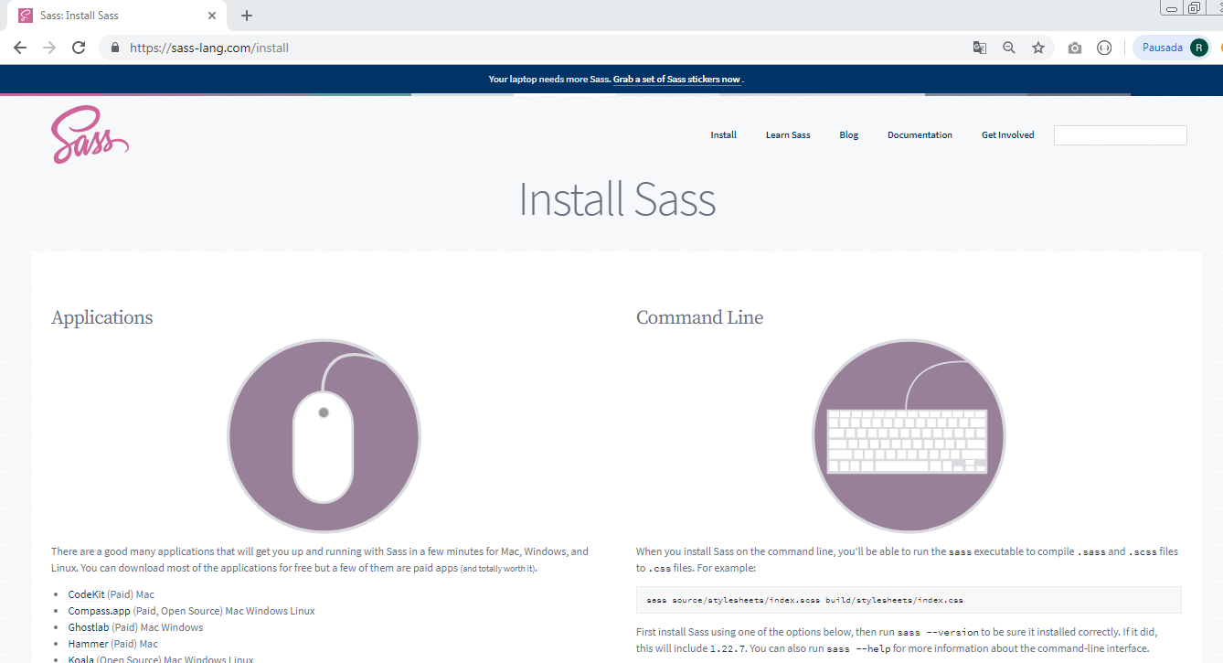

- Descarregue o Ruby Installer em:

https://rubyinstaller.org/downloads/

- E posteriormente instale-o.

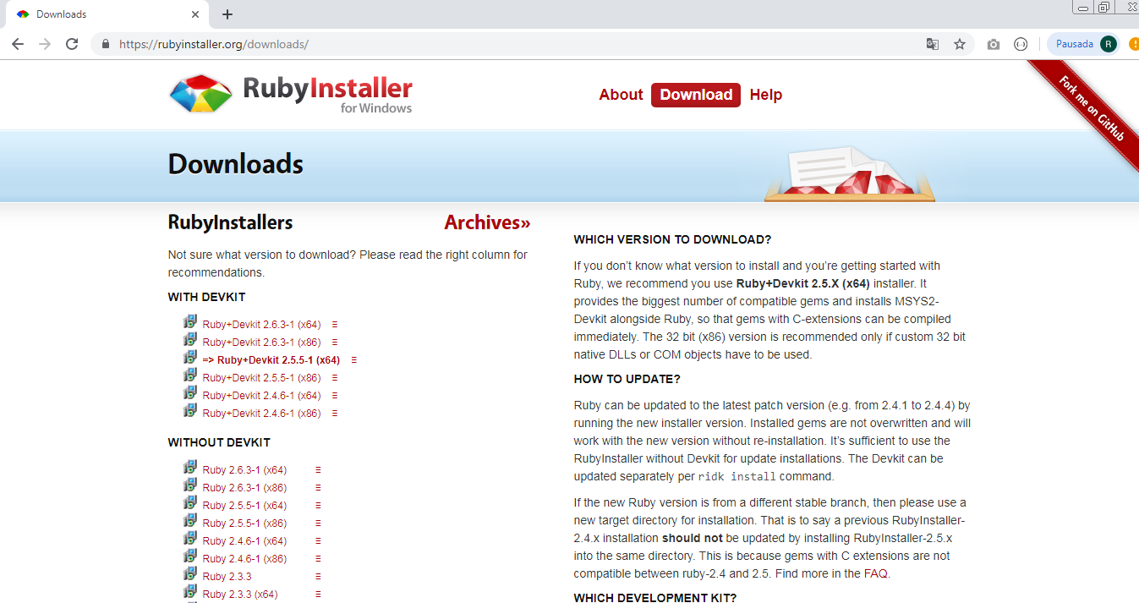

Para visualizar a versão instalada, entre com o comando:

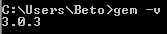

- Para instalar o SASS, entre com o comando:

gem install sass

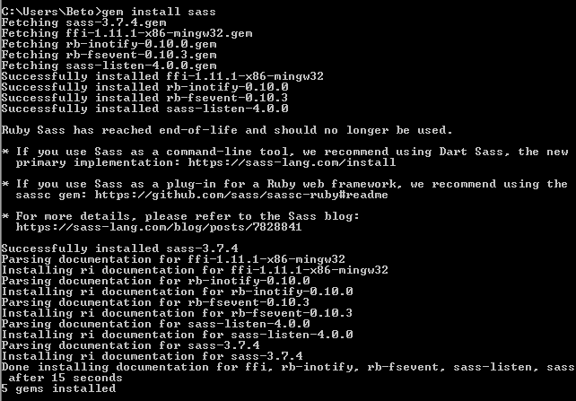

Para confirmar a versão do SASS instalado:

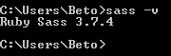

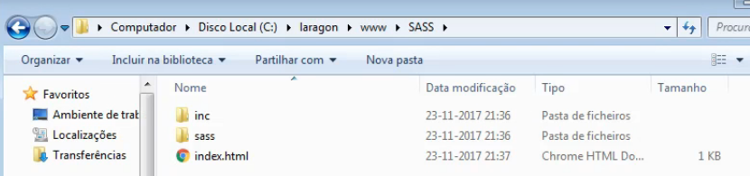

aula1.html

<!DOCTYPE html>
<html lang="pt-br">
<head>
<meta charset="UTF-8">
<meta name="viewport" content="width=device-width, initial-scale=1.0">
<meta http-equiv="X-UA-Compatible" content="ie=edge">
<title>SASS - Aula 1</title>
<link rel="stylesheet" href="inc/aula1.css">
</head>
<body>
<p>Este texto é azul</p>
</body>
</html>

Dentro da pasta sass, crie o arquivo main.scss:

sass/aula1.scss

// Teste de SASS
/* Teste de SASS */

$cor: blue;

p {
color: $cor;
}

Compilando

- Abra o terminal no Visual Studio Code e entre com:

sass --watch sass:inc

ou:

sass -w sass:inc

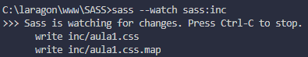

- Dentro da pasta inc será criado o arquivo aula1.css

inc/aula1.css

/* Teste de SASS */
p {
color: blue; }

/*# sourceMappingURL=aula1.css.map */

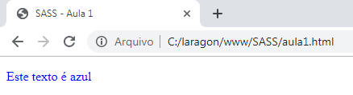

Aula 2 - Variáveis

aula2.html

<!DOCTYPE html>
<html lang="pt-br">
<head>
<meta charset="UTF-8">
<meta name="viewport" content="width=device-width, initial-scale=1.0">
<meta http-equiv="X-UA-Compatible" content="ie=edge">
<title>SASS</title>
<link rel="stylesheet" href="inc/aula2.css">
</head>
<body>
<p>Este texto é azul</p>
</body>
</html>

sass/aula2.scss

// Teste de SASS
/* Teste de SASS */

$cor: blue;
$tamanho: 36px;
$tipo_fonte: 'Trebuchet MS';

p {
color: $cor;
font-size: $tamanho;
font-family: $tipo_fonte;
}

- Dentro da pasta inc será criado o arquivo aula2.css

inc/aula2.css

/* Teste de SASS */
p {
color: blue;
font-size: 36px;
font-family: "Trebuchet MS"; }

/*# sourceMappingURL=aula2.css.map */

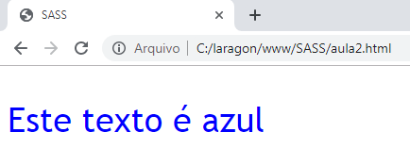

Aula 3 - Nesting (Aninhamento)

aula3.html

<!DOCTYPE html>
<html lang="pt-br">
<head>
<meta charset="UTF-8">
<meta name="viewport" content="width=device-width, initial-scale=1.0">
<meta http-equiv="X-UA-Compatible" content="ie=edge">
<title>SASS - Aula 3</title>
<link rel="stylesheet" href="inc/aula3.css">
</head>
<body>

<p>texto</p>

<a href="">Link 1</a>
<a href="">Link 2</a>

<ul>
<li>Item 1</li>
<li>Item 2</li>
<li>Item 3</li>
</ul>

<div class="caixa">
<ul>
<li>Item 1</li>
<li>Item 2</li>
<li>Item 3</li>
</ul>
<a href="">Ler mais</a>

<div>
<p>TITULO</p>
</div>
</div>
</body>
</html>

sass/aula3.scss

$tamanho: 2em;

ul {
color: red;
}

.caixa{

ul{
color: green;
}

a{
text-decoration: none;
color: red;
}

a:hover{
color: yellow;
}

div{
p{
font-size: $tamanho;
}
}

}

inc/aula3.css

ul {
color: red; }
.caixa ul {
color: green; }
.caixa a {
text-decoration: none;
color: red; }
.caixa a:hover {
color: yellow; }
.caixa div p {
font-size: 2em; }
/*# sourceMappingURL=aula3.css.map */

Aula 4 - Partials e Import

aula4.html

<!DOCTYPE html>
<html lang="pt-br">
<head>
<meta charset="UTF-8">
<meta name="viewport" content="width=device-width, initial-scale=1.0">
<meta http-equiv="X-UA-Compatible" content="ie=edge">
<title>SASS - Aula 4</title>
<link rel="stylesheet" href="inc/aula4.css">
</head>
<body>

<p class="titulo">TÍTULO</p>

<div class="seccao1">
<p>secção 1</p>
</div>

<div class="seccao2">
<p>secção 2</p>
</div>

<div class="seccao3">
<p>secção 3</p>
</div>

</body>
</html>

sass/_seccao1.scss

// secção 1

.seccao1{
font-size: 1.5em;
color: red;
}

sass/_seccao2.scss

// secção 2

.seccao2{
font-size: 2em;
color: blue;
}

sass/_seccao3.scss

// secção 3

.seccao3{
font-size: 3em;
color: green;
}

sass/aula4.scss

.titulo{
font-size: 4em;
}

@import 'seccao1';
@import 'seccao2';
@import 'seccao3';

inc/aula4.css

.titulo {
font-size: 4em; }
.seccao1 {
font-size: 1.5em;
color: red; }
.seccao2 {
font-size: 2em;
color: blue; }
.seccao3 {
font-size: 3em;
color: green; }

/*# sourceMappingURL=aula4.css.map */

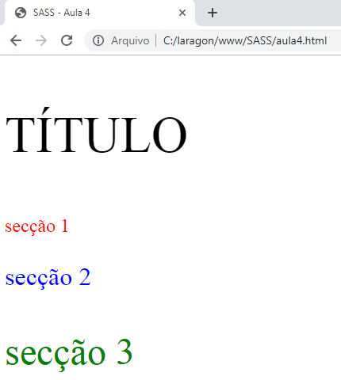

Aula 5 - Mixins

aula5.html

<!DOCTYPE html>
<html lang="pt-br">
<head>
<meta charset="UTF-8">
<meta name="viewport" content="width=device-width, initial-scale=1.0">
<meta http-equiv="X-UA-Compatible" content="ie=edge">
<title>SASS - Aula 5</title>
<link rel="stylesheet" href="inc/aula5.css">
</head>
<body>

<div class="artigo1">
<h1>Título 1</h1>
<p>Lorem Ipsum is simply dummy text of the printing and typesetting industry. Lorem Ipsum has been the industry's standard dummy text ever since the 1500s, when an unknown printer took a galley of type and scrambled it to make a type specimen book. It has survived not only five centuries, but also the leap into electronic typesetting, remaining essentially unchanged. It was popularised in the 1960s with the release of Letraset sheets containing Lorem Ipsum passages, and more recently with desktop publishing software like Aldus PageMaker including versions of Lorem Ipsum.</p>
</div>

<hr>

<div class="artigo2">
<h1>Título 2</h1>
<p>Contrary to popular belief, Lorem Ipsum is not simply random text. It has roots in a piece of classical Latin literature from 45 BC, making it over 2000 years old. Richard McClintock, a Latin professor at Hampden-Sydney College in Virginia, looked up one of the more obscure Latin words, consectetur, from a Lorem Ipsum passage, and going through the cites of the word in classical literature, discovered the undoubtable source. Lorem Ipsum comes from sections 1.10.32 and 1.10.33 of "de Finibus Bonorum et Malorum" (The Extremes of Good and Evil) by Cicero, written in 45 BC. This book is a treatise on the theory of ethics, very popular during the Renaissance. The first line of Lorem Ipsum, "Lorem ipsum dolor sit amet..", comes from a line in section 1.10.32.</p>
</div>

<hr>

<div class="artigo3">
<h1>Título 3</h1>
<p>It is a long established fact that a reader will be distracted by the readable content of a page when looking at its layout. The point of using Lorem Ipsum is that it has a more-or-less normal distribution of letters, as opposed to using 'Content here, content here', making it look like readable English. Many desktop publishing packages and web page editors now use Lorem Ipsum as their default model text, and a search for 'lorem ipsum' will uncover many web sites still in their infancy. Various versions have evolved over the years, sometimes by accident, sometimes on purpose (injected humour and the like).</p>
</div>

<hr>

</body>
</html>

sass/aula5.scss

@mixin caixa_noticia($cor, $p){
border: 1px solid black;
border-radius: 10px;
margin: 20px;
padding: $p;
background-color: $cor;
}

@mixin titulo(){
font-size: 2.5em;
color: blue;
}

.artigo1{
@include caixa_noticia(rgb(180, 180, 180), 20px);
}

.artigo1 h1{
@include titulo();
}

.artigo2{
@include caixa_noticia(rgb(209, 216, 167), 40px);
}

.artigo3{
@include caixa_noticia(rgb(165, 190, 214), 60px);
}

inc/aula5.css

.artigo1 {
border: 1px solid black;
border-radius: 10px;
margin: 20px;
padding: 20px;
background-color: #b4b4b4; }

.artigo1 h1 {
font-size: 2.5em;
color: blue; }

.artigo2 {
border: 1px solid black;
border-radius: 10px;
margin: 20px;
padding: 40px;
background-color: #d1d8a7; }

.artigo3 {
border: 1px solid black;
border-radius: 10px;
margin: 20px;
padding: 60px;
background-color: #a5bed6; }

/*# sourceMappingURL=aula5.css.map */

Aula 6 - Hereditariedade

aula6.html

<!DOCTYPE html>
<html lang="pt-br">
<head>
<meta charset="UTF-8">
<meta name="viewport" content="width=device-width, initial-scale=1.0">
<meta http-equiv="X-UA-Compatible" content="ie=edge">
<title>SASS - Aula 6</title>
<link rel="stylesheet" href="inc/aula6.css">
</head>
<body>

<p class="p1">Parágrafo 1</p>
<p class="p2">Parágrafo 2</p>
<p class="p3">Parágrafo 3</p>

</body>
</html>

sass/aula6.scss

.p1{
background-color: cadetblue;
padding: 20px;
color: black;
font-size: 1.5em;
}

.p2{
@extend .p1;
font-size: 3em;
margin: 30px;
color: navy;
}

.p3{
@extend .p1;
font-size: 5em;
}

inc/aula6.css

.p1, .p2, .p3 {
background-color: cadetblue;
padding: 20px;
color: black;
font-size: 1.5em; }

.p2 {
font-size: 3em;
margin: 30px;
color: navy; }

.p3 {
font-size: 5em; }

/*# sourceMappingURL=aula6.css.map */

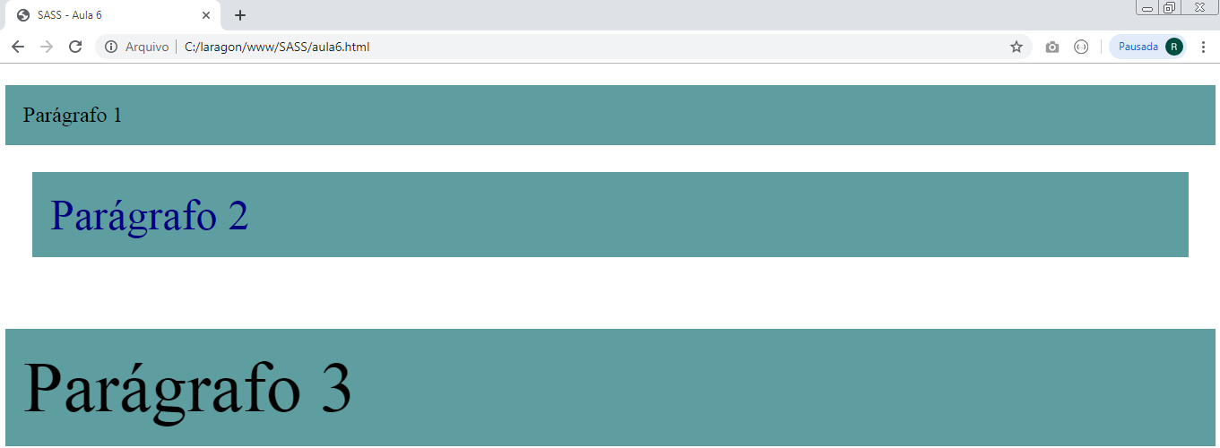

Aula 7 - Utilização de operadores matemáticos

aula7.html

<!DOCTYPE html>
<html lang="pt-br">
<head>
<meta charset="UTF-8">
<meta name="viewport" content="width=device-width, initial-scale=1.0">
<meta http-equiv="X-UA-Compatible" content="ie=edge">
<title>SASS - Aula 7</title>
<link rel="stylesheet" href="inc/aula7.css">
</head>
<body>

<p class="p1">Parágrafo 1</p>
<p class="p2">Parágrafo 2</p>
<p class="p3">Parágrafo 3</p>

</body>
</html>

sass/aula7.scss

$t: 30px;
$red: 150;
$color: white;

.p1{
padding: 30px;
font-size: $t;
background-color: rgb($red, 0, 0);
color: $color;
}

.p2{
padding: 30px;
font-size: $t + 5;
background-color: rgb($red + 50, 0, 0);
color: $color;

}

.p3{
padding: 30px;
font-size: $t - 5px;
background-color: rgb($red + 100, 0, 0);
color: $color;
}

inc/aula7.css

.p1 {
padding: 30px;
font-size: 30px;
background-color: #960000;
color: white; }

.p2 {
padding: 30px;
font-size: 35px;
background-color: #c80000;
color: white; }

.p3 {
padding: 30px;
font-size: 25px;
background-color: #fa0000;
color: white; }

/*# sourceMappingURL=aula7.css.map */

