Curso Vue.js
Aprendible

https://www.youtube.com/watch?v=A91omIs5tU4&list=PLpKWS6gp0jd9eZC7HJhKbFpF4yrYL3soV

Resumo do curso feito por Roberto Pinheiro

Aula 1 - Introdução

Vue.js é um framework de javascript desenhado para construir interfaces web interativas e reativas.

Instalação

Você pode criar um arquivo index.html e incluir Vue com:

<!-- development version, includes helpful console warnings -->
<script src="https://cdn.jsdelivr.net/npm/vue/dist/vue.js"></script>

or:

<!-- production version, optimized for size and speed -->
<script src="https://cdn.jsdelivr.net/npm/vue"></script>

Primeiro exemplo

vuejs-aprendible/aula-1/aula-1a.html

<!DOCTYPE html>
<html lang="en">
<head>
<meta charset="UTF-8">
<title>Aprendendo VueJs</title>
</head>
<body>

<script src="https://cdn.jsdelivr.net/npm/vue/dist/vue.js"></script>

<div id="app">
<h1>Olá {{ message }}</h1>
</div>

<script>
var app = new Vue({
el: '#app',
data: {
message: 'Aprendible'
}
})
</script>

</body>
</html>

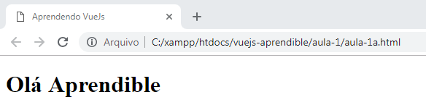

Alterando o valor da variável de forma reativa

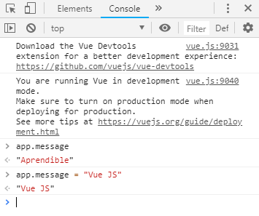
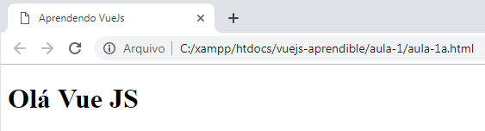

Exibindo o valor da variável em um campo input

vuejs-aprendible/aula-1/aula-1b.html

<!DOCTYPE html>
<html lang="en">
<head>
<meta charset="UTF-8">
<title>Aprendendo VueJs</title>
</head>
<body>

<script src="https://cdn.jsdelivr.net/npm/vue/dist/vue.js"></script>

<div id="app">
<h1>Olá {{ message }}</h1>
<input type="text" v-model="message" />
</div>

<script>
var app = new Vue({
el: '#app',
data: {
message: 'Aprendible'
}
})
</script>

</body>
</html>

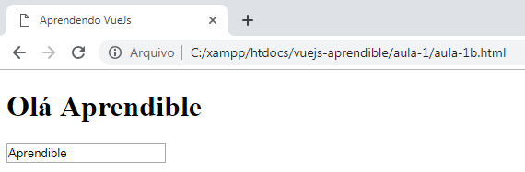

Aula 2 - Condicionais e Loops

vuejs-aprendible/aula-2/aula-2a.html

<!DOCTYPE html>
<html lang="en">
<head>
<meta charset="UTF-8">
<title>Aprendendo VueJs</title>
</head>
<body>

<script src="https://cdn.jsdelivr.net/npm/vue/dist/vue.js"></script>

<div id="app">
<h1>Olá <span v-text="message"></span></h1>
<input type="text" v-model="message" />
</div>

<script>
var app = new Vue({
el: '#app',
data: {
message: 'Aprendible'
}
})
</script>

</body>
</html>

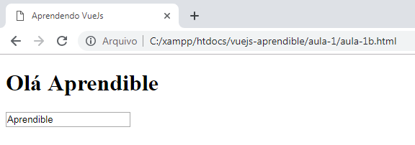

vuejs-aprendible/aula-2/aula-2b.html

<!DOCTYPE html>
<html lang="en">
<head>
<meta charset="UTF-8">
<title>Aprendendo VueJs</title>
</head>
<body>

<script src="https://cdn.jsdelivr.net/npm/vue/dist/vue.js"></script>

<div id="app">
<h1 v-show="message">Olá <span v-text="message"></span></h1>
<input type="text" v-model="message" />
</div>

<script>
var app = new Vue({
el: '#app',
data: {
message: 'Aprendible'
}
})
</script>

</body>
</html>

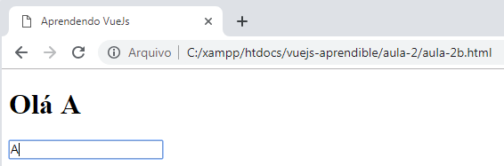

Excluindo a última letra:

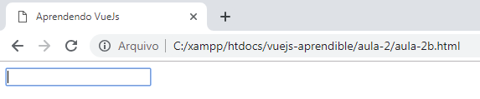

vuejs-aprendible/aula-2/aula-2c.html

<!DOCTYPE html>
<html lang="en">
<head>
<meta charset="UTF-8">
<title>Aprendendo VueJs</title>
</head>
<body>

<script src="https://cdn.jsdelivr.net/npm/vue/dist/vue.js"></script>

<div id="app">
<h1 v-show="message.length > 2">Olá <span v-text="message"></span></h1>
<input type="text" v-model="message" />
</div>

<script>
var app = new Vue({
el: '#app',
data: {
message: 'Aprendible'
}
})
</script>

</body>
</html>

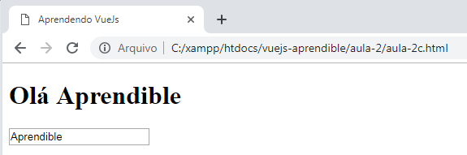

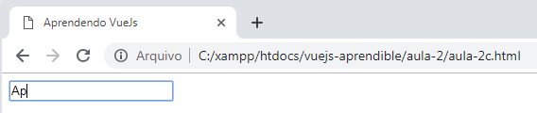

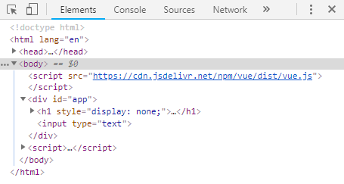

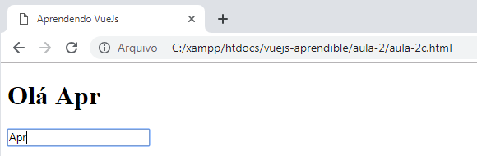

vuejs-aprendible/aula-2/aula-2d.html

<!DOCTYPE html>
<html lang="en">
<head>
<meta charset="UTF-8">
<title>Aprendendo VueJs</title>
</head>
<body>

<script src="https://cdn.jsdelivr.net/npm/vue/dist/vue.js"></script>

<div id="app">
<h1 v-if="message.length > 2">Olá <span v-text="message"></span></h1>
<h1 v-else>Por favor, escreva seu nome.</h1>
<input type="text" v-model="message" />
</div>

<script>
var app = new Vue({
el: '#app',
data: {
message: 'Aprendible'
}
})
</script>

</body>
</html>

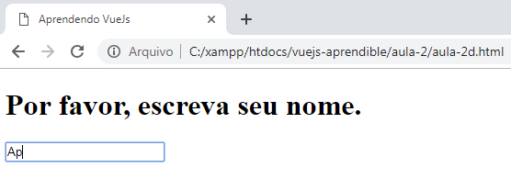

Loops

vuejs-aprendible/aula-2/aula-2e.html

<!DOCTYPE html>
<html lang="en">
<head>
<meta charset="UTF-8">
<title>Aprendendo VueJs</title>
</head>
<body>

<script src="https://cdn.jsdelivr.net/npm/vue/dist/vue.js"></script>

<div id="app">
<h1>Lista de tarefas</h1>
<ul>
<li v-for="tarefa in tarefas">{{ tarefa }}</li>
</ul>
</div>

<script>
var app = new Vue({
el: '#app',
data: {
tarefas: [
'Aprender Laravel',
'Aprender VueJS'
]
}
})
</script>

</body>
</html>

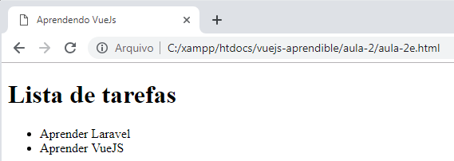

vuejs-aprendible/aula-2/aula-2f.html

<!DOCTYPE html>
<html lang="en">
<head>
<meta charset="UTF-8">
<title>Aprendendo VueJs</title>
</head>
<body>

<script src="https://cdn.jsdelivr.net/npm/vue/dist/vue.js"></script>

<div id="app">
<h1>Lista de tarefas</h1>
<ul>
<li v-for="tarefa in tarefas" v-text="tarefa"></li>
</ul>
</div>

<script>
var app = new Vue({
el: '#app',
data: {
tarefas: [
'Aprender PHP',
'Aprender Laravel',
'Aprender VueJS'
]
}
})
</script>

</body>
</html>

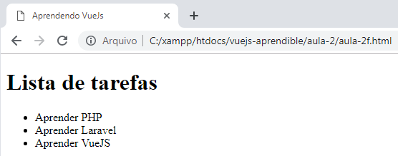

vuejs-aprendible/aula-2/aula-2g.html

<!DOCTYPE html>
<html lang="en">
<head>
<meta charset="UTF-8">
<title>Aprendendo VueJs</title>
</head>
<body>

<script src="https://cdn.jsdelivr.net/npm/vue/dist/vue.js"></script>

<div id="app">
<h1>Lista de tarefas</h1>
<ul>
<li v-for="tarefa in tarefas" v-text="tarefa"></li>
</ul>
</div>

<script>
var app = new Vue({
el: '#app',
data: {
tarefas: [
{ title: 'Aprender PHP' },
{ title: 'Aprender Laravel' },
{ title: 'Aprender VueJS' }
]
}
})
</script>

</body>
</html>

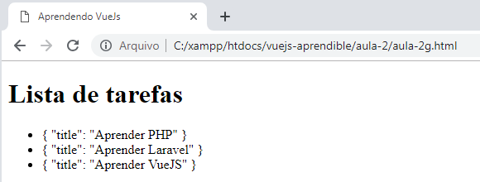

vuejs-aprendible/aula-2/aula-2h.html

<!DOCTYPE html>
<html lang="en">
<head>
<meta charset="UTF-8">
<title>Aprendendo VueJs</title>
</head>
<body>

<script src="https://cdn.jsdelivr.net/npm/vue/dist/vue.js"></script>

<div id="app">
<h1>Lista de tarefas</h1>
<ul>
<li v-for="tarefa in tarefas" v-text="tarefa.title"></li>
</ul>
</div>

<script>
var app = new Vue({
el: '#app',
data: {
tarefas: [
{ title: 'Aprender PHP' },
{ title: 'Aprender Laravel' },
{ title: 'Aprender VueJS' }
]
}
})
</script>

</body>
</html>

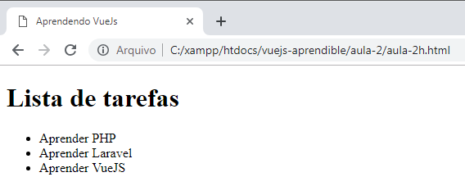

vuejs-aprendible/aula-2/aula-2i.html

<!DOCTYPE html>
<html lang="en">
<head>
<meta charset="UTF-8">
<title>Aprendendo VueJs</title>
</head>
<body>

<script src="https://cdn.jsdelivr.net/npm/vue/dist/vue.js"></script>

<div id="app">
<h1>Lista de tarefas</h1>
<ul>
<li v-for="tarefa in tarefas">
<span v-text="tarefa.title"></span>
<small v-if="tarefa.completed">Tarefa completa</small>
<small v-else>Tarefa incompleta</small>
</li>
</ul>
</div>

<script>
var app = new Vue({
el: '#app',
data: {
tarefas: [
{ title: 'Aprender PHP', completed: true },
{ title: 'Aprender Laravel', completed: true },
{ title: 'Aprender VueJS', completed: false }
]
}
})
</script>

</body>
</html>

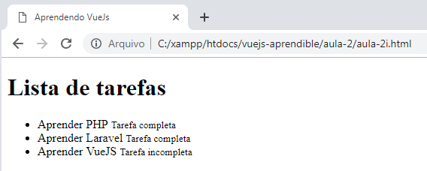

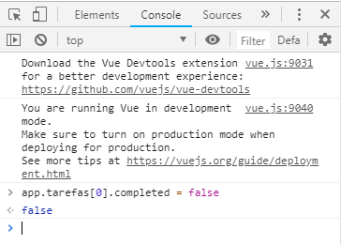

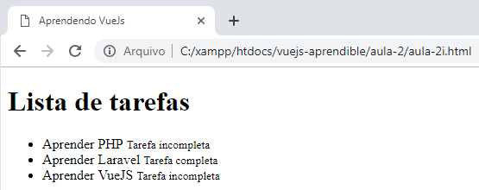

vuejs-aprendible/aula-2/aula-2j.html

<!DOCTYPE html>
<html lang="en">
<head>
<meta charset="UTF-8">
<title>Aprendendo VueJs</title>
</head>
<body>

<script src="https://cdn.jsdelivr.net/npm/vue/dist/vue.js"></script>

<div id="app">

<h1 v-if="message.length > 2">Olá <span v-text="message"></span></h1>
<h1 v-else>Por favor, escreva seu nome.</h1>
<input type="text" v-model="message" />

<h1>Lista de tarefas</h1>
<ul>
<li v-for="tarefa in tarefas">
<span v-text="tarefa.title"></span>
<small v-if="tarefa.completed"> Completa</small>
<small v-else> Incompleta</small>
</li>
</ul>
</div>

<script>
var app = new Vue({
el: '#app',
data: {
message: 'Aprendible',
tarefas: [
{ title: 'Aprender PHP', completed: true },
{ title: 'Aprender Laravel', completed: true },
{ title: 'Aprender VueJS', completed: false }
]
}
})
</script>

</body>
</html>

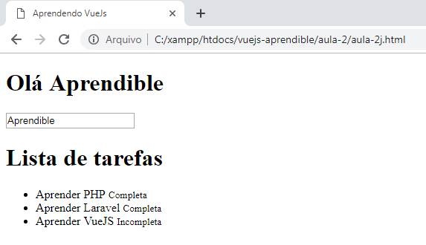

Acrescentando uma nova tarefa

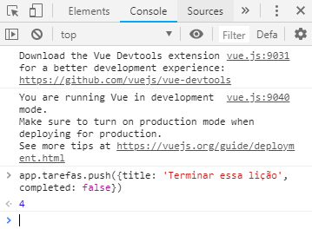

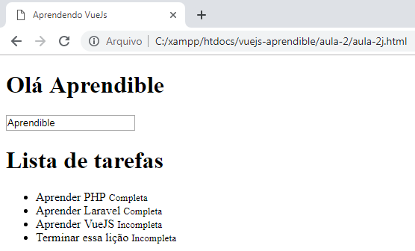

Aula 3 - Eventos e métodos

vuejs-aprendible/aula-3/aula-3a.html

<!DOCTYPE html>
<html lang="en">
<head>
<meta charset="UTF-8">
<title>Aprendendo VueJs</title>
</head>
<body>

<script src="https://cdn.jsdelivr.net/npm/vue/dist/vue.js"></script>

<div id="app">

<h1 v-if="message.length > 2">Olá <span v-text="message"></span></h1>
<h1 v-else>Por favor, escreva seu nome.</h1>
<input type="text" v-model="message" />
<button v-on:click="message = message.split('').reverse().join('')">
Inverter</button>

<h1>Lista de tarefas</h1>
<ul>
<li v-for="tarefa in tarefas">
<span v-text="tarefa.title"></span>
<small v-if="tarefa.completed"> Completa</small>
<small v-else> Incompleta</small>
</li>
</ul>
</div>

<script>
var app = new Vue({
el: '#app',
data: {
message: 'Aprendible',
tarefas: [
{ title: 'Aprender PHP', completed: true },
{ title: 'Aprender Laravel', completed: true },
{ title: 'Aprender VueJS', completed: false }
]
}
})
</script>

</body>
</html>

vuejs-aprendible/aula-3/aula-3b.html

<!DOCTYPE html>
<html lang="en">
<head>
<meta charset="UTF-8">
<title>Aprendendo VueJs</title>
</head>
<body>

<script src="https://cdn.jsdelivr.net/npm/vue/dist/vue.js"></script>

<div id="app">

<h1 v-if="message.length > 2">Olá <span v-text="message"></span></h1>
<h1 v-else>Por favor, escreva seu nome.</h1>
<input type="text" v-model="message" />
<button @click="message = message.split('').reverse().join('')">Inverter</button>

<h1>Lista de tarefas</h1>
<ul>
<li v-for="tarefa in tarefas">
<span v-text="tarefa.title"></span>
<small v-if="tarefa.completed"> Completa</small>
<small v-else> Incompleta</small>
</li>
</ul>
</div>

<script>
var app = new Vue({
el: '#app',
data: {
message: 'Aprendible',
tarefas: [
{ title: 'Aprender PHP', completed: true },
{ title: 'Aprender Laravel', completed: true },
{ title: 'Aprender VueJS', completed: false }
]
}
})
</script>

</body>
</html>

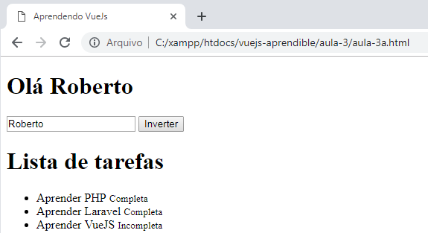

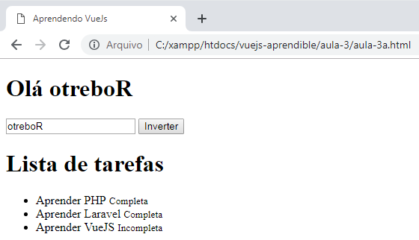

Criando uma função para reutilizar o código

vuejs-aprendible/aula-3/aula-3c.html

<!DOCTYPE html>
<html lang="en">
<head>
<meta charset="UTF-8">
<title>Aprendendo VueJs</title>
</head>
<body>

<script src="https://cdn.jsdelivr.net/npm/vue/dist/vue.js"></script>

<div id="app">

<h1 v-if="message.length > 2">Olá <span v-text="message"></span></h1>
<h1 v-else>Por favor, escreva seu nome.</h1>
<input type="text" v-model="message" />
<button @click="reverse">Inverter</button>

<h1>Lista de tarefas</h1>
<ul>
<li v-for="tarefa in tarefas">
<span v-text="tarefa.title"></span>
<small v-if="tarefa.completed"> Completa</small>
<small v-else> Incompleta</small>
</li>
</ul>
</div>

<script>
var app = new Vue({
el: '#app',
data: {
message: '',
tarefas: [
{ title: 'Aprender PHP', completed: true },
{ title: 'Aprender Laravel', completed: true },
{ title: 'Aprender VueJS', completed: false }
],
},
methods: {
reverse: function(){
this.message = this.message.split('').reverse().join('');
}
}
})
</script>

</body>
</html>

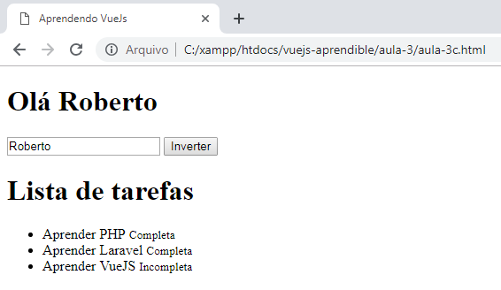

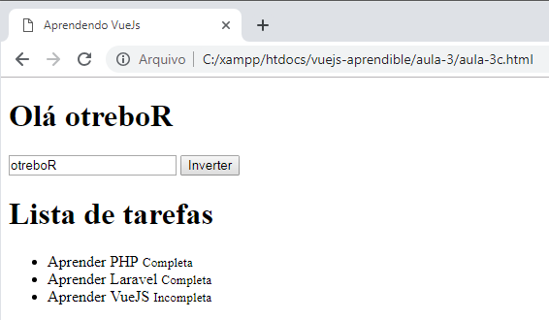

Adicionando tarefas

vuejs-aprendible/aula-3/aula-3d.html

<!DOCTYPE html>
<html lang="en">
<head>
<meta charset="UTF-8">
<!-- Bootstrap CSS -->
<link rel="stylesheet" href="https://maxcdn.bootstrapcdn.com/bootstrap/3.4.0/css/bootstrap.min.css">
<title>Aprendendo VueJs</title>
</head>
<body>

<div class="container">
<script src="https://cdn.jsdelivr.net/npm/vue/dist/vue.js"></script>
<div id="app">
<h1>Lista de tarefas</h1>
<ul>
<li v-for="task in tasks">
<span v-text="task.title"></span>
<small v-if="task.completed"> Completa</small>
<small v-else> Incompleta</small>
</li>
<li class="form-inline">
<input type="text" class="form-control" v-model="newTask">
<button @click="addTask" class="btn btn-primary">+</button>
</li>
</ul>
</div>
<script>
var app = new Vue({
el: '#app',
data: {
newTask: "",
tasks: [
{ title: 'Aprender PHP', completed: true },
{ title: 'Aprender Laravel', completed: true },
{ title: 'Aprender VueJS', completed: false }
],
},
methods: {
addTask: function(){
this.tasks.push(
{title: this.newTask, completed: false}
);
}
}
});
</script>
</div>
</body>
</html>

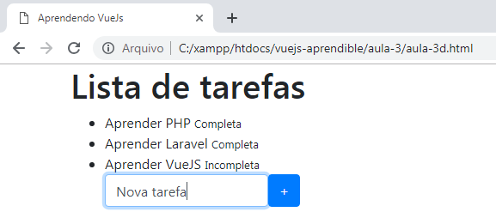

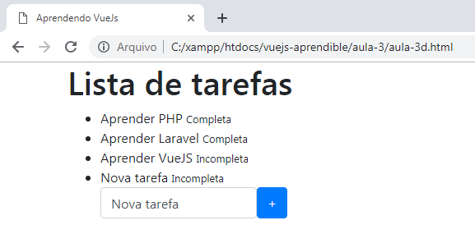

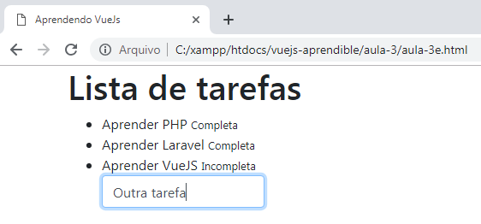

vuejs-aprendible/aula-3/aula-3e.html

<!DOCTYPE html>
<html lang="en">
<head>
<meta charset="UTF-8">
<link rel="stylesheet" href="https://maxcdn.bootstrapcdn.com/bootstrap/3.4.0/css/bootstrap.min.css">
<title>Aprendendo VueJs</title>
<style>
.glyphicon-check, .glyphicon-unchecked{
cursor: pointer;
}
</style>
</head>
<body>

<div class="container">
<script src="https://cdn.jsdelivr.net/npm/vue/dist/vue.js"></script>

<div id="app">

<h1>Lista de tarefas</h1>
<ul>
<li v-for="task in tasks">
<span v-text="task.title"></span>
<span v-on:click="task.completed = false" v-if="task.completed" class="glyphicon glyphicon-check"></span>
<span v-on:click="task.completed = true" v-else class="glyphicon glyphicon-unchecked"></span>
</li>
<li class="form-inline">
<input v-on:keyup.enter="addTask" type="text" class="form-control" v-model="newTask">
</li>
</ul>

<pre>
{{ $data }}
</pre>
</div>

<script>
var app = new Vue({
el: '#app',
data: {
newTask: "",
tasks: [
{ title: 'Aprender PHP', completed: true },
{ title: 'Aprender Laravel', completed: true },
{ title: 'Aprender VueJS', completed: false }
],
},
methods: {
addTask: function(){
if(this.newTask <= 1) return alert('A tarefa não pode estar vazia!');
this.tasks.push({
title: this.newTask,
completed: false
});
this.newTask = "";
}
}
});
</script>

</div>

</body>
</html>

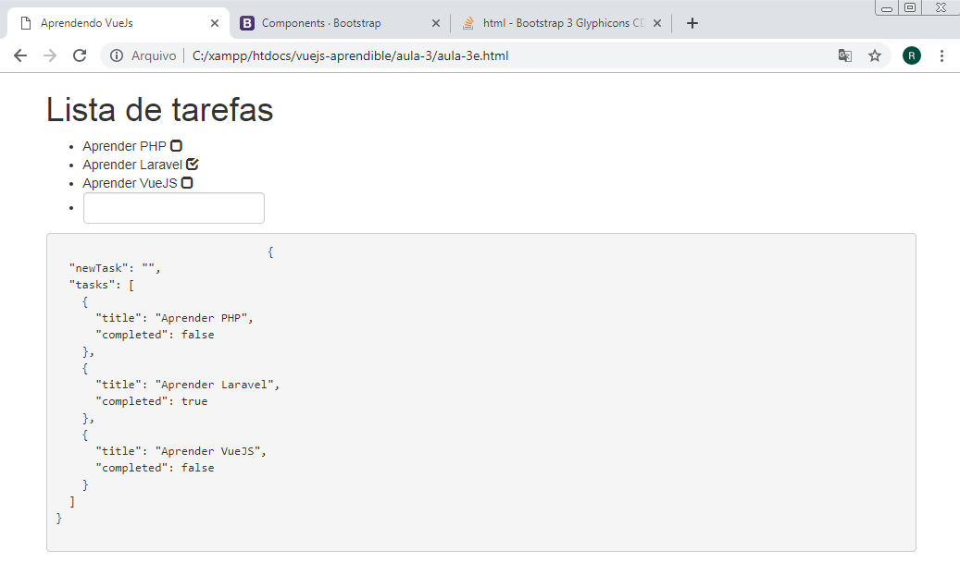

Aula 4 - Ferramentas de desenvolvimento

vuejs-aprendible/aula-4/aula-4a.html

<!DOCTYPE html>
<html lang="en">
<head>
<meta charset="UTF-8">
<link rel="stylesheet" href="https://maxcdn.bootstrapcdn.com/bootstrap/3.4.0/css/bootstrap.min.css">
<title>Aprendendo VueJs</title>
<style>
.glyphicon-check, .glyphicon-unchecked{
cursor: pointer;
}
</style>
</head>
<body>

<div class="container">
<script src="https://cdn.jsdelivr.net/npm/vue/dist/vue.js"></script>

<div id="app">

<h1>Lista de tarefas</h1>
<ul>
<li v-for="task in tasks">
<span v-text="task.title"></span>
<span v-on:click="task.completed = false" v-if="task.completed" class="glyphicon glyphicon-check"></span>
<span v-on:click="task.completed = true" v-else class="glyphicon glyphicon-unchecked"></span>
</li>
<li class="form-inline">
<input v-on:keyup.enter="addTask" type="text" class="form-control" v-model="newTask">
</li>
</ul>

</div>

<script>
var app = new Vue({
el: '#app',
data: {
newTask: "",
tasks: [
{ title: 'Aprender PHP', completed: true },
{ title: 'Aprender Laravel', completed: true },
{ title: 'Aprender VueJS', completed: false }
],
},
methods: {
addTask: function(){
if(this.newTask <= 1) return alert('A tarefa não pode estar vazia!');
this.tasks.push({
title: this.newTask,
completed: false
});
this.newTask = "";
}
}
});
</script>
</div>
</body>
</html>

Extensão Vue.js devtools

https://github.com/vuejs/vue-devtools

Instale no Google Chrome a extensão a seguir:

https://chrome.google.com/webstore/detail/vuejs-devtools/nhdogjmejiglipccpnnnanhbledajbpd

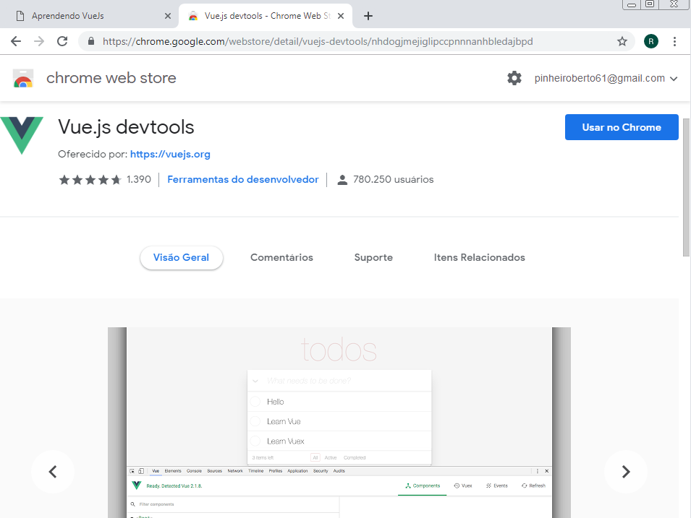

Ativando a extensão no Google Chrome

No Google Chrome, entre no menu "Mais ferramentas -> Extensões"

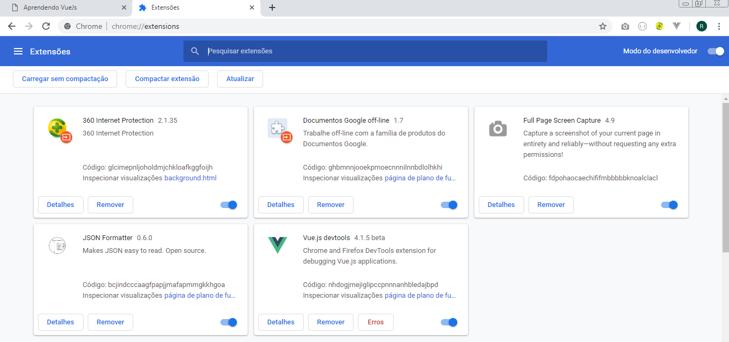

Na extensão Vue.js devtools clique no botão "Detalhes", e ative a opção: "Permitir acesso aos URLs do arquivo", conforme indicado a seguir:

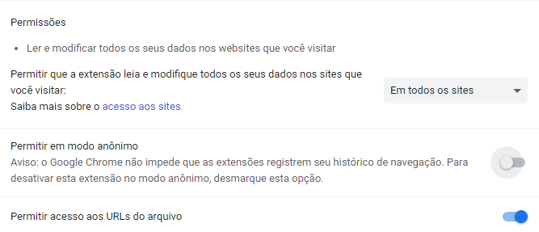

Agora o ícone do Vue.js será exibido ativado, no canto superior direito.

Ao clicar em <F12> será exibida uma nova aba chamada Vue. Clique nela e em seguida em <Root>:

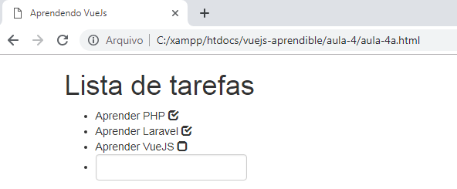

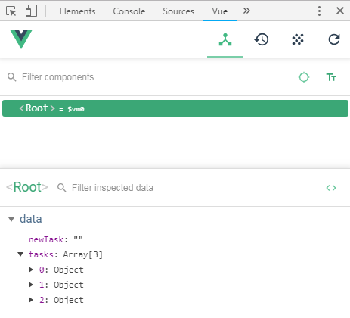
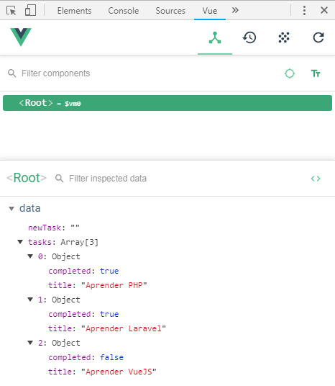

Aula 5 - Propriedades calculadas

vuejs-aprendible/aula-5/aula-5a.html

<!DOCTYPE html>
<html lang="en">
<head>
<meta charset="UTF-8">
<link rel="stylesheet" href="https://maxcdn.bootstrapcdn.com/bootstrap/3.4.0/css/bootstrap.min.css">
<title>Aprendendo VueJs</title>
<style>
.glyphicon-check, .glyphicon-unchecked{
cursor: pointer;
}
</style>
</head>
<body>

<div class="container">
<script src="https://cdn.jsdelivr.net/npm/vue/dist/vue.js"></script>

<div id="app">

<h1>Lista de tarefas</h1>
<p>{{ reversedTask }}</p>

<ul>
<li v-for="task in tasks">
<span v-text="task.title"></span>
<span v-on:click="task.completed = false" v-if="task.completed" class="glyphicon glyphicon-check"></span>
<span v-on:click="task.completed = true" v-else class="glyphicon glyphicon-unchecked"></span>
</li>
<li class="form-inline">
<input v-on:keyup.enter="addTask" type="text" class="form-control" v-model="newTask">
</li>
</ul>

</div>

<script>
var app = new Vue({
el: '#app',
data: {
newTask: "",
tasks: [
{ title: 'Aprender PHP', completed: true },
{ title: 'Aprender Laravel', completed: true },
{ title: 'Aprender VueJS', completed: false }
],
},
methods: {
addTask: function(){
if(this.newTask <= 1) return alert('A tarefa não pode estar vazia!');
this.tasks.push({
title: this.newTask,
completed: false
});
this.newTask = "";
}
},
computed: {
reversedTask: function(){
return this.newTask.split('').reverse().join('');
}
}
});
</script>

</div>

</body>
</html>

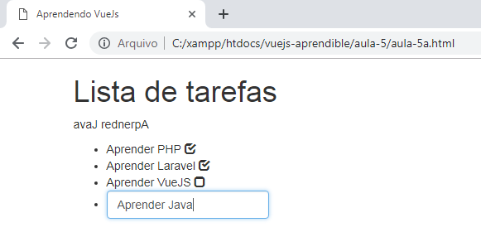

vuejs-aprendible/aula-5/aula-5b.html

<!DOCTYPE html>
<html lang="en">
<head>
<meta charset="UTF-8">
<link rel="stylesheet" href="https://maxcdn.bootstrapcdn.com/bootstrap/3.4.0/css/bootstrap.min.css">
<title>Aprendendo VueJs</title>
<style>
.glyphicon-check, .glyphicon-unchecked{
cursor: pointer;
}
</style>
</head>
<body>

<div class="container">
<script src="https://cdn.jsdelivr.net/npm/vue/dist/vue.js"></script>

<div id="app">

<h1>Lista de tarefas</h1>
<p>{{ reversedTask }}</p>

<h4>Tarefas completas: {{ completedTasks() }}</h4>
<h4>Tarefas incompletas: {{ incompletedTasks() }}</h4>

<ul>
<li v-for="task in tasks">
<span v-text="task.title"></span>
<span v-on:click="task.completed = false" v-if="task.completed" class="glyphicon glyphicon-check"></span>
<span v-on:click="task.completed = true" v-else class="glyphicon glyphicon-unchecked"></span>
</li>
<li class="form-inline">
<input v-on:keyup.enter="addTask" type="text" class="form-control" v-model="newTask">
</li>
</ul>

</div>

<script>
var app = new Vue({
el: '#app',
data: {
newTask: "",
tasks: [
{ title: 'Aprender PHP', completed: true },
{ title: 'Aprender Laravel', completed: true },
{ title: 'Aprender VueJS', completed: false }
],
},
methods: {
addTask: function(){
if(this.newTask <= 1) return alert('A tarefa não pode estar vazia!');
this.tasks.push({
title: this.newTask,
completed: false
});
this.newTask = "";
},
completedTasks: function(){
return this.tasks.filter(function(task){
return task.completed;
}).length;
},
incompletedTasks: function(){
return this.tasks.filter(function(task){
return !task.completed;
}).length;
}

},
computed: {
reversedTask: function(){
return this.newTask.split('').reverse().join('');
}
}
});
</script>

</div>

</body>
</html>

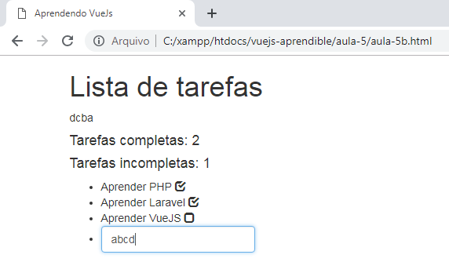
Ao se digitar cada letra da nova tarefa, os triggers são disparados:

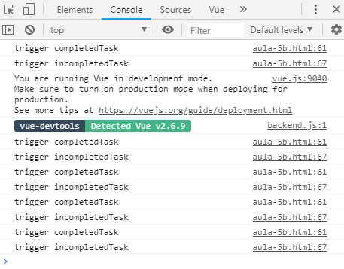

vuejs-aprendible/aula-5/aula-5c.html

<!DOCTYPE html>
<html lang="en">
<head>
<meta charset="UTF-8">
<link rel="stylesheet" href="https://maxcdn.bootstrapcdn.com/bootstrap/3.4.0/css/bootstrap.min.css">
<title>Aprendendo VueJs</title>
<style>
.glyphicon-check, .glyphicon-unchecked{
cursor: pointer;
}
</style>
</head>
<body>

<div class="container">
<script src="https://cdn.jsdelivr.net/npm/vue/dist/vue.js"></script>

<div id="app">

<h1>Lista de tarefas</h1>

<p>{{ reversedTask }}</p>

<h4 v-if="completedTasks">Tarefas completas: {{ completedTasks }}</h4>
<h4 v-if="incompletedTasks">Tarefas incompletas: {{ incompletedTasks }}</h4>

<ul>
<li v-for="task in tasks">
<span v-text="task.title"></span>
<span v-on:click="task.completed = false" v-if="task.completed" class="glyphicon glyphicon-check"></span>
<span v-on:click="task.completed = true" v-else class="glyphicon glyphicon-unchecked"></span>
</li>
<li class="form-inline">
<input v-on:keyup.enter="addTask" type="text" class="form-control" v-model="newTask">
</li>
</ul>

</div>

<script>
var app = new Vue({
el: '#app',
data: {
newTask: "",
tasks: [
{ title: 'Aprender PHP', completed: true },
{ title: 'Aprender Laravel', completed: true },
{ title: 'Aprender VueJS', completed: false }
],
},
methods: {
addTask: function(){
if(this.newTask <= 1) return alert('A tarefa não pode estar vazia!');
this.tasks.push({
title: this.newTask,
completed: false
});
this.newTask = "";
}
},
computed: {
reversedTask: function(){
return this.newTask.split('').reverse().join('');
},
completedTasks: function(){
console.log('trigger completedTask');
return this.tasks.filter(function(task){
return task.completed;
}).length;
},
incompletedTasks: function(){
console.log('trigger incompletedTask');
return this.tasks.filter(function(task){
return !task.completed;
}).length;
}
}
});
</script>

</div>

</body>
</html>

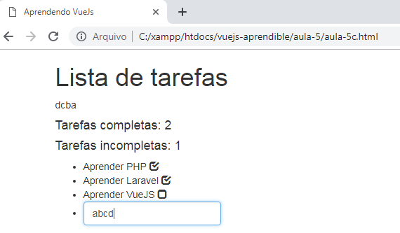

Ao se digitar cada letra da nova tarefa, os triggers não são disparados:

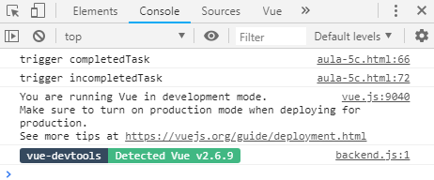

Os triggers só serão disparados, ao clicarmos nas tarefas para marcá-las ou desmarcá-las:

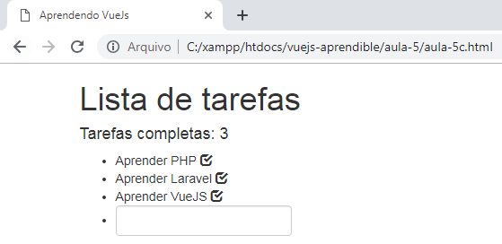

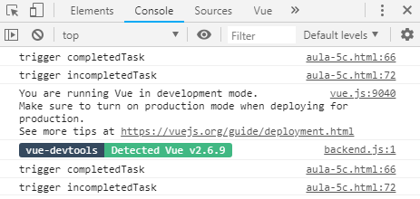

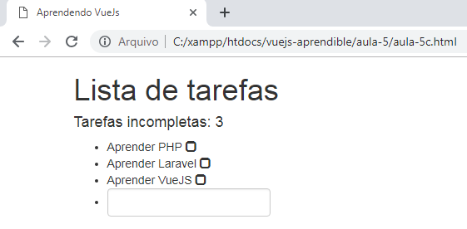

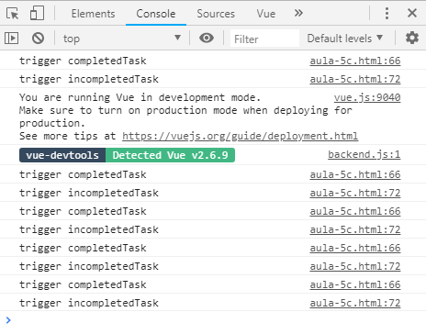

Aula 6 - Classes CSS dinâmicas

vuejs-aprendible/aula-6/aula-6a.html

<!DOCTYPE html>
<html lang="en">
<head>
<meta charset="UTF-8">
<link rel="stylesheet" href="https://maxcdn.bootstrapcdn.com/bootstrap/3.4.0/css/bootstrap.min.css">
<title>Aprendendo VueJs</title>
<style>
.glyphicon-check, .glyphicon-unchecked{
cursor: pointer;
}
</style>
</head>
<body>

<div class="container">
<script src="https://cdn.jsdelivr.net/npm/vue/dist/vue.js"></script>

<div id="app">

<h1>Lista de tarefas</h1>

<p>{{ reversedTask }}</p>

<h4 v-if="completedTasks">Tarefas completas: {{ completedTasks }}</h4>
<h4 v-if="incompletedTasks">Tarefas incompletas: {{ incompletedTasks }}</h4>

<ul>
<li v-for="task in tasks">
<span v-text="task.title"></span>
<span @click="task.completed = ! task.completed"
v-bind:class="{
'glyphicon':true,
'glyphicon-check':task.completed,
'glyphicon-unchecked':! task.completed}">
</span>
</li>
<li class="form-inline">
<input v-on:keyup.enter="addTask" type="text" class="form-control" v-model="newTask">
</li>
</ul>

</div>

<script>
var app = new Vue({
el: '#app',
data: {
newTask: "",
tasks: [
{ title: 'Aprender PHP', completed: true },
{ title: 'Aprender Laravel', completed: true },
{ title: 'Aprender VueJS', completed: false }
],
},
methods: {
addTask: function(){
if(this.newTask <= 1) return alert('A tarefa não pode estar vazia!');
this.tasks.push({
title: this.newTask,
completed: false
});
this.newTask = "";
}
},
computed: {
reversedTask: function(){
return this.newTask.split('').reverse().join('');
},
completedTasks: function(){
console.log('trigger completedTask');
return this.tasks.filter(function(task){
return task.completed;
}).length;
},
incompletedTasks: function(){
console.log('trigger incompletedTask');
return this.tasks.filter(function(task){
return !task.completed;
}).length;
}
}
});
</script>

</div>

</body>
</html>

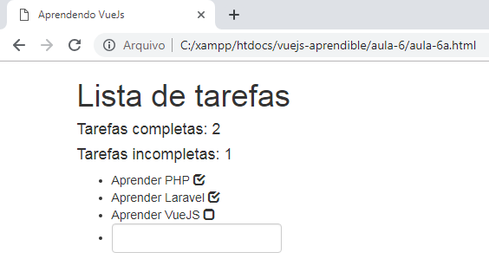

vuejs-aprendible/aula-6/aula-6b.html

<!DOCTYPE html>
<html lang="en">
<head>
<meta charset="UTF-8">
<link rel="stylesheet" href="https://maxcdn.bootstrapcdn.com/bootstrap/3.4.0/css/bootstrap.min.css">
<title>Aprendendo VueJs</title>
<style>
.glyphicon-check, .glyphicon-unchecked{
cursor: pointer;
}
</style>
</head>
<body>

<div class="container">
<script src="https://cdn.jsdelivr.net/npm/vue/dist/vue.js"></script>

<div id="app">

<h1>Lista de tarefas</h1>

<p>{{ reversedTask }}</p>

<h4 v-if="completedTasks">Tarefas completas: {{ completedTasks }}</h4>
<h4 v-if="incompletedTasks">Tarefas incompletas: {{ incompletedTasks }}</h4>

<ul>
<li v-for="task in tasks">
<span v-text="task.title"></span>
<span @click="task.completed = ! task.completed"
:class="[
'glyphicon',
task.completed ? 'glyphicon-check' : 'glyphicon-unchecked'
]">
</span>
</li>
<li class="form-inline">
<input v-on:keyup.enter="addTask" type="text" class="form-control" v-model="newTask">
</li>
</ul>

</div>

<script>
var app = new Vue({
el: '#app',
data: {
newTask: "",
tasks: [
{ title: 'Aprender PHP', completed: true },
{ title: 'Aprender Laravel', completed: true },
{ title: 'Aprender VueJS', completed: false }
],
},
methods: {
addTask: function(){
if(this.newTask <= 1) return alert('A tarefa não pode estar vazia!');
this.tasks.push({
title: this.newTask,
completed: false
});
this.newTask = "";
}
},
computed: {
reversedTask: function(){
return this.newTask.split('').reverse().join('');
},
completedTasks: function(){
console.log('trigger completedTask');
return this.tasks.filter(function(task){
return task.completed;
}).length;
},
incompletedTasks: function(){
console.log('trigger incompletedTask');
return this.tasks.filter(function(task){
return !task.completed;
}).length;
}
}
});
</script>

</div>

</body>
</html>

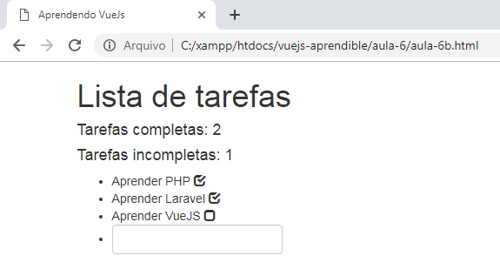

vuejs-aprendible/aula-6/aula-6c.html

<!DOCTYPE html>
<html lang="en">
<head>
<meta charset="UTF-8">
<link rel="stylesheet" href="https://maxcdn.bootstrapcdn.com/bootstrap/3.4.0/css/bootstrap.min.css">
<title>Aprendendo VueJs</title>
<style>
.glyphicon-check, .glyphicon-unchecked{
cursor: pointer;
}
</style>
</head>
<body>

<div class="container">
<script src="https://cdn.jsdelivr.net/npm/vue/dist/vue.js"></script>

<div id="app">

<h1>Lista de tarefas</h1>

<p>{{ reversedTask }}</p>

<h4 v-if="completedTasks">Tarefas completas: {{ completedTasks }}</h4>
<h4 v-if="incompletedTasks">Tarefas incompletas: {{ incompletedTasks }}</h4>

<ul>
<li v-for="task in tasks">
<span v-text="task.title"></span>
<span @click="task.completed = ! task.completed"
:class="taskClasses(task)">
</span>
</li>
<li class="form-inline">
<input v-on:keyup.enter="addTask" type="text" class="form-control" v-model="newTask">
</li>
</ul>

</div>

<script>
var app = new Vue({
el: '#app',
data: {
newTask: "",
tasks: [
{ title: 'Aprender PHP', completed: true },
{ title: 'Aprender Laravel', completed: true },
{ title: 'Aprender VueJS', completed: false }
],
},
methods: {
addTask: function(){
if(this.newTask <= 1) return alert('A tarefa não pode estar vazia!');
this.tasks.push({
title: this.newTask,
completed: false
});
this.newTask = "";
},
taskClasses: function(task){
return ['glyphicon', task.completed ? 'glyphicon-check' : 'glyphicon-unchecked'];
}
},
computed: {
reversedTask: function(){
return this.newTask.split('').reverse().join('');
},
completedTasks: function(){
console.log('trigger completedTask');
return this.tasks.filter(function(task){
return task.completed;
}).length;
},
incompletedTasks: function(){
console.log('trigger incompletedTask');
return this.tasks.filter(function(task){
return !task.completed;
}).length;
}
}
});
</script>

</div>

</body>
</html>

vuejs-aprendible/aula-6/aula-6d.html

<!DOCTYPE html>
<html lang="en">
<head>
<meta charset="UTF-8">
<link rel="stylesheet" href="https://maxcdn.bootstrapcdn.com/bootstrap/3.4.0/css/bootstrap.min.css">
<title>Aprendendo VueJs</title>
<style>
.glyphicon-check, .glyphicon-unchecked{
cursor: pointer;
}
</style>
</head>
<body>

<div class="container">
<script src="https://cdn.jsdelivr.net/npm/vue/dist/vue.js"></script>

<div id="app">

<h1>Lista de tarefas</h1>

<p>{{ reversedTask }}</p>

<h4 v-if="completedTasks">Tarefas completas: {{ completedTasks }}</h4>
<h4 v-if="incompletedTasks">Tarefas incompletas: {{ incompletedTasks }}</h4>

<ul>
<li v-for="task in tasks">
<span v-text="task.title"></span>
<span @click="completedTask(task)"
:class="taskClasses(task)">
</span>
</li>
<li class="form-inline">
<input v-on:keyup.enter="addTask" type="text" class="form-control" v-model="newTask">
</li>
</ul>

</div>

<script>
var app = new Vue({
el: '#app',
data: {
newTask: "",
tasks: [
{ title: 'Aprender PHP', completed: true },
{ title: 'Aprender Laravel', completed: true },
{ title: 'Aprender VueJS', completed: false }
],
},
methods: {
addTask: function(){
if(this.newTask <= 1) return alert('A tarefa não pode estar vazia!');
this.tasks.push({
title: this.newTask,
completed: false
});
this.newTask = "";
},
taskClasses: function(task){
return ['glyphicon', task.completed ? 'glyphicon-check' : 'glyphicon-unchecked'];
},
completedTask: function(task){
task.completed = ! task.completed;
}
},
computed: {
reversedTask: function(){
return this.newTask.split('').reverse().join('');
},
completedTasks: function(){
return this.tasks.filter(function(task){
return task.completed;
}).length;
},
incompletedTasks: function(){
return this.tasks.filter(function(task){
return !task.completed;
}).length;
}
}
});
</script>
</div>
</body>
</html>

