Vue.JS desde cero - Aulas 15 a 27
Bluuweb - Ignacio Gutierrez

https://www.youtube.com/watch?v=GAQB7Y4X5fM&list=PLPl81lqbj-4J-gfAERGDCdOQtVgRhSvIT

Resumo do curso feito por Roberto Pinheiro

Aula 15 - Instalação de Vue CLI

Instalando o Node

Inicialmente baixe e instale Node em seu computador:

https://nodejs.org/en/download/

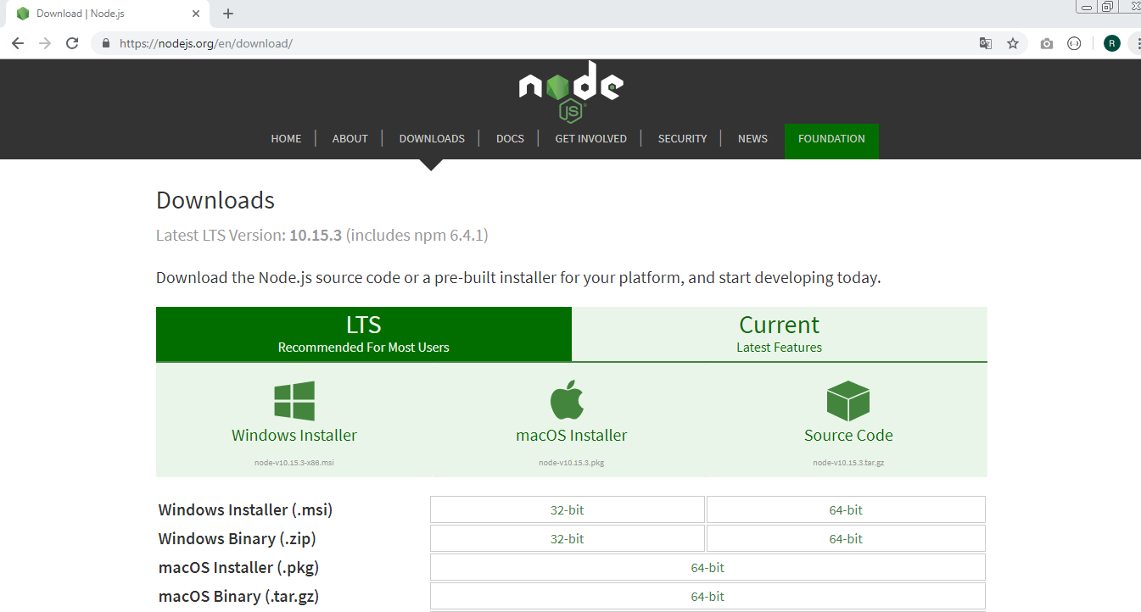

Para confirmar se a instalação foi corretamente instalada, entre com:

node -v

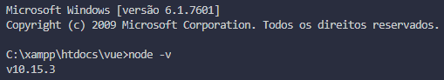

Instalando o Vue CLI

Acesse a página do Vue CLI:
https://cli.vuejs.org/

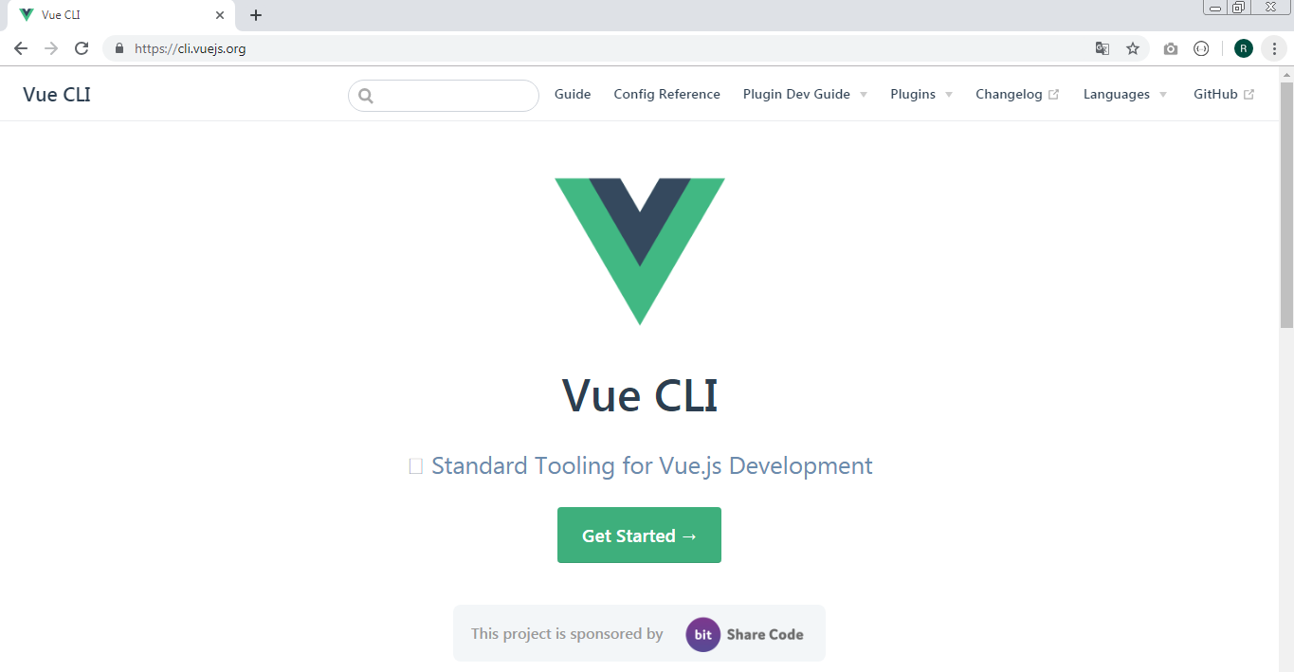

Clique no botão Get Started:

No menu existente na coluna à esquerda, selecione a opção instalation:

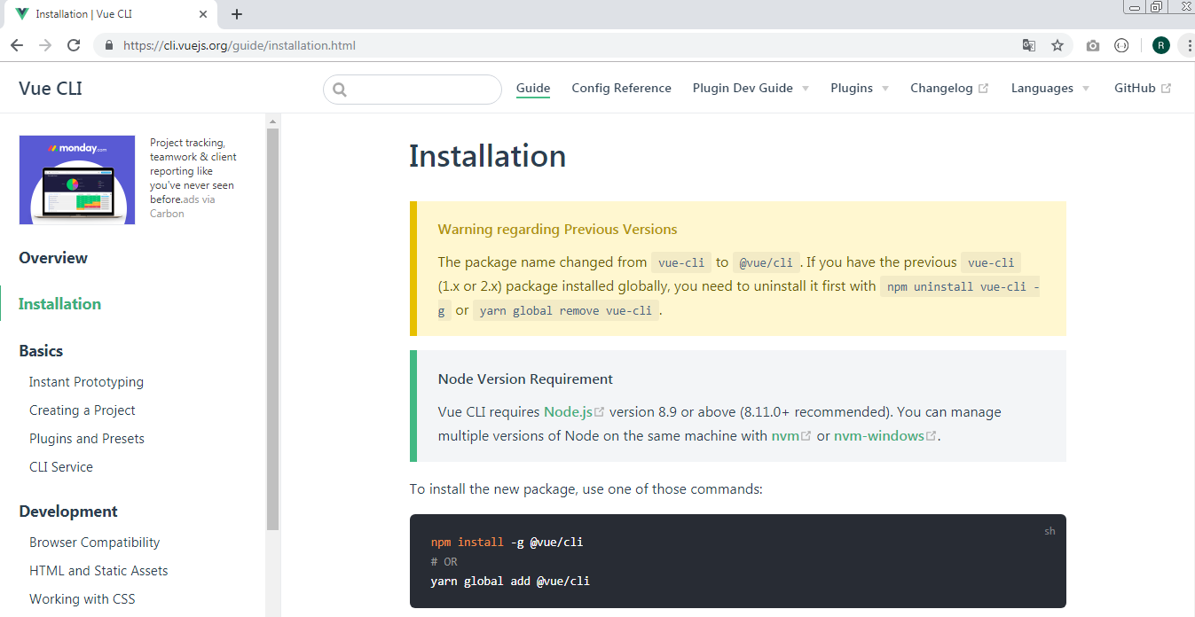

Entre, em qualquer pasta, com o comando:
npm install -g @vue/cli

Criando um projeto

No terminal do Visual Studio Code entre com o comando:

vue create projeto-1

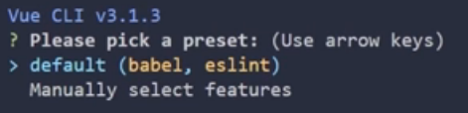

Escolha a instalação manual.

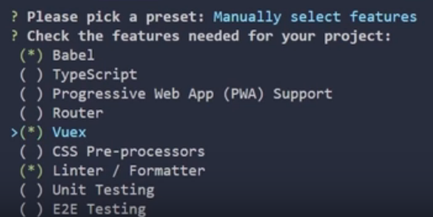

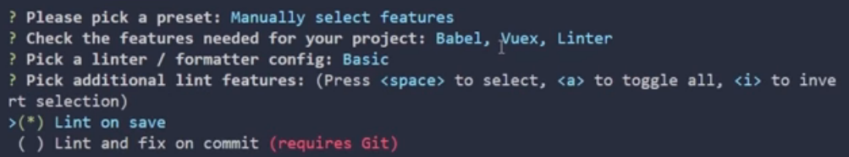

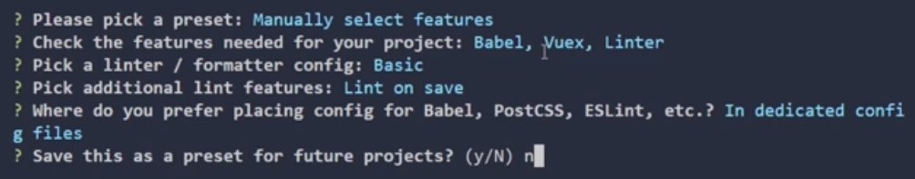

Ativando o servidor

Após criar o projeto, na pasta projeto-1, entre com o comando:

npm run serve

Isso ativará o servidor.

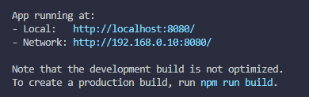

Clique no link:
- Local: http://localhost:8080

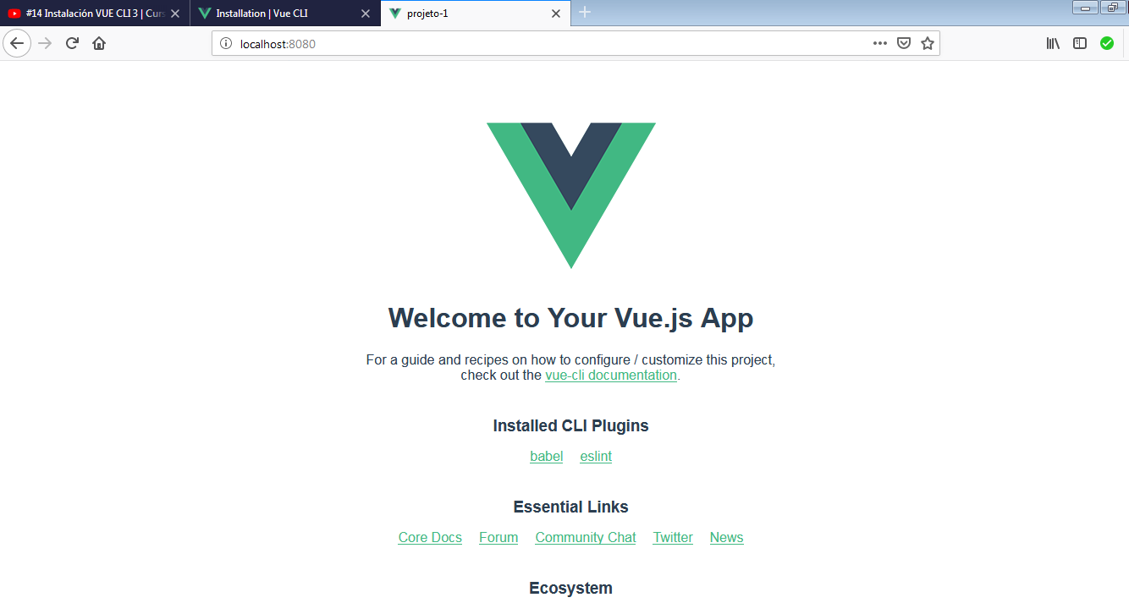

Aula 16 - Vue CLI 3 UI

Criando um projeto com interface gráfica

Ative o servidor:

npm run serve

No terminal, entre com o comando:

vue ui

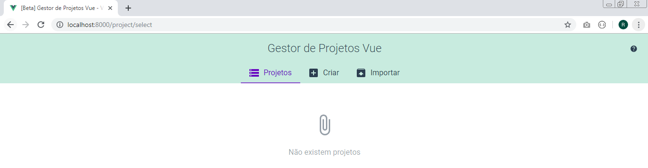

Clique no botão "Criar":

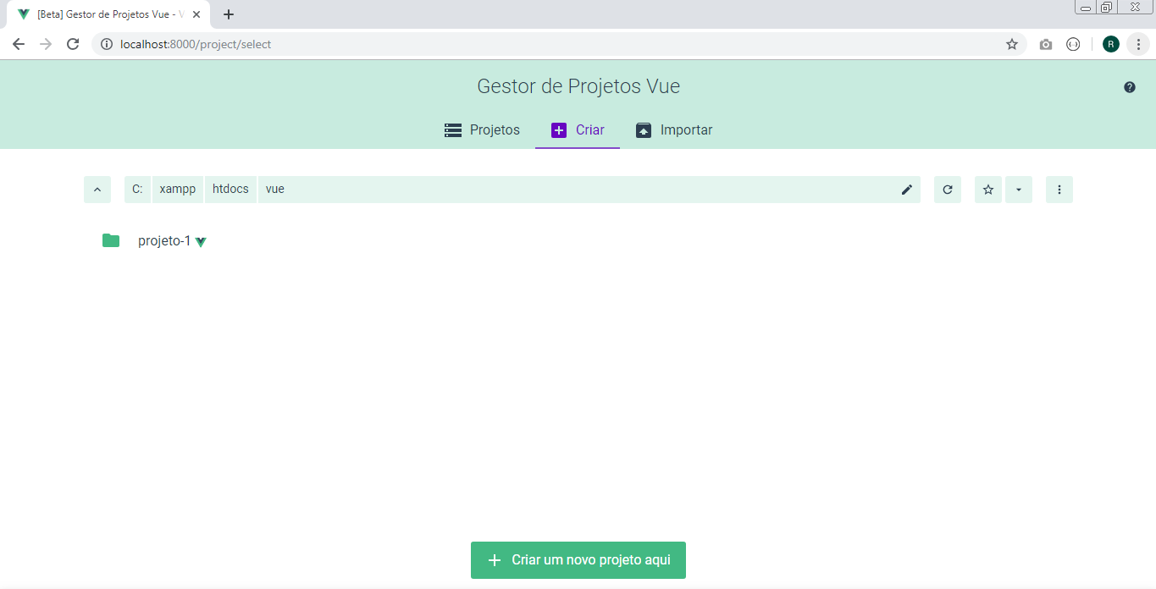

Clique no botão "Criar um novo projeto aqui"

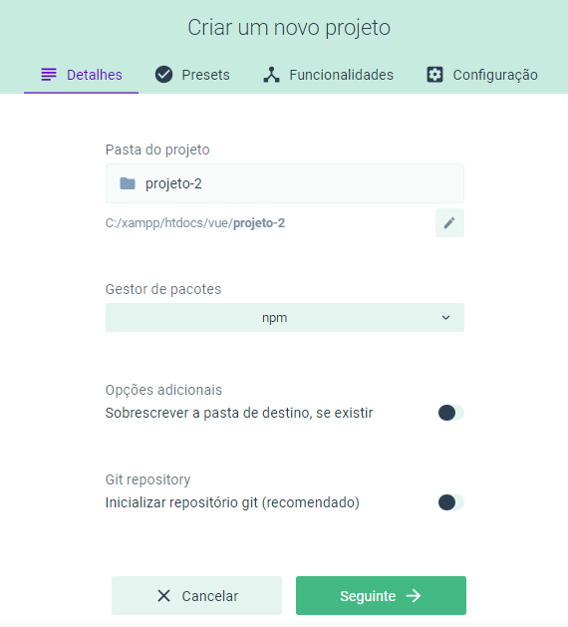

Clique no botão "Seguinte":

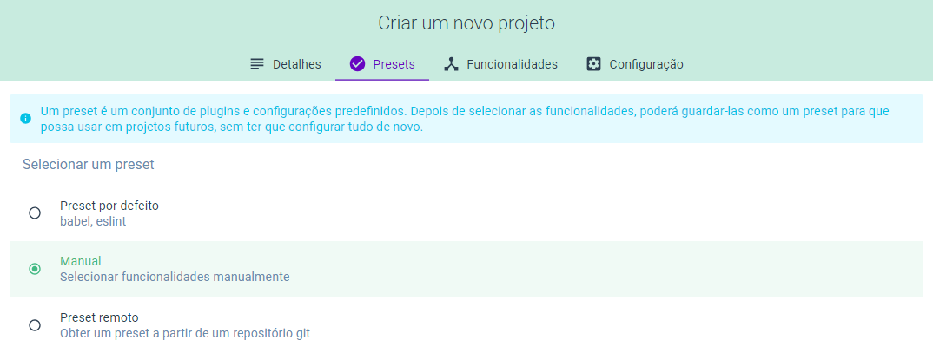

Selecione a opção "Manual" e clique no botão "Seguinte".

Ative a funcionalidade "Babel" e "Vuex". Deixe desativada as demais.

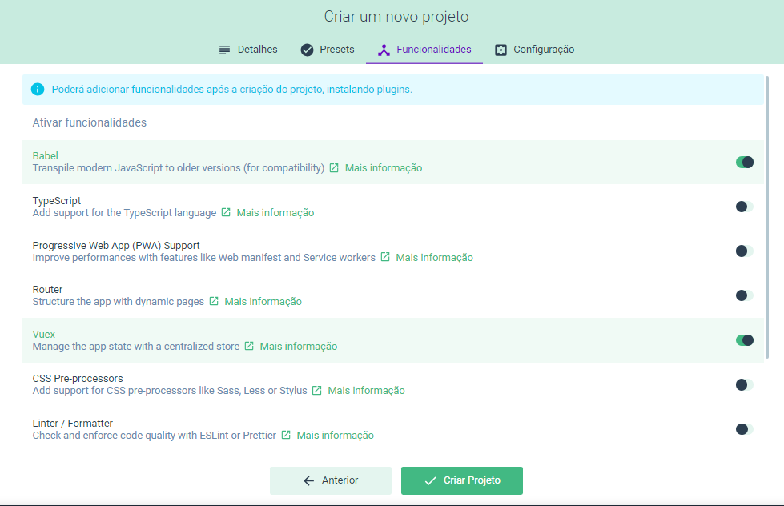

Clique no botão "Criar Projeto"

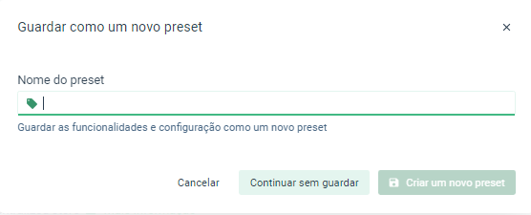

Sem preencher nada, clique no botão "Continuar sem guardar".

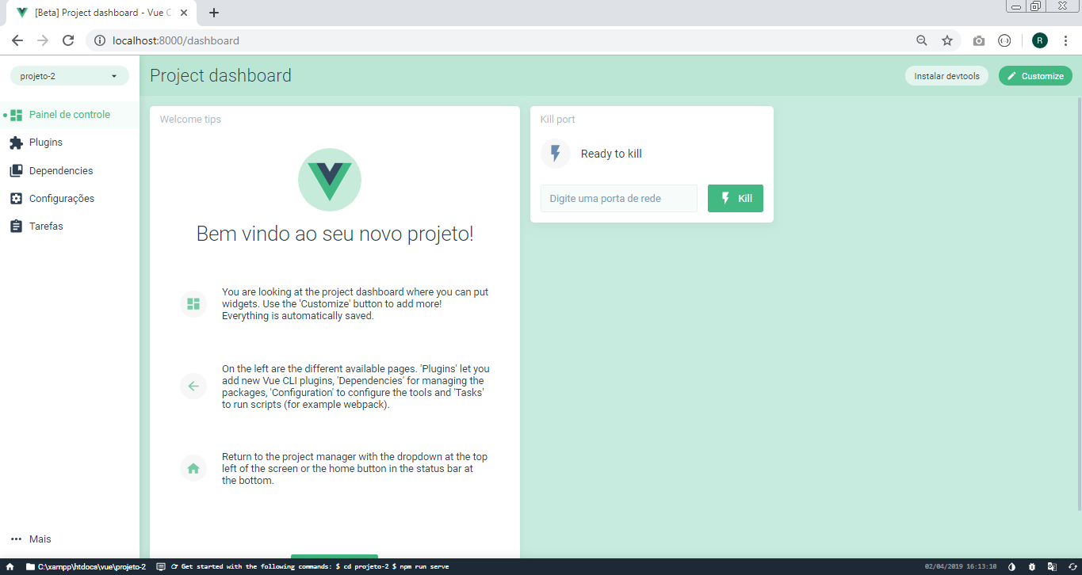

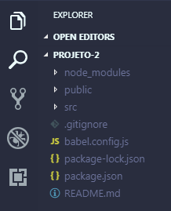

No menu lateral, clique em "Tarefas":

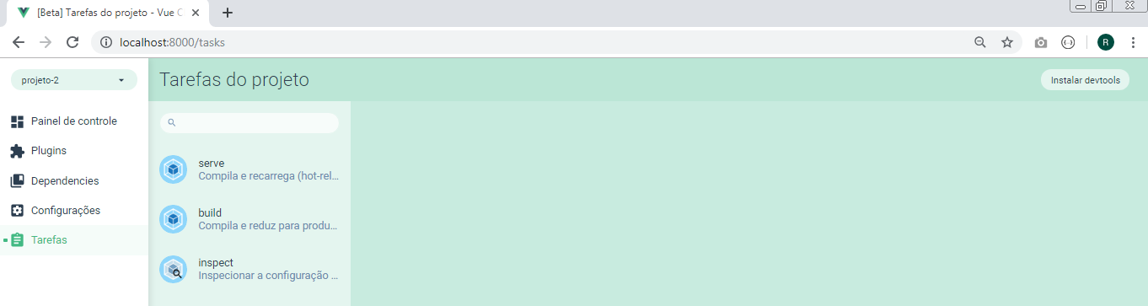

Clique no link "serve" e em seguida no botão "Executar tarefa"

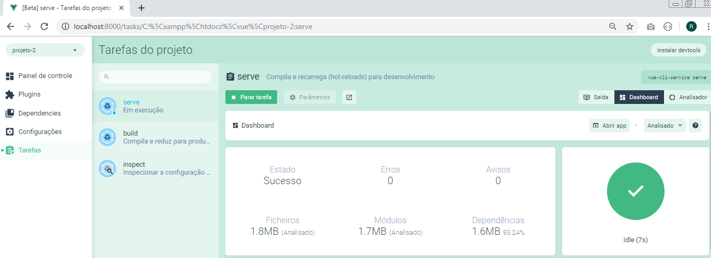

Clique no botão "abrir app":

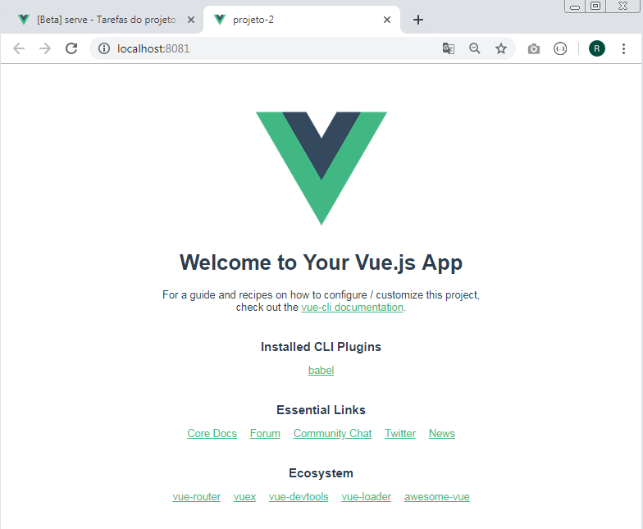

Aula 17 - Estrutura de Vue CLI - Vista prévia

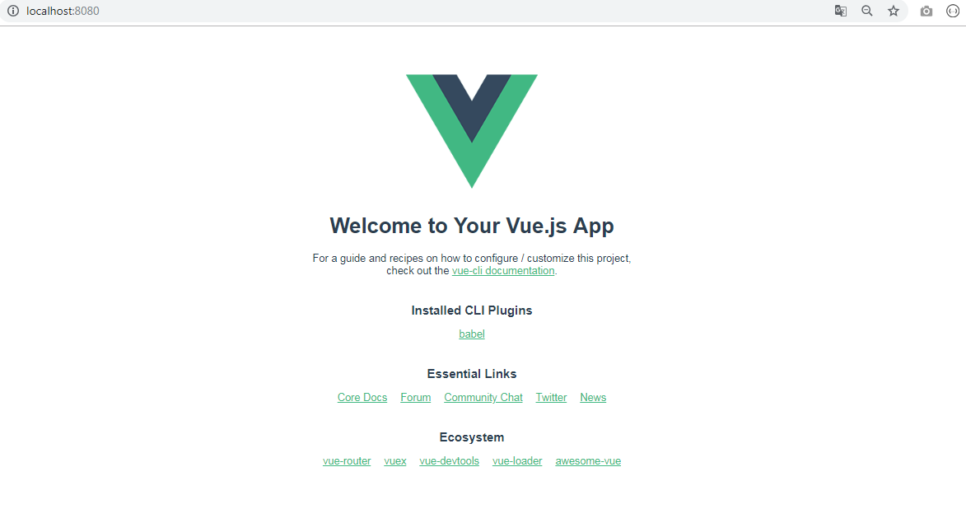

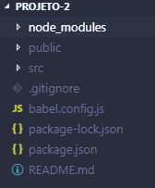

Pasta src

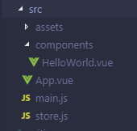

Pasta src/components

HelloWorld.vue

<template>
<div class="hello">
<h1>{{ msg }}</h1>
<p>
For a guide and recipes on how to configure / customize this project,<br>
check out the
<a href="https://cli.vuejs.org" target="_blank" rel="noopener">vue-cli documentation</a>.
</p>
<h3>Installed CLI Plugins</h3>
<ul>
<li><a href="https://github.com/vuejs/vue-cli/tree/dev/packages/%40vue/cli-plugin-babel" target="_blank" rel="noopener">babel</a></li>
</ul>
<h3>Essential Links</h3>
<ul>
<li><a href="https://vuejs.org" target="_blank" rel="noopener">Core Docs</a></li>
<li><a href="https://forum.vuejs.org" target="_blank" rel="noopener">Forum</a></li>
<li><a href="https://chat.vuejs.org" target="_blank" rel="noopener">Community Chat</a></li>
<li><a href="https://twitter.com/vuejs" target="_blank" rel="noopener">Twitter</a></li>
<li><a href="https://news.vuejs.org" target="_blank" rel="noopener">News</a></li>
</ul>
<h3>Ecosystem</h3>
<ul>
<li><a href="https://router.vuejs.org" target="_blank" rel="noopener">vue-router</a></li>
<li><a href="https://vuex.vuejs.org" target="_blank" rel="noopener">vuex</a></li>
<li><a href="https://github.com/vuejs/vue-devtools#vue-devtools" target="_blank" rel="noopener">vue-devtools</a></li>
<li><a href="https://vue-loader.vuejs.org" target="_blank" rel="noopener">vue-loader</a></li>
<li><a href="https://github.com/vuejs/awesome-vue" target="_blank" rel="noopener">awesome-vue</a></li>
</ul>
</div>
</template>

<script>
export default {
name: 'HelloWorld',
props: {
msg: String
}
}
</script>

<!-- Add "scoped" attribute to limit CSS to this component only -->
<style scoped>
h3 {
margin: 40px 0 0;
}
ul {
list-style-type: none;
padding: 0;
}
li {
display: inline-block;
margin: 0 10px;
}
a {
color: #42b983;
}
</style>

- template é o código HTML.
- script é a configuração do componente.
- style scoped é o estilo CSS válido apenas para o componente. Se for apenas style o estilo CSS passa a ser global.

Todo componente deve obrigatoriamente ter um template, script e style são opcionais.

Em script, name é o nome do componente.

Somente arquivos com extensão .vue permitem trabalhar com template, script e style.

App.vue

<template>
<div id="app">
<img alt="Vue logo" src="./assets/logo.png">
<HelloWorld msg="Welcome to Your Vue.js App"/>
</div>
</template>

<script>
import HelloWorld from './components/HelloWorld.vue'

export default {
name: 'app',
components: {
HelloWorld
}
}
</script>

<style>
#app {
font-family: 'Avenir', Helvetica, Arial, sans-serif;
-webkit-font-smoothing: antialiased;
-moz-osx-font-smoothing: grayscale;
text-align: center;
color: #2c3e50;
margin-top: 60px;
}
</style>

É o componente principal (componente pai).

main.js

import Vue from 'vue'
import App from './App.vue'
import store from './store'

Vue.config.productionTip = false

new Vue({
store,
render: h => h(App)
}).$mount('#app')

Neste arquivo é criada uma instância de Vue. É chamado o arquivo store.js que renderiza a aplicação numa div chamada app (em public/index.html).

public/index.html

<!DOCTYPE html>
<html lang="en">
<head>
<meta charset="utf-8">
<meta http-equiv="X-UA-Compatible" content="IE=edge">
<meta name="viewport" content="width=device-width,initial-scale=1.0">
<link rel="icon" href="<%= BASE_URL %>favicon.ico">
<title>projeto-2</title>
</head>
<body>
<noscript>
<strong>We're sorry but projeto-2 doesn't work properly without JavaScript enabled. Please enable it to continue.</strong>
</noscript>
<div id="app"></div>
<!-- built files will be auto injected -->
</body>
</html>

store.js

import Vue from 'vue'
import Vuex from 'vuex'

Vue.use(Vuex)

export default new Vuex.Store({
state: {
},
mutations: {
},
actions: {
}
})

O navegador não entende arquivos com a extensão .vue, porisso a necessidade do pacote babel para realizar esse trabalho.

Aula 18 - Prática Vue CLI e Vuex

No Visual Studio Code, instale as extensões Vetur e Vue 2 Snippets.

public/index.html

<!DOCTYPE html>
<html lang="en">
<head>
<meta charset="utf-8">
<meta http-equiv="X-UA-Compatible" content="IE=edge">
<meta name="viewport" content="width=device-width,initial-scale=1.0">
<link rel="icon" href="<%= BASE_URL %>favicon.ico">
<link rel="stylesheet" href="https://stackpath.bootstrapcdn.com/bootstrap/4.3.1/css/bootstrap.min.css">
<title>projeto-2</title>
</head>
<body>
<noscript>
<strong>We're sorry but projeto-2 doesn't work properly without JavaScript enabled. Please enable it to continue.</strong>
</noscript>
<div id="app"></div>
<!-- built files will be auto injected -->
</body>
</html>

src/components/Cabecalho.vue

<template>
<div>
<h1>Frutas</h1>
</div>
</template>

<script>
export default {
nome: 'Cabecalho'
}
</script>

src/components/Lista.vue

<template>
<div>
<ul class="list-group">
<li v-for="(item, index) of arrayOrdenado" :key="item.id" @click="aumentar(index)"
class="list-group-item d-flex justify-content-between align-items-center">
{{ index }} - {{ item.nome }}
<span class="badge badge-primary badge-pill">{{item.quantidade}}</span>
</li>
</ul>
<button class="btn btn-danger btn-block" @click="reiniciar">Reiniciar</button>
</div>
</template>

<script>
import {mapState, mapMutations} from 'vuex';
export default {
nome: "Lista",
computed: {
...mapState(['frutas']),
arrayOrdenado(){
return this.frutas.sort( (a, b) => b.quantidade - a.quantidade )
}
},
methods: {
...mapMutations(['aumentar','reiniciar'])
}
};
</script>

src/App.vue

<template>
<div id="app" class="container">
<img alt="Vue logo" src="./assets/logo.png">
<Cabecalho></Cabecalho>
<Lista></Lista>
</div>
</template>

<script>
import Cabecalho from './components/Cabecalho.vue'
import Lista from './components/Lista.vue'

export default {
name: 'app',
components: {
Cabecalho,
Lista
}
}
</script>

<style>
#app {
font-family: 'Avenir', Helvetica, Arial, sans-serif;
-webkit-font-smoothing: antialiased;
-moz-osx-font-smoothing: grayscale;
text-align: center;
color: #2c3e50;
margin-top: 60px;
}
</style>

src/store.js

import Vue from 'vue'
import Vuex from 'vuex'

Vue.use(Vuex)

export default new Vuex.Store({
state: {
frutas: [
{nome: 'Maçã', quantidade: 0},
{nome: 'Pera', quantidade: 0},
{nome: 'Laranja', quantidade: 0}
]
},
mutations: {
aumentar(state, index){
state.frutas[index].quantidade ++
},
reiniciar(state){
state.frutas.forEach(elemento => {
elemento.quantidade = 0
})
}
},
actions: {

}
})

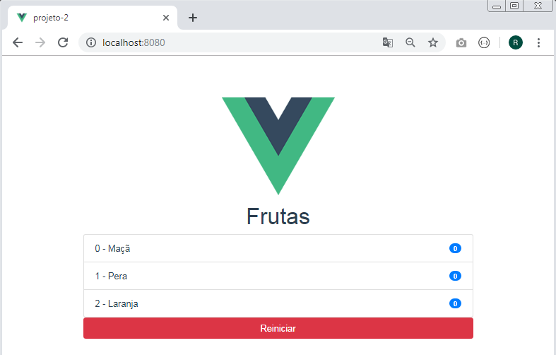

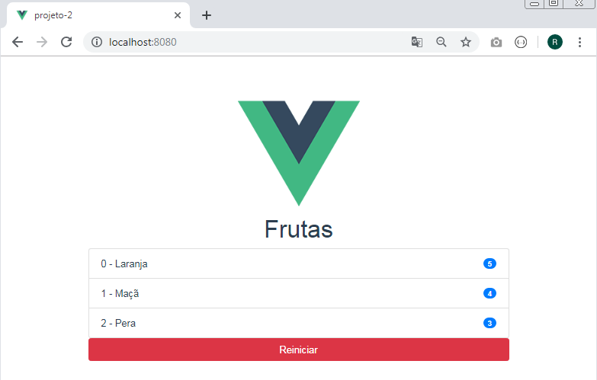

Aula 19 - Rotas com Vue (router-view)

Criando um novo projeto usando interface gráfica

No terminal do Visual Studio Code entre com o comando:

vue ui

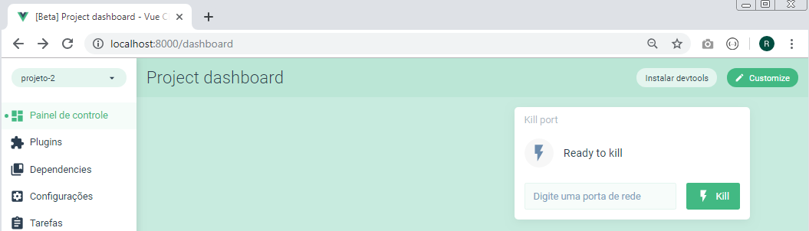

Na parter superior esquerda, no seletor de projetos, altere de projetos-2, para "Gestor de Projetos Vue"

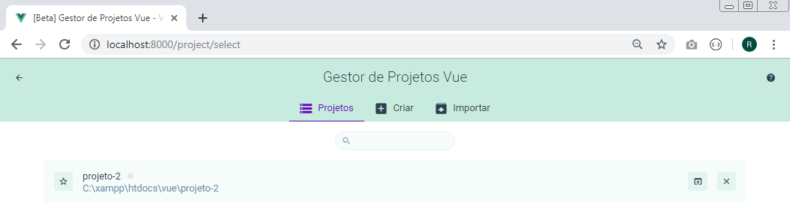
Clique em Criar, e em seguida na aba que corresponde a pasta dos projetos (vue):

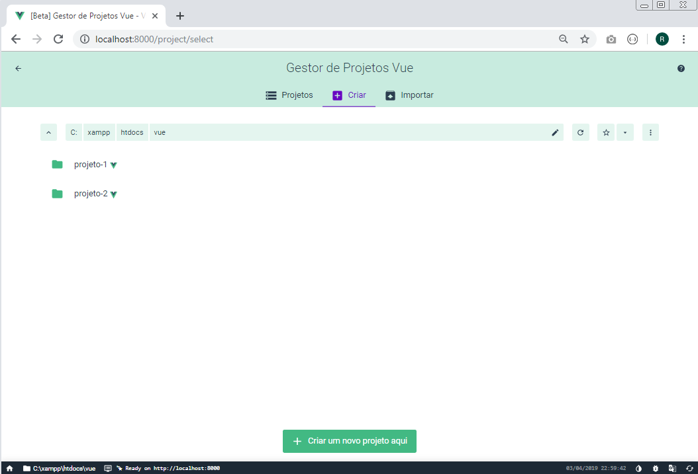

- Clique no botão "Criar um novo projeto aqui":
- Como pasta do projeto entre com: vue-route-1
- Gerador de pacotes: npm
- E desabilite Git repository

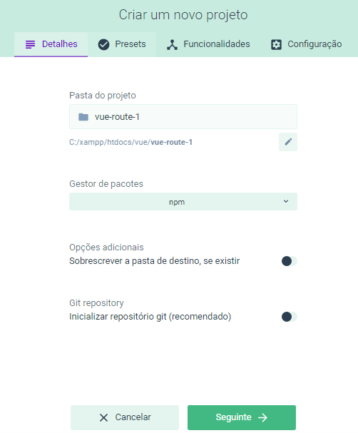

Clique no botão "Seguinte"

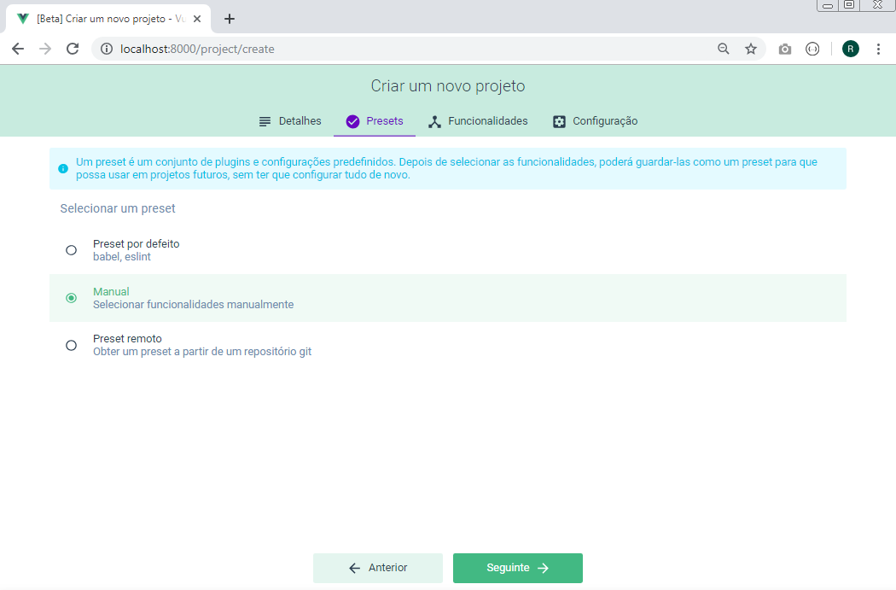

Selecione a opção "Manual" e clique no botão "Seguinte"

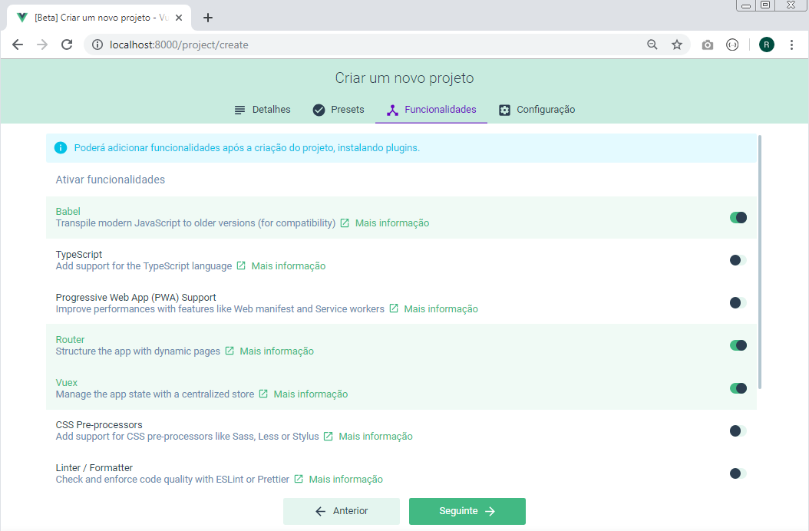

Deixe habilitado apenas as opções: Babel, Router e Vuex e clique no botão "Seguinte".

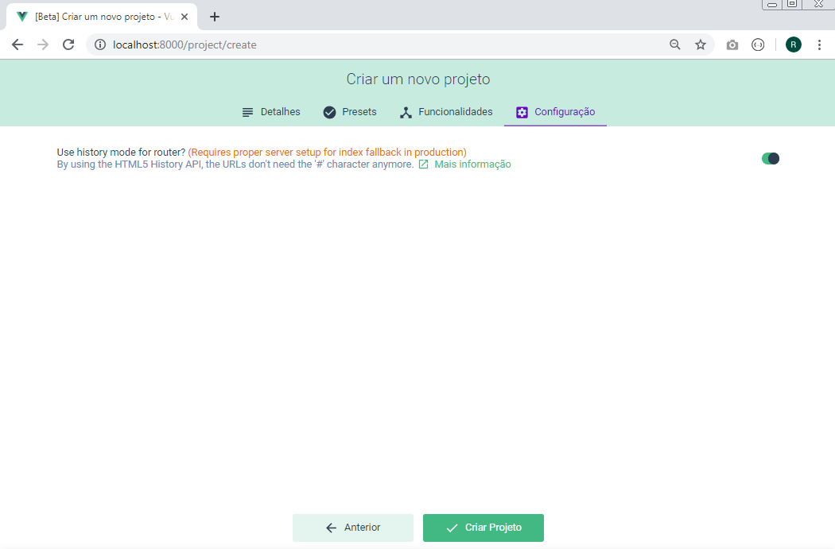

Habilite "Use history for route" e clique no botão "Criar Projeto".

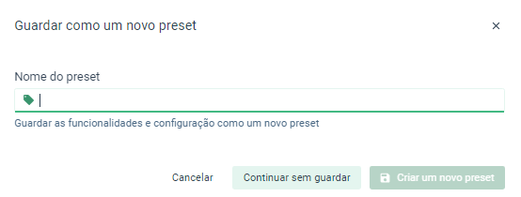

Clique no botão "Continuar sem guardar"

Aguarde a criação do projeto.

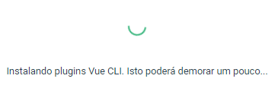

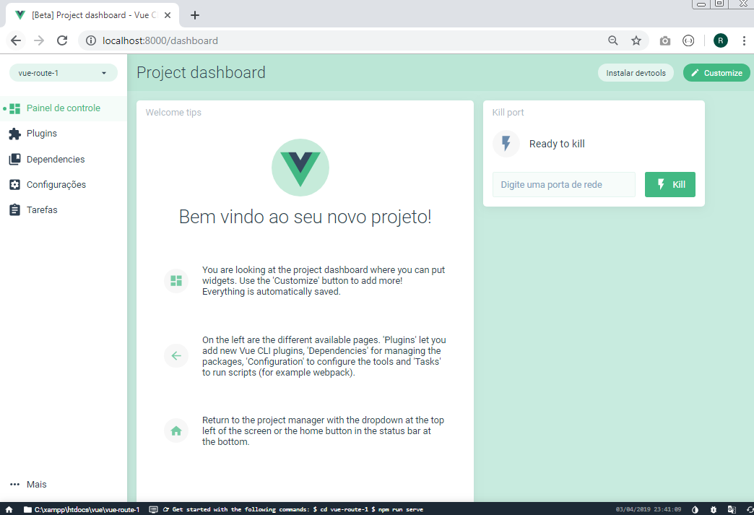

Clique no botão "Tarefas".

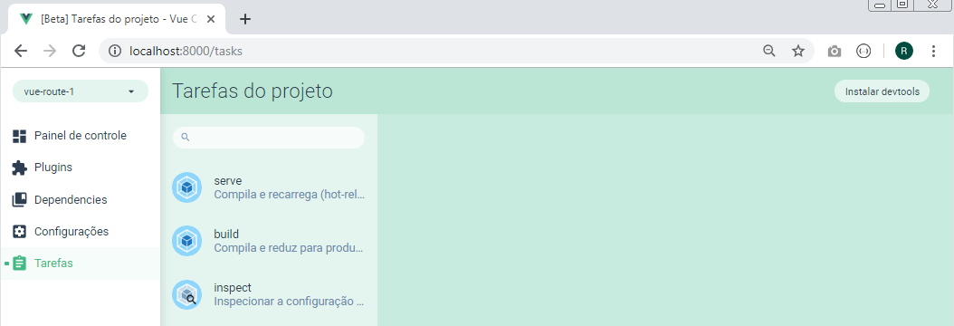

Clique em "serve".

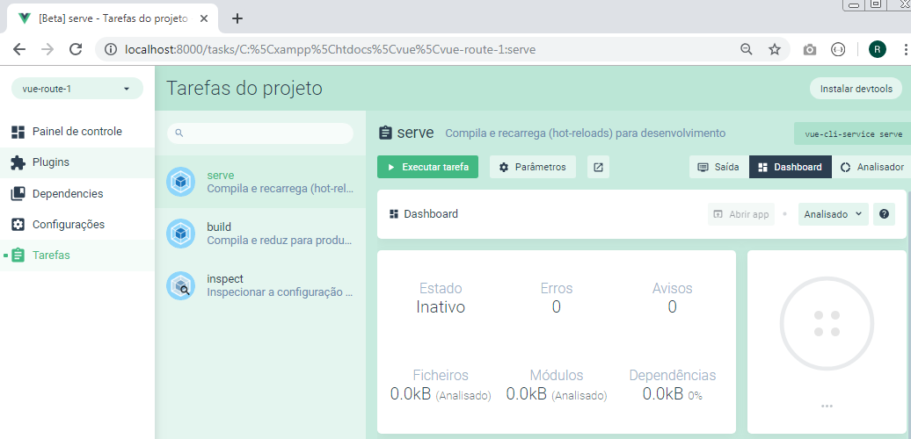

Clique no botão "Executar tarefa"

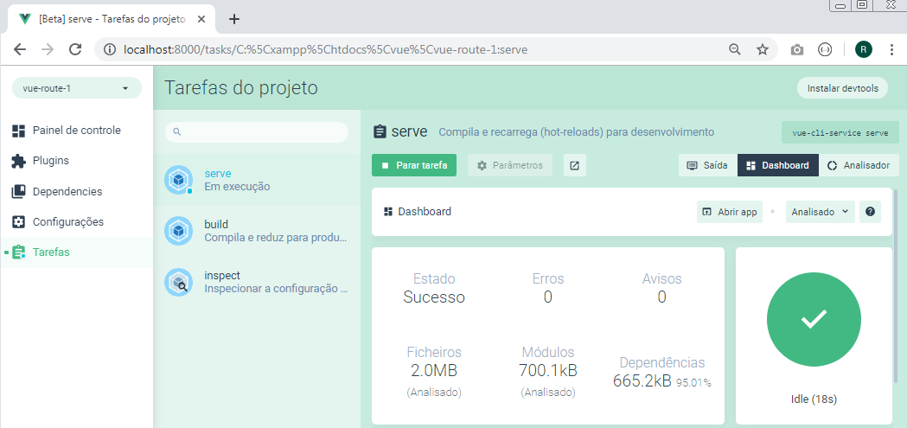

Finalmente clique no botão "Abrir app"

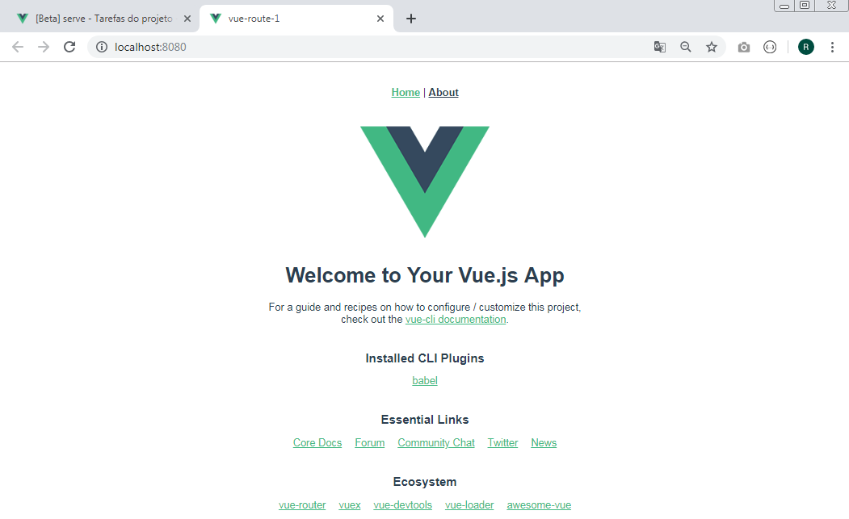

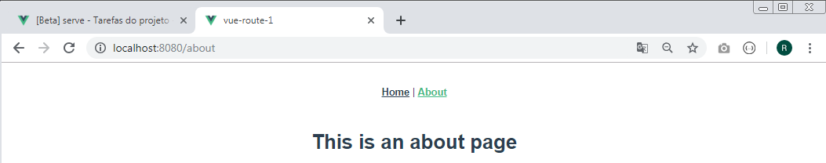

No Visual Studio Code, abra a pasta correspondente ao projeto criado.

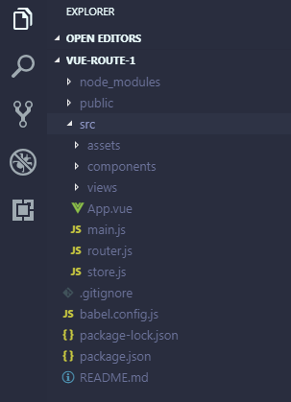

Em relação ao projeto anterior, observe agora a existência de uma nova pasta: views e de um novo arquivo: router.js

src/router.js

import Vue from 'vue'
import Router from 'vue-router'

Vue.use(Router)

export default new Router({
mode: 'history',
base: process.env.BASE_URL,
routes: [
{
path: '/',
name: 'home',
component: () => import(/* webpackChunkName: "home" */ './views/Home.vue')
},
{
path: '/about',
name: 'about',
component: () => import(/* webpackChunkName: "about" */ './views/About.vue')
},
{
path: '/servicos',
name: 'servicos',
component: () => import(/* webpackChunkName: "servicos" */ './views/Servicos.vue')
}
]
})

src/views/About.vue

<template>
<div class="about">
<h1>This is an about page</h1>
</div>
</template>

src/views/Servicos.vue

<template>
<div>
<h1>Página de Serviços</h1>
</div>
</template>

src/views/Home.vue

<template>
<div class="home">
<img alt="Vue logo" src="../assets/logo.png">
<HelloWorld msg="Welcome to Your Vue.js App"/>
</div>
</template>

<script>
// @ is an alias to /src
import HelloWorld from '@/components/HelloWorld.vue'

export default {
name: 'home',
components: {
HelloWorld
}
}
</script>

src/App.vue

<template>
<div id="app">
<div id="nav">
<router-link to="/">Home</router-link> |
<router-link to="/about">About</router-link> |
<router-link to="/servicos">Serviços</router-link>
</div>
<router-view/>
</div>
</template>

<style>
#app {
font-family: 'Avenir', Helvetica, Arial, sans-serif;
-webkit-font-smoothing: antialiased;
-moz-osx-font-smoothing: grayscale;
text-align: center;
color: #2c3e50;
}
#nav {
padding: 30px;
}

#nav a {
font-weight: bold;
color: #2c3e50;
}

#nav a.router-link-exact-active {
color: #42b983;
}
</style>

src/components/HelloWorld.vue

<template>
<div class="hello">
<h1>{{ msg }}</h1>
<p>
For a guide and recipes on how to configure / customize this project,<br>
check out the
<a href="https://cli.vuejs.org" target="_blank" rel="noopener">vue-cli documentation</a>.
</p>
<h3>Installed CLI Plugins</h3>
<ul>
<li><a href="https://github.com/vuejs/vue-cli/tree/dev/packages/%40vue/cli-plugin-babel" target="_blank" rel="noopener">babel</a></li>
</ul>
<h3>Essential Links</h3>
<ul>
<li><a href="https://vuejs.org" target="_blank" rel="noopener">Core Docs</a></li>
<li><a href="https://forum.vuejs.org" target="_blank" rel="noopener">Forum</a></li>
<li><a href="https://chat.vuejs.org" target="_blank" rel="noopener">Community Chat</a></li>
<li><a href="https://twitter.com/vuejs" target="_blank" rel="noopener">Twitter</a></li>
<li><a href="https://news.vuejs.org" target="_blank" rel="noopener">News</a></li>
</ul>
<h3>Ecosystem</h3>
<ul>
<li><a href="https://router.vuejs.org" target="_blank" rel="noopener">vue-router</a></li>
<li><a href="https://vuex.vuejs.org" target="_blank" rel="noopener">vuex</a></li>
<li><a href="https://github.com/vuejs/vue-devtools#vue-devtools" target="_blank" rel="noopener">vue-devtools</a></li>
<li><a href="https://vue-loader.vuejs.org" target="_blank" rel="noopener">vue-loader</a></li>
<li><a href="https://github.com/vuejs/awesome-vue" target="_blank" rel="noopener">awesome-vue</a></li>
</ul>
</div>
</template>

<script>
export default {
name: 'HelloWorld',
props: {
msg: String
}
}
</script>

<!-- Add "scoped" attribute to limit CSS to this component only -->
<style scoped>
h3 {
margin: 40px 0 0;
}
ul {
list-style-type: none;
padding: 0;
}
li {
display: inline-block;
margin: 0 10px;
}
a {
color: #42b983;
}
</style>

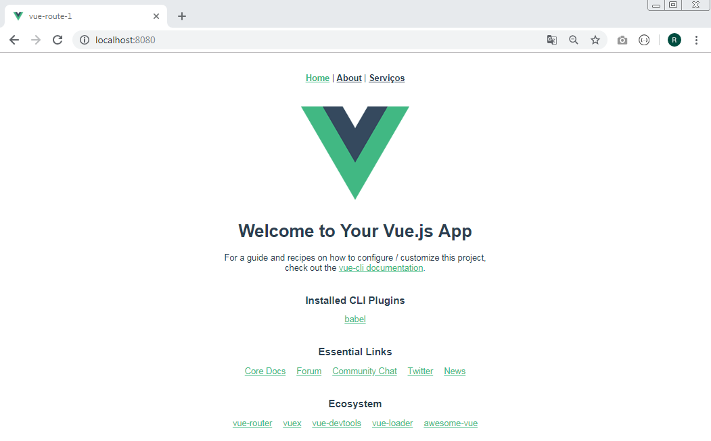

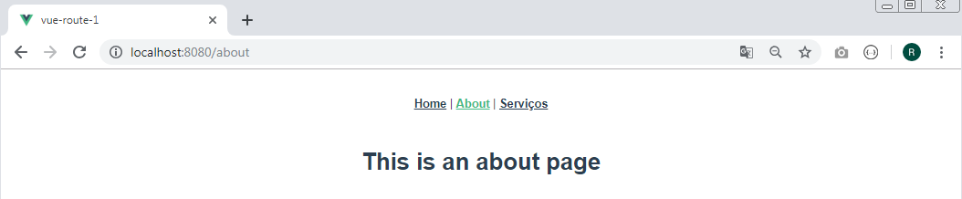

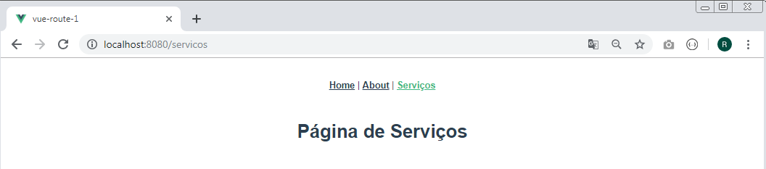

Aula 20 - Router Link e Rotas com parâmetros

Parâmetros dinâmicos

src/router.js

import Vue from 'vue'
import Router from 'vue-router'

Vue.use(Router)

export default new Router({
mode: 'history',
base: process.env.BASE_URL,
routes: [
{
path: '/',
name: 'home',
component: () => import(/* webpackChunkName: "home" */ './views/Home.vue')
},
{
path: '/about',
name: 'about',
component: () => import(/* webpackChunkName: "about" */ './views/About.vue')
},
{
path: '/servicos',
name: 'servicos',
component: () => import(/* webpackChunkName: "servicos" */ './views/Servicos.vue')
},
{
path: '/fotos/:id',
name: 'fotos',
component: () => import(/* webpackChunkName: "fotos" */ './views/Fotos.vue')
}

]
})

src/views/Fotos.vue

<template>
<div>
<h1>Galeria de Fotos</h1>
<foto />
</div>
</template>

<script>
import Foto from "@/components/Fotografia.vue";

export default {
components: {
Foto
}
}
</script>

src/components/Fotografia.vue

<template>
<div>
<h1>Foto a partir do componente: {{ $route.params.id }}</h1>
</div>
</template>

<script>
export default {
nome: 'Foto'
}
</script>

src/App.vue

<template>
<div id="app">
<div id="nav">
<router-link to="/">Home</router-link> |
<router-link to="/about">About</router-link> |
<router-link to="/servicos">Serviços</router-link> |
<router-link to="/fotos">Fotos</router-link>
</div>
<router-view/>
</div>
</template>

<style>
#app {
font-family: 'Avenir', Helvetica, Arial, sans-serif;
-webkit-font-smoothing: antialiased;
-moz-osx-font-smoothing: grayscale;
text-align: center;
color: #2c3e50;
}
#nav {
padding: 30px;
}

#nav a {
font-weight: bold;
color: #2c3e50;
}

#nav a.router-link-exact-active {
color: #42b983;
}
</style>

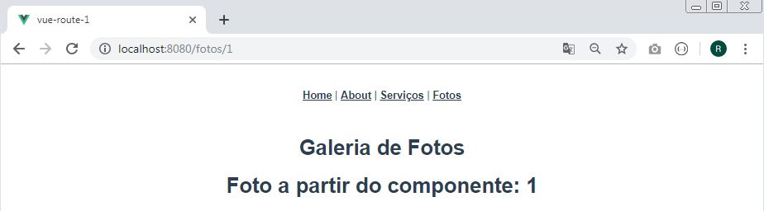

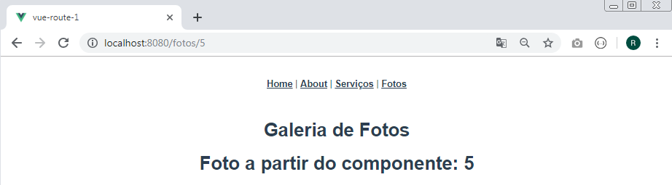

Aula 21 - Parâmetros dinâmicos e rotas através de eventos

src/views/Fotos.vue

<template>
<div>
<h1>Galeria de Fotos</h1>
<router-link :to="{ name: 'fotos', params: {id: item} }"
v-for="(item, index) of fotosArray" :key = "index">
<button>foto {{ item }}</button>
</router-link>
<foto />
<button @click="home">Home</button>
<button @click="anterior">Anterior</button>
<button @click="seguinte">Seguinte</button>
</div>
</template>

<script>
import Foto from "@/components/Fotografia.vue";

export default {
components: {
Foto
},
data() {
return {
fotosArray : [1,2,3]
}
},
methods: {
home(){
this.$router.push('/')
},
anterior(){
this.$router.go(-1)
},
seguinte(){
this.$router.go(1)
}
}
}
</script>

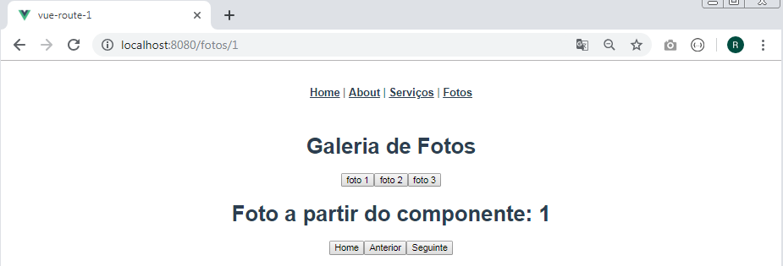

Clicando no botão "Home":

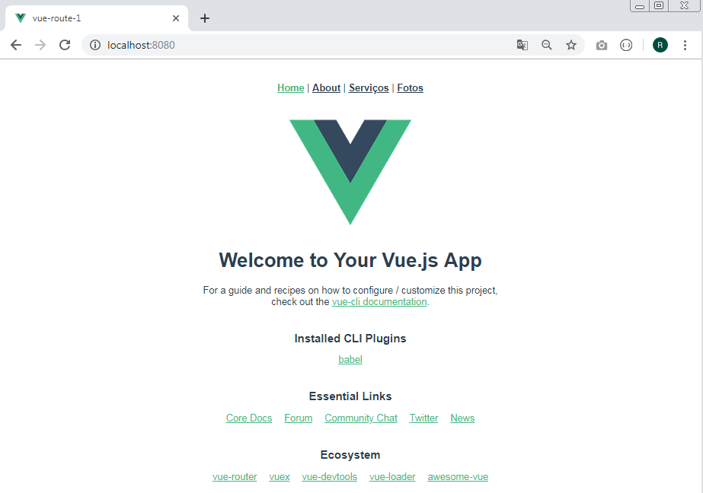

Clicando no botão "foto 2"

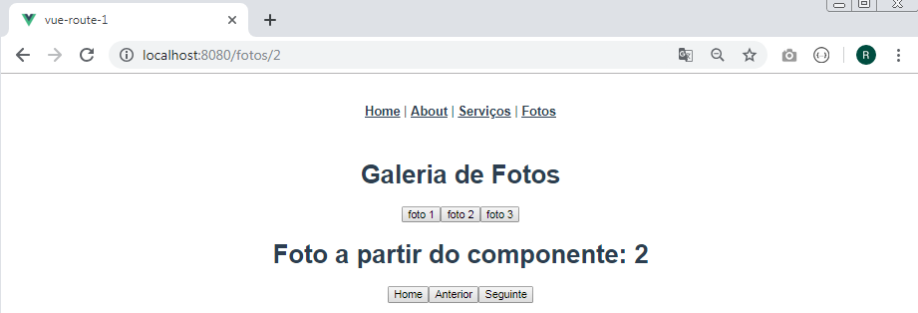

Clicando no botão "foto 3"

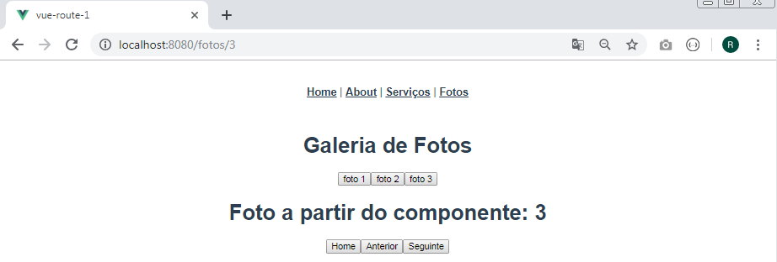

Clicando no botão "anterior"

Clicando no botão "anterior"

Clicando no botão "seguinte"

Clicando no botão "seguinte"

Clicando no botão "seguinte"

Aula 22 - Bootstrap + Vue

Usando vue ui, crie um novo projeto com rotas e nome de "instalando-bootstrap"

Instalação

npm i vue bootstrap-vue bootstrap

Insira no arquivo src/main.js as seguintes linhas:

import BootstrapVue from 'bootstrap-vue'
Vue.use(BootstrapVue)

import 'bootstrap/dist/css/bootstrap.css'
import 'bootstrap-vue/dist/bootstrap-vue.css'

src/main.js

import Vue from 'vue'
import App from './App.vue'
import router from './router'
import store from './store'

import BootstrapVue from 'bootstrap-vue'
Vue.use(BootstrapVue)

import 'bootstrap/dist/css/bootstrap.css'
import 'bootstrap-vue/dist/bootstrap-vue.css'

Vue.config.productionTip = false

new Vue({
router,
store,
render: h => h(App)
}).$mount('#app')

Inicie o servidor:

npm run serve

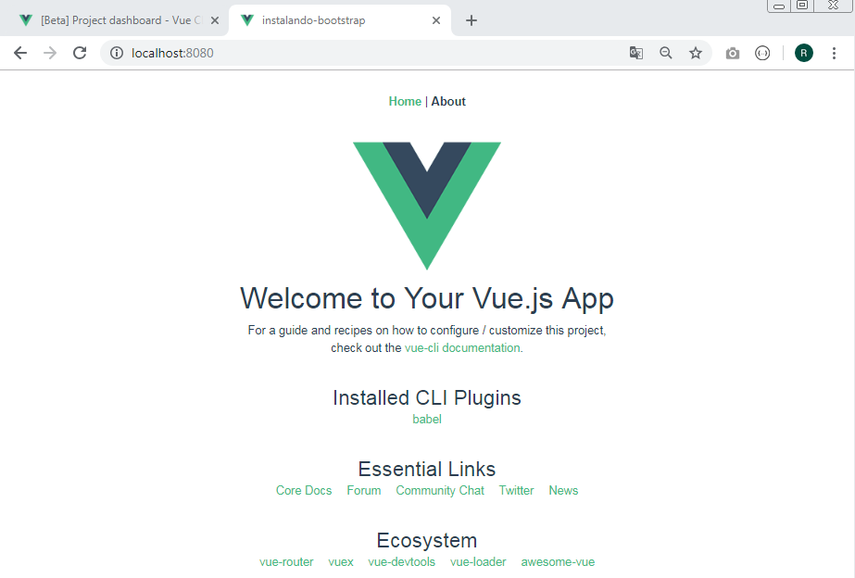

Aula 23 - Navbar [Class Active]

Acesse a URL:
https://bootstrap-vue.js.org/docs/components/navbar/

src/App.vue

<template>
<div id="app">

<b-navbar toggleable="lg" type="dark" variant="danger">
<b-container>
<b-navbar-brand href="#">NavBar</b-navbar-brand>
<b-navbar-toggle target="nav-collapse"></b-navbar-toggle>
<b-collapse id="nav-collapse" is-nav>
<b-navbar-nav>
<b-nav-item :to="{name: 'home'}" exact>Home</b-nav-item>
<b-nav-item :to="{name: 'about'}">About</b-nav-item>
</b-navbar-nav>
</b-collapse>
</b-container>
</b-navbar>

<router-view/>
</div>
</template>

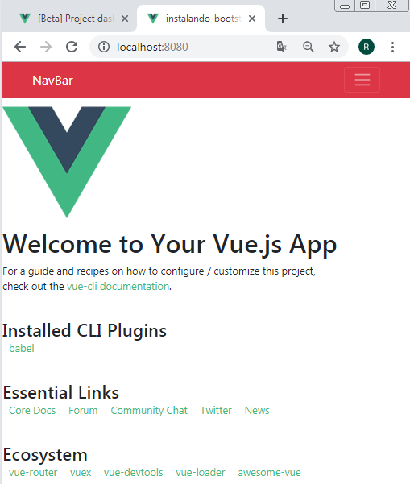

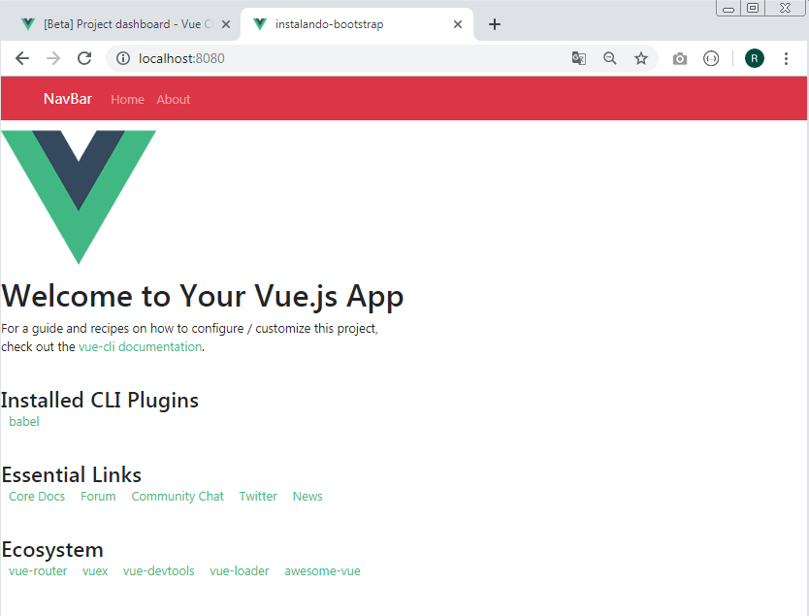
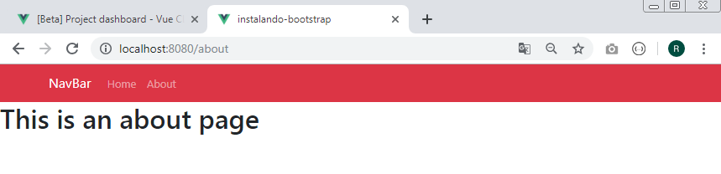

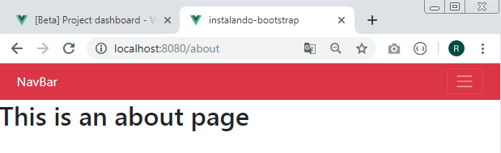

Aula 24 - Colunas responsivas [Row/Col]

Layout and grid system

src/router.js

import Vue from 'vue'
import Router from 'vue-router'
import Home from './views/Home.vue'

Vue.use(Router)

export default new Router({
mode: 'history',
base: process.env.BASE_URL,
routes: [
{
path: '/',
name: 'home',
component: Home
},
{
path: '/about',
name: 'about',
component: () => import(/* webpackChunkName: "about" */ './views/About.vue')
},
{
path: '/grid',
name: 'grid',
component: () => import(/* webpackChunkName: "grid" */ './views/Grid.vue')
}
]
})

src/views/Grid.vue

<template>
<div class="mt-5">
<b-row>
<b-col cols="12" md="6" lg="4">
<p>Lorem ipsum dolor sit amet consectetur adipisicing elit. Ratione, alias laboriosam eius eveniet delectus quo? Nostrum facere aliquam ut illum delectus accusantium quo velit ratione corporis. Cum deserunt repudiandae provident.</p>
</b-col>
<b-col cols="12" md="6" lg="8">
<p>Lorem ipsum dolor sit amet consectetur adipisicing elit. Ratione, alias laboriosam eius eveniet delectus quo? Nostrum facere aliquam ut illum delectus accusantium quo velit ratione corporis. Cum deserunt repudiandae provident.</p>
</b-col>
<b-col cols="12" md="6" lg="4">
<p>Lorem ipsum dolor sit amet consectetur adipisicing elit. Ratione, alias laboriosam eius eveniet delectus quo? Nostrum facere aliquam ut illum delectus accusantium quo velit ratione corporis. Cum deserunt repudiandae provident.</p>
</b-col>
<b-col cols="12" md="6" lg="8">
<p>Lorem ipsum dolor sit amet consectetur adipisicing elit. Ratione, alias laboriosam eius eveniet delectus quo? Nostrum facere aliquam ut illum delectus accusantium quo velit ratione corporis. Cum deserunt repudiandae provident.</p>
</b-col>
</b-row>
</div>
</template>

<script>
export default {
name: 'Grid'
}
</script>

src/App.vue

<template>
<div id="app">

<b-navbar toggleable="lg" type="dark" variant="danger">
<b-container>
<b-navbar-brand href="#">NavBar</b-navbar-brand>
<b-navbar-toggle target="nav-collapse"></b-navbar-toggle>

<b-collapse id="nav-collapse" is-nav>

<b-navbar-nav>
<b-nav-item :to="{name: 'home'}" exact>Home</b-nav-item>
<b-nav-item :to="{name: 'about'}">About</b-nav-item>
<b-nav-item :to="{name: 'grid'}">Grid</b-nav-item>
</b-navbar-nav>

</b-collapse>

</b-container>
</b-navbar>

<b-container>
<router-view/>
</b-container>

</div>
</template>

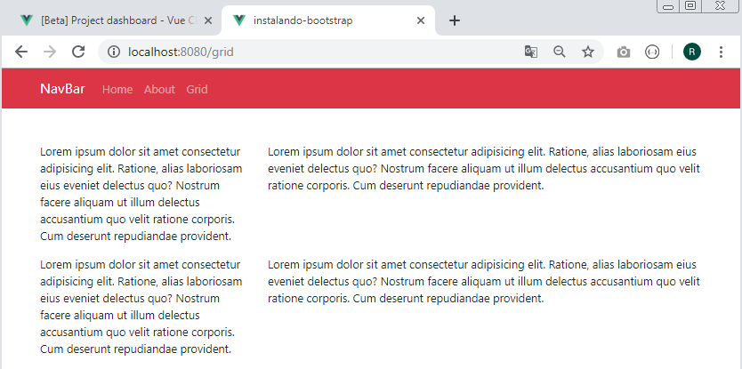

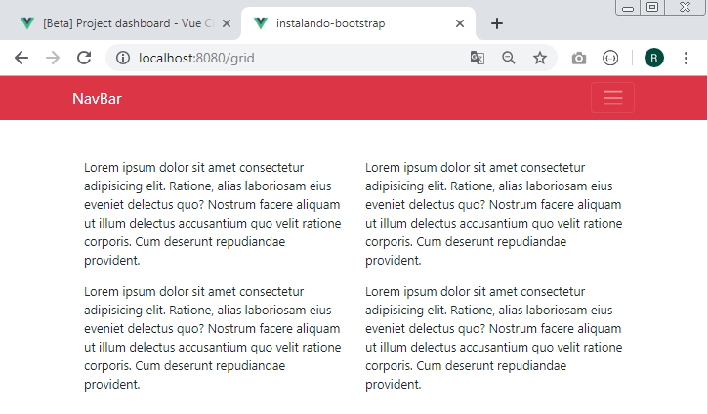

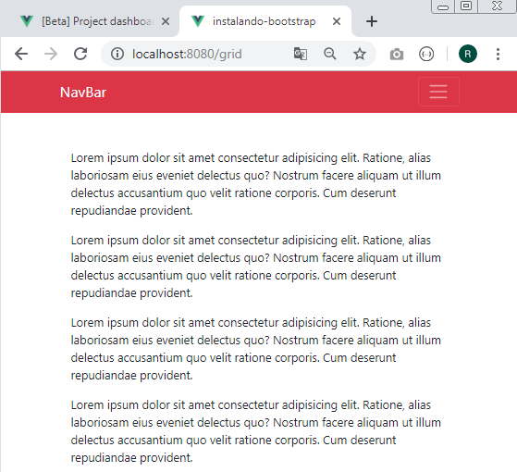

Aula 25 - Botões e Cards

src/router.js

import Vue from 'vue'
import Router from 'vue-router'
import Home from './views/Home.vue'

Vue.use(Router)

export default new Router({
mode: 'history',
base: process.env.BASE_URL,
routes: [
{
path: '/',
name: 'home',
component: Home
},
{
path: '/about',
name: 'about',
component: () => import(/* webpackChunkName: "about" */ './views/About.vue')
},
{
path: '/grid',
name: 'grid',
component: () => import(/* webpackChunkName: "grid" */ './views/Grid.vue')
},
{
path: '/cards',
name: 'cards',
component: () => import(/* webpackChunkName: "cards" */ './views/Cards.vue')
}

]
})

src/views/Cards.vue

<template>
<div class="mt-5">
<b-button variant="success">Texto</b-button>
<b-button variant="info">Texto</b-button>
<b-button variant="danger">Texto</b-button>
<b-button variant="primary">Texto</b-button>
<b-button variant="warning">Texto</b-button>
<b-button variant="dark">Texto</b-button>

<b-row class="mt-5">
<b-col cols="12" md="4">
<b-card img-src="https://picsum.photos/600/300/?image=25" img-top>
<p>Lorem ipsum dolor sit amet, consectetur adipisicing elit. Libero excepturi aspernatur ullam dicta exercitationem suscipit? Architecto, commodi. Cum minima cumque perferendis incidunt? Cupiditate magni, vero magnam qui accusamus odio architecto.</p>
<b-button variant="dark" href="#">Texto</b-button>
</b-card>
</b-col>
<b-col cols="12" md="4">
<b-card img-src="https://picsum.photos/600/300/?image=25" img-top>
<p>Lorem ipsum dolor sit amet, consectetur adipisicing elit. Libero excepturi aspernatur ullam dicta exercitationem suscipit? Architecto, commodi. Cum minima cumque perferendis incidunt? Cupiditate magni, vero magnam qui accusamus odio architecto.</p>
<b-button variant="dark" href="#">Texto</b-button>
</b-card>
</b-col>
<b-col cols="12" md="4">
<b-card img-src="https://picsum.photos/600/300/?image=25" img-top>
<p>Lorem ipsum dolor sit amet, consectetur adipisicing elit. Libero excepturi aspernatur ullam dicta exercitationem suscipit? Architecto, commodi. Cum minima cumque perferendis incidunt? Cupiditate magni, vero magnam qui accusamus odio architecto.</p>
<b-button variant="dark" href="#">Texto</b-button>
</b-card>
</b-col>
</b-row>

</div>
</template>

<script>
export default {
name:'Cards'
}
</script>

src/App.vue

<template>
<div id="app">

<b-navbar toggleable="lg" type="dark" variant="danger">
<b-container>
<b-navbar-brand href="#">NavBar</b-navbar-brand>
<b-navbar-toggle target="nav-collapse"></b-navbar-toggle>

<b-collapse id="nav-collapse" is-nav>

<b-navbar-nav>
<b-nav-item :to="{name: 'home'}" exact>Home</b-nav-item>
<b-nav-item :to="{name: 'about'}">About</b-nav-item>
<b-nav-item :to="{name: 'grid'}">Grid</b-nav-item>
<b-nav-item :to="{name: 'cards'}">Cards</b-nav-item>
</b-navbar-nav>

</b-collapse>

</b-container>
</b-navbar>

<b-container>
<router-view/>
</b-container>

</div>
</template>

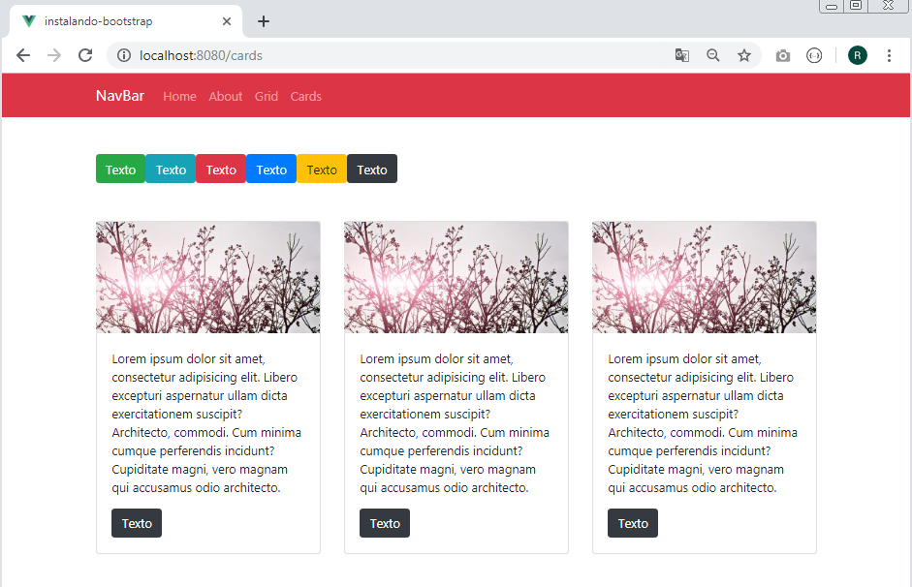

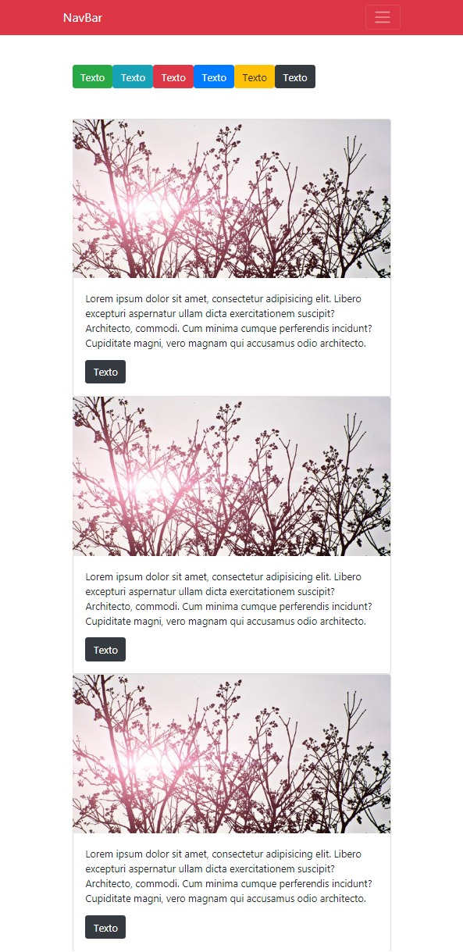

Aula 26 - Formulário INPUT com Bootstrap + Vue

src/router.js

import Vue from 'vue'
import Router from 'vue-router'
import Home from './views/Home.vue'

Vue.use(Router)

export default new Router({
mode: 'history',
base: process.env.BASE_URL,
routes: [
{
path: '/',
name: 'home',
component: Home
},
{
path: '/about',
name: 'about',
component: () => import(/* webpackChunkName: "about" */ './views/About.vue')
},
{
path: '/grid',
name: 'grid',
component: () => import(/* webpackChunkName: "grid" */ './views/Grid.vue')
},
{
path: '/cards',
name: 'cards',
component: () => import(/* webpackChunkName: "cards" */ './views/Cards.vue')
},
{
path: '/form',
name: 'form',
component: () => import(/* webpackChunkName: "form" */ './views/Form.vue')
}
]
})

src/App.vue

<template>
<div id="app">

<b-navbar toggleable="lg" type="dark" variant="danger">
<b-container>
<b-navbar-brand href="#">NavBar</b-navbar-brand>
<b-navbar-toggle target="nav-collapse"></b-navbar-toggle>

<b-collapse id="nav-collapse" is-nav>

<b-navbar-nav>
<b-nav-item :to="{name: 'home'}" exact>Home</b-nav-item>
<b-nav-item :to="{name: 'about'}">About</b-nav-item>
<b-nav-item :to="{name: 'grid'}">Grid</b-nav-item>
<b-nav-item :to="{name: 'cards'}">Cards</b-nav-item>
<b-nav-item :to="{name: 'form'}">Form</b-nav-item>
</b-navbar-nav>

</b-collapse>

</b-container>
</b-navbar>

<b-container>
<router-view/>
</b-container>

</div>
</template>

src/views/Form.vue

<template>
<div class="mt-5">
<h1>Formulários</h1>
<form>
<b-row>
<b-col md="6">
<b-form-input type="text" v-model="texto" :state="comprovar"></b-form-input>
<small>Mínimo: 3 caracteres</small>
</b-col>
</b-row>
<p>Texto: {{ texto }}</p>
</form>

</div>
</template>

<script>
export default {
name: 'Form',
data(){
return {
texto: ''
}
},
computed: {
comprovar(){
return this.texto.length > 2 ? true : false
}
}
}
</script>

Input type

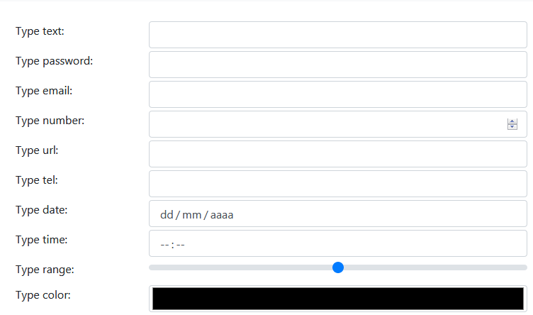

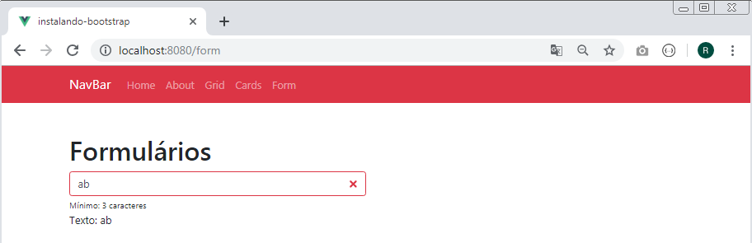

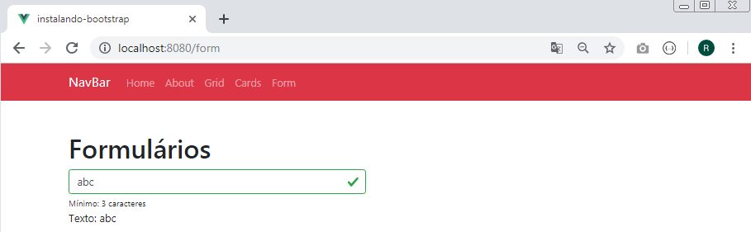

Aula 27 - Formulário Select e RadioButton

src/views/Form.vue

<template>
<div class="mt-5">
<h1>Formulários</h1>
<form>
<b-row>
<b-col md="3">
<b-form-input type="text" v-model="texto" :state="comprovar"></b-form-input>
<small>Mínimo: 3 caracteres</small>
</b-col>
<b-col md="3">
<b-form-select v-model="select" :options="animais"></b-form-select>
<p>Seleção: {{ select }}</p>
</b-col>
<b-col md="3">
<b-form-radio-group v-model="radio" :options="animaisRadio"></b-form-radio-group>
<p>Radio: {{ radio }}</p>
</b-col>
<b-col md="3">
<b-form-checkbox-group v-model="check" :options="animaisRadio"></b-form-checkbox-group>
<p>Múltiplo: {{ check }}</p>
</b-col>
</b-row>
<p>Texto: {{ texto }}</p>
</form>

</div>
</template>

<script>
export default {
name: 'Form',
data(){
return {
texto: '',
check: [],
radio: null,
select: null,
animais: [
{value: null, text: 'Selecione um animal'},
{value: 'cachorro', text: 'au, au'},
{value: 'gato', text: 'miau, miau'},
{value: 'pato', text: 'quack, quack'}
],
animaisRadio: [
{value: 'cachorro', text: 'au, au'},
{value: 'gato', text: 'miau, miau'},
{value: 'pato', text: 'quack, quack'}
]
}
},
computed: {
comprovar(){
return this.texto.length > 2 ? true : false
},
animais(){

}
}
}
</script>

