Minha primeira API Rest em Laravel 8
Code Experts

Vídeo:
https://www.youtube.com/watch?v=jq-FkfKBZ50

composer create-project laravel/laravel:^8.0 laravel8_a
pi_rest

touch database/database.sqlite

.env

DB_CONNECTION=sqlite
# DB_HOST=127.0.0.1
# DB_PORT=3306
# DB_DATABASE=laravel
# DB_USERNAME=root
# DB_PASSWORD=

Gerando os models, migration e factory

php artisan make:model Store -mf

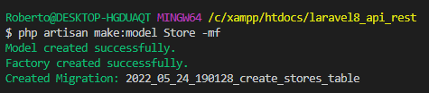

php artisan make:model Product -mf

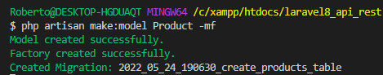

Models

app\Models\Store.php

<?php

namespace App\Models;

use Illuminate\Database\Eloquent\Factories\HasFactory;
use Illuminate\Database\Eloquent\Model;

class Store extends Model
{
use HasFactory;

protected $fillable = ['name', 'description'];

public function products()
{
return $this->hasMany(Product::class); //store_id
}
}

app\Models\Product.php

<?php

namespace App\Models;

use Illuminate\Database\Eloquent\Factories\HasFactory;
use Illuminate\Database\Eloquent\Model;

class Product extends Model
{
use HasFactory;

protected $fillable = ['name', 'description', 'price'];

public function store()
{
return $this->belongsTo(Store::class);
}
}

Criando as tabelas

php artisan migrate

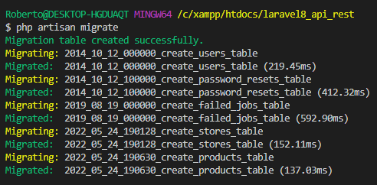

database\factories\StoreFactory.php

<?php

namespace Database\Factories;

use App\Models\Store;
use Illuminate\Database\Eloquent\Factories\Factory;

class StoreFactory extends Factory
{
/**
* The name of the factory's corresponding model.
*
* @var string
*/
protected $model = Store::class;

/**
* Define the model's default state.
*
* @return array
*/
public function definition()
{
return [
'name' => $this->faker->words(3, true),
'description' => $this->faker->sentence
];
}
}

database\factories\ProductFactory.php

<?php

namespace Database\Factories;

use App\Models\Product;
use Illuminate\Database\Eloquent\Factories\Factory;

class ProductFactory extends Factory
{
/**
* The name of the factory's corresponding model.
*
* @var string
*/
protected $model = Product::class;

/**
* Define the model's default state.
*
* @return array
*/
public function definition()
{
return [
'name' => $this->faker->words(3, true),
'description' => $this->faker->sentence,
'price' => $this->faker->randomFloat(2, 10, 300)
];
}
}

app\Models\Product.php

<?php

namespace App\Models;

use Illuminate\Database\Eloquent\Factories\HasFactory;
use Illuminate\Database\Eloquent\Model;

class Product extends Model
{
use HasFactory;

protected $fillable = ['name', 'description', 'price'];

public function getPriceAttribute()
{
return $this->attributes['price'] / 100; // 1990 -> 19.9
}

public function setPriceAttribute($attr)
{
return $this->attributes['price'] = $attr * 100; //19.90 -> 1990
}

public function store()
{
return $this->belongsTo(Store::class);
}
}

database\seeders\DatabaseSeeder.php

<?php

namespace Database\Seeders;

use Illuminate\Database\Seeder;

class DatabaseSeeder extends Seeder
{
/**
* Seed the application's database.
*
* @return void
*/
public function run()
{
\App\Models\Store::factory(10)
->hasProducts(10)
->create();
}
}

php artisan db:seed

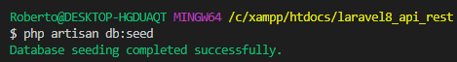

php artisan tinker

$store = \App\Models\Store::first()

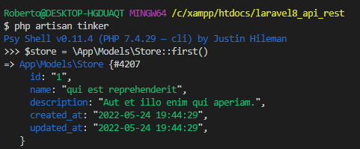

$store -> products -> count()

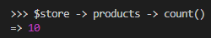

$store -> products -> pluck('name')

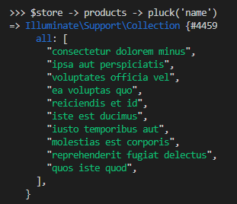

$store -> products

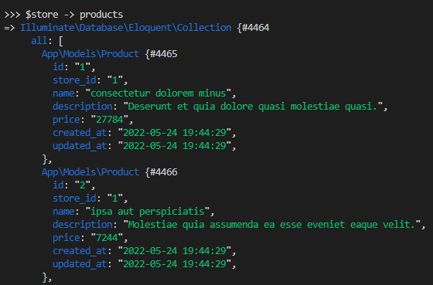
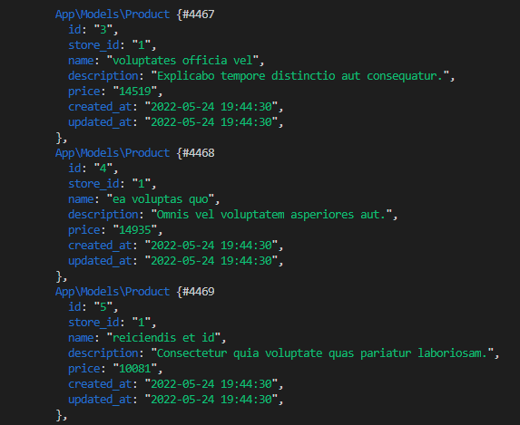
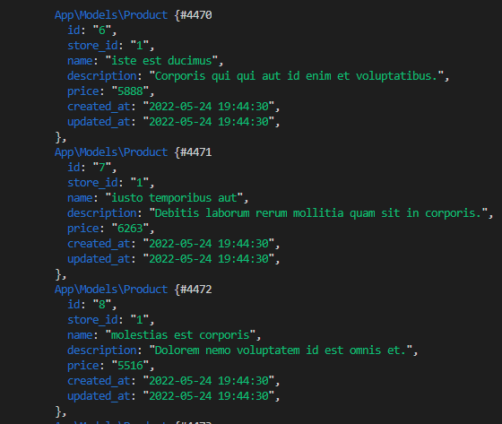
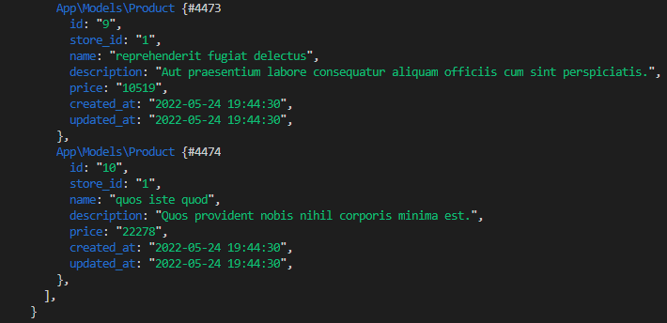

Rotas

routes\api.php

<?php

use Illuminate\Http\Request;
use Illuminate\Support\Facades\Route;

/*
|--------------------------------------------------------------------------
| API Routes
|--------------------------------------------------------------------------
|
| Here is where you can register API routes for your application. These
| routes are loaded by the RouteServiceProvider within a group which
| is assigned the "api" middleware group. Enjoy building your API!
|
*/

Route::middleware('auth:sanctum')->get('/user', function (Request $request) {
return $request->user();
});

Route::apiResource('stores', \App\Http\Controllers\Api\StoreController::class);
Route::apiResource('stores.products', \App\Http\Controllers\Api\ProductController::class) ->only(['index']);

Controllers

php artisan make:controller Api/StoreController --resource --api

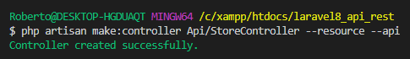

php artisan make:controller Api/ProductController -r --api

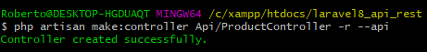

app\Http\Controllers\Api\StoreController.php

<?php

namespace App\Http\Controllers\Api;

use App\Http\Controllers\Controller;
use Illuminate\Http\Request;
use App\Models\Store;

class StoreController extends Controller
{
private $store;

public function __construct(Store $store)
{
$this->store = $store;
}

/**
* Display a listing of the resource.
*
* @return \Illuminate\Http\Response
*/
public function index()
{
return $this->store->paginate(5);
}

/**
* Store a newly created resource in storage.
*
* @param \Illuminate\Http\Request $request
* @return \Illuminate\Http\Response
*/
public function store(Request $request)
{
return $this->store->create($request->all());
}

/**
* Display the specified resource.
*
* @param Store $store
* @return \Illuminate\Http\Response
*/
public function show(Store $store)
{
//stores/:id/products
return $store;
}

/**
* Update the specified resource in storage.
*
* @param \Illuminate\Http\Request $request
* @param Store $store
* @return \Illuminate\Http\Response
*/
public function update(Request $request, Store $store)
{
$store->update($request->all()); //true or false

return $store;
}

/**
* Remove the specified resource from storage.
*
* @param Store $store
* @return \Illuminate\Http\Response
*/
public function destroy(Store $store)
{
return $store->delete();
}
}

app\Http\Controllers\Api\ProductController.php

<?php

namespace App\Http\Controllers\Api;

use App\Http\Controllers\Controller;
use Illuminate\Http\Request;
use App\Models\Store;

class ProductController extends Controller
{
/**
* Display a listing of the resource.
*
* @return \Illuminate\Http\Response
*/
public function index(Store $store)
{
//$store->with('products')->first()
return $store->products;
}

/**
* Store a newly created resource in storage.
*
* @param \Illuminate\Http\Request $request
* @return \Illuminate\Http\Response
*/
public function store(Request $request)
{
//
}

/**
* Display the specified resource.
*
* @param int $id
* @return \Illuminate\Http\Response
*/
public function show($id)
{
//
}

/**
* Update the specified resource in storage.
*
* @param \Illuminate\Http\Request $request
* @param int $id
* @return \Illuminate\Http\Response
*/
public function update(Request $request, $id)
{
//
}

/**
* Remove the specified resource from storage.
*
* @param int $id
* @return \Illuminate\Http\Response
*/
public function destroy($id)
{
//
}
}

Listando as rotas

php artisan route:list

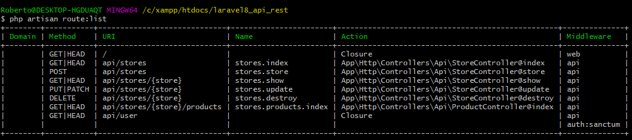

Rodando o servidor

php artisan serve

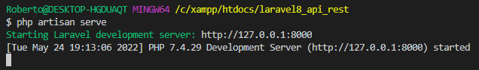

Listando as lojas no browser

http://127.0.0.1:8000/api/stores

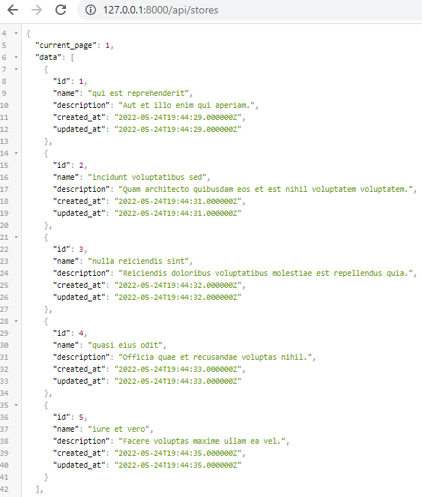

http://127.0.0.1:8000/api/stores/?page=2

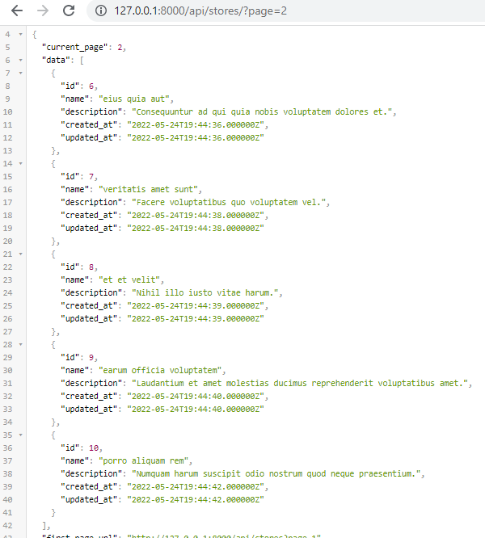

São 10 lojas e são exibidas 5 por página.

Listar lojas - página 1

GET
http://127.0.0.1:8000/api/stores

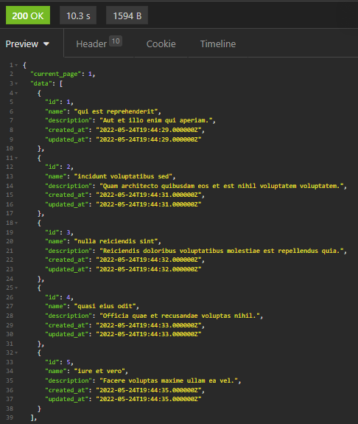

Listar lojas - página 2

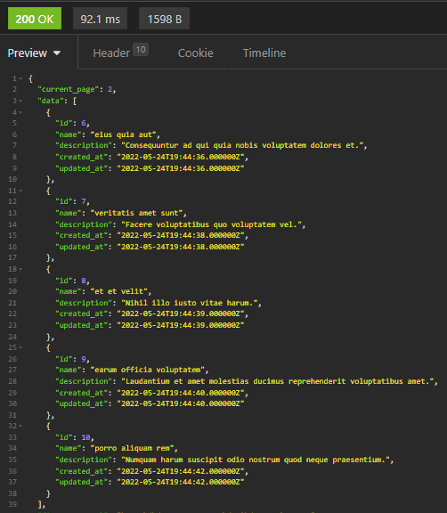

Listar dados de uma loja

GET
http://127.0.0.1:8000/api/stores/9



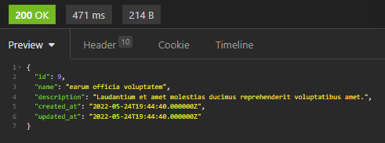

Inserir loja

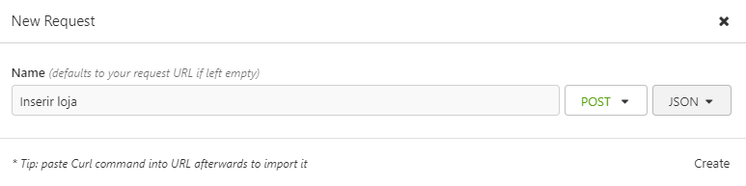

POST
http://127.0.0.1:8000/api/stores

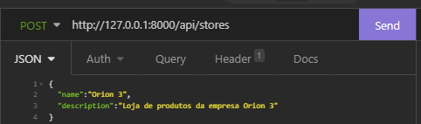

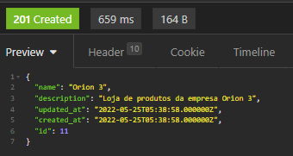

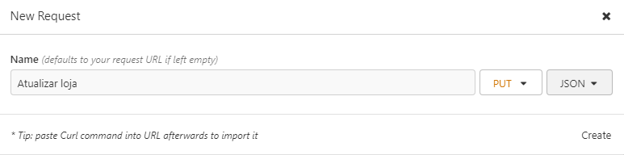

PUT
http://127.0.0.1:8000/api/stores/11

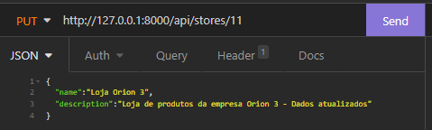

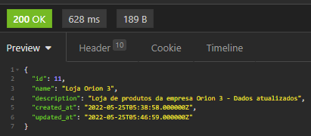

Excluir loja

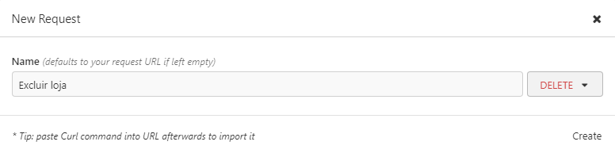

DELETE
http://127.0.0.1:8000/api/stores/11

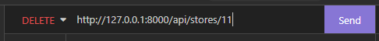

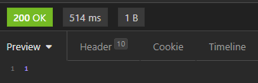

São 10 produtos por loja.

Listar produtos de uma loja

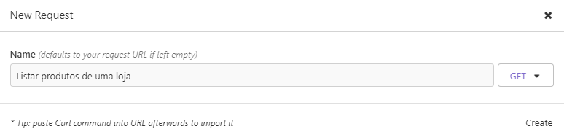

Listando os produtos da loja de id 1

GET
http://127.0.0.1:8000/api/stores/1/products

