Laravel 8 - Jetstream
Code Experts

https://www.youtube.com/watch?v=ulWQZ8QWmas&list=PLswa9HeoJUq8_8xDGrXBy6MfLtjsSXkTJ

Resumo feito por Roberto Pinheiro

Aula 06 - Conhecendo o Laravel Jetstream

Laravel Jetstream é um scaffold de autenticação. É um pacote que gera uma aplicação base para user usada incialmente em seu projeto com Laravel. Ele inclui login, registro, verificação de email, autenticação em dois fatores, gerenciamento de sessão, suporte a API e gerenciamento de usuários. Este pacote irá substituir o atual template base de autenticação que existe no Laravel. Laravel UI será descontinuado.

Por baixo dos panos Jetstream usa Tailwind CSS e oferece a opção de usar Livewire ou Inertia.

Livewire + Blade

Laravel Livewire é uma biblioteca que simplifica a construção de interfaces modernas, reativas e dinâmicas usando o Laravel Blade como sua linguagem de templates. É um ótimo stack para escolher se você deseja construir um aplicativo que seja dinâmico e reativo, mas não se sente confortável pulando para uma estrutura JavaScript completa como Vue.js.

Ao usar o Livewire, você pode escolher quais partes do seu aplicativo serão um componente do Livewire, enquanto o restante do seu aplicativo pode ser renderizado como os modelos Blade tradicionais com os quais você está acostumado.

Criando uma aplicação com Jetstream

laravel new --help

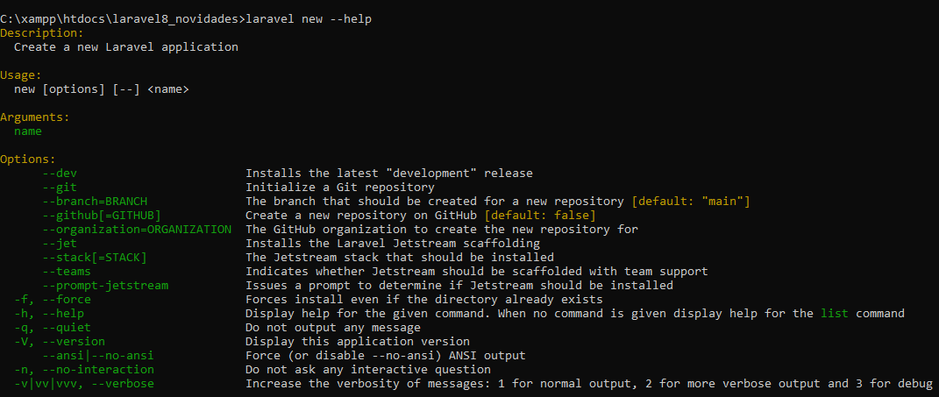

laravel new app --jet --teams

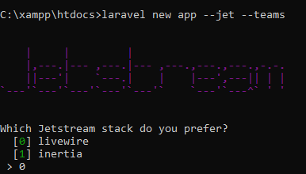

- Selecione a opção 0 (livewire) e aguarde a instalação.

cd app

npm install

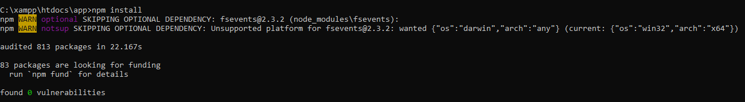

npm run dev

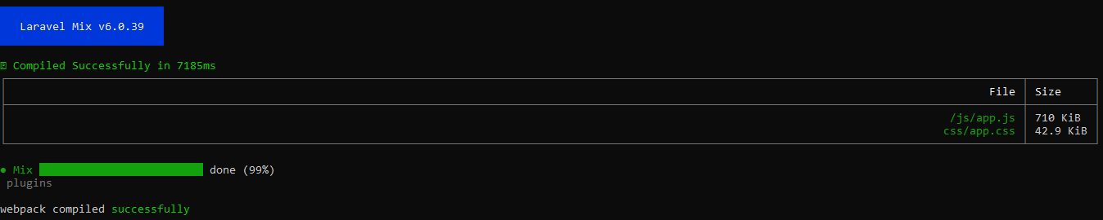

.env

APP_NAME=Laravel
APP_ENV=local
APP_KEY=base64:vri+LqkF5t6GVS0Ip3Qg1aggDodgd3PhfiCBsSHRlvI=
APP_DEBUG=true
APP_URL=http://127.0.0.1:8000

LOG_CHANNEL=stack
LOG_DEPRECATIONS_CHANNEL=null
LOG_LEVEL=debug

DB_CONNECTION=mysql
DB_HOST=127.0.0.1
DB_PORT=3306
DB_DATABASE=app
DB_USERNAME=root
DB_PASSWORD=

BROADCAST_DRIVER=log
CACHE_DRIVER=file
FILESYSTEM_DRIVER=local
QUEUE_CONNECTION=sync
SESSION_DRIVER=database
SESSION_LIFETIME=120

MEMCACHED_HOST=127.0.0.1

REDIS_HOST=127.0.0.1
REDIS_PASSWORD=null
REDIS_PORT=6379

MAIL_MAILER=smtp
MAIL_HOST=mailhog
MAIL_PORT=1025
MAIL_USERNAME=null
MAIL_PASSWORD=null
MAIL_ENCRYPTION=null
MAIL_FROM_ADDRESS=null
MAIL_FROM_NAME="${APP_NAME}"

AWS_ACCESS_KEY_ID=
AWS_SECRET_ACCESS_KEY=
AWS_DEFAULT_REGION=us-east-1
AWS_BUCKET=
AWS_USE_PATH_STYLE_ENDPOINT=false

PUSHER_APP_ID=
PUSHER_APP_KEY=
PUSHER_APP_SECRET=
PUSHER_APP_CLUSTER=mt1

MIX_PUSHER_APP_KEY="${PUSHER_APP_KEY}"
MIX_PUSHER_APP_CLUSTER="${PUSHER_APP_CLUSTER}"

- Execute o Xampp (Apache e MySQL)

- Abra o PHPMyAdmin e crie a base de dados chamada app.

- Crie as tabelas da BD:

php artisan migrate

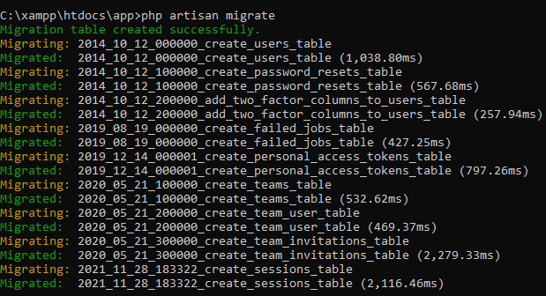

php artisan serve

- No browser entre com:

http://127.0.0.1:8000/

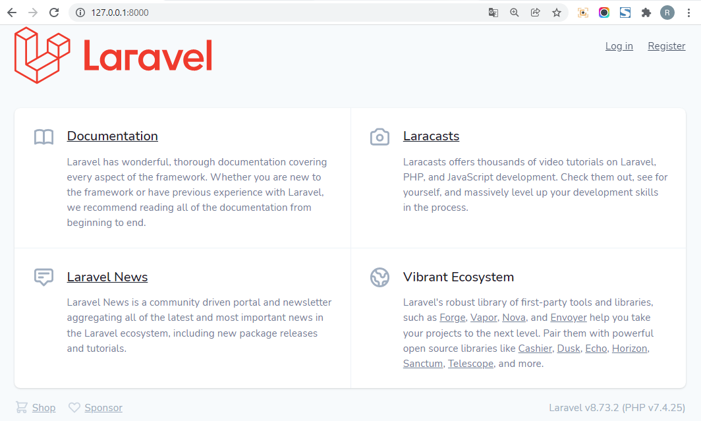

- Registre um usuário:

http://127.0.0.1:8000/register

Password: 12345678

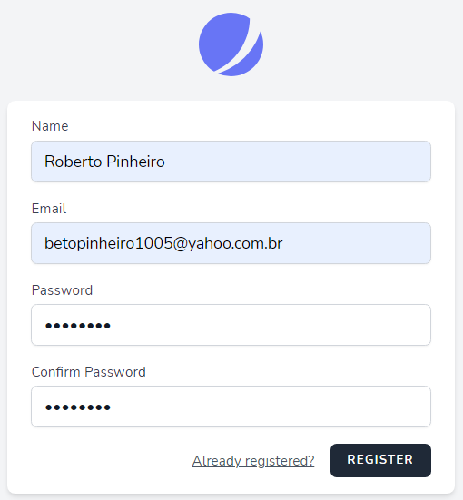

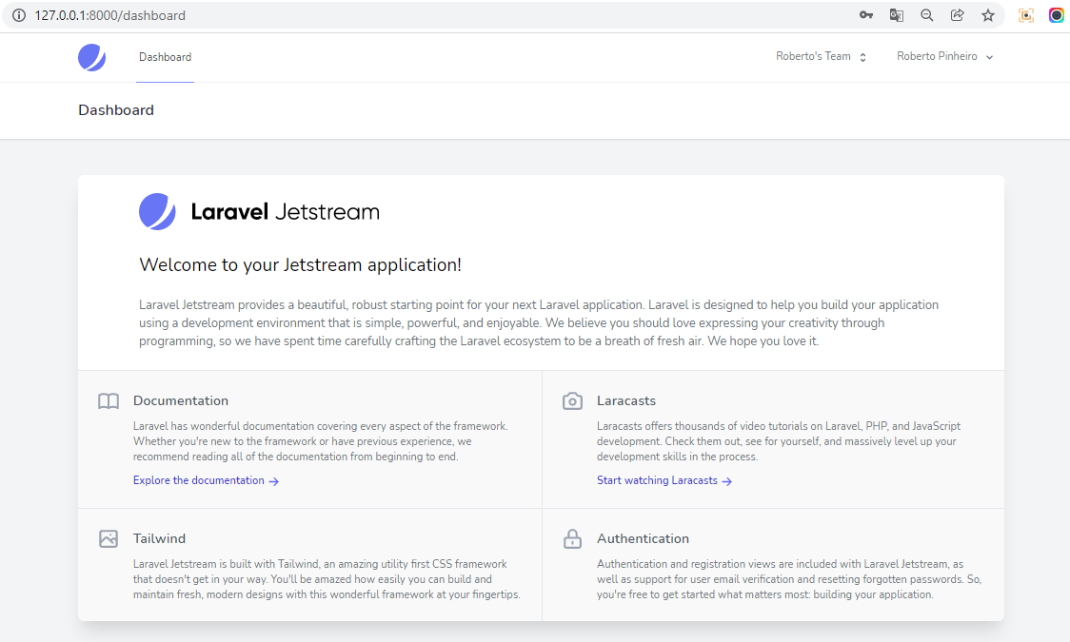

config\fortify.php

<?php

use App\Providers\RouteServiceProvider;
use Laravel\Fortify\Features;

return [

/*
|--------------------------------------------------------------------------
| Fortify Guard
|--------------------------------------------------------------------------
|
| Here you may specify which authentication guard Fortify will use while
| authenticating users. This value should correspond with one of your
| guards that is already present in your "auth" configuration file.
|
*/

'guard' => 'web',

/*
|--------------------------------------------------------------------------
| Fortify Password Broker
|--------------------------------------------------------------------------
|
| Here you may specify which password broker Fortify can use when a user
| is resetting their password. This configured value should match one
| of your password brokers setup in your "auth" configuration file.
|
*/

'passwords' => 'users',

/*
|--------------------------------------------------------------------------
| Username / Email
|--------------------------------------------------------------------------
|
| This value defines which model attribute should be considered as your
| application's "username" field. Typically, this might be the email
| address of the users but you are free to change this value here.
|
| Out of the box, Fortify expects forgot password and reset password
| requests to have a field named 'email'. If the application uses
| another name for the field you may define it below as needed.
|
*/

'username' => 'email',

'email' => 'email',

/*
|--------------------------------------------------------------------------
| Home Path
|--------------------------------------------------------------------------
|
| Here you may configure the path where users will get redirected during
| authentication or password reset when the operations are successful
| and the user is authenticated. You are free to change this value.
|
*/

'home' => RouteServiceProvider::HOME,

/*
|--------------------------------------------------------------------------
| Fortify Routes Prefix / Subdomain
|--------------------------------------------------------------------------
|
| Here you may specify which prefix Fortify will assign to all the routes
| that it registers with the application. If necessary, you may change
| subdomain under which all of the Fortify routes will be available.
|
*/

'prefix' => '',

'domain' => null,

/*
|--------------------------------------------------------------------------
| Fortify Routes Middleware
|--------------------------------------------------------------------------
|
| Here you may specify which middleware Fortify will assign to the routes
| that it registers with the application. If necessary, you may change
| these middleware but typically this provided default is preferred.
|
*/

'middleware' => ['web'],

/*
|--------------------------------------------------------------------------
| Rate Limiting
|--------------------------------------------------------------------------
|
| By default, Fortify will throttle logins to five requests per minute for
| every email and IP address combination. However, if you would like to
| specify a custom rate limiter to call then you may specify it here.
|
*/

'limiters' => [
'login' => 'login',
'two-factor' => 'two-factor',
],

/*
|--------------------------------------------------------------------------
| Register View Routes
|--------------------------------------------------------------------------
|
| Here you may specify if the routes returning views should be disabled as
| you may not need them when building your own application. This may be
| especially true if you're writing a custom single-page application.
|
*/

'views' => true,

/*
|--------------------------------------------------------------------------
| Features
|--------------------------------------------------------------------------
|
| Some of the Fortify features are optional. You may disable the features
| by removing them from this array. You're free to only remove some of
| these features or you can even remove all of these if you need to.
|
*/

'features' => [
Features::registration(),
Features::resetPasswords(),
// Features::emailVerification(),
Features::updateProfileInformation(),
Features::updatePasswords(),
Features::twoFactorAuthentication([
'confirmPassword' => true,
]),
],

];

config\jetstream.php

<?php

use Laravel\Jetstream\Features;

return [

/*
|--------------------------------------------------------------------------
| Jetstream Stack
|--------------------------------------------------------------------------
|
| This configuration value informs Jetstream which "stack" you will be
| using for your application. In general, this value is set for you
| during installation and will not need to be changed after that.
|
*/

'stack' => 'livewire',

/*
|--------------------------------------------------------------------------
| Jetstream Route Middleware
|--------------------------------------------------------------------------
|
| Here you may specify which middleware Jetstream will assign to the routes
| that it registers with the application. When necessary, you may modify
| these middleware; however, this default value is usually sufficient.
|
*/

'middleware' => ['web'],

/*
|--------------------------------------------------------------------------
| Features
|--------------------------------------------------------------------------
|
| Some of Jetstream's features are optional. You may disable the features
| by removing them from this array. You're free to only remove some of
| these features or you can even remove all of these if you need to.
|
*/

'features' => [
// Features::termsAndPrivacyPolicy(),
Features::profilePhotos(),
// Features::api(),
Features::teams(['invitations' => true]),
Features::accountDeletion(),
],

/*
|--------------------------------------------------------------------------
| Profile Photo Disk
|--------------------------------------------------------------------------
|
| This configuration value determines the default disk that will be used
| when storing profile photos for your application's users. Typically
| this will be the "public" disk but you may adjust this if needed.
|
*/

'profile_photo_disk' => 'public',

];

- Habilite a feature Features::profilePhotos(), desmarcando o comentário.

- No menu, selecione a opção "Profile":

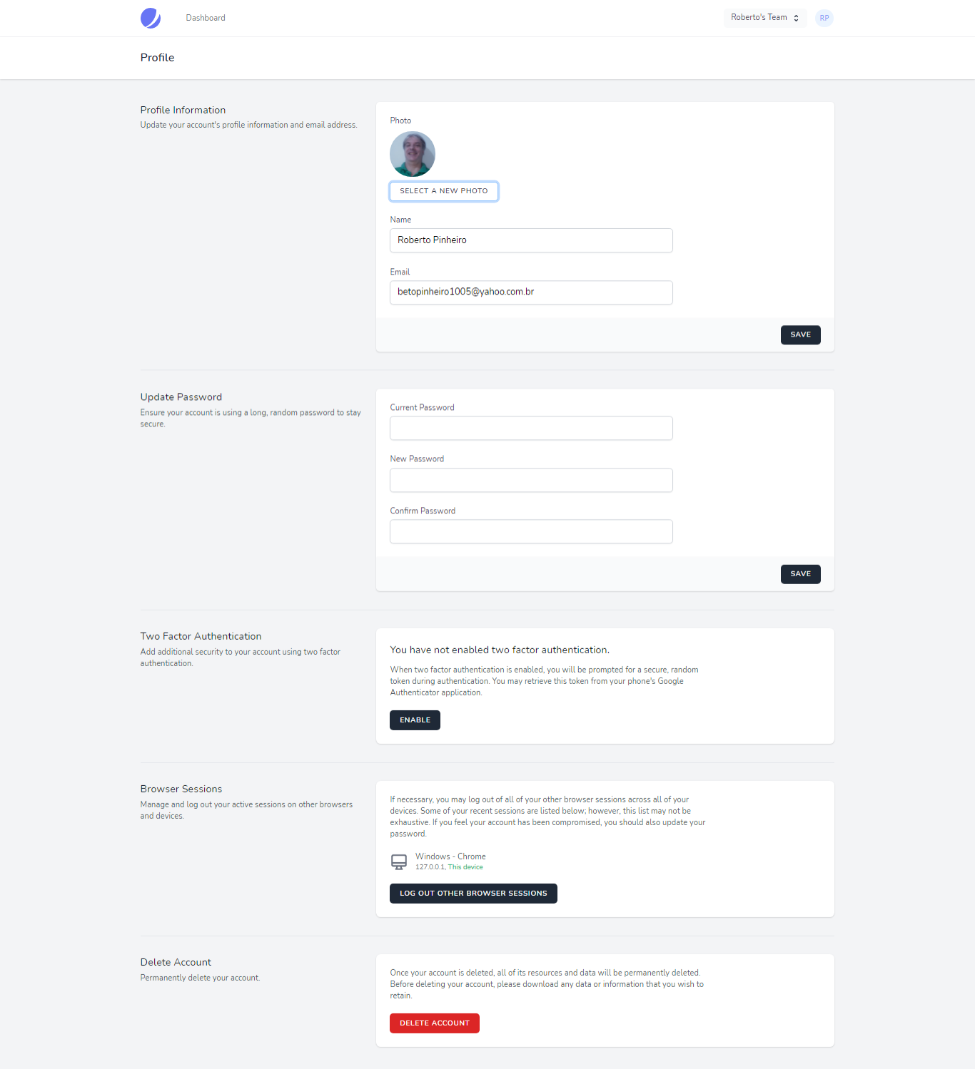

- Selecione uma foto sua, e clique no botão "Save":

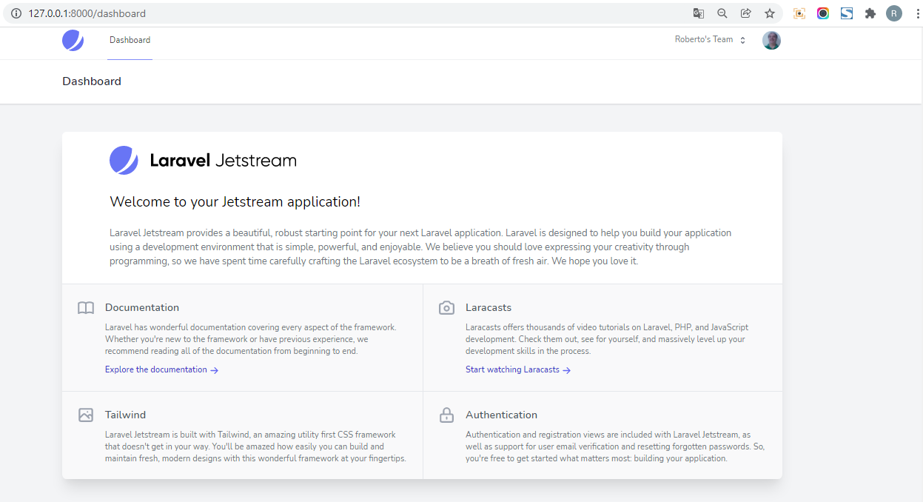

Aula 07 - Laravel Jetstream em um Projeto já Existente

Instalando o Laravel Jetstream

composer require laravel/jetstream

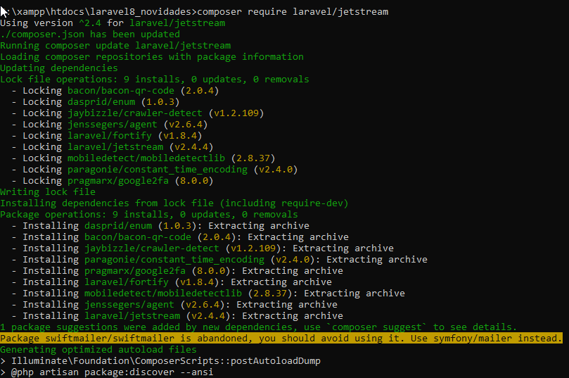
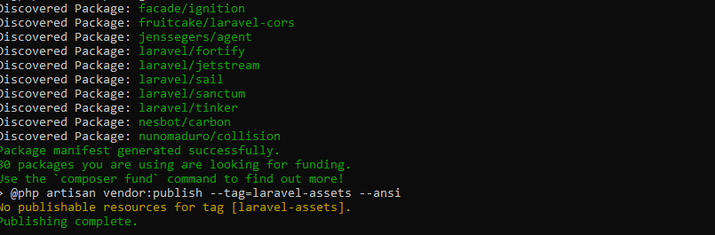

php artisan jetstream:install --help

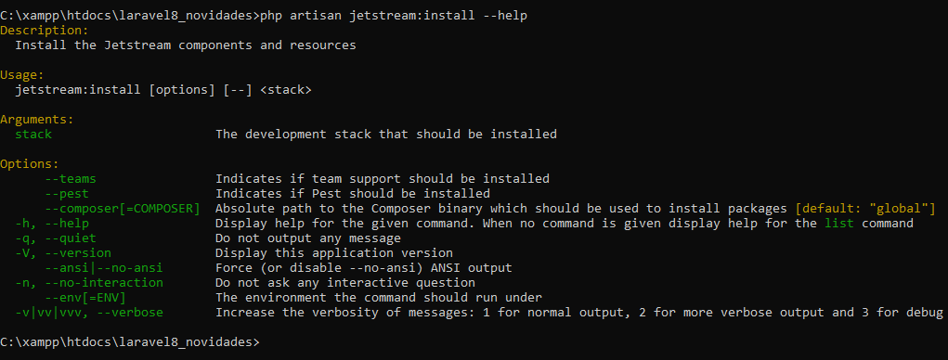

php artisan jetstream:install livewire --teams

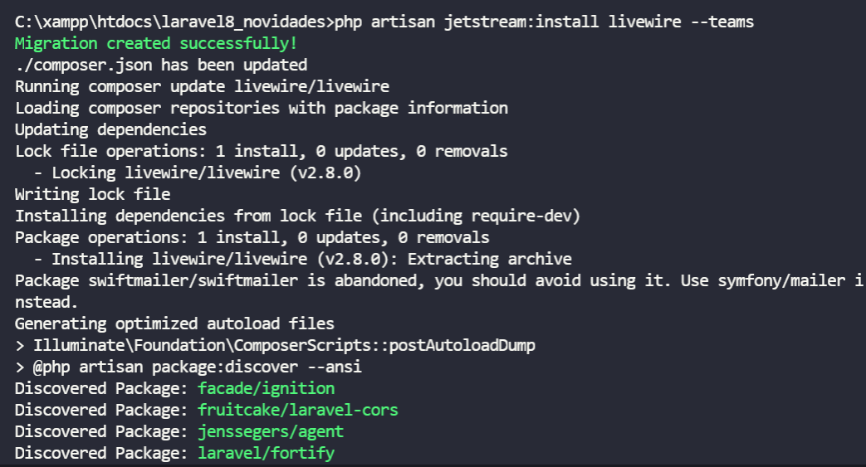
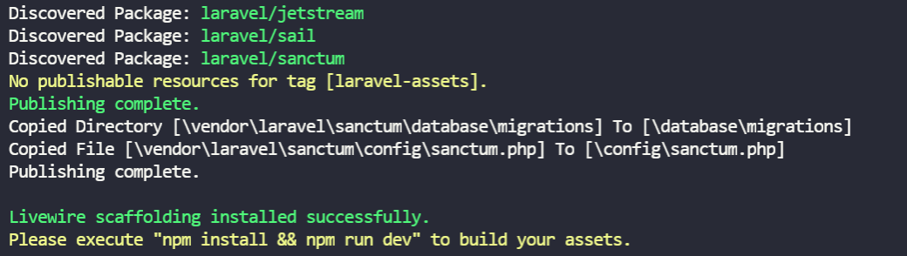

npm install && npm run dev

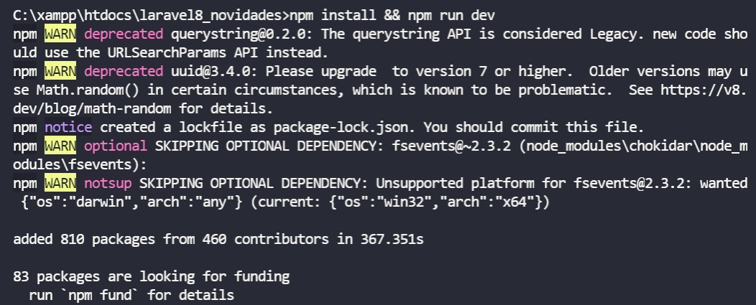
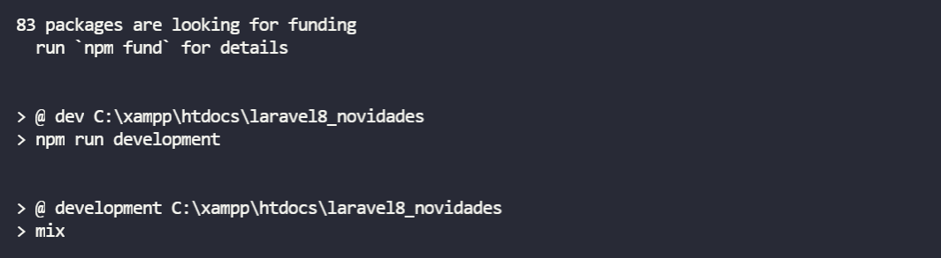
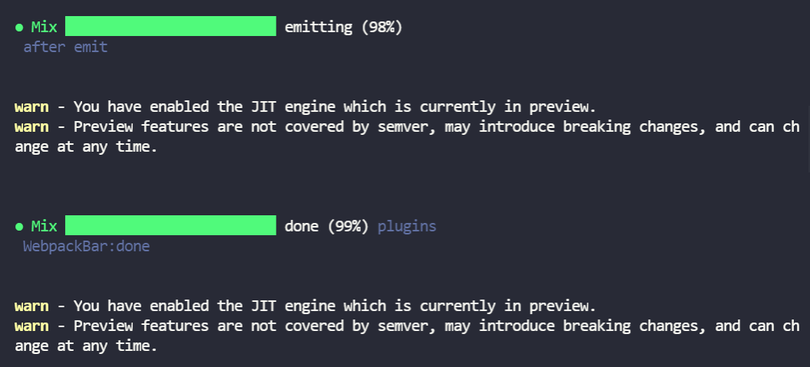
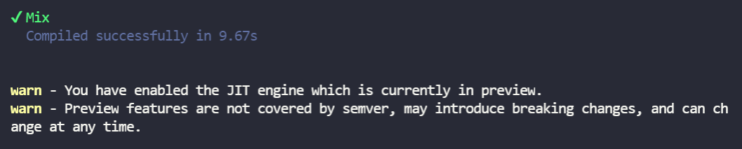
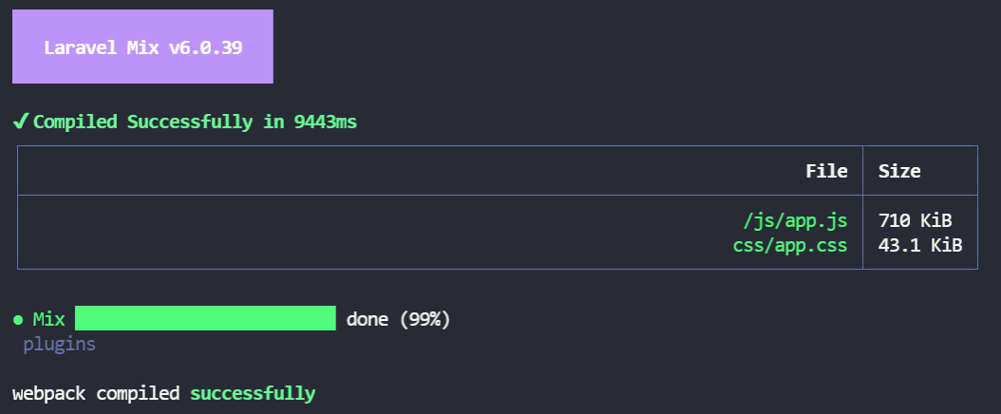

php artisan migrate:fresh

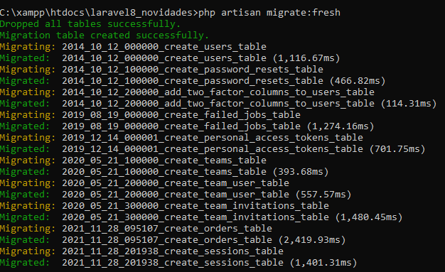

php artisan serve

http://127.0.0.1:8000/

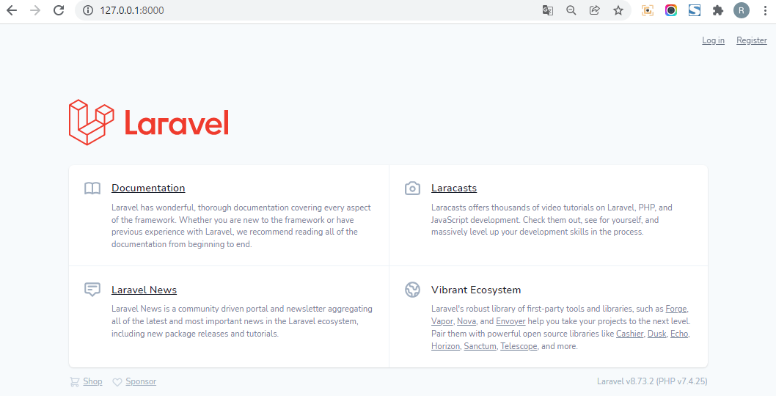

- Registre um usuário:

http://127.0.0.1:8000/register

