Curso jQuery (Core - Aulas 31 a 45)
Universidade XTI (Ricardo Lopes Costa)

https://www.youtube.com/watch?v=YOTFZx9CeX4&list=PLxQNfKs8YwvGOv4evjpsB3JWWZnYChp04

Resumo feito por Roberto Pinheiro

Aula 31 - Exemplo jQuery UI - Instalação jQueryUI

https://jqueryui.com/themeroller/

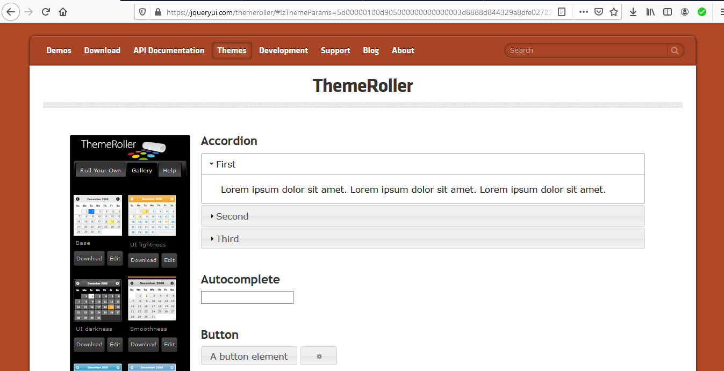

- Faça download do tema Smoothness, com todas as opções marcadas.

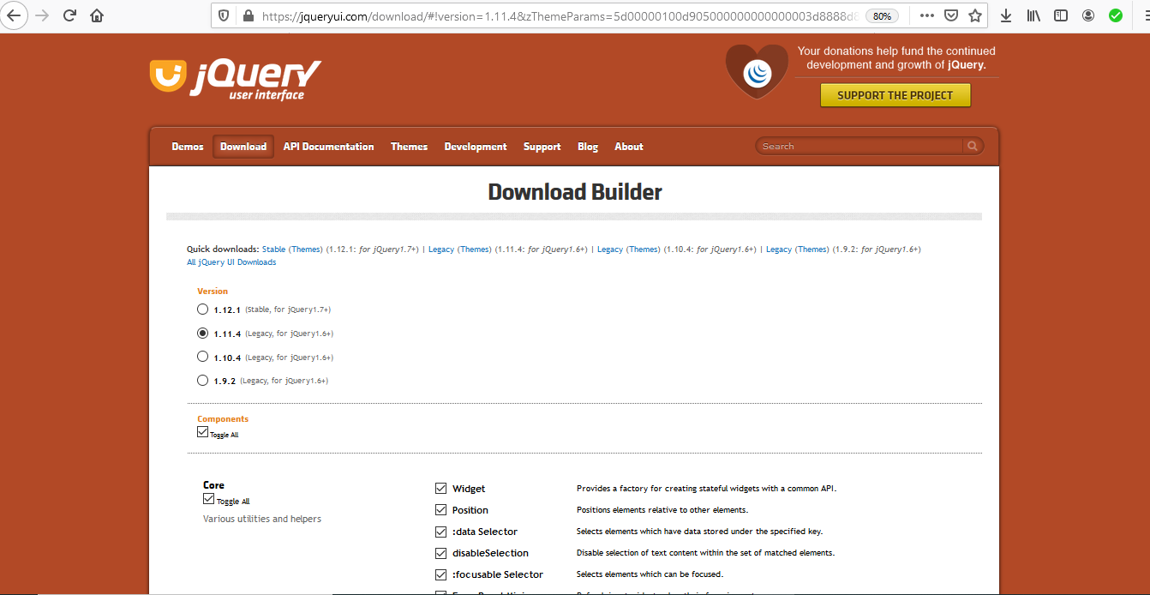
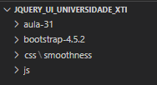

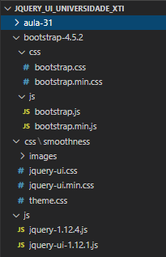

Testando

aula-31\aula-31a.html

<!DOCTYPE html>
<html lang="pt-br">
<head>
<meta charset="UTF-8">
<meta name="viewport" content="width=device-width, initial-scale=1.0">
<title>Introdução a jQuery UI</title>

<!-- CSS -->
<link rel="stylesheet" type="text/css" href="../css/smoothness/jquery-ui.css">
<link rel="stylesheet" href="../bootstrap-4.5.2/css/bootstrap.css">
<link rel="stylesheet" href="css/aula-31.css">

<!-- JS -->
<script src="../js/jquery-1.12.4.js"></script>
<script src="../js/jquery-ui-1.12.1.js"></script>
<script src="js/aula-31.js"></script>
</head>
<body>

<div class="row">
<div class="col-md-4"></div>
<div class="col-md-4 basico" >
<label for="date">Data:</label>
<input type="text" name="date" id="date">
</div>
<div class="col-md-4"></div>
</div>

</body>
</html>

aula-31\css\aula-31.css

.basico{
border: 1px solid black;
padding:20px;
margin-top: 15px;
margin-bottom: 15px;
}

aula-31\js\aula-31.js

$(function(){
$("#date").datepicker();
});



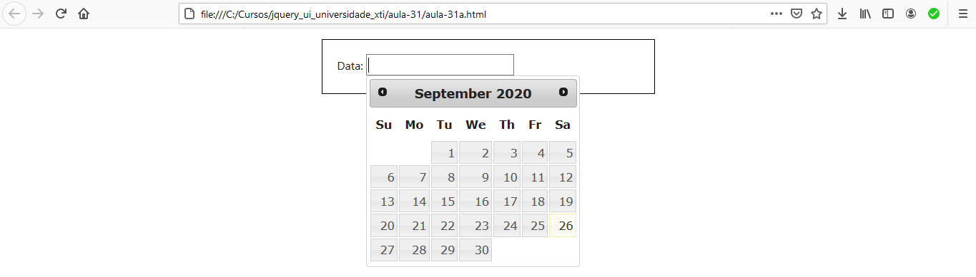



Aula 32 - Exemplo jQuery UI - Accordion

aula-32\aula-32a.html

<!DOCTYPE html>
<html lang="pt-br">
<head>
<meta charset="UTF-8">
<meta name="viewport" content="width=device-width, initial-scale=1.0">
<title>jQuery UI - Accordion</title>

<!-- CSS -->
<link rel="stylesheet" type="text/css" href="../css/smoothness/jquery-ui.css">
<link rel="stylesheet" href="../bootstrap-4.5.2/css/bootstrap.css">
<link rel="stylesheet" href="css/aula-32.css">

<!-- JS -->
<script src="../js/jquery-1.12.4.js"></script>
<script src="../js/jquery-ui-1.12.1.js"></script>
<script src="js/aula-32a.js"></script>
</head>
<body>

<div class="row">
<div class="col-md-4"></div>
<div class="col-md-4 basico" >
<h5 class="titulo">jQuery UI - Accordion</h5>
<div id="accordion">
<h3>Section 1</h3>
<div>
<p>Mauris mauris ante, blandit et, ultrices a, suscipit eget, quam. Integer ut neque. Vivamus nisi metus, molestie vel, gravida in, condimentum sit amet, nunc. Nam a nibh. Donec suscipit eros. Nam mi. Proin viverra leo ut odio. Curabitur malesuada. Vestibulum a velit eu ante scelerisque vulputate.</p>
</div>
<h3>Section 2</h3>
<div>
<p>Sed non urna. Donec et ante. Phasellus eu ligula. Vestibulum sit amet purus. Vivamus hendrerit, dolor at aliquet laoreet, mauris turpis porttitor velit, faucibus interdum tellus libero ac justo. Vivamus non quam. In suscipit faucibus urna. </p>
</div>
<h3>Section 3</h3>
<div>
<p>Nam enim risus, molestie et, porta ac, aliquam ac, risus. Quisque lobortis. Phasellus pellentesque purus in massa. Aenean in pede. Phasellus ac libero ac tellus pellentesque semper. Sed ac felis. Sed commodo, magna quis lacinia ornare, quam ante aliquam nisi, eu iaculis leo purus venenatis dui. </p>
<ul>
<li>List item one</li>
<li>List item two</li>
<li>List item three</li>
</ul>
</div>
<h3>Section 4</h3>
<div>
<p>Cras dictum. Pellentesque habitant morbi tristique senectus et netus et malesuada fames ac turpis egestas. Vestibulum ante ipsum primis in faucibus orci luctus et ultrices posuere cubilia Curae; Aenean lacinia mauris vel est. </p><p>Suspendisse eu nisl. Nullam ut libero. Integer dignissim consequat lectus. Class aptent taciti sociosqu ad litora torquent per conubia nostra, per inceptos himenaeos. </p>
</div>
</div>
</div>
<div class="col-md-4"></div>
</div>

</body>
</html>

aula-32\css\aula-32.css

.basico{
border: 1px solid black;
padding:20px;
margin-top: 15px;
margin-bottom: 15px;
}
.titulo{
text-align: center;
color: red;
margin-bottom: 20px;
}

aula-32\js\aula-32.js

$( function() {
$( "#accordion" ).accordion({
collapsible: true
});
});

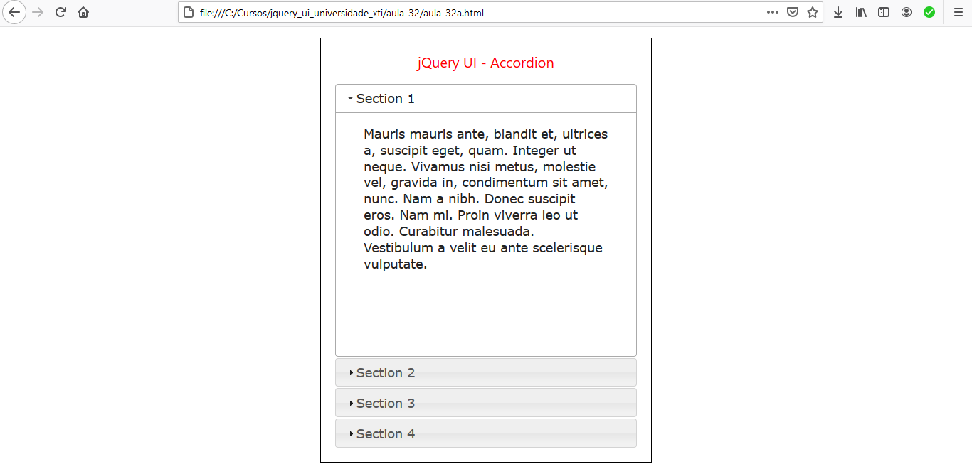

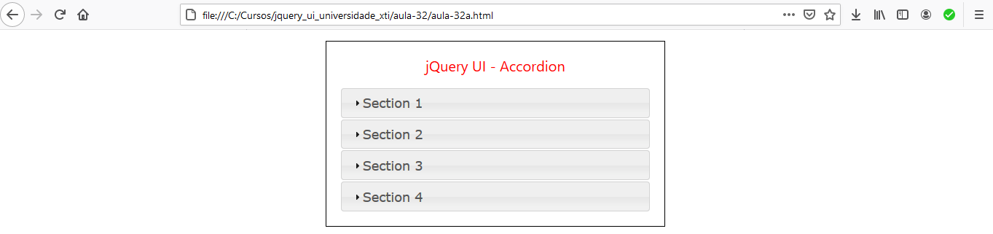

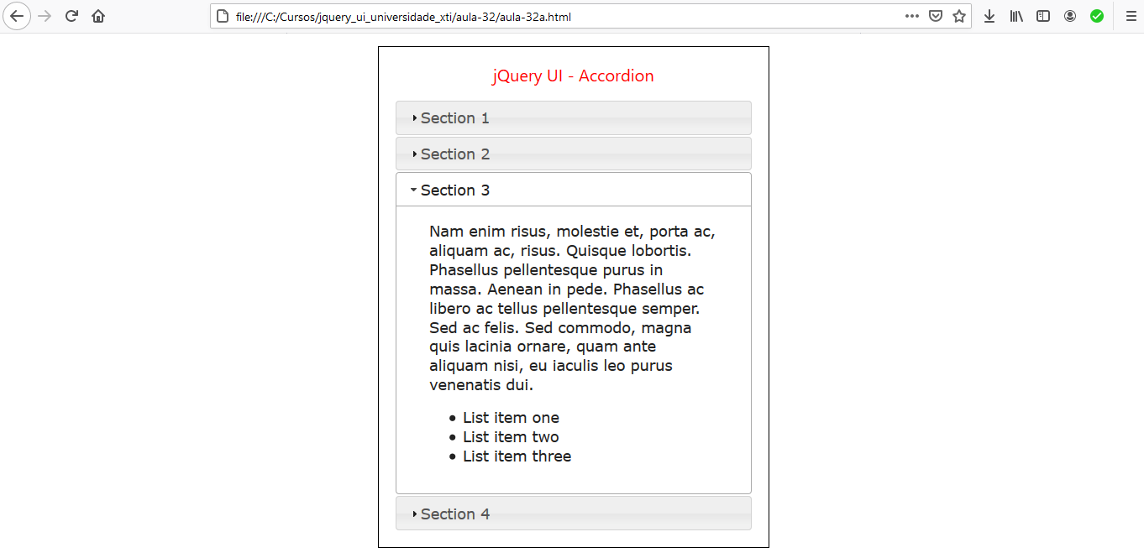

Abas com icones e altura nativa do conteúdo das abas

- É possível personalizar os ícones do cabeçalho com a opção de ícones, que aceita classes para o estado padrão e ativo (aberto) do cabeçalho. Use qualquer classe da estrutura de UI CSS ou crie classes personalizadas com imagens de fundo.

- Configurando heightStyle: "content" permite que os painéis do accordion mantenham sua altura nativa.

aula-32\aula-32b.html

<!DOCTYPE html>
<html lang="pt-br">
<head>
<meta charset="UTF-8">
<meta name="viewport" content="width=device-width, initial-scale=1.0">
<title>jQuery UI - Accordion - Icones customizados</title>

<!-- CSS -->
<link rel="stylesheet" type="text/css" href="../css/smoothness/jquery-ui.css">
<link rel="stylesheet" href="../bootstrap-4.5.2/css/bootstrap.css">
<link rel="stylesheet" href="css/aula-32.css">

<!-- JS -->
<script src="../js/jquery-1.12.4.js"></script>
<script src="../js/jquery-ui-1.12.1.js"></script>
<script src="js/aula-32b.js"></script>
</head>
<body>

<div class="row">
<div class="col-md-4"></div>
<div class="col-md-4 basico" >
<h5 class="titulo">jQuery UI - Accordion - Icones customizados e altura nativa do conteúdo das abas</h5>
<div id="accordion">
<h3>Section 1</h3>
<div>
<p>Mauris mauris ante, blandit et, ultrices a, suscipit eget, quam. Integer ut neque. Vivamus nisi metus, molestie vel, gravida in, condimentum sit amet, nunc. Nam a nibh. Donec suscipit eros. Nam mi. Proin viverra leo ut odio. Curabitur malesuada. Vestibulum a velit eu ante scelerisque vulputate.</p>
</div>
<h3>Section 2</h3>
<div>
<p>Sed non urna. Donec et ante. Phasellus eu ligula. Vestibulum sit amet purus. Vivamus hendrerit, dolor at aliquet laoreet, mauris turpis porttitor velit, faucibus interdum tellus libero ac justo. Vivamus non quam. In suscipit faucibus urna. </p>
</div>
<h3>Section 3</h3>
<div>
<p>Nam enim risus, molestie et, porta ac, aliquam ac, risus. Quisque lobortis. Phasellus pellentesque purus in massa. Aenean in pede. Phasellus ac libero ac tellus pellentesque semper. Sed ac felis. Sed commodo, magna quis lacinia ornare, quam ante aliquam nisi, eu iaculis leo purus venenatis dui. </p>
<ul>
<li>List item one</li>
<li>List item two</li>
<li>List item three</li>
</ul>
</div>
<h3>Section 4</h3>
<div>
<p>Cras dictum. Pellentesque habitant morbi tristique senectus et netus et malesuada fames ac turpis egestas. Vestibulum ante ipsum primis in faucibus orci luctus et ultrices posuere cubilia Curae; Aenean lacinia mauris vel est. </p><p>Suspendisse eu nisl. Nullam ut libero. Integer dignissim consequat lectus. Class aptent taciti sociosqu ad litora torquent per conubia nostra, per inceptos himenaeos. </p>
</div>
</div>
<br />
<button id="toggle">Toggle icons</button>
</div>
<div class="col-md-4"></div>
</div>

</body>
</html>

aula-32\js\aula-32b.js

$( function() {

$( "#accordion" ).accordion({
collapsible: true,
heightStyle: "content"
});

// Abas com icones

var icons = {
header: "ui-icon-circle-arrow-e",
activeHeader: "ui-icon-circle-arrow-s"
};
$( "#accordion" ).accordion({
icons: icons
});
$( "#toggle" ).button().on( "click", function() {
if ( $( "#accordion" ).accordion( "option", "icons" ) ) {
$( "#accordion" ).accordion( "option", "icons", null );
} else {
$( "#accordion" ).accordion( "option", "icons", icons );
}
});

});

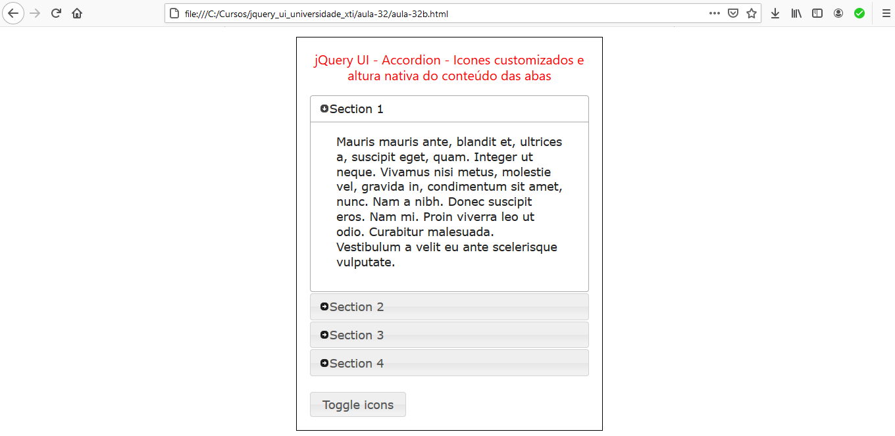

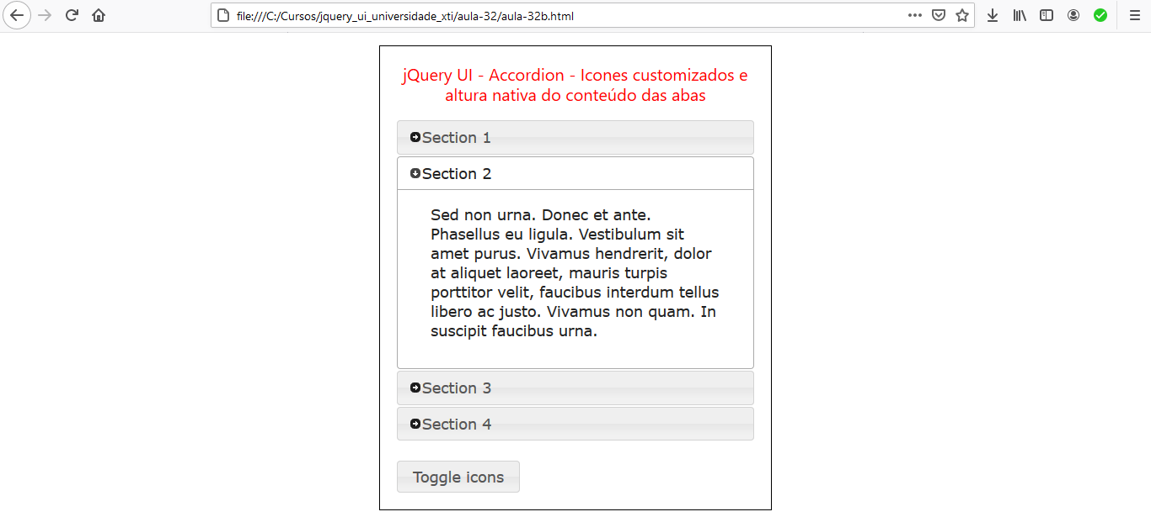

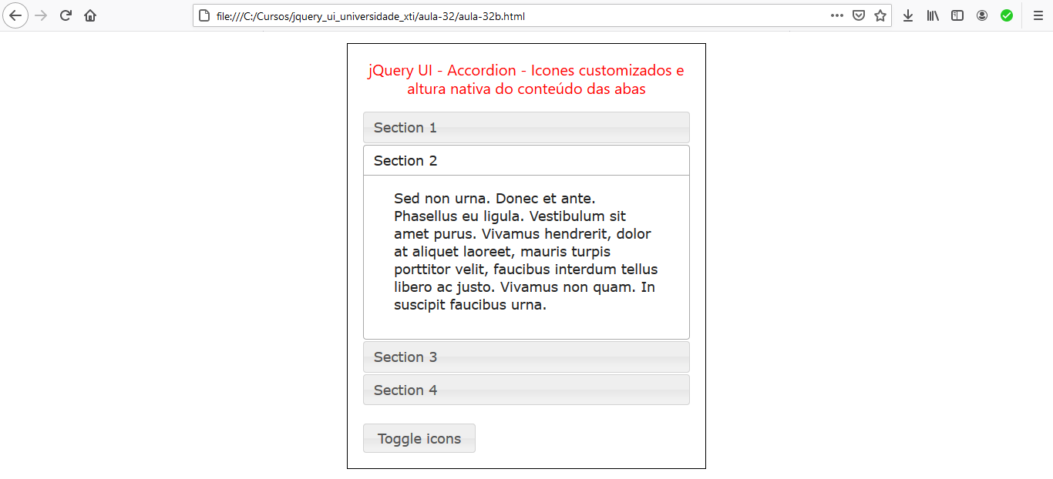

Aula 33 - Exemplo jQuery UI - Autocomplete

Autocomplete simples

aula-33\aula-33a.html

<!DOCTYPE html>
<html lang="pt-br">
<head>
<meta charset="UTF-8">
<meta name="viewport" content="width=device-width, initial-scale=1.0">
<title>jQuery UI - Autocomplete simples</title>

<!-- CSS -->
<link rel="stylesheet" type="text/css" href="../css/smoothness/jquery-ui.css">
<link rel="stylesheet" href="../bootstrap-4.5.2/css/bootstrap.css">
<link rel="stylesheet" href="css/aula-33.css">
<!-- JS -->
<script src="../js/jquery-1.12.4.js"></script>
<script src="../js/jquery-ui-1.12.1.js"></script>
<script src="js/aula-33a.js"></script>
</head>
<body>

<div class="row">
<div class="col-md-4"></div>
<div class="col-md-4 basico" >
<h5 class="titulo">jQuery UI - Autocomplete simples</h5>
<div class="ui-widget">
<label for="tags">Tags: </label>
<input id="tags">
</div>
</div>
<div class="col-md-4"></div>
</div>

</body>
</html>

aula-33\css\aula-33.css

.basico{
border: 1px solid black;
padding:20px;
margin-top: 15px;
margin-bottom: 15px;
}
.titulo{
text-align: center;
color: red;
margin-bottom: 20px;
}

aula-33\js\aula-33a.js

$( function() {
var availableTags = [
"ActionScript",
"AppleScript",
"Asp",
"BASIC",
"C",
"C++",
"Clojure",
"COBOL",
"ColdFusion",
"Erlang",
"Fortran",
"Groovy",
"Haskell",
"Java",
"JavaScript",
"Lisp",
"Perl",
"PHP",
"Python",
"Ruby",
"Scala",
"Scheme"
];
$( "#tags" ).autocomplete({
source: availableTags
});
} );



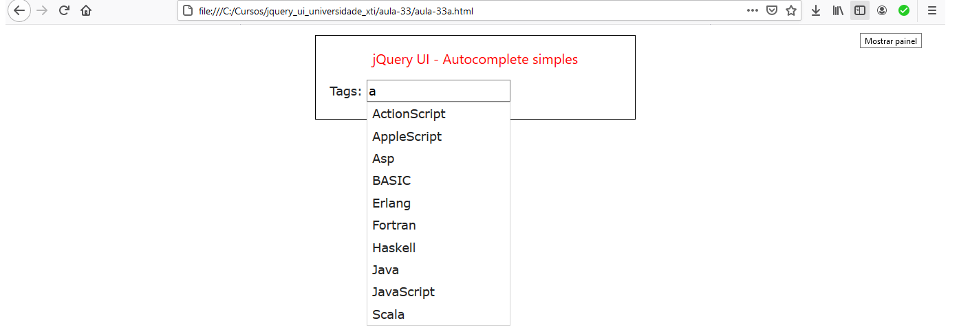

Autocomplete - Scrollable results

aula-33\aula-33b.html

<!DOCTYPE html>
<html lang="pt-br">
<head>
<meta charset="UTF-8">
<meta name="viewport" content="width=device-width, initial-scale=1.0">
<title>jQuery UI - Autocomplete - Scrollable results</title>

<!-- CSS -->
<link rel="stylesheet" type="text/css" href="../css/smoothness/jquery-ui.css">
<link rel="stylesheet" href="../bootstrap-4.5.2/css/bootstrap.css">
<link rel="stylesheet" href="css/aula-33.css">

<!-- JS -->
<script src="../js/jquery-1.12.4.js"></script>
<script src="../js/jquery-ui-1.12.1.js"></script>
<script src="js/aula-33b.js"></script>
</head>
<body>

<div class="row">
<div class="col-md-4"></div>
<div class="col-md-4 basico" >
<h5 class="titulo">jQuery UI - Autocomplete - Scrollable results</h5>
<div class="ui-widget">
<label for="tags">Tags: </label>
<input id="tags">
</div>
</div>
<div class="col-md-4"></div>
</div>

</body>
</html>

aula-33\css\aula-33.css

.basico{
border: 1px solid black;
padding:20px;
margin-top: 15px;
margin-bottom: 15px;
}
.titulo{
text-align: center;
color: red;
margin-bottom: 20px;
}
.ui-autocomplete {
max-height: 100px;
overflow-y: auto;
/* prevent horizontal scrollbar */
overflow-x: hidden;
}
/* IE 6 doesn't support max-height
* we use height instead, but this forces the menu to always be this tall
*/
* html .ui-autocomplete {
height: 100px;
}

aula-33\js\aula-33b.js

$( function() {
var availableTags = [
"ActionScript",
"AppleScript",
"Asp",
"BASIC",
"C",
"C++",
"Clojure",
"COBOL",
"ColdFusion",
"Erlang",
"Fortran",
"Groovy",
"Haskell",
"Java",
"JavaScript",
"Lisp",
"Perl",
"PHP",
"Python",
"Ruby",
"Scala",
"Scheme"
];
$( "#tags" ).autocomplete({
source: availableTags
});
} );

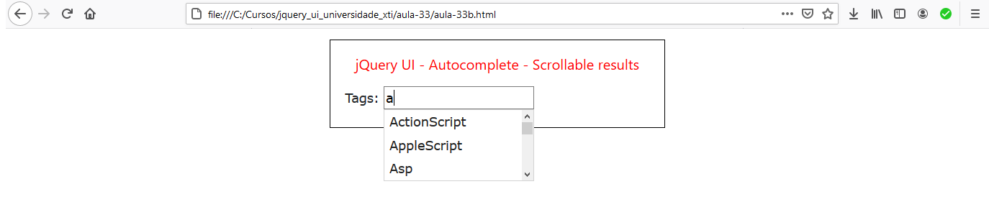

Aula 34 - Exemplo jQuery UI - Auto Complete - WebService Ajax JSON

Base de dados que vamos acessar

https://rapidapi.com/



- Para acessar as API's é necessário estar cadastrado.
- Cadastre-se neste site para obter sua chave de acesso às API's.

Dados de um país

aula-34\aula-34a.html

<!DOCTYPE html>
<html lang="pt-br">
<head>
<meta charset="UTF-8">
<meta name="viewport" content="width=device-width, initial-scale=1.0">
<title>jQuery UI - Autocomplete Ajax e Webservice</title>

<!-- CSS -->
<link rel="stylesheet" type="text/css" href="../css/smoothness/jquery-ui.css">
<link rel="stylesheet" href="../bootstrap-4.5.2/css/bootstrap.css">
<link rel="stylesheet" href="css/aula-34.css">

<!-- JS -->
<script src="../js/jquery-1.12.4.js"></script>
<script src="../js/jquery-ui-1.12.1.js"></script>
<script src="js/aula-34a.js"></script>
</head>
<body>

<div class="row">
<div class="col-md-4"></div>
<div class="col-md-4 basico" >
<h5 class="titulo">jQuery UI - Autocomplete Ajax e Webservice</h5>

<p class="text-center"><a id="link-0" href="">Limpar dados</a></p>

<div class="form-group">
<label for="country">País:</label>
<input class="form-control" type="text" name="country" id="country">
</div>

<div id="info"></div>

</div>
<div class="col-md-4"></div>
</div>

</body>
</html>

aula-34\css\aula-34.css

.basico{
border: 1px solid black;
padding:20px;
margin-top: 15px;
margin-bottom: 15px;
}
.titulo{
text-align: center;
color: red;
margin-bottom: 20px;
}
.ui-autocomplete-loading {
background: white url('img/ajax.gif') right center no-repeat;
}

aula-34\js\aula-34a.js

$( function() {

$("#link-0").click(function(){
$("#country").val("");
location.reload();
});

$("#country").autocomplete({
source: function(request, response){
$.ajax({
"async": true,
"crossDomain": true,
// "url": "https://restcountries-v1.p.rapidapi.com/all",
"url": "https://restcountries-v1.p.rapidapi.com/name/" + $("#country").val(),
"method": "GET",
"headers": {
"x-rapidapi-host": "restcountries-v1.p.rapidapi.com",
"x-rapidapi-key": "ef3ee9f9cemsh9681284674dd821p11c62ejsn348dcd6f93a9"
},
success: function(response){
var lista = [];
lista.push("Nome: " + response[0].name + "<br />Nome nativo: " + response[0].nativeName + "<br />Sigla: " + response[0].alpha2Code + "<br />Gentílico: " + response[0].demonym + "<br />Região: " + response[0].region + "<br />Subregião: " + response[0].subregion + "<br />Capital: " + response[0].capital + "<br />Área: " + formatar(response[0].area) + " km&sup2;" + "<br />População: " + formatar(response[0].population) + " habitantes" + "<br />");
$("#info").html(lista);
},
});
},
});

function formatar(nr) {
return String(nr)
.split('').reverse().join('').split(/(\d{3})/).filter(Boolean)
.join('.').split('').reverse().join('');
}

});

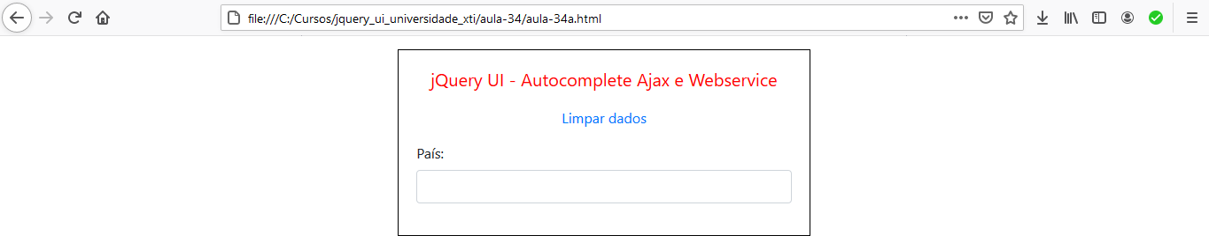

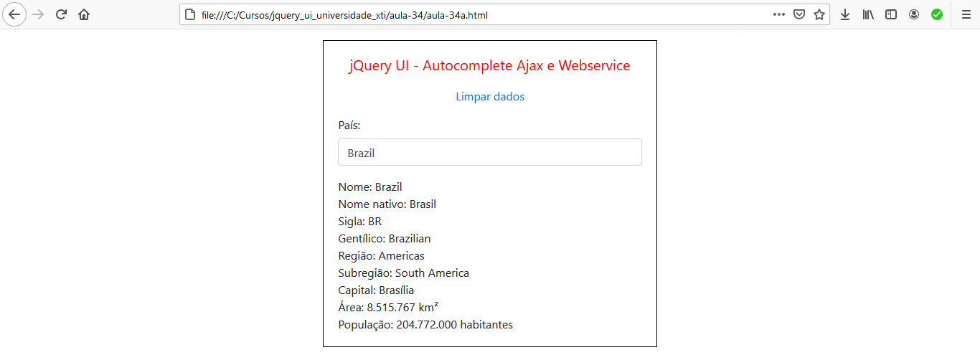

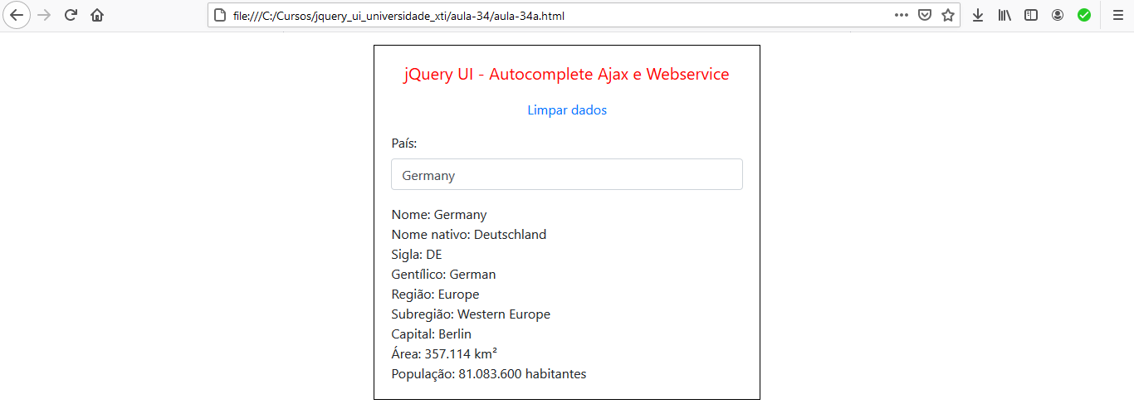

Busca CEP

aula-34\aula-34b.html

<html>
<head>
<meta charset="UTF-8">
<meta name="viewport" content="width=device-width, initial-scale=1.0">
<title>jQuery UI - Autocomplete Ajax e Webservice</title>

<!-- CSS -->
<link rel="stylesheet" type="text/css" href="../css/smoothness/jquery-ui.css">
<link rel="stylesheet" href="../bootstrap-4.5.2/css/bootstrap.css">
<link rel="stylesheet" href="css/aula-34.css">

<!-- JS -->
<script src="../js/jquery-1.12.4.js"></script>
<script src="../js/jquery-ui-1.12.1.js"></script>
<script src="../js/jquery.maskedinput.js"></script>
<script src="js/aula-34b.js"></script>
</head>

<body>

<div class="row">
<div class="col-md-4"></div>
<div class="col-md-4 basico">
<h5 class="titulo">jQuery UI - Autocomplete Ajax e Webservice</h5>
<p class="text-center"><span class="text-danger">Atenção: </span> Entre com o CEP"</p>

<p class="text-center"><a id="link0" href="">Limpar formulário</a></p>

<!-- Inicio do formulario -->
<form class="form-group" method="get" action=".">
<label>Cep (digite só números):</label>
<input name="cep" type="text" id="cep" value="" class="form-control" /></label>
<label>Rua:</label>
<input name="rua" type="text" id="rua" class="form-control" /></label>
<label>Bairro:</label>
<input name="bairro" type="text" id="bairro" class="form-control" /></label>
<label>Cidade:</label>
<input name="cidade" type="text" id="cidade" class="form-control" /></label>
<label>Estado:</label>
<input name="uf" type="text" id="uf" class="form-control" /></label>
<label>IBGE:</label>
<input name="ibge" type="text" id="ibge" class="form-control" /></label>
</form>
</div>
<div class="col-md-4"></div>
</div>

</body>

</html>
aula-34\js\aula-34b.js

$(document).ready(function() {

$("#link0").click(function(){
limpa_formulario_cep();
location.reload();
});

function limpa_formulário_cep() {
// Limpa valores do formulário de cep.
$("#rua").val("");
$("#bairro").val("");
$("#cidade").val("");
$("#uf").val("");
$("#ibge").val("");
}

$("#cep").focus();

$("#cep").mask("99999-999");

$("#cep").autocomplete({
source: function(request, response){
$.ajax({
"async": true,
"crossDomain": true,
"url": "https://viacep.com.br/ws/" + $("#cep").val() + "/json",
"method": "GET",
success: function(response){
if (!("erro" in response)) {
//Atualiza os campos com os valores da consulta.
$("#rua").val(response.logradouro);
$("#bairro").val(response.bairro);
$("#cidade").val(response.localidade);
$("#uf").val(response.uf);
$("#ibge").val(response.ibge);
} //end if.
else {
//CEP pesquisado não foi encontrado.
$("#cep").val("");
alert("CEP não encontrado.");
}
},
});
},
});

});

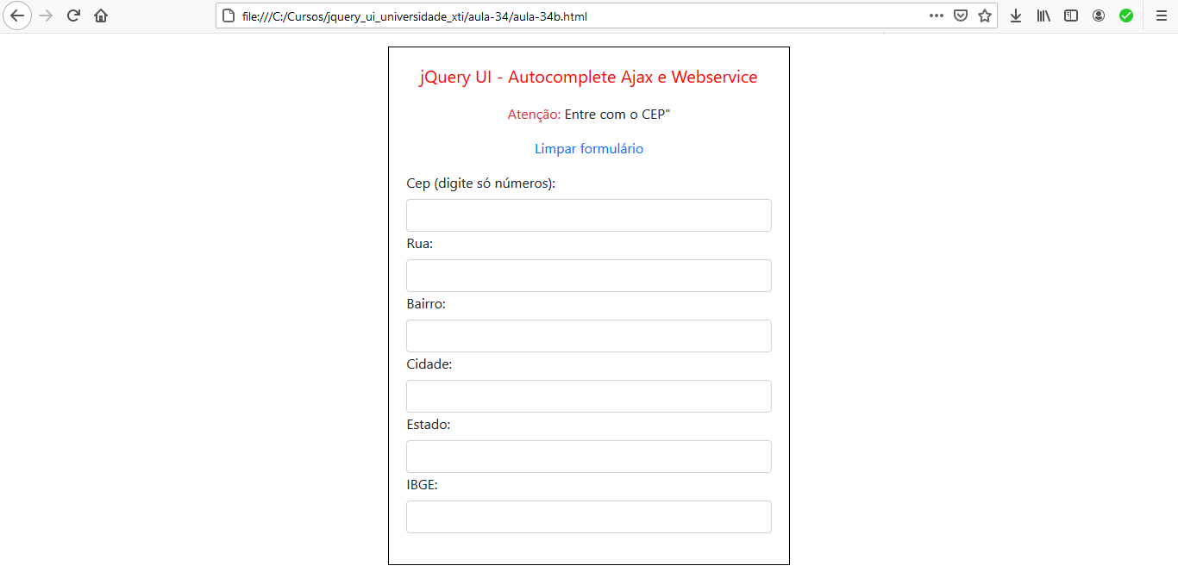

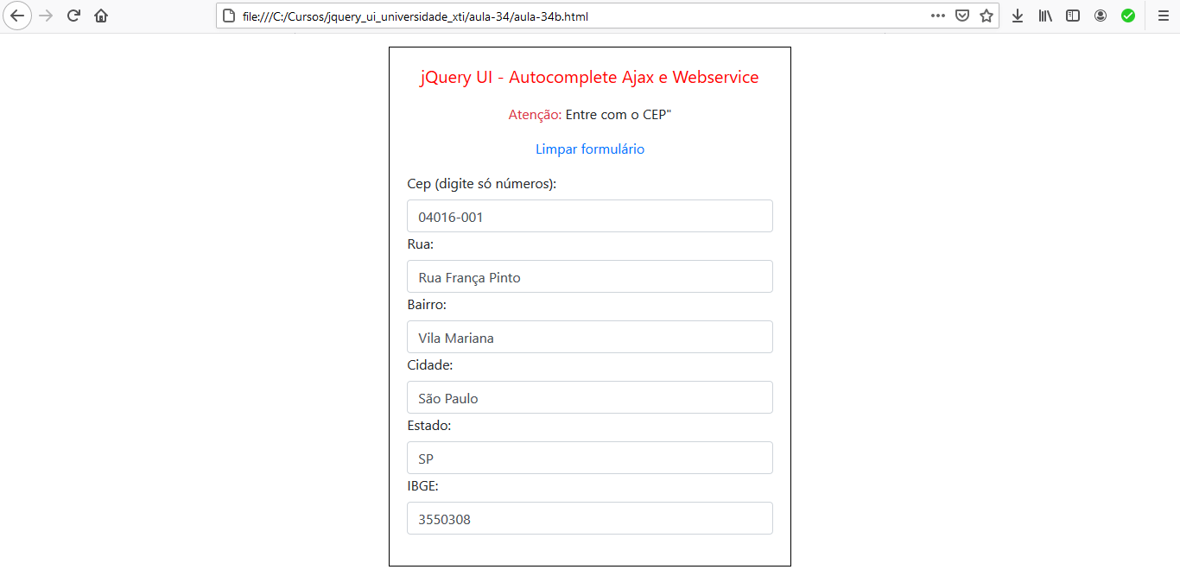

- Se for informado um CEP não existente:

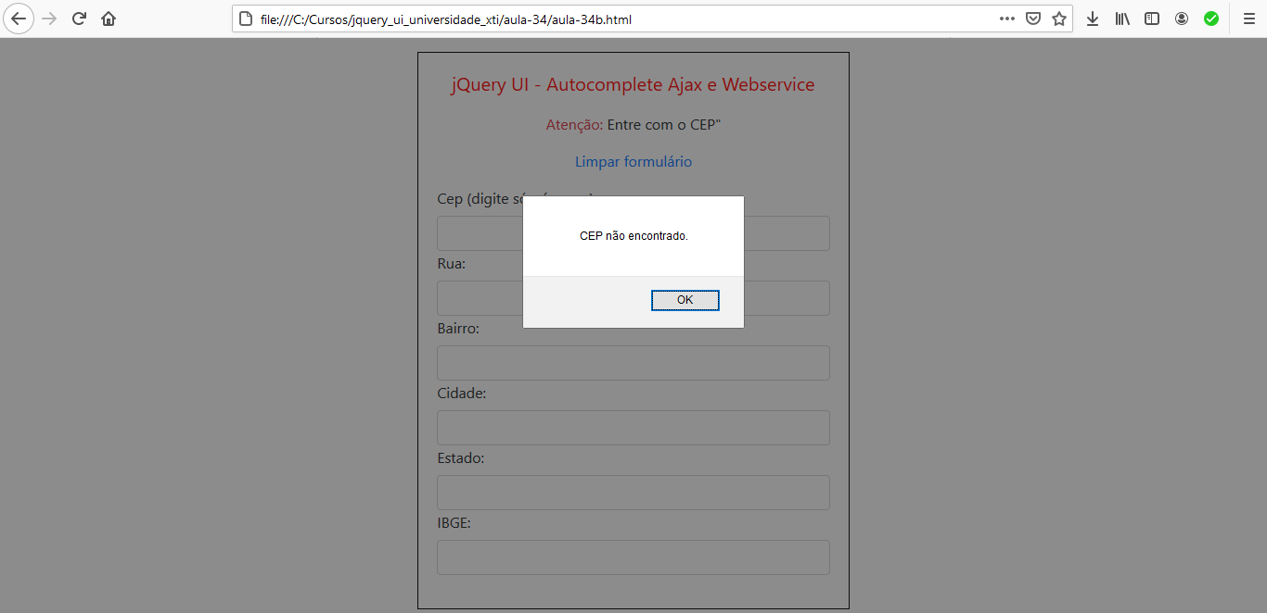

Aula 35 - Exemplo jQuery UI - Button

aula-35\aula-35a.html

<!DOCTYPE html>
<html lang="pt-br">
<head>
<meta charset="UTF-8">
<meta name="viewport" content="width=device-width, initial-scale=1.0">
<title>jQuery UI - Button</title>

<!-- CSS -->
<link rel="stylesheet" type="text/css" href="../css/base/jquery-ui.css">
<link rel="stylesheet" href="../bootstrap-4.5.2/css/bootstrap.css">
<link rel="stylesheet" href="css/aula-35.css">

<!-- JS -->
<script src="../js/jquery-1.12.4.js"></script>
<script src="../js/jquery-ui-1.12.1.js"></script>
<script src="js/aula-35a.js"></script>
</head>
<body>

<div class="row">
<div class="col-md-4"></div>
<div class="col-md-4 basico" >
<h5 class="titulo">jQuery UI - Button</h5>

<h4>Link</h4>
<p><a href="#">Um link</a></p>

<h4>Radio Group</h4>
<p class="text-light bg-dark">Select a Location: </p>
<label for="radio-1">New York</label>
<input type="radio" name="radio-1" id="radio-1">
<label for="radio-2">Paris</label>
<input type="radio" name="radio-1" id="radio-2">
<label for="radio-3">London</label>
<input type="radio" name="radio-1" id="radio-3">

<h4>Checkbox</h4>
<p class="text-light bg-dark">Hotel Ratings: </p>
<label for="checkbox-1">2 Star</label>
<input type="checkbox" name="checkbox-1" id="checkbox-1">
<label for="checkbox-2">3 Star</label>
<input type="checkbox" name="checkbox-2" id="checkbox-2">
<label for="checkbox-3">4 Star</label>
<input type="checkbox" name="checkbox-3" id="checkbox-3">
<label for="checkbox-4">5 Star</label>
<input type="checkbox" name="checkbox-4" id="checkbox-4">
</div>
</div>
<div class="col-md-4"></div>
</div>

</body>
</html>

aula-35\css\aula-35.css

.basico{
border: 1px solid black;
padding:10px;
margin-top: 15px;
margin-bottom: 15px;
}
.titulo{
text-align: center;
color: red;
margin-bottom: 20px;
}

aula-35\js\aula-35a.js

$( function() {

$("a").button({
icons: {
primary: "ui-icon-print"
},
text: false
});

$( "input" ).checkboxradio();

});

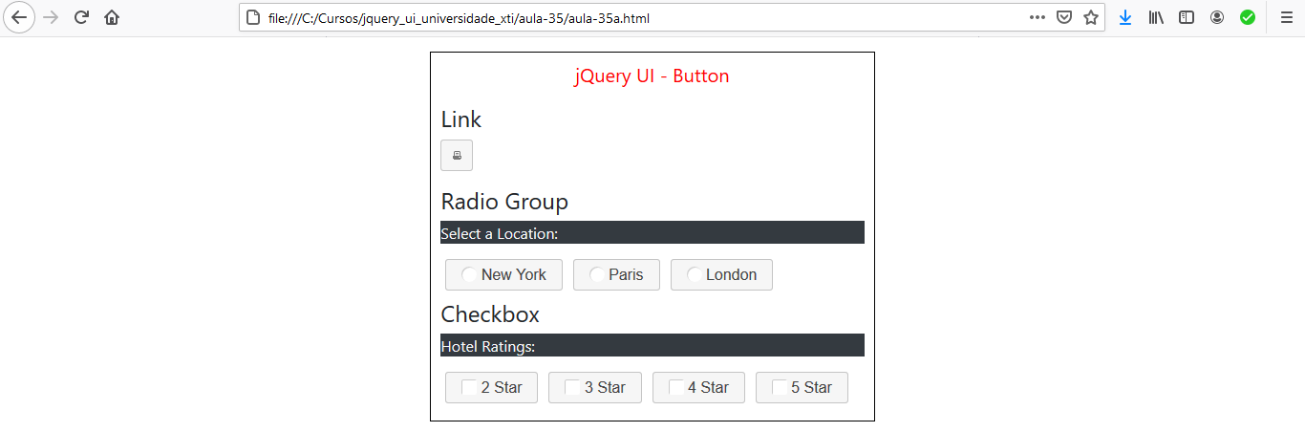

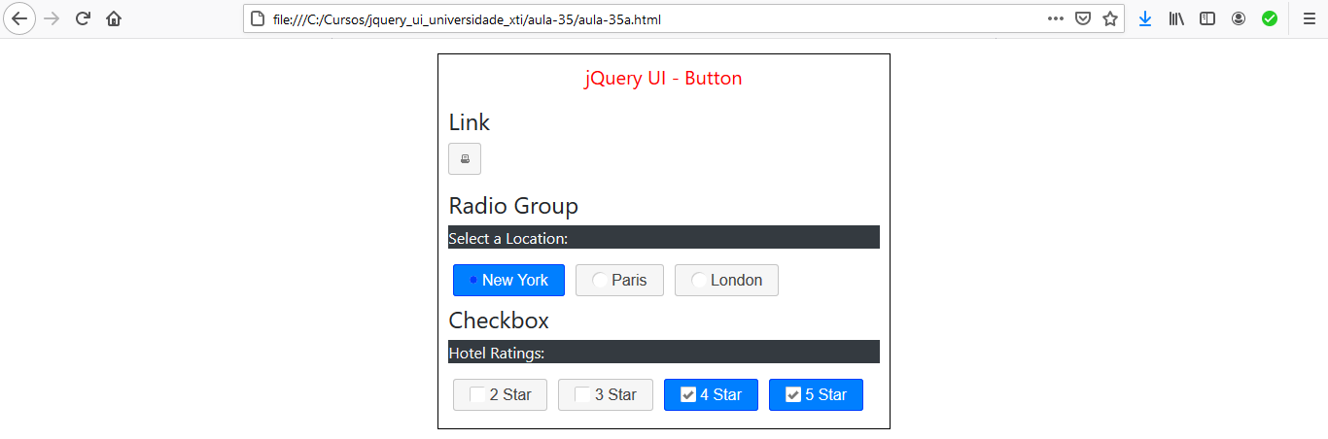

Aula 36 - Exemplo jQuery UI - DatePicker

aula-36\aula-36a.html

<!DOCTYPE html>
<html lang="pt-br">
<head>
<meta charset="UTF-8">
<meta name="viewport" content="width=device-width, initial-scale=1.0">
<title>jQuery UI - DatePicker</title>

<!-- CSS -->
<link rel="stylesheet" type="text/css" href="../css/smoothness/jquery-ui.css">
<link rel="stylesheet" href="../bootstrap-4.5.2/css/bootstrap.css">
<link rel="stylesheet" href="css/aula-36.css">

<!-- JS -->
<script src="../js/jquery-1.12.4.js"></script>
<script src="../js/jquery-ui-1.12.1.js"></script>
<script src="../js/jquery-ui-i18n.js"></script>
<script src="js/aula-36a.js"></script>
</head>
<body>

<div class="row">
<div class="col-md-4"></div>
<div class="col-md-4 basico" >

<h5 class="titulo">jQuery UI - DatePicker</h5>

<label for="date">Data: </label>
<input type="text" name="date" id="date">

</div>
<div class="col-md-4"></div>
</div>

</body>
</html>

aula-36\css\aula-36.css

.basico{
border: 1px solid black;
padding:20px;
margin-top: 15px;
margin-bottom: 15px;
}
.titulo{
text-align: center;
color: red;
margin-bottom: 20px;
}
#date{
margin-right: 5px;
padding-bottom: 5px;
}

aula-36\js\aula-36a.js

$( function() {

$("#date").datepicker({
showOn: "button",
buttonImage: "img/calendar.png",
// buttonImageOnly: true
});

});

js\jquery-ui-i18n.js

/* Brazilian initialisation for the jQuery UI date picker plugin. */
/* Written by Leonildo Costa Silva (leocsilva@gmail.com). */
( function( factory ) {
if ( typeof define === "function" && define.amd ) {

// AMD. Register as an anonymous module.
define( [ "../widgets/datepicker" ], factory );
} else {

// Browser globals
factory( jQuery.datepicker );
}
}( function( datepicker ) {

datepicker.regional[ "pt-BR" ] = {
closeText: "Fechar",
prevText: "&#x3C;Anterior",
nextText: "Próximo&#x3E;",
currentText: "Hoje",
monthNames: [ "Janeiro","Fevereiro","Março","Abril","Maio","Junho",
"Julho","Agosto","Setembro","Outubro","Novembro","Dezembro" ],
monthNamesShort: [ "Jan","Fev","Mar","Abr","Mai","Jun",
"Jul","Ago","Set","Out","Nov","Dez" ],
dayNames: [
"Domingo",
"Segunda-feira",
"Terça-feira",
"Quarta-feira",
"Quinta-feira",
"Sexta-feira",
"Sábado"
],
dayNamesShort: [ "Dom","Seg","Ter","Qua","Qui","Sex","Sáb" ],
dayNamesMin: [ "Dom","Seg","Ter","Qua","Qui","Sex","Sáb" ],
weekHeader: "Sm",
dateFormat: "dd/mm/yy",
firstDay: 0,
isRTL: false,
showMonthAfterYear: false,
yearSuffix: "" };
datepicker.setDefaults( datepicker.regional[ "pt-BR" ] );

return datepicker.regional[ "pt-BR" ];

} ) );



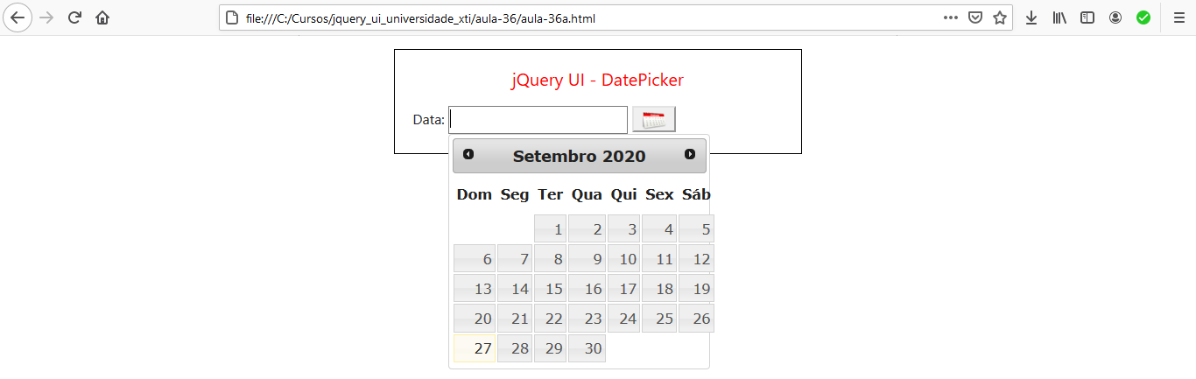



Aula 37 - Exemplo jQuery UI - Dialog

aula-37\aula-37a.html

<!DOCTYPE html>
<html lang="pt-br">
<head>
<meta charset="UTF-8">
<meta name="viewport" content="width=device-width, initial-scale=1.0">
<title>jQuery UI - Dialog</title>

<!-- CSS -->
<link rel="stylesheet" type="text/css" href="../css/smoothness/jquery-ui.css">
<link rel="stylesheet" href="../bootstrap-4.5.2/css/bootstrap.css">
<link rel="stylesheet" href="css/aula-37.css">

<!-- JS -->
<script src="../js/jquery-1.12.4.js"></script>
<script src="../js/jquery-ui-1.12.1.js"></script>
<script src="../js/jquery-ui-i18n.js"></script>
<script src="js/aula-37a.js"></script>
</head>
<body>

<div class="row">
<div class="col-md-4"></div>
<div class="col-md-4 basico" >

<h5 class="titulo">jQuery UI - Dialog</h5>

<div id="dialog" title="Download completo">
<p>
<span class="ui-icon ui-icon-circle-check" style="float:left; margin:0 7px 50px 0;"></span>
Seus arquivos foram baixados, com sucesso, para dentro da pasta <span class="text-primary">Documentos</span>.
</p>
<p>
Atualmente você está usando <span class="text-success">36%</span> do espaço de armazenamento disponível.
</p>
</div>

<p>A janela de diálogo básica é uma sobreposição posicionada dentro da janela de visualização e é protegida do conteúdo da página (como elementos selecionados) brilhando com um iframe. Possui uma barra de título e uma área de conteúdo e pode ser movido, redimensionado e fechado com o ícone 'x' por padrão.</p>

</div>
<div class="col-md-4"></div>
</div>

</body>
</html>

aula-37\css\aula-37.css

.basico{
border: 1px solid black;
padding:20px;
margin-top: 15px;
margin-bottom: 15px;
}
.titulo{
text-align: center;
color: red;
margin-bottom: 20px;
}

aula-37\js\aula-37a.js

$( function() {

$( "#dialog" ).dialog({
modal: true,
width: "500px",
buttons: {
"Ok": function(){
$(this).dialog("close");
}
}
});

});

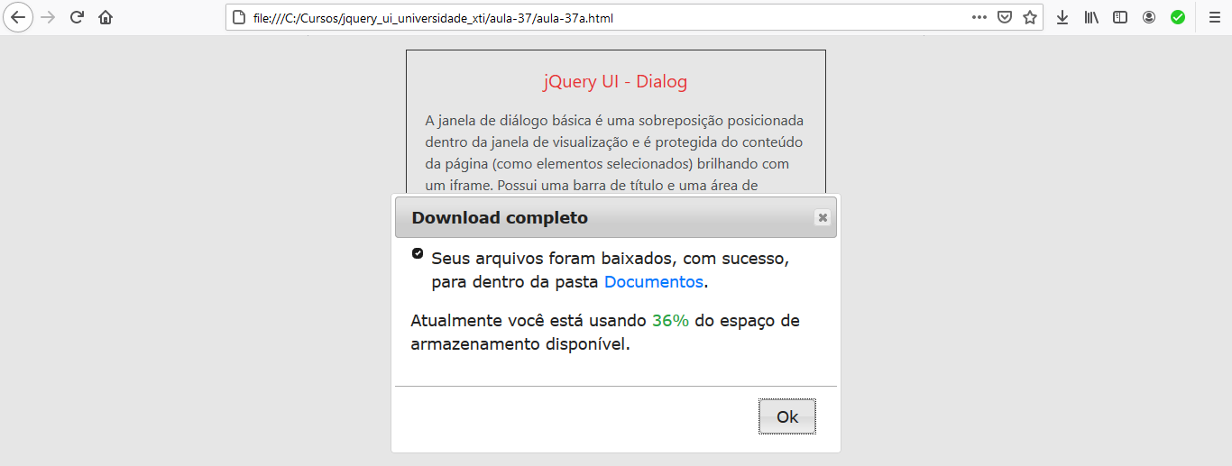

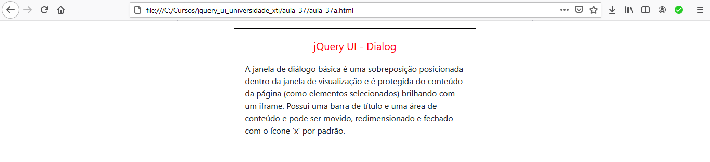

Aula 38 - Exemplo jQuery UI - Drag and drop

aula-38\aula-38a.html

<!DOCTYPE html>
<html lang="pt-br">
<head>
<meta charset="UTF-8">
<meta name="viewport" content="width=device-width, initial-scale=1.0">
<title>jQuery UI - Drag and Drop</title>

<!-- CSS -->
<link rel="stylesheet" type="text/css" href="../css/smoothness/jquery-ui.css">
<link rel="stylesheet" href="../bootstrap-4.5.2/css/bootstrap.css">
<link rel="stylesheet" href="css/aula-38.css">

<!-- JS -->
<script src="../js/jquery-1.12.4.js"></script>
<script src="../js/jquery-ui-1.12.1.js"></script>
<script src="../js/jquery-ui-i18n.js"></script>
<script src="js/aula-38a.js"></script>
</head>
<body>

<div class="row">
<div class="col-md-2"></div>
<div class="col-md-8 basico" >
<h5 class="titulo">jQuery UI - Drag and Drop</h5>
<div>
<p id="drag">Clique e arraste</p>
</div>
<div>
<p id="drop">Solte aqui</p>
</div>
</div>
<div class="col-md-2"></div>
</div>

</body>
</html>

aula-38\css\aula-38.css

.basico{
/* border: 1px solid black; */
padding:20px;
margin-top: 15px;
margin-bottom: 15px;
}
.titulo{
text-align: center;
color: red;
margin-bottom: 20px;
}
#drag{
display: block;
padding: 20px;
width: 170px;
text-align: center;
border: 1px solid black;
}
#drop{
padding: 100px;
width: 70%;
float: right;
text-align: center;
border: 1px solid black;
}

aula-38\js\aula-38a.js

$( function() {

$("#drag").draggable();

$("#drop").droppable({
drop: function(event, ui){
$(this).addClass("ui-state-highlight").html("Elemento arrastável solto nesta área!");
$("#drag").css("background", "yellow");
}
});

});

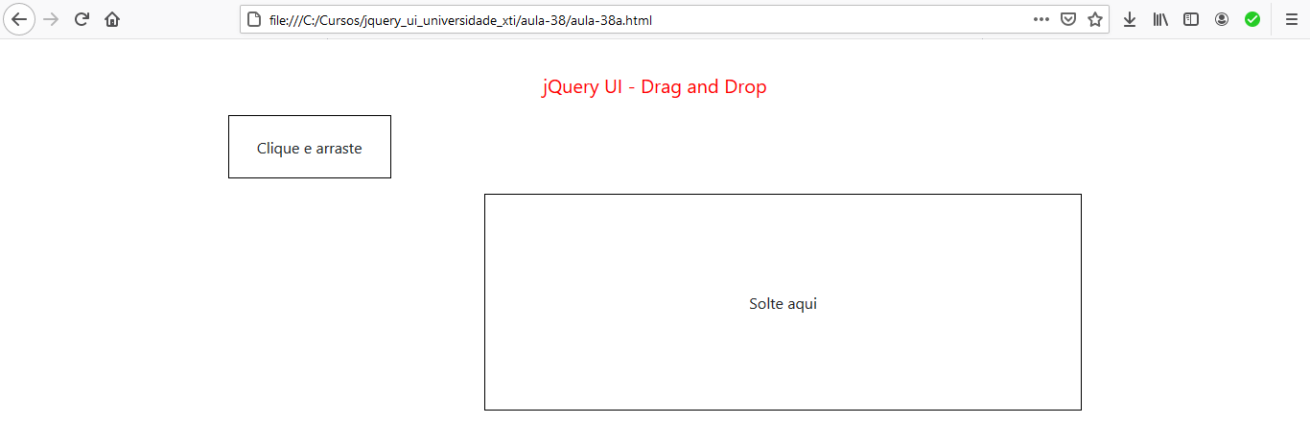

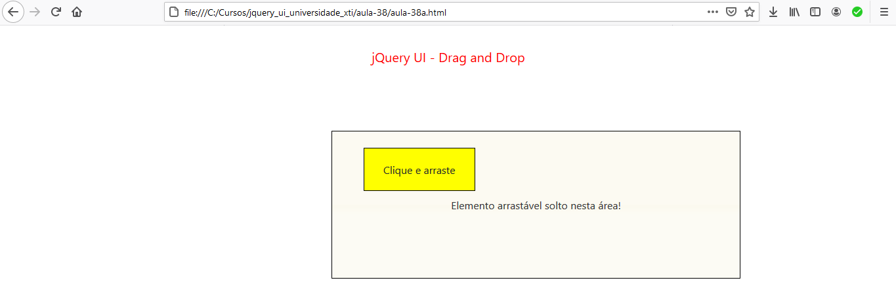

Aula 39 - Exemplo jQuery UI - Drag and Drop (Carrinho de compras)

aula-39\aula-39a.html

<!DOCTYPE html>
<html lang="pt-br">
<head>
<meta charset="UTF-8">
<meta name="viewport" content="width=device-width, initial-scale=1.0">
<title>jQuery UI - Carrinho de compras</title>

<!-- CSS -->
<link rel="stylesheet" type="text/css" href="../css/smoothness/jquery-ui.css">
<link rel="stylesheet" href="../bootstrap-4.5.2/css/bootstrap.css">
<link rel="stylesheet" href="css/aula-39.css">

<!-- JS -->
<script src="../js/jquery-1.12.4.js"></script>
<script src="../js/jquery-ui-1.12.1.js"></script>
<script src="../js/jquery-ui-i18n.js"></script>
<script src="js/aula-39a.js"></script>
</head>
<body>

<div class="row">
<div class="col-md-3"></div>
<div class="col-md-6 basico" >
<h5 class="titulo">jQuery UI - Drag and Drop - Carrinho de compras</h5>

<div id="catalogo">
<ul>
<li>Camisa</li>
<li>Meia</li>
<li>Gravata</li>
<li>Terno</li>
<li>Sapato</li>
</ul>
</div>

<div id="carrinho">
<ul>
<li class="mensagem">Compras</li>
</ul>
</div>
</div>
<div class="col-md-3"></div>
</div>

</body>
</html>

aula-39\css\aula-39.css

.basico{
border: 1px solid black;
padding:20px;
margin-top: 15px;
margin-bottom: 15px;
}
.titulo{
text-align: center;
color: red;
margin-bottom: 40px;
}
ul{
list-style: none;
}
#catalogo li{
padding: 10px;
text-align: center;
border: 1px solid black;
margin-right: 5px;
margin-bottom: 5px;
width: 150px;
}
#carrinho ul{
padding: 50px 120px;
text-align: center;
border: 1px solid black;
float: right;
}

aula-39\js\aula-39a.js

$( function() {

$("#catalogo li").draggable({
helper: "clone"
});

$("#carrinho ul").droppable({
drop: function(event, ui){
$(this).append($("<li />").text(ui.draggable.text()));
$(this).find(".mensagem").remove();
}
});

});

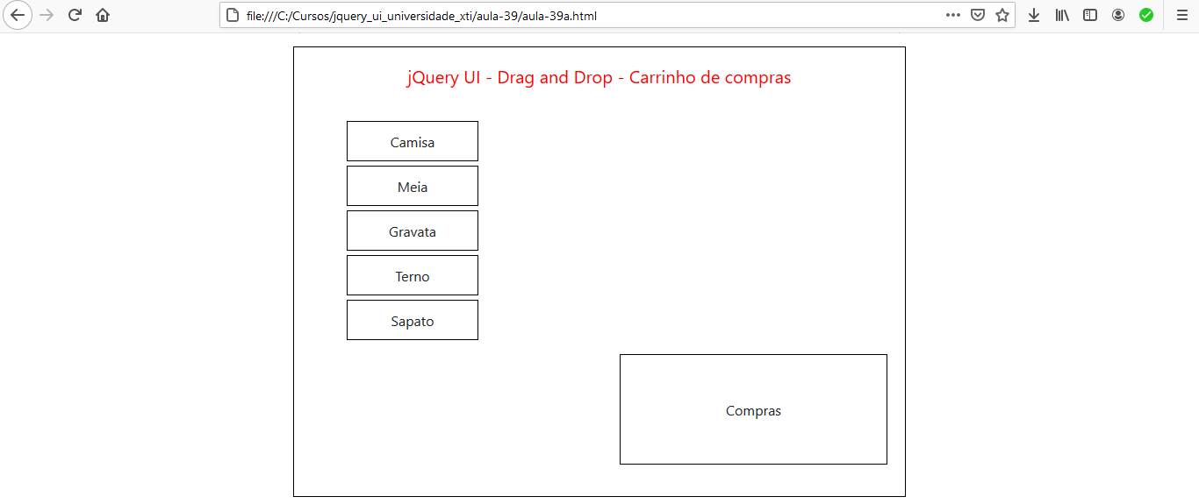

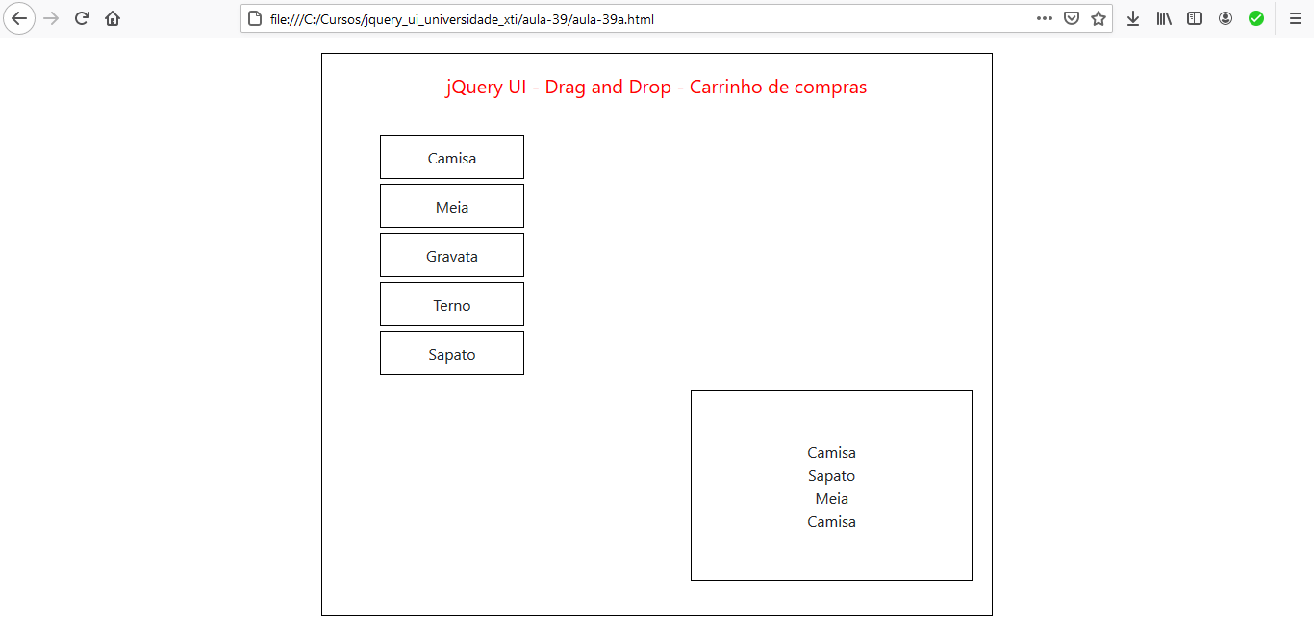

Aula 40 - Exemplo jQuery UI - Barra de progresso

aula-40\aula-40a.html

<!DOCTYPE html>
<html lang="pt-br">
<head>
<meta charset="UTF-8">
<meta name="viewport" content="width=device-width, initial-scale=1.0">
<title>jQuery UI - Barra de progresso</title>

<!-- CSS -->
<link rel="stylesheet" type="text/css" href="../css/smoothness/jquery-ui.css">
<link rel="stylesheet" href="../bootstrap-4.5.2/css/bootstrap.css">
<link rel="stylesheet" href="css/aula-40.css">

<!-- JS -->
<script src="../js/jquery-1.12.4.js"></script>
<script src="../js/jquery-ui-1.12.1.js"></script>
<script src="js/aula-40a.js"></script>
</head>
<body>

<div class="row">
<div class="col-md-4"></div>
<div class="col-md-4 basico" >
<h5 class="titulo">jQuery UI - Drag and Drop - Barra de progresso</h5>

<div id="progressbar"><div class="progress-label">Loading...</div></div>
</div>
<div class="col-md-4"></div>
</div>

</body>
</html>

aula-40\js\aula-40a.js

$( function() {
var progressbar = $( "#progressbar" ),
progressLabel = $( ".progress-label" );

progressbar.progressbar({
value: false,
change: function() {
progressLabel.text( "- " + progressbar.progressbar( "value" ) + "%" + " -");
},
complete: function() {
progressLabel.text( "Complete!" );
}
});

function progress() {
var val = progressbar.progressbar( "value" ) || 0;

progressbar.progressbar( "value", val + 2 );

if ( val < 99 ) {
setTimeout( progress, 80 );
}
}

setTimeout( progress, 4000 );
} );

aula-40\css\aula-40.css

.basico{
border: 1px solid black;
padding:20px;
margin-top: 15px;
margin-bottom: 15px;
}
.titulo{
text-align: center;
color: red;
margin-bottom: 40px;
}
.ui-progressbar {
position: relative;
}
.progress-label {
position: absolute;
left: 39%;
top: 4px;
font-weight: bold;
text-shadow: 1px 1px 0 #fff;
}
.ui-progressbar-value{
background-image: url("../img/pbar-ani.gif");
background-repeat: no-repeat;
}







Aula 41 - Exemplo jQuery UI - Elementos redimensionáveis

aula-41\aula-41a.html

<!DOCTYPE html>
<html lang="pt-br">
<head>
<meta charset="UTF-8">
<meta name="viewport" content="width=device-width, initial-scale=1.0">
<title>jQuery UI - Resizable</title>

<!-- CSS -->
<link rel="stylesheet" type="text/css" href="../css/smoothness/jquery-ui.css">
<link rel="stylesheet" href="../bootstrap-4.5.2/css/bootstrap.css">
<link rel="stylesheet" href="css/aula-41.css">

<!-- JS -->
<script src="../js/jquery-1.12.4.js"></script>
<script src="../js/jquery-ui-1.12.1.js"></script>
<script src="js/aula-41a.js"></script>
</head>
<body>

<div class="row">
<div class="col-md-3"></div>
<div class="col-md-6 basico" >
<h5 class="titulo">jQuery UI - Drag and Drop - Resizable</h5>

<div id="resizable" class="ui-widget-content">
<h5 class="ui-widget-header text-center">Resizable</h5>
</div>
</div>
<div class="col-md-3"></div>
</div>

</body>
</html>

aula-41\css\aula-41.css

.basico{
border: 1px solid black;
padding:20px;
margin-top: 15px;
margin-bottom: 15px;
}
.titulo{
text-align: center;
color: red;
margin-bottom: 40px;
}
#resizable {
width: 150px;
height: 150px;
padding: 0.5em;
}
#resizable h3 {
text-align: center;
margin: 0;
}

aula-41\js\aula-41a.js

$( function() {
$( "#resizable" ).resizable({
maxHeight: 250,
maxWidth: 350,
minHeight: 150,
minWidth: 200
});
});

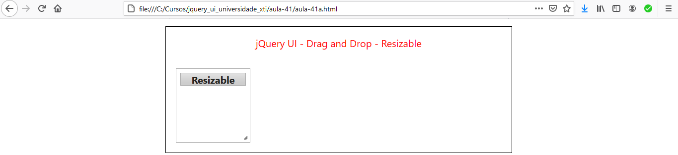

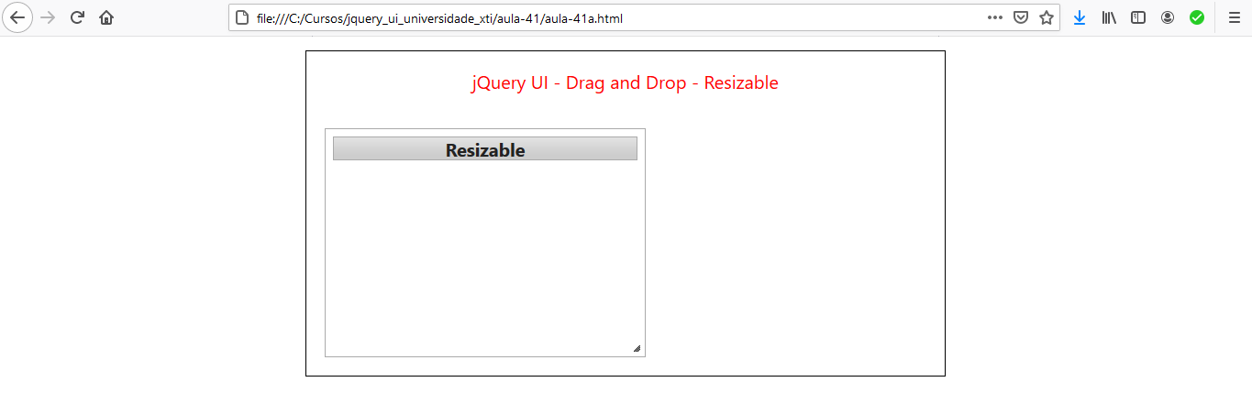

Aula 42 - Exemplo jQuery UI - Tabs (abas)

aula-42\aula-42a.html

<!DOCTYPE html>
<html lang="pt-br">
<head>
<meta charset="UTF-8">
<meta name="viewport" content="width=device-width, initial-scale=1.0">
<title>jQuery UI - Tabs</title>

<!-- CSS -->
<link rel="stylesheet" type="text/css" href="../css/smoothness/jquery-ui.css">
<link rel="stylesheet" href="../bootstrap-4.5.2/css/bootstrap.css">
<link rel="stylesheet" href="css/aula-42.css">

<!-- JS -->
<script src="../js/jquery-1.12.4.js"></script>
<script src="../js/jquery-ui-1.12.1.js"></script>
<script src="js/aula-42a.js"></script>
</head>
<body>

<div class="row">
<div class="col-md-3"></div>
<div class="col-md-6 basico" >
<h5 class="titulo">jQuery UI - Drag and Drop - Tabs (Abas)</h5>

<div id="tabs">
<ul>
<li><a href="#tabs-1">Nunc tincidunt</a></li>
<li><a href="#tabs-2">Proin dolor</a></li>
<li><a href="#tabs-3">Aenean lacinia</a></li>
</ul>
<div id="tabs-1">
<p>Proin elit arcu, rutrum commodo, vehicula tempus, commodo a, risus. Curabitur nec arcu. Donec sollicitudin mi sit amet mauris. Nam elementum quam ullamcorper ante. Etiam aliquet massa et lorem. Mauris dapibus lacus auctor risus. Aenean tempor ullamcorper leo. Vivamus sed magna quis ligula eleifend adipiscing. Duis orci. Aliquam sodales tortor vitae ipsum. Aliquam nulla. Duis aliquam molestie erat. Ut et mauris vel pede varius sollicitudin. Sed ut dolor nec orci tincidunt interdum. Phasellus ipsum. Nunc tristique tempus lectus.</p>
</div>
<div id="tabs-2">
<p>Morbi tincidunt, dui sit amet facilisis feugiat, odio metus gravida ante, ut pharetra massa metus id nunc. Duis scelerisque molestie turpis. Sed fringilla, massa eget luctus malesuada, metus eros molestie lectus, ut tempus eros massa ut dolor. Aenean aliquet fringilla sem. Suspendisse sed ligula in ligula suscipit aliquam. Praesent in eros vestibulum mi adipiscing adipiscing. Morbi facilisis. Curabitur ornare consequat nunc. Aenean vel metus. Ut posuere viverra nulla. Aliquam erat volutpat. Pellentesque convallis. Maecenas feugiat, tellus pellentesque pretium posuere, felis lorem euismod felis, eu ornare leo nisi vel felis. Mauris consectetur tortor et purus.</p>
</div>
<div id="tabs-3">
<p>Mauris eleifend est et turpis. Duis id erat. Suspendisse potenti. Aliquam vulputate, pede vel vehicula accumsan, mi neque rutrum erat, eu congue orci lorem eget lorem. Vestibulum non ante. Class aptent taciti sociosqu ad litora torquent per conubia nostra, per inceptos himenaeos. Fusce sodales. Quisque eu urna vel enim commodo pellentesque. Praesent eu risus hendrerit ligula tempus pretium. Curabitur lorem enim, pretium nec, feugiat nec, luctus a, lacus.</p>
<p>Duis cursus. Maecenas ligula eros, blandit nec, pharetra at, semper at, magna. Nullam ac lacus. Nulla facilisi. Praesent viverra justo vitae neque. Praesent blandit adipiscing velit. Suspendisse potenti. Donec mattis, pede vel pharetra blandit, magna ligula faucibus eros, id euismod lacus dolor eget odio. Nam scelerisque. Donec non libero sed nulla mattis commodo. Ut sagittis. Donec nisi lectus, feugiat porttitor, tempor ac, tempor vitae, pede. Aenean vehicula velit eu tellus interdum rutrum. Maecenas commodo. Pellentesque nec elit. Fusce in lacus. Vivamus a libero vitae lectus hendrerit hendrerit.</p>
</div>
</div>

</div>
<div class="col-md-3"></div>
</div>

</body>
</html>

aula-42\css\aula-42.css

.basico{
border: 1px solid black;
padding:20px;
margin-top: 15px;
margin-bottom: 15px;
}
.titulo{
text-align: center;
color: red;
margin-bottom: 40px;
}

aula-42\js\aula-42a.js

$( function() {
$( "#tabs" ).tabs();
});

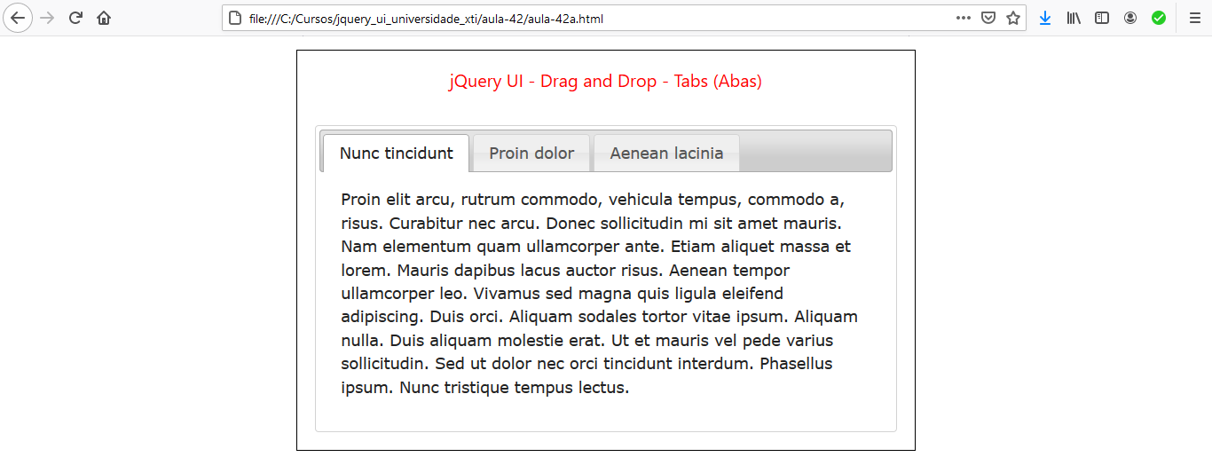

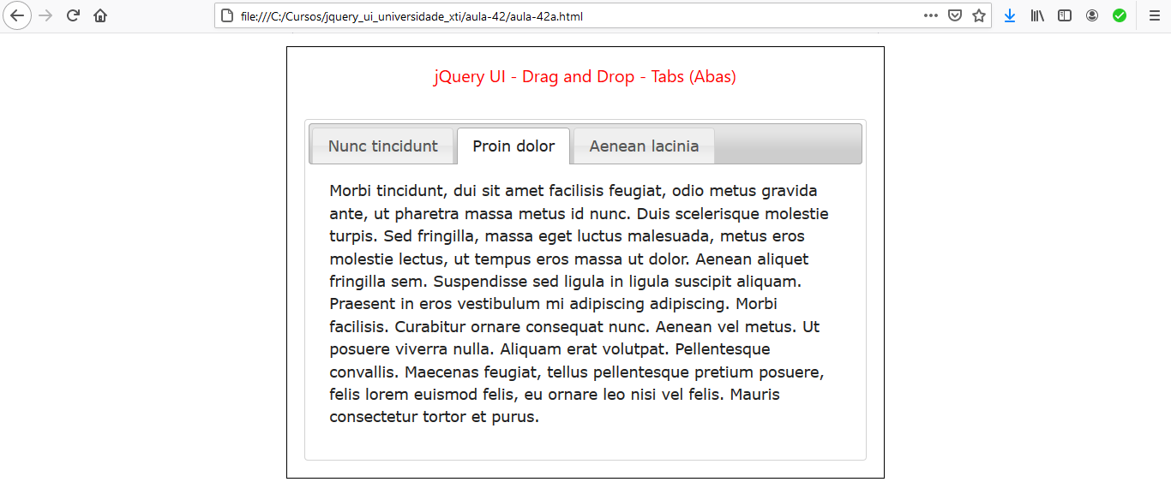

Aula 43 - Exemplo jQuery UI - Slider

aula-43\aula-43a.html

<!DOCTYPE html>
<html lang="pt-br">
<head>
<meta charset="UTF-8">
<meta name="viewport" content="width=device-width, initial-scale=1.0">
<title>jQuery UI - Slider</title>

<!-- CSS -->
<link rel="stylesheet" type="text/css" href="../css/smoothness/jquery-ui.css">
<link rel="stylesheet" href="../bootstrap-4.5.2/css/bootstrap.css">
<link rel="stylesheet" href="css/aula-43a.css">

<!-- JS -->
<script src="../js/jquery-1.12.4.js"></script>
<script src="../js/jquery-ui-1.12.1.js"></script>
<script src="js/aula-43a.js"></script>
</head>
<body>

<div class="row">
<div class="col-md-3"></div>
<div class="col-md-6 basico" >
<h5 class="titulo">jQuery UI - Slider</h5>
<div id="slider"></div>

<br />

<div id="div_valor">
<label for="valor">Valor: </label>
<input class="text-primary" type="text" id="valor" size="3">
</div>

</div>
<div class="col-md-3"></div>
</div>

</body>
</html>

aula-43\css\aula-43.css

.basico{
border: 1px solid black;
padding:20px;
margin-top: 15px;
margin-bottom: 15px;
}
.titulo{
text-align: center;
color: red;
margin-bottom: 40px;
}
#valor{
border: none;
}
#div_valor{
display: block;
text-align: center;
}

aula-43\js\aula-43a.js

$( function() {

var valor = 60;
$("#valor").val(valor);

$( "#slider" ).slider({
min: 10,
max: 100,
value: valor,
// orientation: "vertical",
slide: function(event, ui){
$("#valor").val(ui.value);
}
});
});




aula-43\aula-43b.html

<!DOCTYPE html>
<html lang="pt-br">
<head>
<meta charset="UTF-8">
<meta name="viewport" content="width=device-width, initial-scale=1.0">
<title>jQuery UI - Slider - ColorPicker</title>

<!-- CSS -->
<link rel="stylesheet" type="text/css" href="../css/smoothness/jquery-ui.css">
<link rel="stylesheet" href="../bootstrap-4.5.2/css/bootstrap.css">
<link rel="stylesheet" href="css/aula-43b.css">

<!-- JS -->
<script src="../js/jquery-1.12.4.js"></script>
<script src="../js/jquery-ui-1.12.1.js"></script>
<script src="js/aula-43b.js"></script>
</head>
<body>

<div class="row">
<div class="col-md-3"></div>
<div class="col-md-6 basico" >
<h5 class="titulo">jQuery UI - Slider - ColorPicker</h5>

<p class="ui-state-default ui-corner-all ui-helper-clearfix" style="padding:4px;">
<span class="ui-icon ui-icon-pencil" style="float:left; margin:-2px 5px 0 0;"></span>
Simple Colorpicker
</p>

<div id="red"></div>
<div id="green"></div>
<div id="blue"></div>

<div id="swatch" class="ui-widget-content ui-corner-all"></div>

<h5 class="text-center mt-2">Hexadecimal: <span id="cod_hex" class="text-danger"></span></h5>

</div>
<div class="col-md-3"></div>
</div>

</body>
</html>

aula-43\css\aula-43b.css

.basico{
border: 1px solid black;
padding:20px;
margin-top: 15px;
margin-bottom: 15px;
}
.titulo{
text-align: center;
color: red;
margin-bottom: 40px;
}
#red, #green, #blue {
float: left;
clear: left;
width: 300px;
margin: 15px;
}
#swatch {
width: 120px;
height: 100px;
margin-top: 18px;
margin-left: 430px;
background-image: none;
}
#red .ui-slider-range {
background: #ef2929;
}
#red .ui-slider-handle {
border-color: #ef2929;
}
#green .ui-slider-range {
background: #8ae234;
}
#green .ui-slider-handle {
border-color: #8ae234;
}
#blue .ui-slider-range {
background: #729fcf;
}
#blue .ui-slider-handle {
border-color: #729fcf;
}

aula-43\js\aula-43b.js

$( function() {
function hexFromRGB(r, g, b) {
var hex = [
r.toString( 16 ),
g.toString( 16 ),
b.toString( 16 )
];
$.each( hex, function( nr, val ) {
if ( val.length === 1 ) {
hex[ nr ] = "0" + val;
}
});
return hex.join( "" ).toUpperCase();
}
function refreshSwatch() {
var red = $( "#red" ).slider( "value" ),
green = $( "#green" ).slider( "value" ),
blue = $( "#blue" ).slider( "value" ),
hex = hexFromRGB( red, green, blue );
$("#cod_hex").text("#" + hex);

$( "#swatch" ).css( "background-color", "#" + hex );
}

$( "#red, #green, #blue" ).slider({
orientation: "horizontal",
range: "min",
max: 255,
value: 127,
slide: refreshSwatch,
change: refreshSwatch
});
$( "#red" ).slider( "value", 255 );
$( "#green" ).slider( "value", 140 );
$( "#blue" ).slider( "value", 60 );
} );

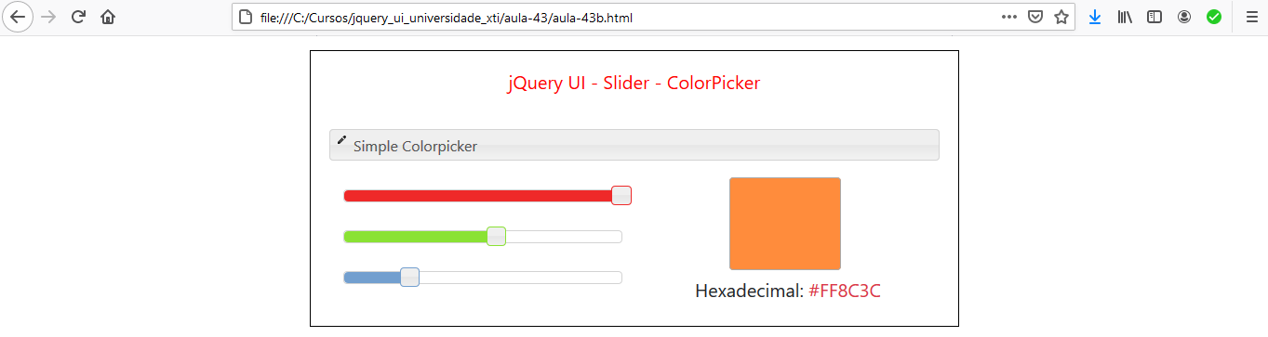

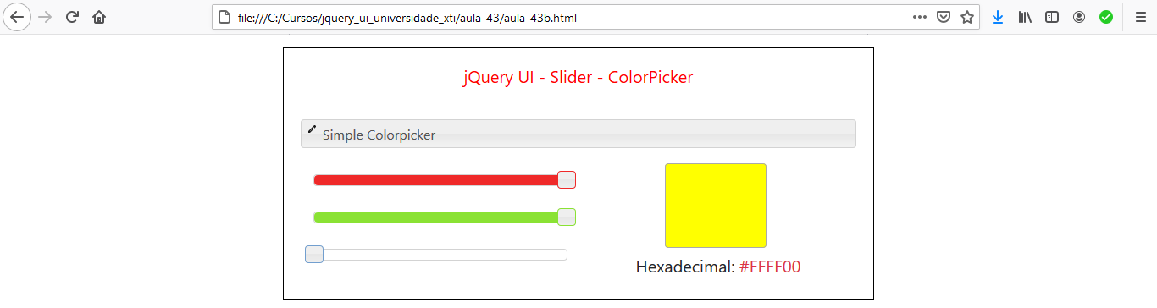

Aula 44 - Exemplo jQuery UI - Selectable (Elementos selecionáveis)

aula-44\aula-44a.html

<!DOCTYPE html>
<html lang="pt-br">
<head>
<meta charset="UTF-8">
<meta name="viewport" content="width=device-width, initial-scale=1.0">
<title>jQuery UI - Selectable</title>

<!-- CSS -->
<link rel="stylesheet" type="text/css" href="../css/smoothness/jquery-ui.css">
<link rel="stylesheet" href="../bootstrap-4.5.2/css/bootstrap.css">
<link rel="stylesheet" href="css/aula-44a.css">

<!-- JS -->
<script src="../js/jquery-1.12.4.js"></script>
<script src="../js/jquery-ui-1.12.1.js"></script>
<script src="js/aula-44a.js"></script>
</head>
<body>

<div class="row">
<div class="col-md-4"></div>
<div class="col-md-4 basico" >
<h5 class="titulo">jQuery UI - Selectable - Elementos selecionáveis</h5>

<ol id="selectable">
<li class="ui-widget-content">Item 1</li>
<li class="ui-widget-content">Item 2</li>
<li class="ui-widget-content">Item 3</li>
<li class="ui-widget-content">Item 4</li>
<li class="ui-widget-content">Item 5</li>
<li class="ui-widget-content">Item 6</li>
<li class="ui-widget-content">Item 7</li>
</ol>

</div>
<div class="col-md-4"></div>
</div>

</body>
</html>

aula-44\css\aula-44a.css

.basico{
border: 1px solid black;
padding:20px;
margin-top: 15px;
margin-bottom: 15px;
}
.titulo{
text-align: center;
color: red;
margin-bottom: 40px;
}
#feedback {
font-size: 1.4em;
}
#selectable .ui-selecting {
background: #FECA40;
}
#selectable .ui-selected {
background: #F39814;
color: white;
}
#selectable {
list-style-type: none;
margin: 0;
padding: 0px;
width: 60%;
}
#selectable li {
padding: 10px;
margin-bottom: 5px;
}

aula-44\js\aula-44a.js

$( function() {
$( "#selectable" ).selectable();
});

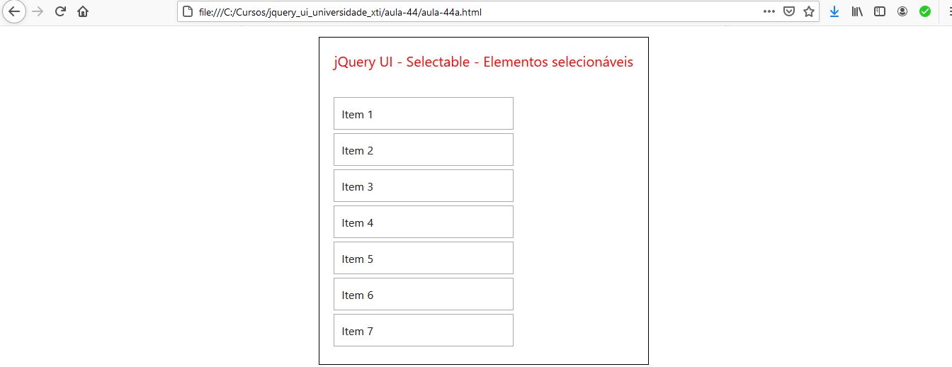
- Usando a tecla <Shift>:

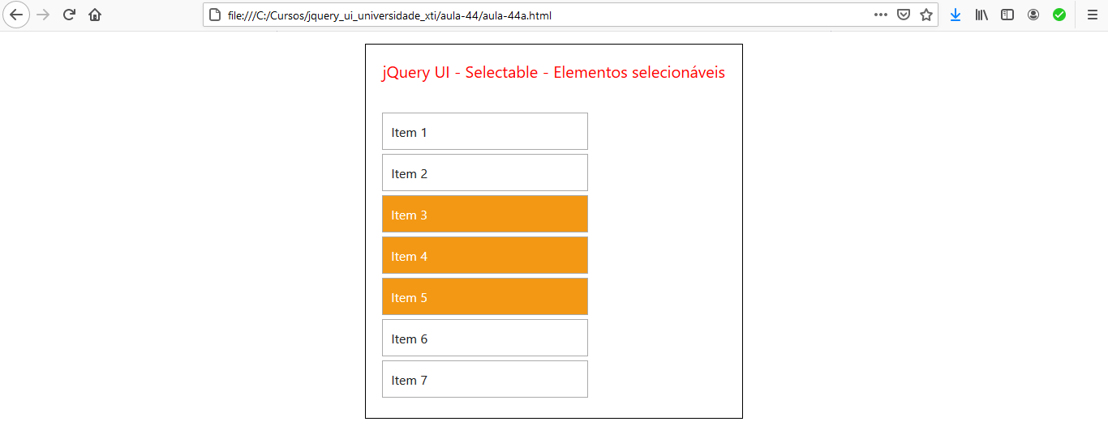

- Usando a tecla <Ctrl>:

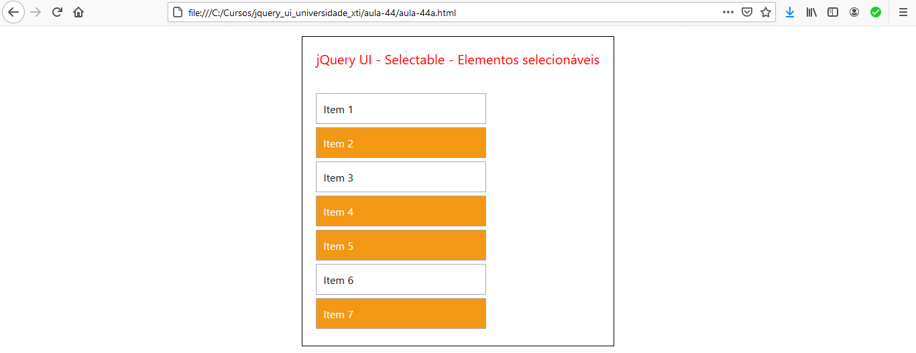

Aula 45 - Exemplo jQuery UI - Sortable (Elementos ordenáveis)

aula-45\aula-45a.html

<!DOCTYPE html>
<html lang="pt-br">
<head>
<meta charset="UTF-8">
<meta name="viewport" content="width=device-width, initial-scale=1.0">
<title>jQuery UI - Sortable</title>

<!-- CSS -->
<link rel="stylesheet" type="text/css" href="../css/smoothness/jquery-ui.css">
<link rel="stylesheet" href="../bootstrap-4.5.2/css/bootstrap.css">
<link rel="stylesheet" href="css/aula-45a.css">

<!-- JS -->
<script src="../js/jquery-1.12.4.js"></script>
<script src="../js/jquery-ui-1.12.1.js"></script>
<script src="js/aula-45a.js"></script>
</head>
<body>

<div class="row">
<div class="col-md-4"></div>
<div class="col-md-4 basico" >
<h5 class="titulo">jQuery UI - Sortable - Elementos ordenáveis</h5>

<ul id="sortable">
<li class="ui-state-default"><span class="ui-icon ui-icon-arrowthick-2-n-s"></span>Item 1</li>
<li class="ui-state-default"><span class="ui-icon ui-icon-arrowthick-2-n-s"></span>Item 2</li>
<li class="ui-state-default"><span class="ui-icon ui-icon-arrowthick-2-n-s"></span>Item 3</li>
<li class="ui-state-default"><span class="ui-icon ui-icon-arrowthick-2-n-s"></span>Item 4</li>
<li class="ui-state-default"><span class="ui-icon ui-icon-arrowthick-2-n-s"></span>Item 5</li>
<li class="ui-state-default"><span class="ui-icon ui-icon-arrowthick-2-n-s"></span>Item 6</li>
<li class="ui-state-default"><span class="ui-icon ui-icon-arrowthick-2-n-s"></span>Item 7</li>
</ul>

</div>
<div class="col-md-4"></div>
</div>

</body>
</html>

aula-45\css\aula-45a.css

.basico{
border: 1px solid black;
padding:20px;
margin-top: 15px;
margin-bottom: 15px;
}
.titulo{
text-align: center;
color: red;
margin-bottom: 40px;
}
#sortable {
list-style-type: none;
margin: 0;
padding: 0;
width: 60%;
}
#sortable li {
padding: 12px;
margin-bottom: 10px;
}
#sortable li span {
position: absolute;
margin-left: -0.8em;
}

aula-45\js\aula-45a.js

$( function() {
$( "#sortable" ).sortable();
$( "#sortable" ).disableSelection();
});

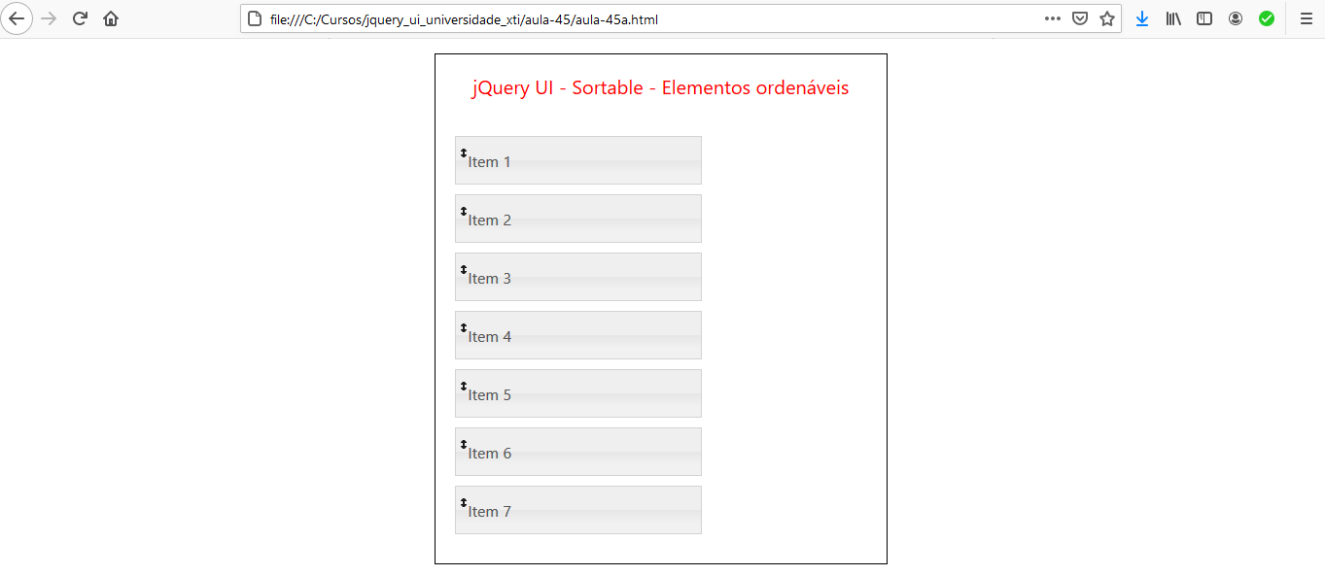

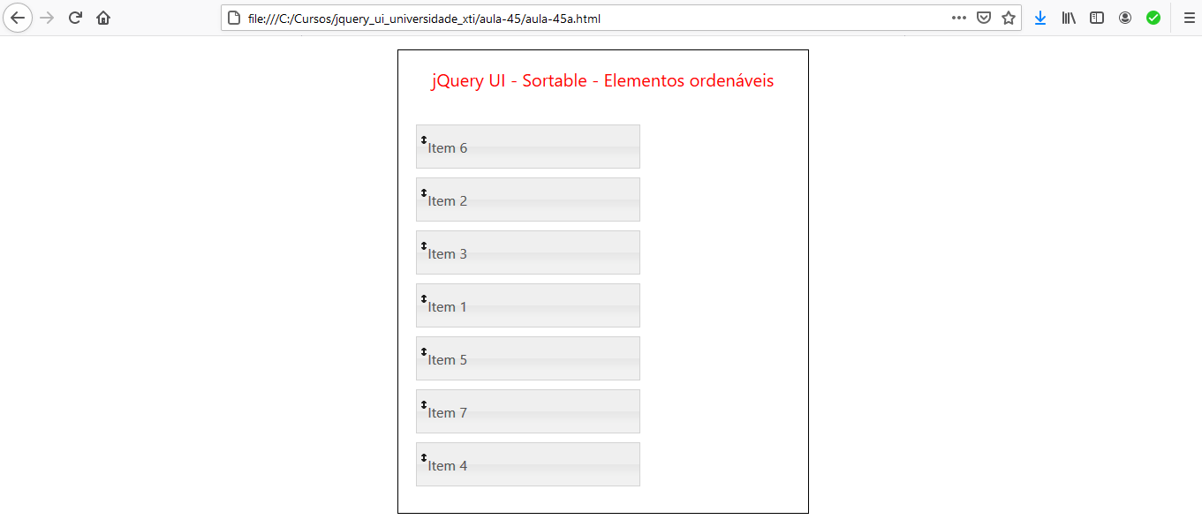

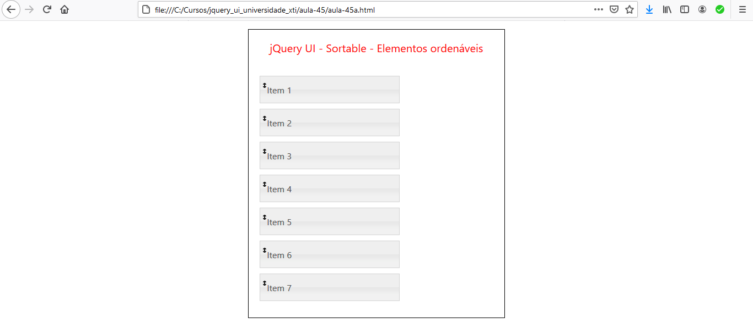

Sortable - Grid

aula-45\aula-45b.html

<!DOCTYPE html>
<html lang="pt-br">
<head>
<meta charset="UTF-8">
<meta name="viewport" content="width=device-width, initial-scale=1.0">
<title>jQuery UI - Sortable - Grid</title>

<!-- CSS -->
<link rel="stylesheet" type="text/css" href="../css/smoothness/jquery-ui.css">
<link rel="stylesheet" href="../bootstrap-4.5.2/css/bootstrap.css">
<link rel="stylesheet" href="css/aula-45b.css">

<!-- JS -->
<script src="../js/jquery-1.12.4.js"></script>
<script src="../js/jquery-ui-1.12.1.js"></script>
<script src="js/aula-45b.js"></script>
</head>
<body>

<div class="row">
<div class="col-md-4"></div>
<div class="col-md-4 basico" >
<h5 class="titulo">jQuery UI - Sortable - Grid</h5>

<ul id="sortable">
<li class="ui-state-default">1</li>
<li class="ui-state-default">2</li>
<li class="ui-state-default">3</li>
<li class="ui-state-default">4</li>
<li class="ui-state-default">5</li>
<li class="ui-state-default">6</li>
<li class="ui-state-default">7</li>
<li class="ui-state-default">8</li>
<li class="ui-state-default">9</li>
</ul>

</div>
<div class="col-md-4"></div>
</div>

</body>
</html>

aula-45\css\aula-45b.css

.basico{
border: 1px solid black;
padding:20px;
margin-top: 15px;
margin-bottom: 15px;
}
.titulo{
text-align: center;
color: red;
margin-bottom: 40px;
}
#sortable {
list-style-type: none;
margin-left: 60px;
padding: 0;
width: 350px;
}
#sortable li {
margin: 3px 3px 3px 0;
padding: 1px;
float: left;
width: 100px;
height: 90px;
font-size: 4em;
text-align: center;
}

aula-45\js\aula-45b.js

$( function() {
$( "#sortable" ).sortable();
$( "#sortable" ).disableSelection();
});

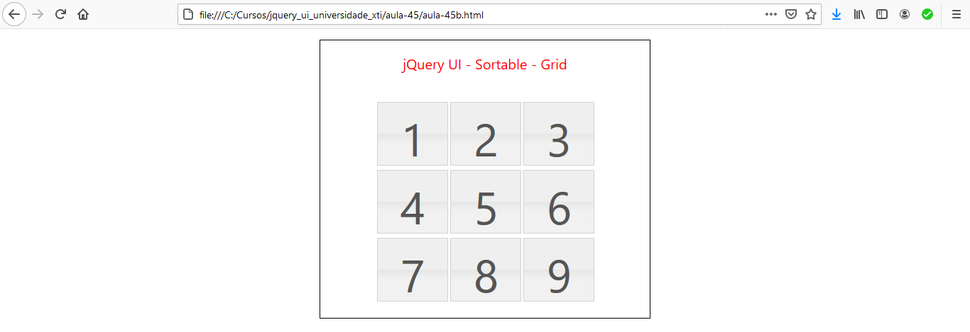

- Quadrado mágico 3 x 3:

