CRUD Laravel 5.4
Italo Morales (Rimorsoft Online)

https://www.youtube.com/watch?v=AiEhC2AluJ4&list=PLhCiuvlix-rTH5idwru7vKkPAmVODYJJB

Resumo dos vídeos feito por Roberto Pinheiro

Aula 2 - Migrate,Seeder,Factory,Model,Controller

Criando model, migration e controller

php artisan make:model Product -mc

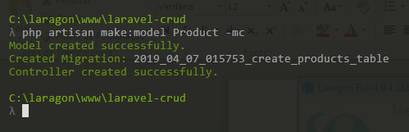

app/Product.php

<?php

namespace App;

use Illuminate\Database\Eloquent\Model;

class Product extends Model
{
protected $fillable = [
'name', 'short', 'body',
];
}

Criando seeder

php artisan make:seeder ProductsTableSeeder

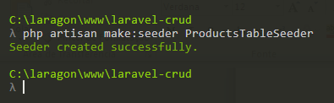

Criando e populando a tabela de produtos

php artisan migrate:refresh --seed

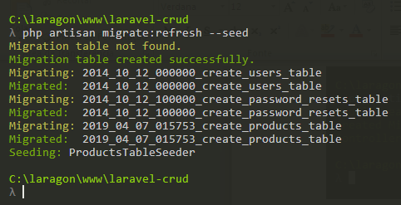

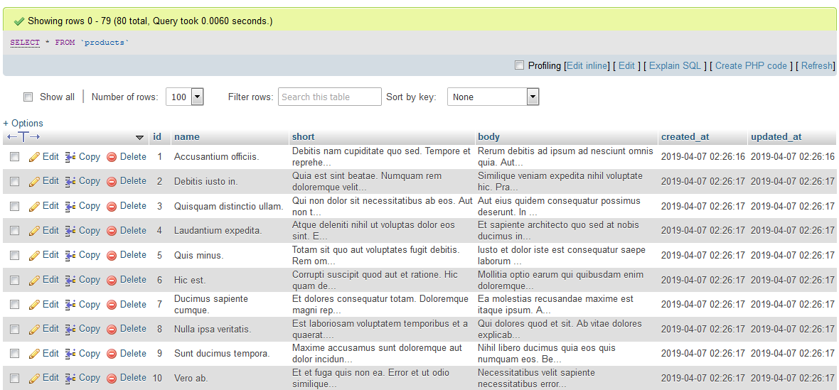

Aula 4 - Route resource e index para listar

Rotas

routes/web.php

<?php

/*
|--------------------------------------------------------------------------
| Web Routes
|--------------------------------------------------------------------------
|
| Here is where you can register web routes for your application. These
| routes are loaded by the RouteServiceProvider within a group which
| contains the "web" middleware group. Now create something great!
|
*/

Route::get('/', function () {
return view('welcome');
});

Route::resource('products', 'ProductController');

Listando as rotas

php artisan route:list

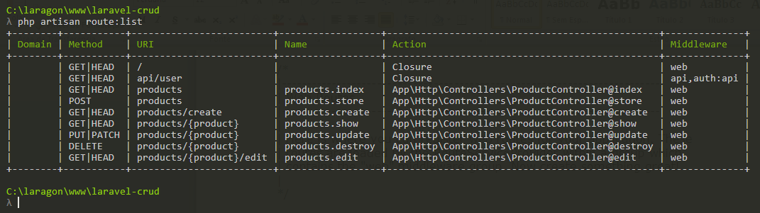

Http/Controllers/ProductController.php

<?php

namespace App\Http\Controllers;

use Illuminate\Http\Request;

class ProductController extends Controller
{
public function index(){
return 'index';
}
}

resources/views/welcome.php

<!doctype html>
<html lang="{{ app()->getLocale() }}">
<head>
<meta charset="utf-8">
<meta http-equiv="X-UA-Compatible" content="IE=edge">
<meta name="viewport" content="width=device-width, initial-scale=1">

<title>Laravel</title>

<!-- Fonts -->
<link href="https://fonts.googleapis.com/css?family=Raleway:100,600" rel="stylesheet" type="text/css">

<!-- Styles -->
<style>
html, body {
background-color: #fff;
color: #636b6f;
font-family: 'Raleway', sans-serif;
font-weight: 100;
height: 100vh;
margin: 0;
}

.full-height {
height: 100vh;
}

.flex-center {
align-items: center;
display: flex;
justify-content: center;
}

.position-ref {
position: relative;
}

.top-right {
position: absolute;
right: 10px;
top: 18px;
}

.content {
text-align: center;
}

.title {
font-size: 84px;
}

.links > a {
color: #636b6f;
padding: 0 25px;
font-size: 12px;
font-weight: 600;
letter-spacing: .1rem;
text-decoration: none;
text-transform: uppercase;
}

.m-b-md {
margin-bottom: 30px;
}
</style>
</head>

<body>
<div class="flex-center position-ref full-height">
@if (Route::has('login'))
<div class="top-right links">
@auth
<a href="{{ url('/home') }}">Home</a>
@else
<a href="{{ route('login') }}">Login</a>
<a href="{{ route('register') }}">Register</a>
@endauth
</div>
@endif

<div class="content">
<div class="title m-b-md">
CRUD Laravel
</div>

<div class="links">
<a href="{{ route('products.index') }}">Listagem de produtos</a>
</div>
</div>
</div>
</body>
</html>

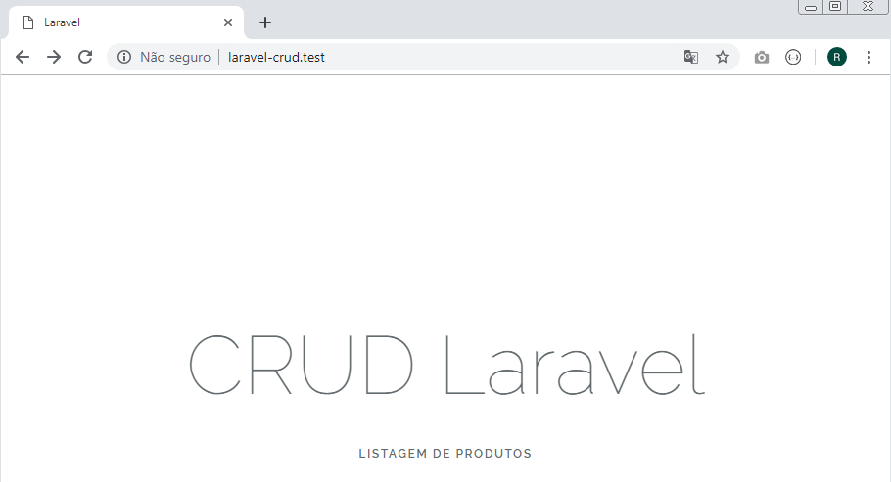

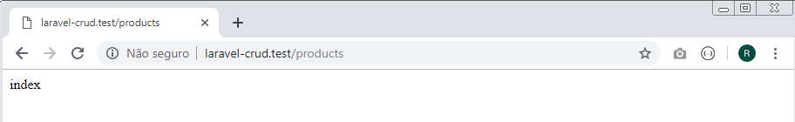

Aula 5 - Gerência de templates - Blade em Laravel

resources/views/layout.blade.php

<!DOCTYPE html>
<html lang="pt-br">
<head>
<meta charset="UTF-8">
<title>App | Rimorsoft Online</title>
<link rel="stylesheet" href="https://stackpath.bootstrapcdn.com/bootstrap/4.3.1/css/bootstrap.min.css">
</head>
<body>
<div class="container">

<div class="row">

<div class="col-sm-12">
<h1 class="page-header text-center">CRUD Laravel 5.4</h1>
</div>

@yield('content')

</div>

</div>

<script src="https://code.jquery.com/jquery-3.3.1.slim.min.js"></script>
<script src="https://cdnjs.cloudflare.com/ajax/libs/popper.js/1.14.7/umd/popper.min.js"></script>
<script src="https://stackpath.bootstrapcdn.com/bootstrap/4.3.1/js/bootstrap.min.js"></script>
</body>
</html>

resources/views/products/index.blade.php

@extends('layout')

@section('content')
<div class="col-sm-8">
Listagem de produtos
</div>
<div class="col-sm-4">
Mensagem
</div>
@endsection

Http/Controllers/ProductController.php

<?php

namespace App\Http\Controllers;

use Illuminate\Http\Request;

class ProductController extends Controller
{
public function index(){
return view('products.index');
}
}

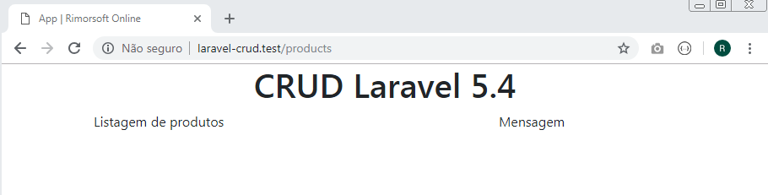

Aula 6 - Listar e paginar elementos em Laravel

Http/Controllers/ProductController.php

<?php

namespace App\Http\Controllers;

use Illuminate\Http\Request;
use App\Product;

class ProductController extends Controller
{
public function index(){
$products = Product::orderBy('id','DESC')->paginate();
return view('products.index',compact('products'));
}
}

resources/views/products/index.blade.php

@extends('layout')

@section('content')
<div class="col-sm-8">
<h2>Listagem de produtos
<a href="{{ route('products.create') }}" class="btn btn-primary float-right">Novo</a>
</h2>
<table class="table table-hover table-striped">
<thead>
<tr>
<th width="20px">ID</th>
<th>Nome do produto</th>
<th colspan="3">&nbsp;</th>
</tr>
</thead>
<tbody>
@foreach($products as $product)
<tr>
<td>{{ $product->id }}</td>
<td>
<strong>{{ $product->name }}</strong>
{{ $product->short }}
</td>
<td>Exibir</td>
<td>Editar</td>
<td>Eliminar</td>
</tr>
@endforeach
</tbody>
</table>
{!! $products->render() !!}
</div>
<div class="col-sm-4">
Mensagem
</div>
@endsection

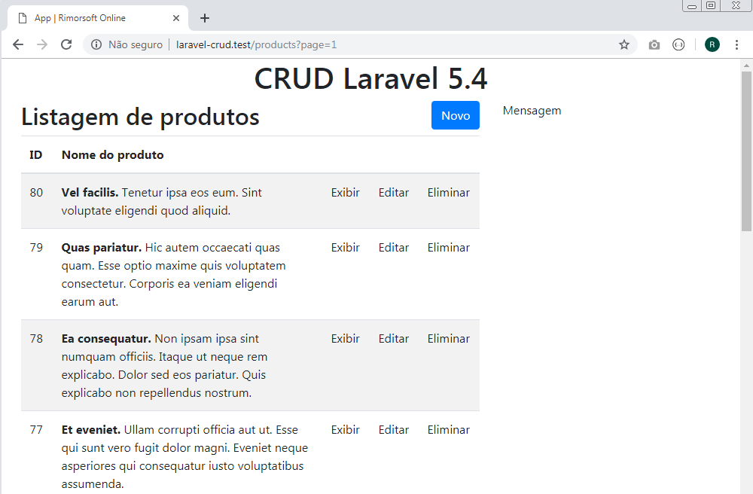

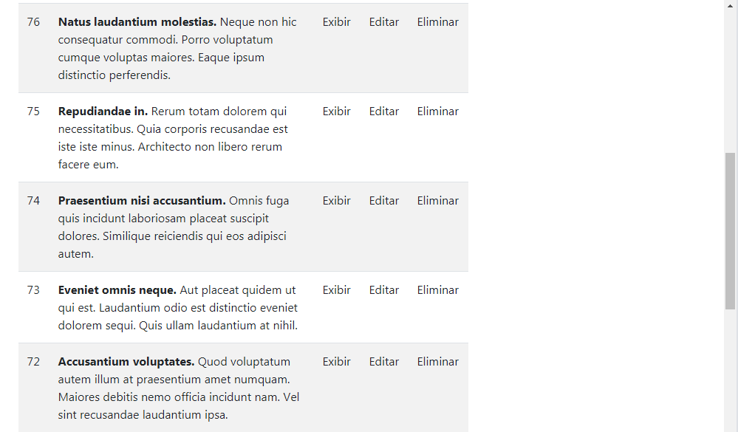

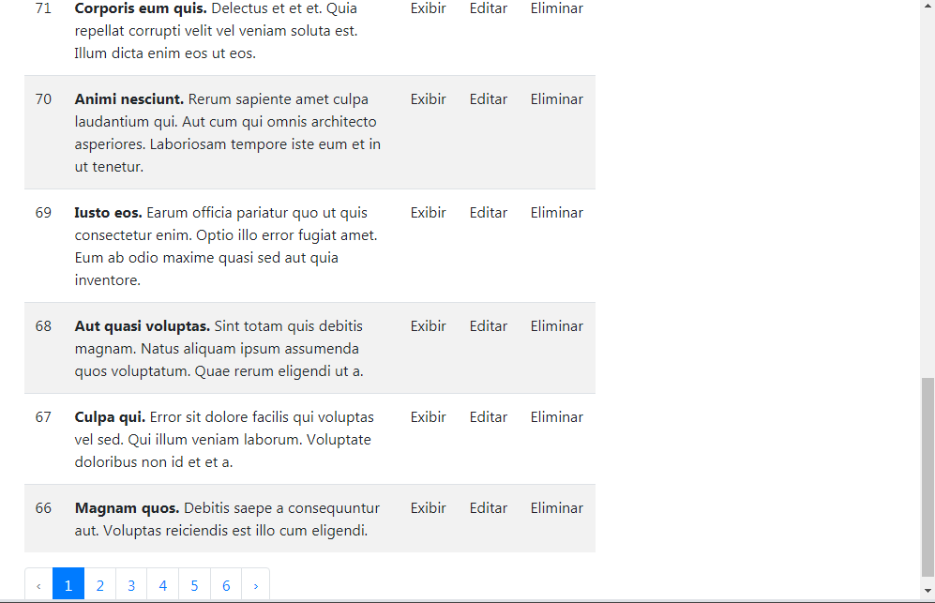

Aula 7 - Letra R de CRUD

resources/views/products/index.blade.php

@extends('layout')

@section('content')
<div class="col-sm-8">
<h2>Listagem de produtos
<a href="{{ route('products.create') }}" class="btn btn-primary float-right">Novo</a>
</h2>
<table class="table table-hover table-striped">
<thead>
<tr>
<th width="20px">ID</th>
<th>Nome do produto</th>
<th colspan="3">&nbsp;</th>
</tr>
</thead>
<tbody>
@foreach($products as $product)
<tr>
<td>{{ $product->id }}</td>
<td>
<strong>{{ $product->name }}</strong>
{{ $product->short }}
</td>
<td>
<a href="{{ route('products.show', $product->id) }}">Exibir</a>
</td>
<td>
<a href="{{ route('products.edit', $product->id) }}">Editar</a>
</td>
<td>Eliminar</td>
</tr>
@endforeach
</tbody>
</table>
{!! $products->render() !!}
</div>
<div class="col-sm-4">
Mensagem
</div>
@endsection

Http/Controllers/ProductController.php

<?php

namespace App\Http\Controllers;

use Illuminate\Http\Request;
use App\Product;

class ProductController extends Controller
{
public function index(){
$products = Product::orderBy('id','DESC')->paginate();
return view('products.index',compact('products'));
}

public function show($id){
$product = Product::find($id);
return view('products.show',compact('product'));
}
}

resources/views/products/show.blade.php

@extends('layout')

@section('content')
<div class="col-sm-8">
<h2>
{{ $product->name }}
<a href="{{ route('products.edit', $product->id) }}" class="btn btn-primary float-right">Editar</a>
</h2>
<p>{{ $product->short }}</p>
{!! $product->body !!}
</div>
<div class="col-sm-4">
Mensagem
</div>
@endsection

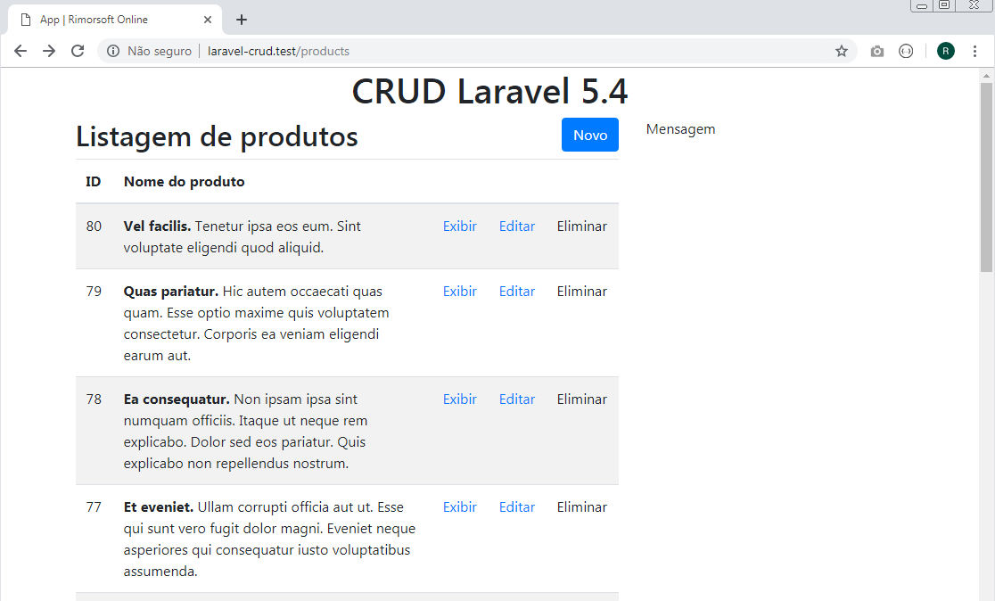

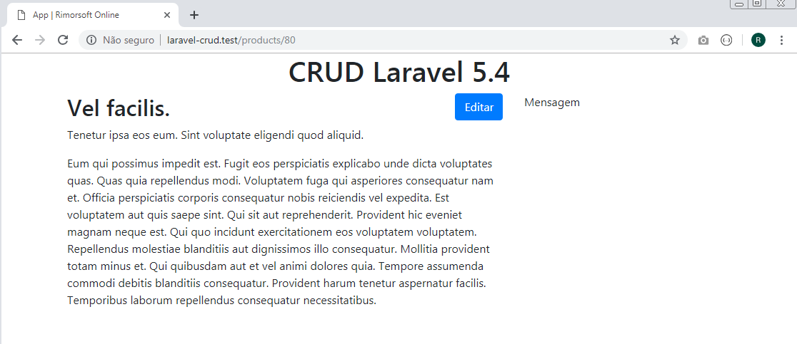

Aula 8 - Letra D de CRUD

resources/views/products/index.blade.php

@extends('layout')

@section('content')
<div class="col-sm-8">
<h2>Listagem de produtos
<a href="{{ route('products.create') }}" class="btn btn-primary float-right">Novo</a>
</h2>
<table class="table table-hover table-striped">
<thead>
<tr>
<th width="20px">ID</th>
<th>Nome do produto</th>
<th colspan="3">&nbsp;</th>
</tr>
</thead>
<tbody>
@foreach($products as $product)
<tr>
<td>{{ $product->id }}</td>
<td>
<strong>{{ $product->name }}</strong>
{{ $product->short }}
</td>
<td>
<a href="{{ route('products.show', $product->id) }}" class="btn btn-link">Exibir</a>
</td>
<td>
<a href="{{ route('products.edit', $product->id) }}" class="btn btn-link">Editar</a>
</td>
<td>
<form action="{{ route('products.destroy', $product->id) }}" method="POST">
{{ csrf_field() }}
<input type="hidden" name="_method" value="DELETE">
<button class="btn btn-link">Eliminar</button>
</form>
</td>
</tr>
@endforeach
</tbody>
</table>
{!! $products->render() !!}
</div>
<div class="col-sm-4">
Mensagem
</div>
@endsection

Http/Controllers/ProductController.php

<?php

namespace App\Http\Controllers;

use Illuminate\Http\Request;
use App\Product;

class ProductController extends Controller
{
public function index(){
$products = Product::orderBy('id','DESC')->paginate();
return view('products.index',compact('products'));
}

public function show($id){
$product = Product::find($id);
return view('products.show',compact('product'));
}

public function destroy($id){
$product = Product::find($id);
$product->delete();

return back()->with('info','O produto foi eliminado!');
}

}

Eliminando o produto de id 79:

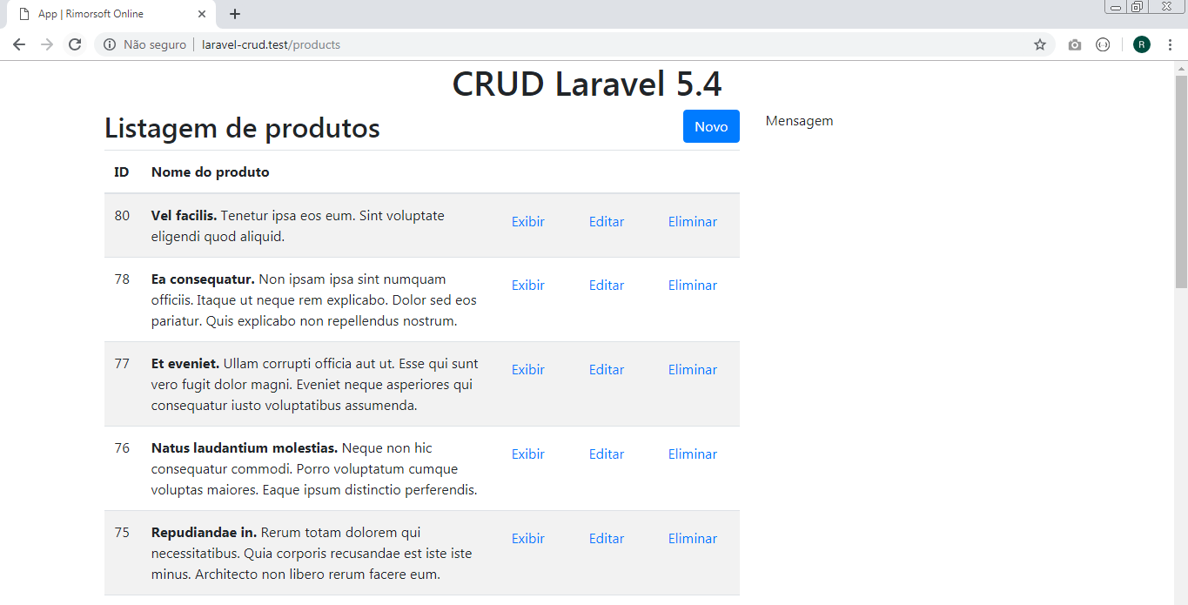

Eliminando o produto de id 78:

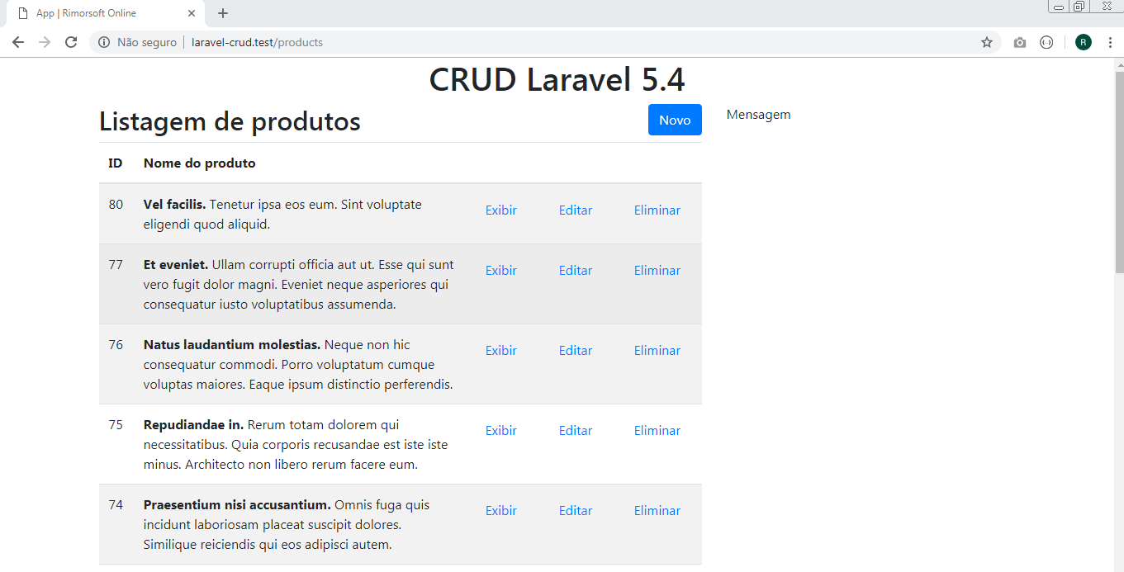

Aula 9 - Templates e Parciais

resources/views/products/fragment/info.blade.php

@if(Session::has('info'))
<div class="alert alert-info">
<button type="button" class="close" data-dismiss="alert">
&times;
</button>
{{ Session::get('info') }}
</div>
@endif

resources/views/products/fragment/aside.blade.php

<p class="alert alert-info">
Aqui podemos criar, eliminar, listar e editar os produtos...
</p>

resources/views/products/show.blade.php

@extends('layout')

@section('content')
<div class="col-sm-8">
<h2>
{{ $product->name }}
<a href="{{ route('products.edit', $product->id) }}" class="btn btn-primary float-right">Editar</a>
</h2>
<p>{{ $product->short }}</p>
{!! $product->body !!}
</div>
<div class="col-sm-4">
@include('products.fragment.aside')
</div>
@endsection

resources/views/products/index.blade.php

@extends('layout')
@section('content')
<div class="col-sm-8">
<h2>Listagem de produtos
<a href="{{ route('products.create') }}" class="btn btn-primary float-right">Novo</a>
</h2>
@include('products.fragment.info')
<table class="table table-hover table-striped">
<thead>
<tr>
<th width="20px">ID</th>
<th>Nome do produto</th>
<th colspan="3">&nbsp;</th>
</tr>
</thead>
<tbody>
@foreach($products as $product)
<tr>
<td>{{ $product->id }}</td>
<td>
<strong>{{ $product->name }}</strong>
{{ $product->short }}
</td>
<td>
<a href="{{ route('products.show', $product->id) }}" class="btn btn-link">Exibir</a>
</td>
<td>
<a href="{{ route('products.edit', $product->id) }}" class="btn btn-link">Editar</a>
</td>
<td>
<form action="{{ route('products.destroy', $product->id) }}" method="POST">
{{ csrf_field() }}
<input type="hidden" name="_method" value="DELETE">
<button class="btn btn-link">Eliminar</button>
</form>
</td>
</tr>
@endforeach
</tbody>
</table>
{!! $products->render() !!}
</div>
<div class="col-sm-4">
@include('products.fragment.aside')
</div>
@endsection

Eliminando o produto de id 80:

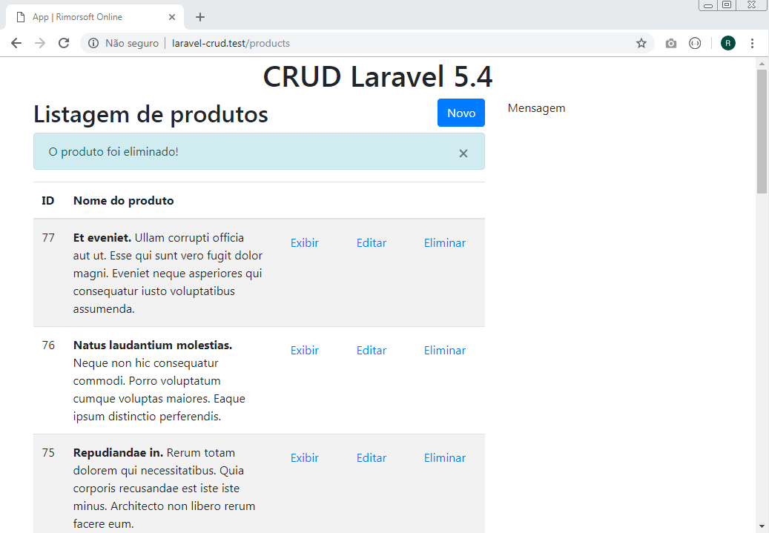

Eliminando o produto de id 77:

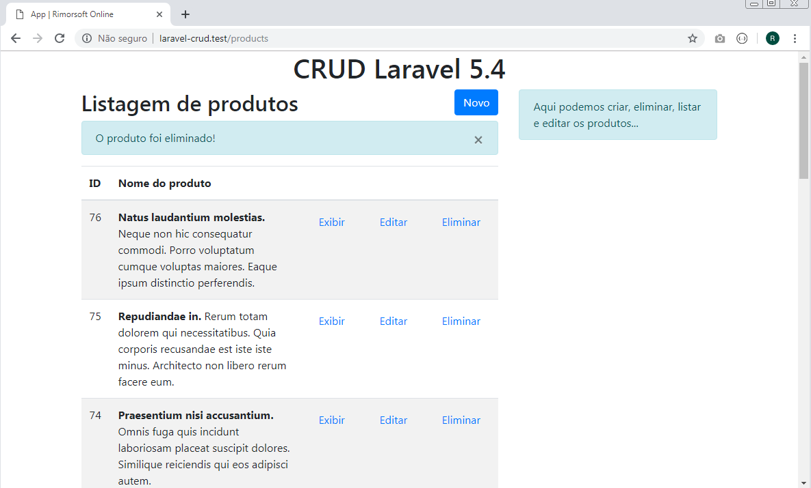

Aula 10 - Vistas, Edit e Create em Laravel

Instalação do Laravel Collective

https://blog.especializati.com.br/como-utilizar-o-pacote-laravel-collective-form/

Vamos utilizar a versão 5.5 do laravel que não precisa registrar providers e aliases, este processo é feito automaticamente pelo novo recurso desta versão chamado Auto-Discovery

Rode este comando:

composer require "laravelcollective/html":"^5.5.0"

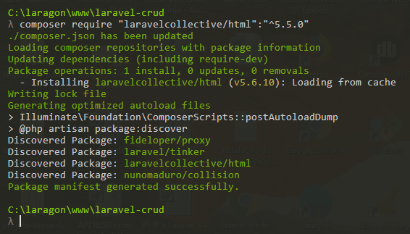

Aguarde o composer terminar o download do pacote ele vai registrar a dependência no arquivo composer.json em require:
“laravelcollective/html”: “^5.5.0”

composer.json

{
"name": "laravel/laravel",
"description": "The Laravel Framework.",
"keywords": ["framework", "laravel"],
"license": "MIT",
"type": "project",
"require": {
"php": "^7.1.3",
"fideloper/proxy": "^4.0",
"laravel/framework": "5.6.*",
"laravel/tinker": "^1.0",
"laravelcollective/html": "^5.5.0"
},
.
.
.
}

config/app.php

'providers' => [
// ...
Collective\Html\HtmlServiceProvider::class,
// ...
],

'aliases' => [
// ...
'Form' => Collective\Html\FormFacade::class,
'Html' => Collective\Html\HtmlFacade::class,
// ...
],

resources/views/products/edit.blade.php

@extends('layout')

@section('content')
<div class="col-sm-8">
<h2>
Editar produto
<a href="{{ route('products.index') }}" class="btn btn-primary float-right">Listagem</a>
</h2>
{!! Form::model($product, ['route' => ['products.update', $product->id], 'method' => 'PUT']) !!}
@include('products.fragment.form')
{!! Form::close() !!}
</div>
<div class="col-sm-4">
@include('products.fragment.aside')
</div>
@endsection

resources/views/products/create.blade.php

@extends('layout')

@section('content')
<div class="col-sm-8">
<h2>
Novo produto
<a href="{{ route('products.create') }}" class="btn btn-primary float-right">Listagem</a>
</h2>

{!! Form::open( ['route' => 'products.store']) !!}
@include('products.fragment.form')
{!! Form::close() !!}

</div>
<div class="col-sm-4">
@include('products.fragment.aside')
</div>
@endsection

resources/views/products/fragment/form.blade.php

<div class="form-group">
{!! Form::label('name', 'Nome do produto') !!}
{!! Form::text('name', null, ['class'=>'form-control'] ) !!}
</div>

<div class="form-group">
{!! Form::label('short', 'Descrição breve do produto') !!}
{!! Form::text('short', null, ['class'=>'form-control'] ) !!}
</div>

<div class="form-group">
{!! Form::label('body', 'Descrição do produto') !!}
{!! Form::textarea('body', null, ['class'=>'form-control'] ) !!}
</div>

<div class="form-group">
{!! Form::submit('ENVIAR', null, ['class'=>'btn btn-primary'] ) !!}
</div>

Http/Controllers/ProductController.php

<?php

namespace App\Http\Controllers;

use Illuminate\Http\Request;
use App\Product;

class ProductController extends Controller
{
public function index(){
$products = Product::orderBy('id','DESC')->paginate();
return view('products.index',compact('products'));
}

public function create(){
return view('products.create');
}

public function edit($id){
$product = Product::find($id);
return view('products.edit', compact('product'));
}

public function show($id){
$product = Product::find($id);
return view('products.show', compact('product'));
}

public function destroy($id){
$product = Product::find($id);
$product->delete();

return back()->with('info','O produto foi eliminado!');
}
}

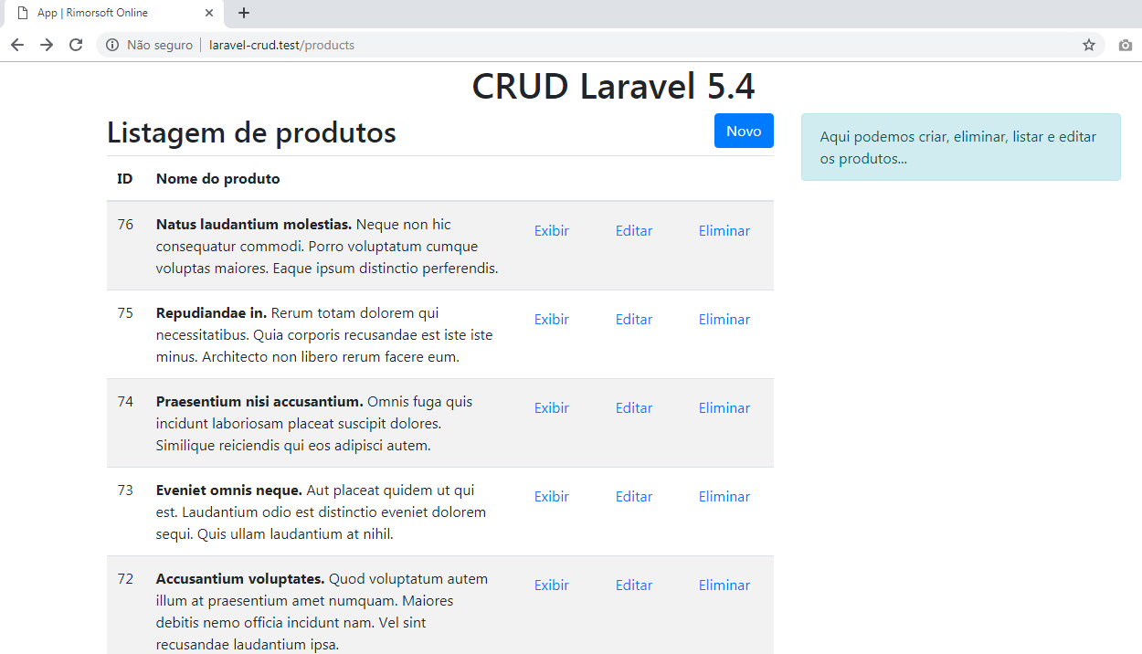

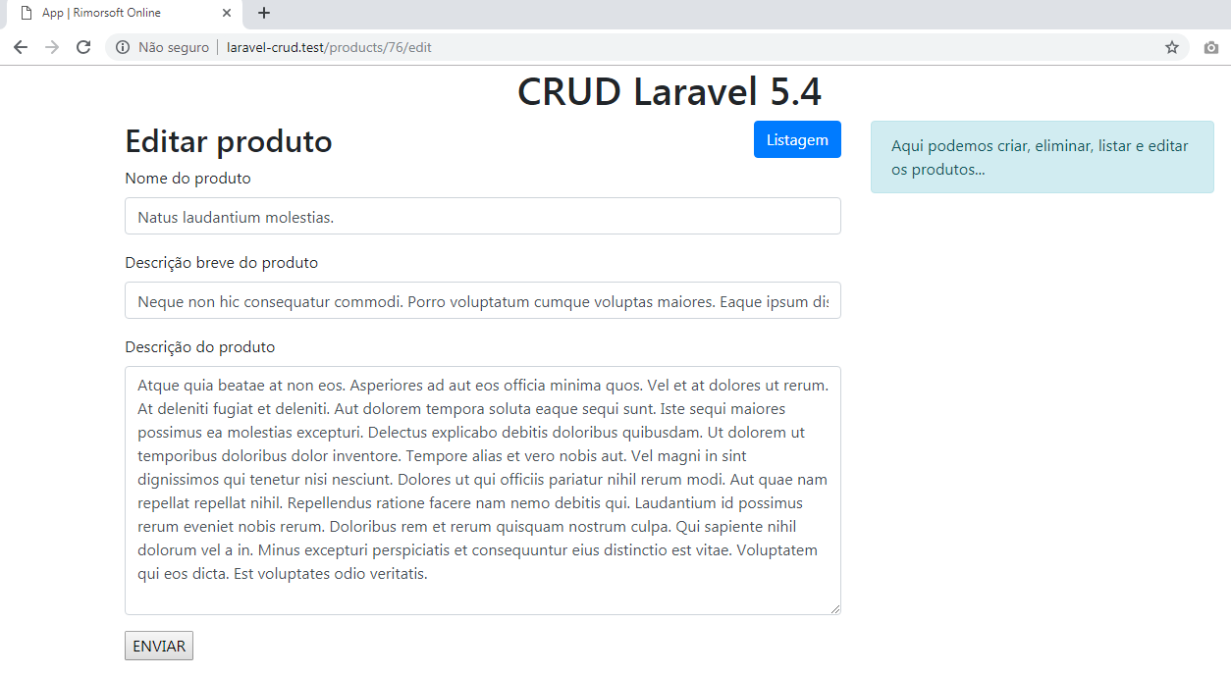

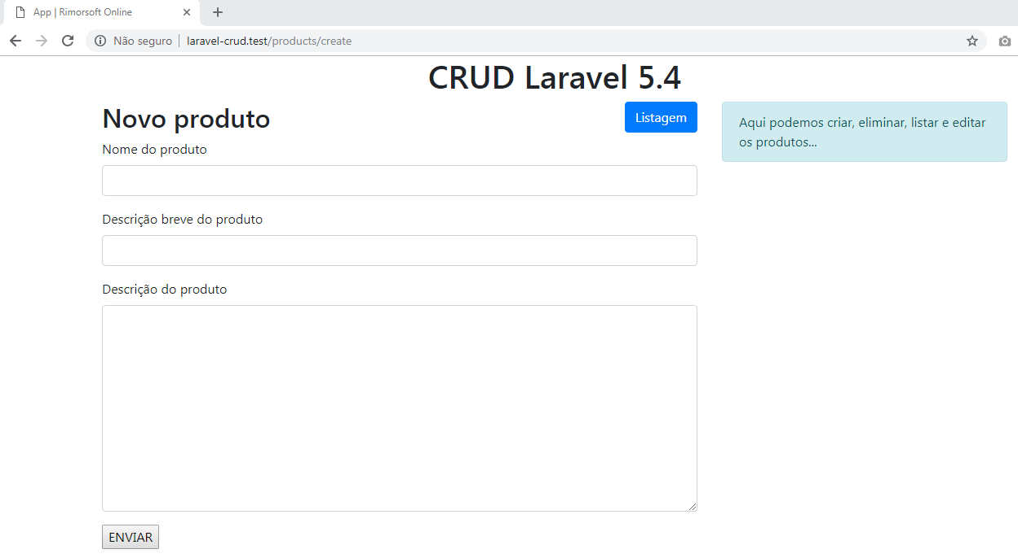

Aula 11 - Validação (Form Requests)

Criando um Request

php artisan make:request ProductRequest

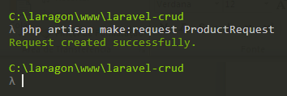

app/Http/Requests/ProductRequest.php

<?php

namespace App\Http\Requests;

use Illuminate\Foundation\Http\FormRequest;

class ProductRequest extends FormRequest
{
public function authorize()
{
return true;
}

public function rules()
{
return [
'name' => 'required',
'short' => 'required',
'body' => 'required'
];
}
}

Http/Controllers/ProductController.php

<?php

namespace App\Http\Controllers;

use Illuminate\Http\Request;
use App\Product;
use App\Http\Requests\ProductRequest;

class ProductController extends Controller
{
public function index(){
$products = Product::orderBy('id','DESC')->paginate();
return view('products.index',compact('products'));
}

public function create(){
return view('products.create');
}

public function store(ProductRequest $request){
return 'Produto gravado!';
}

public function edit($id){
$product = Product::find($id);
return view('products.edit', compact('product'));
}

public function update(ProductRequest $request, $id){
return 'Produto atualizado ' . $id;
}

public function show($id){
$product = Product::find($id);
return view('products.show', compact('product'));
}

public function destroy($id){
$product = Product::find($id);
$product->delete();

return back()->with('info','O produto foi eliminado!');
}
}
resources/views/products/fragment/error.blade.php

@if (count($errors))
<div class="alert alert-danger">
<button type="button" class="close" data-dismiss="alert">
&times;
</button>
<ul>
@foreach($errors->all() as $error)
<li>{{ $error }}</li>
@endforeach
</ul>
</div>
@endif

resources/views/products/create.blade.php

@extends('layout')

@section('content')
<div class="col-sm-8">
<h2>
Novo produto
<a href="{{ route('products.create') }}" class="btn btn-primary float-right">Listagem</a>
</h2>

@include('products.fragment.error')

{!! Form::open( ['route' => 'products.store']) !!}
@include('products.fragment.form')
{!! Form::close() !!}
</div>
<div class="col-sm-4">
@include('products.fragment.aside')
</div>
@endsection

resources/views/products/edit.blade.php

@extends('layout')

@section('content')
<div class="col-sm-8">
<h2>
Editar produto
<a href="{{ route('products.index') }}" class="btn btn-primary float-right">Listagem</a>
</h2>

@include('products.fragment.error')

{!! Form::model($product, ['route' => ['products.update', $product->id], 'method' => 'PUT']) !!}

@include('products.fragment.form')

{!! Form::close() !!}
</div>
<div class="col-sm-4">
@include('products.fragment.aside')
</div>
@endsection

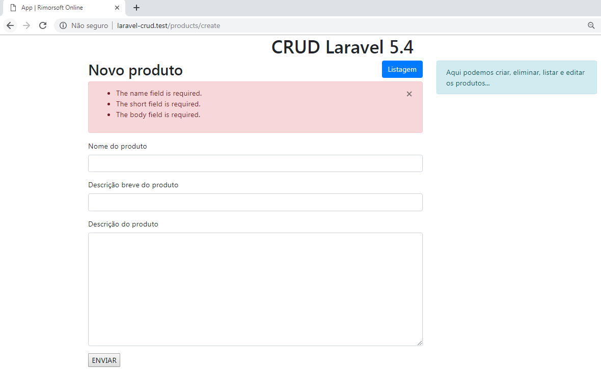

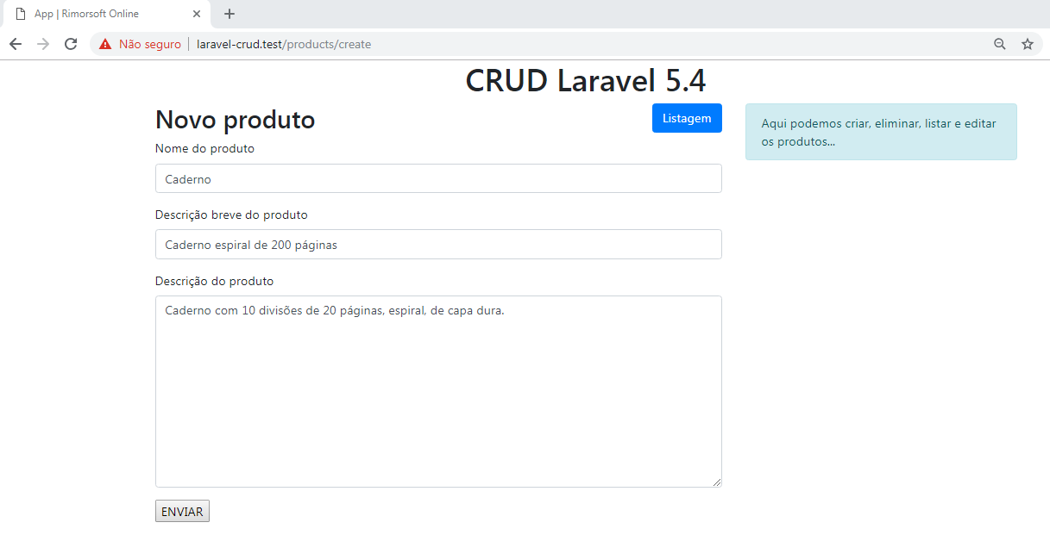

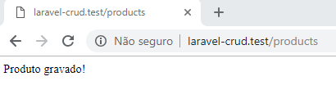

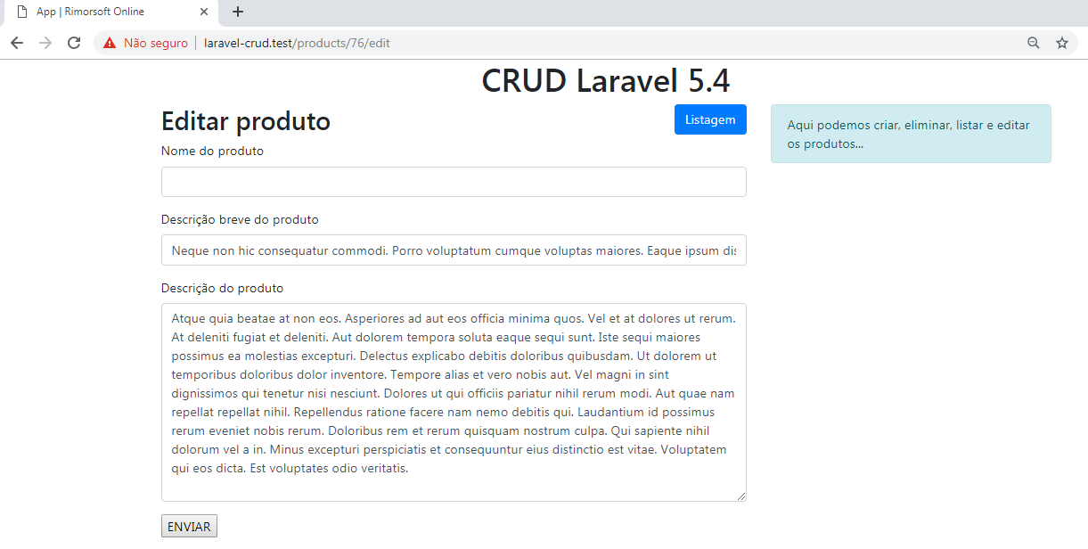

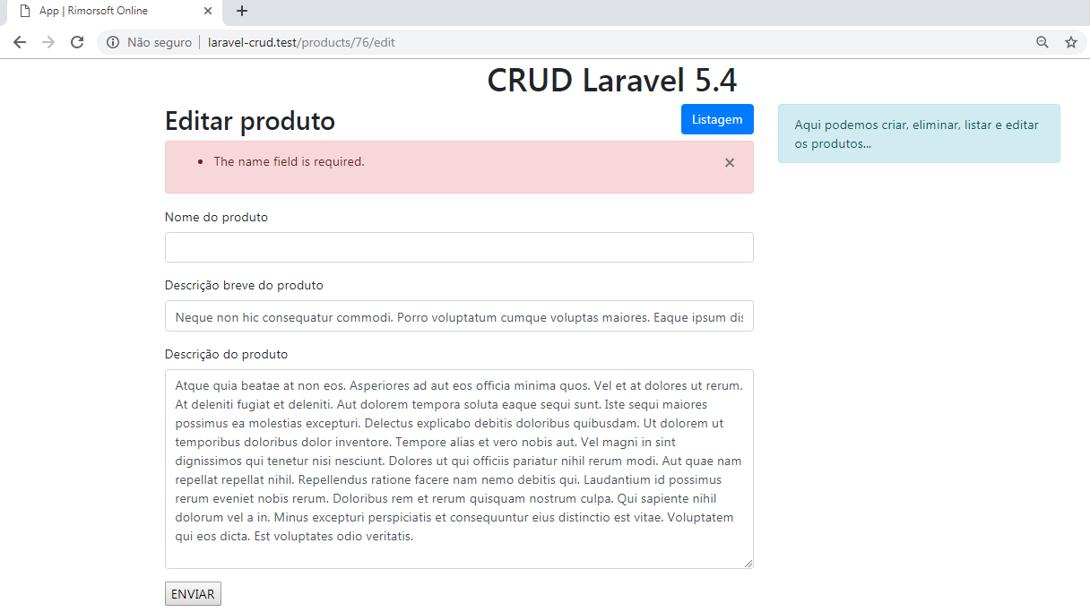

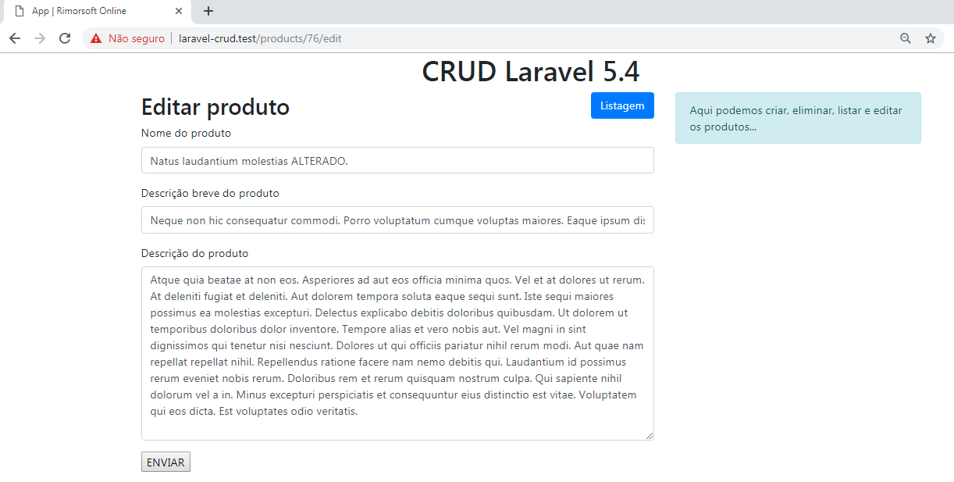

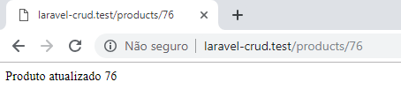

Aula 12 - Letra C e U de CRUD

Http/Controllers/ProductController.php

<?php

namespace App\Http\Controllers;

use Illuminate\Http\Request;
use App\Product;
use App\Http\Requests\ProductRequest;

class ProductController extends Controller
{
public function index(){
$products = Product::orderBy('id','DESC')->paginate();
return view('products.index',compact('products'));
}

public function create(){
return view('products.create');
}

public function store(ProductRequest $request){
$product = new Product;
$product -> name = $request -> name;
$product -> short = $request -> short;
$product -> body = $request -> body;
$product -> save();

return redirect() -> route('products.index')
-> with('info','O produto foi gravado!');
}

public function edit($id){
$product = Product::find($id);
return view('products.edit', compact('product'));
}

public function update(ProductRequest $request, $id){
$product = Product::find($id);
$product -> name = $request -> name;
$product -> short = $request -> short;
$product -> body = $request -> body;
$product -> save();

return redirect() -> route('products.index')
-> with('info','O produto foi atualizado!');
}

public function show($id){
$product = Product::find($id);
return view('products.show', compact('product'));
}

public function destroy($id){
$product = Product::find($id);
$product->delete();

return back()->with('info','O produto foi eliminado!');
}
}

Editando um produto

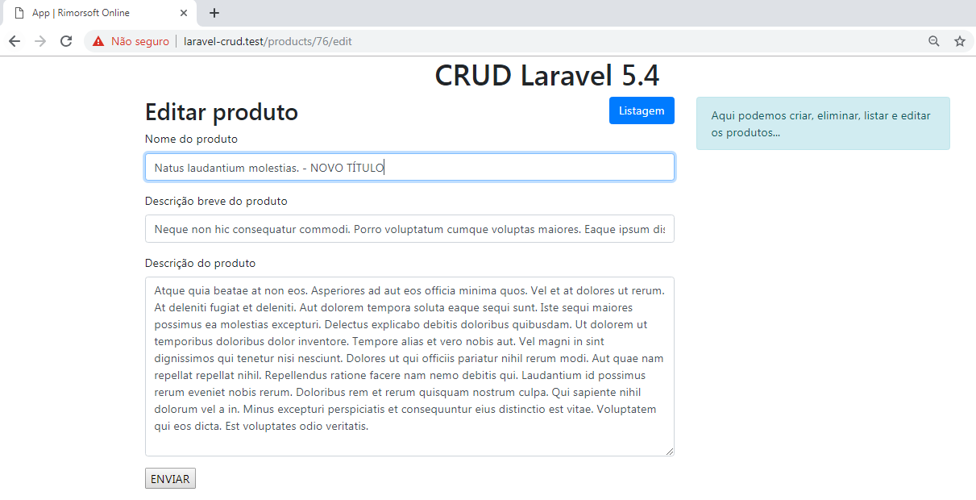

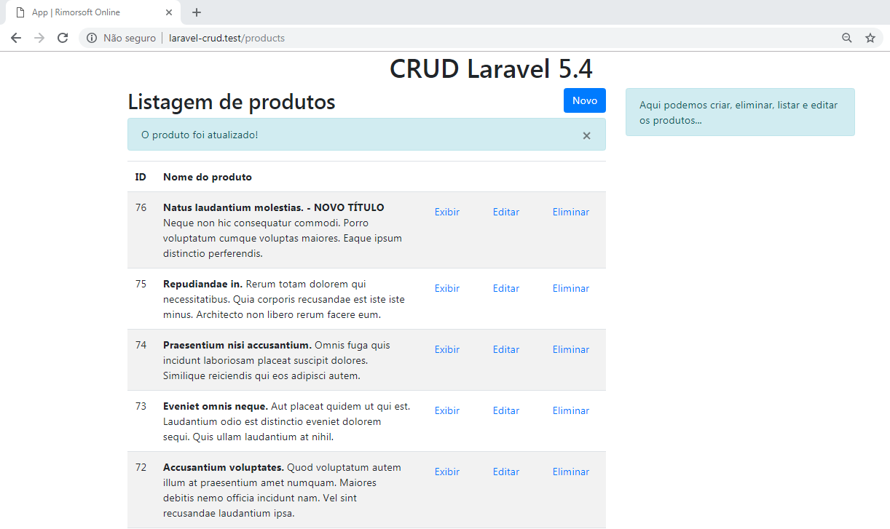

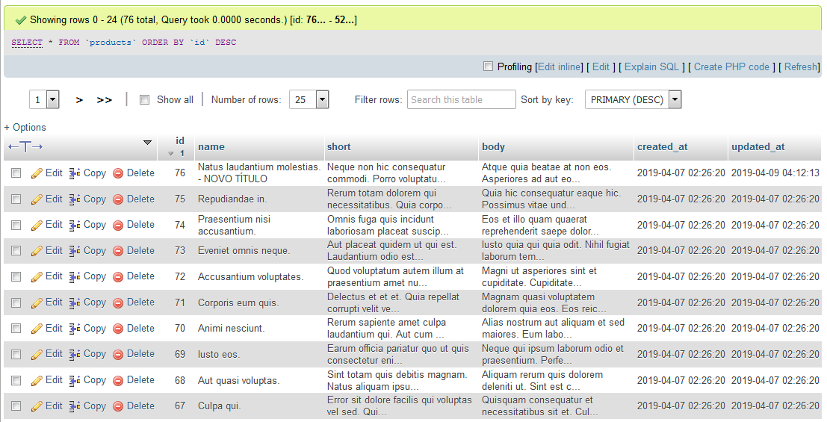

Cadastrando um produto

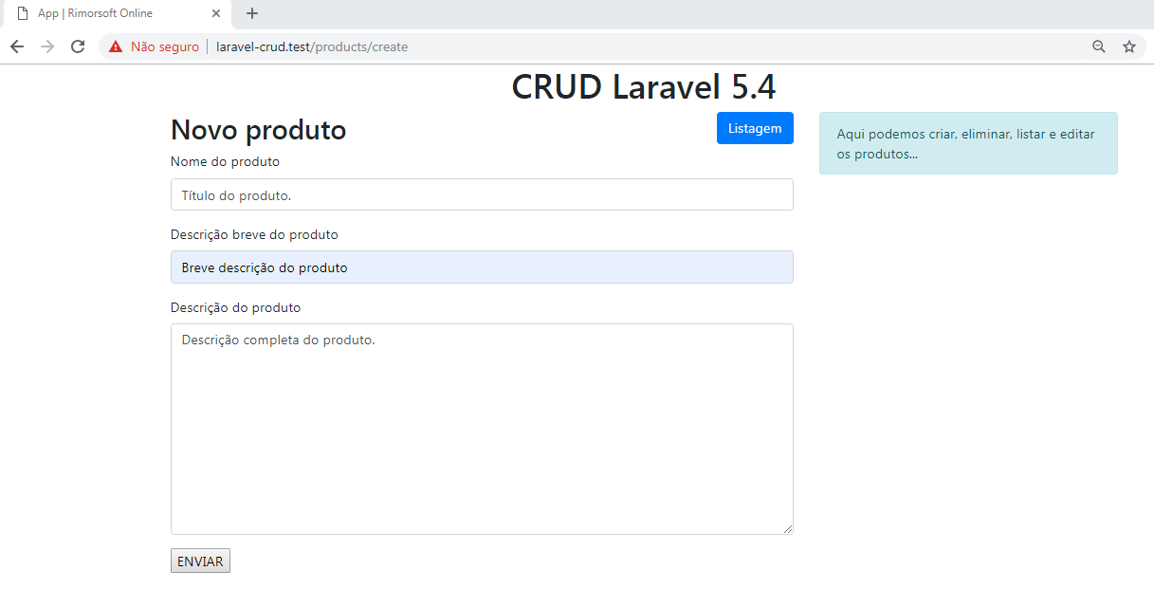

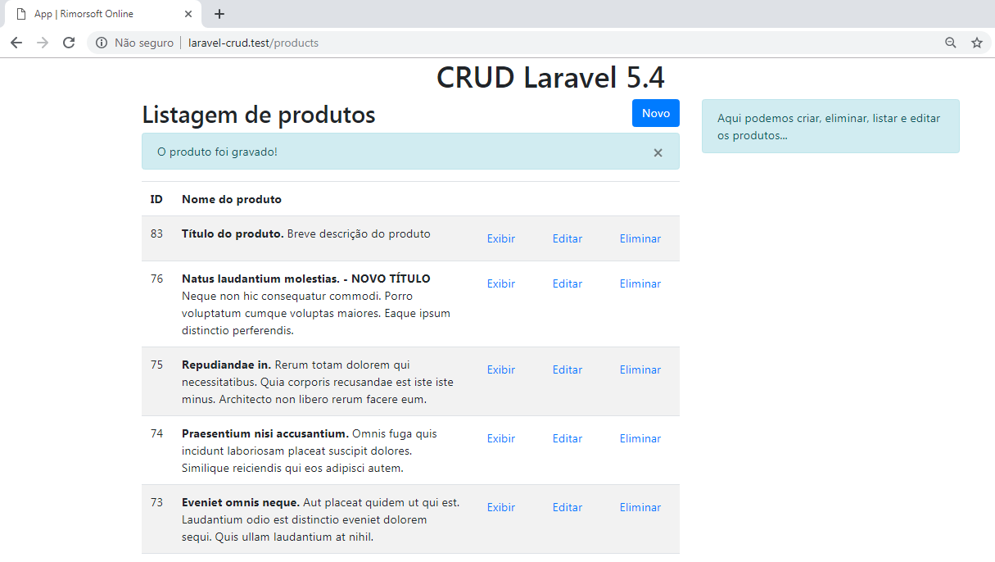

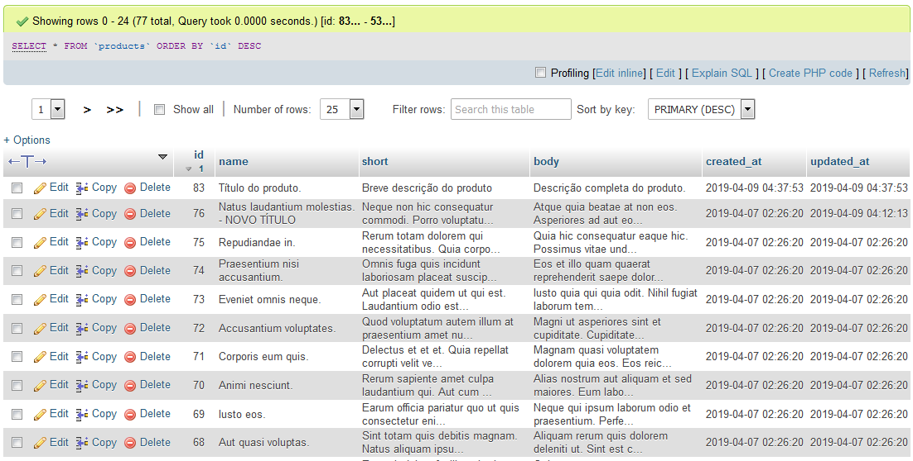

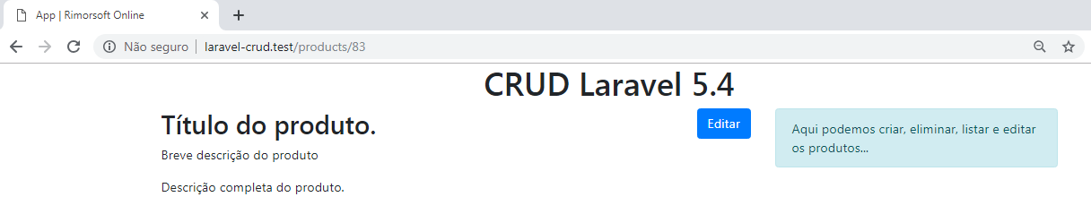

Aula 13 - Componente de tradução em Laravel

No arquivo config/app.php, alterar:

'locale' => 'en',

por:

'locale' => 'pt-BR',

Acesse a URL:
https://github.com/italomoralesf/Laravel-lang

insira a pasta pt-BR em resources/lang

No arquivo validation.php inserir:

'attributes' => [
'name' => 'Nome do produto',
'short' => 'Descrição breve do produto',
'body' => 'Descrição do produto'
],

