Curso de Ruby on Rails - aulas 21 a 30
Jackson Pires

https://www.youtube.com/watch?v=ZHPondVB9RQ&list=PLe3LRfCs4go-mkvHRMSXEOG-HDbzesyaP

Resumo do curso feito por Roberto Pinheiro

Aula 21 - Rails Composer

https://github.com/RailsApps/rails-composer

rails new myappcomposer -m https://raw.github.com/RailsApps/rails-composer/master/composer.rb

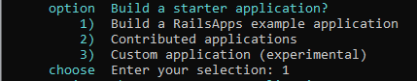

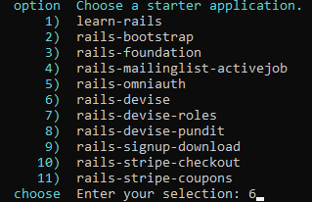

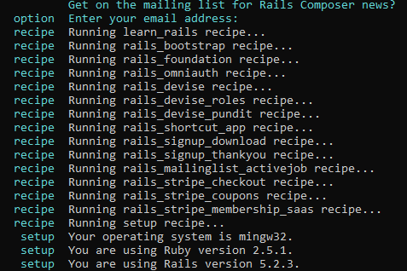

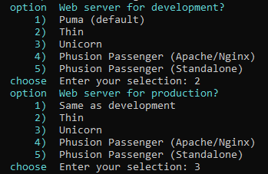

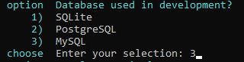

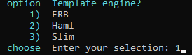

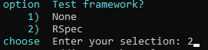

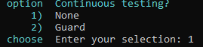

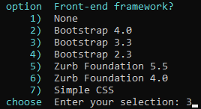

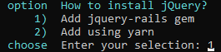

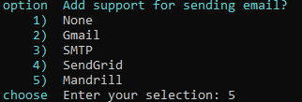

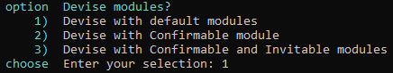

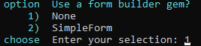

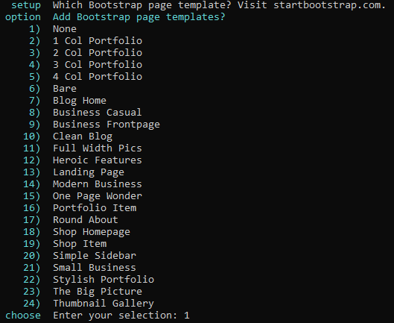

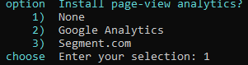

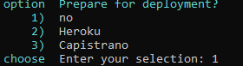

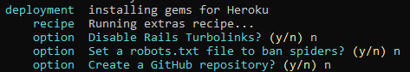

cd myappcomposer

rails s

No navegador:

localhost:3000

Aula 22 - Rake db:seed

rails g scaffold User name:string email:string

rake db:create db:migrate

Gemfile

source 'https://rubygems.org'
git_source(:github) { |repo| "https://github.com/#{repo}.git" }

ruby '2.5.1'

# Faker
gem 'faker'
# Bundle edge Rails instead: gem 'rails', github: 'rails/rails'
gem 'rails', '~> 5.2.3'
# Use mysql as the database for Active Record
gem 'mysql2', '>= 0.4.4', '< 0.6.0'
# Use Puma as the app server
gem 'puma', '~> 3.11'
# Use SCSS for stylesheets
gem 'sass-rails', '~> 5.0'
# Use Uglifier as compressor for JavaScript assets
gem 'uglifier', '>= 1.3.0'
# See https://github.com/rails/execjs#readme for more supported runtimes
gem 'duktape'
# Use CoffeeScript for .coffee assets and views
gem 'coffee-rails', '~> 4.2'
# Turbolinks makes navigating your web application faster. Read more: https://github.com/turbolinks/turbolinks
gem 'turbolinks', '~> 5'
# Build JSON APIs with ease. Read more: https://github.com/rails/jbuilder
gem 'jbuilder', '~> 2.5'
# Use Redis adapter to run Action Cable in production
# gem 'redis', '~> 4.0'
# Use ActiveModel has_secure_password
# gem 'bcrypt', '~> 3.1.7'

# Use ActiveStorage variant
# gem 'mini_magick', '~> 4.8'

# Use Capistrano for deployment
# gem 'capistrano-rails', group: :development

# Reduces boot times through caching; required in config/boot.rb
gem 'bootsnap', '>= 1.1.0', require: false

group :development, :test do
# Call 'byebug' anywhere in the code to stop execution and get a debugger console
gem 'byebug', platforms: [:mri, :mingw, :x64_mingw]
end

group :development do
# Access an interactive console on exception pages or by calling 'console' anywhere in the code.
gem 'web-console', '>= 3.3.0'
end

group :test do
# Adds support for Capybara system testing and selenium driver
gem 'capybara', '>= 2.15'
gem 'selenium-webdriver'
# Easy installation and use of chromedriver to run system tests with Chrome
gem 'chromedriver-helper'
end

# Windows does not include zoneinfo files, so bundle the tzinfo-data gem
gem 'tzinfo-data', platforms: [:mingw, :mswin, :x64_mingw, :jruby]

bundle install

config/application.rb

require_relative 'boot'

require 'rails/all'

# Require the gems listed in Gemfile, including any gems
# you've limited to :test, :development, or :production.
Bundler.require(*Rails.groups)

module RorCurso
class Application < Rails::Application
# Initialize configuration defaults for originally generated Rails version.
config.load_defaults 5.2

# Settings in config/environments/* take precedence over those specified here.
# Application configuration can go into files in config/initializers
# -- all .rb files in that directory are automatically loaded after loading
# the framework and any gems in your application.
config.i18n.default_locale = "pt-BR"
end
end

db/seeds.rb

10.times do |i|
user_name = Faker::Name.name
user_email = Faker::Internet.email
user = "#{user_name} - #{user_email}"
puts "Cadastrando #{user}"
User.create(name: user_name, email: user_email)
end

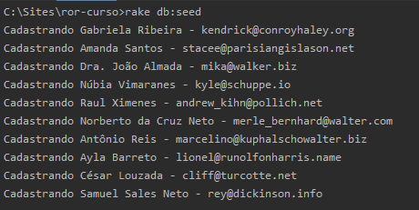

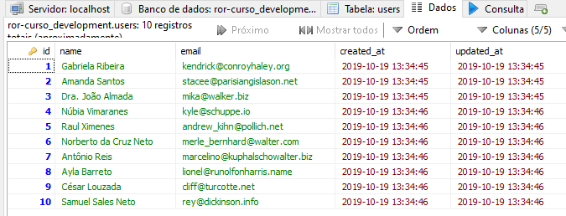

Rake Task

Anatomia

rake -T

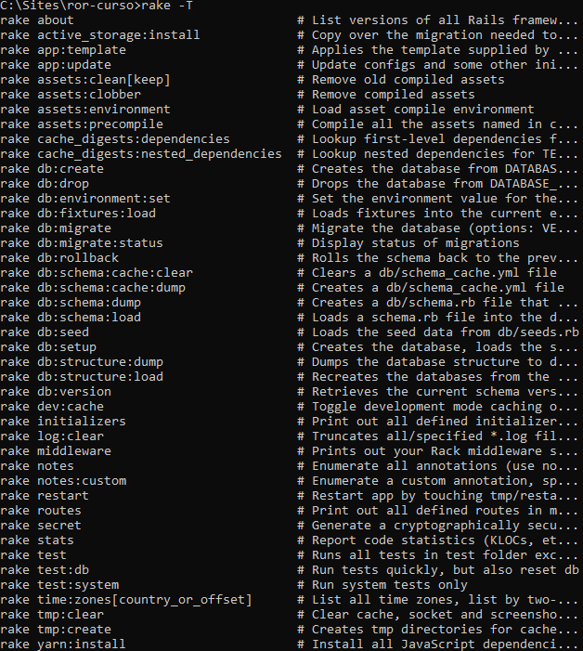

Filtrando as tarefas

rake -T db

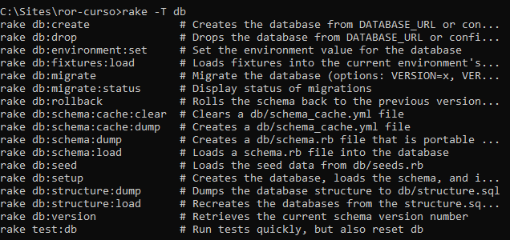

rake -t db:s

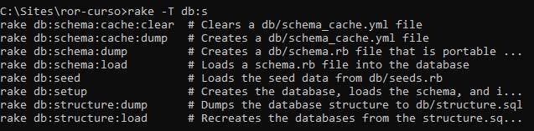

Aula 23 - Criando suas próprias Rake Tasks

rails generate task utils setup_user

lib/tasks/utils.rake

namespace :utils do
desc "Popular a tabela users"
task setup_user: :environment do
10.times do |i|
user_name = Faker::Name.name
user_email = Faker::Internet.email
user = "#{user_name} - #{user_email}"
puts "Cadastrando #{user}"
User.create(name: user_name, email: user_email)
end
end
end

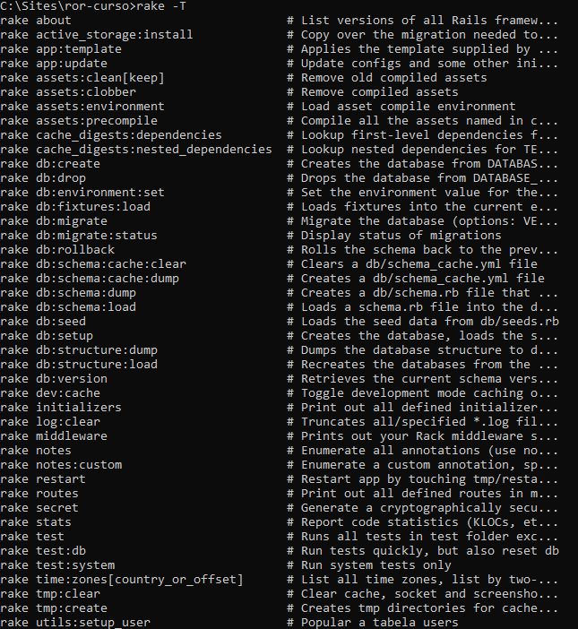

rake utils:setup_user

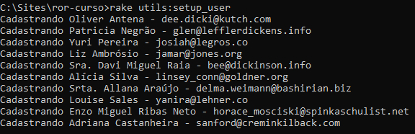

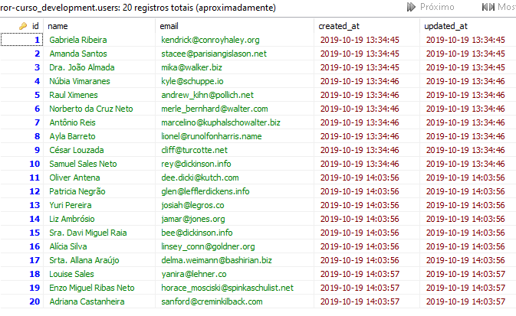
rake utils:setup_user

namespace :utils do
desc "Popular a tabela users com 10 nomes"
task setup_user: :environment do
10.times do |i|
user_name = Faker::Name.name
user_email = Faker::Internet.email
user = "#{user_name} - #{user_email}"
puts "Cadastrando #{user}"
User.create(name: user_name, email: user_email)
end
end

desc "Popular a tabela users com 50 nomes"
task setup_user_50: :environment do
50.times do |i|
user_name = Faker::Name.name
user_email = Faker::Internet.email
user = "#{user_name} - #{user_email}"
puts "Cadastrando #{user}"
User.create(name: user_name, email: user_email)
end
end

end

rake -T util

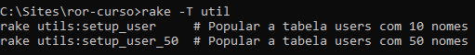

rake utils:setup_user_50

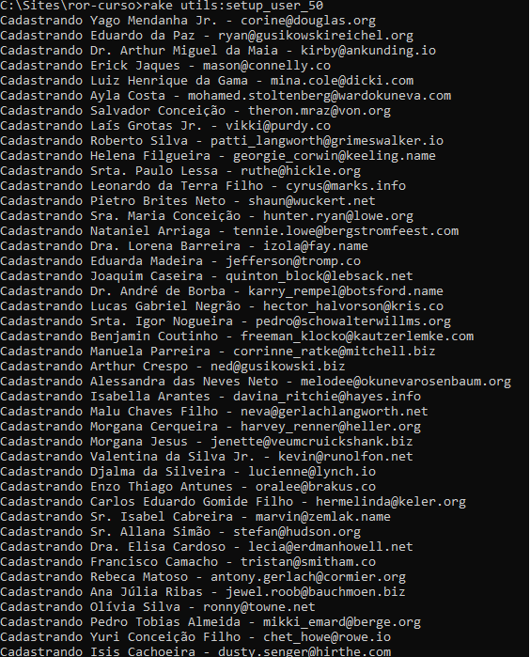
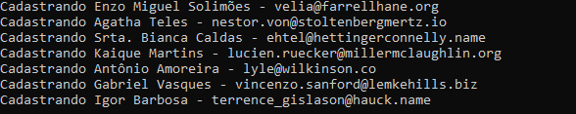

rake utils:setup_user

namespace :utils do
desc "Popular a tabela users a quantidade informada"
task setup_user: :environment do
if Rails.env.development?
if(ARGV.size == 2) && (ENV['qtd'] != "")
ENV['qtd'].to_i.times do |i|
user_name = Faker::Name.name
user_email = Faker::Internet.email
user = "#{user_name} - #{user_email}"
puts "Cadastrando #{user}"
User.create(name: user_name, email: user_email)
end
else
puts "Você precisa informar a quantidade desejada!"
puts "Exemplo: rake utils:setup_user qtd=10"
end
else
puts "Você não está em modo de desenvolvimento!"
end
end
end

rake utils:setup_user

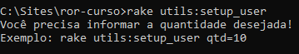

rake utils:setup_user 5

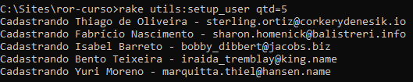

Aula 24 - Associações

belongs_to

Pertence a...

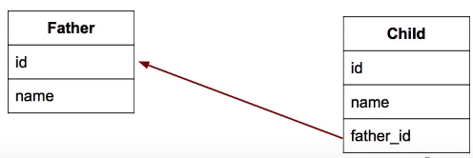

has many

Possui muitos...

rails g model Father name:string

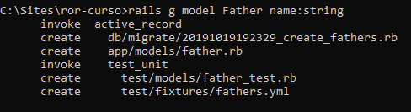

rails g model Child name:string father:references

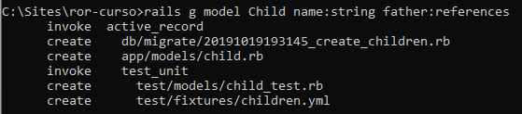

db/migrate/20191019192329_create_fathers.rb

class CreateFathers < ActiveRecord::Migration[5.2]
def change
create_table :fathers do |t|
t.string :name

t.timestamps
end
end
end

db/migrate/20191019193145_create_children.rb

class CreateChildren < ActiveRecord::Migration[5.2]
def change
create_table :children do |t|
t.string :name
t.references :father, foreign_key: true

t.timestamps
end
end
end

app/models/child.rb

class Child < ApplicationRecord
belongs_to :father
end

app/models/father.rb

class Father < ApplicationRecord
has_many :children
end

rake db:create db:migrate

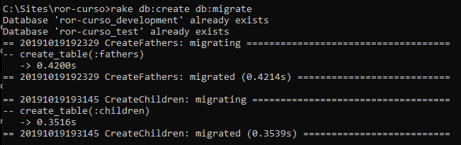

rails c

pai = Father.create(name: "Jackson")

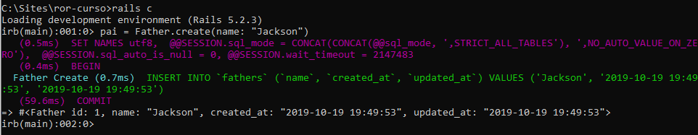

filho = Child.create(name: "Bruno")

Fazendo a associação

filho.father = pai

filho.save!

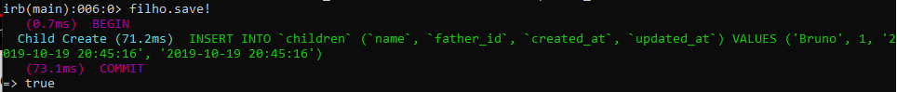
pai
filho

filho.father

pai.children

pai.children.create(name: "Joaquina")

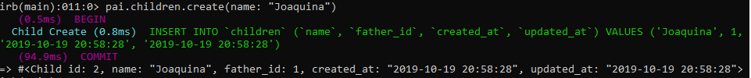

pai.children

j = Child.last

j.father

Aula 25 - Associações na View - Parte 1

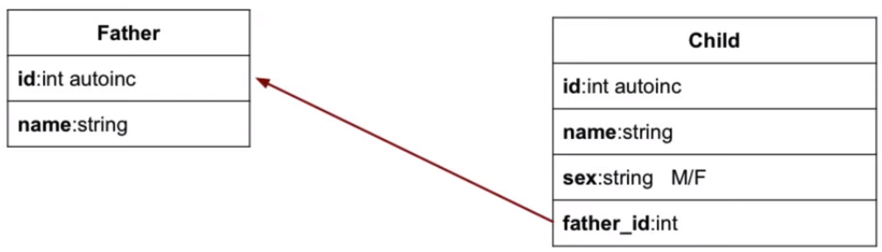

rake db:drop

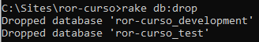

rake db:create

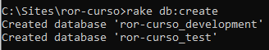

- Apague os arquivos criados na aula anterior: models (father.rb, child.rb), migrations, etc.

- Crie os seguintes scaffolds:

rails g scaffold Father name:string

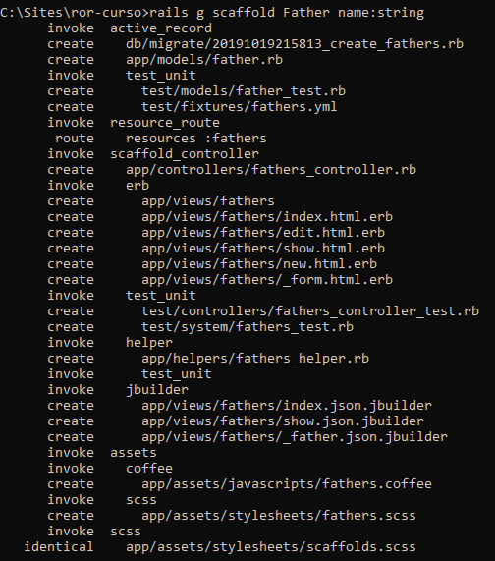

rails g scaffold Child name:string sex:string father:references

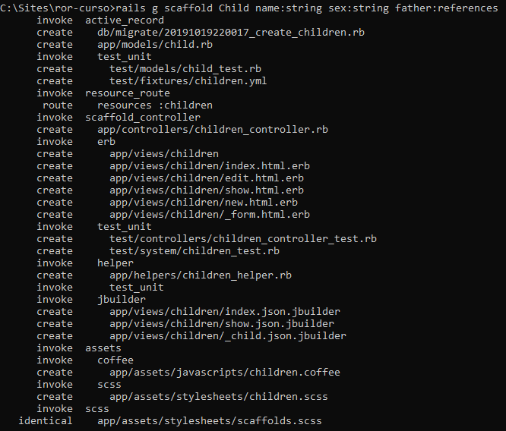

rake db:create db:migrate

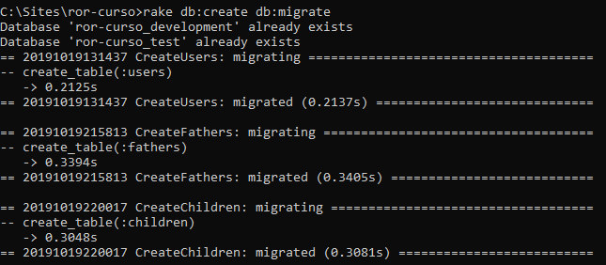

app/models/child.rb

class Child < ApplicationRecord
belongs_to :father
end

app/models/father.rb

class Father < ApplicationRecord
has_many :children
end

app/views/children/_form.html.erb

<%= form_with(model: child, local: true) do |form| %>
<% if child.errors.any? %>
<div id="error_explanation">
<h2><%= pluralize(child.errors.count, "error") %> prohibited this child from being saved:</h2>

<ul>
<% child.errors.full_messages.each do |message| %>
<li><%= message %></li>
<% end %>
</ul>
</div>
<% end %>

<div class="field">
<%= form.label :name %>
<%= form.text_field :name %>
</div>

<div class="field">
<%= form.label :sex %>
<%= form.select(:sex,
options_for_select([["Masculino", "M"], ["Feminino", "F"]], child.sex),
{ include_blank: "Selecione" })
%>
</div>

<div class="field">
<%= form.label :father_id %>
<%= form.collection_select(:father_id,
Father.all,
:id, :name,
{ include_blank: "Selecione" })
%>
</div>

<div class="actions">
<%= form.submit %>
</div>
<% end %>

app/views/children/show.html.erb

<p id="notice"><%= notice %></p>

<p>
<strong>Name:</strong>
<%= @child.name %>
</p>

<p>
<strong>Sex:</strong>
<%= @child.sex %>
</p>

<p>
<strong>Father:</strong>
<%= @child.father.name %>
</p>

<%= link_to 'Edit', edit_child_path(@child) %> |
<%= link_to 'Back', children_path %>

app/views/children/index.html.erb

<p id="notice"><%= notice %></p>

<h1>Children</h1>

<table>
<thead>
<tr>
<th>Name</th>
<th>Sex</th>
<th>Father</th>
<th colspan="3"></th>
</tr>
</thead>

<tbody>
<% @children.each do |child| %>
<tr>
<td><%= child.name %></td>
<td><%= child.sex %></td>
<td><%= child.father.name %></td>
<td><%= link_to 'Show', child %></td>
<td><%= link_to 'Edit', edit_child_path(child) %></td>
<td><%= link_to 'Destroy', child, method: :delete, data: { confirm: 'Are you sure?' } %></td>
</tr>
<% end %>
</tbody>
</table>

<br>

<%= link_to 'New Child', new_child_path %>

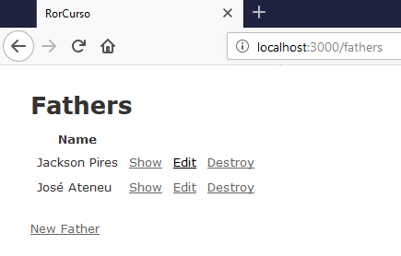

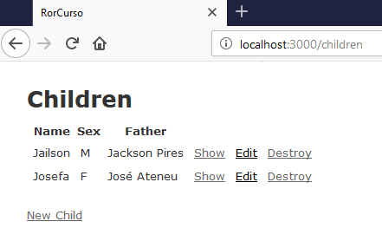

Aula 26 - Associações na View - Parte 2 e criando helpers

app/views/fathers/show.html.erb

<p id="notice"><%= notice %></p>

<p>
<strong>Name:</strong>
<%= @father.name %>
<hr>
<% @father.children.each do |child| %>
<ul>
<li>
<%= "#{child.name} - #{child.sex}" %>
</li>
</ul>
<% end %>
</p>

<%= link_to 'Edit', edit_father_path(@father) %> |
<%= link_to 'Back', fathers_path %>

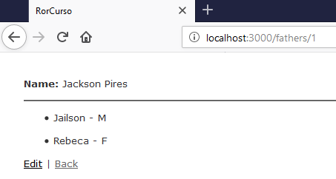

Helpers

app/views/fathers/show.html.erb

<p id="notice"><%= notice %></p>

<p>
<strong>Name:</strong>
<%= @father.name %>
<hr>
<% @father.children.each do |child| %>
<ul>
<li>
<%= "#{child.name} - #{pegar_sexo(child.sex)}" %>
</li>
</ul>
<% end %>
</p>

<%= link_to 'Edit', edit_father_path(@father) %> |
<%= link_to 'Back', fathers_path %>

app/helpers/application_helper.rb

module ApplicationHelper
def pegar_sexo(sex)
html = ""
if (sex == 'M')
html = "Masculino"
elsif (sex == 'F')
html = "Feminino"
end
html
end
end

app/controllers/children_controller.rb

class ChildrenController < ApplicationController
before_action :set_child, only: [:show, :edit, :update, :destroy]
before_action :set_father, only: [:new, :edit, :update]

# GET /children
# GET /children.json
def index
@children = Child.all
end

# GET /children/1
# GET /children/1.json
def show
end

# GET /children/new
def new
@child = Child.new
end

# GET /children/1/edit
def edit
end

# POST /children
# POST /children.json
def create
@child = Child.new(child_params)

respond_to do |format|
if @child.save
format.html { redirect_to @child, notice: 'Child was successfully created.' }
format.json { render :show, status: :created, location: @child }
else
format.html { render :new }
format.json { render json: @child.errors, status: :unprocessable_entity }
end
end
end

# PATCH/PUT /children/1
# PATCH/PUT /children/1.json
def update
respond_to do |format|
if @child.update(child_params)
format.html { redirect_to @child, notice: 'Child was successfully updated.' }
format.json { render :show, status: :ok, location: @child }
else
format.html { render :edit }
format.json { render json: @child.errors, status: :unprocessable_entity }
end
end
end

# DELETE /children/1
# DELETE /children/1.json
def destroy
@child.destroy
respond_to do |format|
format.html { redirect_to children_url, notice: 'Child was successfully destroyed.' }
format.json { head :no_content }
end
end

private
# Use callbacks to share common setup or constraints between actions.
def set_child
@child = Child.find(params[:id])
end

def set_father
@fathers = Father.all
end

# Never trust parameters from the scary internet, only allow the white list through.
def child_params
params.require(:child).permit(:name, :sex, :father_id)
end
end

app/views/children/_form.html.erb

<%= form_with(model: child, local: true) do |form| %>
<% if child.errors.any? %>
<div id="error_explanation">
<h2><%= pluralize(child.errors.count, "error") %> prohibited this child from being saved:</h2>

<ul>
<% child.errors.full_messages.each do |message| %>
<li><%= message %></li>
<% end %>
</ul>
</div>
<% end %>

<div class="field">
<%= form.label :name %>
<%= form.text_field :name %>
</div>

<div class="field">
<%= form.label :sex %>
<%= form.select(:sex,
options_for_select([["Masculino", "M"], ["Feminino", "F"]], child.sex),
{ include_blank: "Selecione" })
%>
</div>

<div class="field">
<%= form.label :father_id %>
<%= form.collection_select(:father_id,
@fathers,
:id, :name,
{ include_blank: "Selecione" })
%>
</div>

<div class="actions">
<%= form.submit %>
</div>
<% end %>

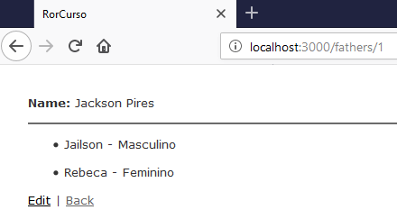

Aula 27 - Adicionando novos campos após o scaffold

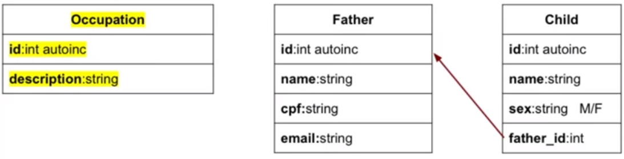

rails g scaffold Occupation description:string

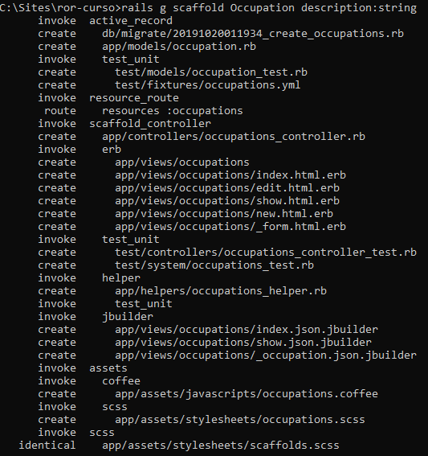

rake db:migrate

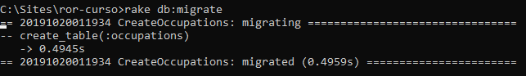

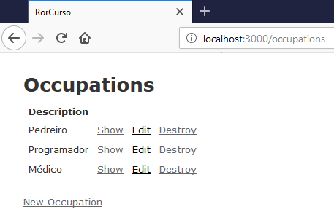

Associações na View

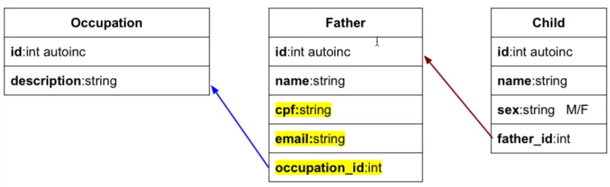

Adicionando campos na tabela fathers

rails g migration AddFieldsToFather cpf:string email:string occupation:references

C:\Sites\ror-curso\db\migrate\20191020043229_add_fields_to_father.rb

class AddFieldsToFather < ActiveRecord::Migration[5.2]
def change
add_column :fathers, :cpf, :string
add_column :fathers, :email, :string
add_reference :fathers, :occupation, foreign_key: true
end
end

rake db:migrate

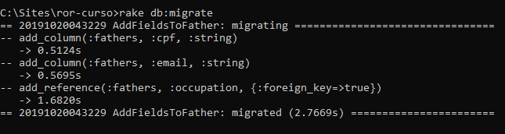

app/controllers/fathers_controller.rb

class FathersController < ApplicationController
before_action :set_father, only: [:show, :edit, :update, :destroy]
before_action :set_occupation, only: [:new, :create, :edit, :update]

# GET /fathers
# GET /fathers.json
def index
@fathers = Father.all
end

# GET /fathers/1
# GET /fathers/1.json
def show
end

# GET /fathers/new
def new
@father = Father.new
end

# GET /fathers/1/edit
def edit
end

# POST /fathers
# POST /fathers.json
def create
@father = Father.new(father_params)

respond_to do |format|
if @father.save
format.html { redirect_to @father, notice: 'Father was successfully created.' }
format.json { render :show, status: :created, location: @father }
else
format.html { render :new }
format.json { render json: @father.errors, status: :unprocessable_entity }
end
end
end

# PATCH/PUT /fathers/1
# PATCH/PUT /fathers/1.json
def update
respond_to do |format|
if @father.update(father_params)
format.html { redirect_to @father, notice: 'Father was successfully updated.' }
format.json { render :show, status: :ok, location: @father }
else
format.html { render :edit }
format.json { render json: @father.errors, status: :unprocessable_entity }
end
end
end

# DELETE /fathers/1
# DELETE /fathers/1.json
def destroy
@father.destroy
respond_to do |format|
format.html { redirect_to fathers_url, notice: 'Father was successfully destroyed.' }
format.json { head :no_content }
end
end

private
# Use callbacks to share common setup or constraints between actions.
def set_father
@father = Father.find(params[:id])
end

def set_occupation
@occupations = Occupation.all
end

# Never trust parameters from the scary internet, only allow the white list through.
def father_params
params.require(:father).permit(:name, :cpf, :email, :occupation_id)
end
end

app/models/father.rb

class Father < ApplicationRecord
has_many :children
belongs_to :occupation
end

app/views/fathers/index.html.erb

<p id="notice"><%= notice %></p>

<h1>Fathers</h1>

<table>
<thead>
<tr>
<th>Name</th>
<th>CPF</th>
<th>Email</th>
<th>Occupation</th>
<th colspan="3"></th>
</tr>
</thead>

<tbody>
<% @fathers.each do |father| %>
<tr>
<td><%= father.name %></td>
<td><%= father.cpf %></td>
<td><%= father.email %></td>
<td><%= father.occupation.description %></td>
<td><%= link_to 'Show', father %></td>
<td><%= link_to 'Edit', edit_father_path(father) %></td>
<td><%= link_to 'Destroy', father, method: :delete, data: { confirm: 'Are you sure?' } %></td>
</tr>
<% end %>
</tbody>
</table>

<br>

<%= link_to 'New Father', new_father_path %>

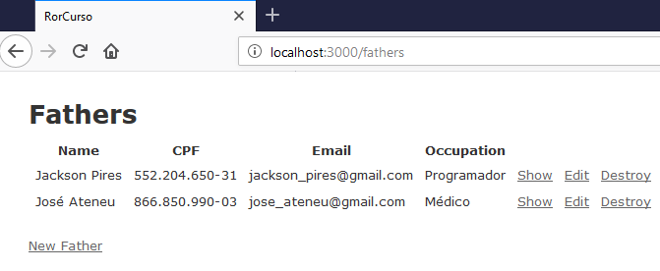

app/views/fathers/show.html.erb

<p id="notice"><%= notice %></p>

<p>
<strong>Name:</strong>
<%= @father.name %>
<strong>CPF:</strong>
<%= @father.cpf %>
<strong>Email:</strong>
<%= @father.email %>
<strong>Ocupação:</strong>
<%= @father.occupation.description %>
<hr>
</p>

<% @father.children.each do |child| %>
<ul>
<li>
<%= "#{child.name} - #{pegar_sexo(child.sex)}" %>
</li>
</ul>
<% end %>

<%= link_to 'Edit', edit_father_path(@father) %> |
<%= link_to 'Back', fathers_path %>

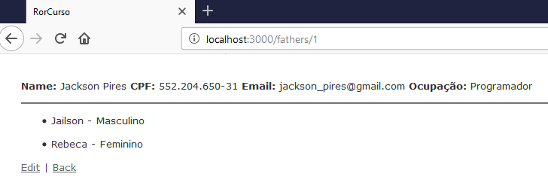

app/views/fathers/_form.html.erb

<%= form_with(model: father, local: true) do |form| %>
<% if father.errors.any? %>
<div id="error_explanation">
<h2><%= pluralize(father.errors.count, "error") %> prohibited this father from being saved:</h2>

<ul>
<% father.errors.full_messages.each do |message| %>
<li><%= message %></li>
<% end %>
</ul>
</div>
<% end %>

<div class="field">
<%= form.label :name %>
<%= form.text_field :name %>
</div>

<div class="field">
<%= form.label :cpf %>
<%= form.text_field :cpf %>
</div>

<div class="field">
<%= form.label :email %>
<%= form.text_field :email %>
</div>

<div class="field">
<%= form.label :occupation_id %>
<%= form.collection_select(:occupation_id,
@occupations,
:id, :description,
{ include_blank: "Selecione" })
%>
</div>

<div class="actions">
<%= form.submit %>
</div>
<% end %>

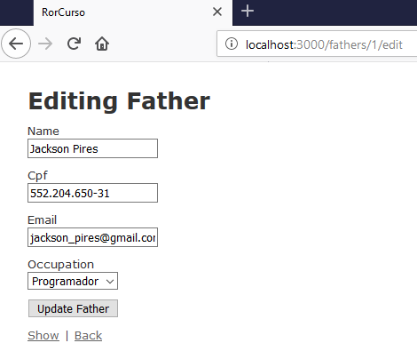

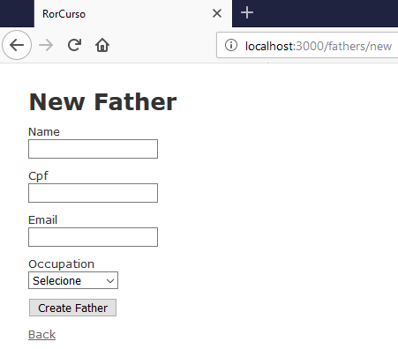

Aula 28 - Validações e criando métodos no model

Validações

app/models/father.rb

class Father < ApplicationRecord
has_many :children
belongs_to :occupation

validates :name, presence: true
validates :email, presence: true, uniqueness: true
end

Internacionalização

config/application.rb

require_relative 'boot'

require 'rails/all'

Bundler.require(*Rails.groups)

module RorCurso
class Application < Rails::Application
config.load_defaults 5.2

config.i18n.default_locale="pt-BR"
end
end

config/locales/pt-BR.yml

pt-BR:
activerecord:
models:
father: Pai
child: Filho
attributes:
father:
name: Nome
email: Email
cpf: CPF
occupation_id: Profissão
created_at: Criado em
update_at: Atualizado em
child:
name: Nome
sex: Sexo
father_id: Pai
created_at: Criado em
update_at: Atualizado em
errors:
messages:
record_invalid: 'A validação falhou: %{errors}'
restrict_dependent_destroy:
has_one: Não é possível excluir o registro pois existe um %{record} dependente
has_many: Não é possível excluir o registro pois existem %{record} dependentes
date:
abbr_day_names:
- dom
- seg
- ter
- qua
- qui
- sex
- sáb
abbr_month_names:
-
- jan
- fev
- mar
- abr
- mai
- jun
- jul
- ago
- set
- out
- nov
- dez
day_names:
- domingo
- segunda-feira
- terça-feira
- quarta-feira
- quinta-feira
- sexta-feira
- sábado
formats:
default: "%d/%m/%Y"
long: "%d de %B de %Y"
short: "%d de %B"
month_names:
-
- janeiro
- fevereiro
- março
- abril
- maio
- junho
- julho
- agosto
- setembro
- outubro
- novembro
- dezembro
order:
- :day
- :month
- :year
datetime:
distance_in_words:
about_x_hours:
one: aproximadamente 1 hora
other: aproximadamente %{count} horas
about_x_months:
one: aproximadamente 1 mês
other: aproximadamente %{count} meses
about_x_years:
one: aproximadamente 1 ano
other: aproximadamente %{count} anos
almost_x_years:
one: quase 1 ano
other: quase %{count} anos
half_a_minute: meio minuto
less_than_x_seconds:
one: menos de 1 segundo
other: menos de %{count} segundos
less_than_x_minutes:
one: menos de um minuto
other: menos de %{count} minutos
over_x_years:
one: mais de 1 ano
other: mais de %{count} anos
x_seconds:
one: 1 segundo
other: "%{count} segundos"
x_minutes:
one: 1 minuto
other: "%{count} minutos"
x_days:
one: 1 dia
other: "%{count} dias"
x_months:
one: 1 mês
other: "%{count} meses"
x_years:
one: 1 ano
other: "%{count} anos"
prompts:
second: Segundo
minute: Minuto
hour: Hora
day: Dia
month: Mês
year: Ano
errors:
format: "%{attribute} %{message}"
messages:
accepted: deve ser aceito
blank: não pode ficar em branco
confirmation: não é igual a %{attribute}
empty: não pode ficar vazio
equal_to: deve ser igual a %{count}
even: deve ser par
exclusion: não está disponível
greater_than: deve ser maior que %{count}
greater_than_or_equal_to: deve ser maior ou igual a %{count}
inclusion: não está incluído na lista
invalid: não é válido
less_than: deve ser menor que %{count}
less_than_or_equal_to: deve ser menor ou igual a %{count}
model_invalid: 'A validação falhou: %{errors}'
not_a_number: não é um número
not_an_integer: não é um número inteiro
odd: deve ser ímpar
other_than: deve ser diferente de %{count}
present: deve ficar em branco
required: é obrigatório(a)
taken: já está em uso
too_long:
one: 'é muito longo (máximo: 1 caracter)'
other: 'é muito longo (máximo: %{count} caracteres)'
too_short:
one: 'é muito curto (mínimo: 1 caracter)'
other: 'é muito curto (mínimo: %{count} caracteres)'
wrong_length:
one: não possui o tamanho esperado (1 caracter)
other: não possui o tamanho esperado (%{count} caracteres)
template:
body: 'Por favor, verifique o(s) seguinte(s) campo(s):'
header:
one: 'Não foi possível gravar %{model}: 1 erro'
other: 'Não foi possível gravar %{model}: %{count} erros'
helpers:
select:
prompt: Por favor selecione
submit:
create: Criar %{model}
submit: Salvar %{model}
update: Atualizar %{model}
number:
currency:
format:
delimiter: "."
format: "%u %n"
precision: 2
separator: ","
significant: false
strip_insignificant_zeros: false
unit: R$
format:
delimiter: "."
precision: 3
separator: ","
significant: false
strip_insignificant_zeros: false
human:
decimal_units:
format: "%n %u"
units:
billion:
one: bilhão
other: bilhões
million:
one: milhão
other: milhões
quadrillion:
one: quatrilhão
other: quatrilhões
thousand: mil
trillion:
one: trilhão
other: trilhões
unit: ''
format:
delimiter: ''
precision: 3
significant: true
strip_insignificant_zeros: true
storage_units:
format: "%n %u"
units:
byte:
one: Byte
other: Bytes
eb: EB
gb: GB
kb: KB
mb: MB
pb: PB
tb: TB
percentage:
format:
delimiter: "."
format: "%n%"
precision:
format:
delimiter: "."
support:
array:
last_word_connector: " e "
two_words_connector: " e "
words_connector: ", "
time:
am: ''
formats:
default: "%a, %d de %B de %Y, %H:%M:%S %z"
long: "%d de %B de %Y, %H:%M"
short: "%d de %B, %H:%M"
pm: ''

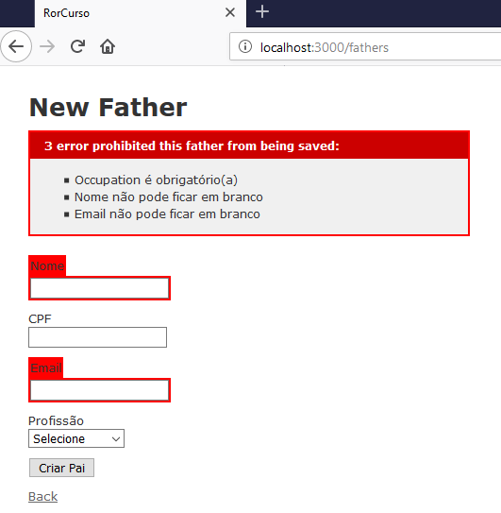

Criando métodos no model

app/views/fathers/index.html.erb

<p id="notice"><%= notice %></p>

<h1>Fathers</h1>

<table>
<thead>
<tr>
<th>Name</th>
<th>CPF</th>
<th>Email</th>
<th>Occupation</th>
<th colspan="3"></th>
</tr>
</thead>

<tbody>
<% @fathers.each do |father| %>
<tr>
<td><%= father.name %></td>
<td><%= father.cpf %></td>
<td><%= father.email %></td>
<td><%= father.occupation_description %></td>
<td><%= link_to 'Show', father %></td>
<td><%= link_to 'Edit', edit_father_path(father) %></td>
<td><%= link_to 'Destroy', father, method: :delete, data: { confirm: 'Are you sure?' } %></td>
</tr>
<% end %>
</tbody>
</table>

<br>

<%= link_to 'New Father', new_father_path %>

app/views/fathers/show.html.erb

<p id="notice"><%= notice %></p>

<p>
<strong>Name:</strong>
<%= @father.name %>
<strong>CPF:</strong>
<%= @father.cpf %>
<strong>Email:</strong>
<%= @father.email %>
<hr>
<strong>Ocupação:</strong>
<%= @father.occupation_description %>
<hr>
</p>

<% @father.children.each do |child| %>
<ul>
<li>
<%= "#{child.name} - #{pegar_sexo(child.sex)}" %>
</li>
</ul>
<% end %>

<%= link_to 'Edit', edit_father_path(@father) %> |
<%= link_to 'Back', fathers_path %>

app/models/father.rb

class Father < ApplicationRecord
has_many :children
belongs_to :occupation

validates :name, presence: true
validates :email, presence: true, uniqueness: true

def occupation_description
if self.occupation.blank?
" - "
else
self.occupation.description
end
end
end

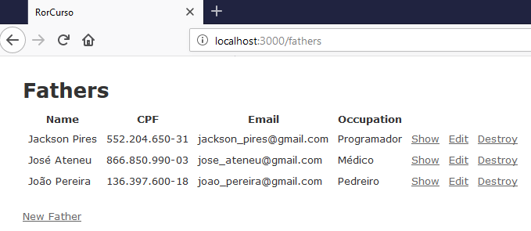

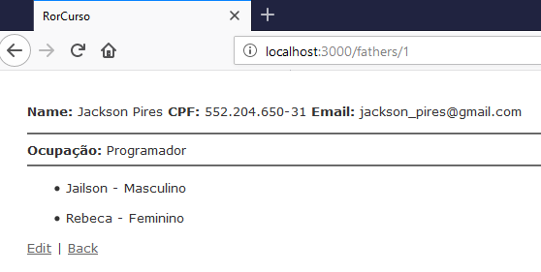

Aula 29 - Upload de imagens / arquivos

gem Paperclip

https://github.com/thoughtbot/paperclip

Pré-requisito: ImageMagick

ftp://ftp.nluug.nl/pub/ImageMagick

Obs.: O PaperClip está depreciado.

Gemfile

source 'https://rubygems.org'
git_source(:github) { |repo| "https://github.com/#{repo}.git" }

ruby '2.5.1'

#Paperclip
gem "paperclip", "~> 6.0.0"
# Faker
gem 'faker'
# Bundle edge Rails instead: gem 'rails', github: 'rails/rails'
gem 'rails', '~> 5.2.3'
# Use mysql as the database for Active Record
gem 'mysql2', '>= 0.4.4', '< 0.6.0'
# Use Puma as the app server
gem 'puma', '~> 3.11'
# Use SCSS for stylesheets
gem 'sass-rails', '~> 5.0'
# Use Uglifier as compressor for JavaScript assets
gem 'uglifier', '>= 1.3.0'
# See https://github.com/rails/execjs#readme for more supported runtimes
gem 'duktape'
# Use CoffeeScript for .coffee assets and views
gem 'coffee-rails', '~> 4.2'
# Turbolinks makes navigating your web application faster. Read more: https://github.com/turbolinks/turbolinks
gem 'turbolinks', '~> 5'
# Build JSON APIs with ease. Read more: https://github.com/rails/jbuilder
gem 'jbuilder', '~> 2.5'
# Use Redis adapter to run Action Cable in production
# gem 'redis', '~> 4.0'
# Use ActiveModel has_secure_password
# gem 'bcrypt', '~> 3.1.7'

# Use ActiveStorage variant
# gem 'mini_magick', '~> 4.8'

# Use Capistrano for deployment
# gem 'capistrano-rails', group: :development

# Reduces boot times through caching; required in config/boot.rb
gem 'bootsnap', '>= 1.1.0', require: false

group :development, :test do
# Call 'byebug' anywhere in the code to stop execution and get a debugger console
gem 'byebug', platforms: [:mri, :mingw, :x64_mingw]
end

group :development do
# Access an interactive console on exception pages or by calling 'console' anywhere in the code.
gem 'web-console', '>= 3.3.0'
end

group :test do
# Adds support for Capybara system testing and selenium driver
gem 'capybara', '>= 2.15'
gem 'selenium-webdriver'
# Easy installation and use of chromedriver to run system tests with Chrome
gem 'chromedriver-helper'
end

# Windows does not include zoneinfo files, so bundle the tzinfo-data gem
gem 'tzinfo-data', platforms: [:mingw, :mswin, :x64_mingw, :jruby]

bundle install

rails generate paperclip father avatar

db/migrate/20191021112858_add_avatar_to_fathers.rb

class AddAttachmentAvatarToFathers < ActiveRecord::Migration[5.2]
def self.up
change_table :fathers do |t|
t.attachment :avatar
end
end

def self.down
remove_attachment :fathers, :avatar
end
end

rake db:migrate

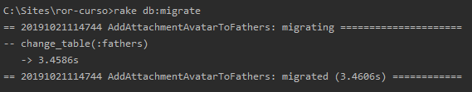

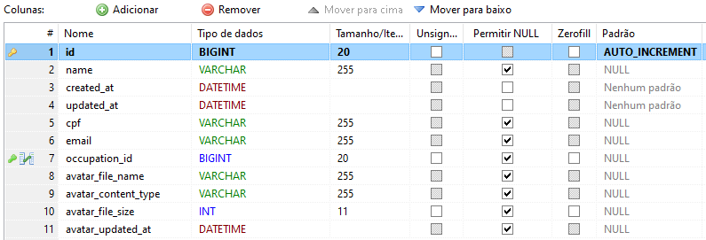

app/models/father.rb

class Father < ApplicationRecord
has_many :children
belongs_to :occupation

validates :name, presence: true
validates :email, presence: true, uniqueness: true

has_attached_file :avatar, styles: { medium: "300x300>", thumb: "100x100>" }
validates_attachment_content_type :avatar, content_type: /\Aimage\/.*\z/

def occupation_description
if self.occupation.blank?
" - "
else
self.occupation.description
end
end
end

app/views/father/_form.html.erb

<%= form_for @father, html: { multipart: true } do |form| %>
<% if father.errors.any? %>
<div id="error_explanation">
<h2><%= pluralize(father.errors.count, "error") %> prohibited this father from being saved:</h2>

<ul>
<% father.errors.full_messages.each do |message| %>
<li><%= message %></li>
<% end %>
</ul>
</div>
<% end %>

<div class="field">
<%= form.label :avatar %>
<%= form.file_field :avatar %>
</div>

<div class="field">
<%= form.label :name %>
<%= form.text_field :name %>
</div>

<div class="field">
<%= form.label :cpf %>
<%= form.text_field :cpf %>
</div>

<div class="field">
<%= form.label :email %>
<%= form.text_field :email %>
</div>

<div class="field">
<%= form.label :occupation_id %>
<%= form.collection_select(:occupation_id,
@occupations,
:id, :description,
{ include_blank: "Selecione" })
%>
</div>

<div class="actions">
<%= form.submit %>
</div>
<% end %>

app/views/father/show.html.erb

<p id="notice"><%= notice %></p>

<p>
<strong>Name:</strong>
<%= @father.name %>
<strong>CPF:</strong>
<%= @father.cpf %>
<strong>Email:</strong>
<%= @father.email %>
<hr>
<strong>Ocupação:</strong>
<%= @father.occupation_description %>
<hr>
<strong>Avatar:</strong>
<%= image_tag @father.avatar.url(:medium) %>
<hr>
</p>

<h3>Filhos:</h3>

<% @father.children.each do |child| %>
<ul>
<li>
<%= "#{child.name} - #{pegar_sexo(child.sex)}" %>
</li>
</ul>
<% end %>

<%= link_to 'Edit', edit_father_path(@father) %> |
<%= link_to 'Back', fathers_path %>

app/controllers/fathers_controller.rb

class FathersController < ApplicationController
before_action :set_father, only: [:show, :edit, :update, :destroy]
before_action :set_occupation, only: [:new, :create, :edit, :update]

# GET /fathers
# GET /fathers.json
def index
@fathers = Father.all
end

# GET /fathers/1
# GET /fathers/1.json
def show
end

# GET /fathers/new
def new
@father = Father.new
end

# GET /fathers/1/edit
def edit
end

# POST /fathers
# POST /fathers.json
def create
@father = Father.new(father_params)

respond_to do |format|
if @father.save
format.html { redirect_to @father, notice: 'Father was successfully created.' }
format.json { render :show, status: :created, location: @father }
else
format.html { render :new }
format.json { render json: @father.errors, status: :unprocessable_entity }
end
end
end

# PATCH/PUT /fathers/1
# PATCH/PUT /fathers/1.json
def update
respond_to do |format|
if @father.update(father_params)
format.html { redirect_to @father, notice: 'Father was successfully updated.' }
format.json { render :show, status: :ok, location: @father }
else
format.html { render :edit }
format.json { render json: @father.errors, status: :unprocessable_entity }
end
end
end

# DELETE /fathers/1
# DELETE /fathers/1.json
def destroy
@father.destroy
respond_to do |format|
format.html { redirect_to fathers_url, notice: 'Father was successfully destroyed.' }
format.json { head :no_content }
end
end

private
# Use callbacks to share common setup or constraints between actions.
def set_father
@father = Father.find(params[:id])
end

def set_occupation
@occupations = Occupation.all
end

# Never trust parameters from the scary internet, only allow the white list through.
def father_params
params.require(:father).permit(:name, :cpf, :email, :occupation_id, :avatar)
end
end

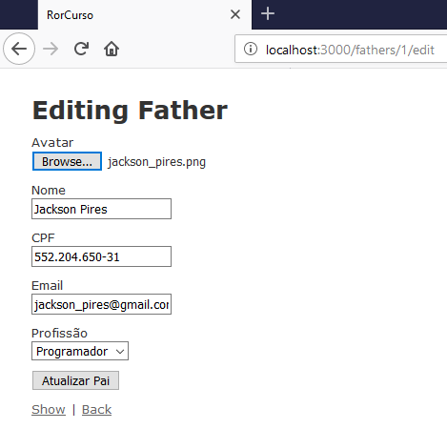

Aula 30 - Fazendo o primeiro deploy no Heroku

rails g controller welcome index

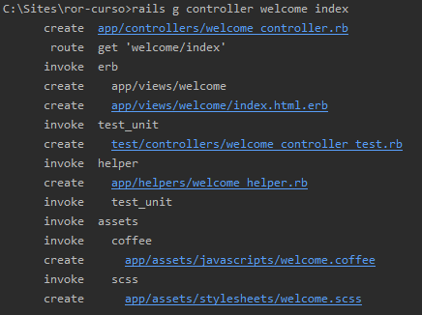

Gemfile

source 'https://rubygems.org'
git_source(:github) { |repo| "https://github.com/#{repo}.git" }

# Heroku
gem 'rails_12factor', group: :production
# Postgres
gem 'pg', group: :production
# Bootstrap
gem 'bootstrap-sass'
# Faker
gem 'faker'
# Bundle edge Rails instead: gem 'rails', github: 'rails/rails'
gem 'rails', '~> 5.2.3'
# Use mysql as the database for Active Record
gem 'mysql2', '>= 0.4.4', '< 0.6.0', group: :development
# Use Puma as the app server
gem 'puma', '~> 3.11'
# Use SCSS for stylesheets
gem 'sass-rails', '~> 5.0'
# Use Uglifier as compressor for JavaScript assets
gem 'uglifier', '>= 1.3.0'
# See https://github.com/rails/execjs#readme for more supported runtimes
gem 'duktape'
# Use CoffeeScript for .coffee assets and views
gem 'coffee-rails', '~> 4.2'
# Turbolinks makes navigating your web application faster. Read more: https://github.com/turbolinks/turbolinks
gem 'turbolinks', '~> 5'
# Build JSON APIs with ease. Read more: https://github.com/rails/jbuilder
gem 'jbuilder', '~> 2.5'
# Use Redis adapter to run Action Cable in production
# gem 'redis', '~> 4.0'
# Use ActiveModel has_secure_password
# gem 'bcrypt', '~> 3.1.7'

# Use ActiveStorage variant
# gem 'mini_magick', '~> 4.8'

# Use Capistrano for deployment
# gem 'capistrano-rails', group: :development

# Reduces boot times through caching; required in config/boot.rb
gem 'bootsnap', '>= 1.1.0', require: false

group :development, :test do
# Call 'byebug' anywhere in the code to stop execution and get a debugger console
gem 'byebug', platforms: [:mri, :mingw, :x64_mingw]
end

group :development do
# Access an interactive console on exception pages or by calling 'console' anywhere in the code.
gem 'web-console', '>= 3.3.0'
end

group :test do
# Adds support for Capybara system testing and selenium driver
gem 'capybara', '>= 2.15'
gem 'selenium-webdriver'
# Easy installation and use of chromedriver to run system tests with Chrome
gem 'chromedriver-helper'
end

# Windows does not include zoneinfo files, so bundle the tzinfo-data gem
gem 'tzinfo-data', platforms: [:mingw, :mswin, :x64_mingw, :jruby]

ruby '2.5.1'

bundle install

Heroku Documentation

https://devcenter.heroku.com/articles/getting-started-with-rails5

Gerando a chave SSH

ssh-keygen -t rsa -C beto10561@gmail.com

heroku keys:add

Fazendo o deploy

heroku login

git init

git status

git add .

git status

git commit -m "Commit inicial"

heroku create app-fatherschildren

git push heroku master

heroku run rake db:migrate

heroku open

Usando Bootstrap

app/assets/stylesheets/application.scss

/*
* This is a manifest file that'll be compiled into application.css, which will include all the files
* listed below.
*
* Any CSS and SCSS file within this directory, lib/assets/stylesheets, or any plugin's
* vendor/assets/stylesheets directory can be referenced here using a relative path.
*
* You're free to add application-wide styles to this file and they'll appear at the bottom of the
* compiled file so the styles you add here take precedence over styles defined in any other CSS/SCSS
* files in this directory. Styles in this file should be added after the last require_* statement.
* It is generally better to create a new file per style scope.
*
*= require_tree .
*= require_self
*/
@import 'bootstrap-sprockets';
@import 'bootstrap';

app/assets/stylesheets/scaffold.scss

body {
background-color: #fff;
color: #333;
margin: 33px;
font-family: verdana, arial, helvetica, sans-serif;
font-size: 13px;
line-height: 18px;
}

p, ol, ul, td {
font-family: verdana, arial, helvetica, sans-serif;
font-size: 13px;
line-height: 18px;
}

pre {
background-color: #eee;
padding: 10px;
font-size: 11px;
}

a {
color: #000;

&:hover {
color: #fff;
background-color: #000;
}
}

th {
padding-bottom: 5px;
}

td {
padding: 0 5px 7px;
}

div {
&.field, &.actions {
margin-bottom: 10px;
}
}

#notice {
color: green;
}

.field_with_errors {
padding: 2px;
background-color: red;
display: table;
}

#error_explanation {
width: 450px;
border: 2px solid red;
padding: 7px 7px 0;
margin-bottom: 20px;
background-color: #f0f0f0;

h2 {
text-align: left;
font-weight: bold;
padding: 5px 5px 5px 15px;
font-size: 12px;
margin: -7px -7px 0;
background-color: #c00;
color: #fff;
}

ul li {
font-size: 12px;
list-style: square;
}
}

label {
display: block;
}

config/application.rb

require_relative 'boot'

require 'rails/all'

Bundler.require(*Rails.groups)

module RorCurso
class Application < Rails::Application
config.load_defaults 5.2
config.time_zone = 'Brasilia'
config.i18n.default_locale = "pt-BR"
I18n.config.available_locales = "pt-BR"
end
end

config/locales/pt-BR.yml

"pt-BR":
Father: "Pai"
New: "Novo"
activerecord:
models:
father: Pai
child: Filho
occupation: Profissão
attributes:
father:
name: Nome
email: Email
cpf: CPF
occupation: Profissão
occupation_id: Profissão
created_at: Criado em
update_at: Atualizado em
child:
name: Nome
sex: Sexo
father: Pai
father_id: Pai
created_at: Criado em
update_at: Atualizado em
occupation:
description: Descrição

errors:
messages:
record_invalid: 'A validação falhou: %{errors}'
restrict_dependent_destroy:
has_one: Não é possível excluir o registro pois existe um %{record} dependente
has_many: Não é possível excluir o registro pois existem %{record} dependentes
date:
abbr_day_names:
- dom
- seg
- ter
- qua
- qui
- sex
- sáb
abbr_month_names:
-
- jan
- fev
- mar
- abr
- mai
- jun
- jul
- ago
- set
- out
- nov
- dez
day_names:
- domingo
- segunda-feira
- terça-feira
- quarta-feira
- quinta-feira
- sexta-feira
- sábado
formats:
default: "%d/%m/%Y"
long: "%d de %B de %Y"
short: "%d de %B"
month_names:
-
- janeiro
- fevereiro
- março
- abril
- maio
- junho
- julho
- agosto
- setembro
- outubro
- novembro
- dezembro
order:
- :day
- :month
- :year
datetime:
distance_in_words:
about_x_hours:
one: aproximadamente 1 hora
other: aproximadamente %{count} horas
about_x_months:
one: aproximadamente 1 mês
other: aproximadamente %{count} meses
about_x_years:
one: aproximadamente 1 ano
other: aproximadamente %{count} anos
almost_x_years:
one: quase 1 ano
other: quase %{count} anos
half_a_minute: meio minuto
less_than_x_seconds:
one: menos de 1 segundo
other: menos de %{count} segundos
less_than_x_minutes:
one: menos de um minuto
other: menos de %{count} minutos
over_x_years:
one: mais de 1 ano
other: mais de %{count} anos
x_seconds:
one: 1 segundo
other: "%{count} segundos"
x_minutes:
one: 1 minuto
other: "%{count} minutos"
x_days:
one: 1 dia
other: "%{count} dias"
x_months:
one: 1 mês
other: "%{count} meses"
x_years:
one: 1 ano
other: "%{count} anos"
prompts:
second: Segundo
minute: Minuto
hour: Hora
day: Dia
month: Mês
year: Ano
errors:
format: "%{attribute} %{message}"
messages:
accepted: deve ser aceito
blank: não pode ficar em branco
confirmation: não é igual a %{attribute}
empty: não pode ficar vazio
equal_to: deve ser igual a %{count}
even: deve ser par
exclusion: não está disponível
greater_than: deve ser maior que %{count}
greater_than_or_equal_to: deve ser maior ou igual a %{count}
inclusion: não está incluído na lista
invalid: não é válido
less_than: deve ser menor que %{count}
less_than_or_equal_to: deve ser menor ou igual a %{count}
model_invalid: 'A validação falhou: %{errors}'
not_a_number: não é um número
not_an_integer: não é um número inteiro
odd: deve ser ímpar
other_than: deve ser diferente de %{count}
present: deve ficar em branco
required: é obrigatório(a)
taken: já está em uso
too_long:
one: 'é muito longo (máximo: 1 caracter)'
other: 'é muito longo (máximo: %{count} caracteres)'
too_short:
one: 'é muito curto (mínimo: 1 caracter)'
other: 'é muito curto (mínimo: %{count} caracteres)'
wrong_length:
one: não possui o tamanho esperado (1 caracter)
other: não possui o tamanho esperado (%{count} caracteres)
template:
body: 'Por favor, verifique o(s) seguinte(s) campo(s):'
header:
one: 'Não foi possível gravar %{model}: 1 erro'
other: 'Não foi possível gravar %{model}: %{count} erros'
helpers:
select:
prompt: Por favor selecione
submit:
create: Criar %{model}
submit: Salvar %{model}
update: Atualizar %{model}
number:
currency:
format:
delimiter: "."
format: "%u %n"
precision: 2
separator: ","
significant: false
strip_insignificant_zeros: false
unit: R$
format:
delimiter: "."
precision: 3
separator: ","
significant: false
strip_insignificant_zeros: false
human:
decimal_units:
format: "%n %u"
units:
billion:
one: bilhão
other: bilhões
million:
one: milhão
other: milhões
quadrillion:
one: quatrilhão
other: quatrilhões
thousand: mil
trillion:
one: trilhão
other: trilhões
unit: ''
format:
delimiter: ''
precision: 3
significant: true
strip_insignificant_zeros: true
storage_units:
format: "%n %u"
units:
byte:
one: Byte
other: Bytes
eb: EB
gb: GB
kb: KB
mb: MB
pb: PB
tb: TB
percentage:
format:
delimiter: "."
format: "%n%"
precision:
format:
delimiter: "."
support:
array:
last_word_connector: " e "
two_words_connector: " e "
words_connector: ", "
time:
am: ''
formats:
default: "%a, %d de %B de %Y, %H:%M:%S %z"
long: "%d de %B de %Y, %H:%M"
short: "%d de %B, %H:%M"
pm: ''
actions:
show: Exibir
edit: Editar
destroy: Excluir
new: Novo
back: Voltar
helpers:
submit:
create: "Criar %{model}"
update: "Alterar %{model}"

confirm: Você tem certeza?

app/helpers/application_helper.rb

module ApplicationHelper
def pegar_sexo(sex)
html = ""
if (sex == 'M')
html = "Masculino"
elsif (sex == 'F')
html = "Feminino"
end
html
end
end

app/controllers/fathers_controller.rb

class FathersController < ApplicationController
before_action :set_father, only: [:show, :edit, :update, :destroy]
before_action :set_occupation, only: [:new, :create, :edit, :update]

# GET /fathers
# GET /fathers.json
def index
@fathers = Father.all
end

# GET /fathers/1
# GET /fathers/1.json
def show
end

# GET /fathers/new
def new
@father = Father.new
end

# GET /fathers/1/edit
def edit
end

# POST /fathers
# POST /fathers.json
def create
@father = Father.new(father_params)

respond_to do |format|
if @father.save
format.html { redirect_to @father, notice: 'Pai criado com sucesso!' }
format.json { render :show, status: :created, location: @father }
else
format.html { render :new }
format.json { render json: @father.errors, status: :unprocessable_entity }
end
end
end

# PATCH/PUT /fathers/1
# PATCH/PUT /fathers/1.json
def update
respond_to do |format|
if @father.update(father_params)
format.html { redirect_to @father, notice: 'Pai atualizado com sucesso!' }
format.json { render :show, status: :ok, location: @father }
else
format.html { render :edit }
format.json { render json: @father.errors, status: :unprocessable_entity }
end
end
end

# DELETE /fathers/1
# DELETE /fathers/1.json
def destroy
@father.destroy
respond_to do |format|
format.html { redirect_to fathers_url, notice: 'Pai apagado com sucesso!' }
format.json { head :no_content }
end
end

private
# Use callbacks to share common setup or constraints between actions.
def set_father
@father = Father.find(params[:id])
end

def set_occupation
@occupations = Occupation.all
end

# Never trust parameters from the scary internet, only allow the white list through.
def father_params
params.require(:father).permit(:name, :cpf, :email, :occupation_id, :avatar)
end
end

app/controllers/children_controller.rb

class ChildrenController < ApplicationController
before_action :set_child, only: [:show, :edit, :update, :destroy]
before_action :set_father, only: [:new, :create, :edit, :update]

# GET /children
# GET /children.json
def index
@children = Child.all
end

# GET /children/1
# GET /children/1.json
def show
end

# GET /children/new
def new
@child = Child.new
end

# GET /children/1/edit
def edit
end

# POST /children
# POST /children.json
def create
@child = Child.new(child_params)

respond_to do |format|
if @child.save
format.html { redirect_to @child, notice: 'Filho criado com sucesso!' }
format.json { render :show, status: :created, location: @child }
else
format.html { render :new }
format.json { render json: @child.errors, status: :unprocessable_entity }
end
end
end

# PATCH/PUT /children/1
# PATCH/PUT /children/1.json
def update
respond_to do |format|
if @child.update(child_params)
format.html { redirect_to @child, notice: 'Filho atualizado com sucesso!' }
format.json { render :show, status: :ok, location: @child }
else
format.html { render :edit }
format.json { render json: @child.errors, status: :unprocessable_entity }
end
end
end

# DELETE /children/1
# DELETE /children/1.json
def destroy
@child.destroy
respond_to do |format|
format.html { redirect_to children_url, notice: 'Filho apagado com sucesso!' }
format.json { head :no_content }
end
end

private
# Use callbacks to share common setup or constraints between actions.
def set_child
@child = Child.find(params[:id])
end

def set_father
@fathers = Father.all
end

# Never trust parameters from the scary internet, only allow the white list through.
def child_params
params.require(:child).permit(:name, :sex, :father_id)
end
end

app/controllers/occupations_controller.rb

class OccupationsController < ApplicationController
before_action :set_occupation, only: [:show, :edit, :update, :destroy]

# GET /occupations
# GET /occupations.json
def index
@occupations = Occupation.all
end

# GET /occupations/1
# GET /occupations/1.json
def show
end

# GET /occupations/new
def new
@occupation = Occupation.new
end

# GET /occupations/1/edit
def edit
end

# POST /occupations
# POST /occupations.json
def create
@occupation = Occupation.new(occupation_params)

respond_to do |format|
if @occupation.save
format.html { redirect_to @occupation, notice: 'Profissão criada com sucesso!' }
format.json { render :show, status: :created, location: @occupation }
else
format.html { render :new }
format.json { render json: @occupation.errors, status: :unprocessable_entity }
end
end
end

# PATCH/PUT /occupations/1
# PATCH/PUT /occupations/1.json
def update
respond_to do |format|
if @occupation.update(occupation_params)
format.html { redirect_to @occupation, notice: 'Profissão atualizada com sucesso!' }
format.json { render :show, status: :ok, location: @occupation }
else
format.html { render :edit }
format.json { render json: @occupation.errors, status: :unprocessable_entity }
end
end
end

# DELETE /occupations/1
# DELETE /occupations/1.json
def destroy
@occupation.destroy
respond_to do |format|
format.html { redirect_to occupations_url, notice: 'Profissão apagada com sucesso!' }
format.json { head :no_content }
end
end

private
# Use callbacks to share common setup or constraints between actions.
def set_occupation
@occupation = Occupation.find(params[:id])
end

# Never trust parameters from the scary internet, only allow the white list through.
def occupation_params
params.require(:occupation).permit(:description)
end
end

db/seeds.rb

Occupation.create(description: "Pedreiro")
Occupation.create(description: "Programador")
Occupation.create(description: "Médico")

Father.create(name: "Jackson Pires", cpf: "552.204.650-31", email: "jackson_pires@gmail.com", occupation_id: 2)
Father.create(name: "José Ateneu", cpf: "866.850.990-03", email: "jose_ateneu@gmail.com", occupation_id: 3)
Father.create(name: "João Pereira", cpf: "136.397.600-18", email: "joao_pereira@gmail.com", occupation_id: 1)
Father.create(name: "Roberto Pinheiro", cpf: "967.853.050-39", email: "betopinheiro1005@yahoo.com.br", occupation_id: 2)

Child.create(name: "Jailson", sex: "M", father_id: 1)
Child.create(name: "Josefa", sex: "F", father_id: 2)
Child.create(name: "Rebeca", sex: "F", father_id: 1)
Child.create(name: "Alexandre", sex: "M", father_id: 4)
Child.create(name: "Vanessa", sex: "F", father_id: 4)

app/views/layouts/application.html.erb

<!DOCTYPE html>
<html>
<head>
<title>RorCurso</title>
<%= csrf_meta_tags %>
<%= csp_meta_tag %>

<%= stylesheet_link_tag 'application', media: 'all', 'data-turbolinks-track': 'reload' %>
<%= javascript_include_tag 'application', 'data-turbolinks-track': 'reload' %>
</head>

<body>
<div class="container">
<%= yield %>
</div>
</body>
</html>

app/views/children/new.html.erb

<h1>Novo Filho</h1>

<%= render 'form', child: @child %>

<%= link_to 'Voltar', children_path, class: "btn btn-default" %>

app/views/children/edit.html.erb

<h1>Editar Filho</h1>

<%= render 'form', child: @child %>

<%= link_to 'Detalhes', @child, class: "btn btn-success" %>
<%= link_to 'Voltar', children_path, class: "btn btn-default" %>

app/views/children/_form.html.erb

<%= form_with(model: child, local: true) do |form| %>
<% if child.errors.any? %>
<div id="error_explanation">
<h2><%= pluralize(child.errors.count, "erro encontrado!", "erros encontrados!") %> </h2>

<ul>
<% child.errors.full_messages.each do |message| %>
<li><%= message %></li>
<% end %>
</ul>
</div>
<% end %>

<div class="form-group">
<%= form.label :name %>
<%= form.text_field :name, class:"form-control" %>
</div>

<div class="form-group">
<%= form.label :sex %>
<%= form.select(:sex,
options_for_select([["Masculino", "M"], ["Feminino", "F"]], child.sex),
{ include_blank: "Selecione" }, class:"form-control")
%>
</div>

<div class="form-group">
<%= form.label :father_id %>
<%= form.collection_select(:father_id,
@fathers,
:id, :name,
{ include_blank: "Selecione" }, class:"form-control")
%>
</div>

<div class="actions">
<%= form.submit class: "btn btn-primary" %>
</div>
<% end %>

<br>

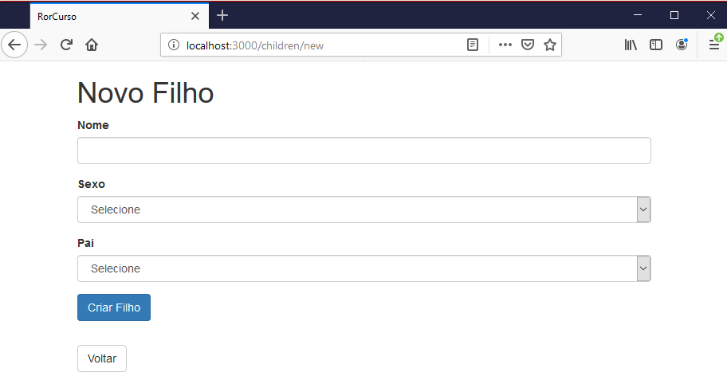

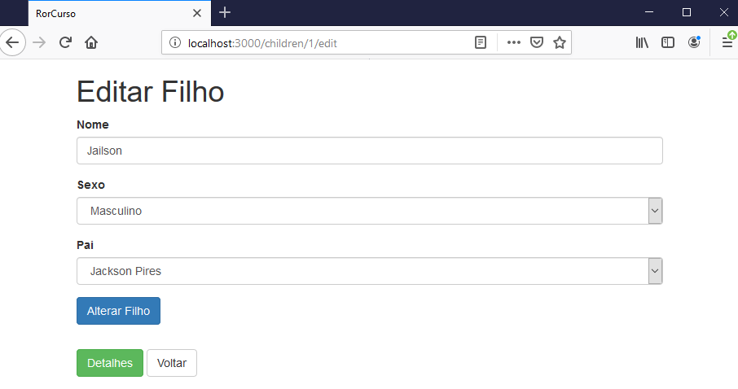

app/views/children/index.html.erb

<p id="notice"><%= notice %></p>

<h1>Filhos</h1>

<table class="table table-striped">
<thead>
<tr>
<th>Nome</th>
<th>Sexo</th>
<th>Pai</th>
<th>Cadastrado em</th>
<th colspan="3">Ações</th>
</tr>
</thead>

<tbody>
<% @children.each do |child| %>
<tr>
<td><%= child.name %></td>
<td><%= pegar_sexo(child.sex) %></td>
<td><%= child.father.name %></td>
<td><%= child.created_at %></td>
<td><%= link_to 'Detalhes', child, class: "btn btn-success" %></td>
<td><%= link_to 'Editar', edit_child_path(child), class: "btn btn-warning" %></td>
<td><%= link_to 'Eliminar', child, method: :delete, data: { confirm: 'Tem certeza que deseja excluir?' }, class: "btn btn-danger" %></td>
</tr>
<% end %>
</tbody>
</table>

<br>

<%= link_to 'Novo Filho', new_child_path, class: "btn btn-primary" %>
<%= link_to 'Página Inicial', welcome_index_path, class: 'btn btn-default' %>

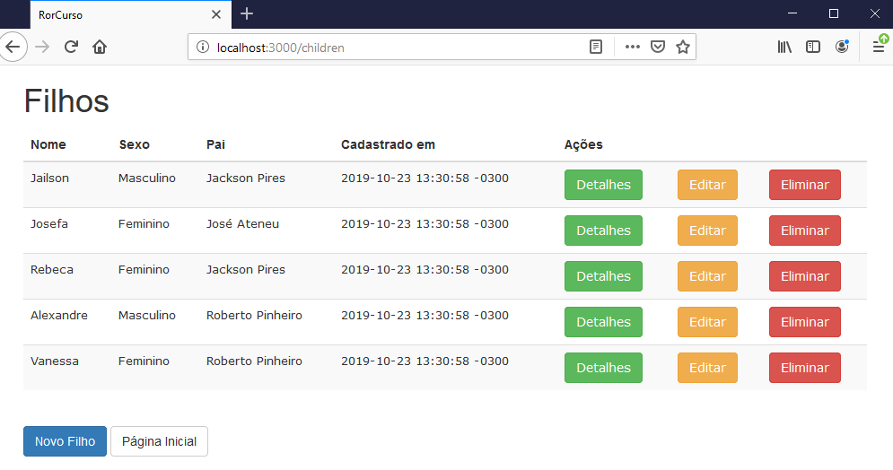

app/views/children/show.html.erb

<br>

<p id="notice"><%= notice %></p>

<h3>Filho</h3>

<br>

<p><span class="text-primary">Nome:</span> <%= @child.name %></p>
<p><span class="text-primary">Sexo:</span> <%= pegar_sexo(@child.sex) %></p>
<p><span class="text-primary">Pai:</span> <%= @child.father.name %></p>
<p><span class="text-primary">Cadastrado em:</span> <%= @child.created_at %></p>
<p><span class="text-primary">Atualizado em:</span> <%= @child.updated_at %></p>

<br>

<%= link_to 'Editar', edit_child_path(@child), class:'btn btn-warning' %>
<%= link_to 'Voltar', children_path, class:'btn btn-default' %>

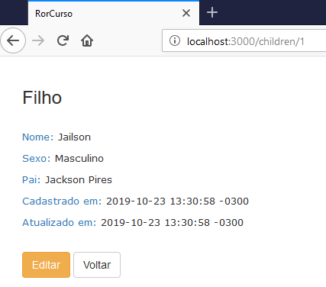

app/views/fathers/new.html.erb

<h1>Novo Pai</h1>

<%= render 'form', father: @father %>

<%= link_to 'Voltar', fathers_path, class: 'btn btn-default' %>

app/views/fathers/edit.html.erb

<h1>Editar Pai</h1>

<%= render 'form', father: @father %>

<%= link_to 'Detalhes', @father, class: 'btn btn-success' %>
<%= link_to 'Voltar', fathers_path, class: 'btn btn-default' %>

app/views/fathers/_form.html.erb

<%= form_for @father, html: { multipart: true } do |form| %>
<% if father.errors.any? %>
<div id="error_explanation">
<h2><%= pluralize(father.errors.count, "erro encontrado!", "erros encontrados!") %> </h2>

<ul>
<% father.errors.full_messages.each do |message| %>
<li><%= message %></li>
<% end %>
</ul>
</div>
<% end %>

<div class="form-group">
<%= form.label :name %>
<%= form.text_field :name, class: 'form-control' %>
</div>

<div class="form-group">
<%= form.label :cpf %>
<%= form.text_field :cpf, class: 'form-control' %>
</div>

<div class="form-group">
<%= form.label :email %>
<%= form.text_field :email, class: 'form-control' %>
</div>

<div class="form-group">
<%= form.label :occupation_id %>
<%= form.collection_select(:occupation_id,
@occupations,
:id, :description,
{ include_blank: "Selecione" }, class:'form-control')
%>
</div>

<div>
<%= form.submit class: "btn btn-primary" %>
</div>

<br>
<% end %>

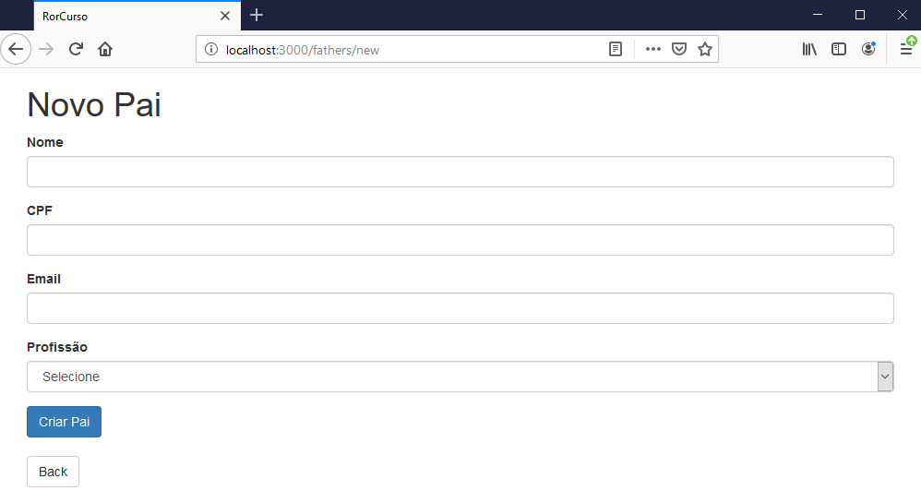

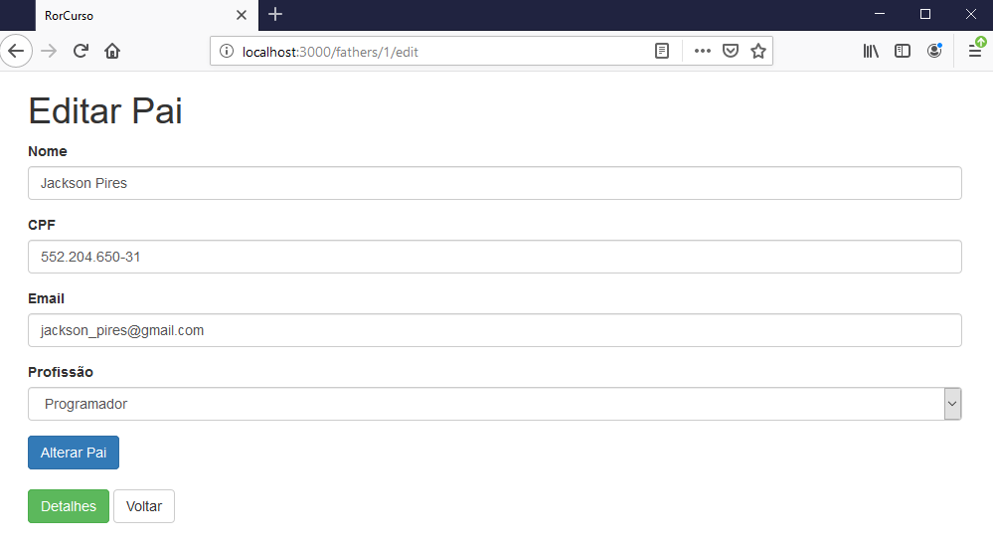

app/views/fathers/index.html.erb

<p id="notice"><%= notice %></p>
<h1>Pais</h1>
<table class="table table-striped">
<thead>
<tr>
<th>Nome</th>
<th>CPF</th>
<th>Email</th>
<th>Profissão</th>
<th colspan="3">Ações</th>
</tr>
</thead>
<tbody>
<% @fathers.each do |father| %>
<tr>
<td><%= father.name %></td>
<td><%= father.cpf %></td>
<td><%= father.email %></td>
<td><%= father.occupation_description %></td>
<td><%= link_to 'Detalhes', father, class:'btn btn-success' %></td>
<td><%= link_to 'Editar', edit_father_path(father), class:'btn btn-warning' %></td>
<td><%= link_to 'Excluir', father, method: :delete, data: { confirm: 'Tem certeza que deseja excluir?' }, class:'btn btn-danger' %></td>
</tr>
<% end %>
</tbody>
</table>
<br>
<%= link_to 'Novo Pai', new_father_path, class: 'btn btn-primary' %>
<%= link_to 'Página Inicial', welcome_index_path, class: 'btn btn-default' %>

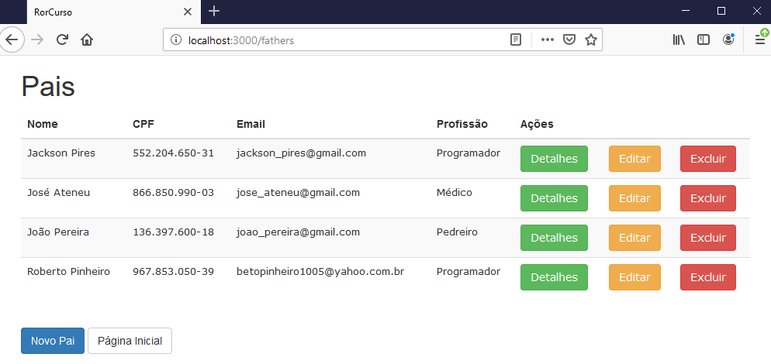

app/views/fathers/show.html.erb

<br>

<div>

<p id="notice"><%= notice %></p>

<h3>Pai</h3>

<br>

<p><span class="text-primary">Nome:</span> <%= @father.name %></p>
<p><span class="text-primary">CPF:</span> <%= @father.cpf %></p>
<p><span class="text-primary">Email:</span> <%= @father.email %></p>
<p><span class="text-primary">Profissão:</span> <%= @father.occupation_description %></p>

<% if @father.children.count > 0 %>
<p class="text-primary">Filhos:</p>
<% @father.children.each do |child| %>
<ul>
<li>
<%= "#{child.name} - #{pegar_sexo(child.sex)}" %>
</li>
</ul>
<% end %>
<% else %>
<p><span class="text-primary">Filhos:</span> Não tem</p>
<% end %>
<p><span class="text-primary">Cadastrado em:</span> <%= @father.created_at %></p>
<p><span class="text-primary">Última atualização:</span> <%= @father.updated_at %></p>
<br>

<%= link_to 'Editar', edit_father_path(@father), class:'btn btn-warning' %>
<%= link_to 'Voltar', fathers_path, class:'btn btn-default' %>

</div>

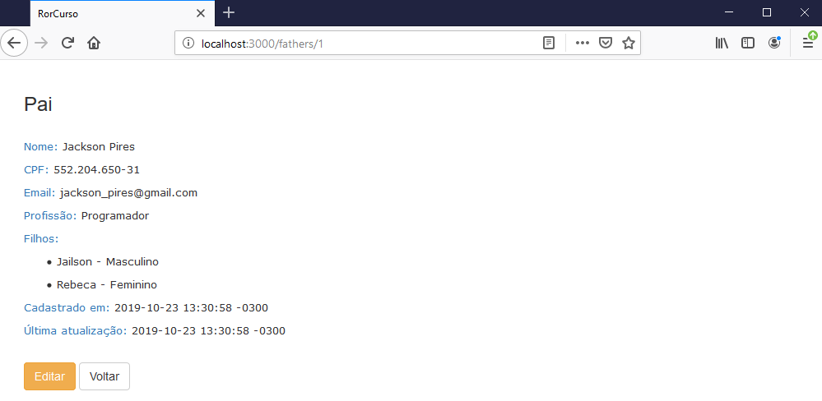

app/views/occupations/new.html.erb

<h1>New Occupation</h1>

<%= render 'form', occupation: @occupation %>

<%= link_to 'Back', occupations_path %>

app/views/occupations/edit.html.erb

<h1>Editar Profissão</h1>

<%= render 'form', occupation: @occupation %>

<%= link_to 'Detalhes', @occupation, class: "btn btn-success" %>
<%= link_to 'Voltar', occupations_path, class: "btn btn-default" %>

app/views/occupations/_form.html.erb

<%= form_with(model: occupation, local: true) do |form| %>
<% if occupation.errors.any? %>
<div id="error_explanation">
<h2><%= pluralize(occupation.errors.count, "error") %> prohibited this occupation from being saved:</h2>

<ul>
<% occupation.errors.full_messages.each do |message| %>
<li><%= message %></li>
<% end %>
</ul>
</div>
<% end %>

<div class="form-group">
<%= form.label :description %>
<%= form.text_field :description, class: "form-control" %>
</div>

<div class="actions">
<%= form.submit class: "btn btn-primary" %>
</div>
<% end %>

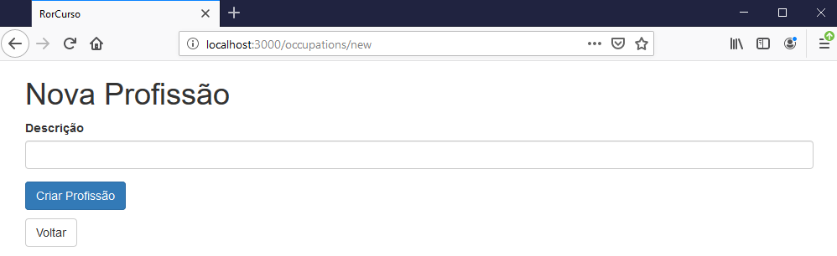

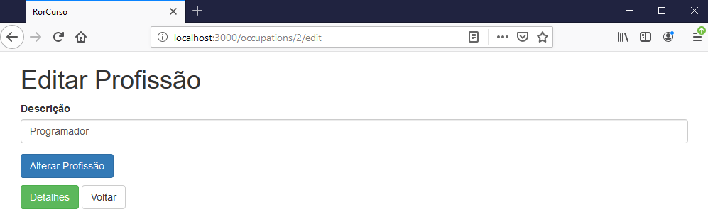

app/views/occupations/index.html.erb

<p id="notice"><%= notice %></p>

<h1>Profissões</h1>

<table class="table table-striped">
<thead>
<tr>
<th>Descrição</th>
<th>Cadastrada em:</th>
<th>Atualizada em:</th>
<th colspan="3">Ações</th>
</tr>
</thead>

<tbody>
<% @occupations.each do |occupation| %>
<tr>
<td><%= occupation.description %></td>
<td><%= occupation.created_at %></td>
<td><%= occupation.updated_at %></td>
<td><%= link_to 'Detalhes', occupation, class: "btn btn-success" %></td>
<td><%= link_to 'Editar', edit_occupation_path(occupation), class: "btn btn-warning" %></td>
<td><%= link_to 'Eliminar', occupation, method: :delete, data: { confirm: 'Tem certeza que deseja excluir?' }, class: "btn btn-danger" %></td>
</tr>
<% end %>
</tbody>
</table>

<br>

<%= link_to 'Nova Profissão', new_occupation_path, class: "btn btn-primary" %>
<%= link_to 'Página Inicial', welcome_index_path, class: 'btn btn-default' %>

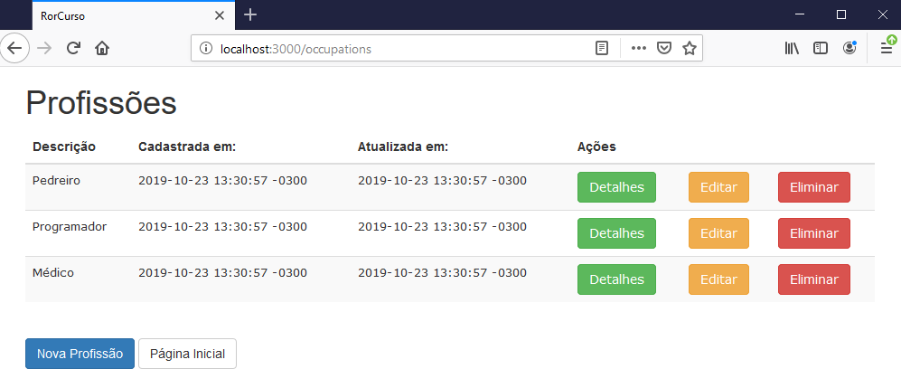

app/views/occupations/show.html.erb

<p id="notice"><%= notice %></p>

<h3>Profissão</h3>

<br>

<p><span class="text-primary">Description:</span> <%= @occupation.description %></p>

<% if @occupation.fathers.count > 0 %>
<p class="text-primary">Pais:</p>
<% @occupation.fathers.each do |pai| %>
<ul>
<li>
<%= pai.name %>
</li>
</ul>
<% end %>
<% else %>
<p><span class="text-primary">Filhos:</span> Não tem</p>
<% end %>

<p><span class="text-primary">Cadastrada em:</span> <%= @occupation.created_at %></p>
<p><span class="text-primary">Atualizada em:</span> <%= @occupation.updated_at %></p>

<br>

<%= link_to 'Editar', edit_occupation_path(@occupation), class: "btn btn-primary" %>
<%= link_to 'Voltar', occupations_path, class: "btn btn-default" %>

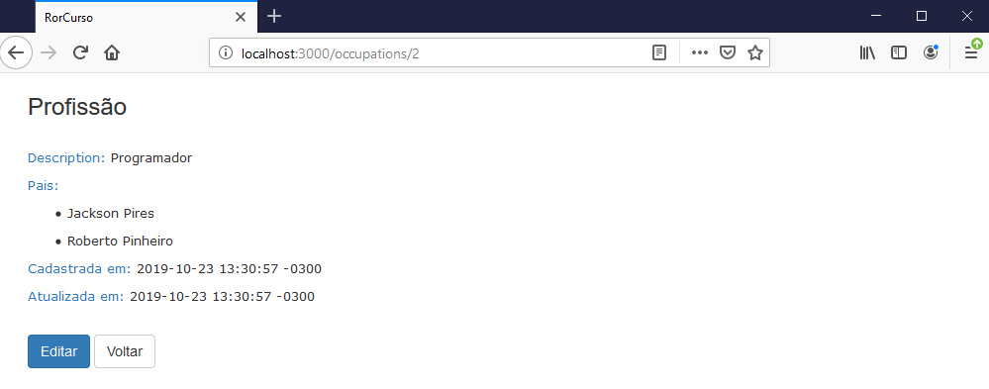

app/views/welcome/index.html.erb

<h1>Welcome!!!</h1>
<br>
<p><%= link_to 'Pais', fathers_path, class: "btn btn-default" %>
<%= link_to 'Filhos', children_path, class: "btn btn-default" %>
<%= link_to 'Profissões', occupations_path, class: "btn btn-default" %></p>

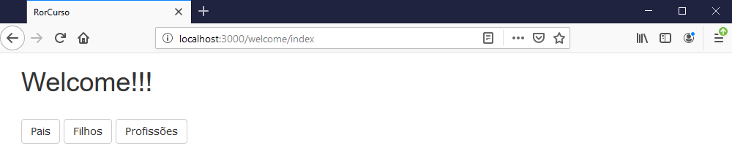

Validações e relacionamentos

app/models/child.rb

class Occupation < ApplicationRecord
has_many :fathers
validates :description, presence: true
validates :father_id, presence: true
end

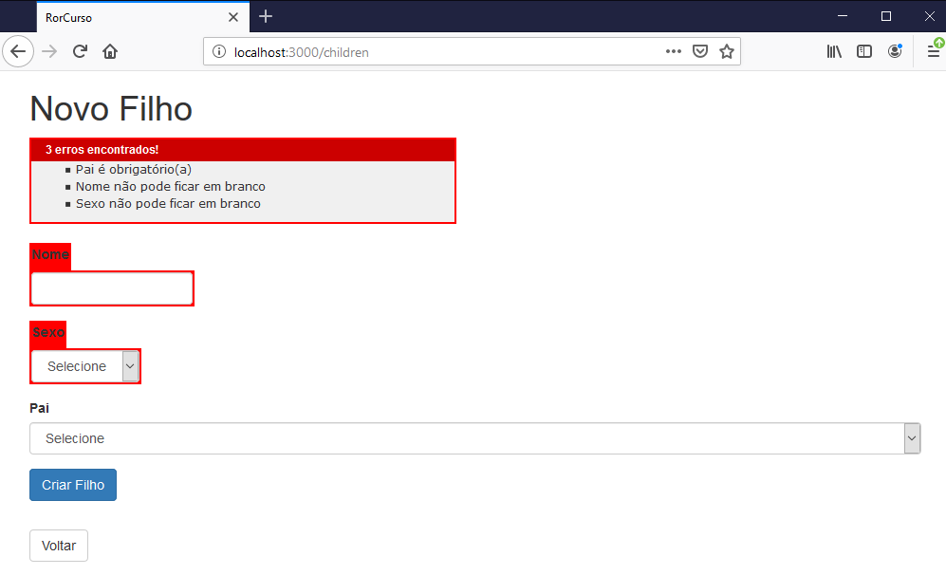

app/models/father.rb

class Father < ApplicationRecord
has_many :children
belongs_to :occupation

validates :name, presence: true
validates :email, presence: true, uniqueness: true
validates :cpf, presence: true

has_one_attached :avatar

def occupation_description
if self.occupation.blank?
" - "
else
self.occupation.description
end
end
end

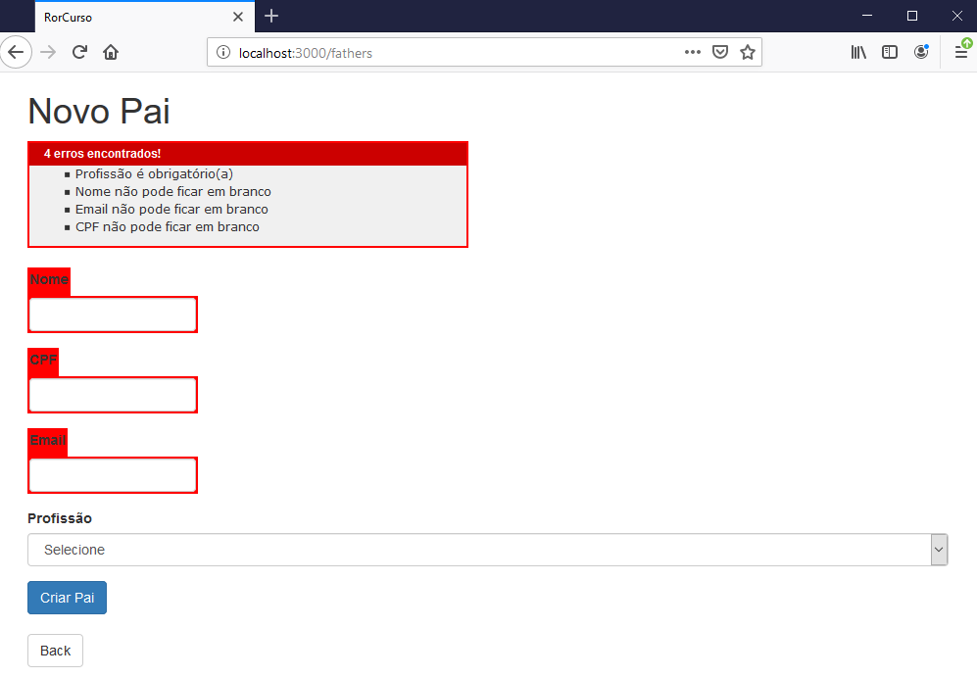

app/models/occupation.rb

class Occupation < ApplicationRecord
has_many :fathers
validates :description, presence: true
end

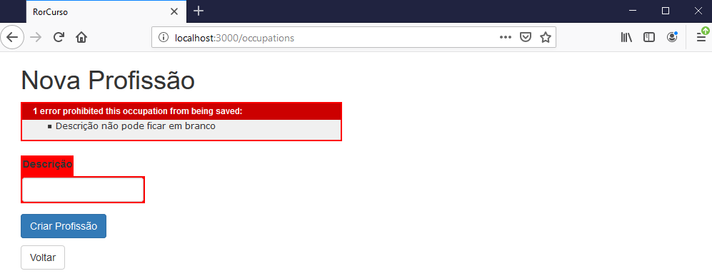

Fazendo o deploy

heroku login

git init

git status

git add .

git status

git commit -m "Usando Bootstrap"

git push heroku master

heroku run rake db:seed

heroku open

