Main Page

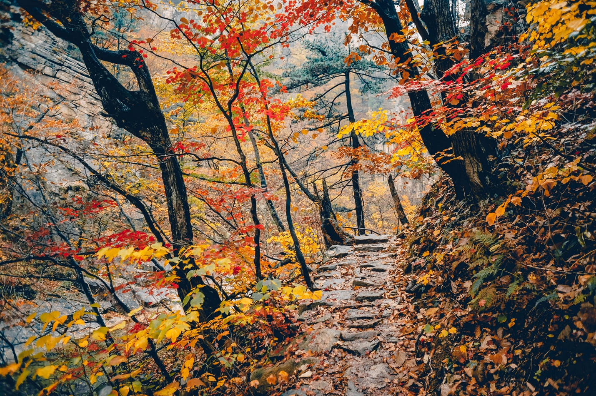

[This Photo](https://commons.wikimedia.org/wiki/File:Way_Through_Autumn_Forest_(187194663).jpeg) by Unknown Author is licensed under [CC BY-SA](https://creativecommons.org/licenses/by-sa/3.0/)

|  |  |
| --- | --- |
| Marlene | /Users/beto/Projects/bug/docx-bug/build/resources/test/pics/pic1.jpg |
| Sophia | /Users/beto/Projects/bug/docx-bug/build/resources/test/pics/pic2.jpg |
| Miguel | /Users/beto/Projects/bug/docx-bug/build/resources/test/pics/pic3.jpg |