novikovPrac6.R

Новиков Денис Владиславович ИНБО-05-22

2024-04-19

# Задание 1 ---------------------------------------------------------------  
  
# Обработка данных --------------------------------------------------------  
  
download.file(url = 'https://raw.githubusercontent.com/qwerty29544/RpracticeBook/master/2Data/01FlatTables/ECG_yurchenkov.txt',   
 destfile = 'my_file.txt')  
  
df = read.csv('my_file.txt', skip=47, sep='\t', header=F)  
  
colnames(df) = c('мс', 'ЭКГ', 'ФПГ1', 'ФПГ2', 'КГР', 'РД')  
  
print(paste0('Num of observations: ', sum(df['мс'] == 0)))

## [1] "Num of observations: 13"

split_indices <- c(which(df$мс == 0), nrow(df)+1)  
split_indices

## [1] 1 3841 33957 39776 84850 89944 150067 154650 214776 216856  
## [11] 246922 248270 279126 282947

sub_datasets <- list()  
  
for (i in 1:(length(split_indices)-1)) {  
 sub_df <- df[(split_indices[i]):((split_indices[i+1])-1), ]  
 sub_datasets[[i]] <- sub_df  
}  
  
for (i in 1:(length(sub_datasets) - 1)) {  
 sub_datasets[[i]] = sub_datasets[[i]][1:(nrow(sub_datasets[[i]]) - 6),]  
}  
  
for (i in 1:length(sub_datasets)) {  
 for (col in names(sub_datasets[[i]])) {  
 sub_datasets[[i]][[col]] <- gsub(",", ".", sub_datasets[[i]][[col]])  
 }  
}  
  
for (i in 1:length(sub_datasets)) {  
 for (col in names(sub_datasets[[i]])) {  
 sub_datasets[[i]][[col]] <- as.numeric(sub_datasets[[i]][[col]])  
 }  
}  
  
all_df = data.frame()  
  
for (cur_df in sub_datasets) {  
 all_df = rbind(all_df, cur_df)  
}  
  
head(all_df)

## мс ЭКГ ФПГ1 ФПГ2 КГР РД  
## 1 0 -0.02875 -0.024375 0.3125 -1.44196 1.4750  
## 2 4 -0.01800 -0.023125 0.3125 -1.44196 1.5125  
## 3 8 0.02975 -0.021875 0.2375 -1.44196 1.5375  
## 4 12 -0.01025 -0.021250 0.0875 -1.44043 1.5750  
## 5 16 -0.12150 -0.021250 -0.1000 -1.43890 1.6125  
## 6 20 -0.13750 -0.021875 -0.3375 -1.43890 1.6500

# Вывод гистограмм --------------------------------------------------------  
  
hist(unlist(all_df['ЭКГ']),  
 main = "ЭКГ общее",  
 xlab = "Values",  
 ylab = "Frequency",  
 col = "skyblue",  
 border = "black"  
)

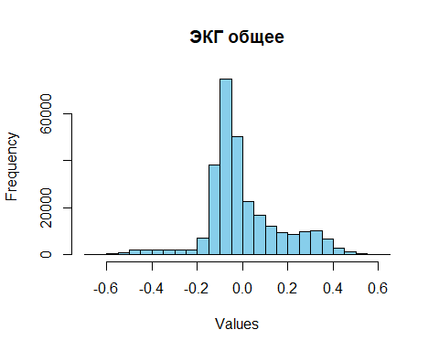

hist(unlist(sub_datasets[[1]]['ЭКГ']),  
 main = "ЭКГ эксперимент 1",  
 xlab = "Values",  
 ylab = "Frequency",  
 col = "skyblue",  
 border = "black"  
)

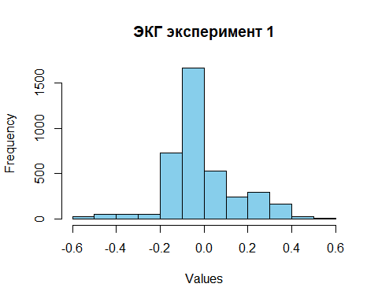

hist(unlist(all_df['РД']),  
 main = "РД общее",  
 xlab = "Values",  
 ylab = "Frequency",  
 col = "skyblue",  
 border = "black"  
)

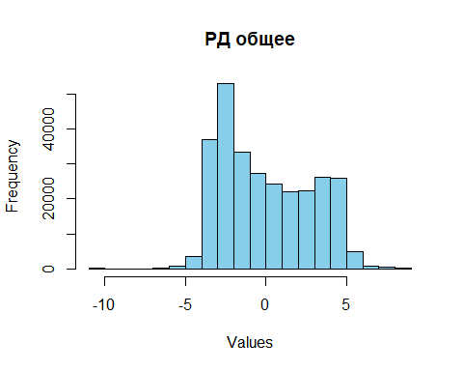

hist(unlist(sub_datasets[[13]]['РД']),  
 main = "РД эксперимент 13",  
 xlab = "Values",  
 ylab = "Frequency",  
 col = "skyblue",  
 border = "black"  
)

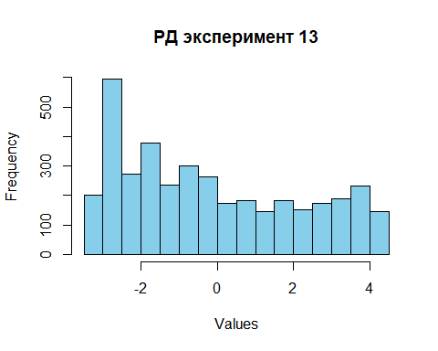

par(mfrow = c(1, 3))  
  
for (i in 1:3) {  
 hist(unlist(sub_datasets[[i]]['ФПГ2']),   
 main = paste("ФПГ2 эксперимент", i),  
 xlab = "Values",  
 ylab = "Frequency",  
 col = "skyblue",  
 border = "black"  
 )  
}

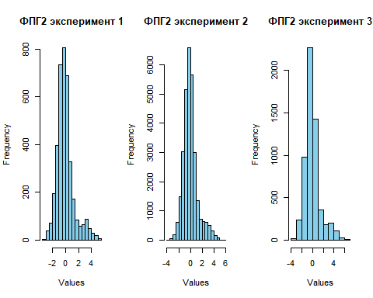

par(mfrow = c(1, 1))  
  
# Статистика --------------------------------------------------------------  
  
print('Статистика для ЭКГ (все эксперименты)')

## [1] "Статистика для ЭКГ (все эксперименты)"

summary(unlist(all_df['ЭКГ']))

## Min. 1st Qu. Median Mean 3rd Qu. Max.   
## -0.6565000 -0.0900000 -0.0432500 -0.0001308 0.0695000 0.6462500

for (i in 1:13) {  
 print(paste0('Статистика для ЭКГ (эксперимент ', i, ')'))  
 print(summary(unlist(sub_datasets[[i]]['ЭКГ'])))  
}

## [1] "Статистика для ЭКГ (эксперимент 1)"  
## Min. 1st Qu. Median Mean 3rd Qu. Max.   
## -0.58400 -0.09775 -0.05287 -0.01480 0.05075 0.56300   
## [1] "Статистика для ЭКГ (эксперимент 2)"  
## Min. 1st Qu. Median Mean 3rd Qu. Max.   
## -0.577250 -0.091000 -0.047750 -0.004348 0.059187 0.548000   
## [1] "Статистика для ЭКГ (эксперимент 3)"  
## Min. 1st Qu. Median Mean 3rd Qu. Max.   
## -0.5890000 -0.0870000 -0.0405000 0.0000667 0.0672500 0.5337500   
## [1] "Статистика для ЭКГ (эксперимент 4)"  
## Min. 1st Qu. Median Mean 3rd Qu. Max.   
## -0.597500 -0.085000 -0.040750 0.002441 0.068500 0.577000   
## [1] "Статистика для ЭКГ (эксперимент 5)"  
## Min. 1st Qu. Median Mean 3rd Qu. Max.   
## -0.594000 -0.088500 -0.041250 0.001812 0.073500 0.532750   
## [1] "Статистика для ЭКГ (эксперимент 6)"  
## Min. 1st Qu. Median Mean 3rd Qu. Max.   
## -0.5975000 -0.0887500 -0.0450000 0.0005802 0.0670000 0.6235000   
## [1] "Статистика для ЭКГ (эксперимент 7)"  
## Min. 1st Qu. Median Mean 3rd Qu. Max.   
## -0.5977500 -0.0950000 -0.0427500 0.0007804 0.0802500 0.5627500   
## [1] "Статистика для ЭКГ (эксперимент 8)"  
## Min. 1st Qu. Median Mean 3rd Qu. Max.   
## -0.6217500 -0.0910000 -0.0420000 0.0000137 0.0705000 0.6462500   
## [1] "Статистика для ЭКГ (эксперимент 9)"  
## Min. 1st Qu. Median Mean 3rd Qu. Max.   
## -0.53175 -0.08994 -0.04525 -0.00154 0.06212 0.53050   
## [1] "Статистика для ЭКГ (эксперимент 10)"  
## Min. 1st Qu. Median Mean 3rd Qu. Max.   
## -0.6422500 -0.0910000 -0.0412500 -0.0002643 0.0747500 0.5912500   
## [1] "Статистика для ЭКГ (эксперимент 11)"  
## Min. 1st Qu. Median Mean 3rd Qu. Max.   
## -0.5597500 -0.0885625 -0.0362500 0.0000011 0.0690625 0.5765000   
## [1] "Статистика для ЭКГ (эксперимент 12)"  
## Min. 1st Qu. Median Mean 3rd Qu. Max.   
## -0.6565000 -0.0945000 -0.0425000 0.0001181 0.0785000 0.6132500   
## [1] "Статистика для ЭКГ (эксперимент 13)"  
## Min. 1st Qu. Median Mean 3rd Qu. Max.   
## -0.5840000 -0.0940000 -0.0425000 -0.0001807 0.0830000 0.6060000

# Моя функция -------------------------------------------------------------  
  
myfunc = function(y) {  
   
 a = numeric(length(y))  
   
 for (tau in 1:(length(y) - 2)) {  
   
 val = 0.0  
   
 for (i in 1:(length(y) - tau)) {  
 val = val + abs(y[i + tau] - y[i])  
 }  
   
 val = val * (2 / (length(y) - tau))  
 a[tau] = val  
 }  
   
 return(a[a != 0])  
}  
  
line = unlist(sub_datasets[[1]]['ЭКГ'])  
plot(line, type='l')

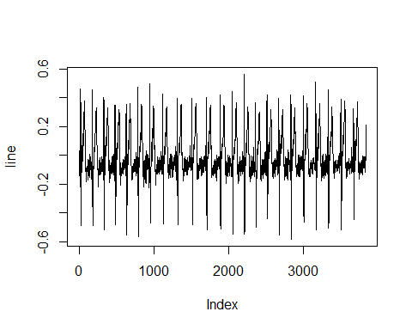

line = myfunc(line)  
plot(line, type='l')

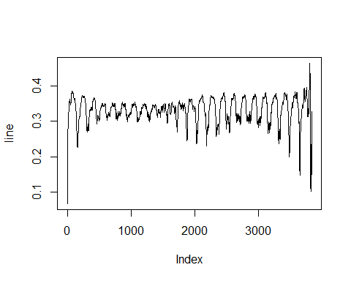

line = unlist(sub_datasets[[1]]['РД'])  
plot(line, type='l')

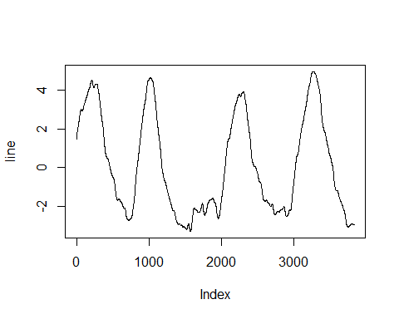

line = myfunc(line)  
plot(line, type='l')

