Table of Contents
Title Page....................................................................................................
Cover Page.................................................................................................................
Table of Contents ........................................................................................................... ii
Executive Summary ....................................................................................................1
Customer Validation Board ..............................................................................................
Customer and Problem Validation ...............................................................2
Assumptions, Validation, Solution and Value .............................................3
Startup Description .......................................................................................................
Startup Project Name........................................................................................4
Synergy ..............................................................................................................4
Product Type......................................................................................................4
Startup Stage.....................................................................................................5
Product/Service Description .............................................................................7
The Problem ......................................................................................................7
Customer Segments .........................................................................................7
Competitive Advantage.....................................................................................8
Revenue Stream................................................................................................9
Team Description ............................................................................................10

Executive Summary (2 PARAGRAPH)

CUSTOMER VALIDATION BOARD
Customer Validation Board
Startup Idea: | LaunchIt: Startup Business Management System
Stage: | Problem and Solution Validation
Experiment | 1 | 2 | 3
Customer | Startup owners | Small business operators | Platform administrators
Problem | The client might find the dashboard difficult to navigate because of limited experience with digital business systems. | The client might worry that the system will become slow, unavailable, or unreliable when several users or modules are active. | The client might resist switching because the existing paper-based or spreadsheet process already feels familiar and comfortable.
Solution | Use clear role-based navigation, plain labels, guided setup steps, and short onboarding instructions. | Test response time and concurrent access, optimize database requests, and deploy with monitoring, backups, and reliable hosting. | Introduce the system through a guided pilot, demonstrate time-saving tasks, and provide transition assistance.
Riskiest Assumption | We assume user-friendliness is the client’s biggest adoption barrier and that clients will reject the system if core tasks feel too complex. | We assume clients will stop using the system if its speed or availability does not remain acceptable during normal multi-user activity. | We assume clients are willing to leave familiar manual habits when the automated workflow is clearly demonstrated and supported.
Validation Method | Conduct task-based usability testing with five intended users and observe navigation errors, requests for help, and task completion time. | Run controlled performance and concurrent-user tests, then ask five intended users whether the observed response time is acceptable. | Interview five intended users and conduct a guided pilot comparing the manual process with the proposed system workflow.
Success Criteria | At least 4 of 5 users complete the assigned dashboard tasks without assistance and rate the navigation as easy to understand. | The system completes tested tasks within the target response time, and at least 4 of 5 users consider its performance acceptable. | At least 4 of 5 users state that they are willing to adopt the system after completing the guided pilot.
Results and Discussions | Pending validation. Enter the usability test results and the navigation difficulties observed during testing. | Pending validation. Enter the measured response times, concurrent-user results, and participant feedback. | Pending validation. Enter the interview and pilot results concerning willingness to change processes.
Learnings | Record which screens, terms, or actions caused difficulty and which design changes improved task completion. | Record the load conditions that affected performance and the improvements required before deployment. | Record the reasons clients accept or resist the system and the transition support they require.
Figure 1.1: Customer Validation Board for LaunchIt
STARTUP DESCRIPTION
Startup Project Name
- LaunchIt: Startup Business Management System
Synergy
- Information Technology & Business Management
Product Type
Materials
- Web-based management application
- Cloud-hosted database infrastructure
- User authentication & role-based access control
- Business setup & compliance guide management system
- Financial journal entry & accounting report engine
- Support ticketing & announcement broadcast system
- Payment processing & subscription management module
- Activity logging & system performance reporting

STARTUP STAGE
Phase 1: Idea Generation and Research
- Research and Development: Researched existing tools and identified gaps—specifically the lack of integrated compliance guides + accounting for Philippine startups.
- Market research: Surveyed founders and owners to identify top needs: government setup guides, financial recording, reporting, and affordable access.
- Concept development: Designed a two-role system (Admin + Client) combining guides, financial recording, reporting, and subscription management.
- Competitor analysis: Compared features, pricing, and complexity; positioned LaunchIt as compliance-focused, locally relevant, and affordable.
- Idea validation: Verified through interviews that the proposed features solve real problems and users are willing to subscribe.
Phase 2: Planning and Development
- Business plan creation: Defining product scope, target market, pricing model, and financial projections to guide operations and growth.
- MVP/prototype development: Building a working minimum viable product with core modules including dashboard, task management, and basic financial recording.
- Team building and role assignment: Assigning roles covering product design, software development, quality assurance, and business outreach.
- Budget and resource planning:Allocating seed funds for development tools, hosting services, marketing, and contingency expenses.
- Goal and KPI setting: Set measurable targets including user sign-ups, feature adoption rates, and customer satisfaction scores.

Phase 3: Testing and Iteration
• Usability testing:
• User feedback collection:
• Feature iteration:
Phase 4: Product Launch and User Acquisition
• Feedback and Improvement:
• Marketing and sales:
Phase 5: Scaling and Expansion
- Operations optimization:
- User base growth:
- Funding and investment:
- Market expansion:
- Infrastructure and team scaling:
Product/Service Description
LaunchIt is an integrated business management system built exclusively for Philippine startups and early-stage ventures. It is organized into two clear roles: the Admin Module for overseeing users, guides, support, payments, and system performance; and the Client Module that provides step-by-step business setup guidance, ready-to-use business plan templates, financial journal entry, and automated generation of four standard accounting reports.
Clients may subscribe securely via GCash, online bank transfer, or PayPal and receive a special loyalty reward: six years of continuous use grants permanent free access. Accessible via any web browser, the system requires no specialized training so founders can organize operations professionally from day one.

The Problem
- Startup business owners manage operations across many disconnected tools, causing confusion and extra costs.
- Government compliance requirements (DTI, SEC, BIR, LGU) are scattered and difficult to follow in one place.
- Financial records are kept in spreadsheets or notebooks; generating proper accounting reports is difficult or impossible.
- Generic enterprise management systems are too expensive, complicated, and not tailored to Philippine startup needs.
- Business owners lack a secure, affordable way to subscribe to services with locally convenient payment options.
Customer Segments
- Client
- Admin
Competitive Advantage
LaunchIt distinguishes itself by combining Philippine-specific compliance guides (DTI, SEC, BIR, LGU) with integrated accounting a feature combination competitors do not offer at this price point. Every feature addresses a verified pain point, resulting in a system that is simpler, more relevant, and faster to use than generic alternatives. The interface is designed for quick daily use; founders can record transactions or follow compliance steps without navigating complicated menus. Additionally, LaunchIt offers locally preferred payment methods and a unique loyalty reward that permanently removes subscription fees after six years of continuous use.
Beyond features, LaunchIt provides a complete experience: compliance guidance, financial recording, business planning, and reporting all in one platform. Most alternatives require purchasing separate tools or paying extra for accounting and templates; LaunchIt includes everything together. We also prioritize local relevance supporting PHP currency and government requirements that Philippine startups actually face. This focus ensures LaunchIt is not just another management tool, but a system truly built for the way local startups operate.

Revenue Streams
    - Subscription fee
    - One-time purchase






Team Description

Hacker, Hipster, Hustler | Hipster | Hipster | Hipster | Hipster
Natasha A. Tanallon |  | NAME | NAME
Develops the system’s technical components, including the front end, PHP functions, database connection, testing, and troubleshooting. | Designs the system’s interface, page layout, visual style, diagrams, presentation materials, and documentation format. | Assists with interface design, research materials, system diagrams, documentation, and visual presentation. | Assists with interface design, research materials, system diagrams, documentation, and visual presentation. | Helps improve the system’s usability, prepares graphics and presentation materials, and checks the consistency of the documentation.

Table 1.1: Team Description

STARTUP CHALLENGES
Product Definition, Problem and Solution, Conclusion (1 paragraph each)

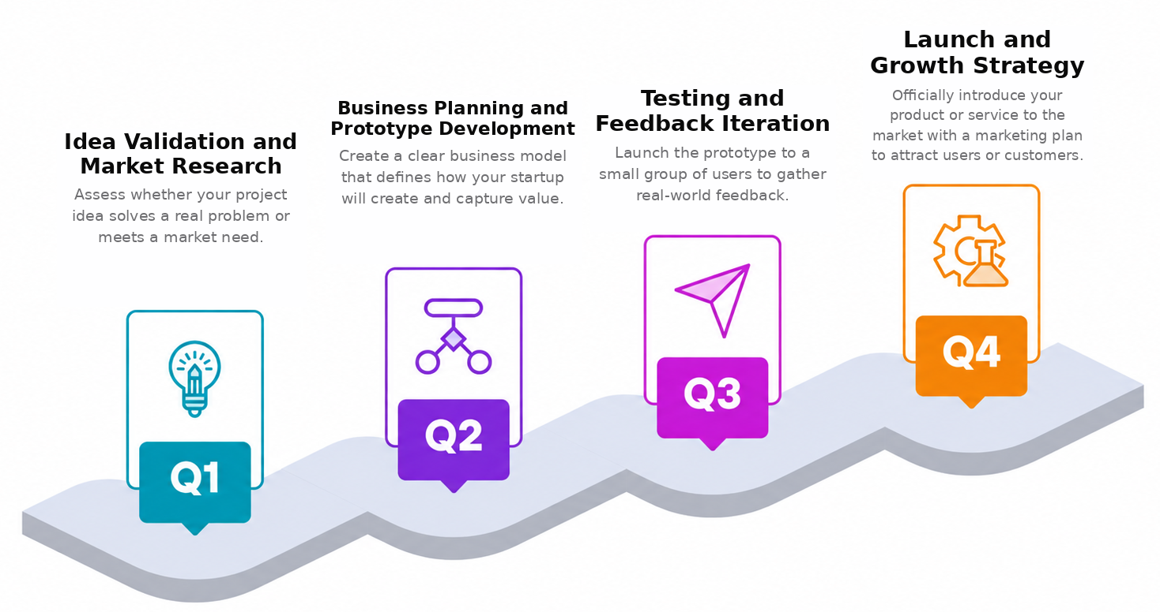
ROADMAP

Figure 1.3: LaunchIt Development Roadmap

Roadmap Details
Idea Validation and Market Research
- Interview startup owners to confirm problems with scattered records, delayed reports, and support tracking. Translate the confirmed needs into clear client and administrator requirements.
Business Planning and Prototype Development
- Define the modules, user roles, permissions, workflows, and database structure. Build the role-based PHP and MySQL prototype for clients and administrators.
Testing and Feedback Iteration
- Test usability, permissions, organization data isolation, record handling, and report output with representative users. Improve the system using documented pilot feedback.
Launch and Growth Strategy
- Deploy LaunchIt to selected pilot users, monitor usage and support concerns, correct release issues, and prepare the security, backup, and hosting requirements for production.

Purpose
LaunchIt exists to lower the barrier of professional business management and compliance for early-stage Philippine startups. We believe every new venture deserves clear government guidance, reliable financial tools, and professional reports without paying enterprise prices or learning complicated software. Our purpose is to help small business owners start legally, record accurately, and grow confidently from day one.

Advantages
- Compliance guides (DTI, SEC, BIR, LGU) integrated with accounting unique all-in-one value
- ​Four standard accounting reports generated automatically no manual spreadsheet work
- ​Locally preferred payment options: GCash, bank transfer, PayPal
- ​Loyalty reward: 6 years continuous use 1 year free access
- Role-based system: powerful admin tools and simple client experience

Disadvantages
• Internet and server dependence: Clients need a stable connection and reliable hosting. Network or server interruptions may temporarily prevent access to business records and system functions.
• Learning curve and resistance to change: Users who are comfortable with paper records or spreadsheets may need training and time before they consistently use the new workflow.
• Security and privacy responsibility: The system stores account, business, and financial information, so weak passwords, incorrect permissions, or missed security updates could expose sensitive data.
• Initial setup and data entry: Organizations must create their profiles, configure permissions, and encode or transfer existing records before they can fully benefit from the system.
• Limited production readiness: The current version still requires production hosting, formal security testing, audit logs, automated backups, and further user acceptance testing before public deployment.

INVESTMENT CAPITAL DISTRIBUTION
The estimated project investment is the planned amount required to develop, test, document, and pilot LaunchIt. The amounts below are estimates in Philippine pesos and should not be presented as actual expenses without receipts or supplier quotations.
Item | Estimated cost | Budget share | Purpose
Pilot hosting/server | ₱1,500 | 30% | Short pilot deployment and basic online hosting
Domain name | ₱800 | 16% | Project web address for the pilot period
Internet/data | ₱1,000 | 20% | Development, testing, research, and coordination
Transportation | ₱700 | 14% | Client interviews, meetings, and user testing
Printing/documentation | ₱500 | 10% | Research forms, review copies, and submission materials
Testing/contingency | ₱500 | 10% | Testing needs and minor unforeseen costs
Total Estimated Investment | ₱5,000 | 100% | Complete estimated project allocation

Table 1.2: Estimated Investment Capital Distribution for LaunchIt
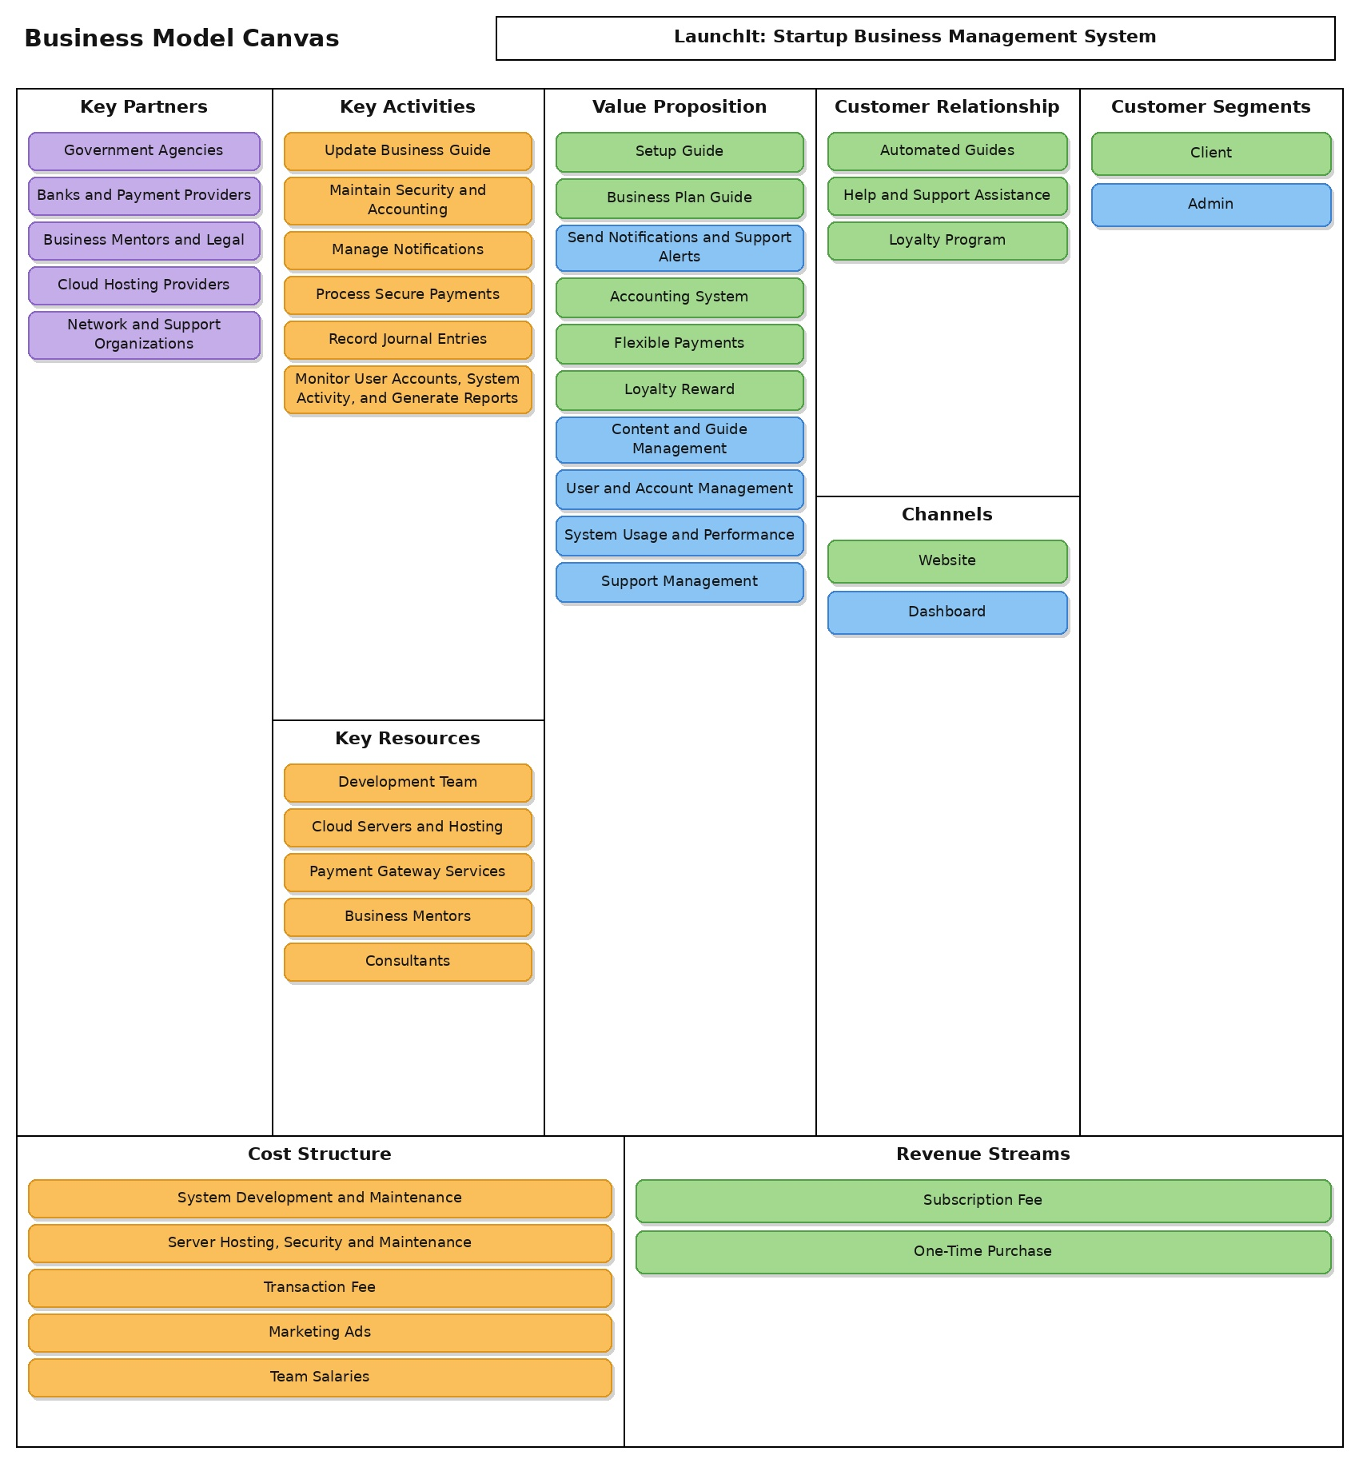
Business Model Canvas

Figure 1.4:

Value Proposition Canvas (each content should have different color)
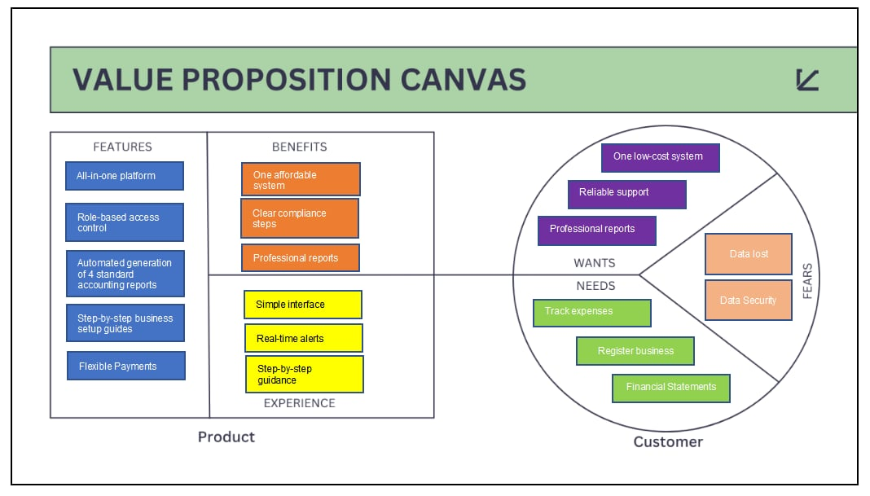

Figure 1.5:

SWOT Analysis (fill in this SWOT ANALYSIS based on your product)
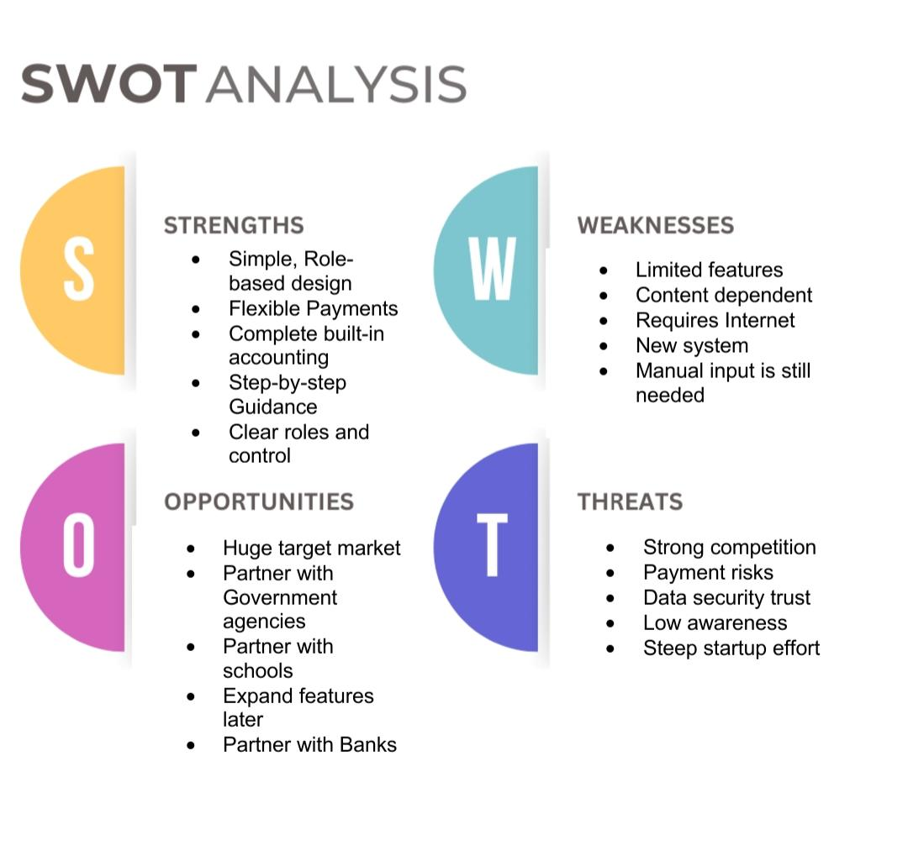
Figure 1.6:

TECHNOLOGY STACK
PRODUCT MATERIALS
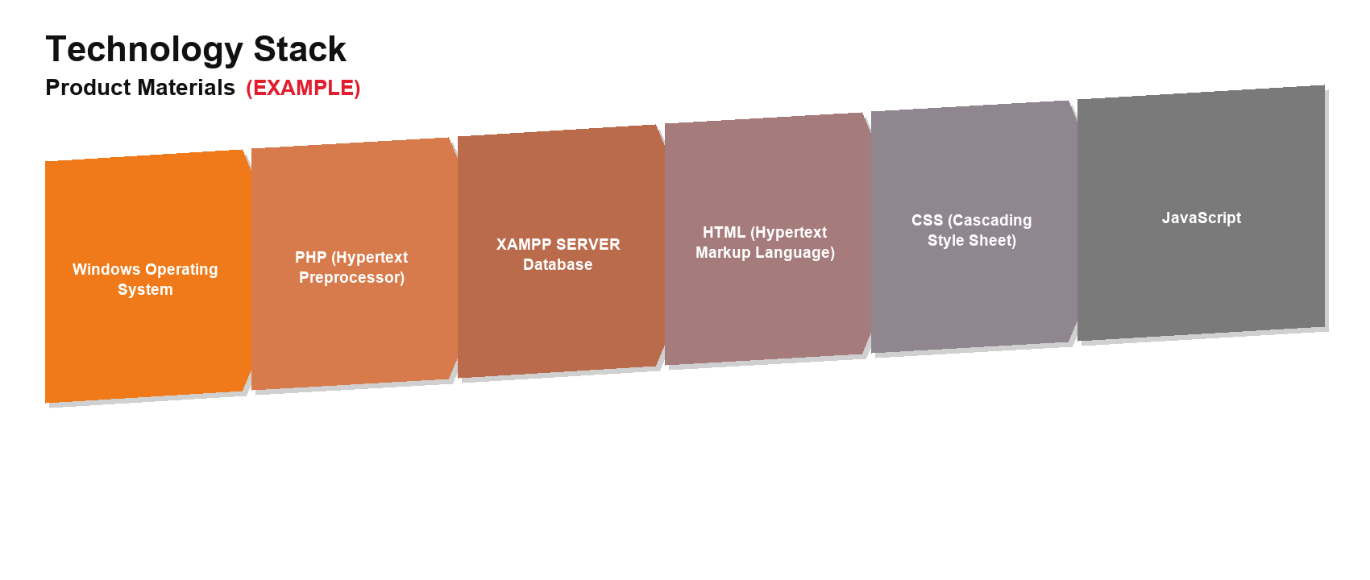
Figure 1.7: Product Materials Used in the LaunchIt Technology Stack
The following product materials are used to develop, test, and operate the LaunchIt web application.
Explanation of Each Product Material
Windows Operating System
Windows is the main operating system used by the development team to create, test, and run the LaunchIt system. It supports the local development tools and provides the working environment for the web application.
PHP Hypertext Preprocessor
PHP is the server-side programming language used to process user requests, validate submitted data, manage login sessions, apply the system's business rules, and communicate with the database.
XAMPP Server and MySQL Database
XAMPP provides the local Apache and PHP server environment used during development and testing. Its MySQL database stores and organizes system information such as user accounts, startup records, financial entries, announcements, and support requests.
HTML HyperText Markup Language
HTML defines the structure and content of the system's web pages. It is used to build headings, navigation menus, forms, tables, buttons, and other elements displayed in the browser.
CSS Cascading Style Sheets
CSS controls the visual appearance and layout of the interface. It is used to apply colors, spacing, typography, responsive sizing, and consistent presentation across the system's pages.
JavaScript
JavaScript adds client-side interaction to the web application. It supports immediate form feedback, interface controls, dynamic page updates, and other actions that respond to the user's input.
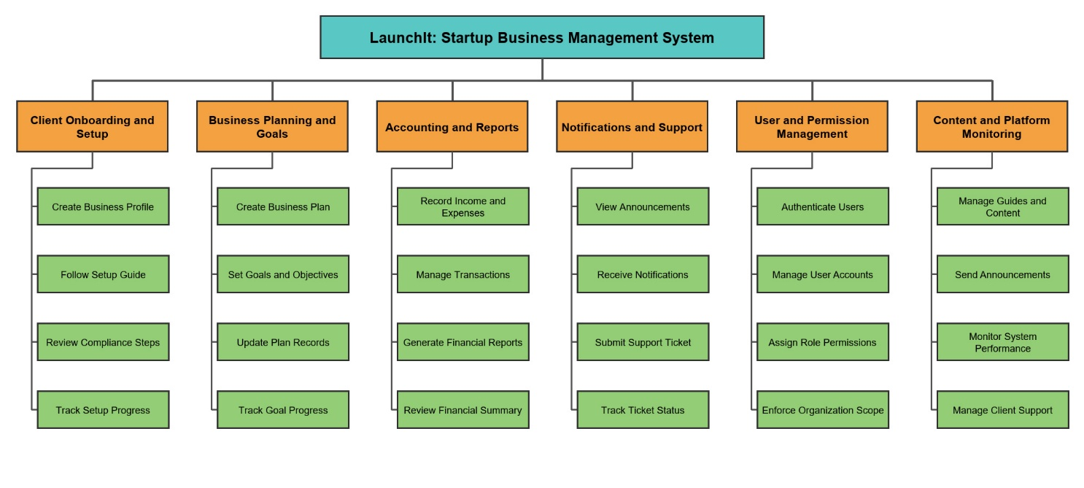
FUNCTIONAL DECOMPOSITION DIAGRAM
Figure 1.8: Functional Decomposition Diagram of LaunchIt

Flow of the Study
Input Process Output

- Storing user activity records

- Storing senior citizen data

- Filtering beneficiary life status

- Analyze eligible beneficiaries’ data.

- Filtering claimed and unclaimed benefits

- Generating senior citizen reports

- Track user activity

- Add senior citizen data

- Track beneficiary life status

- Select eligible beneficiaries

- Track benefits

- Create senior citizen reports

- Display user activity records

- Display senior citizen data

- Display deceased and active beneficiary list

- Display eligible beneficiaries list

- Display benefits status

- Display senior citizen reports

Figure 1.9:

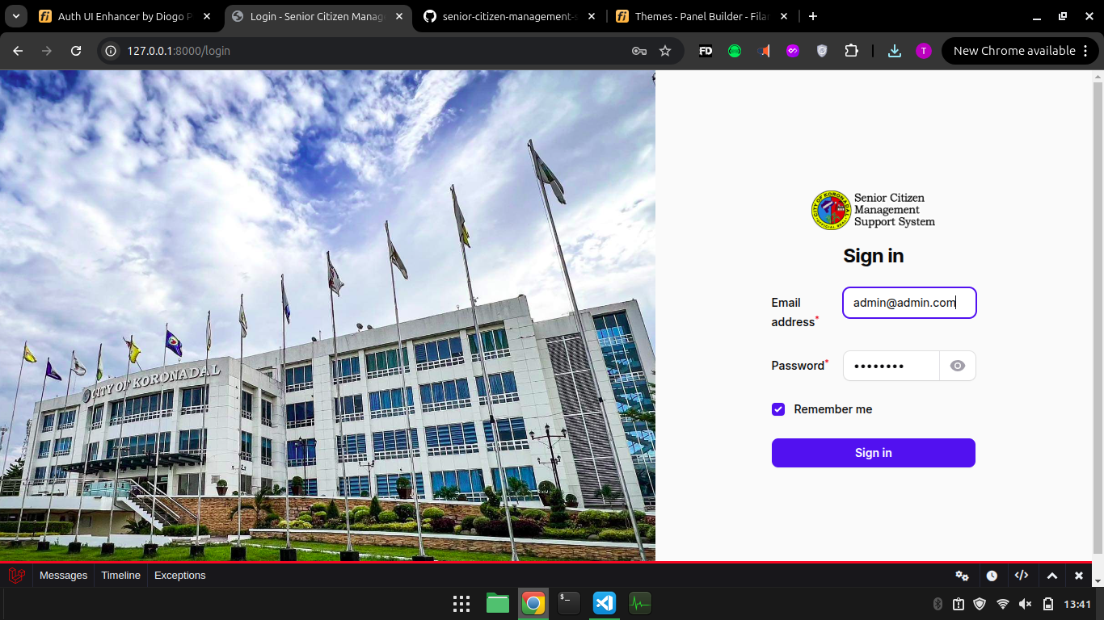
Storyboard

Figure 3.7.0 Senior Citizen Management Support System Admin/User Log in Page
When the admin or user wants to access the Senior Citizen Management Support System (SCMSS), they are first directed to this log-in page using their credentials to gain access to the system's functionalities, ensuring security and authorized access.
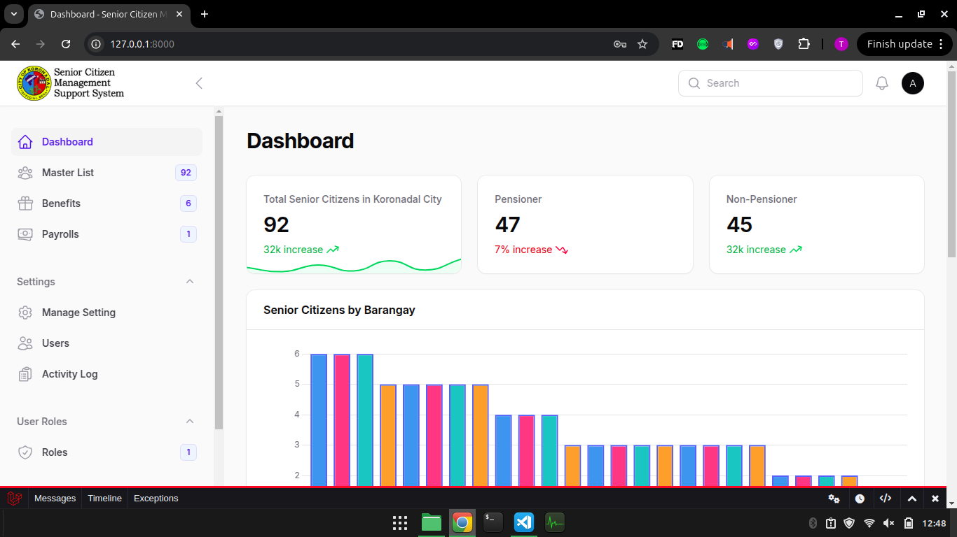

Figure 3.7.1 Senior Citizen Management Support System Dashboard Page
The dashboard provides an overview and quick access to key modules like managing senior citizen data, benefits, and payroll, enabling efficient navigation.

Summary and Conclusion (1 PARAGRAPH EACH)

CURRICULUM VITAE

