Table of Contents
Title Page....................................................................................................
Cover Page.................................................................................................................
Table of Contents ........................................................................................................... ii
Executive Summary ....................................................................................................1
Customer Validation Board ..............................................................................................
Customer and Problem Validation ...............................................................2
Assumptions, Validation, Solution and Value .............................................3
Startup Description .......................................................................................................
Startup Project Name........................................................................................4
Synergy ..............................................................................................................4
Product Type......................................................................................................4
Startup Stage.....................................................................................................5
Product/Service Description .............................................................................7
The Problem ......................................................................................................7
Customer Segments .........................................................................................7
Competitive Advantage.....................................................................................8
Revenue Stream................................................................................................9
Team Description ............................................................................................10

Executive Summary (2 PARAGRAPH)

CUSTOMER VALIDATION BOARD
Customer and Customer Description
Customer persona | Description
Maria Santos | A 35-year-old owner of a small Philippine retail startup. She handles business planning, daily records, income and expenses, and customer concerns. She needs a simple way to keep these activities organized in one place.

Problems Encountered by the Client
Problem | Description
Scattered records | Maria keeps plans, goals, financial entries, and supporting information in separate files, which makes current information difficult to locate.
Delayed reports | Manual recording and repeated checking take time, so financial summaries may not be available when business decisions are needed.
Untracked guidance and support | Questions, announcements, and follow-ups handled through different channels may be missed or difficult to review later.

Riskiest Assumptions
Assumption | Why it is risky
Highest-risk assumption: Maria and similar startup owners struggle to manage business information because their records are scattered. | If intended clients already have an effective process, the main reason for developing an integrated system becomes weak.
Manual transaction recording makes financial summaries slow or difficult to prepare. | If reports are already accurate and timely, the accounting features may provide limited value.
Clients need one place for guidance, announcements, and support requests. | If these interactions are rare or already easy to track, the feature may not be a priority.

Validation Method
The researchers will interview prospective startup owners and observe how they currently organize plans, financial records, and support concerns. They will record the tools used, time required, common delays, and missing information. The same users will then complete representative tasks using the prototype so the team can compare results and validate or reject each assumption.
Assumption to test | Method | Expected evidence
Scattered records affect daily work | Interview and workflow observation | The participant uses several record locations and describes difficulty combining information.
Manual recording delays reports | Observe preparation of a financial summary | The participant identifies repeated entry, checking work, or delays.
Support is difficult to track | Interview and review recent concerns | The participant describes missed follow-ups or difficulty finding previous responses.

Proposed Solution
LaunchIt: Startup Business Management System is a web-based platform that combines setup guidance, business planning, goals, accounting records and reports, notifications, and support in one client workspace. Administrators manage guides, accounts, permissions, announcements, and support while client-owned records remain assigned to the correct organization.
Value and Benefit
If the assumptions are confirmed, LaunchIt can help clients find records faster, reduce repeated manual work, prepare financial summaries more efficiently, and monitor guidance and support concerns from one workspace. These benefits will be treated as expected outcomes until client testing provides evidence.
STARTUP DESCRIPTION
Startup Project Name
- LaunchIt: Startup Business Management System
Synergy
- Information Technology & Business Management
Product Type
Materials
- Web-based management application
- Cloud-hosted database infrastructure
- User authentication & role-based access control
- Business setup & compliance guide management system
- Financial journal entry & accounting report engine
- Support ticketing & announcement broadcast system
- Payment processing & subscription management module
- Activity logging & system performance reporting

STARTUP STAGE
Phase 1: Idea Generation and Research
- Research and Development: Researched existing tools and identified gaps—specifically the lack of integrated compliance guides + accounting for Philippine startups.
- Market research: Surveyed founders and owners to identify top needs: government setup guides, financial recording, reporting, and affordable access.
- Concept development: Designed a two-role system (Admin + Client) combining guides, financial recording, reporting, and subscription management.
- Competitor analysis: Compared features, pricing, and complexity; positioned LaunchIt as compliance-focused, locally relevant, and affordable.
- Idea validation: Verified through interviews that the proposed features solve real problems and users are willing to subscribe.
Phase 2: Planning and Development
- Business plan creation: Defining product scope, target market, pricing model, and financial projections to guide operations and growth.
- MVP/prototype development: Building a working minimum viable product with core modules including dashboard, task management, and basic financial recording.
- Team building and role assignment: Assigning roles covering product design, software development, quality assurance, and business outreach.
- Budget and resource planning:Allocating seed funds for development tools, hosting services, marketing, and contingency expenses.
- Goal and KPI setting: Set measurable targets including user sign-ups, feature adoption rates, and customer satisfaction scores.

Phase 3: Testing and Iteration
• Usability testing:
• User feedback collection:
• Feature iteration:
Phase 4: Product Launch and User Acquisition
• Feedback and Improvement:
• Marketing and sales:
Phase 5: Scaling and Expansion
- Operations optimization:
- User base growth:
- Funding and investment:
- Market expansion:
- Infrastructure and team scaling:
Product/Service Description
LaunchIt is an integrated business management system built exclusively for Philippine startups and early-stage ventures. It is organized into two clear roles: the Admin Module for overseeing users, guides, support, payments, and system performance; and the Client Module that provides step-by-step business setup guidance, ready-to-use business plan templates, financial journal entry, and automated generation of four standard accounting reports.
Clients may subscribe securely via GCash, online bank transfer, or PayPal and receive a special loyalty reward: six years of continuous use grants permanent free access. Accessible via any web browser, the system requires no specialized training so founders can organize operations professionally from day one.

The Problem
- Startup business owners manage operations across many disconnected tools, causing confusion and extra costs.
- Government compliance requirements (DTI, SEC, BIR, LGU) are scattered and difficult to follow in one place.
- Financial records are kept in spreadsheets or notebooks; generating proper accounting reports is difficult or impossible.
- Generic enterprise management systems are too expensive, complicated, and not tailored to Philippine startup needs.
- Business owners lack a secure, affordable way to subscribe to services with locally convenient payment options.
Customer Segments
- Client
- Admin
Competitive Advantage
LaunchIt distinguishes itself by combining Philippine-specific compliance guides (DTI, SEC, BIR, LGU) with integrated accounting a feature combination competitors do not offer at this price point. Every feature addresses a verified pain point, resulting in a system that is simpler, more relevant, and faster to use than generic alternatives. The interface is designed for quick daily use; founders can record transactions or follow compliance steps without navigating complicated menus. Additionally, LaunchIt offers locally preferred payment methods and a unique loyalty reward that permanently removes subscription fees after six years of continuous use.
Beyond features, LaunchIt provides a complete experience: compliance guidance, financial recording, business planning, and reporting all in one platform. Most alternatives require purchasing separate tools or paying extra for accounting and templates; LaunchIt includes everything together. We also prioritize local relevance supporting PHP currency and government requirements that Philippine startups actually face. This focus ensures LaunchIt is not just another management tool, but a system truly built for the way local startups operate.

Revenue Streams
    - Subscription fee
    - One-time purchase






Team Description

Hacker, Hipster, Hustler | Hipster | Hipster | Hipster | Hipster
Natasha A. Tanallon |  | NAME | NAME
Develops the system’s technical components, including the front end, PHP functions, database connection, testing, and troubleshooting. | Designs the system’s interface, page layout, visual style, diagrams, presentation materials, and documentation format. | Assists with interface design, research materials, system diagrams, documentation, and visual presentation. | Assists with interface design, research materials, system diagrams, documentation, and visual presentation. | Helps improve the system’s usability, prepares graphics and presentation materials, and checks the consistency of the documentation.

Table 1.1: Team Description

STARTUP CHALLENGES
Product Definition, Problem and Solution, Conclusion (1 paragraph each)

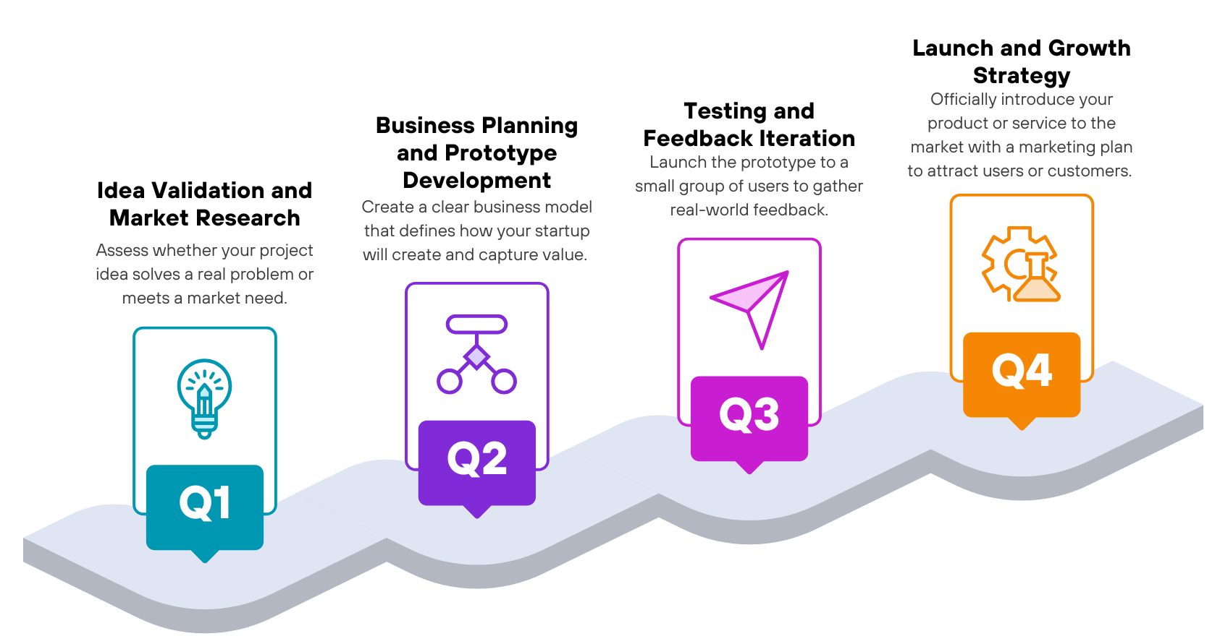
ROADMAP

Figure 1.3:

Answer each based on your product 1 paragraph in a bullet form
Idea Validation and Market Research
- Answer
Business Planning and Prototype Development
- Answer
Testing and Feedback Iteration
- Answer
Launch and Growth Strategy
- Answer

Purpose
LaunchIt exists to lower the barrier of professional business management and compliance for early-stage Philippine startups. We believe every new venture deserves clear government guidance, reliable financial tools, and professional reports without paying enterprise prices or learning complicated software. Our purpose is to help small business owners start legally, record accurately, and grow confidently from day one.

Advantages
- Compliance guides (DTI, SEC, BIR, LGU) integrated with accounting unique all-in-one value
- ​Four standard accounting reports generated automatically no manual spreadsheet work
- ​Locally preferred payment options: GCash, bank transfer, PayPal
- ​Loyalty reward: 6 years continuous use 1 year free access
- Role-based system: powerful admin tools and simple client experience

Disadvantages
List your disadvantages with a brief explanation

INVESTMENT CAPITAL DISTRIBUTION
The estimated project investment is the planned amount required to develop, test, document, and pilot LaunchIt. The amounts below are estimates in Philippine pesos and should not be presented as actual expenses without receipts or supplier quotations.
Item | Estimated cost | Budget share | Purpose
Pilot hosting/server | ₱1,500 | 30% | Short pilot deployment and basic online hosting
Domain name | ₱800 | 16% | Project web address for the pilot period
Internet/data | ₱1,000 | 20% | Development, testing, research, and coordination
Transportation | ₱700 | 14% | Client interviews, meetings, and user testing
Printing/documentation | ₱500 | 10% | Research forms, review copies, and submission materials
Testing/contingency | ₱500 | 10% | Testing needs and minor unforeseen costs
Total Estimated Investment | ₱5,000 | 100% | Complete estimated project allocation

Table 1.2: Estimated Investment Capital Distribution for LaunchIt
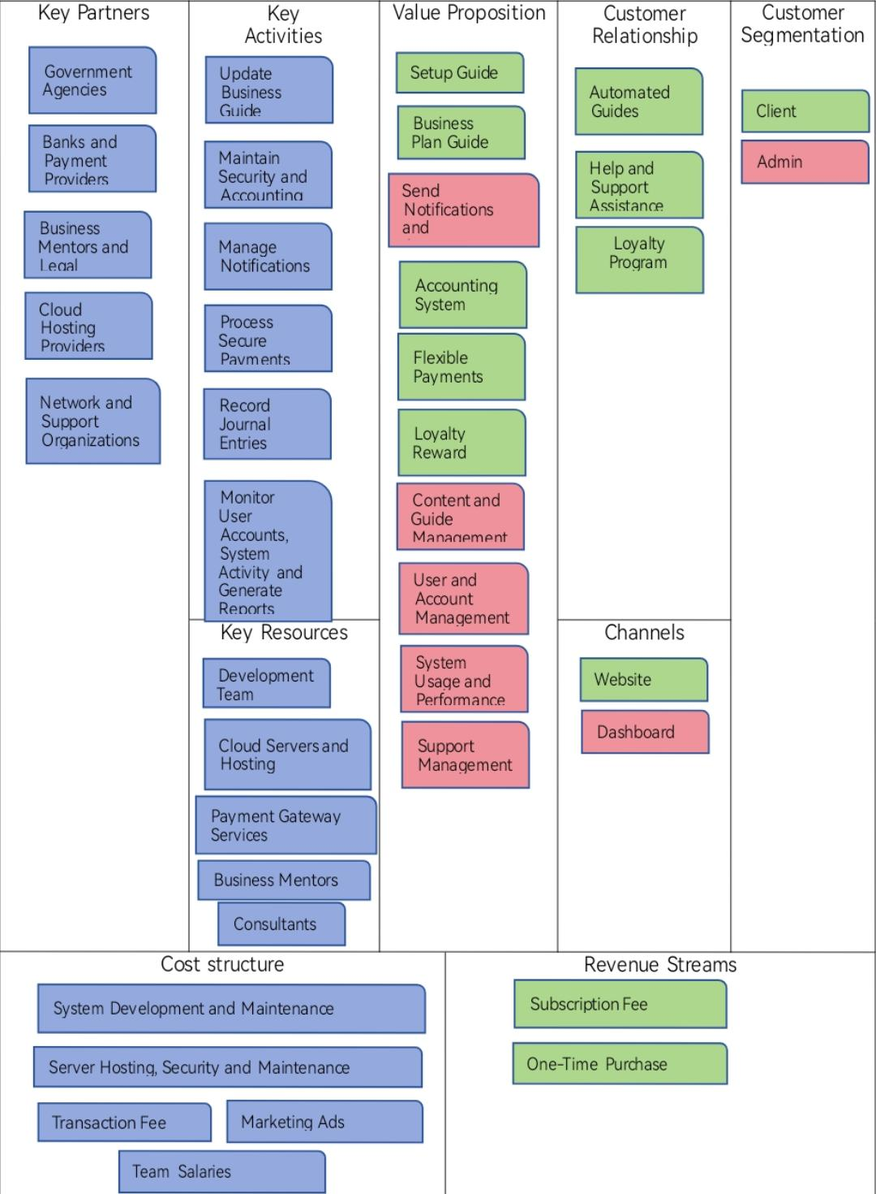
Business Model Canvas

Figure 1.4:

Value Proposition Canvas (each content should have different color)
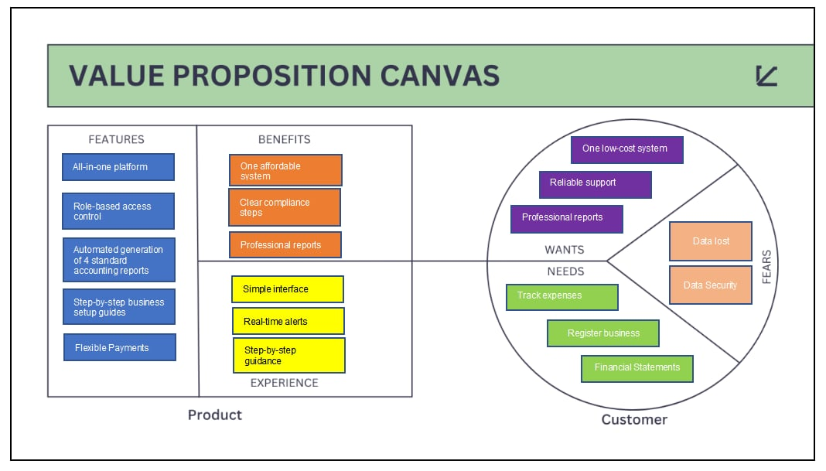

Figure 1.5:

SWOT Analysis (fill in this SWOT ANALYSIS based on your product)
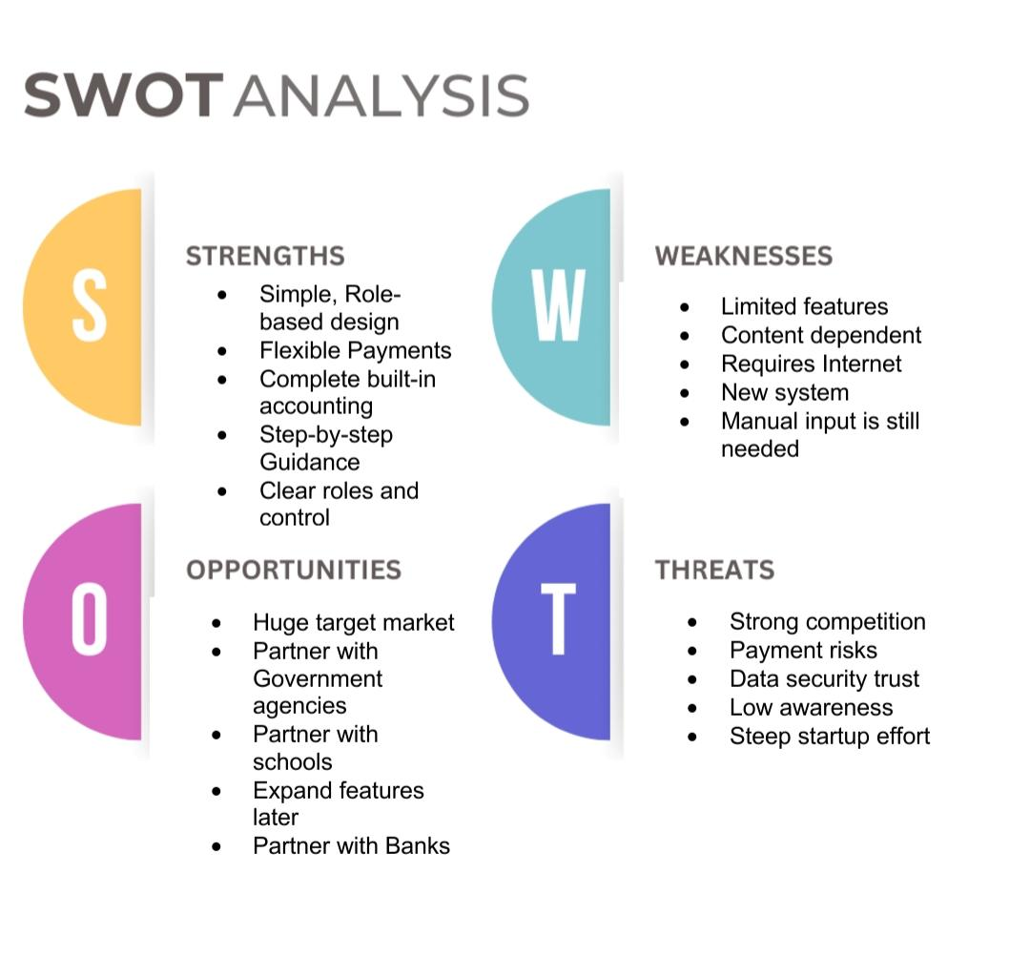
Figure 1.6:

TECHNOLOGY STACK
The technology stack consists of the actual technologies used to build and run the current web application. Front-end technologies create the interface seen by users, while the back end processes requests and stores system data.
Category | Technology | Description
Front end | HTML | Structures the web pages, navigation, forms, tables, and other visible content.
Front end | CSS | Controls the page layout, colors, spacing, and responsive presentation.
Front end | JavaScript | Handles browser interactions and sends requests to the server.
Back end | PHP | Processes authentication, sessions, permissions, validation, and application requests.
Database | MySQL | Stores user accounts, organizations, plans, goals, transactions, notifications, and support records.
Development environment | XAMPP and Apache | Runs the PHP application and MySQL database in the local development environment.
Database setup | SQL migration scripts | Create and update the database tables required by the system.

Figure 1.7: Technology Stack Used in LaunchIt
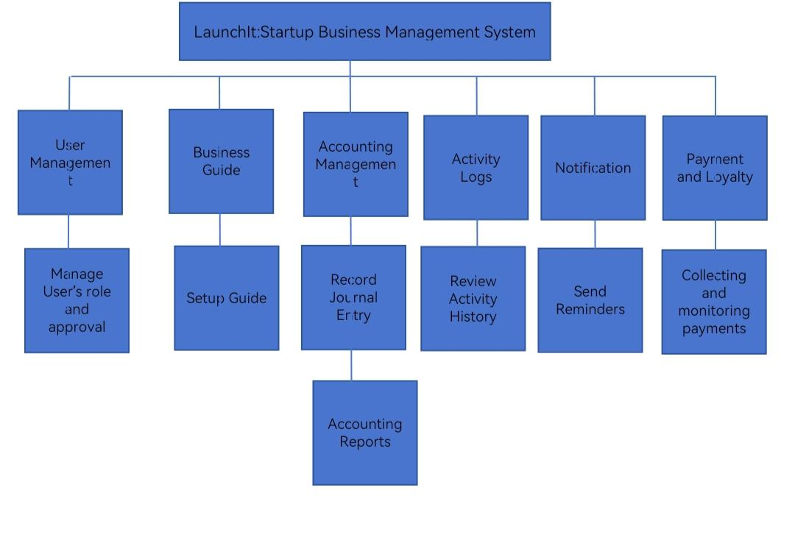
Functional Decomposition Diagram
Figure 1.8:

Flow of the Study
Input Process Output

- Storing user activity records

- Storing senior citizen data

- Filtering beneficiary life status

- Analyze eligible beneficiaries’ data.

- Filtering claimed and unclaimed benefits

- Generating senior citizen reports

- Track user activity

- Add senior citizen data

- Track beneficiary life status

- Select eligible beneficiaries

- Track benefits

- Create senior citizen reports

- Display user activity records

- Display senior citizen data

- Display deceased and active beneficiary list

- Display eligible beneficiaries list

- Display benefits status

- Display senior citizen reports

Figure 1.9:

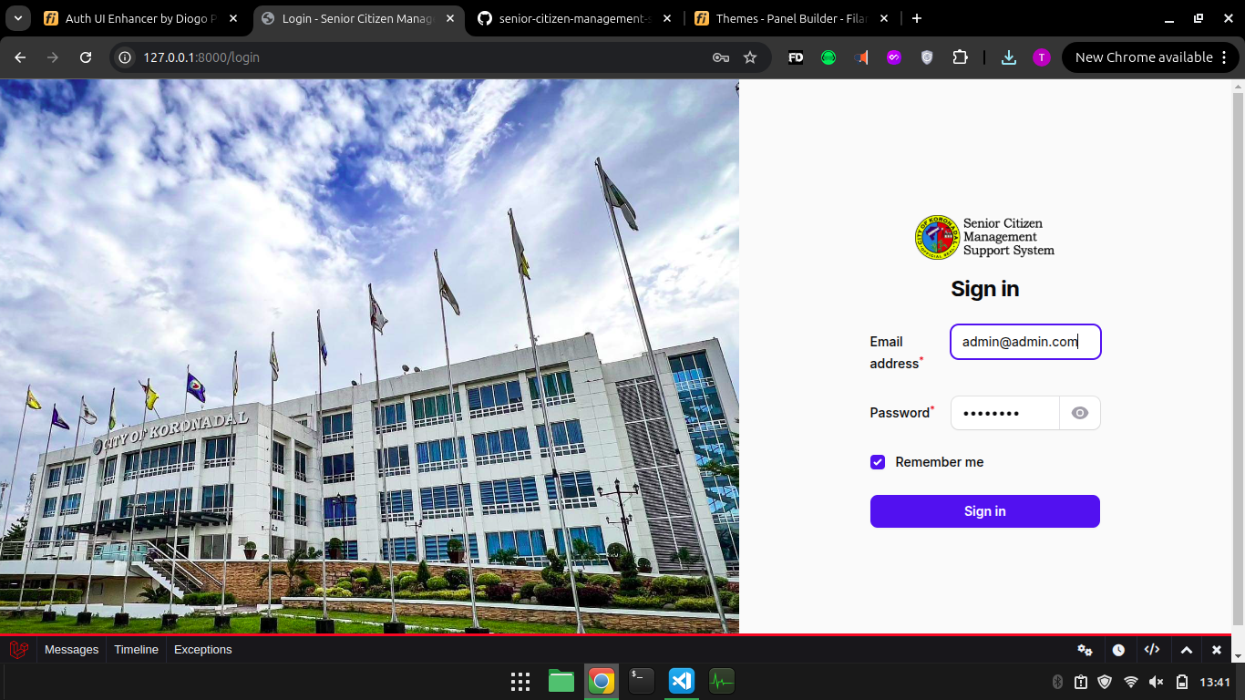
Storyboard

Figure 3.7.0 Senior Citizen Management Support System Admin/User Log in Page
When the admin or user wants to access the Senior Citizen Management Support System (SCMSS), they are first directed to this log-in page using their credentials to gain access to the system's functionalities, ensuring security and authorized access.
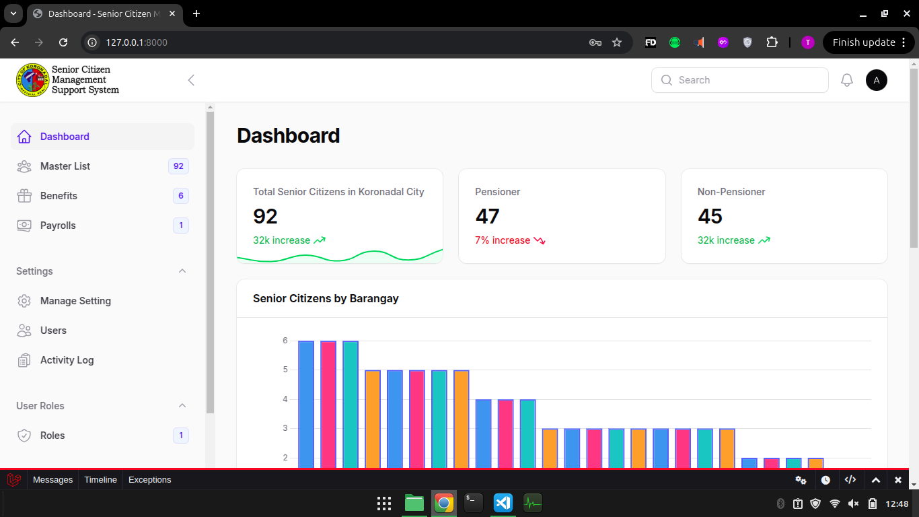

Figure 3.7.1 Senior Citizen Management Support System Dashboard Page
The dashboard provides an overview and quick access to key modules like managing senior citizen data, benefits, and payroll, enabling efficient navigation.

Summary and Conclusion (1 PARAGRAPH EACH)

CURRICULUM VITAE

