Table of Contents
Title Page....................................................................................................
Cover Page.................................................................................................................
Table of Contents ........................................................................................................... ii
Executive Summary ....................................................................................................1
Customer Validation Board ..............................................................................................
Customer and Problem Validation ...............................................................2
Assumptions, Validation, Solution and Value .............................................3
Startup Description .......................................................................................................
Startup Project Name........................................................................................4
Synergy ..............................................................................................................4
Product Type......................................................................................................4
Startup Stage.....................................................................................................5
Product/Service Description .............................................................................7
The Problem ......................................................................................................7
Customer Segments .........................................................................................7
Competitive Advantage.....................................................................................8
Revenue Stream................................................................................................9
Team Description ............................................................................................10

Executive Summary (2 PARAGRAPH)

CUSTOMER VALIDATION BOARD
Customer Validation Board
Startup Idea: | LaunchIt: Startup Business Management System
Stage: | Problem and Solution Validation
Experiment | 1 | 2 | 3
Customer | Maria Santos, 35 - owner of a small retail startup who manages plans, records, income, and expenses. | Carlo Reyes, 27 - founder of a small service startup who prepares reports from spreadsheet records. | Angela Cruz, 31 - online microbusiness owner who tracks guidance and support through several channels.
Problem | Plans, goals, and financial records are stored in separate places and are difficult to find. | Manual transaction checking delays the preparation of reliable financial summaries. | Announcements, questions, and support follow-ups may be missed or difficult to review.
Solution | Provide one client workspace for setup guidance, plans, goals, and business records. | Provide organized transaction recording and automatically prepared financial summaries. | Provide one area for notifications, guidance, and trackable support requests.
Riskiest Assumption | Similar startup owners experience enough difficulty with scattered records to adopt one integrated system. | Similar owners consider delayed financial reporting a serious problem that requires a digital solution. | Similar owners need centralized guidance and support and will use the feature regularly.
Validation Method | Interview and observe five retail startup owners completing a record-finding task. | Observe five service startup owners preparing a recent financial summary. | Interview five online microbusiness owners and review how they follow prior concerns.
Success Criteria | At least 4 of 5 participants confirm that scattered records disrupt their work. | At least 4 of 5 participants report repeated work, errors, or delays when preparing reports. | At least 4 of 5 participants confirm difficulty tracking guidance or support follow-ups.
Results and Discussions | Pending validation. Complete this cell after the five interviews and observations. | Pending validation. Complete this cell after the five reporting tasks. | Pending validation. Complete this cell after the five interviews and record reviews.
Learnings | Record the confirmed causes of scattered information and the features clients value most. | Record the steps that create reporting delays and the summaries clients actually require. | Record the channels clients use and the follow-up information they need to retain.
Figure 1.1: Customer Validation Board for LaunchIt
STARTUP DESCRIPTION
Startup Project Name
- LaunchIt: Startup Business Management System
Synergy
- Information Technology & Business Management
Product Type
Materials
- Web-based management application
- Cloud-hosted database infrastructure
- User authentication & role-based access control
- Business setup & compliance guide management system
- Financial journal entry & accounting report engine
- Support ticketing & announcement broadcast system
- Payment processing & subscription management module
- Activity logging & system performance reporting

STARTUP STAGE
Phase 1: Idea Generation and Research
- Research and Development: Researched existing tools and identified gaps—specifically the lack of integrated compliance guides + accounting for Philippine startups.
- Market research: Surveyed founders and owners to identify top needs: government setup guides, financial recording, reporting, and affordable access.
- Concept development: Designed a two-role system (Admin + Client) combining guides, financial recording, reporting, and subscription management.
- Competitor analysis: Compared features, pricing, and complexity; positioned LaunchIt as compliance-focused, locally relevant, and affordable.
- Idea validation: Verified through interviews that the proposed features solve real problems and users are willing to subscribe.
Phase 2: Planning and Development
- Business plan creation: Defining product scope, target market, pricing model, and financial projections to guide operations and growth.
- MVP/prototype development: Building a working minimum viable product with core modules including dashboard, task management, and basic financial recording.
- Team building and role assignment: Assigning roles covering product design, software development, quality assurance, and business outreach.
- Budget and resource planning:Allocating seed funds for development tools, hosting services, marketing, and contingency expenses.
- Goal and KPI setting: Set measurable targets including user sign-ups, feature adoption rates, and customer satisfaction scores.

Phase 3: Testing and Iteration
• Usability testing:
• User feedback collection:
• Feature iteration:
Phase 4: Product Launch and User Acquisition
• Feedback and Improvement:
• Marketing and sales:
Phase 5: Scaling and Expansion
- Operations optimization:
- User base growth:
- Funding and investment:
- Market expansion:
- Infrastructure and team scaling:
Product/Service Description
LaunchIt is an integrated business management system built exclusively for Philippine startups and early-stage ventures. It is organized into two clear roles: the Admin Module for overseeing users, guides, support, payments, and system performance; and the Client Module that provides step-by-step business setup guidance, ready-to-use business plan templates, financial journal entry, and automated generation of four standard accounting reports.
Clients may subscribe securely via GCash, online bank transfer, or PayPal and receive a special loyalty reward: six years of continuous use grants permanent free access. Accessible via any web browser, the system requires no specialized training so founders can organize operations professionally from day one.

The Problem
- Startup business owners manage operations across many disconnected tools, causing confusion and extra costs.
- Government compliance requirements (DTI, SEC, BIR, LGU) are scattered and difficult to follow in one place.
- Financial records are kept in spreadsheets or notebooks; generating proper accounting reports is difficult or impossible.
- Generic enterprise management systems are too expensive, complicated, and not tailored to Philippine startup needs.
- Business owners lack a secure, affordable way to subscribe to services with locally convenient payment options.
Customer Segments
- Client
- Admin
Competitive Advantage
LaunchIt distinguishes itself by combining Philippine-specific compliance guides (DTI, SEC, BIR, LGU) with integrated accounting a feature combination competitors do not offer at this price point. Every feature addresses a verified pain point, resulting in a system that is simpler, more relevant, and faster to use than generic alternatives. The interface is designed for quick daily use; founders can record transactions or follow compliance steps without navigating complicated menus. Additionally, LaunchIt offers locally preferred payment methods and a unique loyalty reward that permanently removes subscription fees after six years of continuous use.
Beyond features, LaunchIt provides a complete experience: compliance guidance, financial recording, business planning, and reporting all in one platform. Most alternatives require purchasing separate tools or paying extra for accounting and templates; LaunchIt includes everything together. We also prioritize local relevance supporting PHP currency and government requirements that Philippine startups actually face. This focus ensures LaunchIt is not just another management tool, but a system truly built for the way local startups operate.

Revenue Streams
    - Subscription fee
    - One-time purchase






Team Description

Hacker, Hipster, Hustler | Hipster | Hipster | Hipster | Hipster
Natasha A. Tanallon |  | NAME | NAME
Develops the system’s technical components, including the front end, PHP functions, database connection, testing, and troubleshooting. | Designs the system’s interface, page layout, visual style, diagrams, presentation materials, and documentation format. | Assists with interface design, research materials, system diagrams, documentation, and visual presentation. | Assists with interface design, research materials, system diagrams, documentation, and visual presentation. | Helps improve the system’s usability, prepares graphics and presentation materials, and checks the consistency of the documentation.

Table 1.1: Team Description

STARTUP CHALLENGES
Product Definition, Problem and Solution, Conclusion (1 paragraph each)

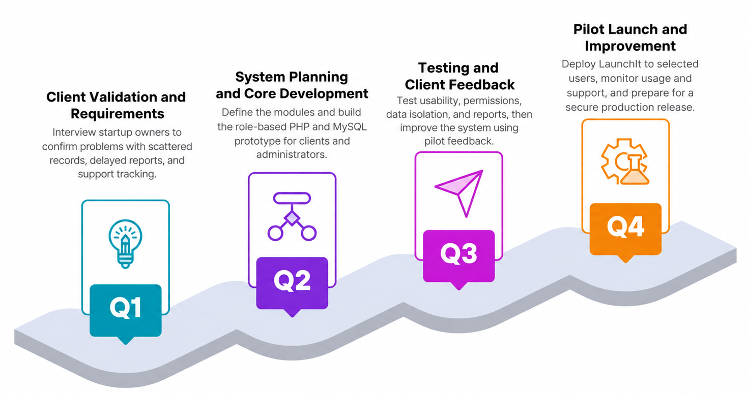
ROADMAP

Figure 1.3: LaunchIt Development Roadmap

Roadmap Details
Q1 Client Validation and Requirements
- Interview startup owners to confirm problems with scattered records, delayed reports, and support tracking. Translate the confirmed needs into clear client and administrator requirements.
Q2 System Planning and Core Development
- Define the modules, user roles, permissions, workflows, and database structure. Build the role-based PHP and MySQL prototype for clients and administrators.
Q3 Testing and Client Feedback
- Test usability, permissions, organization data isolation, record handling, and report output with representative users. Improve the system using documented pilot feedback.
Q4 Pilot Launch and Improvement
- Deploy LaunchIt to selected pilot users, monitor usage and support concerns, correct release issues, and prepare the security, backup, and hosting requirements for production.

Purpose
LaunchIt exists to lower the barrier of professional business management and compliance for early-stage Philippine startups. We believe every new venture deserves clear government guidance, reliable financial tools, and professional reports without paying enterprise prices or learning complicated software. Our purpose is to help small business owners start legally, record accurately, and grow confidently from day one.

Advantages
- Compliance guides (DTI, SEC, BIR, LGU) integrated with accounting unique all-in-one value
- ​Four standard accounting reports generated automatically no manual spreadsheet work
- ​Locally preferred payment options: GCash, bank transfer, PayPal
- ​Loyalty reward: 6 years continuous use 1 year free access
- Role-based system: powerful admin tools and simple client experience

Disadvantages
List your disadvantages with a brief explanation

INVESTMENT CAPITAL DISTRIBUTION
The estimated project investment is the planned amount required to develop, test, document, and pilot LaunchIt. The amounts below are estimates in Philippine pesos and should not be presented as actual expenses without receipts or supplier quotations.
Item | Estimated cost | Budget share | Purpose
Pilot hosting/server | ₱1,500 | 30% | Short pilot deployment and basic online hosting
Domain name | ₱800 | 16% | Project web address for the pilot period
Internet/data | ₱1,000 | 20% | Development, testing, research, and coordination
Transportation | ₱700 | 14% | Client interviews, meetings, and user testing
Printing/documentation | ₱500 | 10% | Research forms, review copies, and submission materials
Testing/contingency | ₱500 | 10% | Testing needs and minor unforeseen costs
Total Estimated Investment | ₱5,000 | 100% | Complete estimated project allocation

Table 1.2: Estimated Investment Capital Distribution for LaunchIt
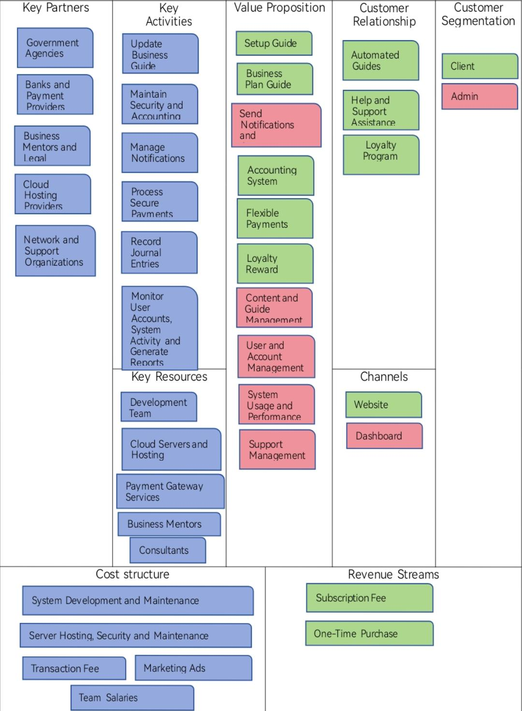
Business Model Canvas

Figure 1.4:

Value Proposition Canvas (each content should have different color)
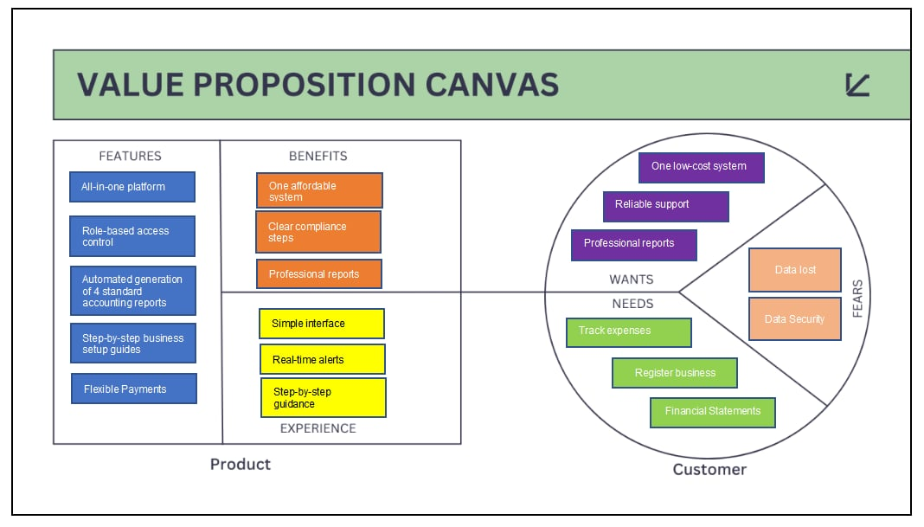

Figure 1.5:

SWOT Analysis (fill in this SWOT ANALYSIS based on your product)
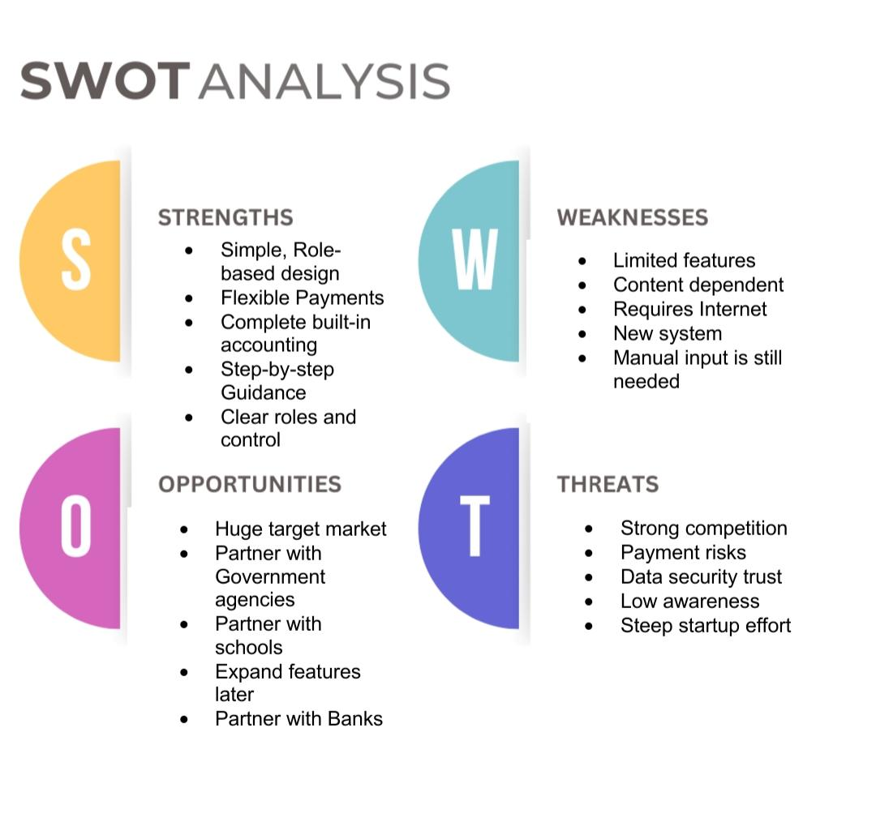
Figure 1.6:

TECHNOLOGY STACK
The technology stack consists of the actual technologies used to build and run the current web application. Front-end technologies create the interface seen by users, while the back end processes requests and stores system data.
Category | Technology | Description
Front end | HTML | Structures the web pages, navigation, forms, tables, and other visible content.
Front end | CSS | Controls the page layout, colors, spacing, and responsive presentation.
Front end | JavaScript | Handles browser interactions and sends requests to the server.
Back end | PHP | Processes authentication, sessions, permissions, validation, and application requests.
Database | MySQL | Stores user accounts, organizations, plans, goals, transactions, notifications, and support records.
Development environment | XAMPP and Apache | Runs the PHP application and MySQL database in the local development environment.
Database setup | SQL migration scripts | Create and update the database tables required by the system.

Figure 1.7: Technology Stack Used in LaunchIt
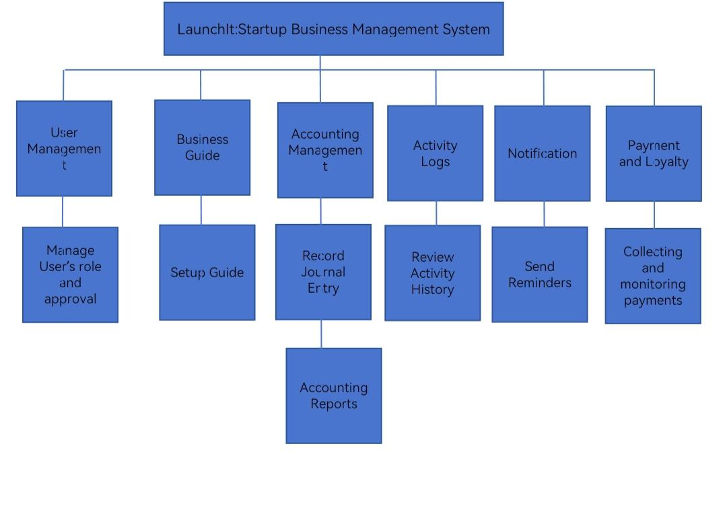
Functional Decomposition Diagram
Figure 1.8:

Flow of the Study
Input Process Output

- Storing user activity records

- Storing senior citizen data

- Filtering beneficiary life status

- Analyze eligible beneficiaries’ data.

- Filtering claimed and unclaimed benefits

- Generating senior citizen reports

- Track user activity

- Add senior citizen data

- Track beneficiary life status

- Select eligible beneficiaries

- Track benefits

- Create senior citizen reports

- Display user activity records

- Display senior citizen data

- Display deceased and active beneficiary list

- Display eligible beneficiaries list

- Display benefits status

- Display senior citizen reports

Figure 1.9:

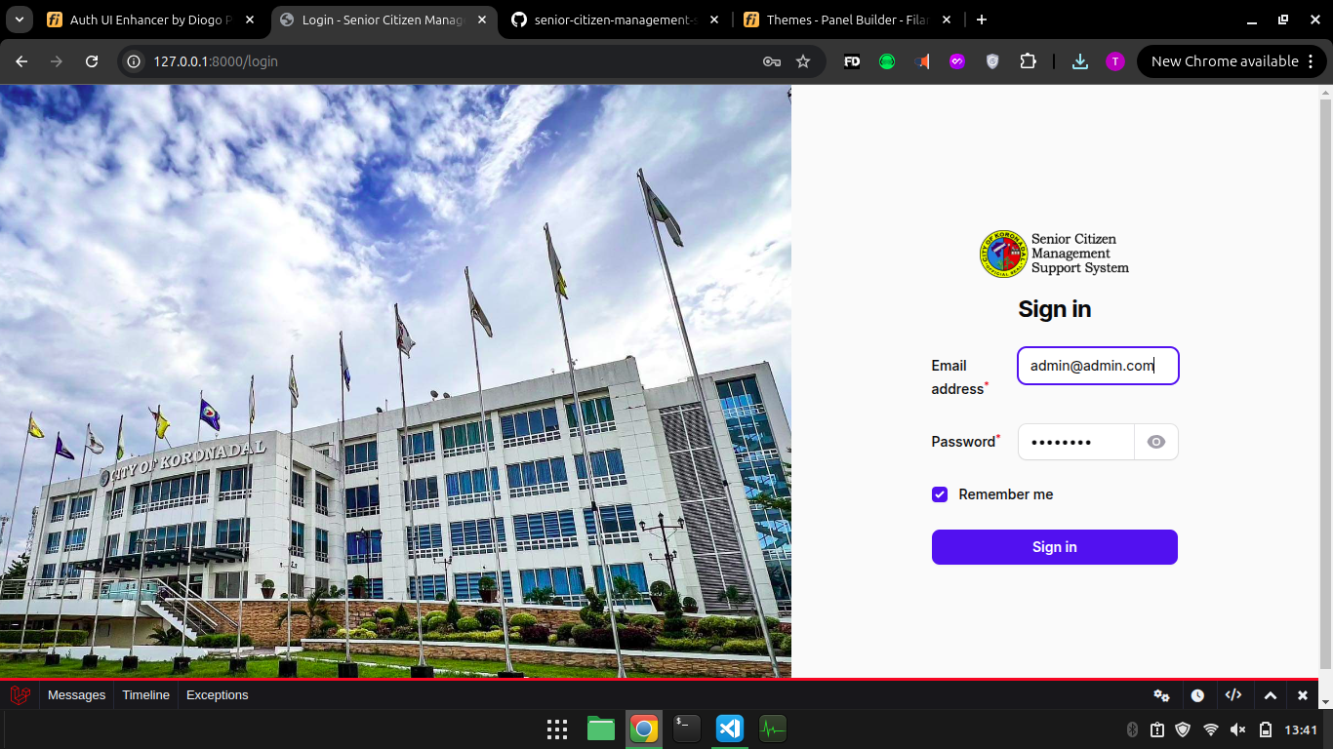
Storyboard

Figure 3.7.0 Senior Citizen Management Support System Admin/User Log in Page
When the admin or user wants to access the Senior Citizen Management Support System (SCMSS), they are first directed to this log-in page using their credentials to gain access to the system's functionalities, ensuring security and authorized access.
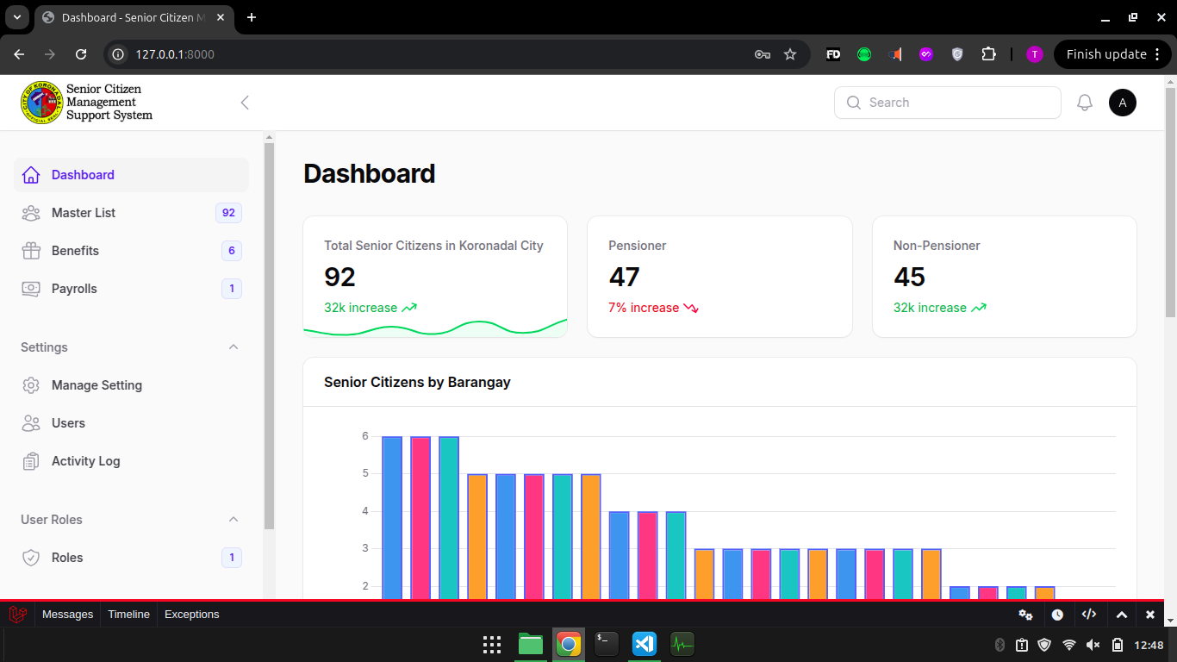

Figure 3.7.1 Senior Citizen Management Support System Dashboard Page
The dashboard provides an overview and quick access to key modules like managing senior citizen data, benefits, and payroll, enabling efficient navigation.

Summary and Conclusion (1 PARAGRAPH EACH)

CURRICULUM VITAE

