STARTUP BUSINESS MANAGEMENT SYSTEM
System and Startup Documentation
A role-based business operations platform for startup clients and administrators
Prepared by the System Development Team
September 2026

TABLE OF CONTENTS
Executive Summary 1
Customer Validation 2
Startup Description 3
Startup Stage 4
Product and Market 5
Team Description 6
Startup Challenges 7
Roadmap 8
Purpose Advantages and Disadvantages 9
Investment Capital Distribution 10
Business Model and Value Proposition 11
SWOT Analysis 12
Technology Stack 13
Functional Decomposition and Flow 14
Storyboard 15
Summary and Conclusion 19

EXECUTIVE SUMMARY
Startup business management system is a web-based platform that helps startup owners complete onboarding, prepare a business plan, set goals, record accounting transactions, review financial reports, receive notifications, and request support from one workspace. The system also gives platform administrators a separate operating view for guide content, client accounts, permissions, system performance, announcements, and support tickets.
The implemented solution uses HTML, CSS, and JavaScript for the interface, PHP for authentication and application programming interfaces, and MySQL for structured storage. Its central control is role-based access: administrators manage the service across organizations, while clients see only the modules and records allowed for their own organization. This reduces confusion, supports data separation, and gives administrators direct control over each client account permission.
Project Scope
• Two supported user roles: Administrator and Client.
• Role-specific navigation that shows only approved modules.
• Organization-scoped storage for client-owned business records.
• Administrator permission settings with none, view, and edit levels.
• Secure sign-in, active-account checks, and protected PHP endpoints.

CUSTOMER VALIDATION BOARD
Stage 1 Problem Validation
Area | Finding | System response
Customer | Startup owners and small business operators | A guided client workspace with plain-language modules
Problem | Business planning and records are spread across separate tools | Planning, goals, accounting, reports, notifications, and support are combined
Risk | Users may view functions they do not need | Navigation and API access follow role and permission rules
Success criterion | A client completes core tasks without administrator intervention | Setup, planning, goal tracking, journal entries, reports, and tickets are self-service

Stage 2 Solution Validation
Test | Expected evidence | Status
Role navigation | Admin and client menus show different modules | Implemented
Tenant isolation | Client records are filtered by organization identifier | Implemented
Permission enforcement | Restricted API requests return an authorization error | Implemented
Usability | Clear labels, consistent cards, tables, and forms | Implemented and ready for user testing

Figure 1.1 Customer validation summary for Startup business management system

STARTUP DESCRIPTION
Startup Project Name
• Startup business management system
Synergy
• Business management
• Financial record keeping
• Startup education and guidance
• Software as a service administration
Product Type
• Responsive web application
• Role-based management information system
• Multi-organization business operations platform
Core Product Materials
• Web browser and XAMPP development environment
• HTML CSS and JavaScript interface
• PHP server-side application
• MySQL relational database
• Secure session authentication and permission data
Product Service Description
The product provides clients with guided startup setup and practical operating tools, while administrators maintain shared content, accounts, permissions, platform health, announcements, and support. Every module is presented inside one consistent dashboard, and every protected action is checked again on the server before data is read or changed.

STARTUP STAGE
Phase 1 Idea Generation and Research
• Research and development: Defined a role-based startup workspace using the supplied feature list.
• Market research: Focused on startup owners who need clear guidance and simple operations.
• Concept development: Combined planning, finance, communication, and support in one interface.
• Competitor analysis: Positioned the system around integrated guidance and permission control.
• Idea validation: Converted client and administrator needs into a role-access matrix.
Phase 2 Planning and Development
• Business plan creation: Documented modules, data ownership, and expected workflows.
• MVP development: Implemented PHP pages, APIs, database tables, and responsive styles.
• Team roles: Separated platform administration from client business operations.
• Budget and resources: Used an open-source local stack to control initial cost.
• Goals and KPIs: Prioritized task completion, access accuracy, and data isolation.
Phase 3 Testing and Iteration
• Usability testing: Reviewed role navigation and common record workflows.
• Feedback collection: Refined features from the client and administrator access notes.
• Feature iteration: Removed unrelated modules and simplified the color system.
Phase 4 Product Launch and User Acquisition
• Feedback and improvement: Continue structured testing with real startup users.
• Marketing and sales: Demonstrate onboarding, accounting, and permissions in a guided pilot.
Phase 5 Scaling and Expansion
• Operations optimization: Add audit logs, scheduled backups, and monitoring.
• User base growth: Onboard organizations with repeatable setup templates.
• Funding and investment: Prioritize security, hosting, and support capacity.
• Market expansion: Add optional client staff roles without changing the core two-role model.

PRODUCT AND MARKET
The Problem
• Startup guidance is often separate from daily business records.
• Generic dashboards expose too many options to new users.
• Weak permission control can reveal data or actions to the wrong account.
• Manual financial summaries take time and introduce mistakes.
• Support requests and announcements are difficult to track across channels.
Customer Segments
• New startup founders and microbusiness owners
• Small service businesses moving from manual records
• Business incubators supporting multiple client organizations
• Platform administrators responsible for content, accounts, and support
Competitive Advantage
The system connects startup learning with practical business operations. A client can move from setup and planning to goals, accounting, reports, notifications, and support without leaving the same role-aware workspace. The interface reveals only relevant modules, which reduces cognitive load for first-time business users.
Its second advantage is enforceable separation. Permissions are not only visual; PHP endpoints verify the required access level and MySQL queries filter client-owned records by organization. Administrators can assign none, view, or edit access to each supported client module while retaining platform-wide administrative control.
Revenue Streams
• Monthly subscription per client organization
• Tiered plans based on storage, users, or reporting needs
• Paid onboarding and data migration services
• Optional premium support and customization

TEAM DESCRIPTION
The initial team structure keeps ownership clear while allowing one person to cover more than one role during the early stage.
Role | Primary responsibility | Key output
Project Lead | Scope, schedule, stakeholder decisions | Approved requirements and release priorities
Frontend Developer | HTML CSS JavaScript and responsive interaction | Accessible role-aware dashboard
Backend Developer | PHP APIs sessions and authorization | Secure application logic
Database and QA | MySQL schema migration and testing | Reliable data model and test evidence

Table 1.1 Team roles for the system development project

STARTUP CHALLENGES
Product Definition
The product must remain simple enough for new business owners while still supporting meaningful controls for platform administrators. The current scope solves this by limiting the released interface to the modules identified for the Client and Administrator roles.
Problem and Solution
The main technical challenge is preventing a role-based interface from becoming only a visual restriction. The solution applies the same permission model in navigation, form actions, API authorization, and organization-scoped database queries.
Conclusion
The core product is suitable for a controlled pilot. Before public use, the project should complete formal security testing, backup procedures, audit logging, and user acceptance tests with representative startup clients.
Key Risks
Risk | Effect | Mitigation
Incorrect permissions | Unauthorized viewing or editing | Default to no access and validate every API request
Cross-organization records | Client data exposure | Require organization filtering for owned resources
Incomplete migrations | Unavailable features | Version schema changes and provide deployment checks
User adoption | Low completion of business tasks | Use guided onboarding and concise interface copy

ROADMAP
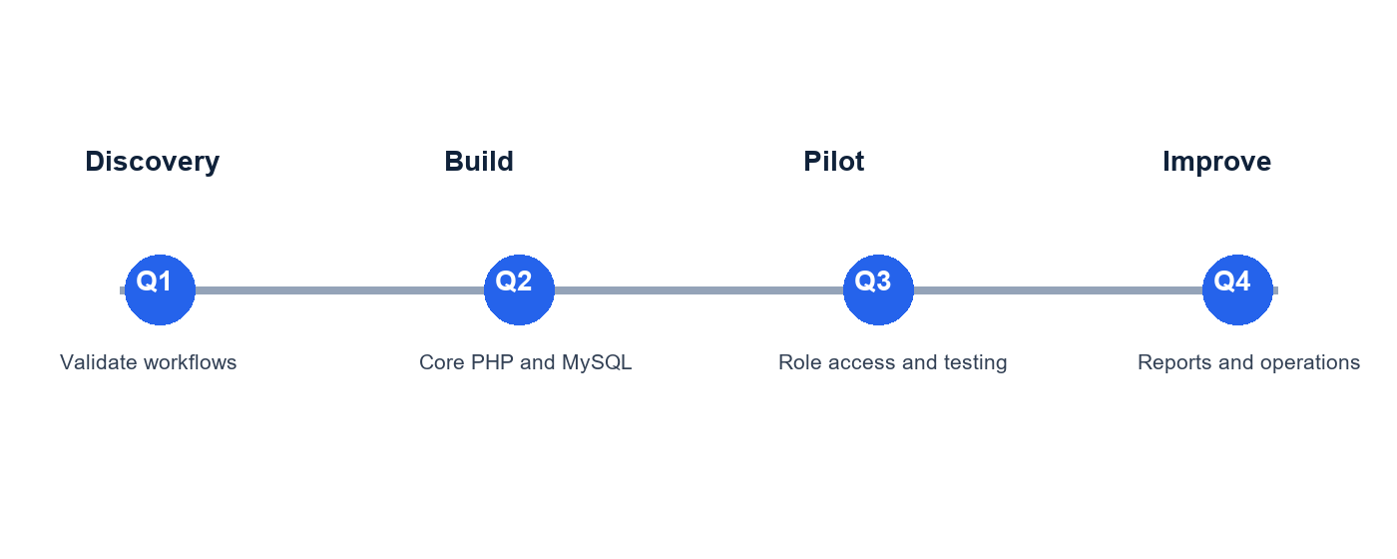
Figure 1.2 Development and release roadmap
Idea Validation and Market Research
• Confirm the highest-value workflows with startup owners and refine the access matrix.
Business Planning and Prototype Development
• Complete the working PHP and MySQL prototype and prepare deployment documentation.
Testing and Feedback Iteration
• Run role, permission, tenant isolation, accessibility, and user acceptance tests.
Launch and Growth Strategy
• Pilot with selected organizations, monitor support patterns, and improve onboarding.

PURPOSE ADVANTAGES AND DISADVANTAGES
Purpose
The purpose of the system is to give startup clients a clear and secure workspace for planning and operating their business while giving administrators the tools required to manage the shared platform.
Advantages
• One consistent workspace for core startup activities
• Clear separation between administrator and client responsibilities
• Administrator-controlled none view and edit permissions
• Organization-scoped client records
• Low-cost and widely supported PHP and MySQL stack
• Responsive interface with plain professional language
Disadvantages
• A local XAMPP installation is not suitable for public production without hardened hosting.
• The current two-role interface does not yet expose limited client staff roles.
• System-wide audit logs and automated backups require further implementation.
• Financial functions provide operational reports and do not replace professional accounting review.

INVESTMENT CAPITAL DISTRIBUTION
An illustrative seed budget of PHP 150,000 prioritizes security, deployment readiness, pilot support, and continued product development. Actual spending should be approved against supplier quotations and the selected hosting model.
Category | Percent | Amount PHP | What it covers
Product development | 35% | 52,500 | Feature completion, testing, interface improvements
Security and quality assurance | 20% | 30,000 | Security review, test devices, remediation
Hosting and operations | 15% | 22,500 | Domain, SSL, backups, monitoring, production hosting
Pilot onboarding and support | 15% | 22,500 | Training materials, onboarding sessions, issue handling
Marketing and demonstrations | 10% | 15,000 | Product materials, demonstrations, outreach
Reserve | 5% | 7,500 | Unexpected launch and maintenance costs
Total | 100% | 150,000 | Full illustrative allocation

Table 1.2 Illustrative seed investment allocation

BUSINESS MODEL CANVAS
Partners | Activities | Value proposition | Relationships | Segments
Hosting and payment providers | Develop secure modules | One clear startup workspace | Guided onboarding | Startup founders
Business mentors and incubators | Maintain guides and support | Role-aware and organization-scoped | Ticket-based support | Micro and small businesses
Technology suppliers | Monitor and improve service | Planning plus daily operations | Announcements and help content | Business support programs

Resources | Channels | Cost structure | Revenue streams
PHP MySQL platform and support team | Direct demonstrations and incubator partnerships | Development hosting support and security | Subscriptions onboarding and premium support

Figure 1.3 Business model canvas
VALUE PROPOSITION CANVAS
Customer jobs | Pains | Gains | Products and services | Pain relievers | Gain creators
Plan and operate a startup | Scattered tools and unclear access | Faster task completion | Guides goals accounting reports and support | Role menus and tenant controls | Integrated workflow and simple language

Figure 1.4 Value proposition canvas

SWOT ANALYSIS
Strengths | Weaknesses
Integrated startup and operations workflow; clear role separation; administrator permissions; organization-scoped records | Limited production hardening; two-role release; local deployment assumptions; no completed audit-log module

Opportunities | Threats
Partnerships with incubators; optional staff roles; richer analytics; managed cloud deployment | Security attacks; privacy failures; changing payment requirements; larger established competitors

Figure 1.5 SWOT analysis

TECHNOLOGY STACK
Layer | Technology | Purpose
Frontend | HTML CSS JavaScript | Responsive layouts forms tables navigation and client-side interactions
Backend | PHP | Authentication sessions authorization validation and JSON APIs
Database | MySQL | Users organizations permissions plans goals transactions notifications content and tickets
Environment | XAMPP Apache | Local application and database hosting
Version control | Git and GitHub | Source history collaboration and publication

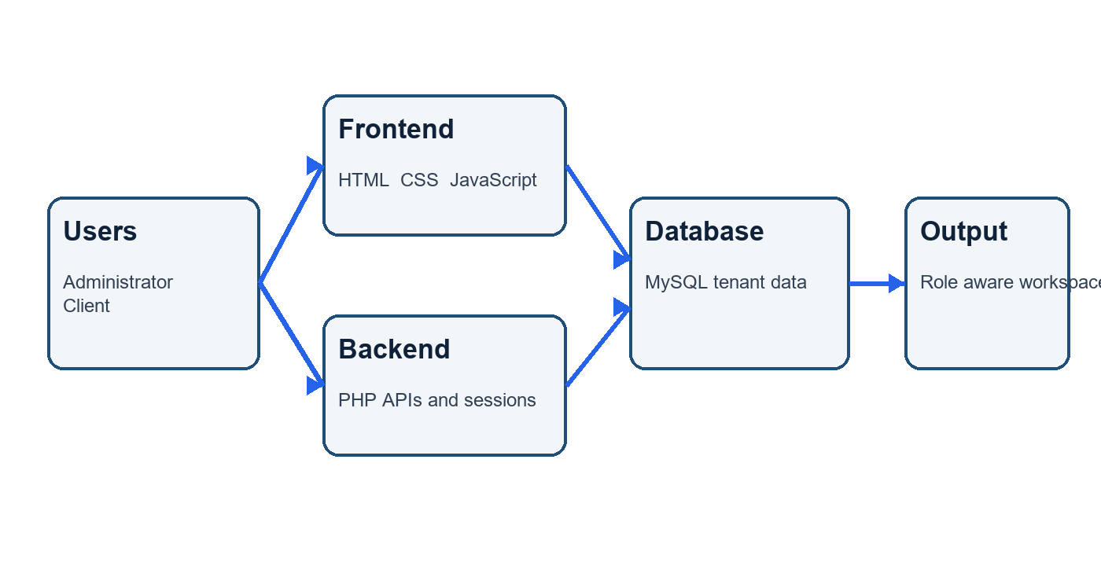
Figure 1.6 Technology architecture

FUNCTIONAL DECOMPOSITION DIAGRAM
User | Available functions
Client | Setup guide; business plan; goals and objectives; accounting journal; accounting reports; notifications; help and support
Administrator | Content and guides; user accounts and permissions; system performance; send announcements; support management

Input Process Output
Input | Process | Output
Credentials role permissions organization | Authenticate user and evaluate module permission | Role-specific workspace
Business plan goals and journal records | Validate request and save organization-scoped data | Updated plans goals and reports
Support requests and announcements | Route records by role audience and organization | Tracked tickets and notifications

Access Control Rules
• Administrator access is platform-wide but limited to the five approved administrative modules.
• Client access is scoped to the signed-in organization and the seven approved client modules.
• Administrators may set none, view, or edit permission for each supported client module.
• The PHP API rechecks permission and organization scope for every protected operation.

STORYBOARD
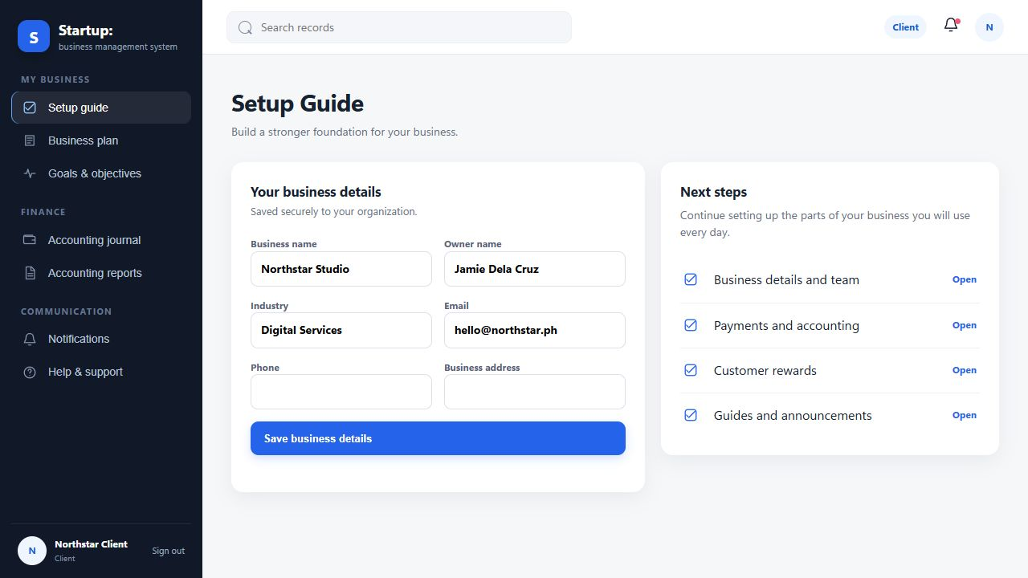
Figure 1.7 Client setup guide page. The form stores business details for the signed-in organization and presents the next onboarding steps.

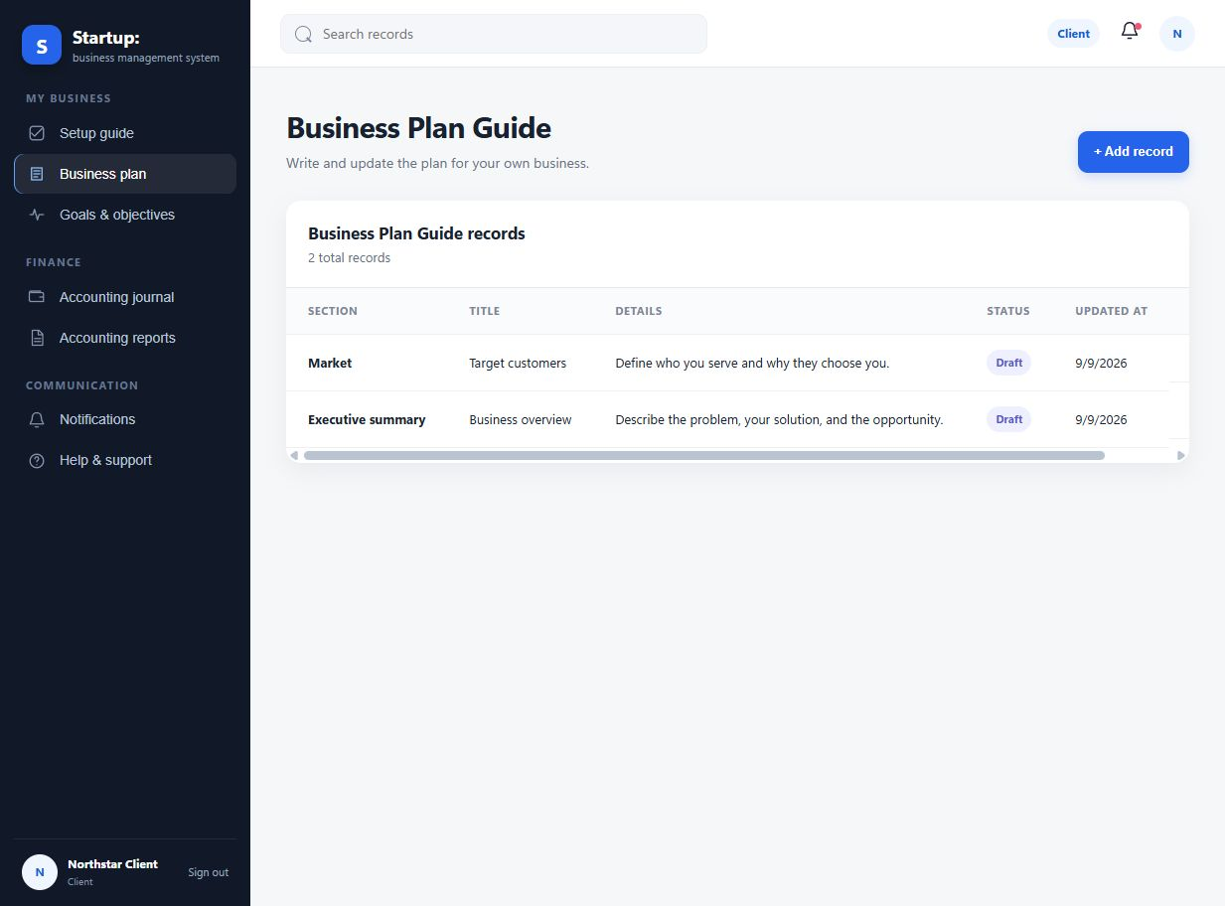
Figure 1.8 Client business plan page. Clients can create and maintain their own planning records in a simple table workflow.

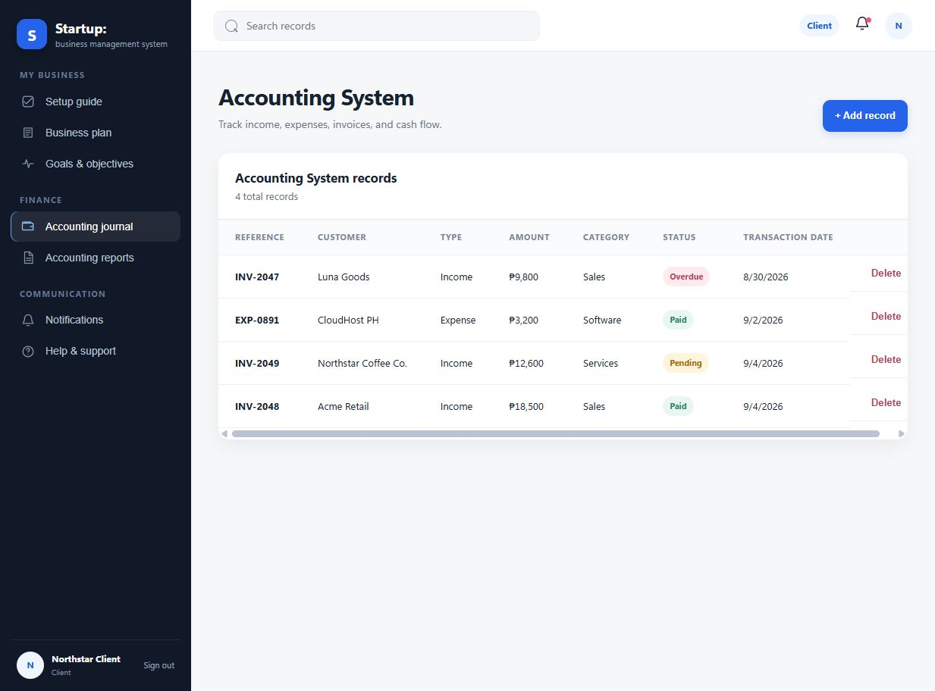
Figure 1.9 Client accounting journal page. Financial entries are managed inside the client organization scope.

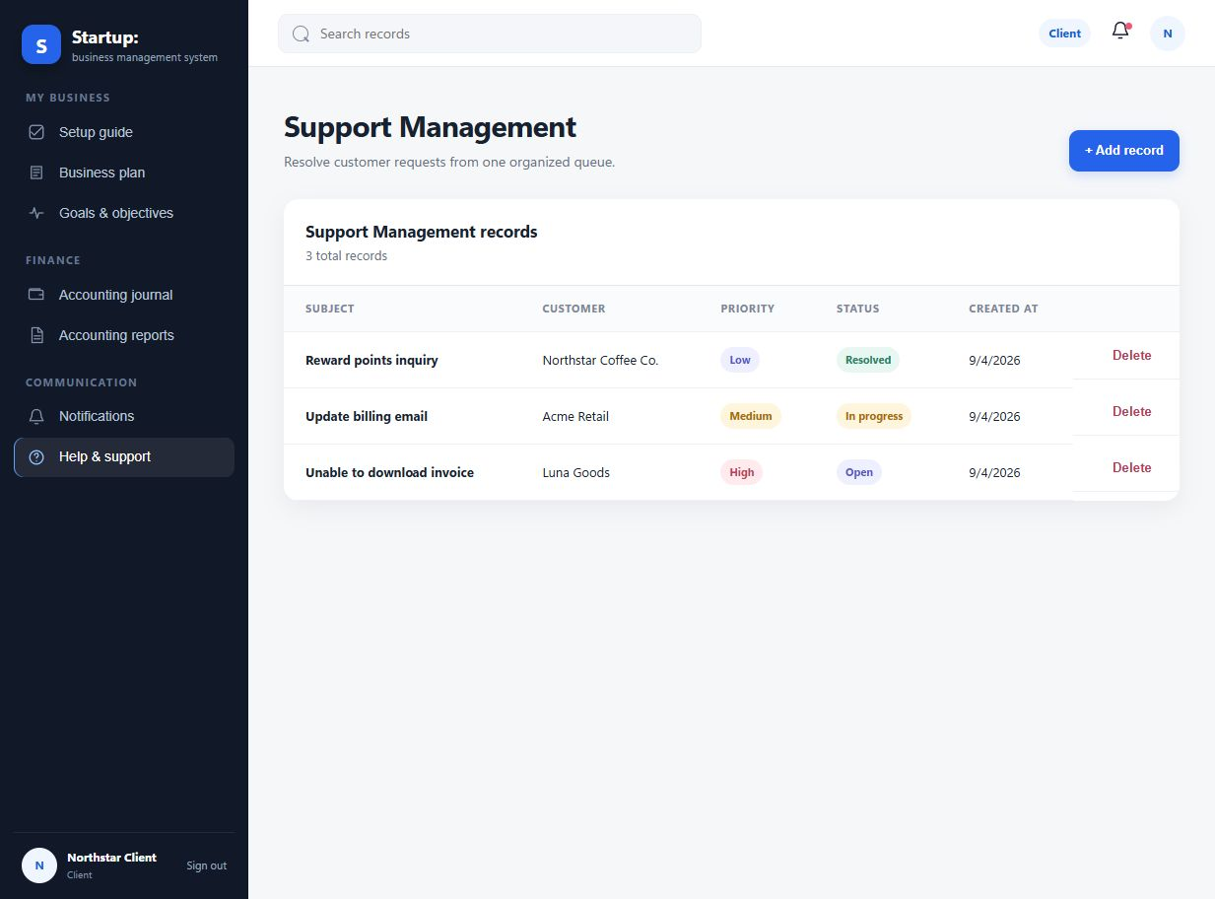
Figure 1.10 Client help and support page. Clients submit tickets and review only tickets available to their account.

SUMMARY AND CONCLUSION
Summary
Startup business management system implements a focused two-role platform for startup operations. Clients receive setup, planning, goals, accounting, reports, notifications, and support functions. Administrators receive content, account and permission, performance, announcement, and support management functions. The shared PHP and MySQL application protects each operation through authentication, permission checks, and organization-scoped data access.
Conclusion
The project meets the defined functional direction and provides a clear foundation for pilot use. Its next development priority is production readiness: formal user acceptance and security testing, audit logging, automated backups, deployment configuration, and documented operating procedures. These additions can strengthen reliability without changing the simple role model already established.
Recommended Next Actions
• Conduct user acceptance testing with at least one administrator and several client users.
• Test every permission combination and direct API request.
• Add audit logs for sign-in, permission, account, and financial changes.
• Deploy to a secured production environment with HTTPS, backups, and monitoring.
• Review financial report terminology with a qualified accounting adviser before commercial launch.

