Identifiability Analysis of a Multi-Cell Line CHO Kinetic Model using a Fast Python Framework

1st Betsabé Arriagada Moya
Department of Chemical and Bioprocess Engineering
Pontifical Catholic University of Chile
Santiago, Chile
barriagada@uc.cl
2nd Benjamín Beneventi Chavez
Department of Chemical and Bioprocess Engineering
Pontifical Catholic University of Chile
Santiago, Chile
benjamn.chavez@uc.cl
3rd Elizabeth Díaz Ciudad
Department of Chemical and Bioprocess Engineering
Pontifical Catholic University of Chile
Santiago, Chile
eadiaz5@uc.cl
4th Sofía Breton Montero
Department of Chemical and Bioprocess Engineering
Pontifical Catholic University of Chile
Santiago, Chile
smbreton@uc.cl

5th José Tomás Suazo Zavando
Department of Chemical and Bioprocess Engineering
Pontifical Catholic University of Chile
Santiago, Chile
jose.suazo@uc.cl
6th José Ricardo Pérez Correa
Department of Chemical and Bioprocess Engineering
Pontifical Catholic University of Chile
Santiago, Chile
jperezc@uc.cl

Abstract—The Multi-Cell Line Kinetic Model (MCKM) was applied to simulate CHO fed-batch cultures with explicit bolus feeding, providing a reproducible framework for identifiability analysis. Structural identifiability of 13 kinetic parameters was evaluated via Singular Value Decomposition of the Relative Output Sensitivity Matrix (ROSM), and robustness was assessed through Monte Carlo sampling of 50 parameter sets (±20%). The full model exhibited a smallest singular value of σ₁₃ = 1 × 10⁻¹⁵, indicating collinearity between Y_{x/gln} and Y_{gln/glu.} Fixing Y_{gln/glu} reduced the system to 12 parameters (σ₁₂ = 5 × 10⁻³), restoring structural identifiability. However, practical identifiability analysis using t-values revealed that the 12-parameter model failed under 5% measurement noise; additional fixation of K_{glc}, Y_{X/lac}, and m_{glc} yielded a parsimonious 9-parameter model satisfying ∣t∣ ≥ 2.03. Unlike the traditional pairwise Collinearity Index, which is limited to two-parameter dependencies, the SVD-ROSM method captures higher-order couplings in a single pass. This framework enables reproducible identifiability assessment, parameter optimization, and data-driven clone selection in CHO cell line development.
Keywords—CHO cells, structural identifiability, practical identifiability, ROSM, Monte Carlo analysis, t-values analysis.

INTRODUCTION
The production of monoclonal antibodies (mAbs) is one of the fastest-growing therapeutic areas in the biopharmaceutical industry, accounting for 63% of a USD 484 billion global market in 2025 [1,2]. Chinese Hamster Ovary (CHO) cells serve as the dominant production platform due to their scalability, human-like post-translational modifications, and adaptability to diverse protein products [2-4]. The development of clonal CHO cell lines (CLD) is challenged by intrinsic genomic plasticity, which leads to high clonal heterogeneity and variable metabolic behavior across clones [4-6]. Kinetic modeling has become a fundamental tool for analyzing and predicting CHO cell growth, metabolism, and protein production, supporting process optimization, scale-up, and rational cell line engineering [4-6].
Traditional kinetic approaches typically require multiple culture runs to calibrate parameters, increasing experimental workload and limiting their applicability across diverse clones [3]. The Multi-Cell Line Kinetic Model (MCKM) addresses these limitations by deriving a complete set of 13 kinetic parameters from a single culture run using only 49 data points, enabling in silico simulation of individual clones and facilitating metabolic characterization across multiple cell lines [3]. Despite these advantages, limited data relative to the high-dimensional parameter space introduces risks of overfitting and parameter correlation, highlighting the need for structural identifiability analysis to ensure that model parameters reflect true biological variation rather than mathematical artifacts [3,5-7].
Structural identifiability evaluates whether model parameters can be uniquely inferred from perfect, noise-free data [9]. If a model lacks structural identifiability, unique parameter values cannot be assigned regardless of data quality or estimation method [7]. In CLD, non-identifiability can cause apparent differences between clones to arise from mathematical correlations rather than true biological variation [3]. Additionally, practical identifiability considers the limitations of experimental noise and sparse measurements [7,8], ensuring that parameters remain meaningful under realistic conditions.
Traditional approaches, such as the collinearity index (CI), evaluate pairwise correlations but fail to detect higher-order dependencies or the model null space and typically rely on proprietary software [3]. To overcome these limitations, a robust framework based on Singular Value Decomposition (SVD) applied to the Relative Output Sensitivity Matrix (ROSM) enables precise determination of the non-identifiable parameter space [7]. This methodology, proposed by Stigter and Molenaar, identifies complete linear combinations of non-identifiable parameters, scales efficiently to large models, and is easily implementable in Python [7,8].
This study aims to evaluate the structural and practical identifiability of the MCKM using an SVD-ROSM framework in Python. The objectives are: (1) to implement the MCKM ODEs with fed-batch dynamics; (2) to perform local structural identifiability and Monte Carlo robustness analyses; (3) to fix collinear parameters to restore structural identifiability; (4) to examine practical identifiability through t-value analysis under experimental noise; and (5) to compare the results with those of Sietaram et al. [3] to assess consistency and identify differences in the model’s identifiability structure.
Section II presents the methodology, including model formulation, numerical implementation, the SVD-ROSM framework, and the Monte Carlo strategy. Section III presents simulation verification, structural collinearity resolution validated through Monte Carlo robustness analysis, practical identifiability via t-value analysis, and comparison with the pairwise CI. Section IV concludes with the findings and their implications for clonal characterization.

METHODOLOGY
This section describes the mathematical formulation of the MCKM, the macroscopic assumptions underlying the bioprocess, and the numerical strategies used to simulate it. Furthermore, it details the theoretical framework used to evaluate the system's local structural and practical identifiability.

Dynamic Model Description
To address the challenge of clone variability in biopharmaceutical production, this study adopts the MCKM model proposed by Sietaram et al. [3]. This is a generalized mechanistic model capable of capturing clone variability by extracting a complete set of kinetic parameters from a single fed-batch culture run, utilizing only limited data points.
The system is modeled at the macroscale to describe the fed-batch cultivation of CHO cells. The nonlinear state-space model consists of eight coupled ordinary differential equations (ODEs) that track the temporal evolution of viable biomass (X_{v}), monoclonal antibody titer (P), five key metabolites (glucose, glutamate, glutamine, ammonium, and lactate), and an auxiliary state for the specific growth rate (μ).
Modeling Assumptions:
The dynamic behavior of the bioreactor is mathematically formulated using macroscopic, non-segregated, and unstructured bioprocess modeling principles. To guarantee model tractability and focus the parameter space on clone-specific metabolic indicators, the following operational assumptions are established:
The bioreactor operates under perfect mixing conditions, ensuring spatial homogeneity of temperature, pH, and chemical concentrations. Cell growth kinetics are strictly limited by the availability of glucose, the primary carbon source, whereas glutamate is fed in excess and is not growth-limiting. Intracellular stress and subsequent cell death are exclusively driven by the accumulation of cytotoxic ammonium in the extracellular medium. The system operates under a fed-batch configuration with a variable culture volume to accommodate discrete bolus feeding of glucose and glutamate over a 15-day cultivation period.
Dynamic Mass Balances:
Cellular growth dynamics are modeled using Monod-type kinetics limited by glucose, while byproduct formation and antibody production follow the Luedeking-Piret relationship. A central feature of this formulation is the inclusion of a mechanistic metabolic switch (lactate switch), which governs the transitions from lactate production to consumption as a function of a glucose concentration threshold. The model operates in a fed-batch configuration with discrete pulses of glucose and glutamate (bolus feeding).
The governing equations are defined as follows [3]:
Cellular Growth and Death:
$$\frac{dX_{v}}{dt}=\left(μ\left(t\right)-μ_{d}\left(t\right)\right)∙X_{v}(t)$$ | (1)
$$μ(t)=\frac{μ_{max}∙glc\left(t\right)}{K_{glc}+glc(t)}$$ | (2)
$$q_{glu}(t)=\frac{μ\left(t\right)}{Y_{X/glu}}$$ | (3)
$$μ_{d}\left(t\right)=k_{D}∙\frac{amm\left(t\right)}{KD_{amm}+amm(t)}$$ | (4)
Product Formation and Substrate Consumption:
$$\frac{dP}{dt}=q_{p}\left(t\right)∙X_{v}$$ |  | (5)
$$q_{p}\left(t\right)=μ\left(t\right)∙Y_{\frac{P}{X}}$$ |  | (6)
$$\frac{dglc}{dt}=-q_{glc}\left(t\right)∙X_{v}\left(t\right)$$  $$+ F\left(t\right)∙\frac{glc_{F,in}-glc(t)}{V_{L}(t)}$$ | (7)
$$\frac{dglu}{dt}=-q_{glu}\left(t\right){∙X}_{v}\left(t\right)$$  $$+ F\left(t\right)∙\frac{glu_{F,in}-glu(t)}{V_{L}\left(t\right)}$$ |  | (8)
$$q_{glc}\left(t\right)=\frac{μ\left(t\right)}{Y_{X/glc}}+m_{glc}$$ |  | (9)
$$\frac{dgln}{dt}=-q_{gln}\left(t\right)∙X_{v}\left(t\right)+Y_{\frac{gln}{glu}}∙q_{glu}\left(t\right)∙X_{v}\left(t\right)$$ |  | (10)
$$q_{gln}\left(t\right)=\frac{μ\left(t\right)}{Y_{X/gln}}$$ |  | (11)
$$\frac{damm}{dt}=q_{amm}\left(t\right)∙X_{v}\left(t\right)$$ |  | (12)
$$q_{amm}\left(t\right)=\frac{μ\left(t\right)}{Y_{X/amm}}$$ |  | (13)
Metabolic Switch (Lactate)
A critical feature of this model is the mechanistic lactate switch, which is governed by a glucose threshold (α_{glc}).
$$\frac{dlac}{dt}=q_{lac}\left(t\right)∙X_{v}(t)$$ | (14)
$$if \left[glc\right]>α_{glc};q_{lac}\left(t\right)=Y_{\frac{lac}{glc}}∙q_{glc}\left(t\right);$$ | (15)
$$else:q_{lac}\left(t\right)=-\frac{μ\left(t\right)}{Y_{\frac{X}{lac}}}∙X_{v}\left(t\right)+ Y_{\frac{lac}{glc}}∙q_{glc}(t)$$ | (16)
Auxiliary Growth Rate Constraint
To stabilize the numerical regression, the derivative of the growth rate is included as an additional constraint, derived via the quotient rule applied to Eq (2) [1]:
$$\frac{dμ}{dt}=μ_{max}\frac{\frac{dglc}{dt}{∙K}_{glc}}{\left(K_{glc}+glc\right)2}$$ | (17)
The model operates under a fed-batch configuration with discrete bolus feeding of glucose and glutamate, represented by the forcing functions F_{glc}(t) and F_{glu}(t). The complete set of 13 kinetic parameters, θ, defines the metabolic profile of each clonal cell line.
TABLE 1. Model parameters and values used in the implementation.
Symbol | Description | Units | Value
$$μ_{max}$$ | Maximum growth rate | 1/h | 0.0257
$$k_{d}$$ | Death rate | 1/h | 0.0160
$$K_{glc}$$ | Michaelis-Menten constant of glucose | mM | 1.0500
$$Y_{\frac{X}{glc}}$$ | Yield of biomass over glucose | 10⁹ cells/mM | 2.0247
$$Y_{\frac{X}{glu}}$$ | Yield of biomass over glutamate | 10⁹ cells/ mM | 8.9000
$$Y_{\frac{X}{gln}}$$ | Yield of biomass over glutamine | 10⁹ cells/mM | 43.2000
$$Y_{\frac{lac}{glc}}$$ | Yield of lactate on glucose | mol/mol | 0.2800
$$Y_{\frac{X}{amm}}$$ | Yield of biomass over ammonium | 10⁹ cells/ mM | 11.000
$$Y_{\frac{gln}{glu}}$$ | Yield of glutamine on glutamate | mol/mol | 0.3800
$$Y_{\frac{X}{lac}}$$ | Yield of biomass over lactate | 10⁹ cells/mM | 3.1500
$$Y_{\frac{P}{X}}$$ | Yield of mAb over biomass | mmol/10⁹ cells | 0.0450
$$m_{glc}$$ | Consumption of glucose for maintenance | mmol/ Lh | 3.15e-6
$${KD}_{amm}$$ | Monod constant of ammonium inhibition | mM | 6.2000
The values used are within the range shown in [3].

Computational Implementation and Solver Benchmarking
To establish a robust foundation for identifiability analysis, the MCKM was implemented in a Python-based computational framework. The primary objective of this phase was to ensure accurate numerical simulation and to evaluate the computational efficiency of different integration schemes.
Due to the multiscale coupling between continuous metabolic pathway dynamics and discrete bolus-feeding, the state-space system exhibits pronounced numerical stiffness. To overcome the stability limitations of explicit integration methods, the dynamic system is simulated utilizing CasADi, an algebraic differentiation and optimization framework. The implicit integration suite IDAS is selected as the exclusive solver environment. IDAS evaluates the state trajectories under strict tolerance profiles (atol = 10⁻⁸, rtol = 10⁻⁶), handling discontinuities smoothly through internal backward differentiation formula (BDF) architectures.
For the simulation, the initial conditions of the variables to start were the following:
TABLE 2. Initial conditions of the variables for the simulation.
Xv | P | Glc | Glu | Gln | Amm | Lac | μ
0.3 10⁹ cells | 0.0 mM | 20.0 mM | 8.0 mM | 2.0 mM | 0.2 mM | 1.0 mM | 0.024 1/h
These values were fixed, except for μ_{0,} which was calculated using equation (3) with the initial glucose concentration.

Fundamentals of Structural Identifiability Analysis
The theoretical framework that guided this work was based on the method proposed by Stigter and Molenaar [7]. This section describes the mathematical principles applied in the analysis.
A model is considered structurally identifiable if, under the assumption of perfect, noise-free data, the unknown parameters θ can be uniquely determined. If a model lacks structural identifiability, unique parameter values cannot be assigned regardless of data quality, meaning observed differences between clones could be artifacts of mathematical correlation rather than true biological divergence [7].
To overcome the limitations of traditional pairwise CI, which fail to capture higher-dimensional correlations, this study implements a Python-based Singular Value Decomposition (SVD) framework applied to the model's null space. The analysis is based on the Relative Output Sensitivity Matrix (ROSM), defined by the normalized parametric sensitivity of the model outputs $y_{i}$ with respect to parameters $θ_{j}$ [7].
$$S_{ij}\left(t\right)=\frac{∂y_{i}\left(t\right)}{∂θ_{j}}$$ | (18)
To prevent geometric scaling distortions arising from disparate parameter magnitudes, the variables are transformed into a normalized Relative Output Sensitivity Matrix:
$${\tilde{S}}_{i,j}\left(t\right)=\frac{θ_{j}}{y_{i}}\frac{∂y_{i}}{∂θ_{j}}$$ | (19)
Singular Value Decomposition (SVD) was applied to the resulting $\tilde{S}$ matrix to assess its rank-deficiency and quantify structural non-identifiability:
$$\tilde{S}=UΣV^{T}$$ | (20)
By performing an SVD on the ROSM, the algorithm identifies the model's null space. The diagonal matrix ∑ reveals the singular values (σ_{k}). Parameters corresponding to zero or near-zero singular values are flagged as structurally non-identifiable. This method not only scales efficiently to large models but also provides a clear mathematical criterion for determining exactly which linear combinations of parameters cannot be decoupled, even with ideal data.
This SVD-based approach is applied to the Python implementation of the MCKM to systematically detect the non-identifiable subset within the 13-parameter space. The outcome informs a model reduction strategy, fixing non-identifiable parameters to biologically plausible constants to yield a robust, minimal model suitable for clone screening.
To accurately reflect the experimental constraints of the CLD process described in [3], the sensitivity analysis is evaluated strictly at the available sampling intervals. The cell culture runs yield 49 total data points, corresponding to 7 observable state variables measured across 7 discrete sampling times. Consequently, CasADi’s forward algorithmic differentiation is used to compute the exact Jacobian of the state vector with respect to the parameter vector exclusively at these time points. This procedure constructs a discrete ROSM, $\tilde{S,}$with dimensions 49x13.
Because this SVD-ROSM framework evaluates local structural identifiability, the conclusions can be sensitive to the specific nominal parameter values chosen. To ensure that the identifiability conclusions are robust globally across the operational space of the CHO cell cultures, a Monte Carlo sampling strategy is implemented. The SVD analysis is repeated over 50 or 100 parameter sets generated by applying a ±20 % uniform random perturbation to the nominal kinetic parameters. This bounds-based distribution accounts for expected biological variability and analytical uncertainty, allowing for the identification of a consistent subset of structurally identifiable parameters.
Unlike the original MCKM study [3], which relied on traditional pairwise CIs evaluated in MATLAB, this Python-based SVD framework enables deterministic, multidimensional evaluation of the model's entire null space in a single computational pass.

Practical Identifiability Analysis
While structural identifiability evaluates model structure under ideal conditions, practical identifiability addresses the reliability of parameter estimation given the limitations of sparse measurements and experimental noise. To ensure the kinetic parameters remain statistically significant under realistic conditions, a t-value analysis is incorporated.

The procedure involves fitting the dynamic model to the experimental data using non-linear least-squares optimization. Subsequently, the Jacobian matrix (J) of the residuals with respect to the estimated parameters is computed. The parameter covariance matrix is then estimated according to the following relationship:
$$Cov\left(\hat{θ}\right)={\left(J^{T}σ^{2}J\right)}^{-1}$$ | (21)
Here, $σ^{2}$ represents a diagonal matrix containing the residual variances, calculated as the mean squared error between the model predictions and the experimental data. The standard errors for each parameter are derived from the square roots of the main diagonal of this covariance matrix.
The t-value for each parameter is computed as the ratio of the parameter’s estimated value to its standard error. A statistical threshold of |t| > 2 is established; parameters failing to meet this threshold are deemed practically non-identifiable, indicating that they do not meaningfully influence the model fit relative to the data noise. To evaluate the stability of these t-values across the operational space, this analysis is integrated into the Monte Carlo simulations.

Comparative Study and Parameter Fixing Strategy
To mitigate both structural rank deficiencies and practical non-identifiability, a systematic parameter-fixing strategy is employed. The algorithm identifies parameters that dominate the null space (from the SVD analysis) and those that frequently exhibit $\left|t\right|<2$. These problematic parameters are iteratively fixed (with recalibration between iterations) to nominal biological values found in the literature until the reduced model restores a minimum singular value ($σ_{min}$) above the numerical noise threshold and all remaining free parameters achieve significant t-values.
Finally, the results of this SVD-ROSM framework and the t-value analysis were directly compared with the traditional pairwise CI method used in the original MCKM reference study. This comparative study aims to highlight the advantages of multidimensional null space evaluation over pairwise indices in high-dimensional biological parameter spaces.

RESULTS AND DISCUSSION

Simulation of the Fed-Batch MCKM Model
Using the parameters, initial conditions, and fed-batch feeding schedule reported in [3], the simulated trajectories reproduced the expected CHO fed-batch behavior (Figure 1). The upper panels show our simulation, while the lower panels show the reference results from Sietaram et al. [3]. In both cases, viable biomass $X_{v}$ increases during the growth phase and decreases near the end of the culture, while mAb accumulates progressively over time. Only $X_{v}$ and mAb are shown in the main text because they were the primary outputs used to validate the reference model, reaching $R^{2}>0.90$ after calibration. The remaining simulated metabolite profiles are reported in the Appendix. This agreement supports the use of these trajectories for the subsequent SVD-ROSM and identifiability analyses.
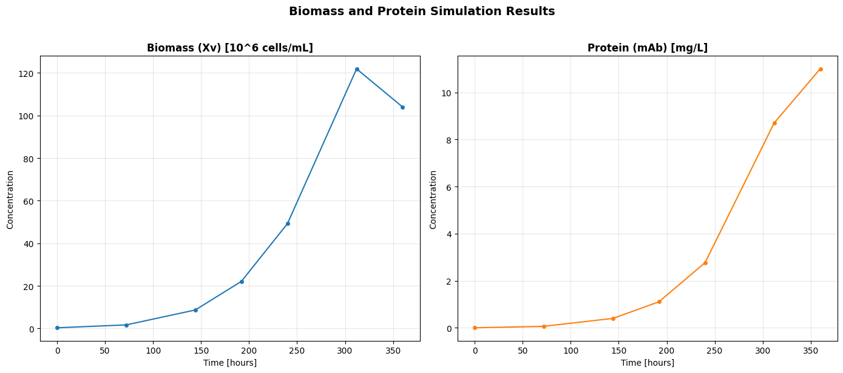
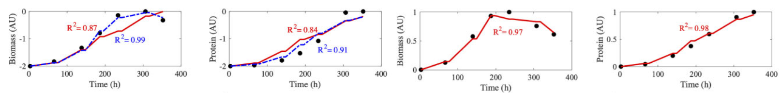
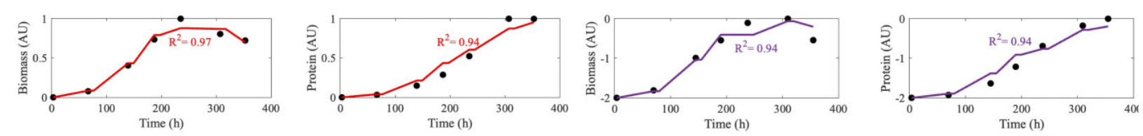
- MCKM dynamic simulation of biomass and mAb production. Upper panels correspond to this work using CasADi-IDAS; lower panels correspond to Sietaram et al. [3].

Structural Identifiability Assessment
Structural identifiability of the full 13-parameter MCKM was evaluated through SVD of the Relative Output Sensitivity Matrix (ROSM). As shown in Figure 2, the smallest singular value remained close to $σ_{13}=1.08×{10}^{-15}$, which is several orders of magnitude below the numerical threshold of ${10}^{-4}$, confirming a rank deficiency in the full model. The corresponding null-space vector shows that this loss of rank is mainly driven by a structural dependency between $Y_{X/gln}$ and $Y_{gln/glu},$ while the remaining parameters contribute only marginally to this non-identifiable direction (see Figure 2). The Monte Carlo analysis with 100 parameter perturbations (±20%) confirmed that this result is not due to a single nominal parameter set but is a structural property of the model.
Unlike the constrained-regression strategy used by Sietaram et al. [3], the SVD-ROSM framework bases parameter fixing on the model's mathematical structure. In the original study, when the initial free-model fit yielded $R_{X_{v}}^{2}<0.90$ or $R_{mAb}^{2}<0.90$, a new regression was automatically triggered in a reduced 12-parameter space by fixing either $μ_{max}$ or $K_{glc}$ at its initial estimate. Although this strategy improved poor fits, parameter selection depended on an empirical goodness-of-fit criterion. In contrast, the $σ_{13}$ value and its associated null-space vector show that the principal structural rank deficiency is not dominated by the growth parameters, but by the dependency between $Y_{X/gln}$ and $Y_{gln/glu}$, which make more sense from a biological point of view. Although Sietaram et al. [3] also detected this pair using a CI, the SVD-ROSM method evaluates all 13 parameters simultaneously and identifies this relationship as the dominant non-identifiable direction of the full model. Thus, the proposed approach replaces fit-triggered parameter selection with a reproducible and mathematically grounded model-reduction strategy.
- Structural non-identifiability of the full MCKM. The upper panel shows the singular values across 100 Monte Carlo perturbations, while the lower panel shows the dominant null-space direction associated with $Y_{X/gln}$ and $Y_{gln/glu}$.
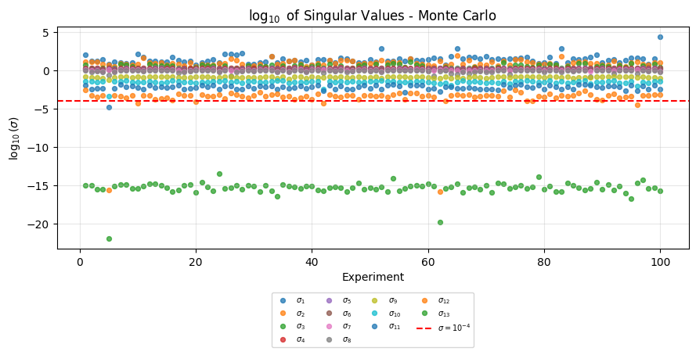
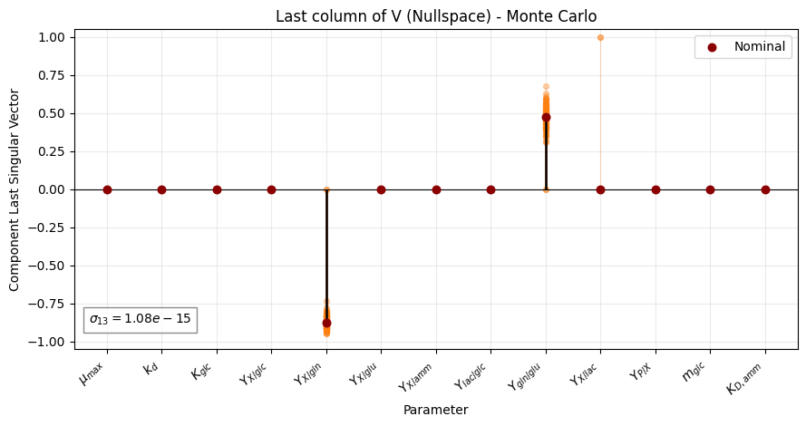

Model Reduction and Sensitivity Analysis
After identifying that the dominant non-identifiable direction was associated with $Y_{X/gln}$ and $Y_{gln/glu}$, $the latter$ was fixed to the nominal value reported in [3], with $Y_{gln/glu}$= 0.38 mol/mol. This decision is justified because the near-zero singular value indicates a null-space direction in which changes in both parameters can compensate for each other, producing nearly the same model response. Therefore, fixing$Y_{gln/glu}$removes this redundant direction from the parameter space, breaks the linear dependency between the corresponding sensitivity columns, and allows $Y_{X/gln}$ to remain free as the clone-dependent parameter. As shown in Figure 3, this reduction shifted all singular values above the numerical noise threshold, removing the initial structural rank deficiency. This step is necessary before practical identifiability analysis, since a strong structural dependency can mask smaller but experimentally relevant parameter variations under realistic noise conditions.
- Structural identifiability of the reduced 12-parameter MCKM after fixing $Y_{gln/glu}$. All singular values remain above the ${10}^{-4}$ threshold.
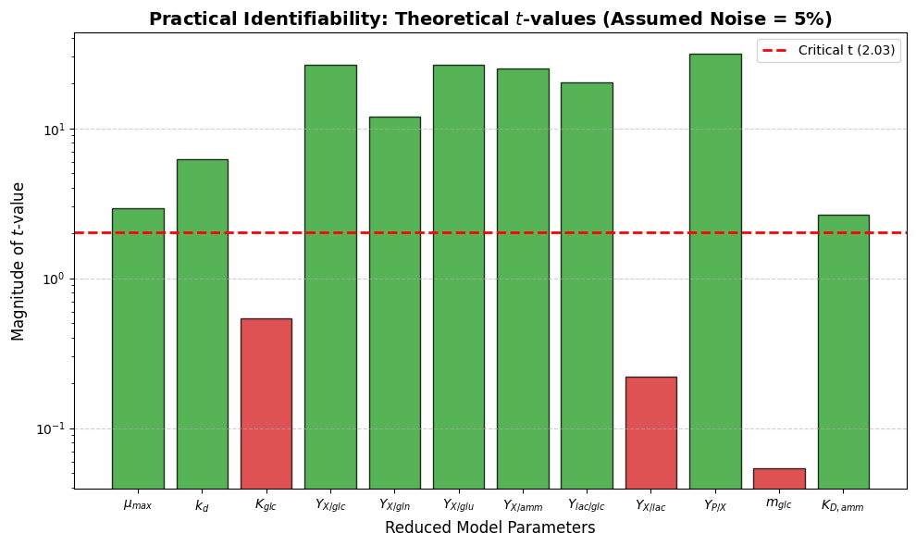
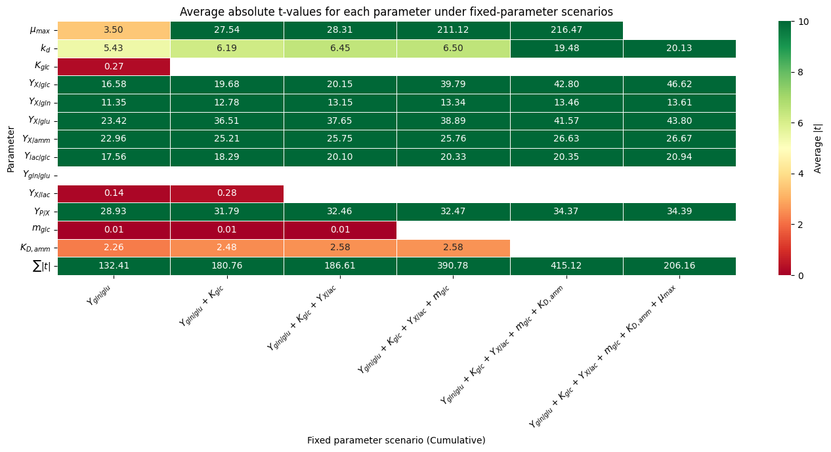

Practical Identifiability and Parameter-Fixing Strategy
After fixing $Y_{gln/glu}$, the reduced 12-parameter model was structurally identifiable but not practically identifiable under an assumed noise level of 5%, as shown in the upper panel of Figure 4. $K_{glc}$, $Y_{X/lac}$, and $m_{glc}$ remained below the critical threshold of $∣t∣=2.03$, indicating that their estimates were not sufficiently reliable under realistic experimental uncertainty.
The poor practical identifiability of $K_{glc}$ and $m_{glc}$ provides an additional explanation for the glucose-modeling anomaly reported by Sietaram et al. [3]. For the set of cell lines producing mAb-A, the study obtained an average glucose coefficient of determination of ${\overset{‾}{R}}_{glc}^{2}=-0.24$, which was mainly attributed to the use of approximate feeding schedules and to the sensitivity of $R^{2}$ to experimental deviations. The t-value analysis performed in this work further indicates that the glucose affinity and maintenance parameters are weakly estimable in the presence of measurement noise. Therefore, the poor predictive performance for glucose may reflect not only operational uncertainty, but also insufficient information in the data to distinguish the individual effects of $K_{glc}$ and $m_{glc}$.
A similar distinction is observed for the lactate parameters. Sietaram et al. [3] reported a pairwise CI of $5×{10}^{6}$ for $Y_{lac/glc}$ and $Y_{X/lac}$, compared with an infinite value for the glutamine-glutamate pair. However, the lactate dependency did not dominate the initial SVD null-space direction, indicating that it was secondary to the structural dependency between $Y_{X/gln}$ and $Y_{gln/glu}$. The later appearance of $Y_{X/lac}$ with a low t-value shows that its estimation becomes particularly weak under sparse and noisy data. Thus, in the reduced model, the lactate limitation is expressed mainly as a practical identifiability problem, although a strong pairwise dependency is already present in the original model structure.
The lower heatmap in Figure 4 shows that systematically fixing $Y_{gln/glu}$, $K_{glc}$, $Y_{X/lac}$, and $m_{glc}$progressively improves practical identifiability. This strategy yields a reduced 9-parameter model in which all remaining free parameters satisfy $∣t∣≥2.03$, improving estimation reliability while preserving a balance between statistical robustness and model flexibility.
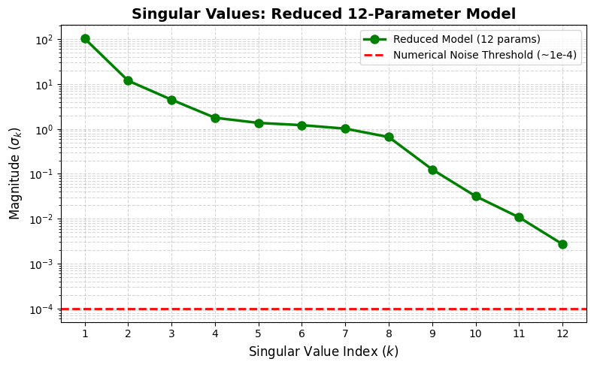
- Practical identifiability of the reduced MCKM under 5% noise. The t-values show that some parameters remain below the critical threshold, while the heatmap summarizes improved scenarios obtained by fixing parameters.

CONCLUSIONS
The MCKM was successfully implemented in Python with CasADi/IDAS, achieving minimal numerical error and validating the simulator against reference data. SVD-ROSM revealed a structural rank deficiency in the 13-parameter model, identifying collinearity between Y_{X/gln} and Y_{gln/glu}. The consistency of the Monte Carlo analysis confirms that this collinearity is not an artifact of the nominal parameter values but an intrinsic property of the model structure. Fixing Y_{gln/glu} restored structural identifiability (σ₁₂ ≈ 5 × 10⁻³), substantially surpassing the numerical noise threshold.
Nevertheless, structural restoration alone did not guarantee practical identifiability; the 12-parameter model failed to meet the t-value criteria under 5 % noise and sparse sampling. The additional fixation of K_{glc}, Y_{X/lac}, and m_{glc} yielded a 9-parameter model satisfying ∣t∣ ≥ 2.03, ensuring that all remaining free parameters exert a distinguishable influence on the model outputs. This underscores that structural identifiability is architecture-dependent, whereas practical identifiability is data-dependent and demands equally rigorous evaluation to avoid spurious inferences in clone characterization.
In contrast to the pairwise CI used by Sietaram et al. [3], our SVD-ROSM evaluates the entire null space in a single pass, capturing higher-order dependencies and providing an objective threshold without heuristic cutoffs. The open-source Python framework is reproducible, scalable, and extensible, facilitating its adoption in both academic and industrial settings for CLD.

SUPPLEMENTARY DATA
Suppementary data to this article can be found online at https://github.com/betsabe9/MCKM-Identifiability-Analysis-CHO-cells.git

REFERENCES
- Grand View Research. (2026). Biopharmaceutical (2026-2033).
- Tang, P., Xu, J., Louey, A., & Liu, S. (2020). Kinetic modeling of Chinese hamster ovary cell culture: factors and principles. Critical Reviews in Biotechnology.
- Sietaram, D., Kotidis, P., Finka, G., & Lapkin, A. A. (2025). A Multi Clone Kinetic Model for characterizing Chinese hamster ovary cell line variability. Journal of Industrial Microbiology and Biotechnology.
- Hefzi, H., Ang, K. S., Hanscho, M., & Lewis, N. E. (2016). A Consensus Genome-scale Reconstruction of Chinese Hamster Ovary Cell Metabolism. Cell Systems.
- Hong, J. K., Lakshmanan, M., Goudar, C., & Lee, D.-Y. (2018). Towards next generation CHO cell line development and engineering by systems approaches. Current Opinion in Chemical Engineering.
- Yeo, H. C., Hong, J., Lakshmanan, M., & Lee, D.-Y. (2020). Enzyme capacity-based genome scale modelling of CHO cells. Metabolic Engineering.
- Stigter, J. D., & Molenaar, J. (2015). A fast algorithm to assess local structural identifiability. Automatica, 58, 118–124.
- Breton, S., Suazo, J. T., Guzman, F., & Perez-Correa, J. R. (2025). A Python framework to find local structural identifiable lumped parameter bioprocess models.

