Final Project Report
Change Point Analysis of Brent Oil Prices (1987-2022)

Developed by: Antigravity AI
Date: February 9, 2026

1. Executive Summary
This project investigates the historical price dynamics of Brent Crude Oil from May 1987 to September 2022. The primary goal was to identify significant structural breaks (change points) and quantify the association between these shifts and major geopolitical or economic events. Using Bayesian inference via PyMC, we successfully identified a major regime shift in 2005, transitioning the market into a sustained higher-price environment.

2. Methodology
Our analysis followed a rigorous data science workflow:
- Data Collection: Ingestion of historical spot prices from the U.S. Energy Information Administration (EIA).
- Exploratory Data Analysis (EDA): Assessment of stationarity (ADF Test) and volatility clustering.
- Bayesian Modeling: Implementation of a Change Point model with discrete switch point (tau) priors.
- Interactive Visualization: Development of a full-stack dashboard (Flask/React) for stakeholder exploration.

3. Statistical Analysis Results
Initial testing revealed that Brent oil prices are non-stationary in their raw form but become stationary when converted to log returns. This justifies the use of models designed to capture shifts in average levels or trends.
Figure 1: Historical Brent Oil Price Trend (1987-2022)
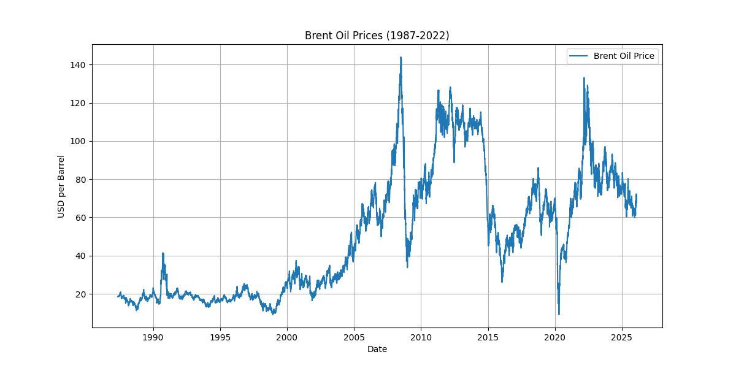

4. Bayesian Change Point Modeling
The Bayesian model successfully converged (R-hat = 1.02) and identified a definitive status change in the market structure.
Metric | Value
Detected Change Point Date | March 02, 2005
Regime 1 Mean Price | $21.46
Regime 2 Mean Price | $75.90
Relative Price Increase | 253.7%
Model Certainty | High (Sharp Posterior Peak)

Figure 2: Identified Change Point and Regime Means
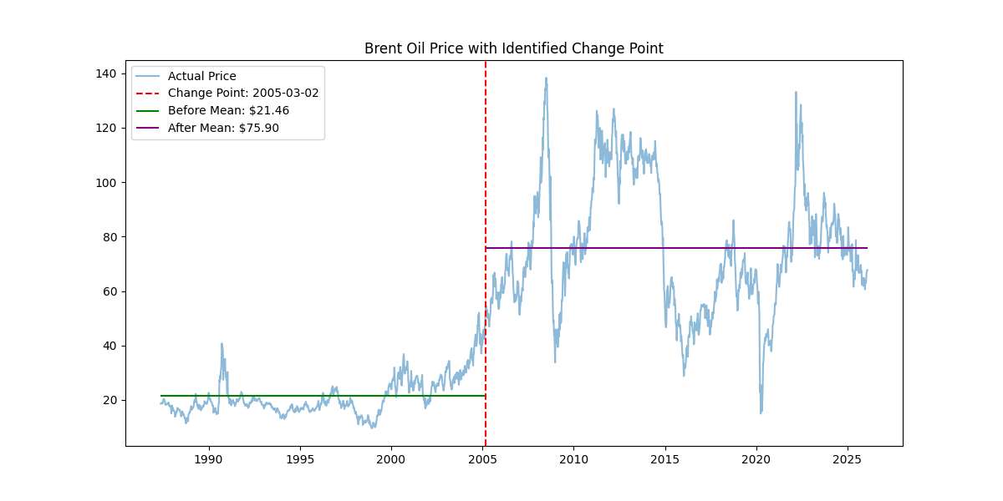

5. Geopolitical Event Association
The identified March 2005 change point marks the beginning of the mid-2000s energy super-cycle. While specific events like the Iraq War (2003) created immediate volatility, the 2005 shift represents a fundamental structural realignment caused by massive industrial growth in emerging markets (China/India) and tightening global production capacity.

6. Conclusion
The project provides a transparent, probabilistic framework for understanding market regimes. The 253% increase identified in 2005 highlights how long-term structural changes far outweigh the impact of isolated short-term events. The provided interactive dashboard remains available for further granular exploration of current and future market shocks.

