**20 HANDY DERIVATIVES FOR CALCULUS**

**Product rule:**

**image0.png**

**Quotient rule:**

**image1.png**

**List of 20 handy derivatives:**

**image2.png**

***Note:* Where *c* is a constant**

**image3.png image4.png**

***Note:* Where *c* is a constant**

**image5.png image6.png image7.png**

***Note:* Where *a* is a constant**

**image8.png  
  
image9.png  
  
image10.png  
  
image11.png  
image12.png  
  
image13.png  
  
image14.png  
  
image15.png  
  
image16.png  
  
image17.png  
  
image18.png  
  
image19.png  
  
image20.png  
  
image21.png**

**20 HANDY INTEGRALS FOR CALCULUS**

**image0.png  
  
image1.png  
  
image2.png  
  
image3.png  
  
image4.png**

***Note:* Where *a* is a constant**

**image5.png  
  
image6.png  
  
image7.png  
  
image8.png  
  
image9.png  
  
image10.png  
image11.png  
  
image12.png  
  
image13.png  
  
image14.png  
  
image15.png  
  
image16.png**

***Note:* Where *a* is a constant**

**image17.png**

***Note:* Where *a* is a constant)**

**image18.png**

***Note:* Where *a* is a constant**

**image19.png**

***Note:* Where *a* is a constant**

**HANDY TRIGONOMETRY: RIGHT TRIANGLES, DEGREES AND RADIANS, IDENTITIES, AND FORMULAS**

**RIGHT TRIANGLE TRIG**

**SohCahToa:**

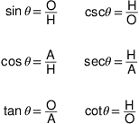

**DEGREES AND RADIANS**

**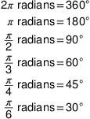  
image2.png**

**image3.png**

**IDENTITIES**

**Reciprocal identities**

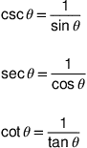

**Quotient identities:**

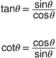

**Pythagorean identities:**

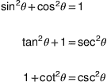

**FORMULAS**

**Half-angle formulas:**

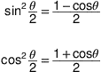

**Double-angle formulas:**

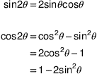

**Reduction formulas:**

