# T620X

PLC CR711s uses 32 bit SP11 patch 0

HMI uses 64 bit SP16p5 – be careful and do no open with the wrong version or upgrade libs!

Big issues if the “System_....” libs version 3.5.16.30 are changed!

## Functionality

Trommel Drum Ramp Down Time

Icon for the Siren

Icon for the Beacon

## Radial model

Side conveyor used as the radial transfer and just comes on with the tail conveyor – needs renamed – is this a good thing?

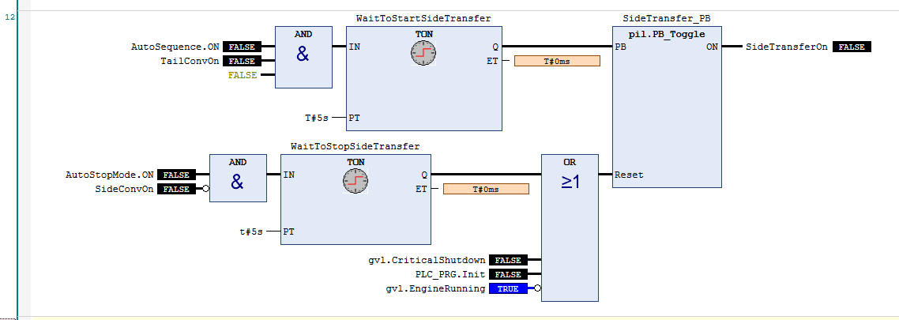

## HMI Version Reporting

Show the software version for PLC CR771S

Show the software version for PLC CR0401

Show the software version for HMI

## Alarms

No Alarm to say the PLC is offline!

## Output Diagnostics

No feedback due to the older style IO tagging

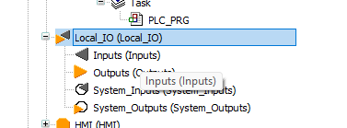

## Inputs Diagnostics