Top 100 Repeated MPB - Transparency Matches
Total Matched Projects: 82

1. Construction of Multi-Purpose Building at Lakeshore Complex, Barangay New Lower Bicutan, Taguig City
- Budget ID: DPWH-Proj-13596
- Amount: P450,000,000.00
- Transparency Matches (3): | Contract ID | Contract Name | Amount | |:————|:————–|:——-| | 25OB0361 | CONSTRUCTION OF MULTI-PURPOSE BUILDING AT LAKESHORE COMPLEX, BARANGAY LOWER BICUTAN, TAGUIG CITY (PHASE 4) | P72,752,854.74 | | 25OB0435 | CONSTRUCTION OF MULTI-PURPOSE BUILDING AT LAKESHORE COMPLEX, BARANGAY LOWER BICUTAN, TAGUIG CITY (PHASE 7) | P48,502,747.98 | | 20O00045 | CONSTRUCTION (COMPLETION) OF MULTI-PURPOSE BUILDING & SITE DEVELOPMENT AT LAKESHORE, BRGY. LOWER BICUTAN, TAGUIG CITY - RE-ADVERTISEMENT | P214,760,531.12 |
Screenshots:
25OB0361: 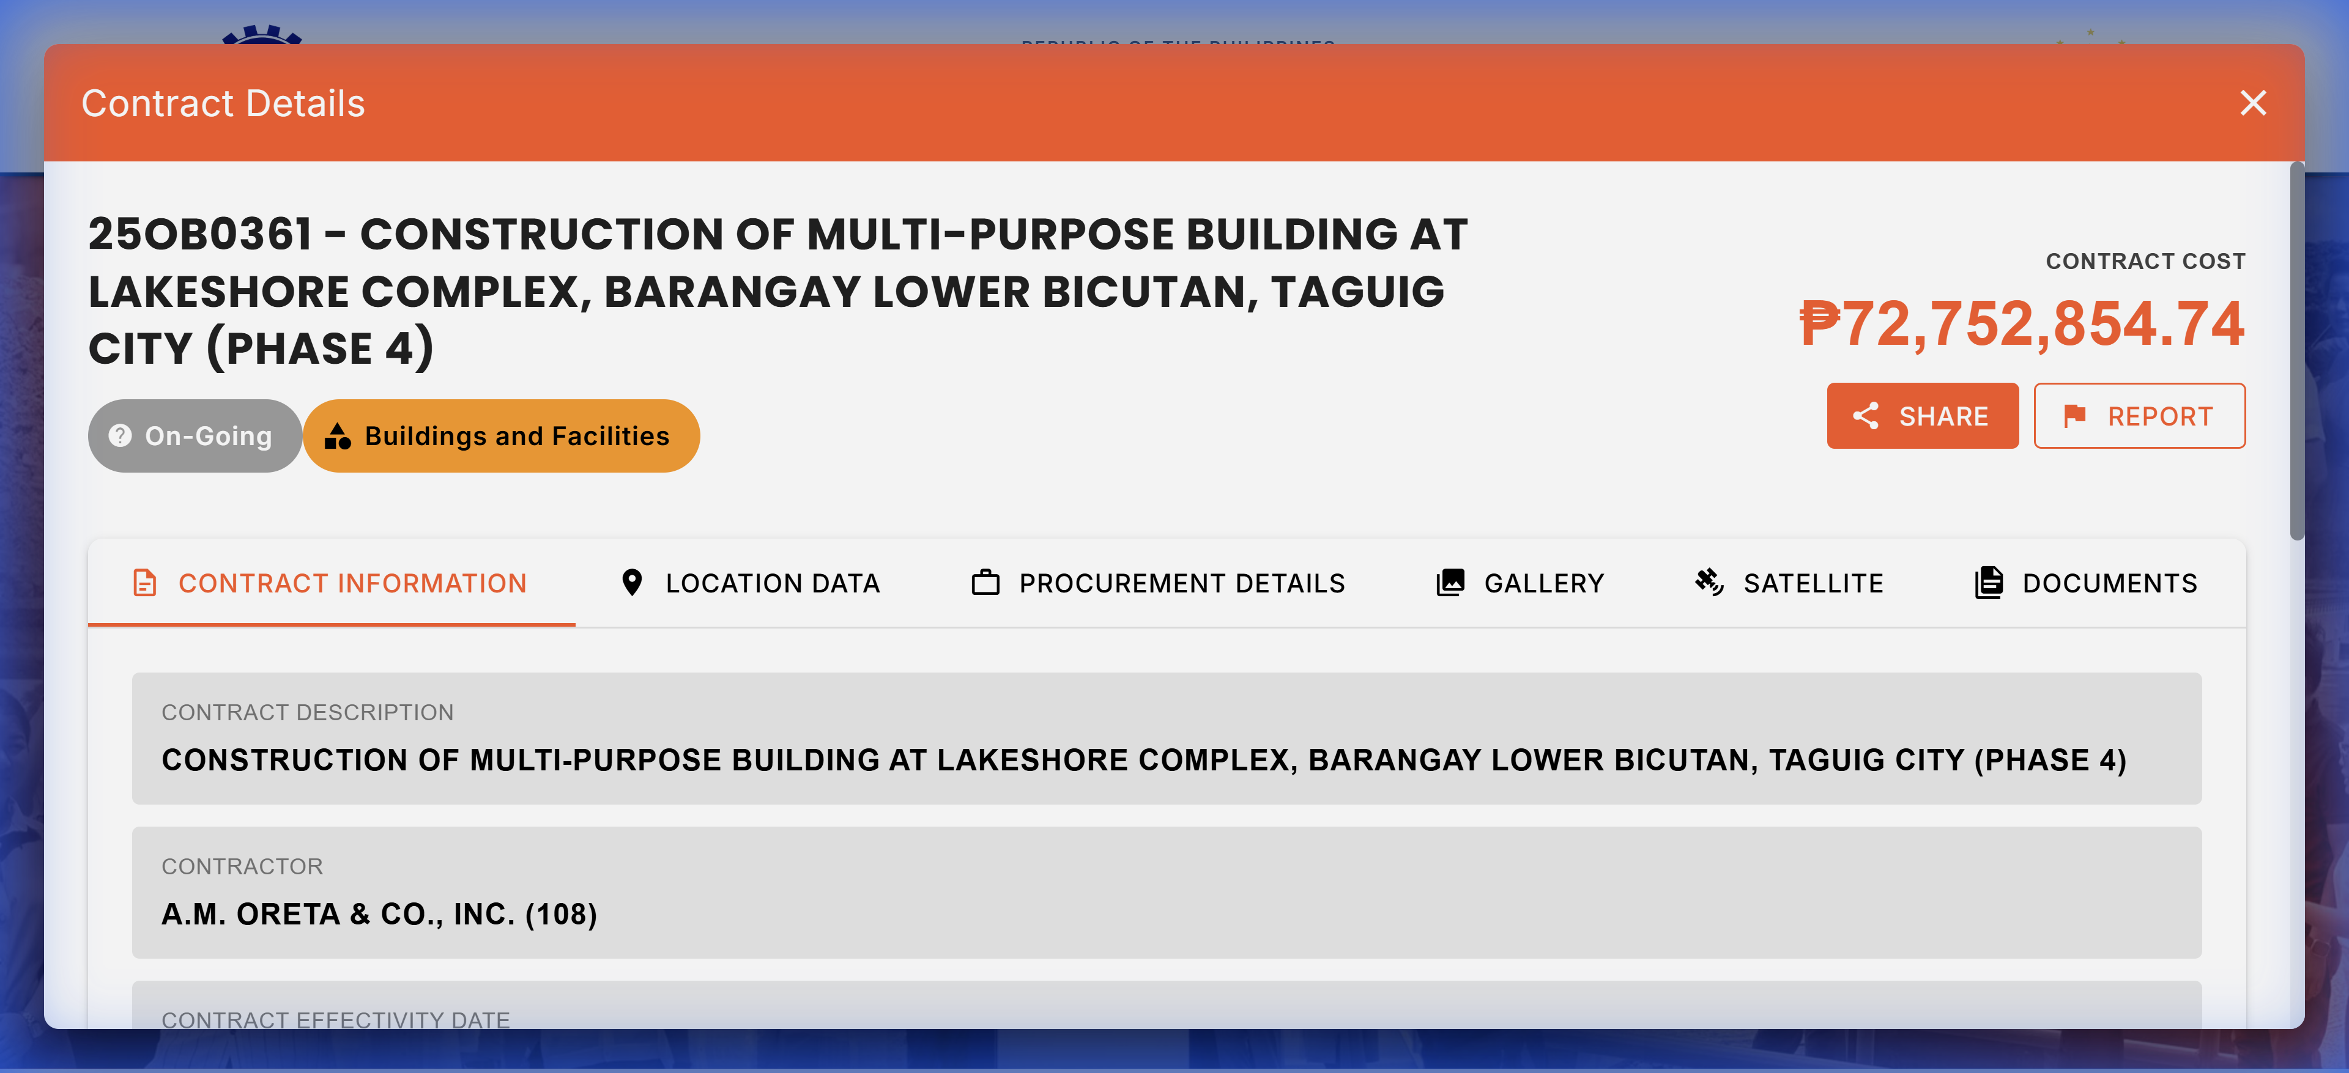 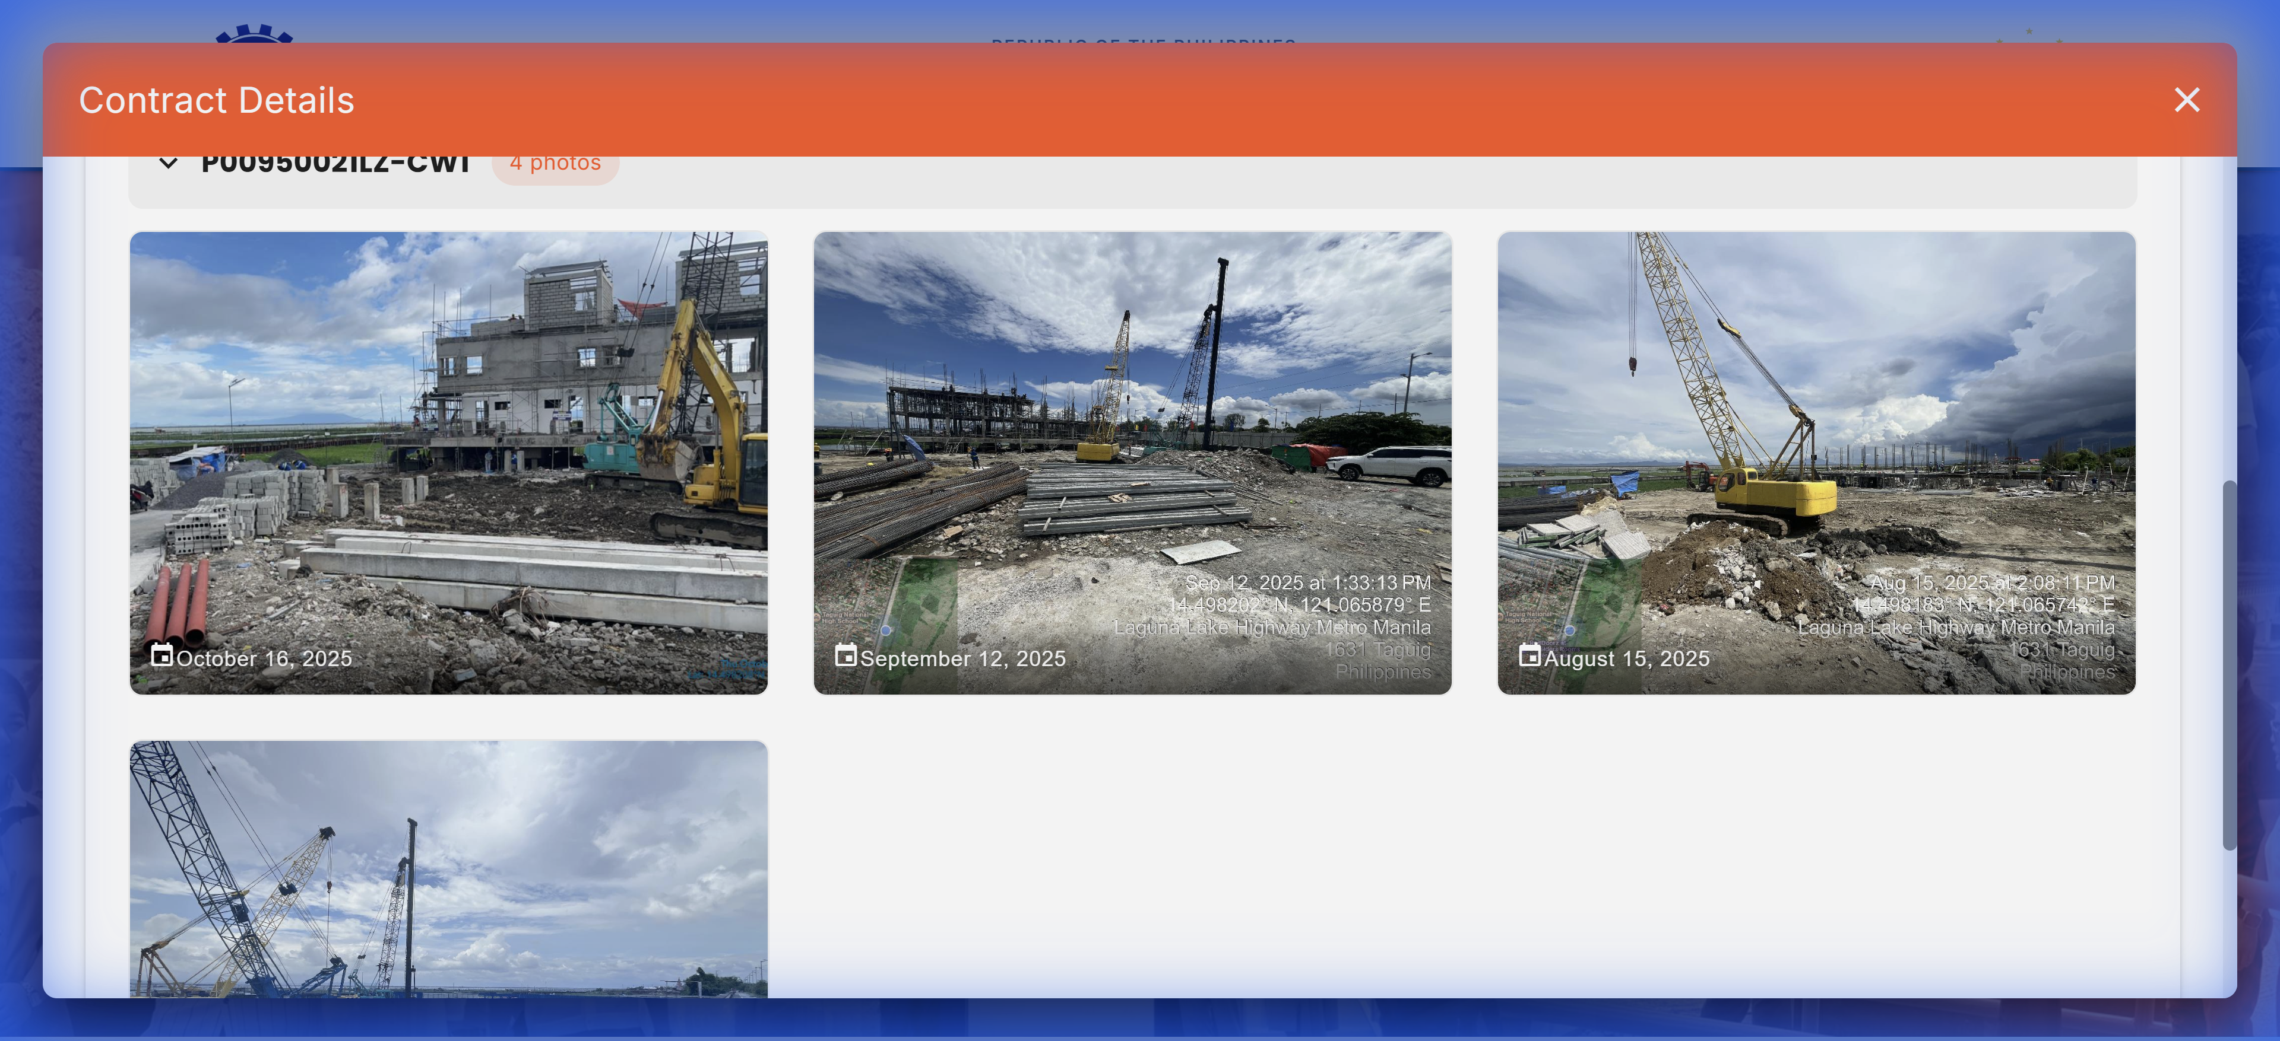
20O00045: 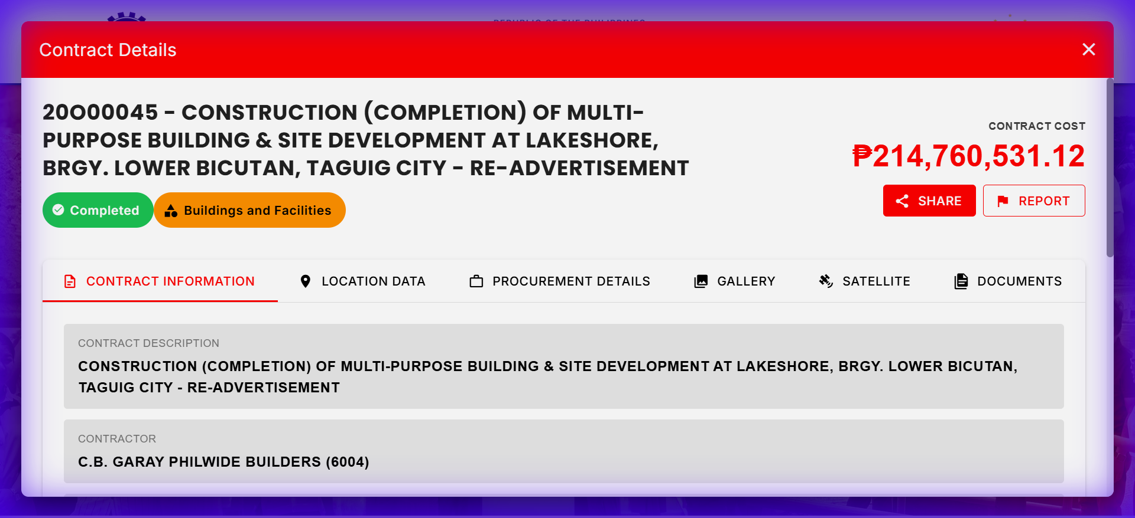 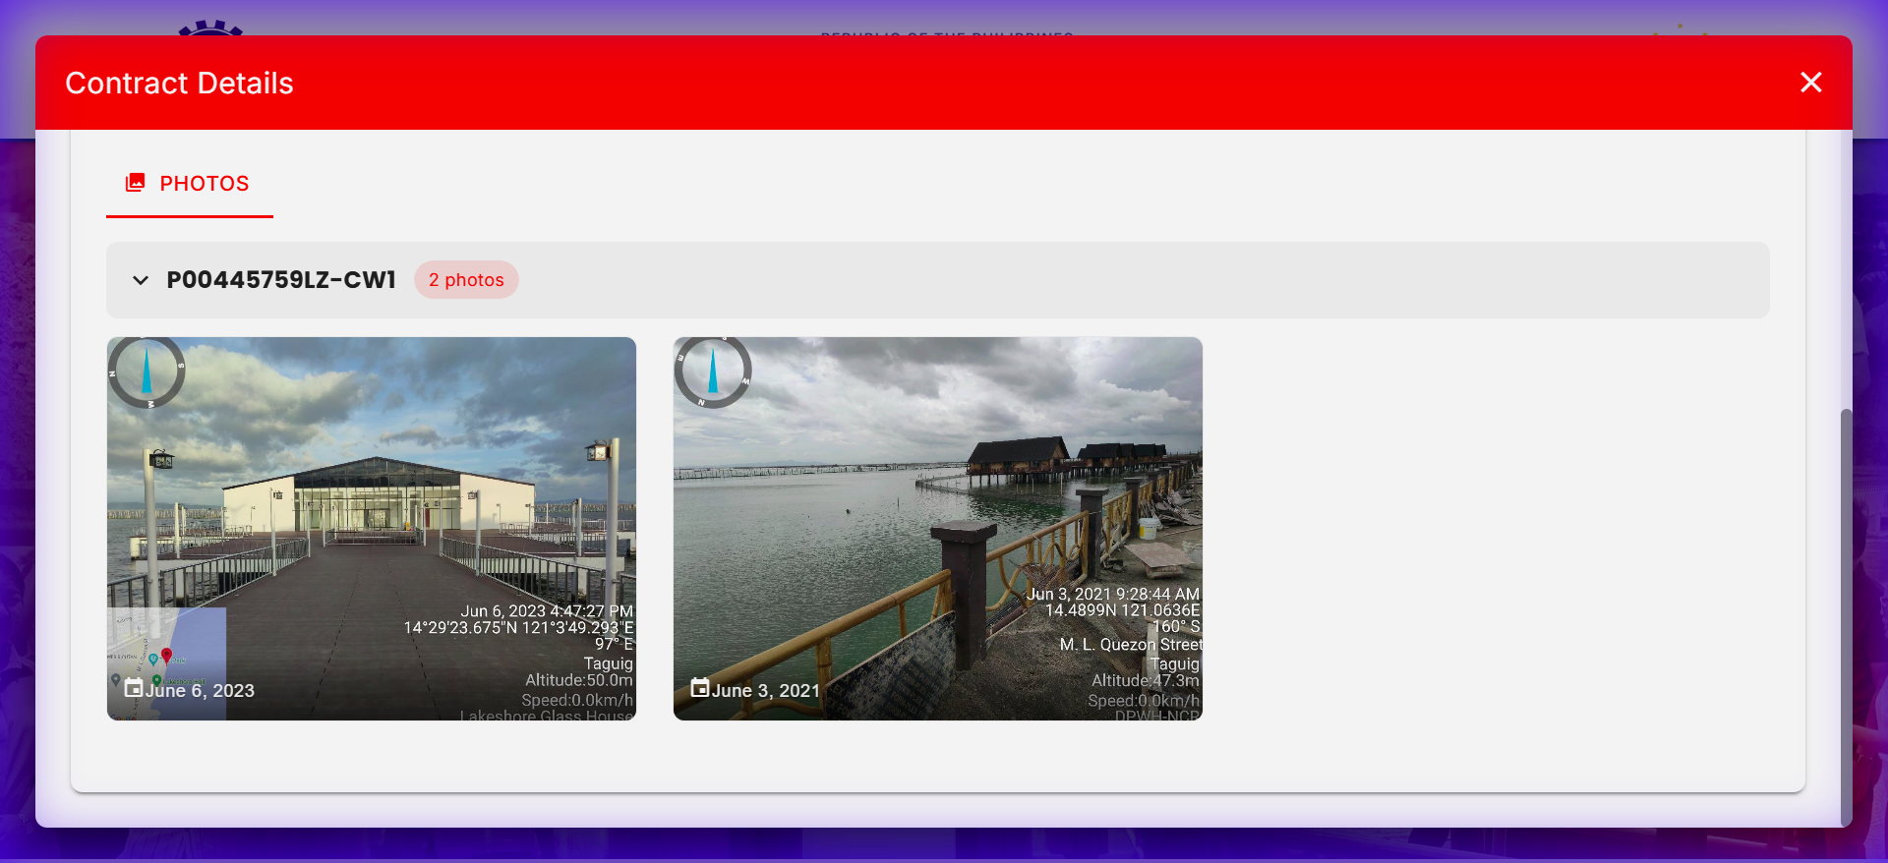

2. Construction of Multi-Purpose Building, Barangay Central, Bicutan, Taguig City (Phase 2)
- Budget ID: DPWH-Proj-11346
- Amount: P249,249,000.00
- Transparency Matches (5): | Contract ID | Contract Name | Amount | |:————|:————–|:——-| | 25OB0207 | CONSTRUCTION (COMPLETION) OF MULTI-PURPOSE BUILDING, INCLUDING SITE DEVELOPMENT AT TCU, BARANGAY CENTRAL BICUTAN, TAGUIG CITY | P48,511,013.75 | | 25OB0368 | CONSTRUCTION OF A MULTI-PURPOSE BUILDING WITH SITE DEVELOPMENT, BRGY. CENTRAL BICUTAN, TAGUIG CITY | P48,499,276.12 | | 25OB0411 | CONSTRUCTION OF MULTI-PURPOSE BUILDING, BARANGAY CENTRAL BICUTAN,TAGUIG CITY (PHASE 3) | P48,494,985.57 | | 25OB0444 | CONSTRUCTION OF MULTI-PURPOSE BUILDING AND SITE DEVELOPMENT AT TCU COMPOUND, BARANGAY CENTRAL BICUTAN, TAGUIG CITY (PHASE 3) | P48,507,474.88 | | 18OB0102 | CONSTRUCTION/REHABILITATION OF MULTI-PURPOSE BUILDING (ISIP MUNA BAYAN COVERED COURT), PUROK 1, BRGY. CENTRAL BICUTAN, TAGUIG CITY | P2,782,513.35 |

3. Construction of Multi-Purpose Building (RFU-NCR Mega Laboratory Building), 1st Quadrant of Camp Bagong Diwa Along Gen. Santos Ave., Bicutan, Taguig City
- Budget ID: DPWH-Proj-11344
- Amount: P200,000,000.00
- Transparency Matches (3): | Contract ID | Contract Name | Amount | |:————|:————–|:——-| | 25OB0451 | CONSTRUCTION OF MULTI-PURPOSE BUILDING (RFU-NCR MEGA LABORATORY BUILDING), 1ST QUADRANT OF CAMP BAGONG DIWA ALONG GEN. SANTOS AVE., BICUTAN, TAGUIG CITY (PHASE V) | P141,782,606.03 | | 25OB0452 | CONSTRUCTION OF MULTI-PURPOSE BUILDING (RFU-NCR MEGA LABORATORY BUILDING), 1ST QUADRANT OF CAMP BAGONG DIWA ALONG GEN. SANTOS AVE., BICUTAN, TAGUIG CITY (PHASE VI) | P141,782,392.82 | | 23OB0383 | CONSTRUCTION OF MULTI-PURPOSE BUILDING (RFU-NCR MEGA LABORATORY BUILDING) (WITH EQUIPMENT), 1ST QUADRANT OF CAMP BAGONG DIWA ALONG GEN. SANTOS AVE., BICUTAN, TAGUIG CITY | P81,188,147.02 |

4. Construction of Multi-Purpose Building (RFU-NCR Mega Laboratory Building), 1st Quadrant of Camp Bagong Diwa Along Gen. Santos Ave., Bicutan, Taguig City
- Budget ID: DPWH-Proj-11344
- Amount: P200,000,000.00
- Transparency Matches (3): | Contract ID | Contract Name | Amount | |:————|:————–|:——-| | 25OB0451 | CONSTRUCTION OF MULTI-PURPOSE BUILDING (RFU-NCR MEGA LABORATORY BUILDING), 1ST QUADRANT OF CAMP BAGONG DIWA ALONG GEN. SANTOS AVE., BICUTAN, TAGUIG CITY (PHASE V) | P141,782,606.03 | | 25OB0452 | CONSTRUCTION OF MULTI-PURPOSE BUILDING (RFU-NCR MEGA LABORATORY BUILDING), 1ST QUADRANT OF CAMP BAGONG DIWA ALONG GEN. SANTOS AVE., BICUTAN, TAGUIG CITY (PHASE VI) | P141,782,392.82 | | 23OB0383 | CONSTRUCTION OF MULTI-PURPOSE BUILDING (RFU-NCR MEGA LABORATORY BUILDING) (WITH EQUIPMENT), 1ST QUADRANT OF CAMP BAGONG DIWA ALONG GEN. SANTOS AVE., BICUTAN, TAGUIG CITY | P81,188,147.02 |

5. Construction of Multi-Purpose Building, Barangay Igulot, Bocaue, Bulacan
- Budget ID: DPWH-Proj-13664
- Amount: P200,000,000.00
- Transparency Matches (5): | Contract ID | Contract Name | Amount | |:————|:————–|:——-| | 25CC0256 | CONSTRUCTION OF MULTI-PURPOSE BUILDING AT BARANGAY IGULOT, BOCAUE, BULACAN | P19,286,841.33 | | 18CC0186 | COMPLETION OF MULTI-PURPOSE BUILDING GYM IGULOT, BOCAUE, BULACAN | P1,862,104.73 | | 18CC0346 | CONSTRUCTION OF MULTI-PURPOSE BUILDING (MUNICIPAL HALL COMPOUND) IGULOT, BOCAUE, BULACAN | P44,674,163.42 | | 20CC0195 | CONSTRUCTION OF MULTI-PURPOSE BUILDING (NEW MUNICIPAL BUILDING EXTENSION) BRGY. IGULOT, BOCAUE, BULACAN | P30,831,810.70 | | 23CC0366 | CONSTRUCTION OF MULTI-PURPOSE BUILDING, BARANGAY IGULOT, BOCAUE, BULACAN | P9,899,995.27 |

6. Construction of Multi-Purpose Building, Barangay Igulot, Bocaue, Bulacan
- Budget ID: DPWH-Proj-13664
- Amount: P200,000,000.00
- Transparency Matches (5): | Contract ID | Contract Name | Amount | |:————|:————–|:——-| | 25CC0256 | CONSTRUCTION OF MULTI-PURPOSE BUILDING AT BARANGAY IGULOT, BOCAUE, BULACAN | P19,286,841.33 | | 18CC0186 | COMPLETION OF MULTI-PURPOSE BUILDING GYM IGULOT, BOCAUE, BULACAN | P1,862,104.73 | | 18CC0346 | CONSTRUCTION OF MULTI-PURPOSE BUILDING (MUNICIPAL HALL COMPOUND) IGULOT, BOCAUE, BULACAN | P44,674,163.42 | | 20CC0195 | CONSTRUCTION OF MULTI-PURPOSE BUILDING (NEW MUNICIPAL BUILDING EXTENSION) BRGY. IGULOT, BOCAUE, BULACAN | P30,831,810.70 | | 23CC0366 | CONSTRUCTION OF MULTI-PURPOSE BUILDING, BARANGAY IGULOT, BOCAUE, BULACAN | P9,899,995.27 |

7. Construction of Multi-Purpose Building, Barangay Igulot, Bocaue, Bulacan
- Budget ID: DPWH-Proj-13664
- Amount: P200,000,000.00
- Transparency Matches (5): | Contract ID | Contract Name | Amount | |:————|:————–|:——-| | 25CC0256 | CONSTRUCTION OF MULTI-PURPOSE BUILDING AT BARANGAY IGULOT, BOCAUE, BULACAN | P19,286,841.33 | | 18CC0186 | COMPLETION OF MULTI-PURPOSE BUILDING GYM IGULOT, BOCAUE, BULACAN | P1,862,104.73 | | 18CC0346 | CONSTRUCTION OF MULTI-PURPOSE BUILDING (MUNICIPAL HALL COMPOUND) IGULOT, BOCAUE, BULACAN | P44,674,163.42 | | 20CC0195 | CONSTRUCTION OF MULTI-PURPOSE BUILDING (NEW MUNICIPAL BUILDING EXTENSION) BRGY. IGULOT, BOCAUE, BULACAN | P30,831,810.70 | | 23CC0366 | CONSTRUCTION OF MULTI-PURPOSE BUILDING, BARANGAY IGULOT, BOCAUE, BULACAN | P9,899,995.27 |

8. Construction of Multi-Purpose Building, Southern Luzon Multi-Specialty Medical Center, Tayabas City, Quezon
- Budget ID: DPWH-Proj-13688
- Amount: P200,000,000.00
- Transparency Matches (1): | Contract ID | Contract Name | Amount | |:————|:————–|:——-| | 25D00078 | CONSTRUCTION OF MULTI-PURPOSE BUILDING, SOUTHERN LUZON MULTI-SPECIALTY MEDICAL CENTER, TAYABAS CITY, QUEZON | P195,023,204.14 |
Screenshots:
25D00078: 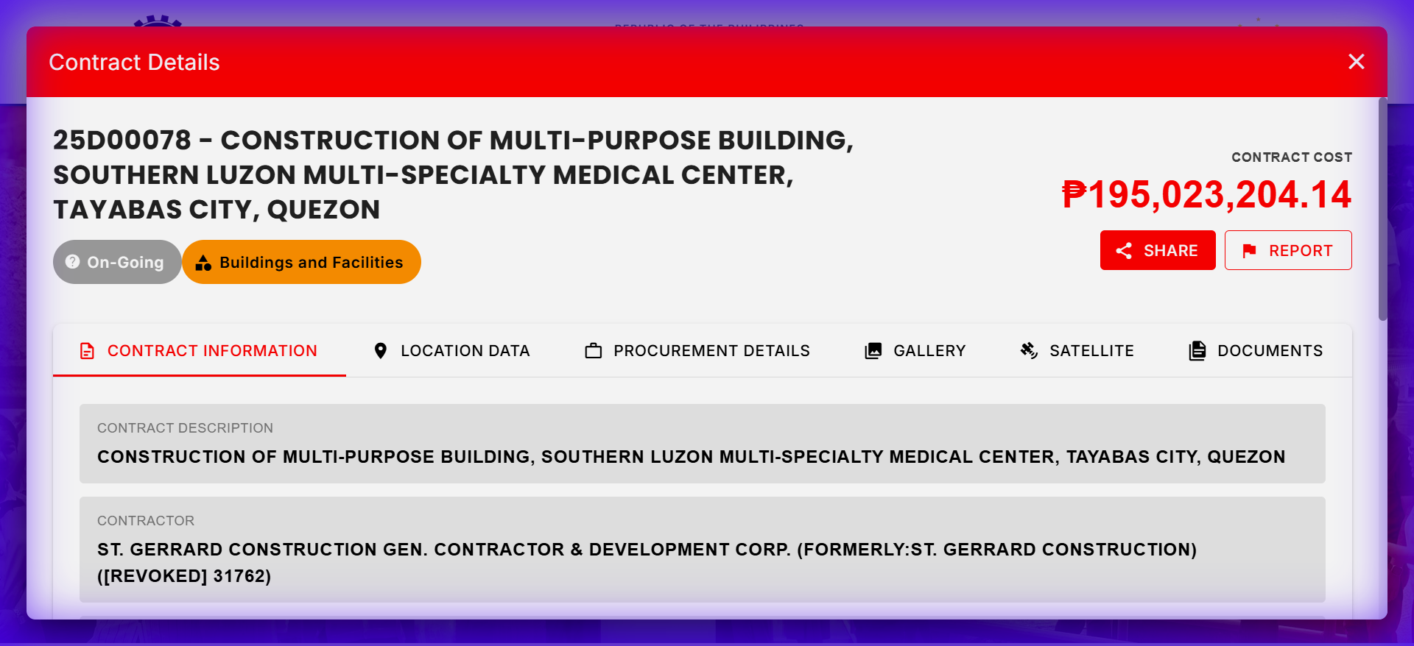 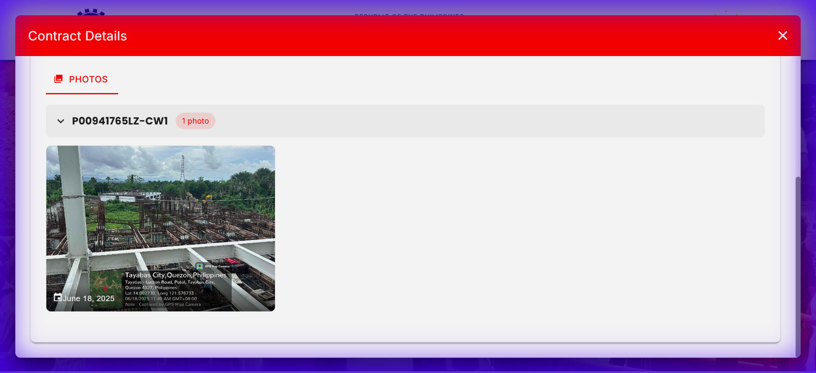

9. Completion of Multi-Purpose Building (City Environment and Management Office (CEMO) Complex), Barangay Sto. Nino, Marikina City
- Budget ID: DPWH-Proj-13567
- Amount: P150,000,000.00
- Transparency Matches (1): | Contract ID | Contract Name | Amount | |:————|:————–|:——-| | 23OB0304 | CONSTRUCTION OF MULTI-PURPOSE BUILDING, (CITY ENVIRONMENT AND MANAGEMENT OFFICE (CEMO) COMPLEX), BRGY. STO. NINO MARIKINA CITY | P37,690,582.90 |

10. Construction of Multi-Purpose Building (Gymnasium) Dao, Pagadian City, Zamboanga del Sur
- Budget ID: DPWH-Proj-13777
- Amount: P150,000,000.00
- Transparency Matches (2): | Contract ID | Contract Name | Amount | |:————|:————–|:——-| | 20JE0073 | CONSTRUCTION OF MULTI-PURPOSE GYMNASIUM, DAO, PAGADIAN CITY, ZAMBOANGA DEL SUR | P29,649,849.75 | | 21J00035 | BUILDINGS AND OTHER STRUCTURES - MULTIPURPOSE / FACILITIES - CONSTRUCTION OF THE MULTI-PURPOSE FACILITY (GYMNASIUM), DAO, PAGADIAN CITY, ZAMBOANGA DEL SUR | P181,479,965.14 |
Screenshots:
21J00035: 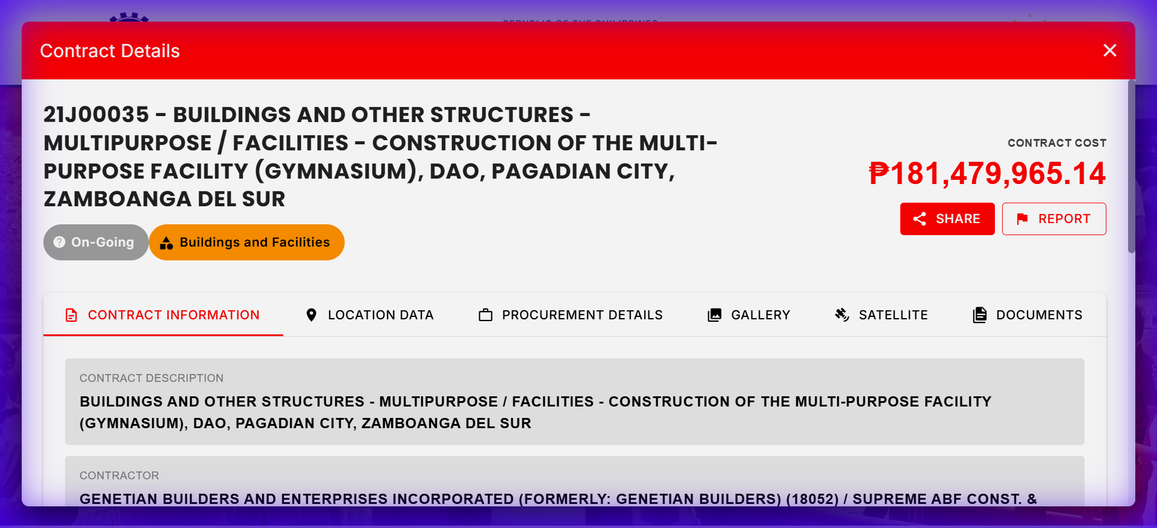 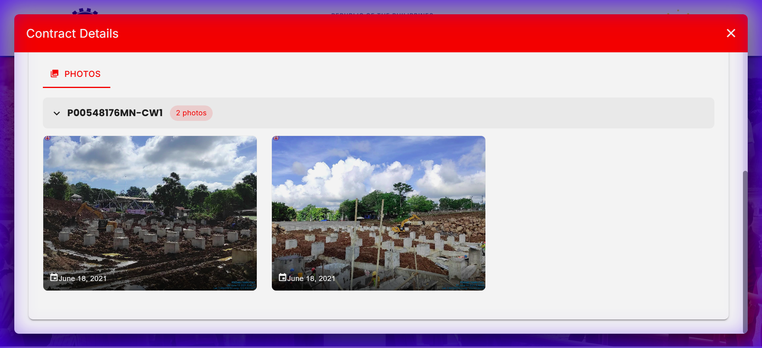

11. Construction of Multi-Purpose Building (Training and Instructional Facility/Meetings Incentives Conferences for Education, Sports Building (Mices) and Primary health Center), Phase 2, Milagros, Masbate
- Budget ID: DPWH-Proj-13423
- Amount: P120,000,000.00
- Transparency Matches (5): | Contract ID | Contract Name | Amount | |:————|:————–|:——-| | 23FB0206 | SIPAG: MULTI-PURPOSE BUILDINGS/FACILITIES TO SUPPORT SOCIAL SERVICES, CONSTRUCTION OF MULTI PURPOSE TRAINING AND INSTRUCTIONAL FACILITY/MEETINGS INCENTIVES CONFERENCES FOR EDUCATION, SPORTS BUILDING (MICES) AND PRIMARY HEALTH CENTERS AT DARAGA, ALBAY | P71,800,737.18 | | 23FB0224 | SIPAG: MULTI-PURPOSE BUILDINGS/ FACILITIES TO SUPPORT SOCIAL SERVICES, CONSTRUCTION OF MULTI PURPOSE TRAINING AND INSTRUCTIONAL FACILITY/ MEETINGS INCENTIVES CONFERENCES FOR EDUCATION, SPORTS BUILDING (MICES) AND PRIMARY HEALTH CENTERS AT CAMALIG, ALBAY | P71,440,368.48 | | 23FB0225 | SIPAG: MULTI-PURPOSE BUILDINGS/ FACILITIES TO SUPPORT SOCIAL SERVICES, CONSTRUCTION OF MULTI PURPOSE TRAINING AND INSTRUCTIONAL FACILITY/ MEETINGS INCENTIVES CONFERENCES FOR EDUCATION, SPORTS BUILDING (MICES) AND PRIMARY HEALTH CENTERS AT MANITO, ALBAY | P71,455,033.36 | | 24FB0228 | BASIC INFRASTRUCTURE PROGRAM (BIP)-MULTI-PURPOSE BUILDINGS/FACILITIES TO SUPPORT SOCIAL SERVICES-CONSTRUCTION OF MULTI - PURPOSE BLDG. (TRAINING AND INSTRUCTIONAL FACILITY/MEETINGS INCENTIVES CONFERENCES FOR EDUCATION, SPORTS BUILDING (MICES) AND PRIMARY | P173,248,450.87 | | 24FB0229 | BASIC INFRASTRUCTURE PROGRAM (BIP) - MULTI-PURPOSE BUILDINGS/FACILITIES TO SUPPORT SOCIAL SERVICES -CONSTRUCTION OF MULTI-PURPOSE BLDG. (TRAINING AND INSTRUCTIONAL FACILITY/MEETINGS INCENTIVES CONFERENCES FOR EDUCATION, SPORTS BUILDING (MICES) AND PRIMARY | P169,783,521.29 |
Screenshots:
24FB0228: 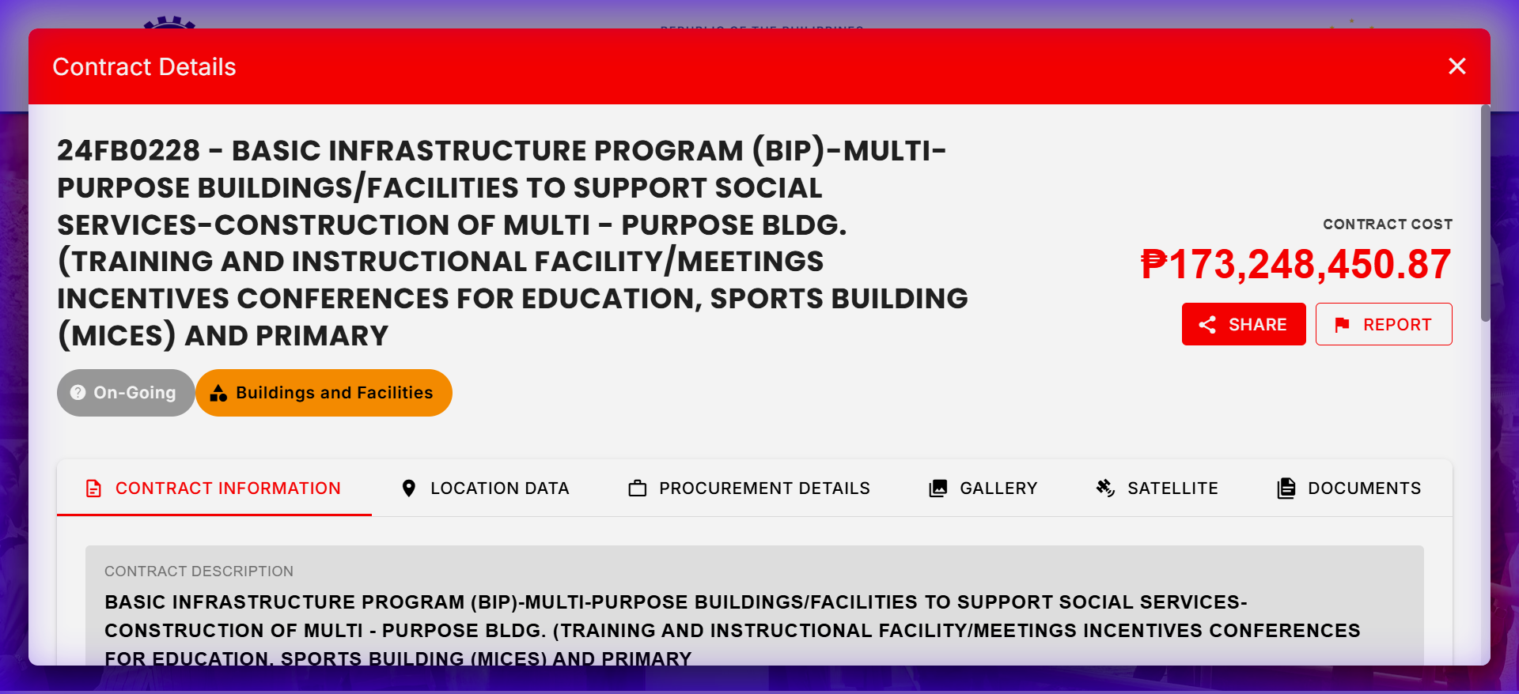 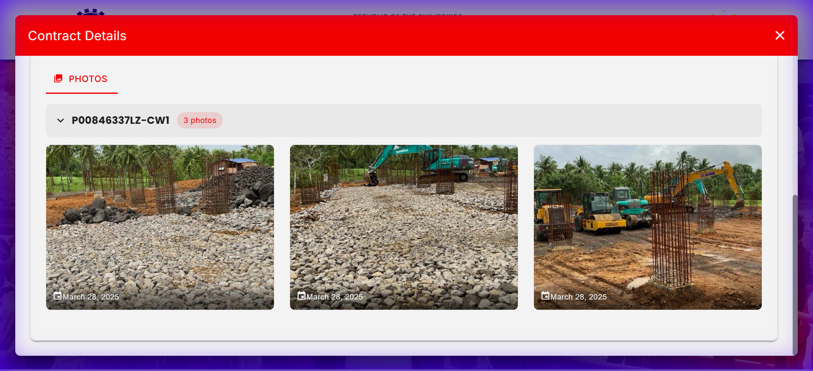
24FB0229: 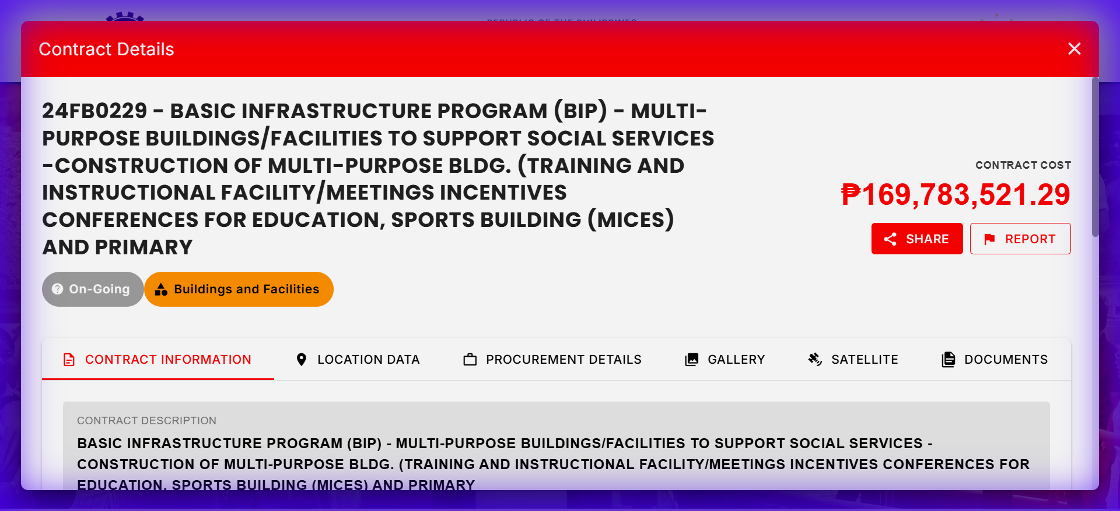 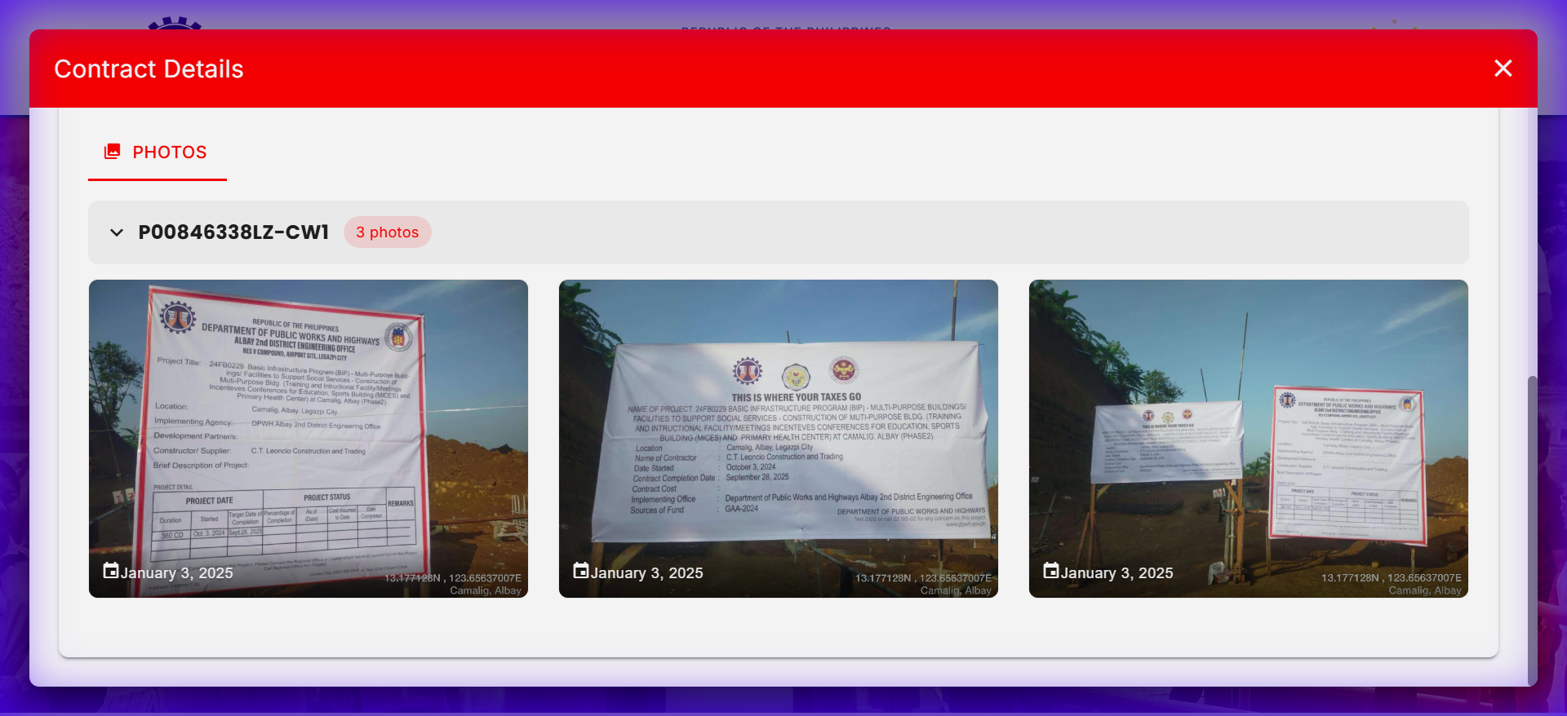

12. Construction of Multi-Purpose Building, Barangay San Miguel, Jordan, Guimaras
- Budget ID: DPWH-Proj-13727
- Amount: P109,291,000.00
- Transparency Matches (5): | Contract ID | Contract Name | Amount | |:————|:————–|:——-| | 25GE0015 | CONSTRUCTION OF MULTI-PURPOSE BUILDING-CONSTRUCTION (COMPLETION) OF MULTI-PURPOSE BUILDING, DPWH GUIMARAS DEO, SAN MIGUEL, JORDAN, GUIMARAS | P19,495,907.24 | | 25GE0030 | CONSTRUCTION OF MULTI-PURPOSE BUILDING-CONSTRUCTION OF MULTI-PURPOSE BUILDING (GUIMARAS ARENA AND CONVENTION CENTER), BARANGAY SAN MIGUEL, JORDAN, GUIMARAS | P34,549,999.57 | | 19GE0056 | CONSTRUCTION OF MULTI-PURPOSE BUILDING, BRGY. SAN MIGUEL, JORDAN, GUIMARAS | P1,410,582.18 | | 19GE0149 | CONSTRUCTION OF MULTI-PURPOSE BUILDING IN INDIGENOUS PEOPLE’S RELOCATION SITE, BRGY. SAN MIGUEL, JORDAN, GUIMARAS | P940,504.84 | | 20GE0009 | CONSTRUCTION OF MULTI-PURPOSE BUILDING (PHASE II), BRGY. SAN MIGUEL, JORDAN, GUIMARAS | P1,880,827.89 |

13. Construction of Multi-Purpose Building, Barangay San Miguel, Jordan, Guimaras
- Budget ID: DPWH-Proj-13727
- Amount: P109,291,000.00
- Transparency Matches (5): | Contract ID | Contract Name | Amount | |:————|:————–|:——-| | 25GE0015 | CONSTRUCTION OF MULTI-PURPOSE BUILDING-CONSTRUCTION (COMPLETION) OF MULTI-PURPOSE BUILDING, DPWH GUIMARAS DEO, SAN MIGUEL, JORDAN, GUIMARAS | P19,495,907.24 | | 25GE0030 | CONSTRUCTION OF MULTI-PURPOSE BUILDING-CONSTRUCTION OF MULTI-PURPOSE BUILDING (GUIMARAS ARENA AND CONVENTION CENTER), BARANGAY SAN MIGUEL, JORDAN, GUIMARAS | P34,549,999.57 | | 19GE0056 | CONSTRUCTION OF MULTI-PURPOSE BUILDING, BRGY. SAN MIGUEL, JORDAN, GUIMARAS | P1,410,582.18 | | 19GE0149 | CONSTRUCTION OF MULTI-PURPOSE BUILDING IN INDIGENOUS PEOPLE’S RELOCATION SITE, BRGY. SAN MIGUEL, JORDAN, GUIMARAS | P940,504.84 | | 20GE0009 | CONSTRUCTION OF MULTI-PURPOSE BUILDING (PHASE II), BRGY. SAN MIGUEL, JORDAN, GUIMARAS | P1,880,827.89 |

14. Construction of Multi-Purpose Building, Barangay San Miguel, Jordan, Guimaras
- Budget ID: DPWH-Proj-13727
- Amount: P109,291,000.00
- Transparency Matches (5): | Contract ID | Contract Name | Amount | |:————|:————–|:——-| | 25GE0015 | CONSTRUCTION OF MULTI-PURPOSE BUILDING-CONSTRUCTION (COMPLETION) OF MULTI-PURPOSE BUILDING, DPWH GUIMARAS DEO, SAN MIGUEL, JORDAN, GUIMARAS | P19,495,907.24 | | 25GE0030 | CONSTRUCTION OF MULTI-PURPOSE BUILDING-CONSTRUCTION OF MULTI-PURPOSE BUILDING (GUIMARAS ARENA AND CONVENTION CENTER), BARANGAY SAN MIGUEL, JORDAN, GUIMARAS | P34,549,999.57 | | 19GE0056 | CONSTRUCTION OF MULTI-PURPOSE BUILDING, BRGY. SAN MIGUEL, JORDAN, GUIMARAS | P1,410,582.18 | | 19GE0149 | CONSTRUCTION OF MULTI-PURPOSE BUILDING IN INDIGENOUS PEOPLE’S RELOCATION SITE, BRGY. SAN MIGUEL, JORDAN, GUIMARAS | P940,504.84 | | 20GE0009 | CONSTRUCTION OF MULTI-PURPOSE BUILDING (PHASE II), BRGY. SAN MIGUEL, JORDAN, GUIMARAS | P1,880,827.89 |

15. CONSTRUCTION OF MULTIPURPOSE BUILDINGS AT BARANGAY PINAGKAWITAN, LIPA CITY, BATANGAS
- Budget ID: DPWH-Proj-11601
- Amount: P100,000,000.00
- Transparency Matches (5): | Contract ID | Contract Name | Amount | |:————|:————–|:——-| | 20DD0241 | LOCAL PROGRAM, LOCAL INFRASTRUCTURE PROGRAM, BUILDINGS AND OTHER STRUCTURES, MULTIPURPOSE/ FACILITIES, CONSTRUCTION OF MULTI-PURPOSE BUILDING AT PINAGKAWITAN ELEMENTARY SCHOOL, BRGY. PINAGKAWITAN, LIPA CITY, BATANGAS | P7,681,246.00 | | 20DD0246 | LOCAL PROGRAM, LOCAL INFRASTRUCTURE PROGRAM, BUILDINGS AND OTHER STRUCTURES, MULTIPURPOSE/ FACILITIES, CONSTRUCTION AND/OR REPAIR/REHABILITATION OF MULTI-PURPOSE BUILDING, BRGY. PINAGKAWITAN, LIPA CITY, BATANGAS | P2,400,316.00 | | 20DD0269 | LOCAL PROGRAM, LOCAL INFRASTRUCTURE PROGRAM, BUILDINGS AND OTHER STRUCTURES, MULTIPURPOSE/ FACILITIES, CONSTRUCTION OF SCHOOL GYM AT PINAGKAWITAN ELEMENTARY SCHOOL, BRGY. PINAGKAWITAN, LIPA CITY, BATANGAS | P8,641,813.00 | | 21DD0031 | LOCAL PROGRAM, LOCAL INFRASTRUCTURE PROGRAM, BUILDINGS AND OTHER STRUCTURES, MULTIPURPOSE/ FACILITIES, CONSTRUCTION/REHABILITATION OF MULTI-PURPOSE BUILDING AT BARANGAY PINAGKAWITAN, LIPA CITY, BATANGAS | P4,805,185.50 | | 21DD0288 | LOCAL PROGRAM, LOCAL INFRASTRUCTURE PROGRAM, BUILDINGS AND OTHER STRUCTURES, MULTIPURPOSE/ FACILITIES, CONSTRUCTION OF MULTIPURPOSE BUILDING AT BARANGAY PINAGKAWITAN, LIPA CITY, BATANGAS | P9,008,877.00 |

16. CONSTRUCTION OF MULTIPURPOSE BUILDINGS AT BARANGAY PINAGKAWITAN, LIPA CITY, BATANGAS
- Budget ID: DPWH-Proj-11601
- Amount: P100,000,000.00
- Transparency Matches (5): | Contract ID | Contract Name | Amount | |:————|:————–|:——-| | 20DD0241 | LOCAL PROGRAM, LOCAL INFRASTRUCTURE PROGRAM, BUILDINGS AND OTHER STRUCTURES, MULTIPURPOSE/ FACILITIES, CONSTRUCTION OF MULTI-PURPOSE BUILDING AT PINAGKAWITAN ELEMENTARY SCHOOL, BRGY. PINAGKAWITAN, LIPA CITY, BATANGAS | P7,681,246.00 | | 20DD0246 | LOCAL PROGRAM, LOCAL INFRASTRUCTURE PROGRAM, BUILDINGS AND OTHER STRUCTURES, MULTIPURPOSE/ FACILITIES, CONSTRUCTION AND/OR REPAIR/REHABILITATION OF MULTI-PURPOSE BUILDING, BRGY. PINAGKAWITAN, LIPA CITY, BATANGAS | P2,400,316.00 | | 20DD0269 | LOCAL PROGRAM, LOCAL INFRASTRUCTURE PROGRAM, BUILDINGS AND OTHER STRUCTURES, MULTIPURPOSE/ FACILITIES, CONSTRUCTION OF SCHOOL GYM AT PINAGKAWITAN ELEMENTARY SCHOOL, BRGY. PINAGKAWITAN, LIPA CITY, BATANGAS | P8,641,813.00 | | 21DD0031 | LOCAL PROGRAM, LOCAL INFRASTRUCTURE PROGRAM, BUILDINGS AND OTHER STRUCTURES, MULTIPURPOSE/ FACILITIES, CONSTRUCTION/REHABILITATION OF MULTI-PURPOSE BUILDING AT BARANGAY PINAGKAWITAN, LIPA CITY, BATANGAS | P4,805,185.50 | | 21DD0288 | LOCAL PROGRAM, LOCAL INFRASTRUCTURE PROGRAM, BUILDINGS AND OTHER STRUCTURES, MULTIPURPOSE/ FACILITIES, CONSTRUCTION OF MULTIPURPOSE BUILDING AT BARANGAY PINAGKAWITAN, LIPA CITY, BATANGAS | P9,008,877.00 |

17. CONSTRUCTION OF MULTIPURPOSE BUILDINGS AT BARANGAY PINAGKAWITAN, LIPA CITY, BATANGAS
- Budget ID: DPWH-Proj-11601
- Amount: P100,000,000.00
- Transparency Matches (5): | Contract ID | Contract Name | Amount | |:————|:————–|:——-| | 20DD0241 | LOCAL PROGRAM, LOCAL INFRASTRUCTURE PROGRAM, BUILDINGS AND OTHER STRUCTURES, MULTIPURPOSE/ FACILITIES, CONSTRUCTION OF MULTI-PURPOSE BUILDING AT PINAGKAWITAN ELEMENTARY SCHOOL, BRGY. PINAGKAWITAN, LIPA CITY, BATANGAS | P7,681,246.00 | | 20DD0246 | LOCAL PROGRAM, LOCAL INFRASTRUCTURE PROGRAM, BUILDINGS AND OTHER STRUCTURES, MULTIPURPOSE/ FACILITIES, CONSTRUCTION AND/OR REPAIR/REHABILITATION OF MULTI-PURPOSE BUILDING, BRGY. PINAGKAWITAN, LIPA CITY, BATANGAS | P2,400,316.00 | | 20DD0269 | LOCAL PROGRAM, LOCAL INFRASTRUCTURE PROGRAM, BUILDINGS AND OTHER STRUCTURES, MULTIPURPOSE/ FACILITIES, CONSTRUCTION OF SCHOOL GYM AT PINAGKAWITAN ELEMENTARY SCHOOL, BRGY. PINAGKAWITAN, LIPA CITY, BATANGAS | P8,641,813.00 | | 21DD0031 | LOCAL PROGRAM, LOCAL INFRASTRUCTURE PROGRAM, BUILDINGS AND OTHER STRUCTURES, MULTIPURPOSE/ FACILITIES, CONSTRUCTION/REHABILITATION OF MULTI-PURPOSE BUILDING AT BARANGAY PINAGKAWITAN, LIPA CITY, BATANGAS | P4,805,185.50 | | 21DD0288 | LOCAL PROGRAM, LOCAL INFRASTRUCTURE PROGRAM, BUILDINGS AND OTHER STRUCTURES, MULTIPURPOSE/ FACILITIES, CONSTRUCTION OF MULTIPURPOSE BUILDING AT BARANGAY PINAGKAWITAN, LIPA CITY, BATANGAS | P9,008,877.00 |

18. Construction of Multi-Purpose Building, San Marcos, Cabarroguis, Quirino
- Budget ID: DPWH-Proj-13645
- Amount: P100,000,000.00
- Transparency Matches (5): | Contract ID | Contract Name | Amount | |:————|:————–|:——-| | 25BK0078 | BASIC INFRASTRUCTURE PROGRAM (BIP) - MULTI-PURPOSE BUILDINGS/FACILITIES TO SUPPORT SOCIAL SERVICES - CONSTRUCTION (COMPLETION) OF MULTI-PURPOSE BUILDING, SAN MARCOS, CABARROGUIS, QUIRINO | P9,602,737.55 | | 25BK0104 | BASIC INFRASTRUCTURE PROGRAM (BIP) - MULTI-PURPOSE BUILDINGS/ FACILITIES TO SUPPORT SOCIAL SERVICES - COMPLETION OF MULTI-PURPOSE BUILDING ( TWO-STOREY OFFICE BUILDING) SAN MARCOS, CABARROGUIS, QUIRINO (PHASE II) | P76,821,825.97 | | 18BK0097 | CONSTRUCTION/REHABILITATION OF MULTI-PURPOSE BUILDING SAN MARCOS, CABARROGUIS, QUIRINO | P1,439,071.48 | | 18BK0114 | CONSTRUCTION OF MULTI-PURPOSE BUILDING SAN MARCOS, CABARROGUIS, QUIRINO | P4,761,600.00 | | 21BK0057 | CONSTRUCTION/REHABILITATION OF MULTI-PURPOSE BUILDING BARANGAY SAN MARCOS, CABARROGUIS, QUIRINO | P4,894,343.79 |

19. Construction of Multi-Purpose Building, Municipal Livelihood and Training Center, Barangay San Nicolas, Castillejos, Zambales
- Budget ID: DPWH-Proj-13649
- Amount: P100,000,000.00
- Transparency Matches (1): | Contract ID | Contract Name | Amount | |:————|:————–|:——-| | 23CM0072 | CONVERGENCE AND SPECIAL SUPPORT PROGRAM, BASIC INFRASTRUCTURE PROGRAM (BIP), MULTI-PURPOSE BUILDINGS/FACILITIES TO SUPPORT SOCIAL SERVICES, CONSTRUCTION OF MULTI-PURPOSE BUILDING MUNICIPAL LIVELIHOOD AND TRAINING CENTER, BARANGAY SAN NICOLAS, CASTILLEJOS, | P29,699,387.68 |

20. Rehabilitation of Multi-Purpose Building (Municipal Hall), Phase 3, Barangay San Agustin, Castillejos, Zambales
- Budget ID: DPWH-Proj-13655
- Amount: P100,000,000.00
- Transparency Matches (1): | Contract ID | Contract Name | Amount | |:————|:————–|:——-| | 25CM0048 | CSSP, BIP, MULTI-PURPOSE BUILDINGS/FACILITIES TO SUPPORT SOCIAL SERVICES, REHABILITATION OF MULTI-PURPOSE BUILDING (MUNICIPAL HALL) PHASE 2 BARANGAY SAN JUAN, CASTILLEJOS, ZAMBALES | P97,890,440.72 |

21. Construction of Multi-Purpose Building in San Luis, Pampanga
- Budget ID: DPWH-Proj-13662
- Amount: P100,000,000.00
- Transparency Matches (5): | Contract ID | Contract Name | Amount | |:————|:————–|:——-| | 18CG0245 | LOCAL INFRASTRUCTURE PROGRAM - REHABILITATION / IMPROVEMENT / COMPLETION OF STA. CRUZ PAMBILOG ES MULTI-PURPOSE BUILDING, SAN LUIS, PAMPANGA | P1,880,011.07 | | 18CG0247 | LOCAL INFRASTRUCTURE PROGRAM - CONSTRUCTION OF BARANGAY STA. CRUZ PAMBILOG E/S MULTI PURPOSE BUILDING (COVERED COURT), SAN LUIS, PAMPANGA | P3,760,019.26 | | 18CG0258 | CONSTRUCTION/COMPLETION OF MULTI-PURPOSE BUILDING (MUNICIPAL HALL) , SAN LUIS, PAMPANGA | P23,226,001.62 | | 18CG0309 | LOCAL INFRASTRUCTURE PROGRAM - REHABILITATION/ IMPROVEMENT OF BARANGAY SAN ISIDRO MULTI-PURPOSE BUILDING (COVERED COURT), SAN LUIS, PAMPANGA | P1,886,949.50 | | 18CG0313 | LOCAL INFRASTRUCTURE PROGRAM - CONSTRUCTION OF SAN ROQUE H/S MULTI-PURPOSE BUILDING (COVERED COURT), SAN LUIS, PAMPANGA | P3,757,874.00 |

22. Construction (Completion) of Multi-Purpose Building in Tagbilaran City, Bohol
- Budget ID: DPWH-Proj-13738
- Amount: P100,000,000.00
- Transparency Matches (5): | Contract ID | Contract Name | Amount | |:————|:————–|:——-| | 25HA0067 | COMPLETION OF MULTI-PURPOSE BUILDING (COVERED COURT/EVACUATION CENTER) AT CAMP FRANCISCO DAGOHOY, TAGBILARAN CITY, BOHOL | P4,930,000.00 | | 25HA0074 | CONSTRUCTION OF MULTI-PURPOSE BUILDING, DR. CECILIO PUTONG NATIONAL HIGH SCHOOL, TAGBILARAN CITY, BOHOL | P9,889,999.96 | | 25HA0084 | CONSTRUCTION OF MULTI-PURPOSE BUILDING IN BARANGAY MANSASA, TAGBILARAN CITY, BOHOL | P4,846,050.61 | | 25HA0092 | CONSTRUCTION (COMPLETION) OF MULTI-PURPOSE BUILDING IN BRGY. UBUJAN, TAGBILARAN CITY, BOHOL | P4,945,000.00 | | 17HA0052 | CONSTRUCTION OF MULTI-PURPOSE BUILDING, (COOPERATIVE TRAINING/EVACUATION CENTER), TEACHER’S VILLAGE, SAN ISIDRO, TAGBILARAN CITY, BOHOL, PROJECT ID: P00144502VS. | P9,474,847.00 |

23. Construction (Completion) of Multi-Purpose Building (Gymnasium), Barangay Zone III, Koronadal City, South Cotabato
- Budget ID: DPWH-Proj-13886
- Amount: P100,000,000.00
- Transparency Matches (5): | Contract ID | Contract Name | Amount | |:————|:————–|:——-| | 20MG0137 | CONSTRUCTION (COMPLETION) OF MULTI-PURPOSE BUILDING (CITY GYMNASIUM), BRGY. ZONE III, CITY OF KORONADAL, SOUTH COTABATO | P2,969,254.32 | | 20MG0109 | CONSTRUCTION (REHABILITATION) OF MULTI-PURPOSE BUILDING (ROOF/GYMNASIUM), BRGY. ZONE I, KORONADAL CITY, SOUTH COTABATO | P984,534.06 | | 18MG0105 | CONSTRUCTION OF MULTI-PURPOSE BUILDING (GYM), PUROK BUMANAAG, BRGY. ZONE III, KORONADAL CITY, SOUTH COTABATO | P2,367,506.72 | | 19MG0055 | CONSTRUCTION OF MULTI-PURPOSE BUILDING (MINI GYM), PUROK MARAÑON, BRGY. ZONE III, KORONADAL CITY, SOUTH COTABATO | P1,575,855.26 | | 19MG0056 | CONSTRUCTION OF MULTI-PURPOSE BUILDING (MINI GYM), PUROK MASAGANA, BRGY. ZONE III, KORONADAL CITY, SOUTH COTABATO | P1,568,938.09 |

24. Construction of Multi-Purpose Building, Barangay Concepcion Dos, Marikina City
- Budget ID: DPWH-Proj-13607
- Amount: P98,000,000.00
- Transparency Matches (5): | Contract ID | Contract Name | Amount | |:————|:————–|:——-| | 25OB0393 | REHABILITATION OF MULTI-PURPOSE BUILDING, SABLE COURT, RANCHO 2, BMI, BARANGAY CONCEPCION DOS, MARIKINA CITY | P13,580,027.90 | | 25OB0397 | CONSTRUCTION/REHABILITATION OF MULTI-PURPOSE BUILDING (BARANGAY HALL), CONCEPCION DOS, MARIKINA CITY | P9,698,899.18 | | 17OB0241 | CONSTRUCTION OF RANCHO IV EAST MULTI-PURPOSE BUILDING, BRGY. CONCEPCION DOS, MARIKINA CITY | P1,897,998.75 | | 17OB0267 | CONSTRUCTION/REPAIR/REHABILITATION OF MULTI-PURPOSE BUILDING INCLUDING SITE DEVELOPMENT, BRGY. CONCEPCION DOS, MARIKINA CITY | P14,232,448.80 | | 17OB0269 | CONSTRUCTION OF MULTI-PURPOSE BUILDING, BRGY. CONCEPCION DOS, MARIKINA CITY | P3,785,507.50 |

25. Construction (Completion) of Multi-Purpose Building, Barangay Maunlad, Gumaca, Quezon
- Budget ID: DPWH-Proj-13666
- Amount: P90,000,000.00
- Transparency Matches (3): | Contract ID | Contract Name | Amount | |:————|:————–|:——-| | 18DL0023 | CLUSTER IIIA. 2. LOCAL INFRASTRUCTURE PROGRAM A. BUILDINGS AND OTHER STRUCTURES 1. MULTIPURPOSE / FACILITIES 4. CONSTRUCTION OF MULTIPURPOSE BUILDING, BRGY. MAUNLAD, GUMACA, QUEZON - P 1,959,751.07B. 2. LOCAL INFRASTRUCTURE PROGRAM A. BUILDINGS AN | P4,799,644.43 | | 23DL0119 | LOCAL PROGRAM, NATIONAL BUILDING PROGRAM, BUILDINGS AND OTHER STRUCTURES, MULTIPURPOSE / FACILITIES 5. CONSTRUCTION OF MULTI-PURPOSE BUILDING (GUMACA PUBLIC MARKET), BRGY. MAUNLAD, GUMACA, QUEZON | P14,700,000.00 | | 24DL0148 | CONVERGENCE AND SPECIAL SUPPORT PROGRAM, BASIC INFRASTRUCTURE PROGRAM (BIP), BIP - MULTI-PURPOSE BUILDINGS/ FACILITIES TO SUPPORT SOCIAL SERVICES 46. CONSTRUCTION OF MULTI-PURPOSE BUILDING, BARANGAY MAUNLAD, GUMACA, QUEZON | P9,899,568.28 |

26. CONSTRUCTION OF MULTI-PURPOSE BUILDING, BARANGAY MATINGAIN II, LEMERY, BATANGAS
- Budget ID: DPWH-Proj-11577
- Amount: P81,000,000.00
- Transparency Matches (1): | Contract ID | Contract Name | Amount | |:————|:————–|:——-| | 25DB0185 | CONVERGENCE AND SPECIAL SUPPORT PROGRAM - BASIC INFRASTRUCTURE PROGRAM (BIP) - MULTI-PURPOSE BUILDINGS/ FACILITIES TO SUPPORT SOCIAL SERVICES - CONSTRUCTION OF MULTI-PURPOSE BUILDING, AT BARANGAY MATINGAIN II, LEMERY BATANGAS | P24,007,500.00 |

27. CONSTRUCTION OF MULTI-PURPOSE BUILDING (MUNICIPAL BUILDING), CALATAGAN, BATANGAS
- Budget ID: DPWH-Proj-11484
- Amount: P80,000,000.00
- Transparency Matches (1): | Contract ID | Contract Name | Amount | |:————|:————–|:——-| | 20DB0035 | CONSTRUCTION (COMPLETION) OF MPB, BRGY. BALIGABO, LIAN; BRGY. BANILAD AND BRGY. PAPAYA, NASUGBU; BRGY. BOLBOK, TUY; BRGY. CARRETONAN, CALATAGAN; MUNICIPAL PLAZA, BRGY. LUNA, TUY, BATANGAS | P5,810,808.20 |
Screenshots:
20DB0035: 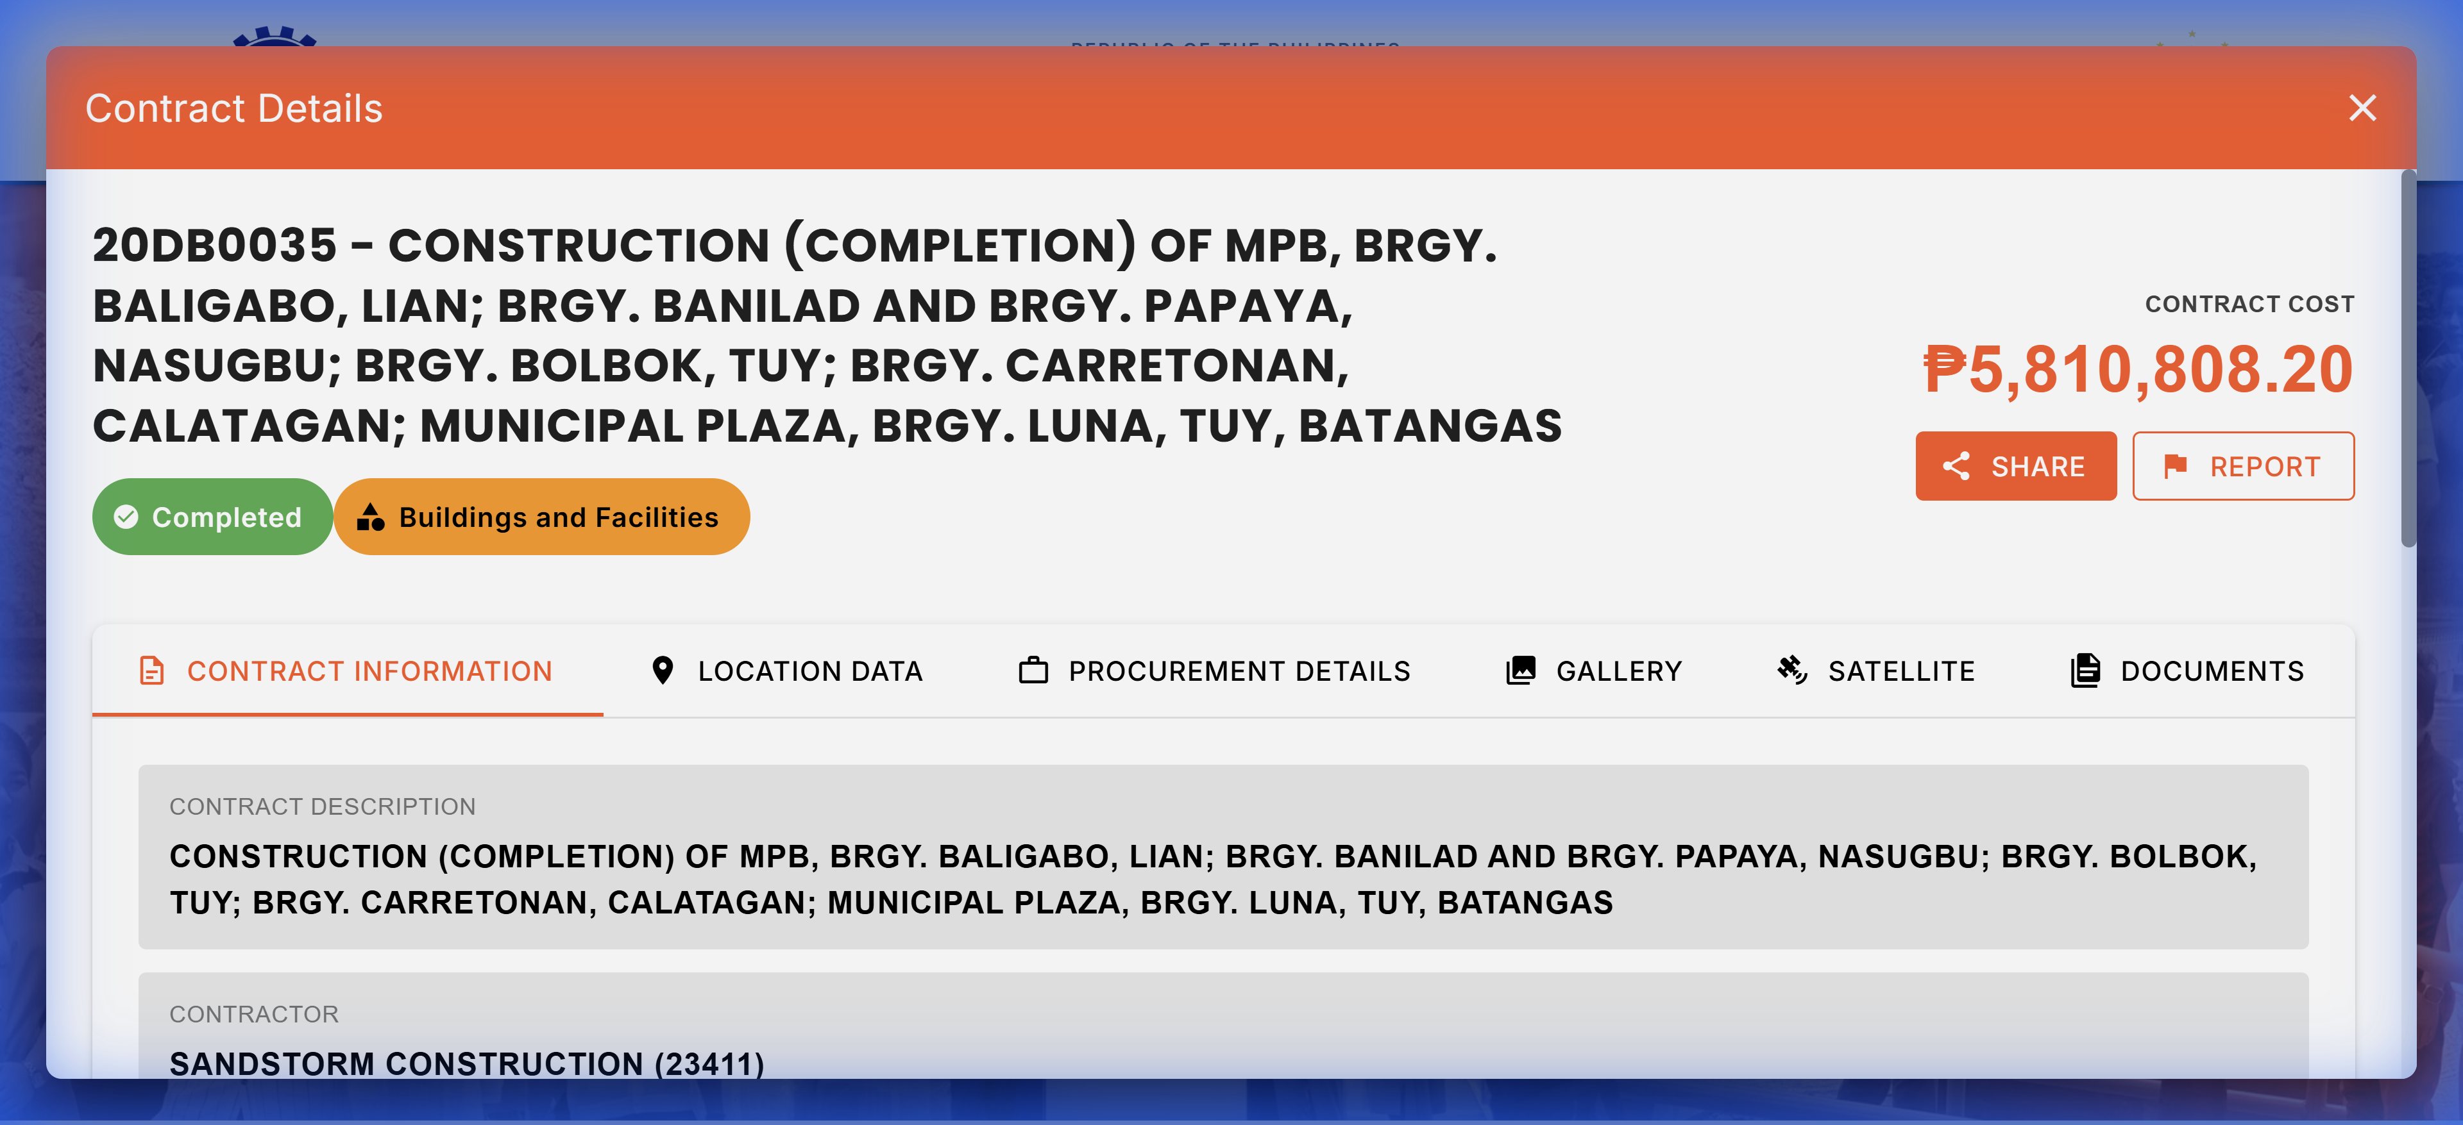 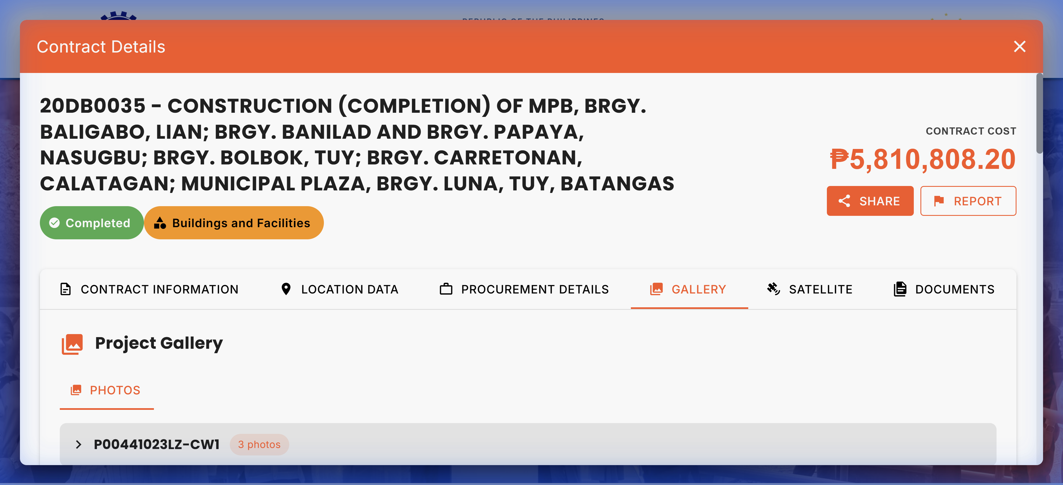

28. Construction of Multi-Purpose Building (Phase 5) F Carlos, Barangay Baesa, Quezon City
- Budget ID: DPWH-Proj-13577
- Amount: P80,000,000.00
- Transparency Matches (1): | Contract ID | Contract Name | Amount | |:————|:————–|:——-| | 25OF0154 | CONSTRUCTION OF MULTI-PURPOSE BUILDING (F CARLOS), BARANGAY BAESA, QUEZON CITY | P97,011,520.54 |

29. Construction of Multi-Purpose Building, Barangay San Antonio, Quezon City
- Budget ID: DPWH-Proj-13609
- Amount: P80,000,000.00
- Transparency Matches (5): | Contract ID | Contract Name | Amount | |:————|:————–|:——-| | 25DJ0008 | CONVERGENCE AND SPECIAL SUPPORT PROGRAM, BASIC INFRASTRUCTURE PROGRAM (BIP) - MULTI-PURPOSE BUILDINGS/FACILITIES TO SUPPORT SOCIAL SERVICES, CONSTRUCTION OF MULTI-PURPOSE BUILDING, BARANGAY PULO, SAN ANTONIO, QUEZON | P7,350,774.44 | | 25DJ0010 | CONVERGENCE AND SPECIAL SUPPORT PROGRAM, BASIC INFRASTRUCTURE PROGRAM (BIP) - MULTI-PURPOSE BUILDINGS/FACILITIES TO SUPPORT SOCIAL SERVICES, CONSTRUCTION OF MULTI-PURPOSE BUILDING, BARANGAY LOOB, SAN ANTONIO, QUEZON | P7,351,014.89 | | 25DJ0014 | CONVERGENCE AND SPECIAL SUPPORT PROGRAM, BASIC INFRASTRUCTURE PROGRAM (BIP) -MULTI-PURPOSE BUILDINGS/ FACILITIES TO SUPPORT SOCIAL SERVICES, CONSTRUCTION OF MULTI-PURPOSE BUILDING, BARANGAY SAMPAGA, SAN ANTONIO, QUEZON | P7,291,350.89 | | 25DJ0021 | CONVERGENCE AND SPECIAL SUPPORT PROGRAM, BASIC INFRASTRUCTURE PROGRAM (BIP) - MULTI-PURPOSE BUILDINGS/FACILITIES TO SUPPORT SOCIAL SERVICES, CONSTRUCTION OF MULTI-PURPOSE BUILDING, BARANGAY BULIHAN, SAN ANTONIO, QUEZON | P7,350,468.40 | | 25DJ0035 | CONVERGENCE AND SPECIAL SUPPORT PROGRAM, BASIC INFRASTRUCTURE PROGRAM (BIP) - MULTI-PURPOSE BUILDINGS/FACILITIES TO SUPPORT SOCIAL SERVICES, CONSTRUCTION OF MULTI-PURPOSE BUILDING, BARANGAY NIING, SAN ANTONIO, QUEZON | P7,350,496.01 |

30. Construction of Multi-Purpose Building, Barangay San Antonio, Quezon City
- Budget ID: DPWH-Proj-13609
- Amount: P80,000,000.00
- Transparency Matches (5): | Contract ID | Contract Name | Amount | |:————|:————–|:——-| | 25DJ0008 | CONVERGENCE AND SPECIAL SUPPORT PROGRAM, BASIC INFRASTRUCTURE PROGRAM (BIP) - MULTI-PURPOSE BUILDINGS/FACILITIES TO SUPPORT SOCIAL SERVICES, CONSTRUCTION OF MULTI-PURPOSE BUILDING, BARANGAY PULO, SAN ANTONIO, QUEZON | P7,350,774.44 | | 25DJ0010 | CONVERGENCE AND SPECIAL SUPPORT PROGRAM, BASIC INFRASTRUCTURE PROGRAM (BIP) - MULTI-PURPOSE BUILDINGS/FACILITIES TO SUPPORT SOCIAL SERVICES, CONSTRUCTION OF MULTI-PURPOSE BUILDING, BARANGAY LOOB, SAN ANTONIO, QUEZON | P7,351,014.89 | | 25DJ0014 | CONVERGENCE AND SPECIAL SUPPORT PROGRAM, BASIC INFRASTRUCTURE PROGRAM (BIP) -MULTI-PURPOSE BUILDINGS/ FACILITIES TO SUPPORT SOCIAL SERVICES, CONSTRUCTION OF MULTI-PURPOSE BUILDING, BARANGAY SAMPAGA, SAN ANTONIO, QUEZON | P7,291,350.89 | | 25DJ0021 | CONVERGENCE AND SPECIAL SUPPORT PROGRAM, BASIC INFRASTRUCTURE PROGRAM (BIP) - MULTI-PURPOSE BUILDINGS/FACILITIES TO SUPPORT SOCIAL SERVICES, CONSTRUCTION OF MULTI-PURPOSE BUILDING, BARANGAY BULIHAN, SAN ANTONIO, QUEZON | P7,350,468.40 | | 25DJ0035 | CONVERGENCE AND SPECIAL SUPPORT PROGRAM, BASIC INFRASTRUCTURE PROGRAM (BIP) - MULTI-PURPOSE BUILDINGS/FACILITIES TO SUPPORT SOCIAL SERVICES, CONSTRUCTION OF MULTI-PURPOSE BUILDING, BARANGAY NIING, SAN ANTONIO, QUEZON | P7,350,496.01 |

31. Construction of Multi-Purpose Building, Barangay San Antonio, Quezon City
- Budget ID: DPWH-Proj-13609
- Amount: P80,000,000.00
- Transparency Matches (5): | Contract ID | Contract Name | Amount | |:————|:————–|:——-| | 25DJ0008 | CONVERGENCE AND SPECIAL SUPPORT PROGRAM, BASIC INFRASTRUCTURE PROGRAM (BIP) - MULTI-PURPOSE BUILDINGS/FACILITIES TO SUPPORT SOCIAL SERVICES, CONSTRUCTION OF MULTI-PURPOSE BUILDING, BARANGAY PULO, SAN ANTONIO, QUEZON | P7,350,774.44 | | 25DJ0010 | CONVERGENCE AND SPECIAL SUPPORT PROGRAM, BASIC INFRASTRUCTURE PROGRAM (BIP) - MULTI-PURPOSE BUILDINGS/FACILITIES TO SUPPORT SOCIAL SERVICES, CONSTRUCTION OF MULTI-PURPOSE BUILDING, BARANGAY LOOB, SAN ANTONIO, QUEZON | P7,351,014.89 | | 25DJ0014 | CONVERGENCE AND SPECIAL SUPPORT PROGRAM, BASIC INFRASTRUCTURE PROGRAM (BIP) -MULTI-PURPOSE BUILDINGS/ FACILITIES TO SUPPORT SOCIAL SERVICES, CONSTRUCTION OF MULTI-PURPOSE BUILDING, BARANGAY SAMPAGA, SAN ANTONIO, QUEZON | P7,291,350.89 | | 25DJ0021 | CONVERGENCE AND SPECIAL SUPPORT PROGRAM, BASIC INFRASTRUCTURE PROGRAM (BIP) - MULTI-PURPOSE BUILDINGS/FACILITIES TO SUPPORT SOCIAL SERVICES, CONSTRUCTION OF MULTI-PURPOSE BUILDING, BARANGAY BULIHAN, SAN ANTONIO, QUEZON | P7,350,468.40 | | 25DJ0035 | CONVERGENCE AND SPECIAL SUPPORT PROGRAM, BASIC INFRASTRUCTURE PROGRAM (BIP) - MULTI-PURPOSE BUILDINGS/FACILITIES TO SUPPORT SOCIAL SERVICES, CONSTRUCTION OF MULTI-PURPOSE BUILDING, BARANGAY NIING, SAN ANTONIO, QUEZON | P7,350,496.01 |

32. Construction of Multi-Purpose Building, Barangay Malaban, Biñan City, Laguna
- Budget ID: DPWH-Proj-13685
- Amount: P80,000,000.00
- Transparency Matches (5): | Contract ID | Contract Name | Amount | |:————|:————–|:——-| | 25DI0097 | REHABILITATION OF MULTI-PURPOSE BUILDING, BARANGAY MALABAN, BINAN CITY, LAGUNA | P16,535,670.00 | | 25DI0147 | CONSTRUCTION OF MULTI-PURPOSE BUILDING BARANGAY MALABAN, BINAN CITY LAGUNA | P48,252,600.00 | | 23DI0104 | CONSTRUCTION OF MULTI-PURPOSE BUILDING, BARANGAY MALABAN, BINAN, LAGUNA | P9,645,578.74 | | 23DI0185 | CONSTRUCTION OF MULTI-PURPOSE BUILDING, MALABAN, BINAN, LAGUNA | P49,473,957.26 | | 24DI0163 | CONSTRUCTION OF MULTI-PURPOSE BUILDING (SCHOOL BUILDING), MALABAN ELEMENTARY SCHOOL (MAIN), BARANGAY MALABAN, BINAN CITY, LAGUNA | P48,346,784.55 |

33. Construction of Multi-Purpose Building, Barangay Malaban, Biñan City, Laguna
- Budget ID: DPWH-Proj-13685
- Amount: P80,000,000.00
- Transparency Matches (5): | Contract ID | Contract Name | Amount | |:————|:————–|:——-| | 25DI0097 | REHABILITATION OF MULTI-PURPOSE BUILDING, BARANGAY MALABAN, BINAN CITY, LAGUNA | P16,535,670.00 | | 25DI0147 | CONSTRUCTION OF MULTI-PURPOSE BUILDING BARANGAY MALABAN, BINAN CITY LAGUNA | P48,252,600.00 | | 23DI0104 | CONSTRUCTION OF MULTI-PURPOSE BUILDING, BARANGAY MALABAN, BINAN, LAGUNA | P9,645,578.74 | | 23DI0185 | CONSTRUCTION OF MULTI-PURPOSE BUILDING, MALABAN, BINAN, LAGUNA | P49,473,957.26 | | 24DI0163 | CONSTRUCTION OF MULTI-PURPOSE BUILDING (SCHOOL BUILDING), MALABAN ELEMENTARY SCHOOL (MAIN), BARANGAY MALABAN, BINAN CITY, LAGUNA | P48,346,784.55 |

34. Construction of Multi-Purpose Building at Barangay Sta. Ana, Taguig City
- Budget ID: DPWH-Proj-14135
- Amount: P80,000,000.00
- Transparency Matches (5): | Contract ID | Contract Name | Amount | |:————|:————–|:——-| | 20OB0327 | CONSTRUCTION OF MULTI-PURPOSE BUILDING (PUBLIC MARKET) BARANGAY STA. ANA, TAGUIG CITY | P47,974,152.75 | | 20OB0328 | CONSTRUCTION OF MULTI-PURPOSE BUILDING (SENIOR CITIZENS CENTER), BRGY. STA. ANA, TAGUIG CITY | P65,171,621.05 | | 20OB0343 | CONSTRUCTION OF MULTI-PURPOSE BUILDING, BRGY. STA. ANA, TAGUIG CITY | P7,602,993.74 | | 21OB0088 | CONSTRUCTION OF MULTI-PURPOSE BUILDING, STA. ANA, TAGUIG CITY | P49,000,000.00 | | 23OB0320 | CONSTRUCTION (COMPLETION) OF MULTI-PURPOSE BUILDING AT SAN ISIDRO ST., BRGY. STA. ANA, TAGUIG CITY | P47,471,025.92 |

35. Construction of Multi-purpose Building in Rizal High School, Pasig City (Phase 2)
- Budget ID: DPWH-Proj-13602
- Amount: P75,000,000.00
- Transparency Matches (1): | Contract ID | Contract Name | Amount | |:————|:————–|:——-| | 25OB0335 | CONSTRUCTION OF MULTI-PURPOSE BUILDING IN RIZAL HIGH SCHOOL, PASIG CITY (PHASE 1) | P97,010,936.40 |

36. Construction (Completion) of Multi-Purpose Building at Barangay Sta. Teresita, Quezon City
- Budget ID: DPWH-Proj-13562
- Amount: P70,000,000.00
- Transparency Matches (5): | Contract ID | Contract Name | Amount | |:————|:————–|:——-| | 25OF0119 | CONSTRUCTION (COMPLETION) OF MULTI-PURPOSE BUILDING (BARANGAY HALL), BARANGAY SANTA TERESITA, QUEZON CITY | P2,916,415.42 | | 20OF0085 | REHABILITATION OF MULTI-PURPOSE BUILDING AT BRGY. STA. TERESITA, QUEZON CITY | P9,612,783.48 | | 20DL0071 | CLUSTER IA. D. LOCAL PROGRAM 3. LOCAL INFRASTRUCTURE PROGRAM A. BUILDINGS AND OTHER STRUCTURES 1. MULTIPURPOSE/ FACILITIES 11. CONSTRUCTION OF MULTI-PURPOSE BUILDING, BRGY. STA. TERESITA, GUINAYANGAN, QUEZON- PHP 2,475,000.00 B. D. LOCAL PROGRAM 3. | P3,900,259.34 | | 21OF0124 | IMPROVEMENT OF MULTI-PURPOSE BUILDING (BARANGAY HALL) AT BARANGAY STA. TERESITA, QUEZON CITY | P4,753,002.00 | | 21OF0203 | CONSTRUCTION OF MULTI-PURPOSE BUILDING IN BARANGAY STA. TERESITA, QUEZON CITY | P4,752,893.30 |
Screenshots:
21OF0203: 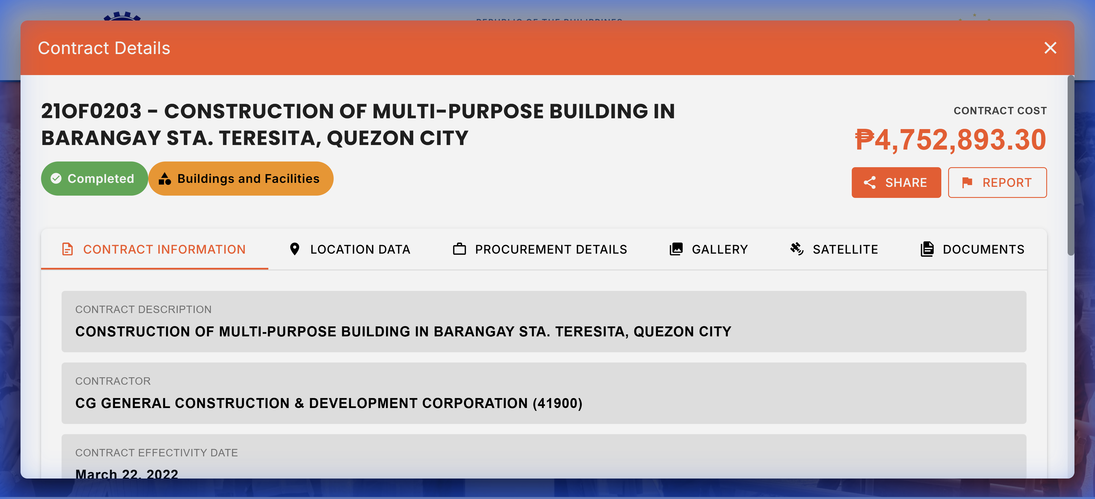

37. Construction (Completion) of Multi-Purpose Building at Barangay Sta. Teresita, Quezon City
- Budget ID: DPWH-Proj-13562
- Amount: P70,000,000.00
- Transparency Matches (5): | Contract ID | Contract Name | Amount | |:————|:————–|:——-| | 25OF0119 | CONSTRUCTION (COMPLETION) OF MULTI-PURPOSE BUILDING (BARANGAY HALL), BARANGAY SANTA TERESITA, QUEZON CITY | P2,916,415.42 | | 20OF0085 | REHABILITATION OF MULTI-PURPOSE BUILDING AT BRGY. STA. TERESITA, QUEZON CITY | P9,612,783.48 | | 20DL0071 | CLUSTER IA. D. LOCAL PROGRAM 3. LOCAL INFRASTRUCTURE PROGRAM A. BUILDINGS AND OTHER STRUCTURES 1. MULTIPURPOSE/ FACILITIES 11. CONSTRUCTION OF MULTI-PURPOSE BUILDING, BRGY. STA. TERESITA, GUINAYANGAN, QUEZON- PHP 2,475,000.00 B. D. LOCAL PROGRAM 3. | P3,900,259.34 | | 21OF0124 | IMPROVEMENT OF MULTI-PURPOSE BUILDING (BARANGAY HALL) AT BARANGAY STA. TERESITA, QUEZON CITY | P4,753,002.00 | | 21OF0203 | CONSTRUCTION OF MULTI-PURPOSE BUILDING IN BARANGAY STA. TERESITA, QUEZON CITY | P4,752,893.30 |
Screenshots:
21OF0203: 

38. Construction of Multi-Purpose Building, Barangay Manresa, Quezon City
- Budget ID: DPWH-Proj-13608
- Amount: P70,000,000.00
- Transparency Matches (4): | Contract ID | Contract Name | Amount | |:————|:————–|:——-| | 20OF0081 | REHABILITATION OF MULTI-PURPOSE BUILDING AT BRGY. MANRESA, QUEZON CITY | P4,752,854.50 | | 20OF0233 | CONSTRUCTION OF MULTI-PURPOSE BUILDING, BRGY. MANRESA, QUEZON CITY | P9,602,998.58 | | 20OF0252 | CONSTRUCTION OF MULTI-PURPOSE BUILDING (LIVELIHOOD TRAINING CENTER), BRGY. MANRESA, QUEZON CITY | P9,603,000.00 | | 21OF0135 | CONSTRUCTION/ REHABILITATION OF MULTI-PURPOSE BUILDING (COVERT COURT), BRGY. MANRESA, QUEZON CITY | P9,571,202.03 |

39. Construction of Multi-Purpose Building, Barangay Manresa, Quezon City
- Budget ID: DPWH-Proj-13608
- Amount: P70,000,000.00
- Transparency Matches (4): | Contract ID | Contract Name | Amount | |:————|:————–|:——-| | 20OF0081 | REHABILITATION OF MULTI-PURPOSE BUILDING AT BRGY. MANRESA, QUEZON CITY | P4,752,854.50 | | 20OF0233 | CONSTRUCTION OF MULTI-PURPOSE BUILDING, BRGY. MANRESA, QUEZON CITY | P9,602,998.58 | | 20OF0252 | CONSTRUCTION OF MULTI-PURPOSE BUILDING (LIVELIHOOD TRAINING CENTER), BRGY. MANRESA, QUEZON CITY | P9,603,000.00 | | 21OF0135 | CONSTRUCTION/ REHABILITATION OF MULTI-PURPOSE BUILDING (COVERT COURT), BRGY. MANRESA, QUEZON CITY | P9,571,202.03 |

40. Construction of Multi-Purpose Building, Barangay Manresa, Quezon City
- Budget ID: DPWH-Proj-13608
- Amount: P70,000,000.00
- Transparency Matches (4): | Contract ID | Contract Name | Amount | |:————|:————–|:——-| | 20OF0081 | REHABILITATION OF MULTI-PURPOSE BUILDING AT BRGY. MANRESA, QUEZON CITY | P4,752,854.50 | | 20OF0233 | CONSTRUCTION OF MULTI-PURPOSE BUILDING, BRGY. MANRESA, QUEZON CITY | P9,602,998.58 | | 20OF0252 | CONSTRUCTION OF MULTI-PURPOSE BUILDING (LIVELIHOOD TRAINING CENTER), BRGY. MANRESA, QUEZON CITY | P9,603,000.00 | | 21OF0135 | CONSTRUCTION/ REHABILITATION OF MULTI-PURPOSE BUILDING (COVERT COURT), BRGY. MANRESA, QUEZON CITY | P9,571,202.03 |

41. Construction of Multi-Purpose Building, Barangay Manresa, Quezon City
- Budget ID: DPWH-Proj-13608
- Amount: P70,000,000.00
- Transparency Matches (4): | Contract ID | Contract Name | Amount | |:————|:————–|:——-| | 20OF0081 | REHABILITATION OF MULTI-PURPOSE BUILDING AT BRGY. MANRESA, QUEZON CITY | P4,752,854.50 | | 20OF0233 | CONSTRUCTION OF MULTI-PURPOSE BUILDING, BRGY. MANRESA, QUEZON CITY | P9,602,998.58 | | 20OF0252 | CONSTRUCTION OF MULTI-PURPOSE BUILDING (LIVELIHOOD TRAINING CENTER), BRGY. MANRESA, QUEZON CITY | P9,603,000.00 | | 21OF0135 | CONSTRUCTION/ REHABILITATION OF MULTI-PURPOSE BUILDING (COVERT COURT), BRGY. MANRESA, QUEZON CITY | P9,571,202.03 |

42. Construction of Multi-Purpose Building, Barangay Balcon Maravilla, Jordan, Guimaras
- Budget ID: DPWH-Proj-13720
- Amount: P65,000,000.00
- Transparency Matches (4): | Contract ID | Contract Name | Amount | |:————|:————–|:——-| | 19GE0102 | CONSTRUCTION OF MULTI-PURPOSE BUILDING (PHASE 2), BRGY. BALCON MARAVILLA, JORDAN, GUIMARAS | P1,410,749.99 | | 20GE0013 | CONSTRUCTION OF MULTI-PURPOSE BUILDING, BRGY. BALCON MARAVILLA, JORDAN, GUIMARAS | P1,881,475.51 | | 21GE0031 | CONSTRUCTION OF MULTI-PURPOSE BUILDING-CONSTRUCTION (PHASE II) OF MULTI-PURPOSE BUILDING, BARANGAY BALCON MARAVILLA, JORDAN, GUIMARAS | P2,686,428.04 | | 23GE0005 | CONSTRUCTION OF MULTI-PURPOSE BUILDING-CONSTRUCTION OF MULTI-PURPOSE BUILDING, BARANGAY BALCON MELLIZA, JORDAN, GUIMARAS | P4,800,897.30 |

43. Construction of Multi-Purpose Building, Convention Hall, at F. Balagtas Elementary School (Phase III), Manila City
- Budget ID: DPWH-Proj-13610
- Amount: P60,000,000.00
- Transparency Matches (1): | Contract ID | Contract Name | Amount | |:————|:————–|:——-| | 23OE0097 | CONSTRUCTION OF MULTI-PURPOSE BUILDING, CONVENTION HALL, AT F. BALAGTAS ELEMENTARY SCHOOL (PHASE 2), MANILA CITY | P45,354,395.91 |

44. Construction of Multi-Purpose Building, Barangay Don Andres, Ipil, Zamboanga Sibugay
- Budget ID: DPWH-Proj-13818
- Amount: P60,000,000.00
- Transparency Matches (1): | Contract ID | Contract Name | Amount | |:————|:————–|:——-| | 24JF0048 | CONSTRUCTION (COMPLETION) OF MULTI-PURPOSE BUILDING IN PUROK BOUGAINVILLEA, DON ANDRES, IPIL, ZAMBOANGA SIBUGAY | P2,725,762.81 |

45. Construction of Multi-Purpose Building, Barangay Don Andres, Ipil, Zamboanga Sibugay
- Budget ID: DPWH-Proj-13818
- Amount: P60,000,000.00
- Transparency Matches (1): | Contract ID | Contract Name | Amount | |:————|:————–|:——-| | 24JF0048 | CONSTRUCTION (COMPLETION) OF MULTI-PURPOSE BUILDING IN PUROK BOUGAINVILLEA, DON ANDRES, IPIL, ZAMBOANGA SIBUGAY | P2,725,762.81 |

46. Construction of Multi-Purpose Building (Government Center), Barangay Libertad, Abulug, Cagayan
- Budget ID: DPWH-Proj-14748
- Amount: P60,000,000.00
- Transparency Matches (3): | Contract ID | Contract Name | Amount | |:————|:————–|:——-| | 24BC0094 | CONVERGENCE AND SPECIAL SUPPORT PROGRAM- BASIC INFRASTRUCTURE PROGRAM (BIP)- MULTI-PURPOSE BUILDINGS/FACILITIES TO SUPPORT SOCIAL SERVICES- CONSTRUCTION OF MULTI-PURPOSE BUILDING (GOVERNMENT CENTER PACKAGE 4), LIBERTAD, ABULUG, CAGAYAN | P98,969,382.21 | | 24BC0102 | CONVERGENCE AND SPECIAL SUPPORT PROGRAM- BASIC INFRASTRUCTURE PROGRAM (BIP)- MULTI-PURPOSE BUILDINGS/FACILITIES TO SUPPORT SOCIAL SERVICES- CONSTRUCTION OF MULTI-PURPOSE BUILDING (GOVERNMENT CENTER), LIBERTAD, ABULUG, CAGAYAN (PHASE 1) | P49,475,065.28 | | 19BC0084 | LIP-CONSTRUCTION OF MULTI-PURPOSE BUILDING (MUNICIPAL HEALTH CENTER), BRGY. LIBERTAD, ABULUG, CAGAYAN | P14,580,000.00 |

47. Rehabilitation of Multi-Purpose Building, Barangay Cabidianan, Nabunturan, Davao de Oro
- Budget ID: DPWH-Proj-13881
- Amount: P55,000,000.00
- Transparency Matches (5): | Contract ID | Contract Name | Amount | |:————|:————–|:——-| | 25LA0088 | CONSTRUCTION (COMPLETION) OF MULTI-PURPOSE BUILDING, HALL OF JUSTICE, BARANGAY CABIDIANAN, NABUNTURAN, DAVAO DE ORO | P34,600,039.03 | | 22LA0040 | CONSTRUCTION OF MULTI-PURPOSE BUILDING (WOMEN’S CENTER) BARANGAY CABIDIANAN, NABUNTURAN, DAVAO DE ORO | P9,124,691.46 | | 22LA0126 | CONSTRUCTION (COMPLETION) OF MULTI-PURPOSE BUILDING, DAVAO DE ORO PROVINCIAL CAPITOL COMPOUND, BARANGAY CABIDIANAN, NABUNTURAN, DAVAO DE ORO | P9,899,924.30 | | 22LA0127 | CONSTRUCTION OF MULTI-PURPOSE BUILDING, DAVAO DE ORO PROVINCIAL CAPITOL COMPOUND, BARANGAY CABIDIANAN, NABUNTURAN, DAVAO DE ORO | P9,888,578.97 | | 22LA0128 | CONSTRUCTION OF MULTI-PURPOSE BUILDING, CABIDIANAN, NABUNTURAN, DAVAO DE ORO | P19,799,863.48 |

48. Construction of Multi-Purpose Building, Barangay Rizal, Roxas, Isabela
- Budget ID: DPWH-Proj-13646
- Amount: P50,399,000.00
- Transparency Matches (5): | Contract ID | Contract Name | Amount | |:————|:————–|:——-| | 25BF0097 | COMPLETION OF MULTI-PURPOSE BUILDING (LEGISLATIVE BUILDING), BRGY. RIZAL, ROXAS, ISABELA | P9,599,381.18 | | 18BF0075 | CONSTRUCTION OF MULTI-PURPOSE BUILDING, BARANGAY RIZAL, ROXAS, ISABELA | P4,701,733.48 | | 19BF0010 | CONSTRUCTION OF MULTI-PURPOSE BUILDING (COMMUNITY CENTER), SITIO CALAOCAN, BRGY. RIZAL, ROXAS, ISABELA | P2,817,046.18 | | 21BF0049 | CONSTRUCTION (COMPLETION) OF MULTI-PURPOSE BUILDING, BARANGAY RIZAL, ROXAS, ISABELA | P2,910,611.68 | | 24BF0099 | CONSTRUCTION (COMPLETION) OF MULTI-PURPOSE BUILDING, BARANGAY RIZAL, ROXAS, ISABELA | P2,959,607.95 |

49. Construction of Multi-Purpose Building, Barangay Rizal, Roxas, Isabela
- Budget ID: DPWH-Proj-13646
- Amount: P50,399,000.00
- Transparency Matches (5): | Contract ID | Contract Name | Amount | |:————|:————–|:——-| | 25BF0097 | COMPLETION OF MULTI-PURPOSE BUILDING (LEGISLATIVE BUILDING), BRGY. RIZAL, ROXAS, ISABELA | P9,599,381.18 | | 18BF0075 | CONSTRUCTION OF MULTI-PURPOSE BUILDING, BARANGAY RIZAL, ROXAS, ISABELA | P4,701,733.48 | | 19BF0010 | CONSTRUCTION OF MULTI-PURPOSE BUILDING (COMMUNITY CENTER), SITIO CALAOCAN, BRGY. RIZAL, ROXAS, ISABELA | P2,817,046.18 | | 21BF0049 | CONSTRUCTION (COMPLETION) OF MULTI-PURPOSE BUILDING, BARANGAY RIZAL, ROXAS, ISABELA | P2,910,611.68 | | 24BF0099 | CONSTRUCTION (COMPLETION) OF MULTI-PURPOSE BUILDING, BARANGAY RIZAL, ROXAS, ISABELA | P2,959,607.95 |

50. Construction of Multi-Purpose Building, Kiamba, Sarangani
- Budget ID: DPWH-Proj-13994
- Amount: P50,000,000.00
- Transparency Matches (5): | Contract ID | Contract Name | Amount | |:————|:————–|:——-| | 25ME0103 | CONSTRUCTION OF SALAKIT MULTI-PURPOSE BUILDING (BARANGAY HALL), SALAKIT, KIAMBA, SARANGANI PROVINCE | P5,761,837.50 | | 25ME0111 | CONSTRUCTION OF LOMUYON MULTI-PURPOSE BUILDING (BARANGAY HALL), LOMUYON, KIAMBA, SARANGANI PROVINCE | P5,932,921.38 | | 19ME0028 | CONSTRUCTION OF MULTI-PURPOSE BUILDING (COVERED COURT) BRGY. TABLAO; KIAMBA, SARANGANI PROVINCE. | P2,958,512.99 | | 20ME0033 | CONSTRUCTION OF MULTI-PURPOSE BUILDING BRGY. DATU DANI; KIAMBA, SARANGANI PROVINCE. | P4,300,493.11 | | 20ME0115 | CONSTRUCTION OF MULTI-PURPOSE BUILDING (BRGY. HALL), BRGY. SULI; KIAMBA, SARANGANI PROVINCE | P4,410,052.98 |

51. Construction of Multi-Purpose Building at Barangay Culiat (Phase 1) Quezon City
- Budget ID: DPWH-Proj-14284
- Amount: P50,000,000.00
- Transparency Matches (5): | Contract ID | Contract Name | Amount | |:————|:————–|:——-| | 20OF0129 | CONSTRUCTION OF MULTI-PURPOSE BUILDING AT METRO HEIGHTS, BRGY. CULIAT, QUEZON CITY | P6,791,100.00 | | 20OF0132 | CONSTRUCTION OF MULTI-PURPOSE BUILDING ZT VILLA FERENZE, CULIAT, QUEZON CITY | P6,757,100.00 | | 20OF0174 | CONSTRUCTION OF MULTI-PURPOSE BUILDING AT CENACLE BRGY. CULIAT, QUEZON CITY | P9,506,000.00 | | 20OF0321 | CONSTRUCTION/REHABILITATION OF MULTI-PURPOSE BUILDING VARGAS COMPOUND, BRGY. CULIAT, QUEZON CITY | P4,801,500.00 | | 21OF0095 | CONSTRUCTION OF MULTI-PURPOSE BUILDING AT METRO HEIGHTS ADELFA, BRGY. CULIAT, QUEZON CITY | P6,722,024.64 |

52. Construction of Multi-Purpose Building at Barangay Peñabatan, Pulilan, Bulacan
- Budget ID: DPWH-Proj-15133
- Amount: P50,000,000.00
- Transparency Matches (1): | Contract ID | Contract Name | Amount | |:————|:————–|:——-| | 23CC0354 | CONSTRUCTION OF MULTI-PURPOSE BUILDING AT BARANGAY PEÑABATAN, PULILAN, BULACAN | P19,796,773.90 |

53. Construction of Multi-Purpose Building, Barangay Mahabang Parang, Santa Maria, Bulacan
- Budget ID: DPWH-Proj-15163
- Amount: P50,000,000.00
- Transparency Matches (1): | Contract ID | Contract Name | Amount | |:————|:————–|:——-| | 23CD0044 | CONSTRUCTION OF MULTI-PURPOSE BUILDING, BARANGAY MAHABANG PARANG, STA. MARIA, BULACAN | P20,790,000.00 |

54. Construction of Multi-Purpose Building, Barangay San Roque, Angat, Bulacan
- Budget ID: DPWH-Proj-15172
- Amount: P50,000,000.00
- Transparency Matches (1): | Contract ID | Contract Name | Amount | |:————|:————–|:——-| | 23CD0134 | CONSTRUCTION OF MULTI-PURPOSE BUILDING, SAN ROQUE, MDRRMO, ANGAT, BULACAN | P9,899,836.81 |

55. Construction of Multi-Purpose Building, Barangay San Roque, Angat, Bulacan
- Budget ID: DPWH-Proj-15172
- Amount: P50,000,000.00
- Transparency Matches (1): | Contract ID | Contract Name | Amount | |:————|:————–|:——-| | 23CD0134 | CONSTRUCTION OF MULTI-PURPOSE BUILDING, SAN ROQUE, MDRRMO, ANGAT, BULACAN | P9,899,836.81 |

56. Construction of Multi-Purpose Building, Magalang, Pampanga
- Budget ID: DPWH-Proj-15368
- Amount: P50,000,000.00
- Transparency Matches (5): | Contract ID | Contract Name | Amount | |:————|:————–|:——-| | 25CI0076 | BASIC INFRASTRUCTURE PROGRAM BIP-BIP MULTI PURPOSE BUILDINGS/FACILITIES SUPPORT SOCIAL SERVICES/CONSTRUCTION/ OF MULTI PURPOSE BUILDING IN MAGALANG. PAMPANGA | P4,949,277.34 | | 25CI0078 | BIP-MULTI PURPOSE BUILDING/FACILITIES TO SUPPORT SOCIAL SERVICES/CONSTRUCTION OF MULTI PURPOSE BUILDING SAN PEDRO II ELEMENTARY SCHOOL, MAGALANG, PAMPANGA | P4,837,891.32 | | 25CI0081 | BIP-MULTI PURPOSE BUILDINGS/FACILITIES TO SUPPORT SOCIAL SERVICES; CONSTRUCTION OF MULTI-PYRPOSE BUILDING (PAMPANGA STATE AGRICULTURAL UNIVERSITY), MAGALANG, PAMPANGA | P9,692,766.22 | | 18CI0012 | LOCAL INFRA PROGRAM/BUILDING AND OTHER STRUCTURE/MULTI-PURPOSE/FACILITIES; CONST/REHAB OF MULTI PURPOSE BUILDING, BRGY STO ROSARIO,MAGALANG,PAMPANGA | P1,921,188.68 | | 18CI0013 | LOCAL INFRA PROGRAM/BUILDING & OTHER STRUCTURE/MULTI-PURPOSE/FACILITIES; CONST OF MULTI PURPOSE BUILDING(COVERED COURT) AT BRGY STA MARIA,MAGALANG, PAMPANGA | P2,640,554.91 |

57. Construction of Multi-Purpose Building, at Barangay San Roque, Rosario, Batangas
- Budget ID: DPWH-Proj-15580
- Amount: P50,000,000.00
- Transparency Matches (5): | Contract ID | Contract Name | Amount | |:————|:————–|:——-| | 25DD0041 | CONVERGENCE AND SPECIAL SUPPORT PROGRAM, BASIC INFRASTRUTURE PROGRAM (BIP), MULTI-PURPOSE BUILDINGS/ FACILITIES TO SUPPORT SOCIAL SERVICES, CONSTRUCTION (COMPLETION) OF MULTI-PURPOSE BUILDING (COVERED COURT), BARANGAY SAN ROQUE, ROSARIO, BATANGAS | P4,322,081.84 | | 18DD0012 | LOCAL PROGRAM, LOCAL INFRASTRUCTURE PROGRAM, BUILDING AND OTHER STRUCTURES, MULTIPURPOSE / FACILITIES, REHABILITATION OF MULTI-PURPOSE BUILDING, BRGY. SAN ROQUE, ROSARIO, BATANGAS | P2,970,000.00 | | 20DD0318 | LOCAL PROGRAM, LOCAL INFRASTRUCTURE PROGRAM, BUILDINGS AND OTHER STRUCTURES, MULTIPURPOSE/ FACILITIES, IMPROVEMENT OF MULTI-PURPOSE BUILDING, BRGY. SAN ROQUE, ROSARIO, BATANGAS | P4,801,500.00 | | 21DD0143 | LOCAL PROGRAM, LOCAL INFRASTRUCTURE PROGRAM, BUILDINGS AND OTHER STRUCTURES, MULTIPURPOSE/ FACILITIES, IMPROVEMENT OF MULTI-PURPOSE BUILDING INCLUDING GROUNDS FACILITIES, ROSARIO NATIONAL HIGH SCHOOL, BARANGAY SAN ROQUE, ROSARIO, BATANGAS | P1,920,348.30 | | 23DD0104 | CONVERGENCE AND SPECIAL SUPPORT PROGRAM, BASIC INFRASTRUCTURE PROGRAM (BIP), MULTI-PURPOSE BUILDINGS/ FACILITIES TO SUPPORT SOCIAL SERVICES, CONSTRUCTION OF MULTI-PURPOSE BUILDING, BRGY. SAN ROQUE, ROSARIO, BATANGAS | P4,800,857.07 |

58. Construction of Multi-Purpose Building, at Barangay San Roque, Rosario, Batangas
- Budget ID: DPWH-Proj-15580
- Amount: P50,000,000.00
- Transparency Matches (5): | Contract ID | Contract Name | Amount | |:————|:————–|:——-| | 25DD0041 | CONVERGENCE AND SPECIAL SUPPORT PROGRAM, BASIC INFRASTRUTURE PROGRAM (BIP), MULTI-PURPOSE BUILDINGS/ FACILITIES TO SUPPORT SOCIAL SERVICES, CONSTRUCTION (COMPLETION) OF MULTI-PURPOSE BUILDING (COVERED COURT), BARANGAY SAN ROQUE, ROSARIO, BATANGAS | P4,322,081.84 | | 18DD0012 | LOCAL PROGRAM, LOCAL INFRASTRUCTURE PROGRAM, BUILDING AND OTHER STRUCTURES, MULTIPURPOSE / FACILITIES, REHABILITATION OF MULTI-PURPOSE BUILDING, BRGY. SAN ROQUE, ROSARIO, BATANGAS | P2,970,000.00 | | 20DD0318 | LOCAL PROGRAM, LOCAL INFRASTRUCTURE PROGRAM, BUILDINGS AND OTHER STRUCTURES, MULTIPURPOSE/ FACILITIES, IMPROVEMENT OF MULTI-PURPOSE BUILDING, BRGY. SAN ROQUE, ROSARIO, BATANGAS | P4,801,500.00 | | 21DD0143 | LOCAL PROGRAM, LOCAL INFRASTRUCTURE PROGRAM, BUILDINGS AND OTHER STRUCTURES, MULTIPURPOSE/ FACILITIES, IMPROVEMENT OF MULTI-PURPOSE BUILDING INCLUDING GROUNDS FACILITIES, ROSARIO NATIONAL HIGH SCHOOL, BARANGAY SAN ROQUE, ROSARIO, BATANGAS | P1,920,348.30 | | 23DD0104 | CONVERGENCE AND SPECIAL SUPPORT PROGRAM, BASIC INFRASTRUCTURE PROGRAM (BIP), MULTI-PURPOSE BUILDINGS/ FACILITIES TO SUPPORT SOCIAL SERVICES, CONSTRUCTION OF MULTI-PURPOSE BUILDING, BRGY. SAN ROQUE, ROSARIO, BATANGAS | P4,800,857.07 |

59. Construction of Multi-Purpose Building at Barangay Sabang, Lipa City, Batangas
- Budget ID: DPWH-Proj-15616
- Amount: P50,000,000.00
- Transparency Matches (5): | Contract ID | Contract Name | Amount | |:————|:————–|:——-| | 25DD0335 | CONVERGENCE AND SPECIAL SUPPORT PROGRAM, BASIC INFRASTRUTURE PROGRAM (BIP), MULTI-PURPOSE BUILDINGS/FACILITIES TO SUPPORT SOCIAL SERVICES, CONSTRUCTION OF MULTI-PURPOSE BUILDING INCLUDING FACILITIES AT BARANGAY SABANG, LIPA CITY, BATANGAS | P96,030,000.00 | | 18DD0662 | REHABILITATION/IMPROVEMENT OF FOUR STOREY MULTIPURPOSE BUILDING AT GAUDENCIO B. LONTOK MEMORIAL ELEMENTARY SCHOOL, BARANGAY SABANG, LIPA CITY, BATANGAS | P7,720,000.00 | | 20DD0076 | LOCAL PROGRAM, LOCAL INFRASTRUCTURE PROGRAM, BUILDINGS AND OTHER STRUCTURES, MULTIPURPOSE/ FACILITIES, CONSTRUCTION OF MULTI-PURPOSE BUILDING, G.B. LONTOC INTEGRATED SCHOOL, BRGY. SABANG, LIPA CITY, BATANGAS | P8,154,222.60 | | 20DD0153 | LOCAL PROGRAM, LOCAL INFRASTRUCTURE PROGRAM, BUILDINGS AND OTHER STRUCTURES, MULTIPURPOSE/ FACILITIES, REHABILITATION/ IMPROVEMENT OF MULTI-PURPOSE BUILDING AT BRGY. SABANG, LIPA CITY, BATANGAS | P1,920,590.00 | | 20DD0185 | LOCAL PROGRAM, LOCAL INFRASTRUCTURE PROGRAM, BUILDINGS AND OTHER STRUCTURES, MULTIPURPOSE/ FACILITIES, CONSTRUCTION OF MULTI-PURPOSE BUILDING AT GAUDENCIO B. LONTOK INTEGRATED SCHOOL, BRGY. SABANG, LIPA CITY, BATANGAS | P7,674,017.20 |

60. Construction of Multi-Purpose Building at Barangay Sabang, Lipa City, Batangas
- Budget ID: DPWH-Proj-15616
- Amount: P50,000,000.00
- Transparency Matches (5): | Contract ID | Contract Name | Amount | |:————|:————–|:——-| | 25DD0335 | CONVERGENCE AND SPECIAL SUPPORT PROGRAM, BASIC INFRASTRUTURE PROGRAM (BIP), MULTI-PURPOSE BUILDINGS/FACILITIES TO SUPPORT SOCIAL SERVICES, CONSTRUCTION OF MULTI-PURPOSE BUILDING INCLUDING FACILITIES AT BARANGAY SABANG, LIPA CITY, BATANGAS | P96,030,000.00 | | 18DD0662 | REHABILITATION/IMPROVEMENT OF FOUR STOREY MULTIPURPOSE BUILDING AT GAUDENCIO B. LONTOK MEMORIAL ELEMENTARY SCHOOL, BARANGAY SABANG, LIPA CITY, BATANGAS | P7,720,000.00 | | 20DD0076 | LOCAL PROGRAM, LOCAL INFRASTRUCTURE PROGRAM, BUILDINGS AND OTHER STRUCTURES, MULTIPURPOSE/ FACILITIES, CONSTRUCTION OF MULTI-PURPOSE BUILDING, G.B. LONTOC INTEGRATED SCHOOL, BRGY. SABANG, LIPA CITY, BATANGAS | P8,154,222.60 | | 20DD0153 | LOCAL PROGRAM, LOCAL INFRASTRUCTURE PROGRAM, BUILDINGS AND OTHER STRUCTURES, MULTIPURPOSE/ FACILITIES, REHABILITATION/ IMPROVEMENT OF MULTI-PURPOSE BUILDING AT BRGY. SABANG, LIPA CITY, BATANGAS | P1,920,590.00 | | 20DD0185 | LOCAL PROGRAM, LOCAL INFRASTRUCTURE PROGRAM, BUILDINGS AND OTHER STRUCTURES, MULTIPURPOSE/ FACILITIES, CONSTRUCTION OF MULTI-PURPOSE BUILDING AT GAUDENCIO B. LONTOK INTEGRATED SCHOOL, BRGY. SABANG, LIPA CITY, BATANGAS | P7,674,017.20 |

61. Construction of Multi-Purpose Building at Barangay Sabang, Lipa City, Batangas
- Budget ID: DPWH-Proj-15616
- Amount: P50,000,000.00
- Transparency Matches (5): | Contract ID | Contract Name | Amount | |:————|:————–|:——-| | 25DD0335 | CONVERGENCE AND SPECIAL SUPPORT PROGRAM, BASIC INFRASTRUTURE PROGRAM (BIP), MULTI-PURPOSE BUILDINGS/FACILITIES TO SUPPORT SOCIAL SERVICES, CONSTRUCTION OF MULTI-PURPOSE BUILDING INCLUDING FACILITIES AT BARANGAY SABANG, LIPA CITY, BATANGAS | P96,030,000.00 | | 18DD0662 | REHABILITATION/IMPROVEMENT OF FOUR STOREY MULTIPURPOSE BUILDING AT GAUDENCIO B. LONTOK MEMORIAL ELEMENTARY SCHOOL, BARANGAY SABANG, LIPA CITY, BATANGAS | P7,720,000.00 | | 20DD0076 | LOCAL PROGRAM, LOCAL INFRASTRUCTURE PROGRAM, BUILDINGS AND OTHER STRUCTURES, MULTIPURPOSE/ FACILITIES, CONSTRUCTION OF MULTI-PURPOSE BUILDING, G.B. LONTOC INTEGRATED SCHOOL, BRGY. SABANG, LIPA CITY, BATANGAS | P8,154,222.60 | | 20DD0153 | LOCAL PROGRAM, LOCAL INFRASTRUCTURE PROGRAM, BUILDINGS AND OTHER STRUCTURES, MULTIPURPOSE/ FACILITIES, REHABILITATION/ IMPROVEMENT OF MULTI-PURPOSE BUILDING AT BRGY. SABANG, LIPA CITY, BATANGAS | P1,920,590.00 | | 20DD0185 | LOCAL PROGRAM, LOCAL INFRASTRUCTURE PROGRAM, BUILDINGS AND OTHER STRUCTURES, MULTIPURPOSE/ FACILITIES, CONSTRUCTION OF MULTI-PURPOSE BUILDING AT GAUDENCIO B. LONTOK INTEGRATED SCHOOL, BRGY. SABANG, LIPA CITY, BATANGAS | P7,674,017.20 |

62. Construction of Multi-Purpose Building at Barangay Sabang, Lipa City, Batangas
- Budget ID: DPWH-Proj-15616
- Amount: P50,000,000.00
- Transparency Matches (5): | Contract ID | Contract Name | Amount | |:————|:————–|:——-| | 25DD0335 | CONVERGENCE AND SPECIAL SUPPORT PROGRAM, BASIC INFRASTRUTURE PROGRAM (BIP), MULTI-PURPOSE BUILDINGS/FACILITIES TO SUPPORT SOCIAL SERVICES, CONSTRUCTION OF MULTI-PURPOSE BUILDING INCLUDING FACILITIES AT BARANGAY SABANG, LIPA CITY, BATANGAS | P96,030,000.00 | | 18DD0662 | REHABILITATION/IMPROVEMENT OF FOUR STOREY MULTIPURPOSE BUILDING AT GAUDENCIO B. LONTOK MEMORIAL ELEMENTARY SCHOOL, BARANGAY SABANG, LIPA CITY, BATANGAS | P7,720,000.00 | | 20DD0076 | LOCAL PROGRAM, LOCAL INFRASTRUCTURE PROGRAM, BUILDINGS AND OTHER STRUCTURES, MULTIPURPOSE/ FACILITIES, CONSTRUCTION OF MULTI-PURPOSE BUILDING, G.B. LONTOC INTEGRATED SCHOOL, BRGY. SABANG, LIPA CITY, BATANGAS | P8,154,222.60 | | 20DD0153 | LOCAL PROGRAM, LOCAL INFRASTRUCTURE PROGRAM, BUILDINGS AND OTHER STRUCTURES, MULTIPURPOSE/ FACILITIES, REHABILITATION/ IMPROVEMENT OF MULTI-PURPOSE BUILDING AT BRGY. SABANG, LIPA CITY, BATANGAS | P1,920,590.00 | | 20DD0185 | LOCAL PROGRAM, LOCAL INFRASTRUCTURE PROGRAM, BUILDINGS AND OTHER STRUCTURES, MULTIPURPOSE/ FACILITIES, CONSTRUCTION OF MULTI-PURPOSE BUILDING AT GAUDENCIO B. LONTOK INTEGRATED SCHOOL, BRGY. SABANG, LIPA CITY, BATANGAS | P7,674,017.20 |

63. Construction of Multi-Purpose Building at Barangay Zone I, Dasmariñas City, Cavite
- Budget ID: DPWH-Proj-15741
- Amount: P50,000,000.00
- Transparency Matches (1): | Contract ID | Contract Name | Amount | |:————|:————–|:——-| | 21DQ0052 | LOCAL PROGRAM - LOCAL INFRASTRUCTURE PROGRAM - BUILDINGS AND OTHER STRUCTURES - MULTIPURPOSE/ FACILITIES - CONSTRUCTION OF MULTI-PURPOSE BUILDING IN BARANGAY ZONE 3, DASMARIÑAS CITY, CAVITE AND CONSTRUCTION OF MULTI-PURPOSE BUILDING IN BARANGAY SABANG, DA | P9,899,586.60 |

64. Construction of Multi-Purpose Building at Barangay Zone IV, Dasmariñas City, Cavite
- Budget ID: DPWH-Proj-15742
- Amount: P50,000,000.00
- Transparency Matches (1): | Contract ID | Contract Name | Amount | |:————|:————–|:——-| | 21DQ0052 | LOCAL PROGRAM - LOCAL INFRASTRUCTURE PROGRAM - BUILDINGS AND OTHER STRUCTURES - MULTIPURPOSE/ FACILITIES - CONSTRUCTION OF MULTI-PURPOSE BUILDING IN BARANGAY ZONE 3, DASMARIÑAS CITY, CAVITE AND CONSTRUCTION OF MULTI-PURPOSE BUILDING IN BARANGAY SABANG, DA | P9,899,586.60 |

65. Construction of Multi-Purpose Building (Municipal Hall), Phase IV, Bay, Laguna
- Budget ID: DPWH-Proj-15810
- Amount: P50,000,000.00
- Transparency Matches (1): | Contract ID | Contract Name | Amount | |:————|:————–|:——-| | 23DI0108 | CONSTRUCTION OF MULTI-PURPOSE BUILDING, BAY MUNICIPAL HALL BUILDING, BRGY. PUYPUY, BAY, LAGUNA | P39,475,097.32 |

66. Construction (Completion) of Multi-Purpose Building, Barangay Cogon, Tagbilaran City, Bohol
- Budget ID: DPWH-Proj-16926
- Amount: P50,000,000.00
- Transparency Matches (5): | Contract ID | Contract Name | Amount | |:————|:————–|:——-| | 18HA0043 | CONSTRUCTION OF MULTI-PURPOSE BUILDING, BARANGAY COGON, TAGBILARAN CITY, BOHOL | P4,900,201.38 | | 18HA0052 | CONSTRUCTION (COMPLETION) OF MULTI-PURPOSE BUILDING, BRGY. COGON, TAGBILARAN CITY, BOHOL | P1,950,000.00 | | 19HA0167 | CONSTRUCTION OF MULTI-PURPOSE BUILDING, COGON ELEMENTARY SCHOOL, BRGY. COGON, TAGBILARAN CITY, BOHOL | P2,959,849.44 | | 21HA0123 | REHABILITATION OF MULTI-PURPOSE BUILDING, BRGY. COGON, TAGBILARAN CITY, BOHOL | P2,966,937.74 | | 21HA0130 | CONSTRUCTION/REHABILITATION OF MULTI-PURPOSE BUILDING (PUBLIC MARKET) IN BARANGAY COGON, TAGBILARAN CITY, BOHOL | P28,946,821.30 |

67. Construction of Multi-Purpose Building, Package A, Barangay Guadalupe, Cebu City, Cebu
- Budget ID: DPWH-Proj-17264
- Amount: P50,000,000.00
- Transparency Matches (5): | Contract ID | Contract Name | Amount | |:————|:————–|:——-| | 16HH0095 | CONSTRUCTION OF MULTI PURPOSE BUILDING, BARANGAY GUADALUPE, CEBU CITY | P4,950,000.00 | | 17H00026 | LOCALLY FUNDED PROJECTS, NATIONAL BUILDING PROGRAM, BUILDINGS AND OTHER STRUCTURES, MULTIPURPOSE/FACILITIES CONSTRUCTION OF THE DEPARTMENT OF JUSTICE BUILDING, M. VELEZ ST., GUADALUPE, CEBU CITY | P75,749,914.42 | | 17HG0018 | CONSTRUCTION OF MULTI-PURPOSE BUILDING GUADALUPE, ALEGRIA, CEBU | P1,918,569.32 | | 18HH0085 | CONSTRUCTION OF MULTI PURPOSE BUILDING, BRGY. GUADALUPE, CEBU CITY | P4,893,183.38 | | 19HH0003 | LOCAL PROGRAM: LOCAL INFRASTRUCTURE PROGRAM - BUILDINGS AND OTHER STRUCTURE - MULTI PURPOSE / FACILITIES - CONSTRUCTION (COMPLETION) OF MULTI - PURPOSE BUILDING, BRGY. GUADALUPE, CEBU CITY | P3,960,000.00 |

68. Construction of Multi-Purpose Building, Package A, Barangay Guadalupe, Cebu City, Cebu
- Budget ID: DPWH-Proj-17264
- Amount: P50,000,000.00
- Transparency Matches (5): | Contract ID | Contract Name | Amount | |:————|:————–|:——-| | 16HH0095 | CONSTRUCTION OF MULTI PURPOSE BUILDING, BARANGAY GUADALUPE, CEBU CITY | P4,950,000.00 | | 17H00026 | LOCALLY FUNDED PROJECTS, NATIONAL BUILDING PROGRAM, BUILDINGS AND OTHER STRUCTURES, MULTIPURPOSE/FACILITIES CONSTRUCTION OF THE DEPARTMENT OF JUSTICE BUILDING, M. VELEZ ST., GUADALUPE, CEBU CITY | P75,749,914.42 | | 17HG0018 | CONSTRUCTION OF MULTI-PURPOSE BUILDING GUADALUPE, ALEGRIA, CEBU | P1,918,569.32 | | 18HH0085 | CONSTRUCTION OF MULTI PURPOSE BUILDING, BRGY. GUADALUPE, CEBU CITY | P4,893,183.38 | | 19HH0003 | LOCAL PROGRAM: LOCAL INFRASTRUCTURE PROGRAM - BUILDINGS AND OTHER STRUCTURE - MULTI PURPOSE / FACILITIES - CONSTRUCTION (COMPLETION) OF MULTI - PURPOSE BUILDING, BRGY. GUADALUPE, CEBU CITY | P3,960,000.00 |

69. Construction of Multi-Purpose Building, Package A, Barangay Guadalupe, Cebu City, Cebu
- Budget ID: DPWH-Proj-17264
- Amount: P50,000,000.00
- Transparency Matches (5): | Contract ID | Contract Name | Amount | |:————|:————–|:——-| | 16HH0095 | CONSTRUCTION OF MULTI PURPOSE BUILDING, BARANGAY GUADALUPE, CEBU CITY | P4,950,000.00 | | 17H00026 | LOCALLY FUNDED PROJECTS, NATIONAL BUILDING PROGRAM, BUILDINGS AND OTHER STRUCTURES, MULTIPURPOSE/FACILITIES CONSTRUCTION OF THE DEPARTMENT OF JUSTICE BUILDING, M. VELEZ ST., GUADALUPE, CEBU CITY | P75,749,914.42 | | 17HG0018 | CONSTRUCTION OF MULTI-PURPOSE BUILDING GUADALUPE, ALEGRIA, CEBU | P1,918,569.32 | | 18HH0085 | CONSTRUCTION OF MULTI PURPOSE BUILDING, BRGY. GUADALUPE, CEBU CITY | P4,893,183.38 | | 19HH0003 | LOCAL PROGRAM: LOCAL INFRASTRUCTURE PROGRAM - BUILDINGS AND OTHER STRUCTURE - MULTI PURPOSE / FACILITIES - CONSTRUCTION (COMPLETION) OF MULTI - PURPOSE BUILDING, BRGY. GUADALUPE, CEBU CITY | P3,960,000.00 |

70. Construction (Completion) of Multi-Purpose Building, Pantukan, Davao de Oro
- Budget ID: DPWH-Proj-18040
- Amount: P50,000,000.00
- Transparency Matches (5): | Contract ID | Contract Name | Amount | |:————|:————–|:——-| | 25LA0010 | CONSTRUCTION OF MULTI-PURPOSE BUILDING, BARANGAY BINUGSAYAN ELEMENTARY SCHOOL, PANTUKAN, DAVAO DE ORO | P4,900,746.68 | | 25LA0032 | CONSTRUCTION OF MULTI-PURPOSE BUILDING, BARANGAY NAPNAPAN, PANTUKAN, DAVAO DE ORO | P4,900,275.84 | | 25LA0048 | CONSTRUCTION OF MULTI-PURPOSE BUILDING, BARANGAY MAGNAGA, PANTUKAN, DAVAO DE ORO | P4,831,001.00 | | 21LA0076 | CONSTRUCTION OF MULTI-PURPOSE BUILDING (GYM) BORINGOT ES, PANTUKAN, DAVAO DE ORO | P4,401,459.19 | | 21LA0079 | CONSTRUCTION OF MULTI-PURPOSE BUILDING (GYM), PANGANASON, PANTUKAN, DAVAO DE ORO | P4,387,745.15 |

71. Construction of Multi-Purpose Building, DPWH Cagayan de Oro City 1st District Engineering Office (DEO), Bulua, Cagayan de Oro City
- Budget ID: DPWH-Proj-11426
- Amount: P50,000,000.00
- Transparency Matches (1): | Contract ID | Contract Name | Amount | |:————|:————–|:——-| | 20KH0022 | CONSTRUCTION OF MULTI-PURPOSE BUILDING OF DPWH CAGAYAN DE ORO CITY, 1ST DISTRICT ENGINEERING OFFICE, BULUA, CAGAYAN DE ORO CITY | P27,204,314.96 |

72. Construction of Multi-Purpose Building, Barangay Timugan, Los Baños, Laguna
- Budget ID: DPWH-Proj-13484
- Amount: P50,000,000.00
- Transparency Matches (2): | Contract ID | Contract Name | Amount | |:————|:————–|:——-| | 20DI0075 | REHABILITATION OF MULTI-PURPOSE BUILDING, BRGY. TIMUGAN, LOS BAÑOS, LAGUNA | P1,920,447.52 | | 24DI0109 | REHABILITATION OF MULTI-PURPOSE BUILDING, LOS BANOS CENTRAL ELEMENTARY SCHOOL BRGY. TIMUGAN, LOS BANOS, LAGUNA | P9,682,125.00 |

73. Construction of Multi-Purpose Building, Purok 6, Barangay Napnapan, Pantukan, Davao de Oro
- Budget ID: DPWH-Proj-18090
- Amount: P48,000,000.00
- Transparency Matches (1): | Contract ID | Contract Name | Amount | |:————|:————–|:——-| | 25LA0032 | CONSTRUCTION OF MULTI-PURPOSE BUILDING, BARANGAY NAPNAPAN, PANTUKAN, DAVAO DE ORO | P4,900,275.84 |

74. Construction/Rehabilitation of Multi-Purpose Building, Barangay Poblacion D, Tayug, Pangasinan
- Budget ID: DPWH-Proj-14529
- Amount: P45,000,000.00
- Transparency Matches (5): | Contract ID | Contract Name | Amount | |:————|:————–|:——-| | 18AI0033 | CONSTRUCTION OF MULTI-PURPOSE BUILDING, BRGY. TRENCHERA, TAYUG, PANGASINAN | P4,803,429.76 | | 18AI0051 | CONSTN OF MULTI-PURPOSE BUILDING, TAYUG, PANGASINAN | P974,945.41 | | 18AI0063 | CONSTRUCTION/IMPROVEMENT OF MULTI-PURPOSE BUILDING, TAYUG, PANGASINAN | P3,799,201.37 | | 19A00131 | VARIOUS INFRASTRUCTURE INCLUDING LOCAL PROJECTS - BUILDING AND OTHER STRUCTURES - MULTIPURPOSE FACILITIES - CONSTRUCTION OF 3-STOREY OFFICE AND BARRACKS BUILDING FOR 2ND PROVINCIAL MOBILE FORCE COMPANY (PMFC), TAYUG, PANGASINAN | P19,299,890.96 | | 19AI0209 | CONSTRUCTION/IMPROVEMENT OF MULTI-PURPOSE BUILDING AT TAYUG, PANGASINAN | P3,858,542.06 |

75. Construction of Multi-Purpose Building, Barangay Platero, Biñan City, Laguna
- Budget ID: DPWH-Proj-15830
- Amount: P45,000,000.00
- Transparency Matches (1): | Contract ID | Contract Name | Amount | |:————|:————–|:——-| | 18DI0100 | LIP- BUILDINGS AND OTHER STRUCTURES -MULTIPURPOSE/ FACILITIES -CONSTRUCTION OF MULTI - PURPOSE BUILDING, BRGY. PLATERO, BIÑAN, LAGUNA | P3,959,889.76 |

76. Construction of Multi-Purpose Building, Barangay Guinhalaran, Silay City, Negros Occidental
- Budget ID: DPWH-Proj-16788
- Amount: P41,000,000.00
- Transparency Matches (1): | Contract ID | Contract Name | Amount | |:————|:————–|:——-| | 21GK0165 | REHABILITATION/MAJOR REPAIR OF MULTI-PURPOSE BUILDING - REHABILITATION OF MULTI-PURPOSE BUILDING, BARANGAY GUINHALARAN, SILAY CITY, NEGROS OCCIDENTAL | P3,464,909.38 |

77. Construction of Multi-Purpose Building, Barangay Guinhalaran, Silay City, Negros Occidental
- Budget ID: DPWH-Proj-16788
- Amount: P41,000,000.00
- Transparency Matches (1): | Contract ID | Contract Name | Amount | |:————|:————–|:——-| | 21GK0165 | REHABILITATION/MAJOR REPAIR OF MULTI-PURPOSE BUILDING - REHABILITATION OF MULTI-PURPOSE BUILDING, BARANGAY GUINHALARAN, SILAY CITY, NEGROS OCCIDENTAL | P3,464,909.38 |

78. Construction of Multi-Purpose Building, Barangay Guinhalaran, Silay City, Negros Occidental
- Budget ID: DPWH-Proj-16788
- Amount: P41,000,000.00
- Transparency Matches (1): | Contract ID | Contract Name | Amount | |:————|:————–|:——-| | 21GK0165 | REHABILITATION/MAJOR REPAIR OF MULTI-PURPOSE BUILDING - REHABILITATION OF MULTI-PURPOSE BUILDING, BARANGAY GUINHALARAN, SILAY CITY, NEGROS OCCIDENTAL | P3,464,909.38 |

79. Construction (Completion) of Multi-Purpose Building (MDRRMC Office, DRRM Operation Center and Evacuation Center), Monreal, Masbate
- Budget ID: DPWH-Proj-11909
- Amount: P40,000,000.00
- Transparency Matches (1): | Contract ID | Contract Name | Amount | |:————|:————–|:——-| | 22FM0029 | CONVERGENCE AND SPECIAL SUPPORT PROGRAM - CONSTRUCTION (COMPLETION) OF MULTI PURPOSE BUILDING (MDRRMC OFFICE, DRRM OPERATION CENTER AND EVACUATION CENTER). | P42,105,334.73 |

80. Construction of Multipurpose Building, (Lakeshore Complex), Barangay Lower Bicutan, Taguig City
- Budget ID: DPWH-Proj-14099
- Amount: P40,000,000.00
- Transparency Matches (5): | Contract ID | Contract Name | Amount | |:————|:————–|:——-| | 25OB0361 | CONSTRUCTION OF MULTI-PURPOSE BUILDING AT LAKESHORE COMPLEX, BARANGAY LOWER BICUTAN, TAGUIG CITY (PHASE 4) | P72,752,854.74 | | 25OB0435 | CONSTRUCTION OF MULTI-PURPOSE BUILDING AT LAKESHORE COMPLEX, BARANGAY LOWER BICUTAN, TAGUIG CITY (PHASE 7) | P48,502,747.98 | | 20O00045 | CONSTRUCTION (COMPLETION) OF MULTI-PURPOSE BUILDING & SITE DEVELOPMENT AT LAKESHORE, BRGY. LOWER BICUTAN, TAGUIG CITY - RE-ADVERTISEMENT | P214,760,531.12 | | 25OB0371 | CONSTRUCTION OF MULTI-PURPOSE FACILITIES AT LAKESHORE, BARANGAY LOWER BICUTAN, TAGUIG CITY (PHASE 1) | P48,484,909.34 | | 25OB0372 | CONSTRUCTION OF MULTI-PURPOSE FACILITIES AT LAKESHORE, BARANGAY LOWER BICUTAN, TAGUIG CITY (PHASE 2) | P48,489,837.39 |
Screenshots:
25OB0361:  
20O00045:  

81. Construction/Rehabilitation of Multi-Purpose Building, Barangay Poblacion, Umingan, Pangasinan
- Budget ID: DPWH-Proj-14527
- Amount: P40,000,000.00
- Transparency Matches (5): | Contract ID | Contract Name | Amount | |:————|:————–|:——-| | 25AI0112 | CONSTRUCTION/REHABILITATION OF MULTI-PURPOSE BUILDING, UMINGAN, PANGASINAN, PHASE 2 | P18,619,302.28 | | 18AI0043 | CONSTRUCTION OF MULTI-PURPOSE BUILDING, UMINGAN, PANGASINAN | P1,920,790.72 | | 19AI0189 | CONSTRUCTION/REHABILITATION OF MULTI-PURPOSE BUILDING (OPEN COURT) AT UMINGAN, PANGASINAN | P2,403,106.48 | | 19AI0210 | CONSTRUCTION/IMPROVEMENT OF MULTI-PURPOSE BUILDING, UMINGAN, PANGASINAN | P6,740,765.25 | | 19AI0219 | CONSTRUCTION OF MULTI-PURPOSE BUILDING AT UMINGAN, PANGASINAN | P18,216,156.51 |

82. Rehabilitation of Multi-Purpose Building (New Tanauan City Hall), Barangay Natatas, Tanauan City, Batangas
- Budget ID: DPWH-Proj-15561
- Amount: P40,000,000.00
- Transparency Matches (1): | Contract ID | Contract Name | Amount | |:————|:————–|:——-| | 23DC0103 | CONVERGENCE AND SPECIAL SUPPORT PROGRAM, BASIC INFRASTRUCTURE PROGRAM (BIP) - MULTI-PURPOSE BUILDINGS/FACILITIES TO SUPPORT SOCIAL SERVICES, REHABILITATION OF MULTI-PURPOSE BUILDING (TANAUAN CITY HALL), BARANGAY NATATAS, TANAUAN CITY, BATANGAS | P19,799,860.00 |

