BetterMaths – a centralised platform created by students, for students at the University of Edinburgh.
Inspired by the Better Informatics website (https://betterinformatics.com), we hope to create an open-source, student run and maintained website with a plethora of useful links and resources for students taking courses in the School of Maths.
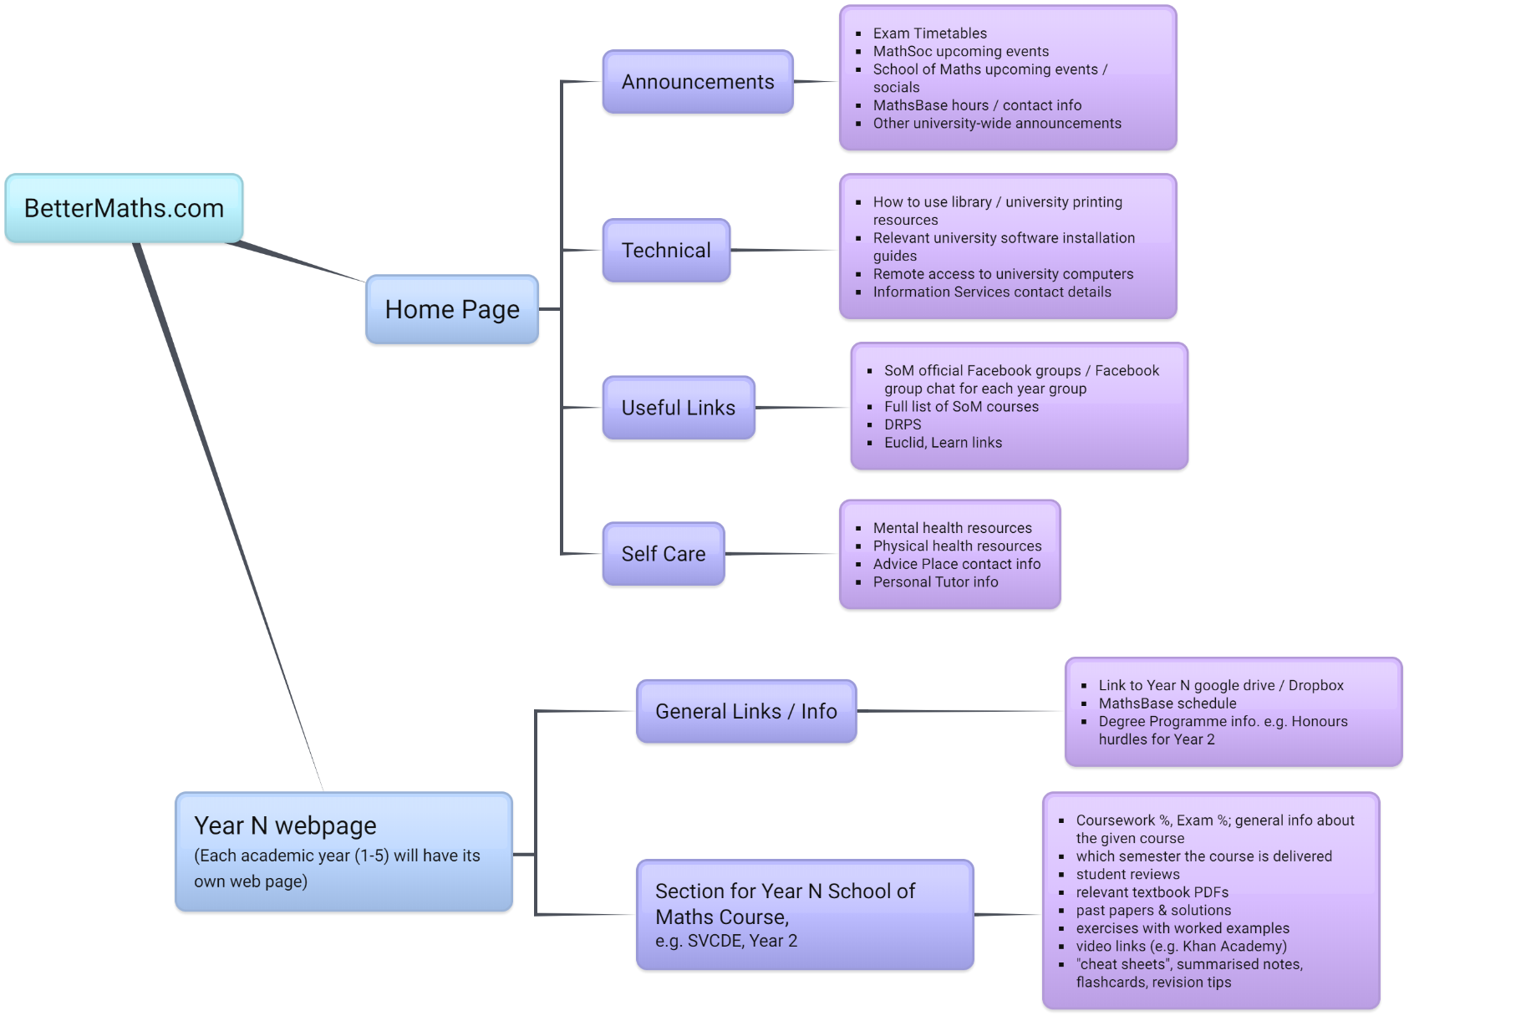
The mind map below illustrates our current concept and structure for the BetterMaths website. Note that the structure/content suggestions are completely open to change depending on students’ wants and needs.
The main idea is to encourage students to contribute to this website, may it be by uploading their own summarized lecture notes, exam cheat sheets, or whatever revision/learning resource they are happy to share with fellow students. This will hopefully benefit all students across the School, but it will also be extremely useful for online distance learners. Having access to these resources will also enable students to make better informed course choices, especially if students upload course reviews.
We would also like a handful of students to update the “Announcements” section of the website when, for instance, exam timetables are published.

