正则表达式：
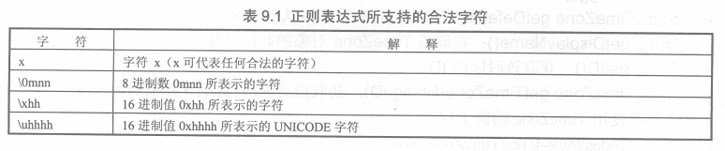
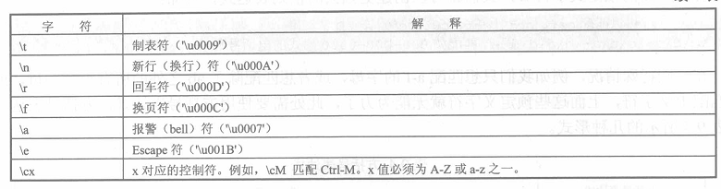
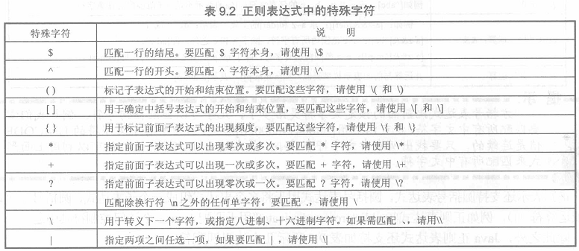
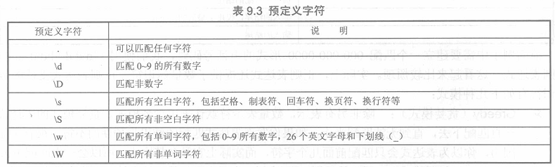
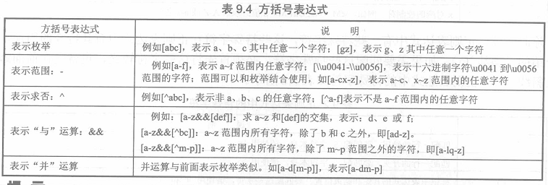
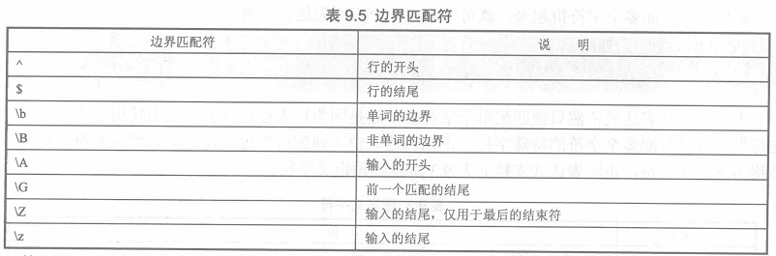
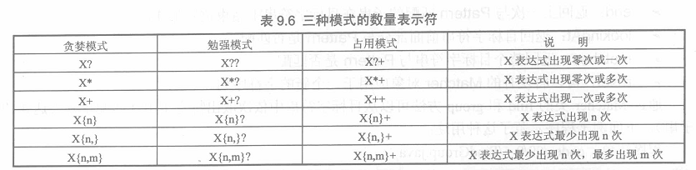
找子串：
import java.util.regex.*;
public class FindGroup
{
public static void main(String[] args)
{
//创建一个Pattern对象，并用它建立一个Matcher对象
Matcher m = Pattern.compile("\\w+")
.matcher("Java is very easy!");
while(m.find())
{
System.out.println(m.group());
}
int i = 0;
while(m.find(i))
{
System.out.print(m.group() + "\t");
i++;
}
}
}
确定子串位置：
import java.util.regex.*;
public class StartEnd
{
public static void main(String[] args)
{
//创建一个Pattern对象，并用它建立一个Matcher对象
String regStr = "Java is very easy!";
System.out.println("目标字符串是：" + regStr);
Matcher m = Pattern.compile("\\w+")
.matcher(regStr);
while(m.find())
{
System.out.println(m.group() + "子串的起始位置："
+ m.start() + "，其结束位置：" + m.end());
}
}
}
对字符串分割、查找、替换
import java.util.regex.*;
public class ReplaceTest
{
public static void main(String[] args)
{
String[] msgs =
{
"Java has regular expressions in 1.4",
"regular expressions now expressing in Java",
"Java represses oracular expressions"
};
Pattern p = Pattern.compile(" re\\w*");
Matcher matcher = null;
for (int i = 0 ; i < msgs.length ; i++)
{
if (matcher == null)
{
matcher = p.matcher(msgs[i]);
}
else
{
matcher.reset(msgs[i]);
}
System.out.println(matcher.replaceAll("哈哈:)"));
}
}
}

