ScootMeal — Module Relationship Diagram
Prepared by: Badrul Aliff Aiman Bin Badrulmunirzaki (102778273) for Mr Felix. COS40005 — Computing Technology Project A. Companion to the Requirements Specification v2 (module names follow its Section 3).
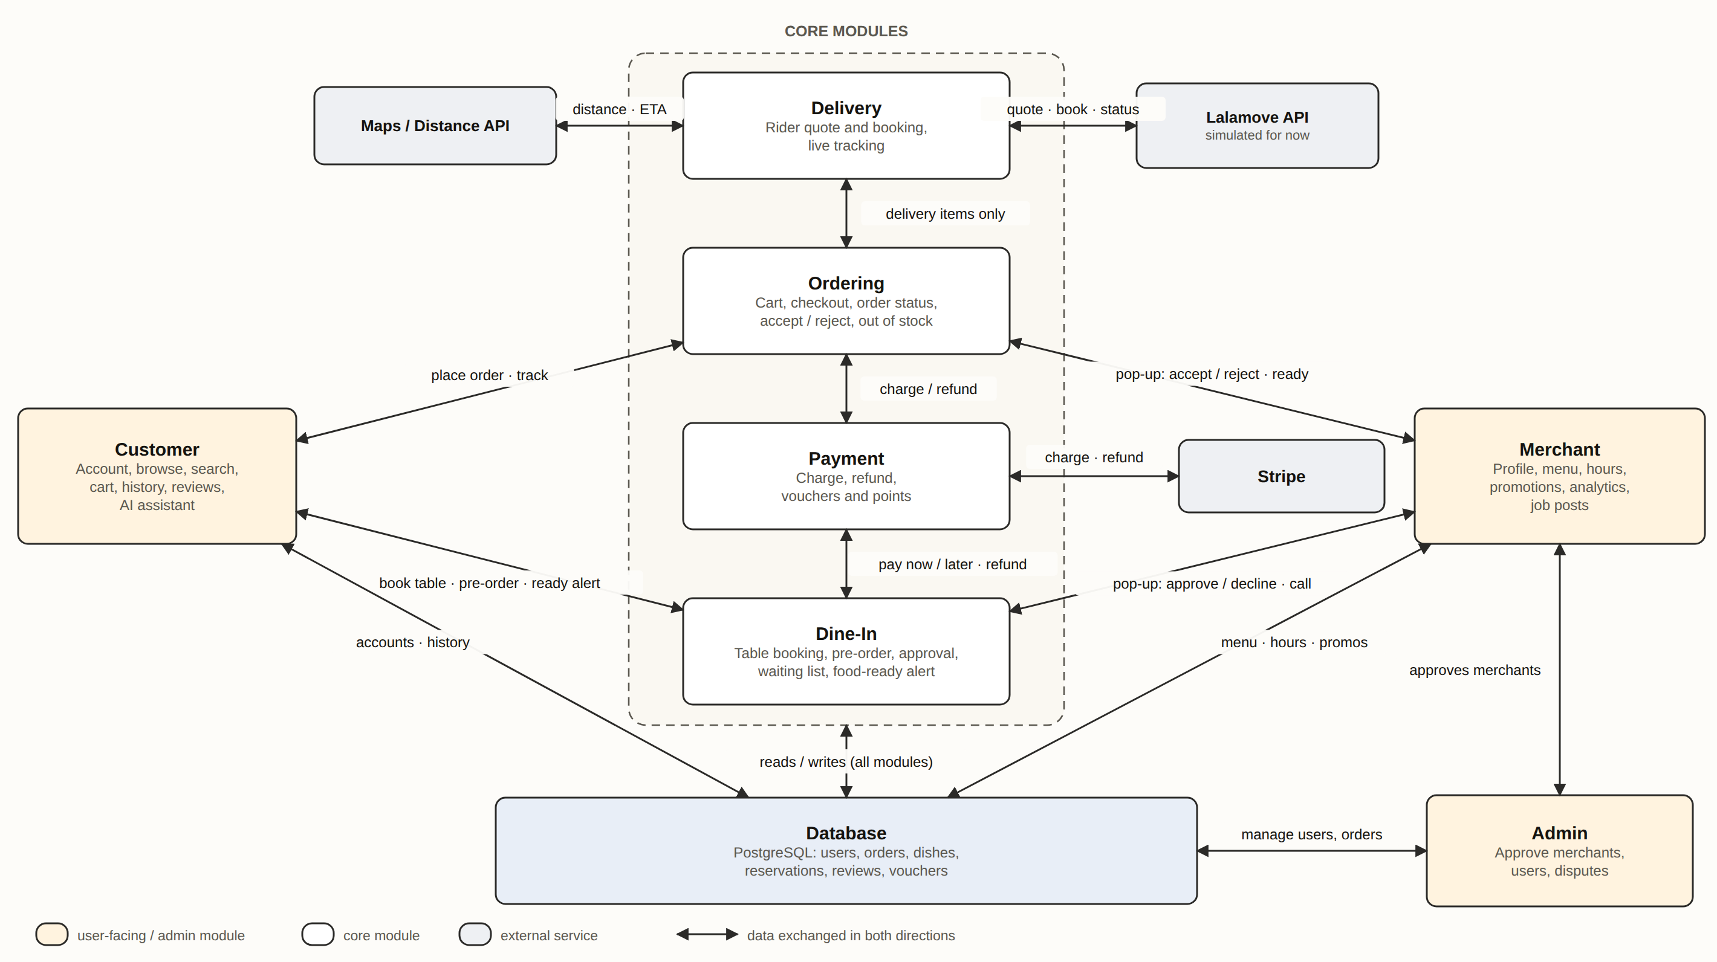
Figure 1. Customer and Merchant reach the four core modules (Delivery, Ordering, Payment, Dine-In); all modules read and write one Database. Stripe, Lalamove and the Maps API are external services.

1. Role of each module
Module | Type | Role
Customer | Customer App / account side | Sign-up and login, browse and search, cart, order and reservation history, reviews, AI assistant.
Merchant | Merchant App side | Restaurant profile, menu, opening hours, promotions, analytics, job posts. Receives the order and reservation pop-ups and responds.
Ordering | Core | Cart and checkout, order status, merchant accept / reject, out-of-stock handling. Splits a mixed order into dine-in and delivery items.
Dine-In | Core | Table booking, restaurant-approved pre-order, waiting list, and the food-ready alert with phone buzz.
Payment | Core | Charges, refunds, vouchers and points. Used by both Ordering and Dine-In.
Delivery | Core | Gets a rider quote, books the rider, tracks the delivery. Only receives items marked for delivery.
Database | Data | Single PostgreSQL store for users, orders, dishes, reservations, reviews and vouchers (see ERD in the requirements document).
Admin | Web Admin side | Approves merchants, manages users and orders, handles disputes (proposed, to confirm).
Stripe / Lalamove / Maps API | External | Card payments; rider booking (simulated for now); distance and ETA.

2. How data flows between modules
Connection | Data exchanged
Customer ↔ Ordering | Out: cart, delivery address, order mode, payment choice. In: order status, tracking updates.
Customer ↔ Dine-In | Out: table request, party size, pre-order items. In: approval or decline, food-ready alert.
Merchant ↔ Ordering | Out: accept / reject, ready, out-of-stock. In: new-order pop-up with a response time limit.
Merchant ↔ Dine-In | Out: approve / decline reservation or pre-order, call customer. In: reservation pop-up with a response time limit.
Ordering → Delivery | Delivery items only: items, drop-off address, order ID. Back: rider status.
Ordering ↔ Payment | Out: amount, voucher. In: payment result; refund when the order is rejected or times out.
Dine-In ↔ Payment | Pay now or pay later, and refund when a reservation or pre-order is declined or unanswered.
Delivery ↔ Lalamove | Quote request, booking, delivery status (simulated for now).
Delivery ↔ Maps API | Addresses out; distance and ETA back.
Payment ↔ Stripe | Charge and refund requests out; confirmation by webhook back.
Core modules ↔ Database | Every module reads and writes its own records through the backend.
Customer / Merchant ↔ Database | Accounts and history; menu, hours and promotions.
Admin ↔ Merchant / Database | Merchant approval; user and order management.

Time limits for the merchant pop-ups are listed in Section 4 of the requirements document, not repeated here, so they stay in one place.

