**2020/12/30 矩陣&分枝度**

|  |  |  |  |  |  |
| --- | --- | --- | --- | --- | --- |
| 無向圖 | A | B | C | D | E |
| A | 0 | 1 | 0 | 1 | 0 |
| B | 1 | 0 | 1 | 1 | 0 |
| C | 0 | 0 | 0 | 0 | 1 |
| D | 1 | 1 | 0 | 0 | 1 |
| E | 0 | 0 | 1 | 1 | 0 |

|  |  |  |  |  |  |
| --- | --- | --- | --- | --- | --- |
| **分枝度** | **A** | **B** | **C** | **D** | **E** |
| **Degree** | 4 | 6 | 4 | 6 | 4 |

|  |  |  |  |  |  |
| --- | --- | --- | --- | --- | --- |
| 有向圖 | A | B | C | D | E |
| A | 0 | 1 | 0 | 0 | 0 |
| B | 0 | 0 | 1 | 1 | 0 |
| C | 0 | 0 | 0 | 0 | 1 |
| D | 1 | 0 | 0 | 0 | 0 |
| E | 0 | 0 | 0 | 1 | 0 |

|  |  |  |  |  |  |
| --- | --- | --- | --- | --- | --- |
| **分枝度** | **A** | **B** | **C** | **D** | **E** |
| **Degree** | 2 | 3 | 2 | 3 | 2 |

**串列：**

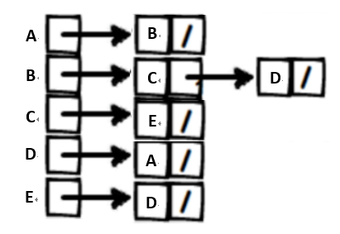

**自行繪製圖形**

**3**

**4**

**5**

**6**

**2**

**1**