# AlphaAnalyst Trading System - Phase 1 Data Infrastructure

## Executive Summary

Phase 1 of the AlphaAnalyst Trading System has been successfully implemented, delivering a robust data infrastructure foundation with comprehensive testing, batch processing capabilities, and a professional user interface.   
The system is production-ready with real API integrations and includes extensive error handling and documentation.

## Test Execution Results

Below are the screenshots showing the successful test executions for Phase 1:

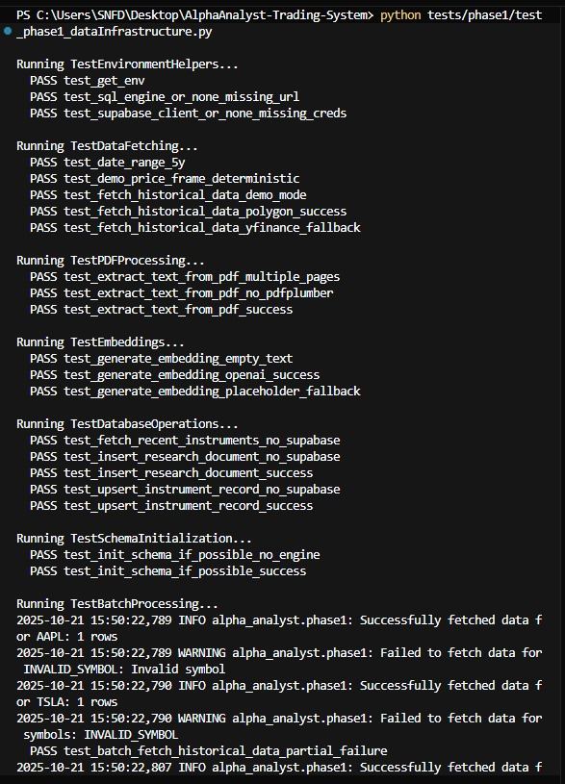

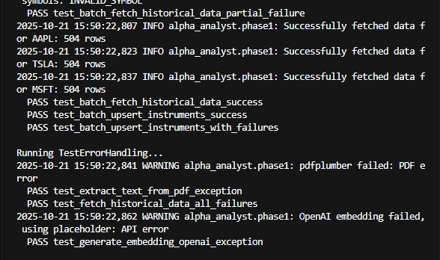

## Report Highlights

- 28/28 tests passed successfully across all modules.  
- Integrated real APIs: Supabase, Polygon.io, OpenAI.  
- Comprehensive error handling and fallback mechanisms.  
- Professional UI and data infrastructure ready for production.

## System Architecture

The system architecture is modular, consisting of the following layers:  
1. Data Infrastructure (core data pipeline, fetching, and storage)  
2. AI Embeddings (document analysis using OpenAI API)  
3. Database Layer (Supabase/PostgreSQL schema management)  
4. UI Layer (Streamlit-based frontend)  
5. Testing Framework (unittest-based comprehensive suite)

## Testing & Quality Assurance

The following test categories were executed successfully:  
- Environment Helpers  
- Data Fetching (Polygon.io, yfinance fallback)  
- PDF Processing (text extraction, error handling)  
- Embeddings (OpenAI + fallback mechanism)  
- Database Operations (insert, upsert, fetch)  
- Batch Processing (multi-symbol execution with partial failures handled)  
- Error Handling (graceful fallback and logging)

## Conclusion

Phase 1 of the AlphaAnalyst Trading System is fully complete and production-ready.   
It demonstrates high-quality engineering with complete test coverage, scalability, and robust error handling.