Name: 4108056007 資工三 鄧雅文

Student ID:

* **Please show both the result of *find* and your program to prove the correctness. (refer to p.16 of the slide)**
* **Without the result of *find*, get no score.**

1. (35%) Snapshot of searching ‘*passwd*’ at root directory

* Your program

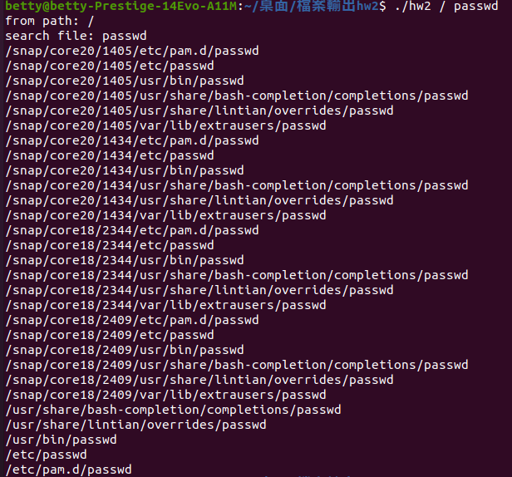

* By *find*

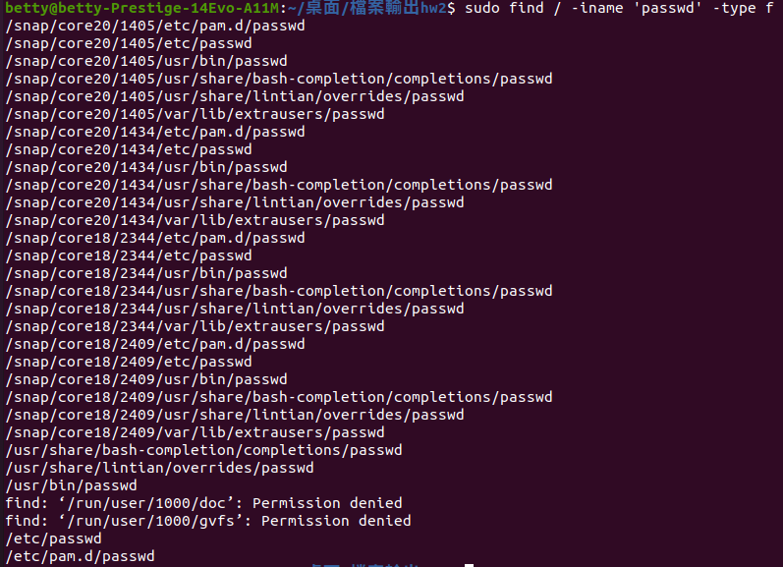

1. (35%) Snapshot of searching ‘*passwd’* at default directory (current directory)
   * Your program

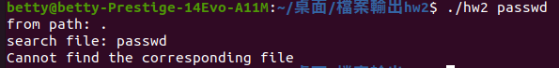

* By *find*



1. (30%) Briefly describe your design.

1. 先讀出argv的參數，並且做整理

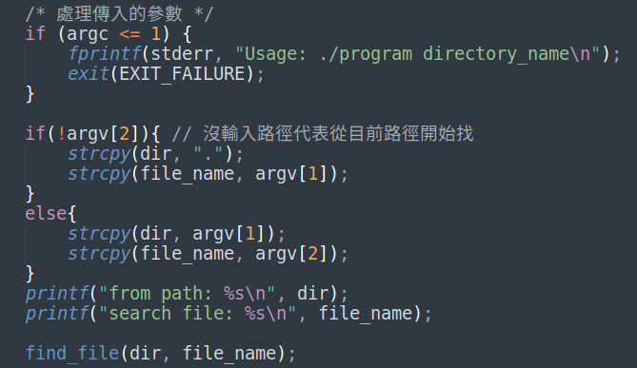

2. 使用一個遞迴function find_file()，去處理檔案

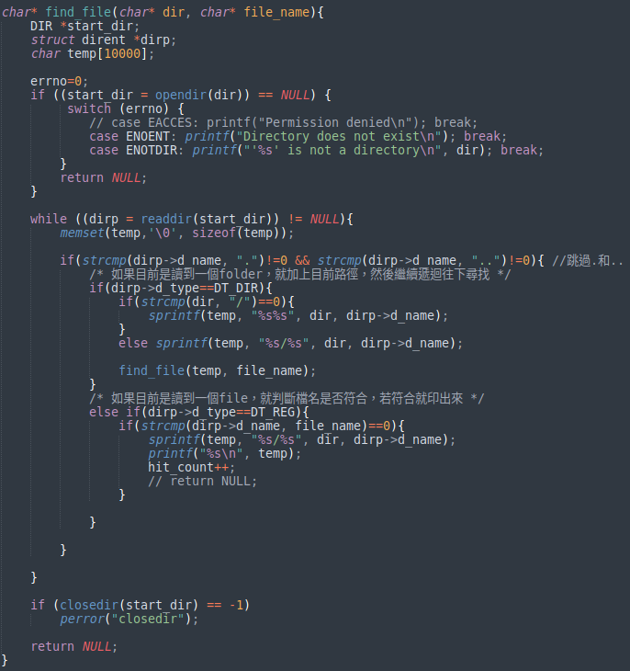

2.1 先opendir()

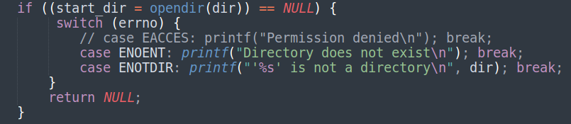2.2 再逐一readdir()，如果是讀到folder，就遞迴繼續往下讀。如果是file，就判斷檔名是否符合。

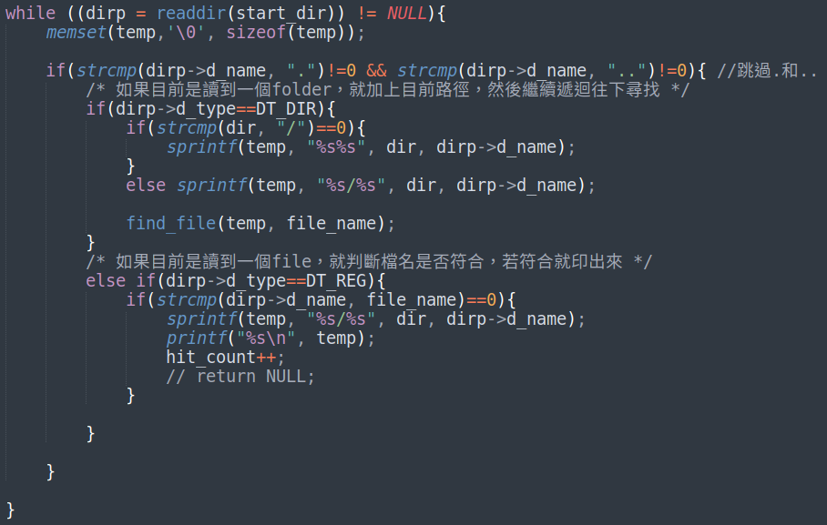2.3 最後closedir()還有return

