ECE415 -- Homework 1

Name: Wang Yunjuan; UIN:661180568

%The MATLAB code is in the zip, so I do not put the code in this file again.

**Transformation matrices & Preserved characteristics**

Mention: The transformation matrices are the same for the following three polygons (equilateral triangle, square, hexagon).

1. Translation

Translation is 5 pixels in the positive direction of both the X-axis and Y-axis.

Translation matrix:

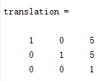

Preserved characteristics:

* The length of sides remain the same.
* The angles between lines remain the same.
* The orientation of object remains the same.

1. Euclidean

Euclidean is based on the translation above and rotate the triangle in 30 degrees clockwise.

Euclidean matrix:

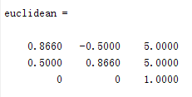

Preserved characteristics:

* The length of sides remain the same.
* The angles between lines remain the same.

1. Similarity

Similarity matrix:

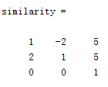

Preserved characteristics:

* The angles between lines remain the same.
* Parallelled lines remain parallel.

1. Affine

Affine matrix:

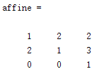

Preserved characteristics:

* Parallelled lines remain parallel.

1. Projective

Projective matrix

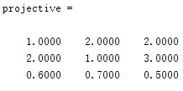

Preserved characteristics:

* Straight lines remain straight.

**Plot each input object and its 5 transformed versions & Print out each object’s vertices in homogeneous and Cartesian coordinates**

1. Equilateral triangle:

Choose the original equilateral triangle as $x_{1}$ =(0,0), $x_{2}$ =(1,0), $x_{3}$ =($\frac{1}{2}$, $\frac{\sqrt{3}}{2}$).

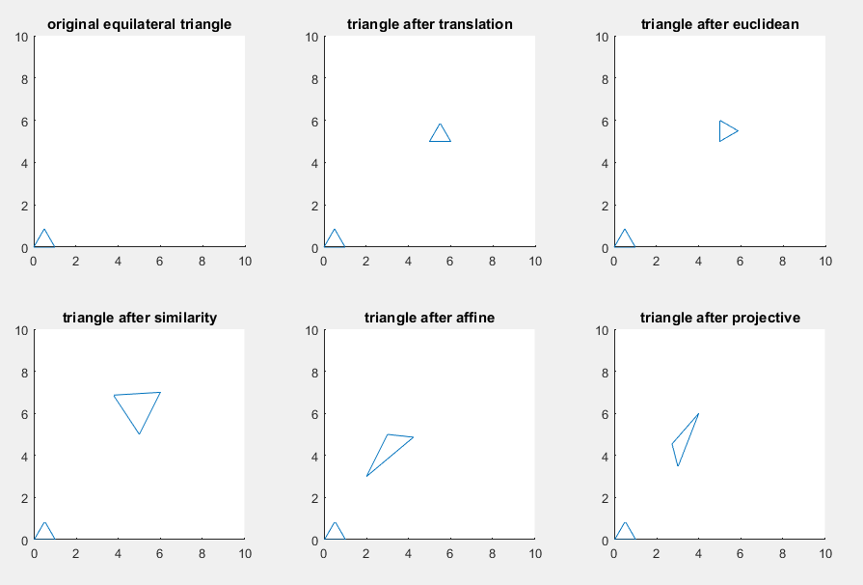

|  |  |  |  |
| --- | --- | --- | --- |
| Coordinates | | Homogeneous coordinates | Cartesian coordinates |
| Input objects | |  |  |
| Transformed objects | Translation |  |  |
| Euclidean |  |  |
| Similarity |  |  |
| Affine |  |  |
| Projective |  |  |

1. Square:

Choose the original square as $x_{1}$ =(0,0), $x_{2}$ =(1,0), $x_{3}$ =(1,1), $x_{4}$ =(0,1).

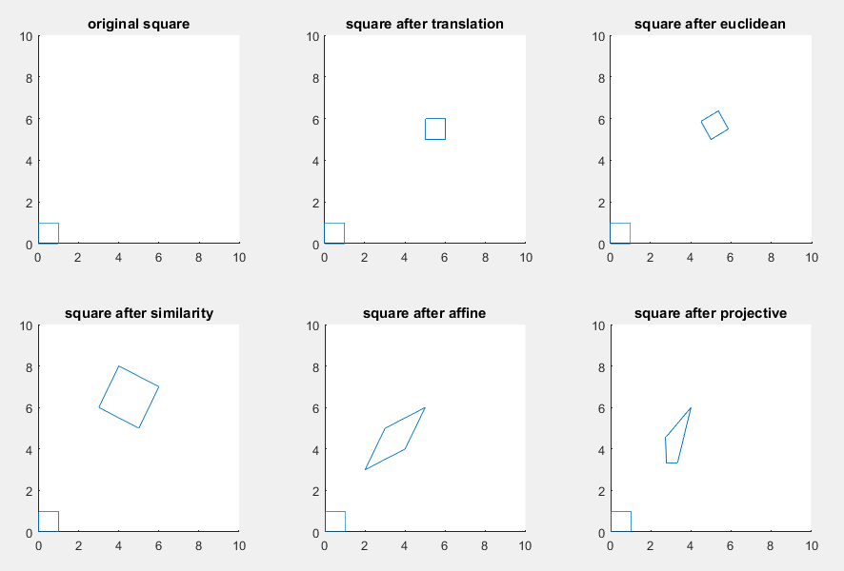

|  |  |  |  |  |
| --- | --- | --- | --- | --- |
| Coordinates | | | Homogeneous coordinates | Cartesian coordinates |
| Input objects | | |  |  |
| Transformed objects | Translation |  | |  |
| Euclidean |  | |  |
| Similarity |  | |  |
| Affine |  | |  |
| Projective |  | |  |

1. Hexagon:

Choose the hexagon as $x_{1}$ =(0, $\frac{1}{2}$), $x_{2}$ =($\frac{1}{2\sqrt{3}}$,0), $x_{3}$ =(1- $\frac{1}{2\sqrt{3}}$,0), $x_{4}$ =(1, $\frac{1}{2}$), $x_{5}$ =(1- $\frac{1}{2\sqrt{3}}$,1), $x_{6}$ =($\frac{1}{2\sqrt{3}}$,1)

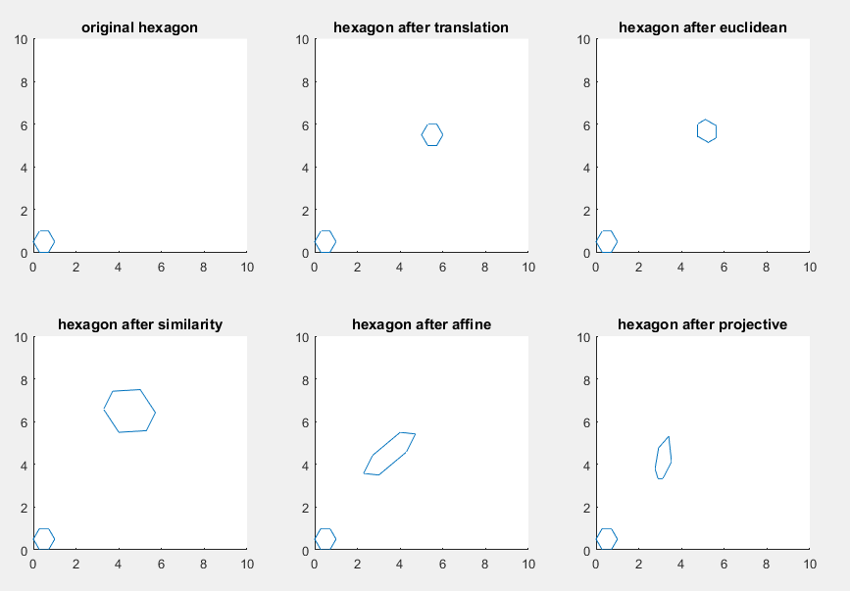

|  |  |  |
| --- | --- | --- |
| Coordinates | | Homogeneous coordinates |
| Input objects | |  |
| Transformed objects | Translation |  |
| Euclidean |  |
| Similarity |  |
| Affine |  |
| Projective |  |

|  |  |  |
| --- | --- | --- |
| Coordinates | | Cartesian coordinates |
| Input objects | |  |
| Transformed objects | Translation |  |
| Euclidean |  |
| Similarity |  |
| Affine |  |
| Projective |  |