ECE415 -- Homework 2

Name: Wang Yunjuan; UIN:661180568

1. **Display the image**

Load the grayscale image Image.bmp into MATLAB and display the image. The picture is shown as follows.

im=imread('Image.bmp');

imshow(im);

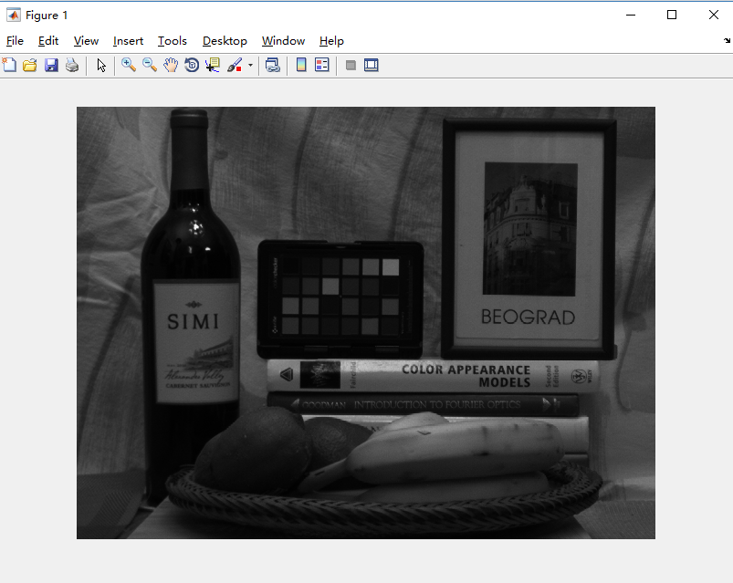

Before solving the following four questions, I first write a function *histogram* to calculate the histogram for the intensity image, which can implement the built-in function of *imhist*. The MATLAB code is as follows. I will use this function in the following questions.

function y=histogram(I)

[row col]=size(I);

h=zeros(1,256);

for i=1:row

for j=1:col

h(I(i,j)+1)=h(I(i,j)+1)+1;

end

end

y=h;

end

1. **Thresholding**

First, we use function *histogram* I have write above to display the histogram of picture. We can easily find a valley in this curve. We roughly evaluate the pixel value of this valley as 40 and choose 40 as our threshold. The result is a binary image. We display the original image and the image after thresholding together to make a comparation.

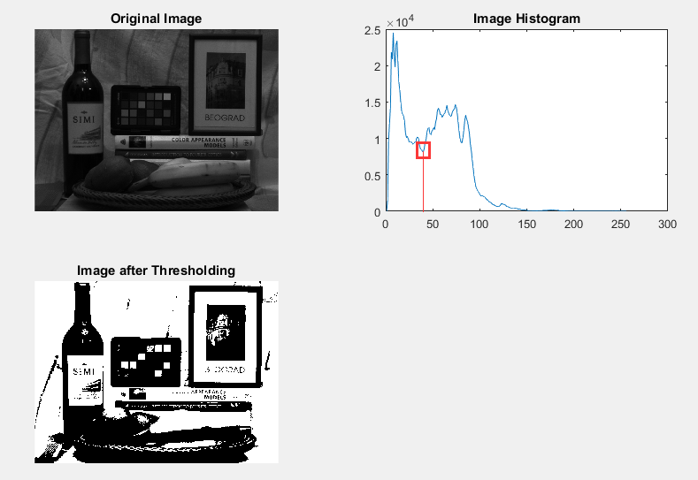

MATLAB code:

clear;clc;

im=imread('Image.bmp');

[row col]=size(im);

subplot(2,2,1);

imshow(im);

title('Original Image');

%% Histogram

h=histogram(im);

subplot(2,2,2);

plot(h);

title('Image Histogram');

%% Thresholding

for i=1:row

for j=1:col

if im(i,j)<40

output(i,j)=0;

else

output(i,j)=255;

end

end

end

output=uint8(output);

subplot(2,2,3);

imshow(output);

title('Image after Thresholding');

1. **Contrast Stretching**

We calculate the actual range that want to stretch is [7,96], the target range is [0,255]. We display the original image and the image after stretching and both of its histogram together to make a comparation. We can find out that the image after stretching is clearer and brighter. Compared with these two histograms, we can find out that in the contrast stretching image histogram, the pixel value is more balanced.

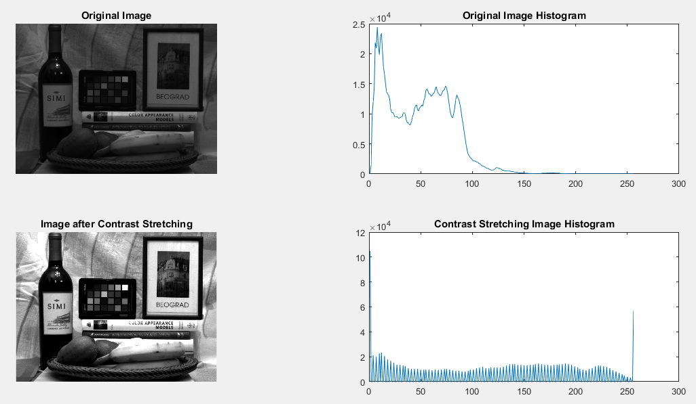

MATLAB code:

clear;clc;

im=imread('Image.bmp');

[row col]=size(im);

imd=double(im);

countleft=0;

countright=0;

h1=histogram(im);

t=0.05*row*col;

for i=1:256

countleft=countleft+h1(i);

if countleft>=t

break

else

continue

end

end

for j=256:-1:1

countright=countright+h1(j);

if countright>=t

break

else

continue

end

end

output=double(zeros(row,col));

for m=1:row

for n=1:col

if im(m,n)<=i

output(m,n)=0;

else

if im(m,n)>=j

output(m,n)=255;

else

output(m,n)=(imd(m,n)-i)/(j-i)*255;

end

end

end

end

output=uint8(output);

subplot(2,2,1);

imshow(im);

title('Original Image');

subplot(2,2,2);

plot(h1);

title('Original Image Histogram');

subplot(2,2,3);

imshow(output);

title('Image after Contrast Stretching');

subplot(2,2,4);

h2=histogram(output);

plot(h2);

title('Contrast Stretching Image Histogram');

1. **Gamma Correction**

I choose gamma equals to 0.5,1.0,2.0 separately and display the final image together as below. It can be seen that the picture is clearer and brighter when gamma is lower than 1, and the picture is darker when gamma is greater than 1.

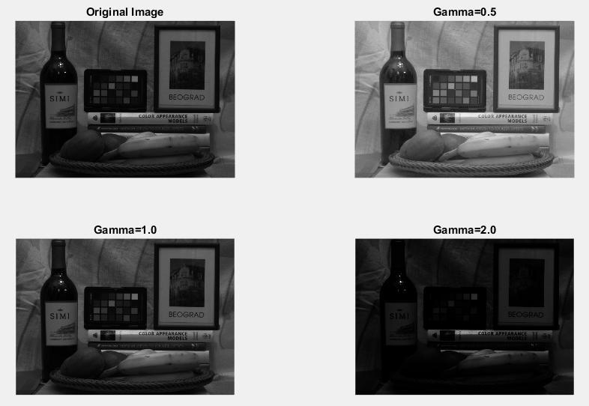

MATLAB code:

clear;clc;

im=imread('Image.bmp');

imd=double(im);

[row col]=size(imd);

%gamma=0.5

gamma1=0.5;

out1=abs((1*imd).^gamma1);

maxm1=max(out1(:));

minm1=min(out1(:));

for j=1:row

for k = 1:col

out1(j,k)=(255*out1(j,k))/(maxm1-minm1);

end

end

out1=uint8(out1);

%gamma=1.0

gamma2=1.0;

out2=abs((1*imd).^gamma2);

maxm2=max(out2(:));

minm2=min(out2(:));

for j=1:row

for k = 1:col

out2(j,k)=(255*out2(j,k))/(maxm2-minm2);

end

end

out2=uint8(out2);

%gamma=2.0

gamma3=2.0;

out3=abs((1*imd).^gamma3);

maxm3=max(out3(:));

minm3=min(out3(:));

for j=1:row

for k = 1:col

out3(j,k)=(255*out3(j,k))/(maxm3-minm3);

end

end

out3=uint8(out3);

subplot(2,2,1);

imshow(im);

title('Original Image');

subplot(2,2,2);

imshow(out1);

title('Gamma=0.5');

subplot(2,2,3);

imshow(out2);

title('Gamma=1.0');

subplot(2,2,4);

imshow(out3);

title('Gamma=2.0');

1. **Histogram equalization**

The image after histogram equalization is below. We can see that the final image is clearer and brighter than before. Compared with these two histograms, we can find out that in the equalized histogram, the pixel value is more balanced.

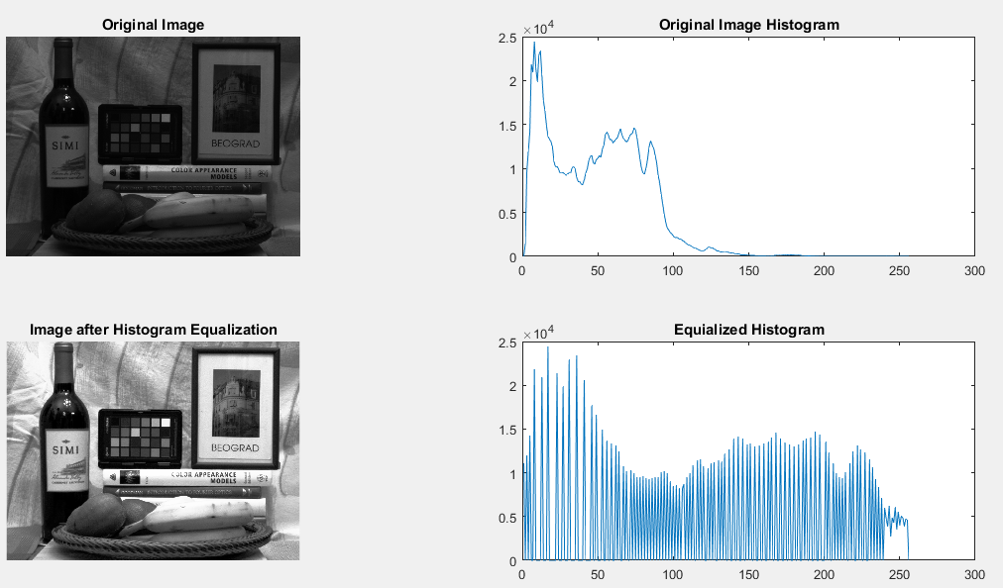

MATLAB code:

clear;clc;

im=imread('Image.bmp');

imd=double(im);

[row col]=size(imd);

h1=histogram(im);

p=h1./(row*col);

cdf=zeros(1,256);

cdf(1)=p(1);

for i=2:256

cdf(i)=cdf(i-1)+p(i);

end

ocdf=zeros(1,256);

ocdf=floor(255.*cdf);

output=zeros(row,col);

for j=1:255

output(im==j)=ocdf(j);

end

output=uint8(output);

h2=histogram(output);

subplot(2,2,1);

imshow(im);

title('Original Image');

subplot(2,2,2);

plot(h1);

title('Original Image Histogram');

subplot(2,2,3);

imshow(output);

title('Image after Histogram Equalization');

subplot(2,2,4);

plot(h2);

title('Equilized Histogram');