Betül Dinçer  
64750  
03/05/2021  
  
 Report #1  
  
Question 1

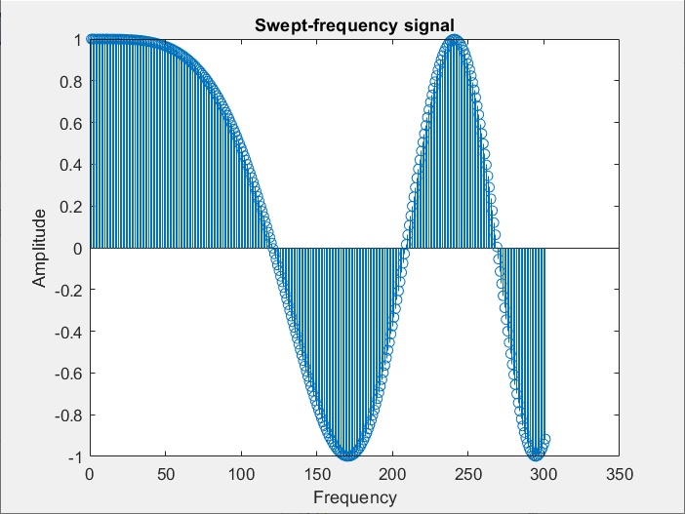  
Figure 1

In this part of the lab, we generated a sinusoidal sweep which has varying frequency in time. Hence the peak value of the sinusoid signal will get closer ot get away as time passed. In genral sinusoidal signal sweep has the form of

$y=\cos\left(w\left(t\right)*t\right)$ w in the equation varies with the rate of change of the frequency which is

$a=\frac{final (w)-initial( w)}{length of time}$ Hence the w is, $w=initial w+a*time vector.$ 
  
   
  
As we can see from the Figure 1. The period of the signal varies as time varies with respect to ‘a’ value.  
  
Question 2  
  
In this part of the lab, we took the two seperate sinusoid with different amplitude and frequency values. We sampled each sinusoids with 1000 as the question suggested. And, we added randomly created noise signal to addition of the these two signals.   
  
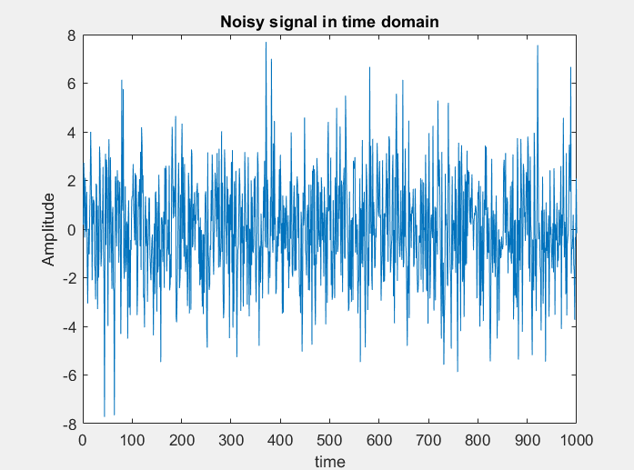

Figure 2.

In Fıgure 2, we see the addition of the two sinusoids but since the noise signals distorts each sample in the addition signal we cannot see two sinusoid in the graph but from the shape we can estimate the shape of sinusoid.   
  
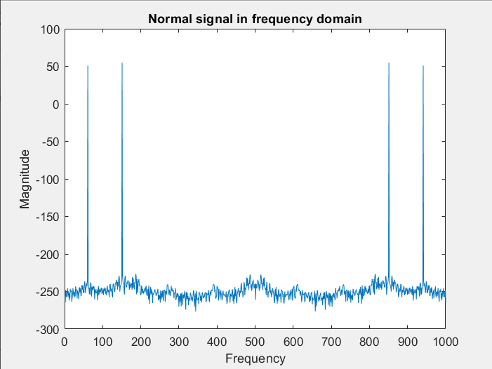  
Figure 3.

If there was not any noise signal, we would expect fourier transform of the addition of these two signals as above. However, since we have noise added to these signals, we will get some signal as follows,

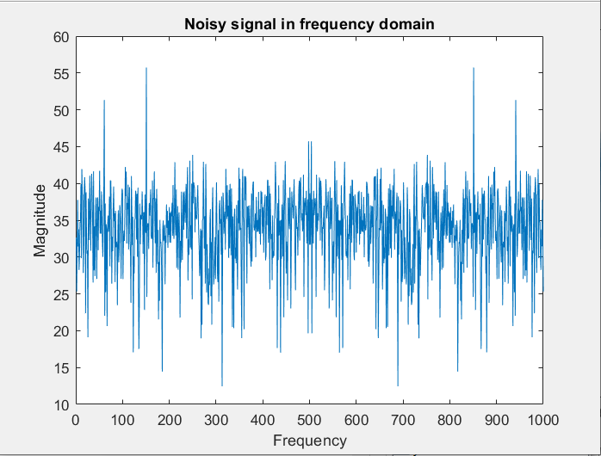

Figure 4.  
  
If we compare Figure 3 and Figure 4, we can clearly see the resemblances. For example both these two signals have peak at exact same frequencies but the noise signlas distorts the signals in Figure 4.  
  
Question 3  
  
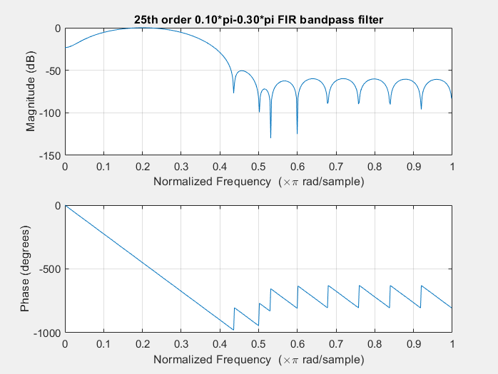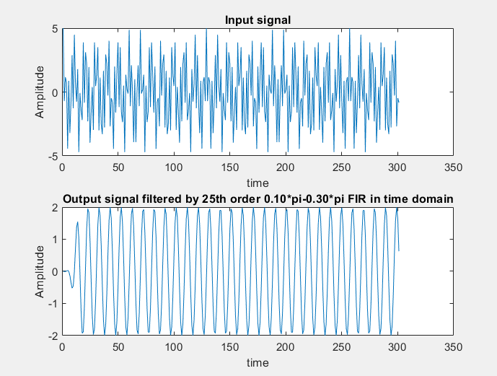  
Figure 5. Figure 6.

We created the FIR bandpass filter with the command of fir1(a,[b c]) where a is the order of the FIR filter and b is the lower frequency of the bandpass filter and c is the upper frequency of the bandpass filter.   
In Figure 5, we see the 25th order bandpass filter with the interval of 0.1pi to 0.3pi. The output signal affected by magnitude and phase of the filter.

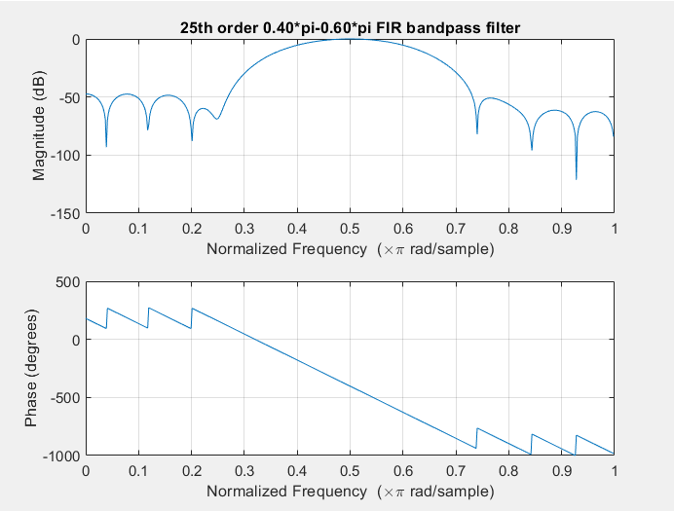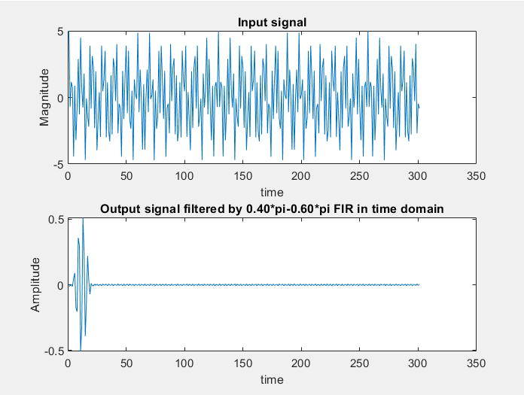

Figure 7 Figure 8  
  
  
  
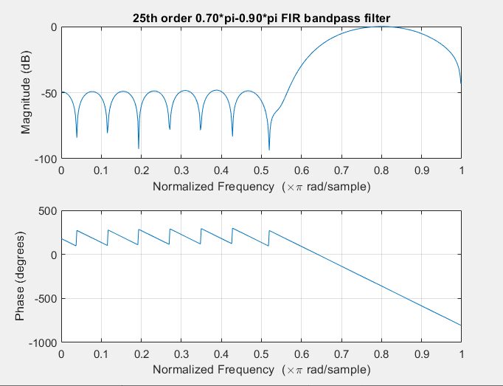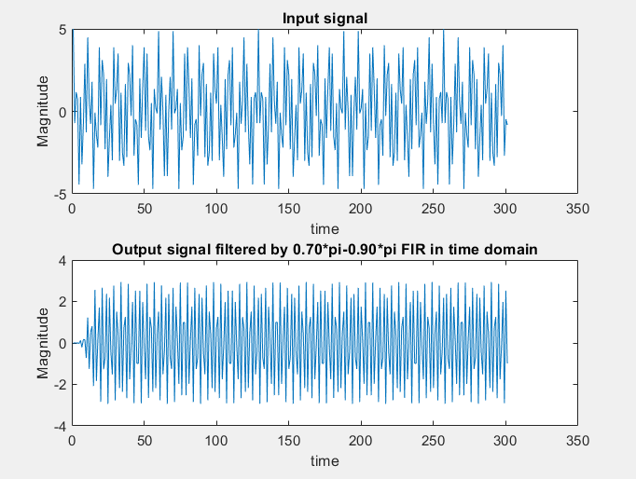  
  
Figure 9 Figure 10  
  
If we compare the results of these three FIR filters, we may say that 0.4pi-0.6pi bandpass filter does not function as other FIR filters since we lost most of the signals after some values. If we compare the first filter with the third one we may say that third one, first FIR bandpass filter leads to a usual sinusoid but the output of the third FIR lead to more complex sinusoid.  
  
Question 4

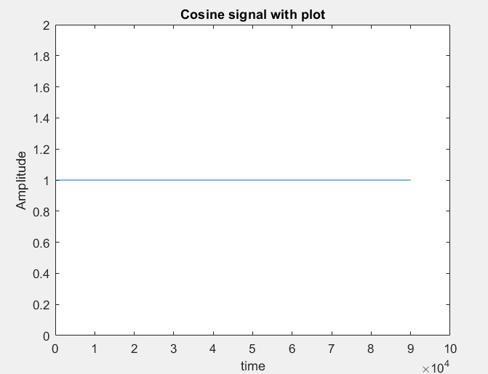 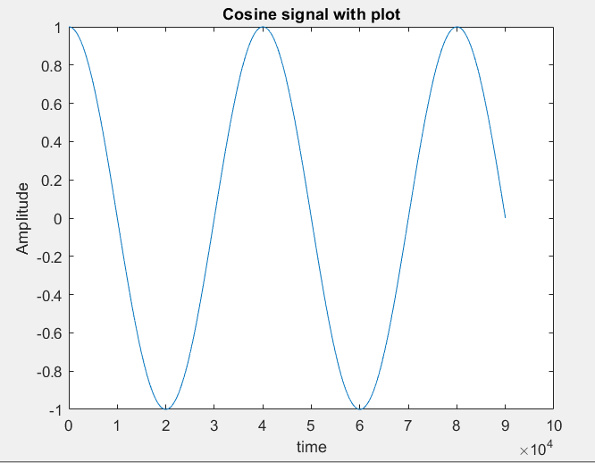 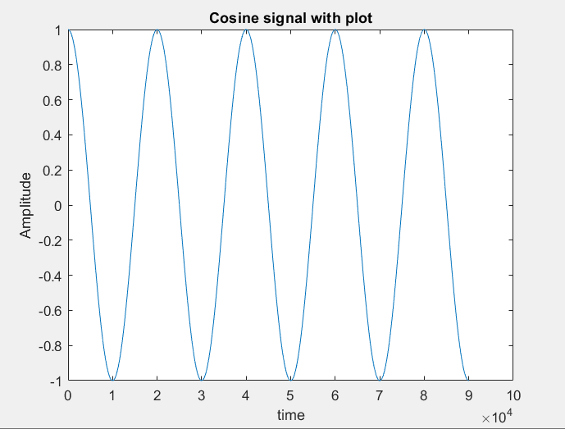

Figure 11 Ω=0 Figure 12 Ω=π/2 Figure 13 Ω=π

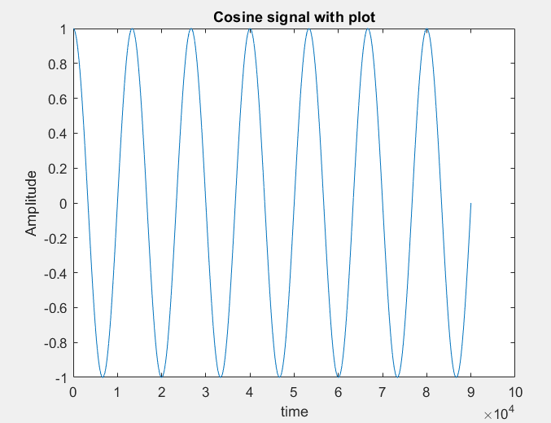 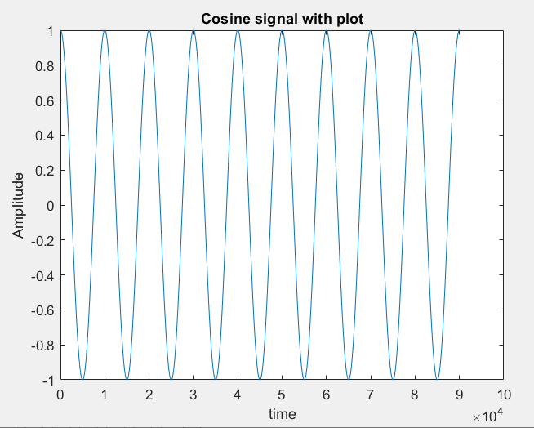  
Figure 14 Ω=3π/2 Figure 15 Ω=2π  
  
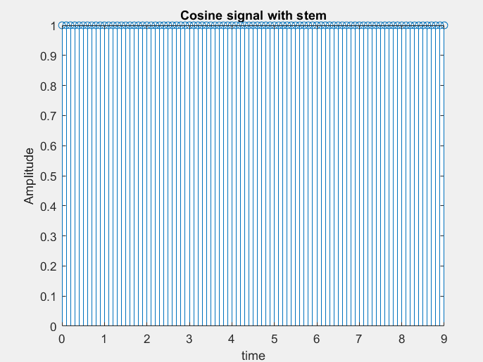 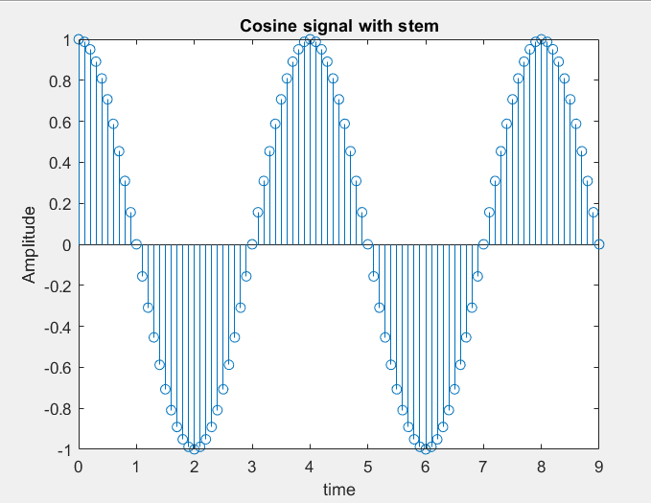 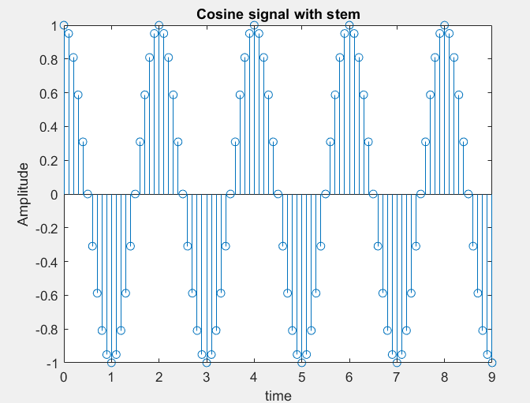

Figure 15 Ω=0 Figure 16 Ω=π/2 Figure 17 Ω=π

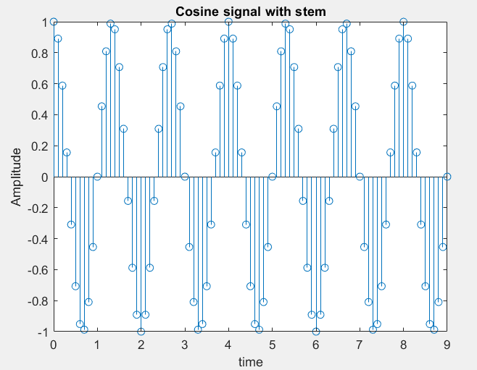 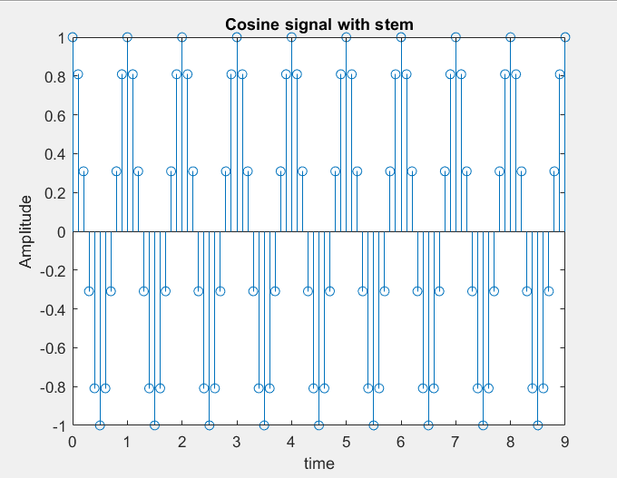  
Figure 18 Ω=3π/2 Figure 19 Ω=2π  
  
When we use plot function, we plotted nearly continous graphs but when we use stem function, we plot dicrete set of datas. As we can see from the graphs the time-frequency relation is same for both plot and stem function, as we increase the frequency the had more cycles in given unit time. And the periodicity also did not change when the frequency equals to the 0, we had non-periodic signal for both stem and plot functions and other frequencies are periodic for both stem and plot function.