Analysis of Loan Approval

Betül ÖĞRETEN
Middle East Technical University
Ankara, Turkey
betul.ogreten@metu.edu.tr

Yaren ÖZARSLAN
Middle East Technical University
Ankara, Turkey
ozarslan.yaren@metu.edu.tr

Abstract— This report aims to analyze and predict loan approval decisions based on the applicants' financial status. The target variable is Loan Status, which is a binary indicator that states whether the applicant got accepted or rejected for the loan. To find important risk indicators, such as credit history and debt-to-income ratios, statistical hypothesis testing (Chi-Square, ANOVA, and Paired T-Tests) and exploratory data analysis (EDA) were used. Several statistical modeling techniques were used for the classification problem, including logistic regression and its regularized variations (Lasso, Ridge, and Elastic Net). Additionally, dimensionality reduction (Principal Component Analysis) and feature selection methods (Recursive Feature Elimination) were used to assess model performance. Metrics including ROC AUC, F1 Score, and Accuracy were used to compare these models' performance. The Python programming language was used for all analysis and modeling procedures.
Keywords—Binary Logistic Regression, MICE, Loan, MCAR SMOTE

Introduction
Strong credit risk management is essential to the financial system's stability. Financial institutions continue to struggle to distinguish between creditworthy candidates and those who are at danger of default due to the growing number of loan applications. This study uses a wide range of financial and demographic data, such as annual income, credit score, loan intent, and past default records, to forecast the likelihood of loan approval. This study uses a multi-stage statistical strategy to methodically examine these issues.
Chi-Square and ANOVA, are the techniques that used for validating the initial connections. Logistic regression was used for predictive modeling, combined with Principal Component Analysis (PCA) and regularized variations (Lasso and Ridge) to handle any possible data redundancy. These models' predictive power was thoroughly assessed and contrasted using measures including ROC AUC, accuracy, and F1 score. Finding the best statistical framework for forecasting loan status while identifying the main factors influencing credit risk is the main goal of this work.

Literature Review
Statistical analytic methods are often used to evaluate loan approvals and credit risk using financial data. Exploratory data analysis (EDA) and hypothesis testing help identify key risk factors that can inform decision-making. Robust non-parametric techniques address non-normal distributions of financial variables. Datasets typically include annual income, credit score, loan intent, and interest rate, with loan intent and credit score shown as statistically significant. This project systematically compares statistical correlations and distributional characteristics among these variables to deepen understanding of their roles in loan approval and credit risk assessment.

Methodology

Dataset
The dataset used in this study is the Loan Approval Data 2025, obtained from Kaggle.com, which includes financial profiles, credit history, and demographic characteristics of loan applicants.
- Age: Information about the age of the applicant
- Occupation Status: The employment status of the applicant (e.g., "Employed", "Self-Employed").
- Years Employed: The duration of the applicant's employment history (in years).
- Annual Income: The total of yearly income of the applicant.
- Credit Score: A numerical rating that evaluates the applicant's creditworthiness.
- Credit History Years: Represents the duration of time that an applicant has been using credit.
- Savings Assets: Total value of an applicant's financial resources that are saved or invested.
- Current Debt: The total amount of outstanding debt the applicant currently holds.
- Defaults on File: A historical record indicating if the applicant has previously defaulted on a loan ("Yes", "No").
- Delinquencies Last 2 Years: The number of times an applicant has been late on a payment by 30 days or more.
- Derogatory Marks: Severe negative records on a credit report that indicate a significant failure to pay debts.
- Product Type: Specific category of financial instrument or service the applicant is requesting from the bank.
- Loan Intent: Specific purpose or reason for which the applicant is borrowing the money.
- Loan Amount: The principal amount of money requested by the applicant.
- Interest Rate: The cost of borrowing money, expressed as a percentage of the loan amount.
- Debt to Income Ratio: Critical financial metric that compares an individual’s total monthly debt payments to their gross monthly income.
- Loan to Income Ratio: Solvency metric that compares the total size of the loan you are asking for against your annual salary.
- Payment to Income Ratio: Specific affordability metric that looks at the relationship between the monthly payment of the new loan you are applying for and your monthly income.
- Loan Status: The target variable indicating whether the loan was approved (1) or rejected (0).

Descriptive Statistics
The first step in better understanding the data is to get descriptive statistics.
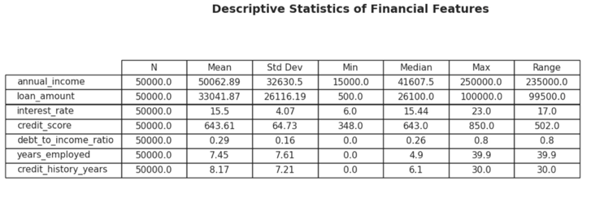
Table 1. Descriptive Statistics
The mean income of the sample of 50,000 individuals is $50,063 and the mean age is 35. The average loan request is $33,000, or 70% of the income one receives; this tells us that the population is overly leveraged.
The average credit score is 644 (Fair), and the average interest rate is 15.5%, which is above average. This means that the risk profiles are moderate. With more than 25% having experienced at least one recent delinquent, there is ample indication of the presence of recent financial stress, despite the fact that historical defaults are very rare (5.3%). The target variable is somewhat balanced, as it is given 55% approval on an absolute level.

Explatory and Confirmatory Data Analysis
Boxplots and histograms were used to demonstrate distributions and they showed financial measures having many outliers as well as large right skewed distributions. The comprehension of this resulted in a need for an elaborate approach for model selection and data preprocessing. It demonstrated how independent variables and target variable (loan_status) are linked.
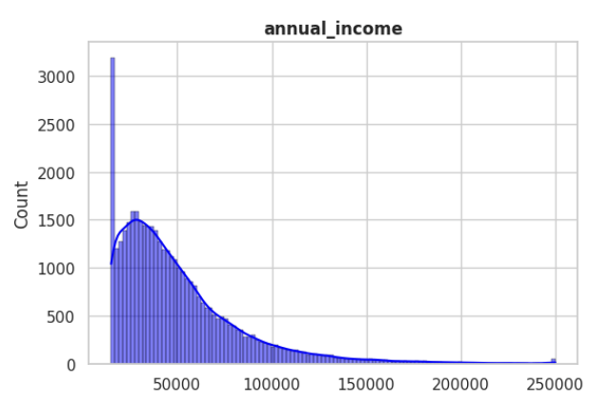
Fig. 1. Skewness
Boxplots for interest rates revealed a strong price difference between approved and denied applications. In contrast, stacked bar charts demonstrated some potential relationships between Loan Intent and approval rates. Pearson’s Chi-Square Test of Independence, Cramer’s V, and t-test were the tests of the relationship
C.1. "Is there a statistically significant association between an applicant's loan intent and the probability of loan default or rejection?"
H₀ (Null Hypothesis): There is no relationship between Loan Intent and Loan Status. They are independent.
H₁ (Alternative Hypothesis): There is a significant relationship between Loan Intent and Loan Status. They are dependent.
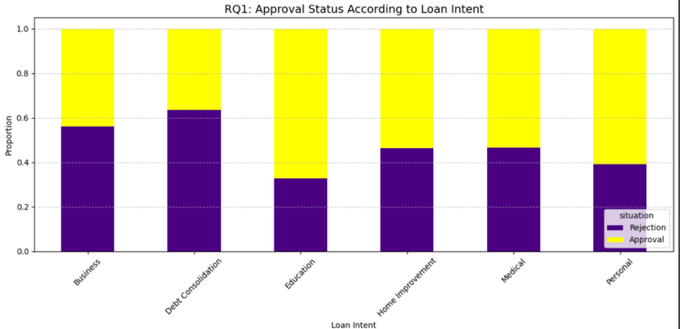
Fig. 2. Box Plot
The stacked bar chart depicts rates of acceptance and rejection of loans over a range of loan intent categories. The visual analysis reveals that there is a stark distinction between the outcomes of the approval process when the applicant specified what they desired from the loan proposal. The rejection rates appear to be higher in the cases of intents concerning financial distress (such as debt consolidation or medical) than intents concerning asset building (such as in education or venture). This difference indicates that the lender’s risk assessment algorithms likely employ what a loan is for as a point of differentiation between the two.
We performed a Chi-Square test and our results were a Chi-Square Statistic at 1477.2884 and a p value of nearly 0. The p-value is less than 1 (so it is below the levels of significance (α=0.05)). So, the null is false. This suggests strongly and statistically that loan intent and the probability of an applicant gaining approval are closely linked
C.2. Does the distribution of derogatory marks differ significantly based on the applicant's loan intent?
H₀ (Null Hypothesis): There is no significant difference in the distribution of derogatory marks across the different loan intent categories. (Statistically, the mean/median rank of derogatory marks is equal for all loan purposes.)
H₁ (Alternative Hypothesis): There is a statistically significant difference in the distribution of derogatory marks for at least one loan intent category compared to the others. (Statistically, at least one loan purpose has a significantly higher or lower frequency of derogatory marks than the rest.)

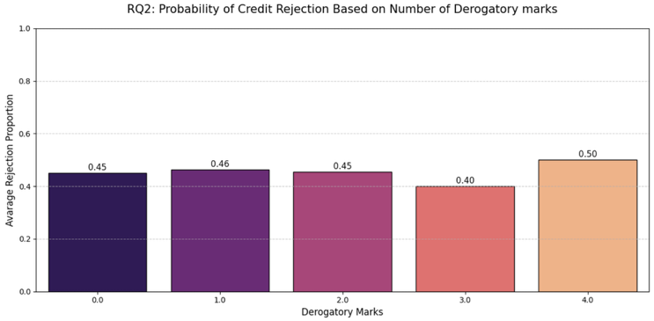
Fig. 3. Box Plot (Credit based on derogatory marks)
Assessing the frequency of derogatory marks for different loan intent groups makes it difficult to know which one is "high-risk" or "low-risk." It's irrelevant whether the applicant is using money to fund business, school, or to pay debts or interest, the average number of negative marks remains unchanged.
The Chi-Square test was performed and found out a 2.7460 Chi-Square Statistic and p-value is less than 0.05. The results are not significant because the p value of 6.0118e-01 is significantly greater than 0.05. The point, this leads us back to at least a sort of conclusion as this runs against the popular assumption that individuals who borrow money for "debt" reasons are born into a shoddy background.
C.3. Is there a statistically significant difference in the average interest rates assigned to approved loan applications compared to rejected ones?
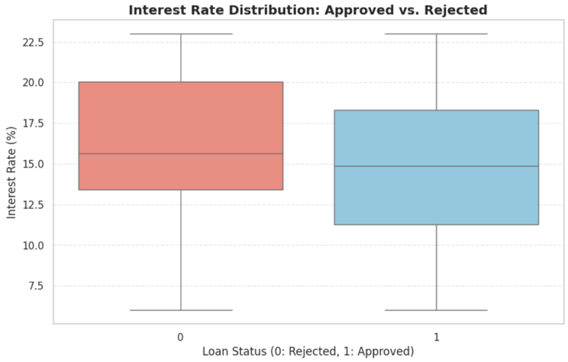
Fig. 4. Box Plot (Interest Rate)
The median line of the Rejected group (red box) indicates a much higher mark than that of the Approved group (blue box).
The visible change is consistent with the statistical conclusion of rejected application being quoted at higher rates on average (~16.3%) than approved ones (~14.8%).
T-Value: 37.1124 P-Value <0.05. The results are statistically significantly different.
Explanation: The bank offers lower rates to loans which are approved because they are safe.
C.4. What is the relative strength of association between various applicant attributes and loan approval outcomes, and which features serve as the primary determinants of creditworthiness?
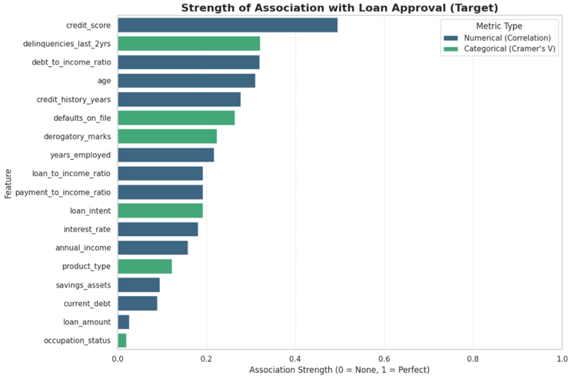
Fig. 5. Comparison Plot
The loan status and the credit score are closest to each other (0.495). This extremely strong ability to predict indicates that the lender’s primary interest is in the applicant’s creditworthiness. It is essentially the “gatekeeper” variable; the lower the score, the smaller the other criteria likely actually count. Below them are two-year delinquencies (Strength: 0.320) and the debt-to-income ratio (Strength: 0.320). The high debt-to-income ratio is particularly telling, because this demonstrates that the lender is willing to consider how much money the borrower can afford right now (Debt-to-Income Ratio) as well as what time it has been an offender (Delinquency). Interesting to note that the debt-to-income ratio, and other ratios based on raw annual income (0.158) fare better. This makes that it should be a consideration only relative to the applicant’s debt load, and not approval on its own.

Missingness
The original dataset has not any missing values. Therefore, artificial missingness was intentionally created at 10% for each variable in the dataset. Since the missing values were created randomly and no patterns missingness mechanism is Missing Completely at Random (MCAR). By generating missing values randomly, the handling techniques could be evaluated without confounding effects.

Imputation
For handling strategy of the missingness, imputation technique applied by using MICEforest algorithm. Since it can handle categorical variables too for imputations and faster than other imputation techniques.
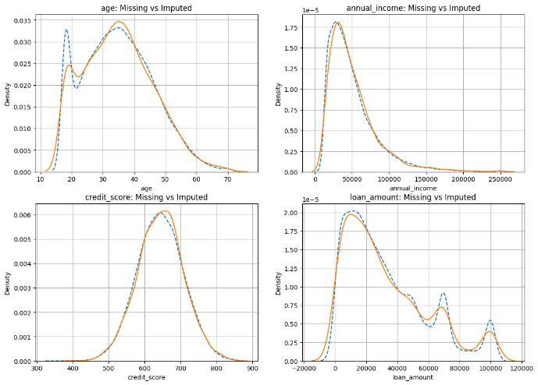
Fig.6. Missing vs Imputed Data
After imputation some predictors compared with MCAR data and shown in Fig.7. and overall the imputed distributions close with observed data that suggest imputation technique preserves the original data distribution.
After that encoding was applied on categorical variables by using dummy encoding for logistic regression with drop_first=True coding.

Feature Selection
A correlation-based filter method was applied by using Pearson correlation for feature selection. For a binary outcome, Pearson correlation is equivalent to the point-biserial correlation, and therefore gives an important measure of linear association between each continuous feature and the target. A correlation heatmap was used to visualize the strength and direction of associations.

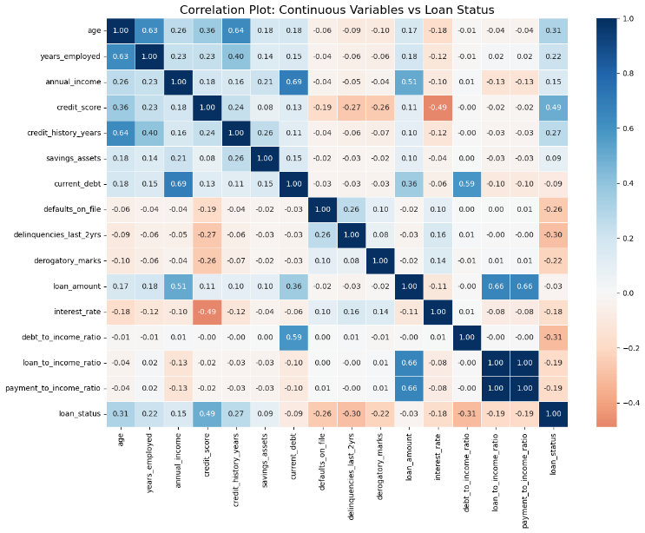
Fig. 7. Correlation Heatmap
As seen in Fig. 1. payment_to_income_ratio and loan_to_income ratio shows identical correlation patterns with target variable and highly correlated with each other that indicate multicollinearity. Since they share same information, VIF values was checked to decide which variable should be removed.
To further assess multicollinearity, Variance Inflation Factor (VIF) values were computed.

Feature | VIF
annual_income | 1433.970505
current_debt | 769.439897
payment_to_income_ratio | 583.958669
loan_to_income_ratio | 583.818454
credit_score | 246.420401
interest_rate | 117.333167
debt_to_income_ratio | 18.825838
Table. 2. Variance Inflation Factor(VIF)
Table.2. shows highest VIF values among all variables. As seen the table payment_to_income_ratio has higher VIF value than loan_to_income_ratio. According to these observation payment_to_income_ratio was removed.
Altought variables such as annual_income, current_dept, credit_score and interest_rate also have high VIF values, they were stayed in the analysis as their fundamental importance in banking and credit risk modeling. Instead of eliminating these important features ratio-based and derived variables that occure multicollinearity was removed. As a result of feature selection with this approach reduced VIF values and reduced redundancy.

Dimension Reduction
To reduce the high-dimensional space to a lower-dimensional space with minimum information loss, dimension reduction was applied with Principal Component Analysis (PCA).
Before applying PCA, transformations were applied to continuous variables to address skewness and nonlinearity and all predictor variables were scaled by using StandardScaler function. Scaling ensured that each variable contributed equally. After scaling, to prevent data leakage, PCA was fitted only on the training data. This ensured that model evaluation reflected true out-of-sample performance.
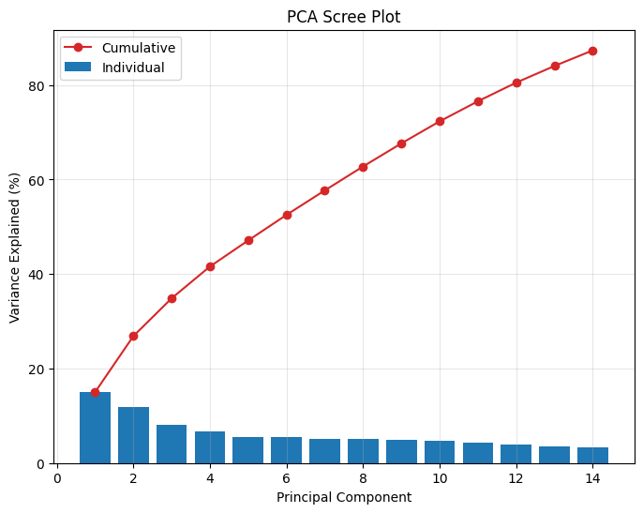
Fig. 8. Scree Plot

The scree plot was utilized to determine the optimal number of principal components.
This plot visualized the proportion of total variance explained by each individual principal component as well as the cumulative variance. According to the plot and the analysis first 13 principal components that explained 84% of the total variance in the dataset were selected by ad-hoc rule. This approach not only eliminates the risk of multicollinearity but also ensures that the logistic regression model focuses on the most informative patterns.
In addition, UMAP (Uniform Manifold Approximation and Projection) was used as non-linear method.
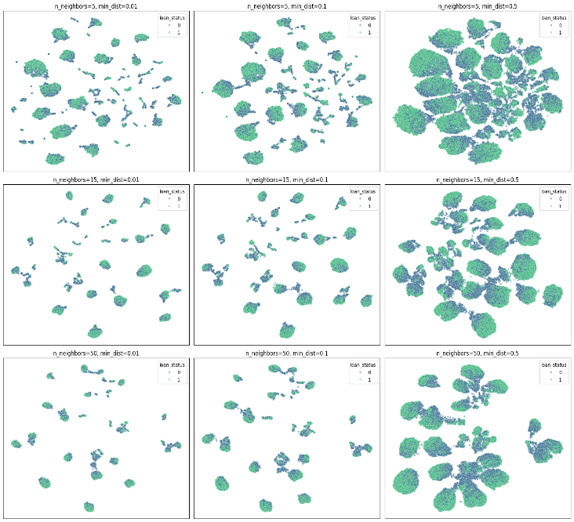
Fig. 9. UMAP (with hyperparameter tuning)
According to the fig.3. n_neighbors parameter controls the balance between local and global structure and min_dist parameter controls how tightly points are packed in the low_dimensional space.
- UMAP(n_neighbors=5, min_dist=0.01) produces very tight and separate clusters. Many small clusters make the global structure difficult to interpret.
- UMAP(n_neighbors=5, min_dist=0.1) compact but less fragmented than the first one. Local separation still strong.
- UMAP(n_neighbors=5,min_dist=0.5)although fragmentation decreases, boundaries become less clear.
- UMAP(n_neighbors=15, min_dist=0.01) shows compact clusters while reducing fragmentation and more interpretable than with smaller n_neighbours sizes.
- UMAP(n_neihgbours=15,min_dist=0.1) separation can be consider suitable. Overlapping still exists.
- UMAP(n_neighbours=15, min_dist=0.5) while the global structure remains coherent, cluster compactness decreases.
- UMAP(n_neighbour=50, min_dist=0.01) local detailed reduced, but cluster regions are identifiable. Due to large n_neighbours size finer structures are lost.
- UMAP(n_neighbours=50, min_dist=0.1) clusters more merged and less distinct but less informative
- UMAP(n_neighbors=50, min_dist=0.5) noticeable overlap exists. While global structure is preserved, class separation is weak.

Cross Validation
Before modeling to obtain robust an unbiased estimate of the model performance, stratified 10-fold cross-validation was applied with specific seed. The number of folds was selected k=10 as it is widely used in the literature and gives good bias-variance trade-off. Same cross validation folds were used for all models ensures that observed performance differences are due to modeling choices rather than data partitioning.

Binary Logistic Regression

Since the target variable is binary, a binary logistic regression was conducted for three models which are original model , with feature selection model and with dimension reduction model. Before modeling, the assumptions of logistic regression was examined and the analysis revealed that the log odds linearity assumption was violated. As an handling strategy Box-Tidwell test was applied with transformation and then regression analysis conducted.

Three logistic regression models were evaluated with same cross-validation metric framework. The first model used all features, serving as baseline and capturing the full information content of the data. The second model conducted with feature selection, where highly correlated variables and those contributing to multicollinearity were removed. The third model employed with dimension reduction via Principal Component Analysis (PCA), were features standardized and then projected onto a lower-dimensional space. 13 principal components were selected based on capturing the most of the variance and reducing multicollinearity through orthogonal components.
All preprocessing steps were implemented within a pipeline structure to guarantee that transformations were fitted only on the training folds for preventing data leakage.
To compare and choose best model among all three accuracy, roc_auc, F1,sensitivity, specificity and kappa scores are evaluated and shown in table1.1
Performance Scores | Model 1  All features | Model 2  With feature selection | Model 3  With PCA
Sensitivity | 0.8776 | 0.8524 | 0.8657
Accuracy | 0.8544 | 0.8165 | 0.8357
Specificity | 0.8260 | 0.7726 | 0.7989
F1 | 0.8691 | 0.8365 | 0.8529
Roc_Auc | 0.9340 | 0.9340 | 0.9340
Kappa | 0.7052 | 0.6277 | 0.6668
Table 3. Models Performance Scores
Based on the Table 3. the logistic regression model using all features achieved the best overall performance across all evaluation metrics. All features model was selected best model and for regularization.

Regularization

For regularization all features model was selected and regularization conducted. In high-dimensional settings where predictors are correlated, regularization helps to overcome multicollinearity problem with Ridge(L2), Lasso( L1) and Elastic Net techniques. Ridge regularization uses L2 penalty that shrinks coefficients toward zero for handling multicollinearity. Lasso regularization uses L1 penalty that shrink some coefficients exactly zero. Elastic Net use both L1 and L2 penalties while combining them balancing variable selection and coefficient shrinkage. All regularized models

used same preprocessing pipeline and cross validation for fair comparison.
Performance Scores | Ridge (L2) | Lasso(L1) | Elastic Net
Sensitivity | 0.8776 | 0.8774 | 0.8777
Specificity | 0.8260 | 0.8265 | 0.8270
Accuracy | 0.8544 | 0.8545 | 0.8546
F1 | 0.8691 | 0.8691 | 0.8691
Roc_Auc | 0.9340 | 0.9340 | 0.9340
Kappa | 0.7052 | 0.7054 | 0.7055
Table 4. Regularization Performance Scores

According to the Table2.2 the results among all three regularization models achieved very similar performance scores. However, Elastic Net regularization shows better result than other two regularizations in terms of sensitivity, specificity, accuracy and kappa scores.

SMOTE
Although, the target variable is balanced as shown in the Table 5. and Fig.9. for additional analysis SMOTE was applied to see whether the moderately balanced model gives better results or not.

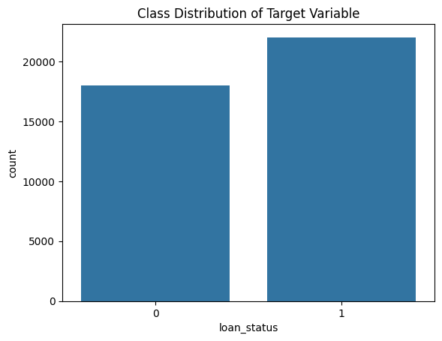 Fig.10. Class Distribution of Target Variable

loan_status | proportion
1 | 0.55045
0 | 0.44955

Table 5. Target variable balance
The dataset exhibits a moderately balanced structure with 55% approval and 45% rejection.

SMOTE technique was conducted for balancing and results shown in Table 6.

Performance Scores | No resampling | With SMOTE
Sensitivity | 0.8775 | 0.8563
Specificity | 0.8265 | 0.8500
Accuracy | 0.8546 | 0.8535
F1 | 0.8691 | 0.8655
Roc_Auc | 0.9340 | 0.9340
Kappa | 0.7055 | 0.7046
The result indicates SMOTE did not gives better performance and meaningful improvement. Therefore, without SMOTE data was used for the final model comparisons.

Model Evaluation and Conclusion
For modelling stage binary logistic regression was conducted for three models which are original, with feature selection by correlation-based filter method and with dimension reduction by PCA. Before starting logistic regression, assumptions are checked and violated one are handled then, cross validation was applied with 10-folds. Models are compared according their sensitivity, specificity, accuracy, F1, roc_auc and kappa scores. Performance scores revealed that the best model of all three is the original one with all features. After deciding best model regularization was conducted with Lasso, Ridge and Elastic Net in terms of same metrices with logistic regression. Scores were close all three techniques but Elastic Net gives relatively better result than others. Additionally SMOTE was applied whether there is any improvement and seen no better results. Consequently, for the final and best model, all features with Elastic Net regularization were chosen.
The coefficients of the final model well suitable with financial risk assessment principles and loan approval analysis. Strongest predictor observed as current debt with 1.62 coefficient for loan approval, second strongest predictor was seen credit score with 1.05, then loan intent for education with 0.87 that indicate loan approval is high when intention is for education. Then, credit history years with 0.70. Derogatory marks and delinquencies last two years shows less effect of the loan status. Historical indicators such as defaults on file and delinquencies significantly reduce approval chances. Model more care about dept to income ratio rather than the raw annual income alone.
Consequently, selected final model exhibit both high predictive accuracy and financially meaningful coefficients estimates.

References

- B. Huang and L. C. Thomas, "Credit card pricing and impact of adverse selection," J. Oper. Res. Soc., vol. 65, no. 8, pp. 1193-1201, 2014.)
- The Banks Association of Türkiye, "Consumer Loans and Housing Loans,"2023.[Online].Available: https://www.tbb.org.tr/Content/Upload/istatistikiraporlar/ekler/4227/Tuketici_Kredileri_Raporu-Eylul_2023.pdfI. S. Jacobs and C. P. Bean, “Fine particles, thin films and exchange anisotropy,” in Magnetism, vol. III, G. T. Rado and H. Suhl, Eds. New York: Academic, 1963, pp. 271–350.
- M. Siles, S. D. Hanson, and L. J. Robison, "Socio‐economics and the probability of loan approval," Appl. Econ. Perspect. Policy, vol. 16, no. 3, pp. 363-372, 1994..
- M. Alaradi and S. Hilal, "Tree-based methods for loan approval," in 2020 International Conference on Data Analytics for Business and Industry: Way Towards a Sustainable Economy (ICDABI), Oct. 2020, pp. 1-6.
- M. A. Sheikh, A. K. Goel, and T. Kumar, "An approach for prediction of loan approval using machine learning algorithm," in 2020 Int. Conf. Electron. Sustainable Commun. Syst. (ICESC), Jul. 2020, pp. 490-494.
- M. Li, A. Mickel, and S. Taylor, "‘Should this loan be approved or denied?’: A large dataset with class assignment guidelines," J. Stat. Educ., vol. 26, no. 1, pp. 55-66, 2018.

Table 6. Performance scores with SMOTE and without SMOTE

