**ISTANBUL TECHNICAL UNIVERSITY**

FACULTY OF SCIENCE AND LETTERS

MATHEMATICAL ENGINEERING

MAT116E

LECTURER: BURCU TUNGA

TERM PROJECT

BOTTLE CAP DETECTION

WITH USING MATLAB

Betül Şener

090180318

June 6, 2021

Outline

Subject

1. Aim of the Project
2. Literature Research
3. Project Steps
   1. Make user to select the image
   2. Crop the image
   3. Process the image
   4. Test if the cover is exist
   5. Give the result to the user
4. Results
5. Possible Improvements
6. Problems Encountered
7. References

**Subject**

Due to the margin of error in water bottling machines, some bottles may be offered to the market without a cap. In order to minimize this error, a cap control system must be used. In this project, a system that provides this control has been created. First of all, capped and uncapped bottle photos were taken on a white background and proper lighting, and it was determined whether there was a cap by image processing method. Successful results have been obtained.

**1. Aim of the Project**

In this project, it is aimed to examine a standard water bottle image with MATLAB to determine whether there is a cap on it. Image processing agortihm used. Due to the margin of error in water bottling machines, some bottles may be offered to the market without a cap. In order to minimize this error, a cap control system must be used. In this project, a system that provides this control has been created. At the same time, since the caps of glass bottles in recycling systems are metal, it should be checked that they are also uncapped. This system can also be used for this purpose.

**2. Literature Research**

A project in this field is carried out in industrial environments, professionally and flawlessly, with a high level laser technology. Since my project was based on MATLAB, I had to follow very different methods than what was done in the literature. After many method researches, it was focused on the algorithm that would give the most successful result.

**3. Project Steps**

There is 5 main steps of this project.

1. Have the user select the image
2. Crop the image.
3. Process the image
4. Test if the cover is exist.
5. Give the result to the user.

**3.1. Make user to select the image**

In order to make it easy to use, a system where the user directly selects the image has been used. In this way, the system can be used in different companies according to the desired image storage method and naming. If the user does not select an image, the system gives a warning.

**Code:**

[filename, pathname] = uigetfile('*.*', 'Pick the Bottle Image');

if isequal(filename,0) || isequal(pathname,0)

disp('User pressed cancel')

else

filename=strcat(pathname,filename);

bottle=imread(filename);

**3.2. Crop the image**

In the system we will use, only this part will be used since our target is the cap of the bottle. For this reason, bottle photos taken with a fixed distance from a fixed point are crop at fixed position values determined to include only the cap. The position of the region to be cut was determined with the “imcrop(x)” command on matlab.

**Code:**

cropped=imcrop(bottle,[518.5 186.5 93 56])

**Image processing results:**

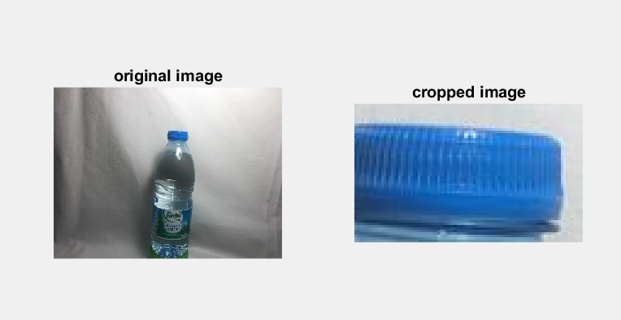

**3.3. Process the image**

Firstly converting the red, green, and blue values to luminance and chrominance. The blue channel of this image was selected by choosing the 2nd channel of the YCbCr image. In the next step, the contrast is increased. Then converted to binary by choosing an appropriate threshold that highlights the blue pixels in the image.

**Code:**

YCbCr_x=rgb2ycbcr(cropped);

blue_channel=YCbCr_x(:,:,2);

constrasted=imadjust(blue_channel);

BlackWhite=imbinarize(contrasted, double(170/256));

**Image processing results:**

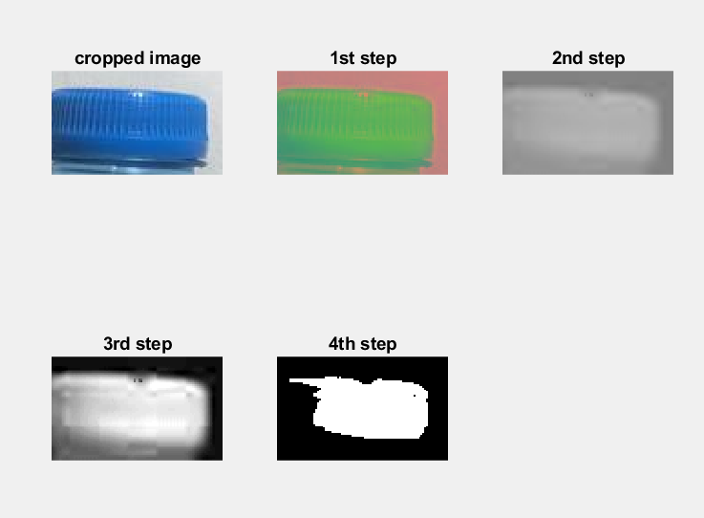 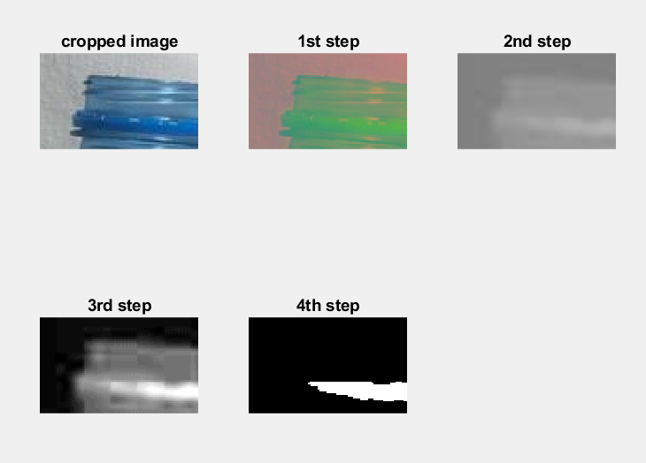

**3.4. Test if the cover is exist**

Black pixels and white pixels in the binary image were calculated. The ratio of black pixels to white pixels has been found and if this value is greater than 0.7, the system will respond 1, if it is less, it will return 0. The value of 0.7 was determined by trial and error.

**Code:**

Blackpixel=sum(BlackWhite(:)==0);

Whitepixel=numel(BlackWhite(:));

percentage=(Blackpixel/Whitepixel);

end

if percentage >0.7

ans=1;

else

ans=0;

end

**3.5. Give the result to the user**

According to the calculated black pixel/white pixel ratio, 1 result is "Bottle cap does not exist..", 0 result is "Bottle cap is here." and the code achieves its purpose.

**Code:**

if ans==1

fprintf('Bottle cap does not exist.')

else

fprintf('Bottle cap here.')

end

**4. Results**

The tests were carried out on 7 capped and 7 capless bottles images taken with appropriate lighting on a white background. The correct result has been achieved in each image.

Number of images: 14 Accuracy: %100 The project has achieved its purpose.

**5. Possible Improvements**

By defining a camera to the system, instant photos can be taken according to the speed of the belt through which the bottles pass, and it can be named according to the appropriate barcode or serial number. Afterwards, the appropriate bottle can be checked by obtaining this barcode or serial number from the user. Or, by checking all the images directly, the numbers of the uncapped bottles can be printed. Adaptation to different colored bottle caps can also be achieved by changing the color channels.

**6. Problems Encountered**

It was a problem that the images found on the internet were in different formats and sizes. Incorrect results were obtained because the bottle photos used before the appropriate lighting and white background may appear blue even though there is no cap on that area. In the photographs taken without determining a fixed point and distance, there were problems in determining the cut area. There was a problem in finding it without cutting, since there was a slight difference in the blue ratio. Finding the blue ratio without binarization during scripting gave incorrect results due to ambient colors. The images were initially taken by selecting the image with the name written in the code, but this caused difficulties in use and the code had to be changed constantly. Instead, the user was allowed to select the photo.

**7. References**

[1] [www.mathworks.com](http://www.mathworks.com)

[2] <https://www.sick.com/tr/tr/birincil-ambalajlama/kapak-besleyici-ve-kapatc/sise-kapaklarnda-kalite-kontrolue/c/p514293>