**Testing:**

**With HTML Validator**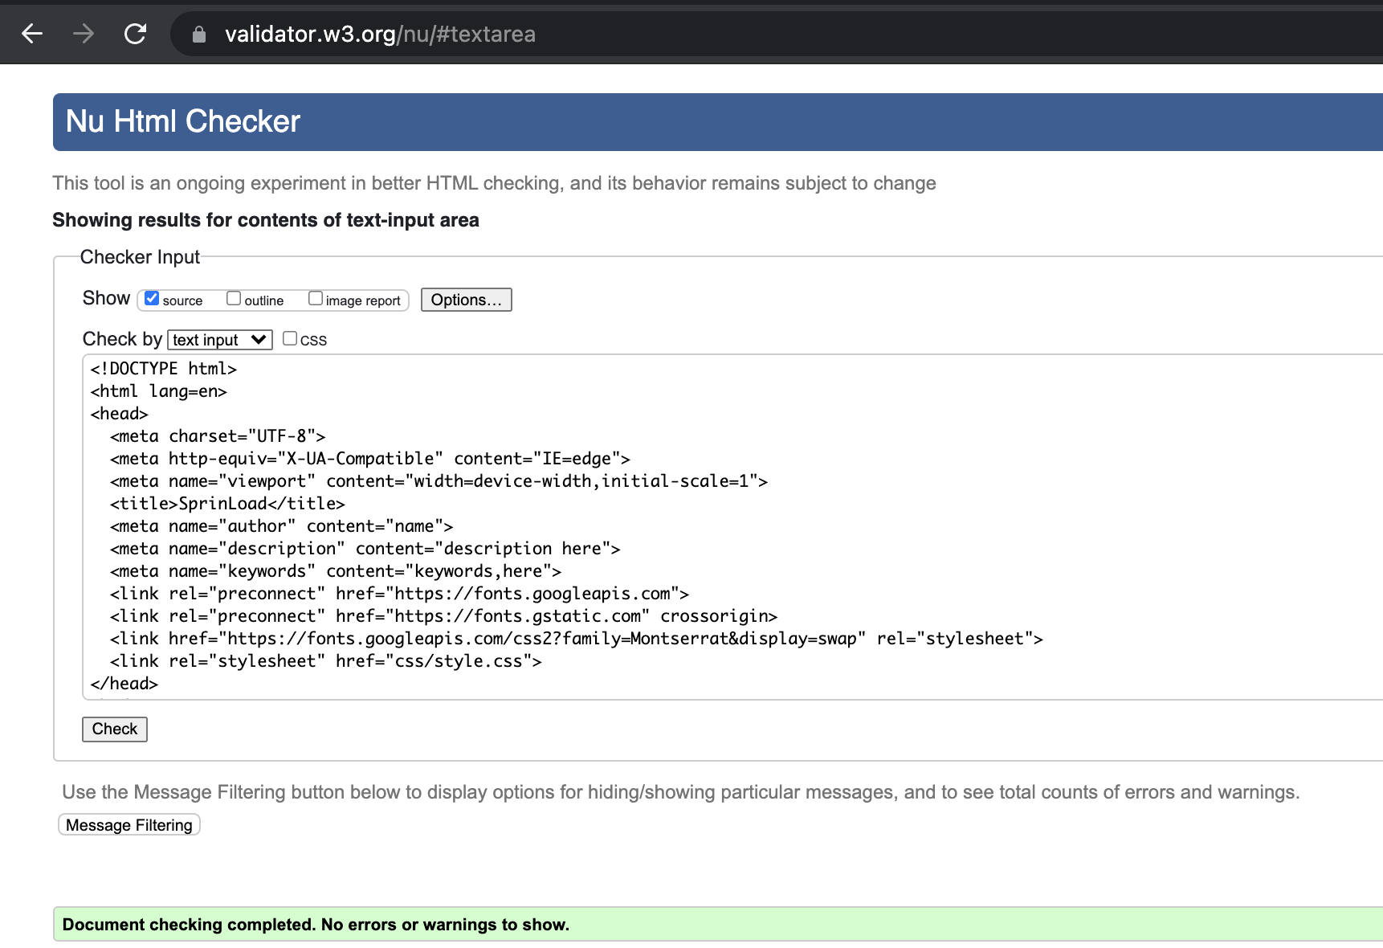

**With CSS Validator**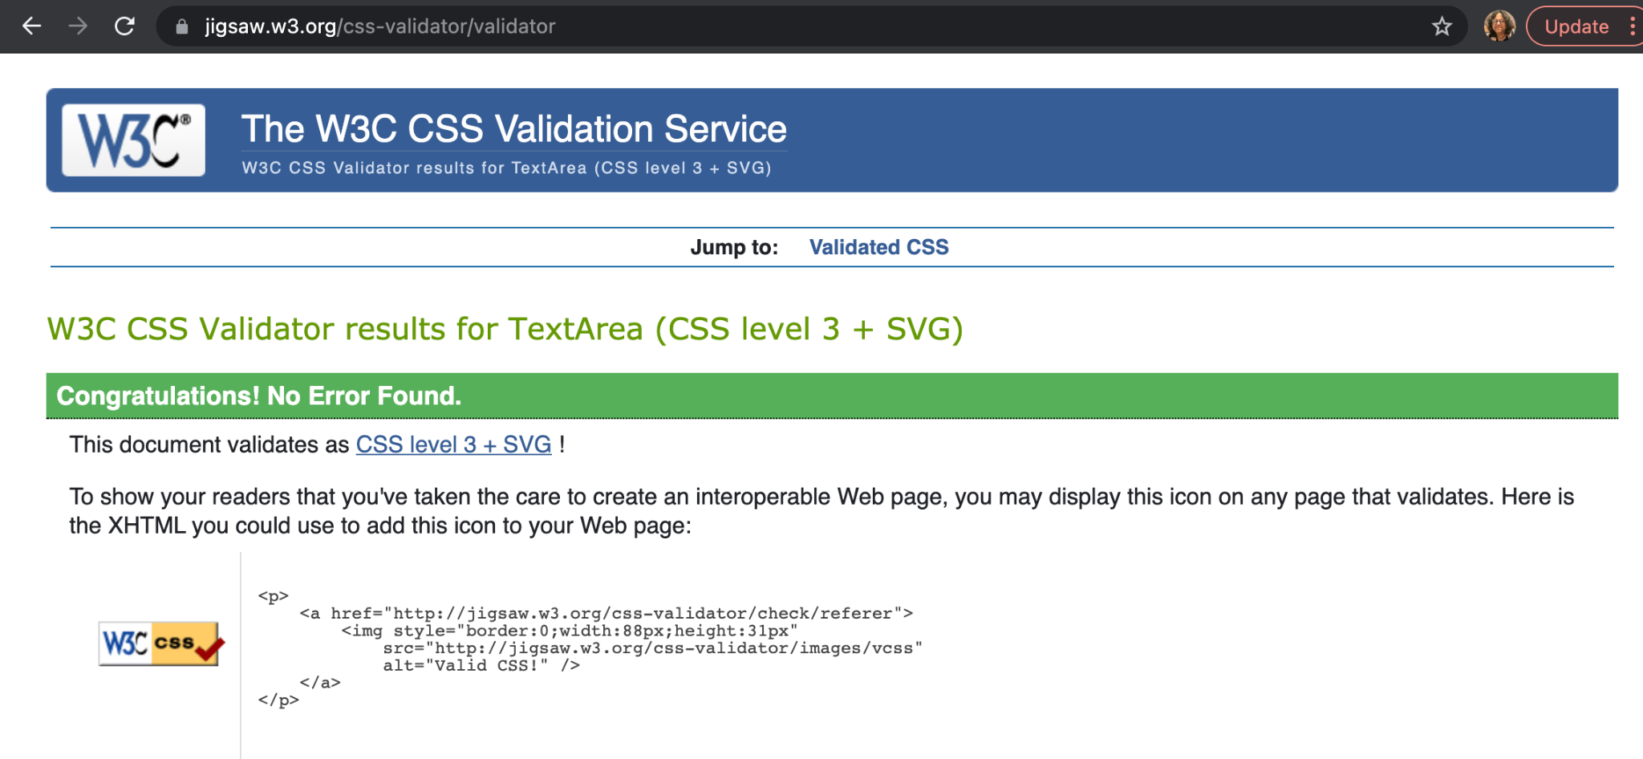

**With JSHint**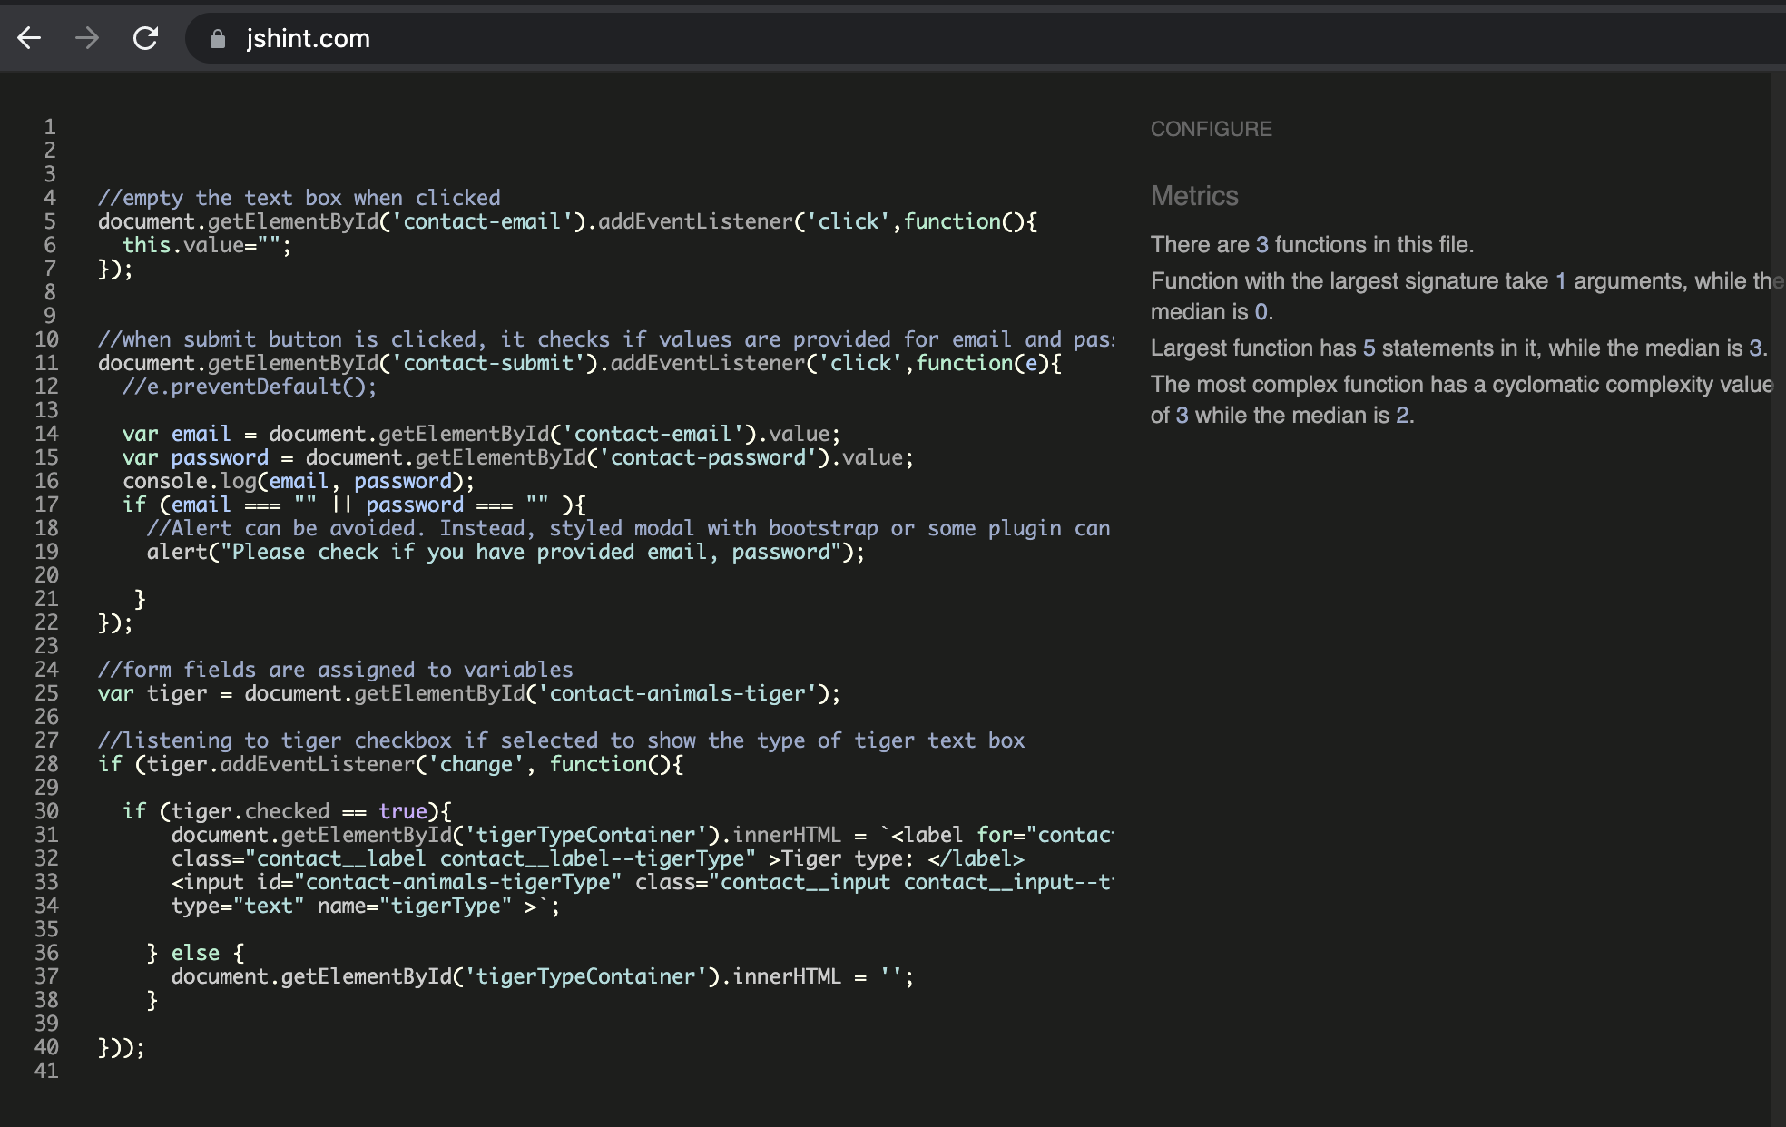

Manual Testing - console is error free. It shows an alert if values are not provided for email and password. Tiger type will not be shown until Tiger is selected.

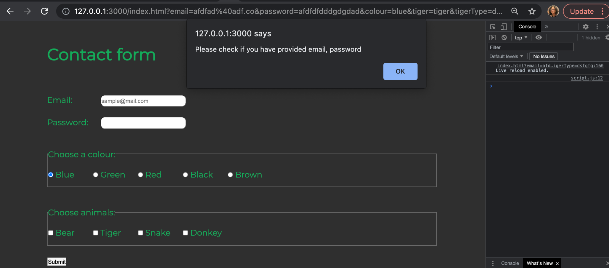

When Tiger is selected the label and text box for Tiger type will show as below:

