# Submission Template

**Entity Relationship Diagram** 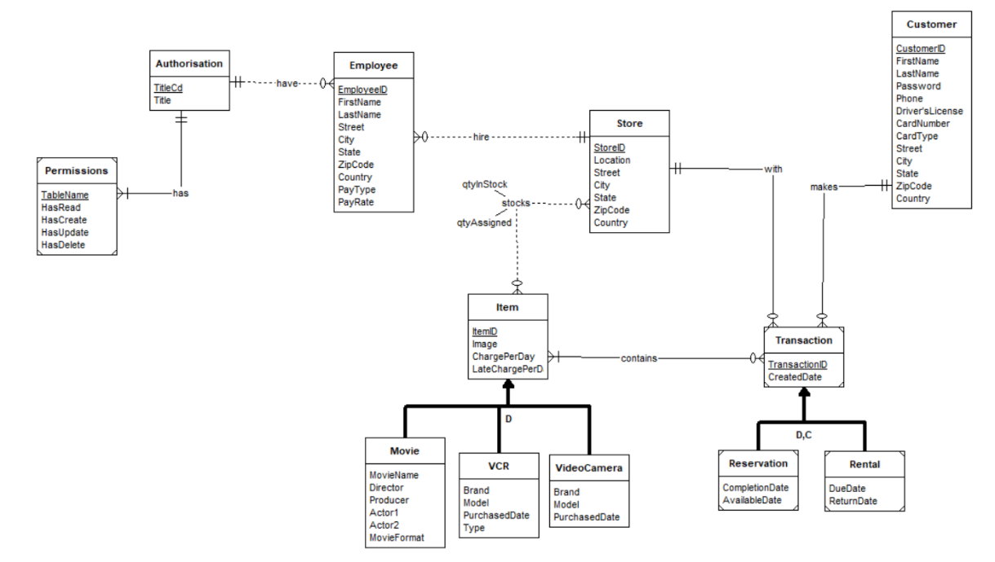

**Database Diagram from SQL Server after tables creation with PK and FK **

**Database Design Explanation**

List all the tables and their fields. Indicate the PK and FK and their referenced tables.

|  |  |  |  |  |  |
| --- | --- | --- | --- | --- | --- |
| **Table** | **Purpose** | **Field** | **DataType** | **Primary**  **Key** | **Foreign**  **Key** |
| Item_types | Lookup table containing item types for items | *Item_type_cd* | Varchar(5) | *Item_type_cd* | *nil* |
| *Item_type* | Varchar(50) |
| Late*_*charges | Lookup table containing late charges for items | *Late_charge_cd* | varchar(5) | *Late_charge_cd* | *Nil* |
| *Late_chage_type* | Varchar(20) |
| *Late_charge_per_day* | Decimal(13,4) |
| Items | Contains shared attributes of items that the stores provide for rental. | *item_id* | Int | *Item_id* | Item_type_cd references item_types item_type_cd |
| *item_type_cd* | varchar(5) |
| *Charge_per_day* | Decimal(13,4) | Late_charge_cd references late_charges late_charge_cd |
| *Late_charge_cd* | Varchar(5) |
| *image* | Varchar(255) |
| vcr | Contains additional details about VCR items that the stores provide for rental | *Item_id* | Int | *Item_id* | Item_id references items item_id |
| *Brand* | Varchar(20) |
| *model* | Varchar(50) |
| *Purchased_date* | Date |
| *Vcr_type* | Varchar(20) |
| Video_camera | Contains additional details about Video Camera items that the stores provide for rental | *Item_id* | Int | Item_id | Item_id references items item_id |
| *Brand* | Varchar(20) |
| *Model* | Varchar(50) |
| *Purchased_date* | date |
| movies | Contains additional details about Movie items that the stores provide for rental | *Item_id* | Int | Item_id | Item_id references items item_id |
| *Movie_name* | Varchar(100) |
| *Director* | Vachar(50) |
| *Producer* | Vachar(50) |
| *Actor1* | Vachar(50) |
| *Actor2* | Vachar(50) |
| *Genre* | Varchar(20) |
| *Movie_format* | Varchar(20) |
| Stores | Contains details about the company’s stores | *Store_id* | Int | Store_id | nil |
| *Location* | Varchar(20) |
| *Street* | Varchar(50) |
| *City* | Varchar(50) |
| *State* | Varchar(20) |
| *Zip_code* | Char(5) |
| *country* | Varchar(50) |
| Store_item_catalogue | Contains information about the number of assigned and in stock items for each store | *Store_id* | Int | (Store_id, item_id) | Store_id references stores store_id |
| *Item_id* | Int |
| *Qty_in_stock* | Int | Item_id references items item_id |
| *Qty_assigned* | int |
| customers | Contains details about customers | *Customer_id* | Int | Customer_id | nil |
| *First_name* | Varchar(50) |
| *Last_name* | Varchar(50) |
| *Password* | Varchar(100) |
| *Phone* | Varchar(15) |
| *Divers_license* | Varchar(255) |
| *Card_number* | Varchar(20) |
| *Street* | Varchar(50) |
| *City* | Varchar(50) |
| *State* | Varchar(20) |
| *Zip_code* | Char(5) |
| *country* | Varchar(50) |
| rentals | Contains information about rentals customers make with stores | *Rental_id* | Int | Rental_id | Store_id references stores store_id |
| *Store_id* | Int |
| *Customer_id* | Int |
| *Created_date* | Date | Customer_id references customers customer_id |
| *Due_date* | Date |
| *Return_date* | Date |
| Rental_items | CContains which items are rented out in rental transactions | *Rental_id* | Int | (Rental_id, item_id) | Rental_id references rentals rental_id |
| *Item_id* | int | Item_id references items item_id |
| reservations | CContains information about reservations customers make with stores | *Reservation_id* | Int | Reservation_id | Store_id references stores store_id |
| *Store_id* | Int |
| *Customer_id* | Int | Customer_id references customers customer_id |
| *Created_date* | int |
| Reservation_items | Contains which items are reserved in rental transactions and dates such as when the item comes back in stock and when those items are either collected or cancelled from the reservation | *Reservation_id* | Int | (Reservation_id, item_id) | Reservation_id references reservations reservation_id |
| *Item_id* | int |
| *Completion_date* | date | Item_id references items item_id |
| *Available_date* | date |
| Pay_types | Lookup table containing pay types for employees | *Pay_cd* | Varchar(5) | Pay_cd | nil |
| *Pay_title* | Varchar(50) |
| *Pay_rate* | Decimal(13,4) |
| Auth_role | Lookup table containing authorization roles for employees | *Auth_cd* | Varchar(5) | Auth_cd | nil |
| *Auth_title* | Varchar(50) |
| Auth_permissions | Contains permissions to view, modify and delete data that each authorization role has | *Auth_cd* | Varchar(5) | (Auth_cd, table_name) | Auth_cd references auth_roles auth_cd |
| *Table_name* | Varchar(50) |
| *Has_read* | Bit |
| *Has_create* | Bit |
| *Has_update* | Bit |
| *Has_delete* | bit |
| Employees | Contains details about employee, including the store they work in, their pay rate and their authorization access | *Employee_id* | Int | Employee_id | Auth_cd references auth_roles auth_cd  Pay_cd refernces pay_types  Pay_cd  Store_id references stores store_id |
| *First_name* | Varchar(50) |
| *Last_name* | Varchar(50) |
| *Street* | Varchar(50) |
| *City* | Varchar(50) |
| *State* | Varchar(20) |
| *Zip_code* | Char(5) |
| *country* | Varchar(50) |
| *Auth_cd* | Varchar(5) |
| *Pay_cd* | Varchar(5) |
| *Store_id* | int |

Table – Name the table

Purpose – State what the table is used for and contains what details Field – List all the columns of the table

DataType – State varchar, integer, decimal etc Primary Key – List the PK (Simple or Composite)

Foreign Key – List the FK (Simple or Composite) and its reference table

**SQL Queries and Results**

|  |  |
| --- | --- |
| Query 1 | Query 1 Results |
|  |  |
| Query 2(i) | Query 2(i) Results |
|  |  |
| Query 2(ii) | Query 2(ii) Results |
|  |  |
| Query 3 | Query 3 Results |
|  |  |
| Query 4 | Query 4 Results |
|  |  |
| Query 5 | Query 5 Results |
|  |  |
| Query 6 | Query 6 Results |
|  |  |