Open powershell as administrator and run

dism.exe /online /enable-feature /featurename:Microsoft-Windows-Subsystem-Linux /all /norestart

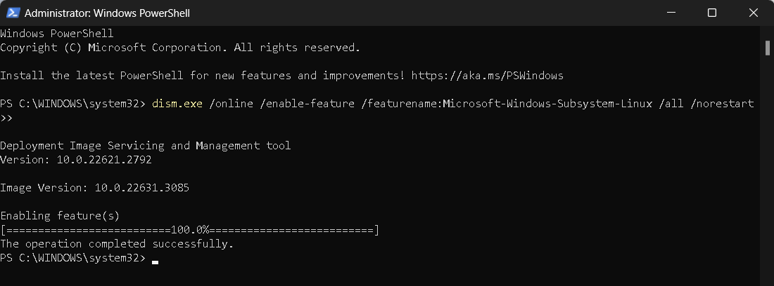

Search and download this app from Microsoft Store

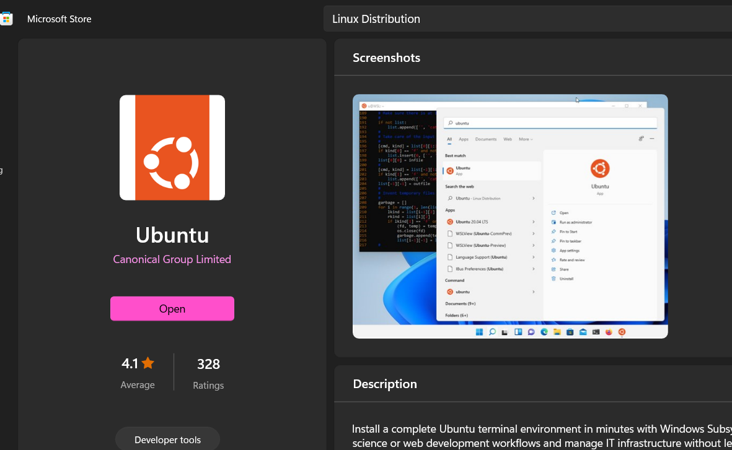

Enable Virtual Machine Platform Feature and reboot

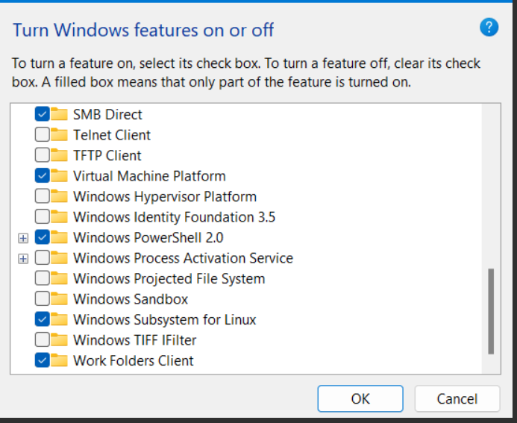

Open Ubuntu app

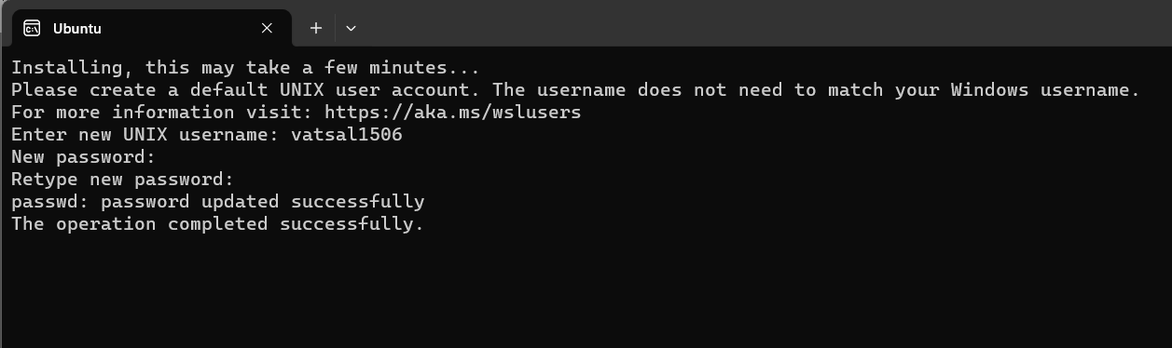

(Type username and password)

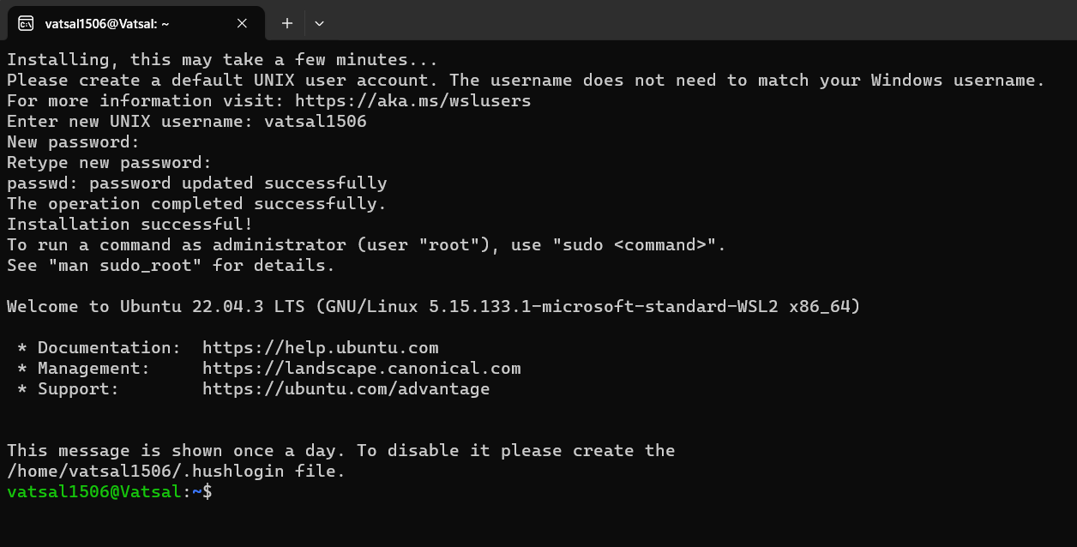

Run this

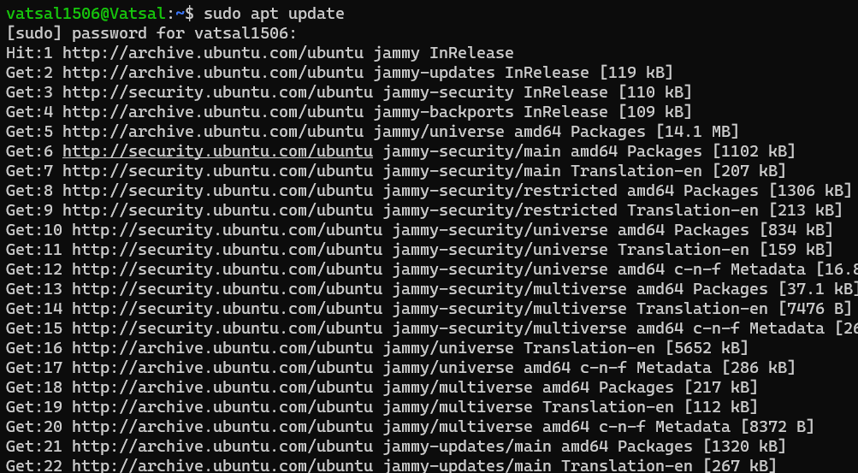

(sudo apt update)

Run this now sudo apt install aircrack-ng

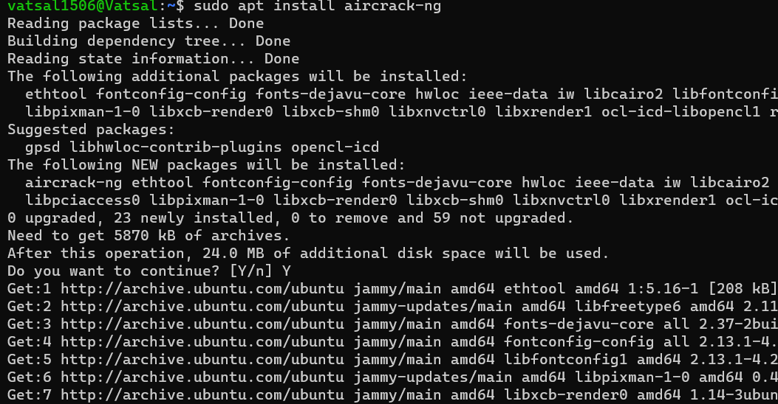

Run sudo apt install net-tools

Run iwconfig

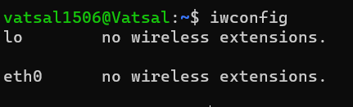

**There is no Wireless Interface Network Adapter (since no ‘wlan’ or ‘wlan0’ or similar)**

**The problem with using WSL that the native Wi-Fi adapters are not directly accessible from WSL. We need to use an external USB Wi-Fi adapter and make sure it is recognized and usable within WSL. Hence, we installed Ubuntu 22.04.3-desktop-amd64 as guest OS using VM Virtual Box.**