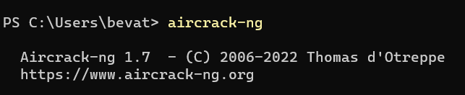

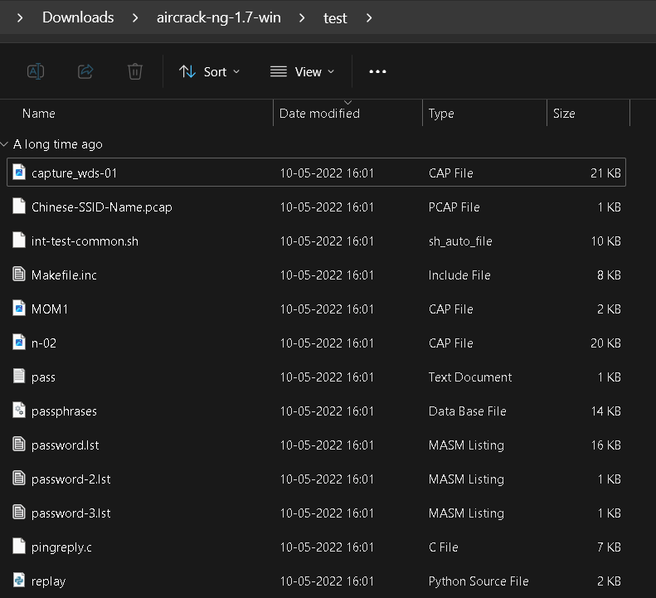



Capture_wds-01 is the .cap file (capture file) and password.lst is the word file.

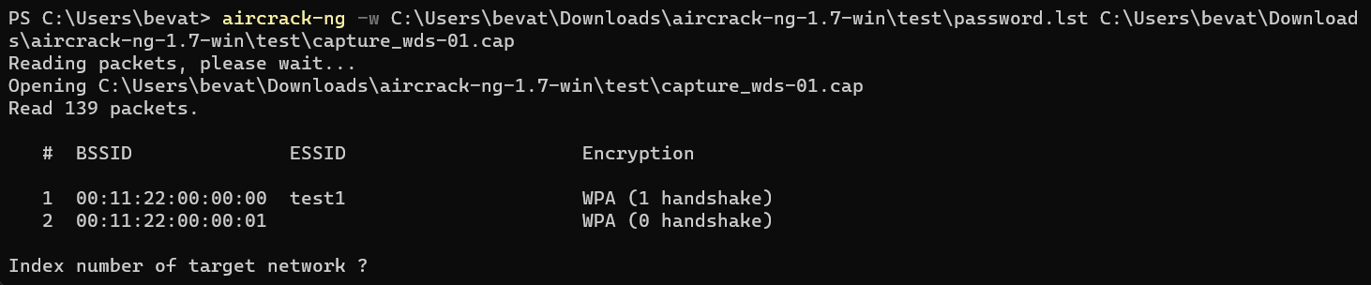

Starts to check every passphrase from password list

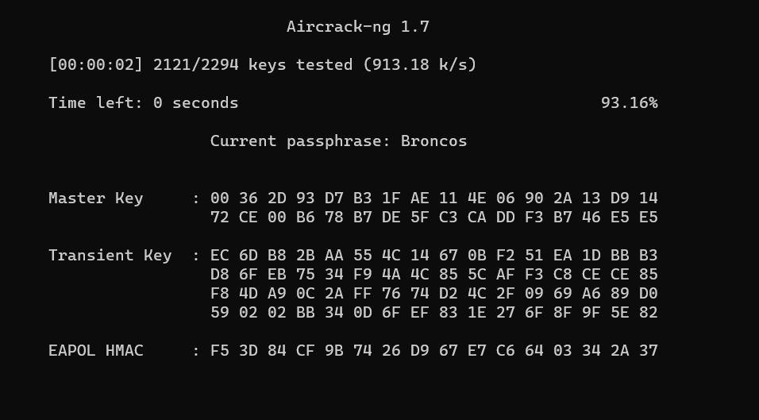

Finally gets the correct password

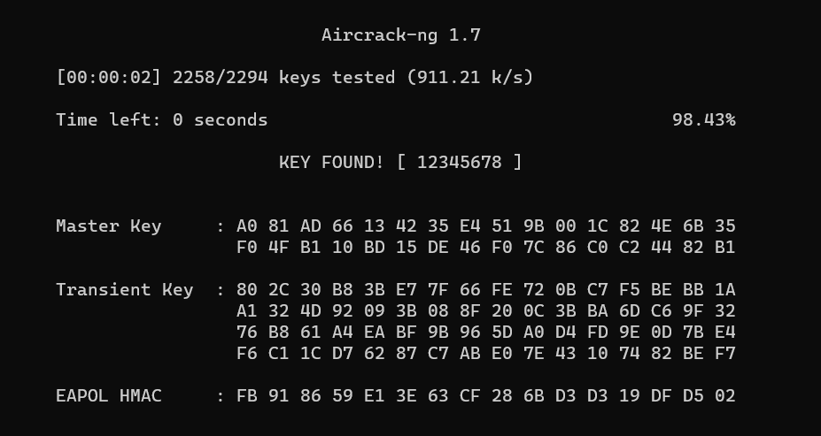

The required key is 12345678.