On all flowcharts, assume that as you look at the flowchart the Y goes to the right and the N goes to the left. All code should be written in JavaScript.

Flowchart #1:
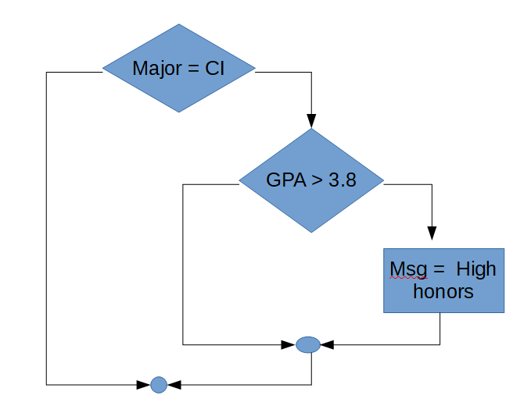
Problem #1: Write the code shown in flowchart #1 using simple if statements.
Problem #2: Write the code shown in flowchart #1 using compound if statements. Note that sometimes they are called complex instead of compound.

Flowchart #2:
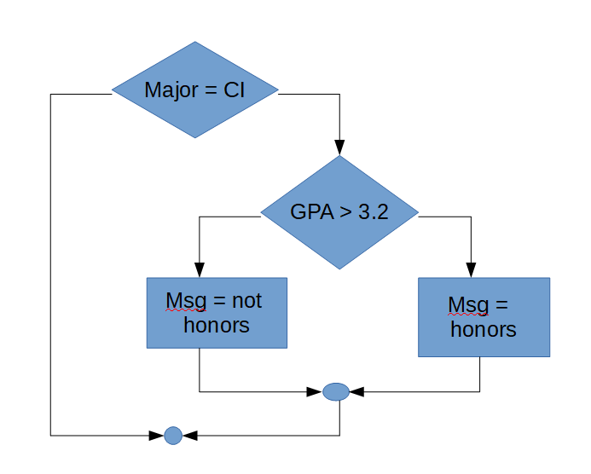
Problem #3: Write the code shown in flowchart #2 using simple if statements.
Problem #4: Could the code shown in flowchart #2 be written using a compound AND statement. Explain your answer.

Flowchart #3:
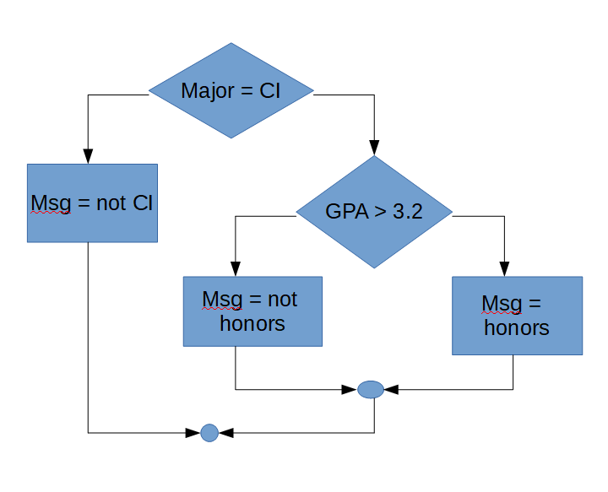
Problem #5: Write the code shown in flowchart #3 using simple if statements.
Problem #6: Could the code shown in flowchart #3 be written using a compound AND statement? Explain your answer

Flowchart #4:
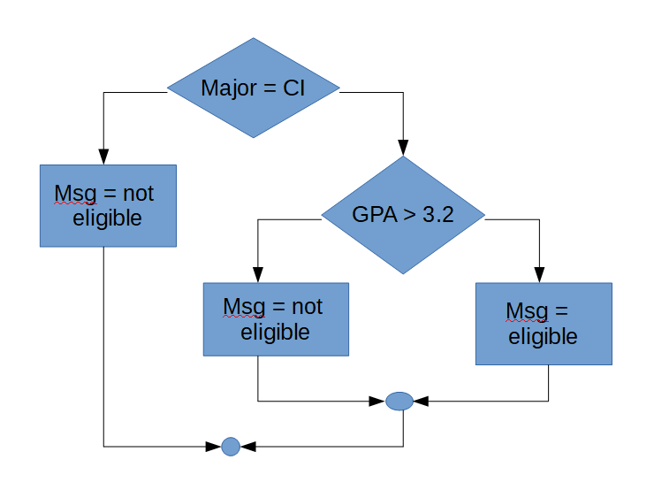
Problem #7: Write the code shown in flowchart #4 using simple if statements.
Problem #8: Write the code shown in flowchart #4 using a compound if statements.

Flowchart #5:
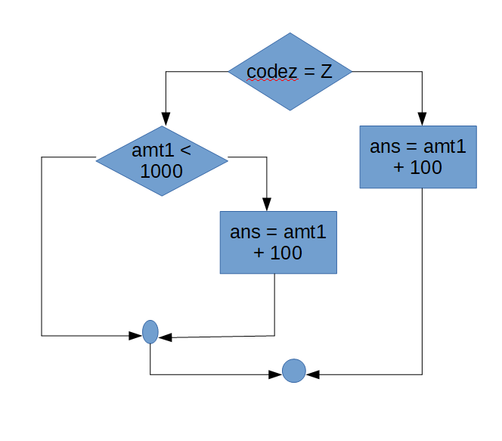
Problem #9: Write the code shown in flowchart #5 using simple if statements.
Problem #10: Write the code shown in flowchart #5 using compound if statements.

Flowchart #6:
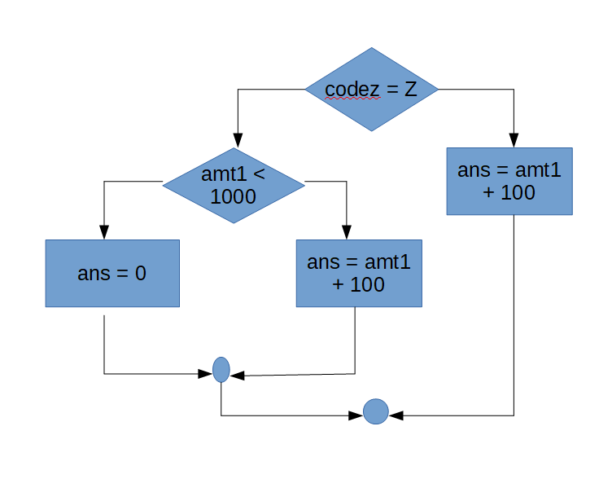
Problem #11: Write the code shown in flowchart #6 using simple if statements.
Problem #12: Write the code shown in flowchart #6 using compound if statements.

Flowchart #7:
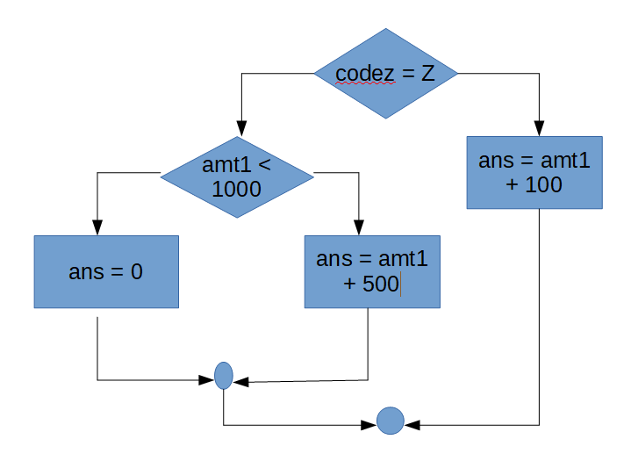
Problem #13: Write the code shown in flowchart #7 using simple if statements.
Problem #14: Could the code shown in flowchart #7 be written using a compound OR statement? Explain your answer.

Flowchart #8:
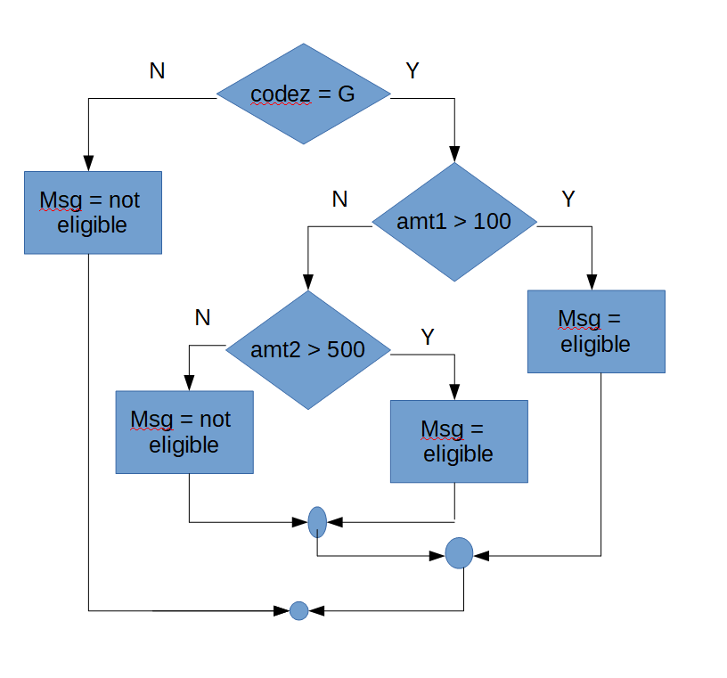
Problem #15: Write the code shown in flowchart #8 using simple if statements.
Problem #16: Write the code shown in flowchart #8 using compound if statements.

Flowchart #9:
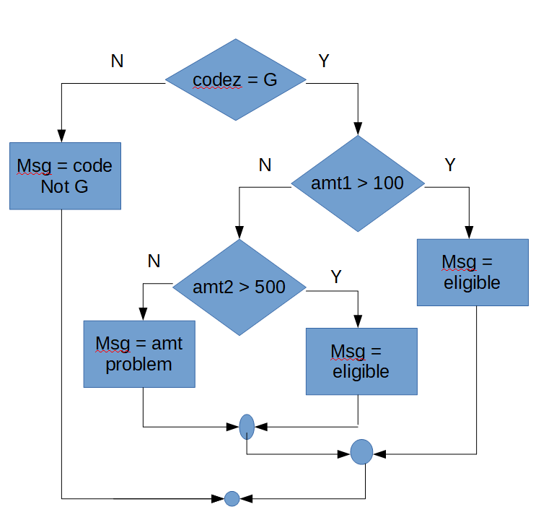
Problem #17: Write the code shown in flowchart #9 using simple if statements.
Problem #18: Could the code shown in flowchart #9 be written using a compound statement? Explain your answer.

