Pulleys And Belts
Farmer John’s tractor is made up of a total of N (1 <= N <= 1,000) pulleys. There are also N-1 belts connecting pulley 1 to pulley 2, pulley 2 to pulley 3… pulley N-1 to pulley N.

As shown in the diagram below, a “straight belt” drives the destination pulley in the same direction as the source pulley (pulley 1 and pulley 2 both rotate counterclockwise). In contrast, a “crossed belt” reverses the direction of rotation (pulley 3 rotates counterclockwise while pulley 4 rotates clockwise).
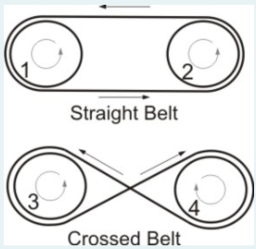

Each belt can be described by three integers:

S_i -- the source pulley

D_i -- the destination pulley

C_i -- the type of the belt (0 represents straight, 1 represents crossed)

Given a list of belt configurations, please help Farmer John determine the rotation of the Nth pulley. Note that the engine drives pulley 1 in a clockwise direction.

INPUT FORMAT

* Line 1: A single integer: N

* Lines 2..N: Each line describes a belt with three integers: S_i, D_i, and C_i

Note that the belt connections might not be given in order.

OUTPUT FORMAT

Print a single integer representing the rotating direction for pulley N (0 represents clockwise, 1 represents counterclockwise).

SAMPLE INPUT

5
3 4 0
1 2 1
4 5 1
2 3 0
SAMPLE OUTPUT

0

