Acorn Harvest

Harry has built an acorn collecting machine to help him gather acorns faster. His machine has an initial wheel with gears that powers the next wheel that powers the next one, so on and so forth. The initial wheel is located at the origin (0,0).

Each wheel has its own set of x_i,y_i (-5,000 <= x_i <= 5,000; -5,000 <= y_i <= 5,000) coordinates, and the radius r_i (3 <= r_i <= 1024) of each of the N (2 <= N <= 1080) wheels are also recorded.

Calculate the x,y coordinate of the last wheel in the chain (the wheel that is driven but drives no other wheel). Every wheel except the initial wheel is driven by exactly one other wheel.

INPUT FORMAT

Line 1: One integer: N
Line 2..N+1: Line i+1 describes wheel i with three space separated integers: x_i, y_i, and r_i

OUTPUT FORMAT

Line 1: A single line with two space-separated integers that are respectively the x,y coordinates of the last wheel in the chain of driven wheels.

SAMPLE INPUT

3
-17 -21 10
-5 -12 5
0 0 8
There are three wheels as illustrated below. Third one is at the origin with radius 8. It drives the wheel at (-5, -12) whose radius is 5. That wheel in turn drives the third wheel located at (-17,-21) with radius 10, which drives no other wheel.

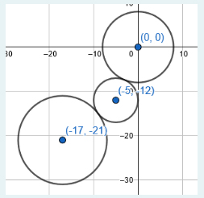
SAMPLE OUTPUT

-17 -21

