**Cardiff Metropolitan University**

**B.Sc. (Hons) in Software Engineering**

**Assignment Cover Sheet**

|  |  |  |  |  |  |  |  |  |  |
| --- | --- | --- | --- | --- | --- | --- | --- | --- | --- |
| **Student Details (Student should fill the content)** | | | | | | | | | |
| Name | | | Francis Jesuthasan Bevon Fernando | | | | | | |
| Student ID | | | **(CL/BSCSD/26/112) 20284583** | | | | | | |
| **Scheduled unit details** | | | | | | | | | |
| Unit code | | | CIS6003 | | | | | | |
| Unit title | | | Advanced Programming | | | | | | |
| Unit enrolment details | | | Year | | 3 | | | | |
| Study period | | 2023 | | | | |
| Lecturer | | | Assignment prepared by Tharik Kanaka | | | | | | |
| Mode of delivery | | | Full Time | | | | | | |
| **Assignment Details** | | | | | | | | | |
| Nature of the Assessment | | | Coursework (a report) | | | | | | |
| Topic of the Case Study | | | Online loan offering system to buy items and it in installments | | | | | | |
| Learning Outcomes covered | | | LO2, LO3, LO4 | | | | | | |
| Word count | | | 4000(report) | | | | | | |
| Due date / Time | | | 7th September, 2023 | | | | | | |
| Extension granted? | | | Yes | No | Extension Date | | |  | |
| Is this a resubmission? | | | Yes | No | Resubmission Date | | |  | |
| **Declaration** | | | | | | | | | |
| I certify that the attached material is my original work. No other person’s work or ideas have been used without acknowledgement. Except where I have clearly stated that I have used some of this material elsewhere, I have not presented it for examination / assessment in any other course or unit at this or any other institution | | | | | | | | | |
| Name/Signature | | | Bevon | | | Date | | 07.09.2023 | |
| **Submission** | | | | | | | | | |
| Return to: | | |  | | | | | | |
| **Result** | | | | | | | | | |
| Marks by 1st Assessor |  | Name & Signature of the 1st Assessor | | | | |  | | **Agreed Mark** |
| Marks by2nd Assessor |  | Name & Signature of the 2nd Assessor | | | | |  | |
| Comments on the Agreed mark |  | | | | | | | | |

|  |  |  |  |  |  |  |  |  |  |  |  |  |
| --- | --- | --- | --- | --- | --- | --- | --- | --- | --- | --- | --- | --- |
| **STUDENT NAME:**  **CMU B.Sc. (HONS) BIS - ASSIGNMENT FEEDBACK SHEET –ICBT CAMPUS**  ***Bevon Fernando*** | | | | | | | | | | **STUDENT NUMBER:**  **(CL/BSCSD/26/112) 20284583** | | |
| **Module Number & Title**: Advanced Programming | | | | | | | | | | **Semester: I** | | |
| **Assignment Type & Title:** Coursework: | | | | | | | | | | | | |
| **For student use: *Critical feedback on the individual progression towards achieving the assignment outcomes*** | | | | | | | | | | | | |
|  | | | | | | | | | | | | |
| **For the Assessors’ feedback**  **Indicate the Task number strength and Weaknesses and the marks for each task** | | | | | | | | | | | | |
| **Task No/Question No** | **Strengths (1st Assessor)** | | | | | | **Strengths (2nd Assessor)** | | | | | |
| **Task No / Question No** | **Weaknesses (1st Assessor)** | | | | | | **Weaknesses (2nd Assessor)** | | | | | |
| **Areas for future improvement** | | | | | | | | | | | | |
| **Comments by 1st Assessor** | | | | | | **Comments by 2nd Assessor** | | | | | | |
| **Marks** | | | | | | | | | | | | |
| **Task /Question No** | | **Marks by 1st Assessor** | **Marks by 2nd Assessor** | | **Marks by IV (if any)** | | | **IV comments (If Any)** | | | | |
|  | |  |  | |  | | |  | | | | |
|  | |  |  | |  | | |
|  | |  |  | |  | | |
| **Total Marks** | |  |  | |  | | |
| **Name and the Signature of the 1st Assessor** | | | |  | | | | | **Date:** | |  | |
| **Name & Signature of the 2ndAssessor:** | | | |  | | | | | **Date:** | |  | |
| **Name & Signature of the IV: (If any)** | | | |  | | | | | **Date:** | | |  |

# **Acknowledgement**

To successfully complete this project, we extended our sincere appreciation to a select group of individuals whose guidance and support have been invaluable. Our heartfelt thanks go out to Mr. Tharik Kanaka, the esteemed course instructor at ICBT Campus, for his exceptional guidance and mentorship. Mr. Kanaka's insightful advice, provided through numerous discussions, significantly contributed to the excellence of this assignment.

**Table of Contents**

Acknowledgement 4

Task A 6

Requirement specification Document 6

Introduction 6

Purpose of the system 6

Scope of the system 7

Objective 8

Functional requirements 9

Non-functional requirements 10

Task B 11

UML Diagrams 11

Use case Diagram 11

Class Diagram 12

Admin - Sequence Diagram 13

Customer - Sequence Diagram 14

Consultant - Sequence Diagram 15

Task C 16

Design Patterns 16

Creational design patterns 16

The singleton patterns 17

The factory patterns 17

The abstract factory patterns 18

The Factory Design Pattern 18

Task D 19

User Interfaces 19

Task E 25

Test Plan and test-driven development 25

Test Cases 27

Test driven Development 34

Task F 35

User manual and technical documentation 35

Task G 38

GitHub Repository 38

References 39

# **Task A**

## **Requirement specification Document**

### **Introduction**

In a time marked by the increasing wave of globalization and heightened job mobility, the Jobs Consultation Centre based in Colombo shines as a guiding light for individuals aspiring to work abroad. Renowned for its outstanding reputation, this center offers complimentary advisory services to those in search of overseas opportunities. Functioning as a hub of expertise, it boasts a team of specialized job consultants who provide personalized guidance tailored to the unique requirements of each job seeker. The center's commitment to delivering top-notch service is evident not only in its dedicated consultant team but also in its determination to adapt and progress in response to the changing landscape. With the growing demand for consultation services among job seekers, the center recognizes the necessity of transitioning from traditional paper-based systems to a modern, internet-based solution.(Bandakkanavar, 2023).

### **Purpose of the system**

* **Efficient Appointment Management:** The core purpose of this system is to provide job seekers with a user-friendly platform for arranging appointments with specialized job consultants. By enabling online appointment booking, it eliminates the requirement for manual scheduling, which improves convenience and accessibility 24/7. This goal is geared towards saving time for both job seekers and receptionists, minimizing scheduling mistakes, and ensuring the efficient use of consultant resources.
* **Enhanced User Engagement:** The primary aim of the system is to deliver an intuitive and user-friendly interface to cater to the needs of all stakeholders. Consultants, receptionists, and job seekers will find it easy to navigate and interact with the system, promoting a positive user experience that stimulates adoption and active participation.
* **Empowering Informed Decision-Making:** One of the pivotal goals of the system is to simplify the processes of collecting, storing, and reporting data. By capturing information concerning consultants, job seekers, and appointments, the system provides management with precise, up-to-the-minute insights. These insights are presented through comprehensive reports, enabling data-driven decision-making to elevate service quality, optimize consultant performance, allocate resources efficiently, and enhance overall center operations.

### **Scope of the system**

1. User Roles and Access Permissions: The proposed web-based system will incorporate a role-based access control system to assign distinct privileges to various user categories: consultants, receptionists, and management. Consultants will access their schedules, appointment details, and relevant job seeker data. Receptionists will efficiently manage appointment scheduling, consultant availability, and inquiries. Management personnel will access comprehensive reports, system settings, and performance metrics to make informed decisions and effectively monitor operations.
2. Job Seeker Registration and Profile Management: Job seekers can register on the platform by providing personal and contact information. After registration, they can create and maintain profiles, specifying job preferences, desired employment locations, and educational qualifications. The system will also support secure document uploads and storage for job seekers.
3. User Interface and User Experience: The system's user interfaces will prioritize user-friendliness. Each user category - consultants, administrators, and job seekers - will have an intuitive, tailored interface for simplified navigation and interaction.
4. Consultant Management: The system will offer comprehensive profiles detailing each consultant's areas of expertise, including countries and job types, facilitating effective consultant management. To ensure precise appointment scheduling, consultants can adjust their availability calendars. Consultants will receive notifications of any changes, cancellations, or new appointments, aiding them in efficiently managing their time and commitments.
5. Appointment Scheduling: Job seekers will have the option to easily schedule appointments online and check real-time consultant availability through the system. The system's algorithm will recommend ideal appointment times based on the job seeker's preferences and the consultant's availability, ensuring a seamless experience without scheduling conflicts or extended waiting times.
6. Data Collection and Storage: The system will record and securely store crucial data, including information about job seekers, consultants, appointment records, and associated documents. A centralized database will facilitate easy information retrieval, effective record management, and overall system performance improvement.

### **Objective**

• The system's main goal is to make it super easy for job seekers to set up appointments with specialized advisers. The system intends to cut waiting times, and improve overall convenience of getting consulting services by providing an online platform for scheduling.

### **Functional requirements**

**Functional Requirements for Job Seekers (Users):**

1. **User Enrollment and Profile Management:** Aspiring job seekers will have the option to register by providing their personal information. They will also be able to create and manage their profiles, including details about their job preferences, preferred countries for work, and educational qualifications.
2. **Consultant Availability and Expertise Insights:** Job seekers will have access to consultant profiles, allowing them to gain insights into the consultants' areas of expertise, which may encompass specific countries and job types. They will also be able to view available time slots.
3. **Convenient Online Appointment Booking:** Job seekers will be able to check the real-time availability of consultants and easily schedule appointments. The system will suggest suitable appointment times based on both consultant availability and the preferences of the job seekers.
4. **Submission of Feedback:** Job seekers will have the opportunity to provide feedback about their consultation experiences, aiding consultants in improving the quality of their services.

**Functional Requirements for Administrators (Admin):**

1. **User Administration:** Administrators should have the ability to manage user accounts, which includes account creation, making adjustments, and deactivating accounts.
2. **Consultant Oversight:** Administrators should be empowered to create and supervise consultant profiles, providing information about their areas of expertise and availability schedules.
3. **Appointment Scheduling Oversight:** Administrators should be capable of overseeing appointment schedules, including assigning appointments and managing changes or cancellations.

**Functional Requirements for Consultants:**

1. **Consultant Availability Oversight:** Consultants should have the authority to oversee their availability schedules, ensuring accuracy in their working hours and time zone settings.
2. **Access to Appointment Specifics:** Consultants should be granted access to detailed appointment information, job seeker profiles, and relevant documents before their consultations.
3. **Document Access and Preparatory Review:** Consultants should be able to access and review job seeker documents as part of their preparation for consultations.

### **Non-functional requirements**

1. **Optimized Performance:** The website should ensure that its loading time remains below three seconds, even during peak traffic periods. This provides users with the assurance that they won't face prolonged delays or disruptions while using the website or conducting transactions.
2. **User-Centric Design:** The website's design should prioritize user-friendliness, offering accurate information about product availability, pricing, and locations. This enables users to easily locate their desired items and make informed purchase decisions.
3. **Robust Security Measures:** The website should implement industry-standard authentication and encryption technologies to protect user data and financial transactions. This gives users the confidence that their personal and financial information is well-secured.
4. **Dependable Accessibility:** The website should maintain a high level of availability, ensuring minimal to no downtime or service disruptions. This guarantees that users can access their accounts and carry out transactions without any interruptions.

.

# **Task B**

## **UML Diagrams**

### **Use case Diagram**

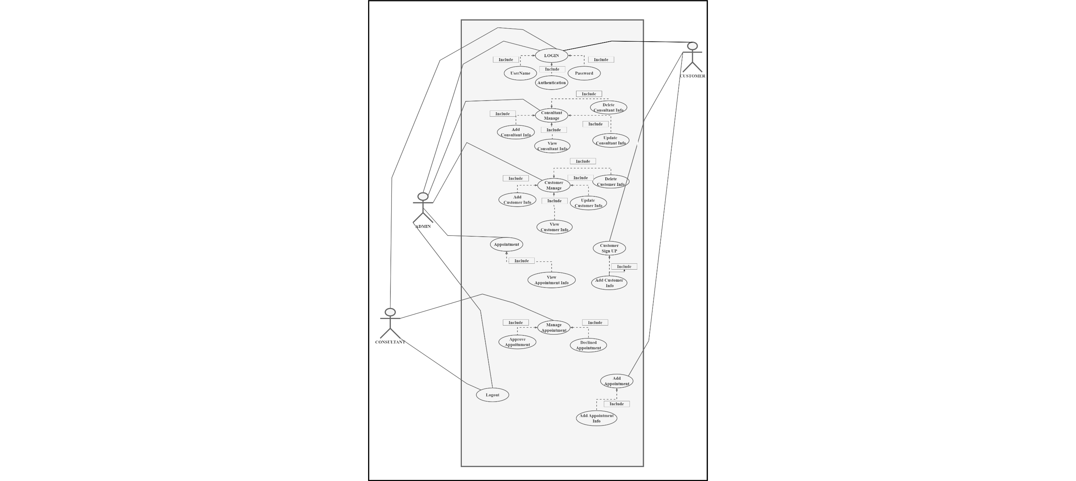

Figure 1 : Use Case Diagram

The functional needs and player interactions of a system are represented visually in a use case diagram. Below is an illustration of a use case layout for a website run by The Job, with three different actors: an administrator, a consultant, and a client. Actors and use cases are the use case diagram's two primary elements.

### **Class Diagram**

Figure 2 : Class Diagram

### **Admin - Sequence Diagram**

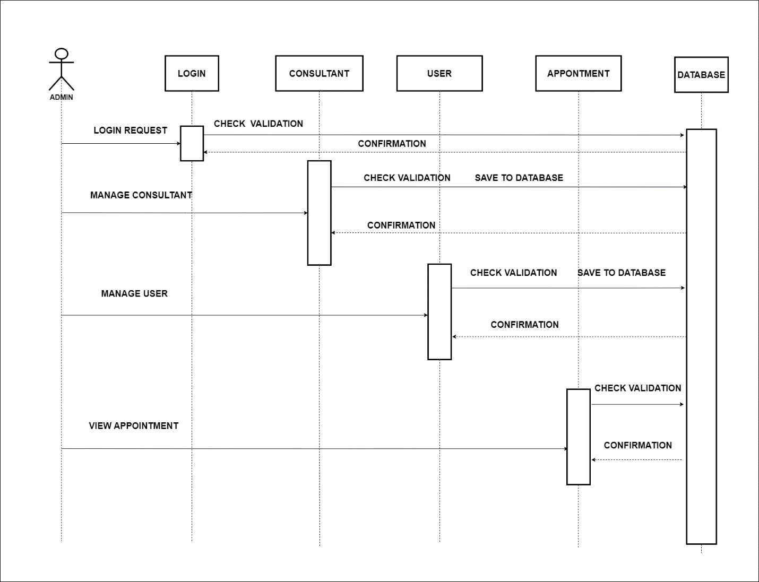

Figure 3 : Admin Sequence Diagram

### **Customer - Sequence Diagram**

Figure 4 : Customer Sequence Diagram

### **Consultant - Sequence Diagram**

Figure 5 : Consultant Sequence Diagram

# **Task C**

## **Design Patterns**

Design patterns are standardized solutions to recurring challenges in software development. These well-crafted solutions have been carefully devised and extensively vetted by experts in software design, providing developers with efficient and swift methods to address common design dilemmas. By integrating design patterns into code, software becomes more manageable, adaptable, and reusable. The use of these patterns not only helps in avoiding common pitfalls and errors but also elevates the overall quality, reliability, and ease of software maintenance. There is a multitude of design patterns available, each offering unique advantages and contexts. Some well-known design patterns include: (Pushpender007, n.d.)

### **Creational design patterns**

The production of objects is at the heart of the design pattern subclass referred to as creational design patterns. These patterns are dedicated to ensuring that objects are created in alignment with specified criteria and offer methodologies for crafting items in a flexible and reusable manner.

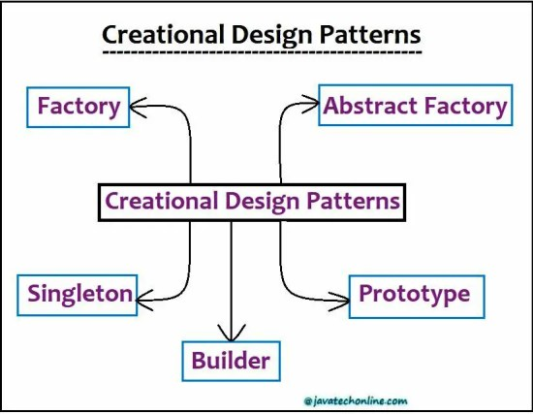

Figure 5 : Creational design patterns

### **The singleton patterns**

By utilizing the singleton pattern, a class guarantees the creation of a single instance. This proves valuable when a lone object must coordinate actions across an entire system, as it establishes a solitary access point to that specific instance.

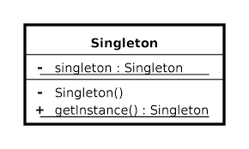

Figure 6 : Singleton patterns

### **The factory patterns**

Subclasses maintain the flexibility to decide which class to instantiate, and users can create objects using factory patterns. When there is a requirement to construct multiple objects with varying parameters or configurations, utilizing factory patterns enables the delegation of object instantiation responsibilities to different subclasses.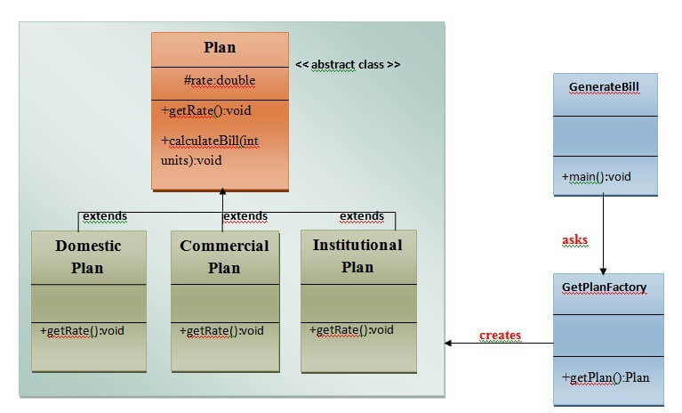

Figure 7 : Factory patterns

### **The abstract factory patterns**

In the realm of design patterns, abstract patterns enable the generation of interconnected or interdependent families of objects without the need to explicitly specify the classes to which each object in the family belongs. This proves especially advantageous when there is a requirement to create multiple interconnected items simultaneously, simplifying the construction of related objects without the need to define the exact type of each individual object..

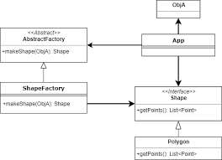

Figure 8 : Abstract factory patterns

### **The Factory Design Pattern**

The factory design pattern, sometimes referred to as the factory method, stands as one of the most commonly employed design patterns in Java programming. Despite its description as "defining an interface to create an object," this pattern offers subclasses the freedom to choose the specific class for object creation. By employing class deferral, the Factory process can be extended through subclassing. This pattern designates a dedicated factory class to handle the initial creation of an Object() [native code] type through a virtual function on the client's behalf. It relies on this factory to carry out the task, providing objects while abstracting away the intricacies of their implementation. The use of a well-defined interface becomes essential for accessing the resulting objects.(Tutorialspoint, 2022)

# **Task D**

**User Interfaces**

1. Home Page



Figure 9 : Home Page

1. Book Appointment

Figure 10 : Book Appointment

1. Consultant Load

Figure 11 : Consultant Load

1. Consultant Filter

Figure 12 : Consultant Filter

1. Consultant Appointment Approve

Figure 13 : Consultant Appointment Approve

1. Admin Appointment Table

Figure 14 : Admin Appointment Table

1. Admin Consultant Add

Figure 15 : Admin Consultant Add

1. Admin Consultant Update

Figure 16 : Admin Consultant Update

1. Admin - Add User

Figure 17 : Admin - Add User

1. Admin - Update User

Figure 18 : Admin - Update User

1. Login/ Signup Interface

Figure 19 : Login/ Signup Interface

# **Task E**

## **Test Plan and test-driven development**

|  |  |  |  |
| --- | --- | --- | --- |
| Test Case ID | Test Case Name | Scenario | Expected Results |
| TC 01 | Checking Login Function Works. | Enter password For Admin. | Login Admin Panel Successfully. |
| TC 02 | Check the Login Work. | Enter Wrong Password for Admin. | Show Alert Message. |
| TC 03 | Check the Add Consultant Working. | Enter Consultant Details. | Successfully Added Consultant. |
| TC 04 | Check the Update Consultant Working. | Enter Consultant Update details. | Successfully Updated Consultant. |
| TC 05 | Check the Delete Consultant Working. | Find and Delete Consultant. | Successfully Deleted Consultant. |
| TC 06 | Check the Add Customer Working. | Enter Customer Details. | Successfully Added Customer. |
| TC 07 | Check the Update Customer Working. | Enter Customer Update details. | Successfully Updated Customer. |
| TC 08 | Check the Delete Customer Working. | Find and Delete Customer. | Successfully Deleted Customer. |
| TC 09 | Check the Add Appointment Working. | Enter Appointment Details. | Successfully Added Appointment. |
| TC 10 | Check Appointment Filtration Working. | Enter Time. | Successfully filtered consultants. |
| TC 11 | Check the Customer Register Working. | Enter the Customer Details. | Successfully Redirect to home page. |
| TC 12 | Check Appointment View Function. | Display Appointment Description Details. | Successfully Displayed Appointment Details. |
| TC 13 | Check Appointment Approve Function. | Enter Approve Button. | Successfully Approved Appointment. |
| TC 14 | Check Appointment Declined Function. | Enter Declined Button. | Successfully Declined Appointment. |

Table 1 : Test Plan

]

## **Test Cases**

|  |  |
| --- | --- |
| Test Case ID | TC 01 |
| Test Objective | Checking Login Function Works. |
| Test Scenario | Enter password For Admin. |
| Expected Result | Login Admin Panel Successfully. |
| Actual Result |  |
| Conclusion | Test Pass |

Table : Test Case 01

|  |  |
| --- | --- |
| Test Case ID | TC 02 |
| Test Objective | Check the Login Work. |
| Test Scenario | Enter Wrong Password for Admin. |
| Expected Result | Show Alert Message. |
| Actual Result |  |
| Conclusion | Test Pass |

Table : Test Case 02

|  |  |
| --- | --- |
| Test Case ID | TC 03 |
| Test Objective | Check the Add Consultant Working. |
| Test Scenario | Enter Consultant Details. |
| Expected Result | Successfully Added Consultant. |
| Actual Result |  |
| Conclusion | Test Pass |

Table : Test Case 03

|  |  |
| --- | --- |
| Test Case ID | TC 04 |
| Test Objective | Check the Update Consultant Working. |
| Test Scenario | Enter Consultant Update details. |
| Expected Result | Successfully Updated Consultant. |
| Actual Result |  |
| Conclusion | Test Pass |

Table : Test Case 04

|  |  |
| --- | --- |
| Test Case ID | TC 05 |
| Test Objective | Check the Delete Consultant Working. |
| Test Scenario | Find and Delete Consultant. |
| Expected Result | Successfully Deleted Consultant. |
| Actual Result |  |
| Conclusion | Test Pass |

Table : Test Case 05

|  |  |
| --- | --- |
| Test Case ID | TC 06 |
| Test Objective | Check the Add Customer Working. |
| Test Scenario | Enter Customer Details. |
| Expected Result | Successfully Added Customer. |
| Actual Result |  |
| Conclusion | Test Pass |

Table : Test Case 06

|  |  |
| --- | --- |
| Test Case ID | TC 07 |
| Test Objective | Check the Update Customer Working. |
| Test Scenario | Enter Customer Update details. |
| Expected Result | Successfully Updated Customer. |
| Actual Result |  |
| Conclusion | Test Pass |

Table : Test Case 07

|  |  |
| --- | --- |
| Test Case ID | TC 08 |
| Test Objective | Check the Delete Customer Working. |
| Test Scenario | Find and Delete Customer. |
| Expected Result | Successfully Deleted Customer. |
| Actual Result |  |
| Conclusion | Test Pass |

Table : Test Case 08

|  |  |
| --- | --- |
| Test Case ID | TC 09 |
| Test Objective | Check the Add Appointment Working. |
| Test Scenario | Enter Appointment Details. |
| Expected Result | Successfully Added Appointment. |
| Actual Result |  |
| Conclusion | Test Pass |

Table : Test Case 09

|  |  |
| --- | --- |
| Test Case ID | TC 10 |
| Test Objective | Check Appointment Filtration Working. |
| Test Scenario | Enter Time. |
| Expected Result | Successfully filtered consultants. |
| Actual Result |  |
| Conclusion | Test Pass |

Table : Test Case 10

|  |  |
| --- | --- |
| Test Case ID | TC 11 |
| Test Objective | Check the Customer Register Working. |
| Test Scenario | Enter the Customer Details. |
| Expected Result | Successfully Redirect to home page. |
| Actual Result |  |
| Conclusion | Test Pass |

Table : Test Case 11

|  |  |
| --- | --- |
| Test Case ID | TC 12 |
| Test Objective | Check Appointment View Function. |
| Test Scenario | Display Appointment Description Details. |
| Expected Result | Successfully Displayed Appointment Details. |
| Actual Result |  |
| Conclusion | Test Pass |

Table : Test Case 12

|  |  |
| --- | --- |
| Test Case ID | TC 13 |
| Test Objective | Check Appointment Approve Function. |
| Test Scenario | Enter Approve Button. |
| Expected Result | Successfully Approved Appointment. |
| Actual Result |  |
| Conclusion | Test Pass |

Table : Test Case 13

|  |  |
| --- | --- |
| Test Case ID | TC 14 |
| Test Objective | Check Appointment Declined Function. |
| Test Scenario | Enter Declined Button. |
| Expected Result | Successfully Declined Appointment. |
| Actual Result |  |
| Conclusion | Test Pass |

Table : Test Case 14

## **Test driven Development**

Appointment Test Automation

Consultant Test Automation

User test automation

# **Task F**

# **User manual and technical documentation**

1. Home Page

Figure 20 : Home Page

* This is the home page.
* This has access to two tab which is Appointment and Contact
* The appointment tab allows you to schedule appointments with our services.
* The Contact tab allows you to get in touch with the site administrators.

1. Book Appointment

Figure 21 : Book Appointment

* This is the Appointment booking page.
* It includes several text fields which is Customer Name, Consultant Name, Contact Number, time slot and Date Booking Calendar.
* Once you're satisfied with the details, click the "Book Appointment" button.

1. Consultant Filtration

Figure 22 : Consultant Filtration

This page is the Consultant Filtration section of the website.

In the provided fields, input your desired Start Time and End Time for the appointment.

Subsequently, you will be presented with a list of consultants available during your specified time slot.

For each available consultant, you will find their name, specialization, and a brief description of their expertise.

To choose a consultant and book an appointment, simply click on the 'Book Appointment' button.

# **Task G**

## **GitHub Repository**

* GitHub Link - https://github.com/bevonfernando/icbt

# **References**

Bandakkanavar, R., 2023. *projects/sample-software-requirements-specificationsrs-report-airline-database.* [Online]   
Available at: https://krazytech.com/projects/sample-software-requirements-specificationsrs-report-airline-database  
[Accessed 31 August 2023].

Javatpoint, 2019. *design-patterns-in-java.* [Online]   
Available at: https://www.javatpoint.com/design-patterns-in-java  
[Accessed 31 August 2023].

Pushpender007, n.d. *https://www.geeksforgeeks.org/abstract-factory-pattern/.* [Online]   
Available at: https://www.geeksforgeeks.org/abstract-factory-pattern/  
[Accessed 2023].

Tutorialspoint, 2022. *design_pattern/index.htm.* [Online]   
Available at: https://www.tutorialspoint.com/design_pattern/index.htm  
[Accessed 31 August 2023].