Joseph Sepich
Science of Music
Problem Set #4
Due: Monday September 23 by 10pm (not Wednesday the 25th…)

Directions: Save this worksheet with the filename “SOMProblemSet4-(lastname)”. (I assume you get the idea by now, so all other directions as shown on previous problem sets still apply. I’m saving bytes and ink droplets)

Part I.
1. For a 0.33 meter long string that is fixed at two ends, complete the following chart. Assume that it is a G string on a violin (f₁=196 Hz). Also draw string displacement diagrams for each mode.
 | Harmonic  Number (n) | Frequency  (f) | Period  (T) | Wavelength on the string  (λ)
First Partial | 1 | 196 Hz | 0.0051 sec | 1.75 m
Second Partial | 2 | 392 Hz | 0.0026 sec | 0.875 m
Third Partial | 3 | 588 Hz | 0.0017 sec | 0.583 m
Fourth Partial | 4 | 784 Hz | 0.0013 sec | 0.4375 m
Fifth Partial | 5 | 980 Hz | 0.0010 sec | 0.35 m

For the period column I used period = 1 / frequency. For the wave length column I used lambda = speed of sound in air / frequency. Frequencies I just multiplied by 2,3,4,5 respectively.

2. For a 1.5 meter long tube that is closed at one end (a quarter-wave resonator), complete the following chart. Also draw air displacement diagrams for each mode.
 | Harmonic  Number (n) | Frequency  (f) | Period  (T) | Wavelength  (λ) | Envisioning the rectangles below to actually be the pipe, draw each partial’s displacement diagram
First Partial | 1 | 57.17 Hz | 0.0175 sec | 6.00 m
Second Partial | 3 | 171.50 Hz | 0.0058 sec | 2.00 m
Third Partial | 5 | 285.83 Hz | 0.0035 sec | 1.20 m
Fourth Partial | 7 | 400.17 Hz | 0.0025 sec | 0.857 m
Fifth Partial | 9 | 514.50 Hz | 0.0019 sec | 0.667 m

For the first frequency I can use the equation of a closed-open pipe: frequency = speed of sound / (4 * length). The rest of the frequencies I can get by multiplying 3, 5, 7, 9. The period as I said last problem is the inverse of the frequency and the wavelength is speed of sound / frequency.

3. This is taken from page 19 from the text by Lapp.

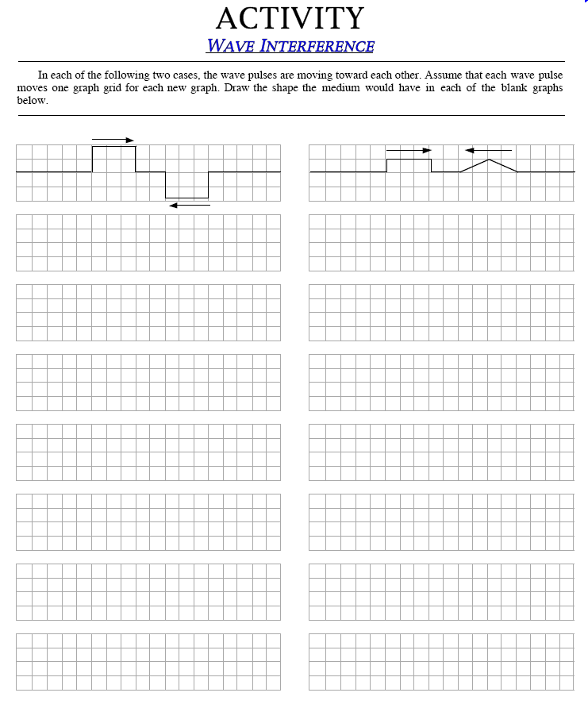

- According to OSHA, what is the maximum length of time one ought to spend at a rock concert (with unprotected ears) where the average dB level is 115 dB?

According to OSHA, a person should have no more than 2 minutes of unprotected exposure to 115 dB.

- Describe the distinction between the terms harmonics, fundamental, partials, and overtones.

- Describe in your own words why the Doppler effect is a thing…how and why does this effect occur?

The Doppler effect occurs due to relative speed of an object and an observer. With soud if an object has movement relative to the observer than the frequency of the wave will be slightly warped when it arrives to the observer. This is observed because as the sound generator moves closer the sound being emitted is coming from closer and closer so the frequency appears to be higher. As the sound travels away from the observer the sound generator produces the same part of the wavelength at an increased interval, so the frequency appears to eb lower.

- Question 2 above spoke of a quarter-wave resonator. Below, draw a tube with the types of ends required of a half-wave resonator, and draw the fundamental PRESSURE (not displacement) diagram.

- Four lead saxophone players are practicing their unison parts, while one of the players’ smartphones (located five feet away) measures dB using an app. The resulting S.I.L. is 92 dB. Then she moves the dB meter five more feet away to test the inverse square law. What do we expect the dB reading to be now?

We now expect the new dB reading to be 86 dB.

- Finally, the other three players pack up and leave. The smartphone owner continues to practice on their own. What do we expect the dB reading to be for this single musician?

Assuming that the sound is now at a quarter of the strength it was before, the dB reading would go down an additional 6 dB. This would result in 80 dB.

- Decibel Levels Derived from Sound Intensities: Compute the decibel levels of the following sound intensities. Show work on at least two problems.

  - 2 x 10⁻⁶ W/m²
    - 0 dB is 10^-12, so 10^-6 is 60 dB.
    - Increase by 3 to double we get 63 dB
  - 4 x 10⁻⁴ W/m²
    - 0 dB is 10^-12, so 10^-4 is 80 dB
    - Increase by 6 to double twice we get 86 dB
  - 8 x 10² W/m²
    - 149 dB
  - 4 x 10⁻¹¹ W/m²
    - 16 dB
  - A sound that is twice as intense as the sound in problem a.
    - Add 3 dB -> 66 dB
  - A sound that is three times (thrice) as intense as the sound in problem b.
    - 90.8 dB
  - A sound that is half as intense as the sound in problem c
    - 146 dB
  - A sound that is four times as intense as the sound in problem d.
    - 22 dB

- Gain a basic knowledge of the aesthetic approach known as minimalism (a compositional approach/philosophy present in art, music and sculpture): Below, write a one paragraph description of what minimalism is. Then, using a Naxos Music Library link or some other electronic means, or Pattee Library’s recordings collection, listen to a piece of minimalist music by one of these composers and describe it using the adjectives on the recent handout (or other pertinent adjectives).
COMPOSERS: Steve Reich, John Adams, Terry Riley, Philip Glass

- Each pair of notes below represents one of the intervals we have discussed and sung in class; each occur in nature as part of the overtone series. Identify each pair by writing its intervallic abbreviation (choose from P1, P4, P5, or P8).

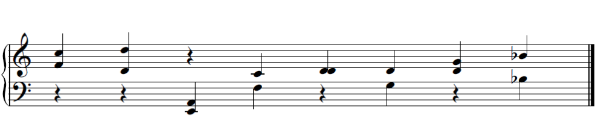

- BONUS QUESTION: Drawings of air displacement in tubes often show fractions of a wavelength, but rarely do they show exactly one entire wavelength. However, one of the modes of vibration in one specific type of tube we discussed, WILL show exactly one period of vibration; i.e. one complete sine wave from crest to crest. What type of pipe, and which harmonic mode of vibration will this be?

An open-open pipe is a half-wave resonator so the first harmonic has a wavelength twice the length of the tube, but this implies that the second harmonic (which is 2x the frequency) would have a wavelength that is exactly the length of the tube.

