Science of Music Joseph Sepich
Problem Set #2
Due: Monday September 9 by 10pm

Directions: Save this worksheet with the filename “SOMProblemSet2-(lastname)”. Be completely sure that you have used the number 2 in the filename, not pasted the number 1 from last week. Enter your answers directly into the document and save, then upload it into Canvas. Clearly show your work. If you are using an equation, write the equation down, then plug in values you are using on the next line. When you are finished with a problem, draw a box around your final result or highlight it. Leave at least a couple of spaces on the paper before starting your next problem. Every answer should include the appropriate units. Remember to submit your homework by 10pm Monday. No homework will be accepted late, so get it done early.

One more reminder about collaboration vs. plagiarism
As with all homework assignments, you should work on each problem on your own. After having done that, you may seek help from other students or professors. But that help should come in the form of a discussion of the problem, not simply looking at the other person's work. You should then go and work the problem by yourself. You may compare final answers. Whenever you received significant assistance, it is your obligation to write a note on your solution to that individual problem that gives credit to that other individual.
Final note on collaboration: You may not get help from written homework of students that have previously taken this class. Of course this is on your honor…and it is our expectation!

1. Using 344 m/sec as the speed of sound in air, calculate the wavelength for each of the following notes:
a) middle C₄, 262 Hz

b) Concert A₄, 440 Hz

c) The note found one octave lower than 440 Hz

d) the lowest note on a piano, A_{o}, 27.5 Hz.

e) the highest note on a piano, C₈, 4186 Hz.

2. What are the frequencies associated with the following wavelengths, assuming these are sound waves traveling in air (our typical 20 degree Celsius temperature)?
a) 0.069 m

b) 1.16 m

c) 0.092 m

d) 5.53 m

e) 0.29 m

f) 9.71 m

3. a) The lowest note most people can hear is around 20 Hz. What is the period of each vibration?

b) The highest note that most young people (who have not gone to rock concerts or worked with a jackhammer) can hear is around 20 kHz (kilohertz). What is the period of each vibration?

4. If you have an empty two-liter coke bottle, and you blow air over it, you will get a note to sound. In order to increase the frequency of the note by one octave (doubling the frequency) you need to add water to the bottle, reducing the volume of air inside the bottle. How much water (in milliliters) do you need to add to the bottle? Explain your work. (Ignore the factor of end correction, which we haven’t gotten to yet)

If you have a two-liter coke bottle and you blow air over it, the note you get to sound will be vibrating the entire bottle, because the bottle is empty. When you add water you dampen the vibration in the area with water filled in it, essentially not vibrating that part of the bottle at all (so the frequency only has to do with the vibration in the area with just air). If you draw a line along the vertical orientation of the bottle you would then get what would be a “string” and as you add water to the bottle, you are putting your finger on that string, where the water stops.

Using this line of thinking we can go back to the video at the beginning of class. We know that an octave is a frequency that is 2 :1 ratio with the other note. This means you can decrease the size of the string by 1 half. Knowing it is an empty 2 liter coke bottle, you would then want to add 1 liter to increase the frequency by one octave.

5.List the frequency ratios and number of half-steps of each of the three musical intervals we have been singing in class. Give each interval’s correct name as well, of course.

Unison – 1:1 ratio, which is 0 half steps.
Octave – 2:1 ratio, which is 12 half steps.
Perfect Fifth – 3:2 ratio, which is 7 half steps.

6. Using the piano keyboard below,
- draw an X on the lowest note that is an E
- write the expression ”8va” on the note an octave above that lowest E (“8va” stands for “an octave higher than”)
- draw arrows to any pair of black keys whose interval forms a perfect fifth.
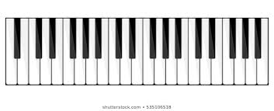

7. On the musical grand staff below, write the name of each pitch.
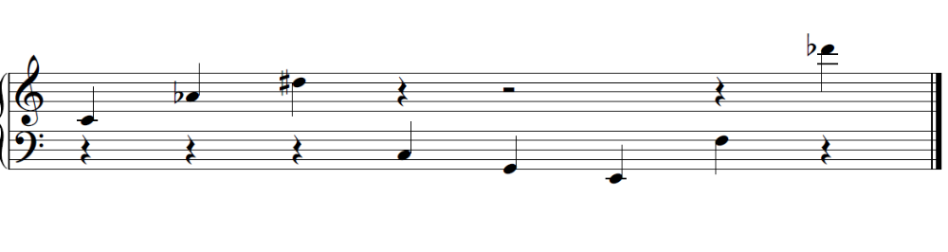
8. Choose one of these music videos:

Love Shack – The B-52s https://www.youtube.com/watch?v=9SOryJvTAGs

Whip It – Devo https://www.youtube.com/watch?v=j_QLzthSkfM

Karn Evil 9, by Emerson Lake and Palmer https://www.youtube.com/watch?v=yIFBpn7_uBQ

The Police – Spirits In The Material World
https://www.youtube.com/watch?v=IBvdHXChNqY&list=PLUj1Ih1wZW5D7LPxLdibdftSLbnvQijTh&index=14

Write a 100+ word reflective commentary on the music included in the video, describing intelligently the music’s use of at least four of the elements below: chord, consonance/dissonance, harmony, instrumentation, interval, intonation, melody, scale, or timbre. Use of adjectives from the adjective sheet discussed in class on Sept 5 will enhance one’s grade on this assignment.

I listened to Whip It by Devo. This song had a recurring theme played by the Piano. The Piano played a 5 note sequence that was comprised of a 1, 4, 5, 7 interval sequence. The Piano is then couple with the synth and where the 7th is a lead in to the synths small interlude back down to the base note that the Piano plays at the start. This leads me into the instrumentation. Devo kept their instrumentation plain including a drum set, whip, vocalist, piano, synth, and guitar. Furthermore, a large part of the time the instruments were not playing together, but in the gaps between each other. The combination of the bass line and instrumentation gave a very pulsating or throbbing feeling. This coupled well with the whip, which gives a sudden crash of sound, but when coupled with the beat made it predictable.

Another part that was interesting was the dissonant section played by the synth towards the end. This part also was pulsating, but made the listener feel on edge like “where is this going to end?” I have mentioned multiple times about the pulsating beat, and they carried this concept into the vocals of the song. Along with the baseline, the main melody that the vocalist was singing would ebb and flow between the line played by the piano and the line played by the synth. Overall I would describe the piece as yearning yet vigorous song that leaves the listener wanting to keep moving after the song is over, thanks to the sudden ending.

