**Title:** Schedule-It

**Who:** Haley Kwiat, Scott Campana, Hayden Nix, Eric Ha, and Ben Wasko.

**Project Tracker:** <https://github.com/haydennix55/Schedule-It/projects/1> 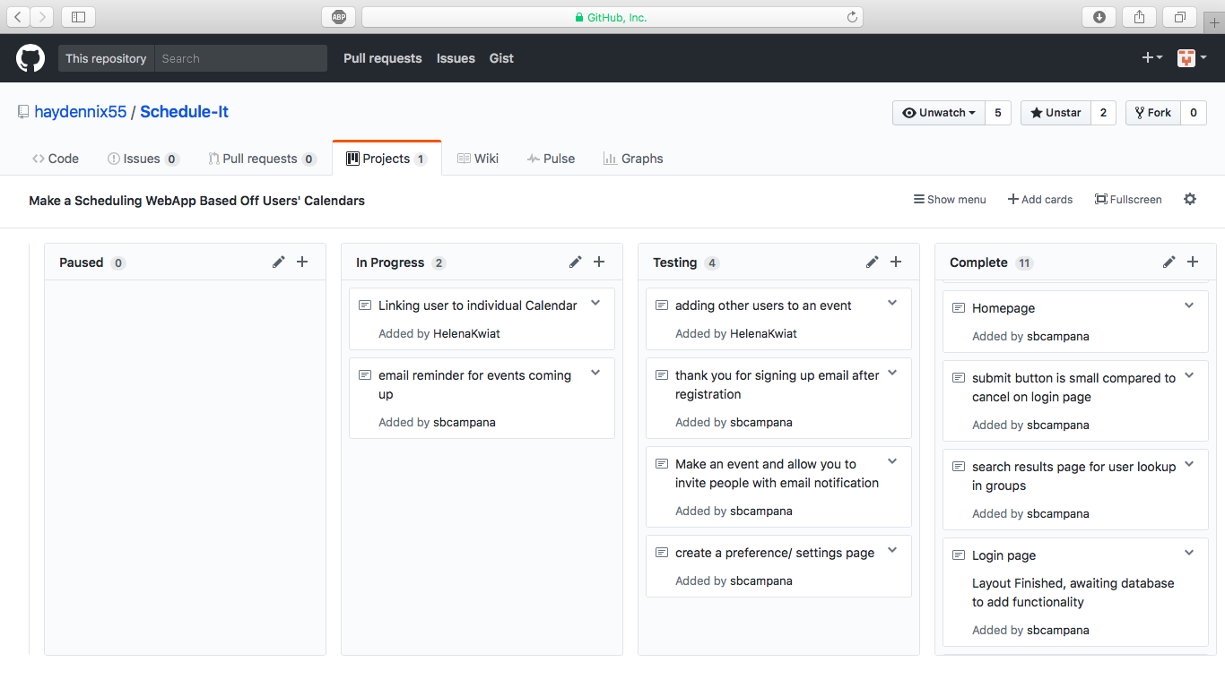

**VCS:** <https://github.com/haydennix55/Schedule-It>

**Contributions:**

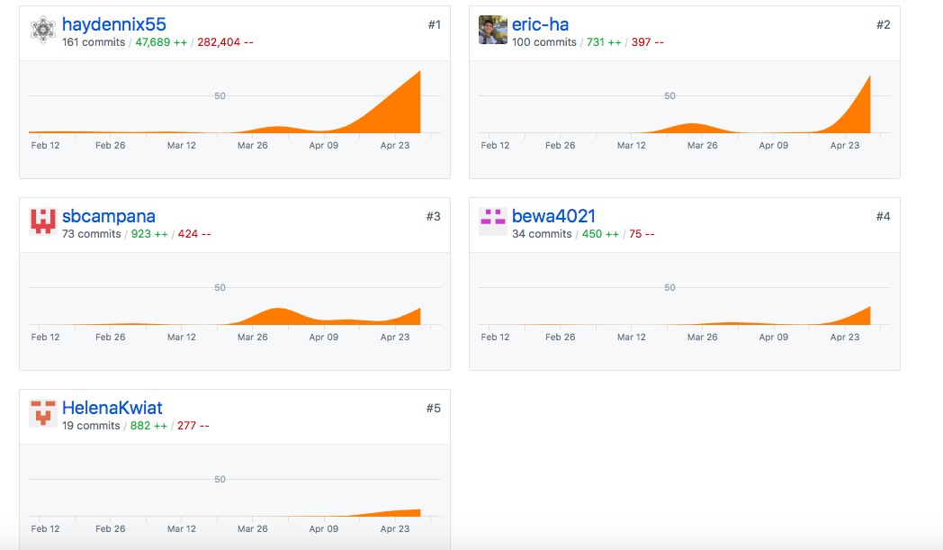

**Deployment:** <http://schedule-it.herokuapp.com>

**AutoDoc:** APIGen

**Link To Auto Doc in github:** <https://github.com/haydennix55/Schedule-It>

(In Schedule-It_AutoDocs)