Name: Bradley Willcott

ID: M198449

Date: 16 September 2021

Assessment Task – 3

Software Deployment

Contents

Figures 2

Project Management Software 1

RationalPlan Single (Linux) 1

Source Control System 2

Git 2

Collaboration Software 1

Trello 1

References 1

# Figures

Figure 1 - RationalPlan About dialog 1

Figure 2 – RationalPlan – Tetris project 1

Figure 3 - Trello - Tetris Game Development 1

# Project Management Software

## RationalPlan Single (Linux)

<https://www.rationalplan.com/>

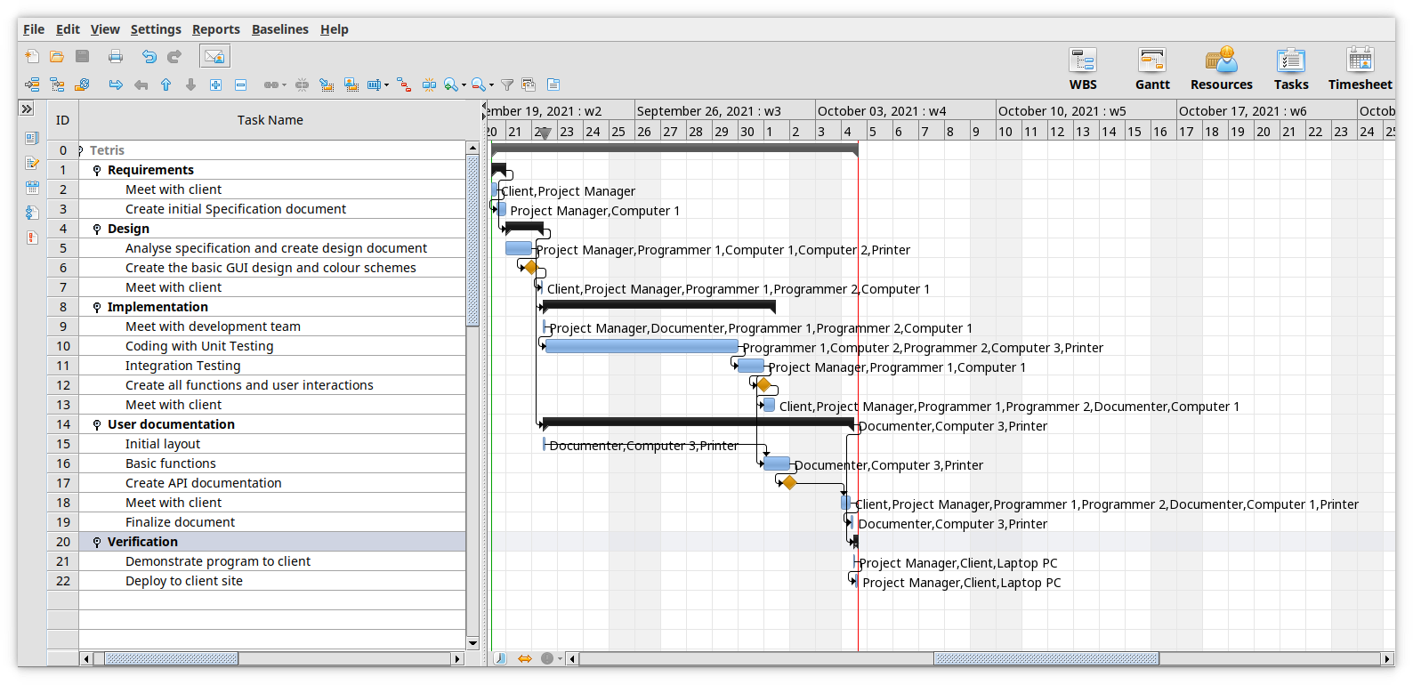

Figure – RationalPlan – Tetris project, updated

# Source Control System

## GitHub

<https://github.com/bewillcott/DeployAT-Three>

Figure - Project on GitHub.com

# Collaboration Software

## Trello

<https://trello.com/b/NfJC9LC2/tetris-game-development>

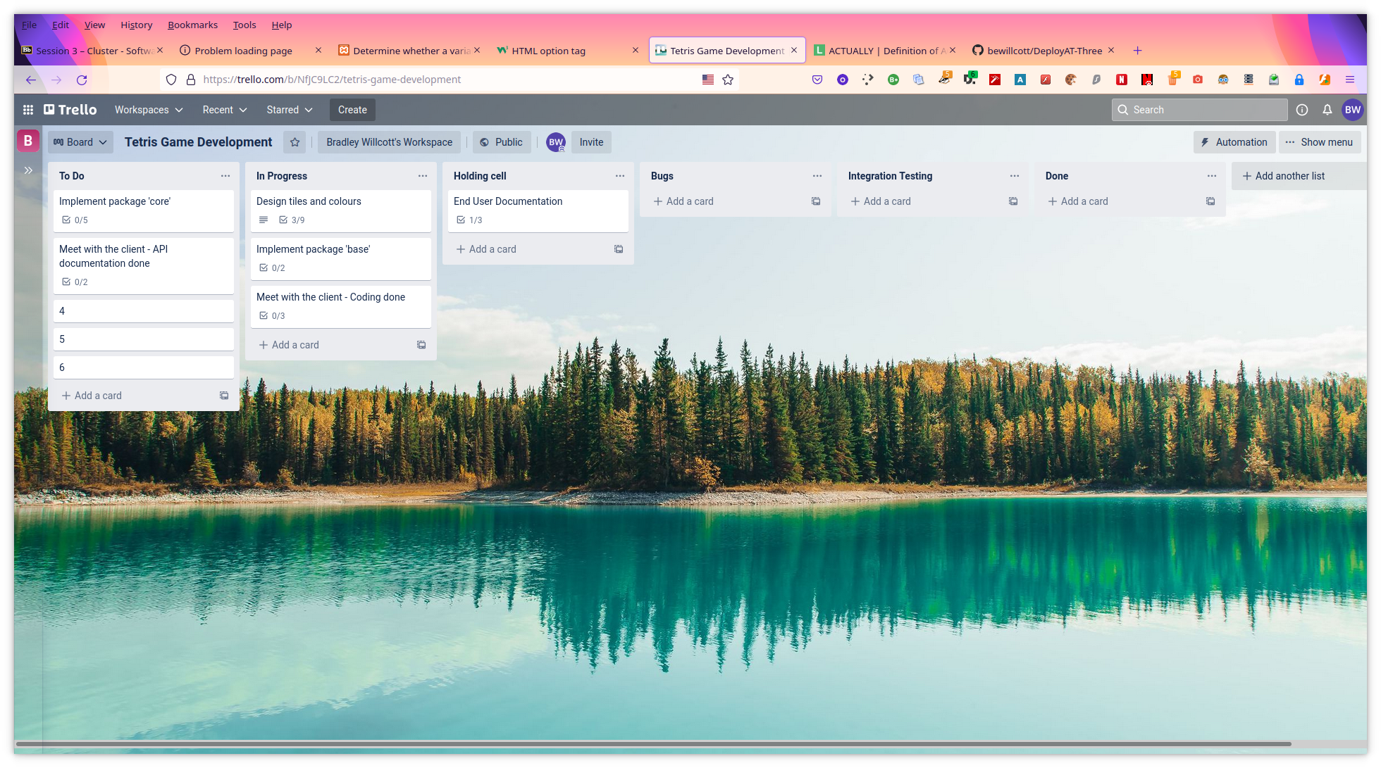

Figure 3 - Trello - Tetris Game Development

# References

**There are no sources in the current document.**